Instructions: Throughout the game, you will make key choices that will determine your political reputation – Sons of Liberty, Fence Sitter, and Loyal Royal. Once you receive your badge, circle it below and use this page to reflect on why you think your choices in the game led you to this side (or no side!).

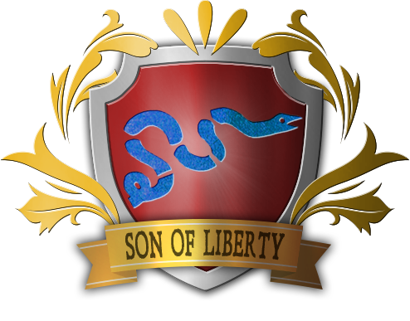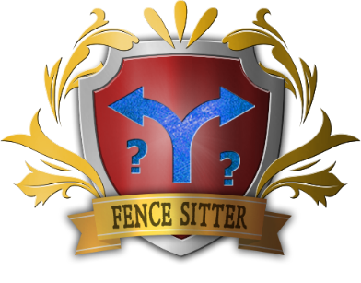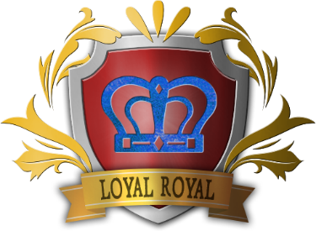

Reflection:
______________________________________________________________________________________________________________________________________________________________________________________________________________________________________________________________________________________________________________________________________________________________________________________________________________________________________________________________________________________________________________________________________________________________________________________________________________________________________________________________________________________________________________________________________________________________________________________________________________________________________________________________________________________________________________________________________________________________________________________________________________________________________________________________________________________________________________________________________________________________________________________________________________________________________

