BENJAMIN EDES
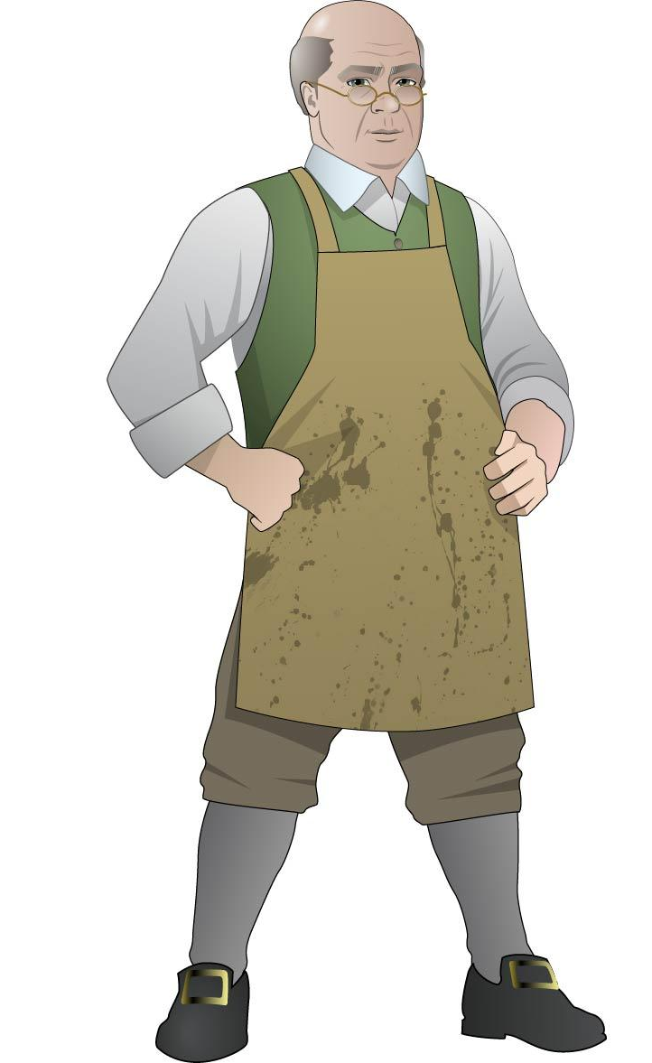
Born on October 14, 1732, Benjamin Edes was a third generation Massachusetts colonist whose grandfather had come over from Britain in 1674. In 1754, Edes married Martha Starr, with whom he would eventually have 10 children. A year later, at the age of 23, Edes and his partner John Gill became editors and proprietors of The Boston Gazette and Country Journal—a weekly newspaper which by the 1760s had become a influential anti-British publication.

Both John and Sam Adams were regular contributors to the Gazette, and Edes himself was a “Son of Liberty” whose writings were highly critical of British policies. Massachusetts Bay Colony Lieutenant Governor Andrew Oliver noted in a 1768 letter to England that "The temper of the people may be surely learned from that infamous paper [The Gazette]," while Governor Francis Bernard advised the arrest of both Edes and Gill as “trumpeters of sedition.”

It was in the Gazette’s offices that Patriots outraged at “taxation without representation” assembled on the afternoon of December, 16 1773 to drink punch and disguise themselves as Indians, before heading down to the harbor to make history with the Boston Tea Party.

During the siege of Boston during the Revolutionary War, Edes escaped with his family to Watertown, Massachusetts, where he continued the publication of the Gazette until 1798. He died on December 1, 1803.

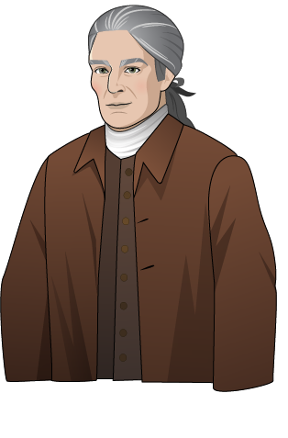
THEOPHILUS LILLIE
Born in Boston in 1730, Theophilus Lillie was a dry-goods merchant who achieved local notoriety in 1769 when he refused to participate in a boycott of imported British goods. Roundly condemned by his Patriotic peers, and with his own business now boycotted, the apolitical Lillie defended himself in an open letter published in the pro-British Boston Chronicle in which he acidly observed the hypocrisy of his critics and their outraged calls for representation in Parliament:
“… it always seemed strange to me that people who contend so much for civil and religious liberty should be so ready to deprive others of their natural liberty; that men who are guarding against being subject to laws which they never gave their consent in person or by their representative should at the same time make laws, and in the most effectual manner execute them upon me and others, to which laws I am sure I never gave my consent either in person or by my representative.”

Lillie went on to warn against the mob mentality of majority rule, citing a good government’s role in protecting the individual:

“If one set of private subjects may at any time take upon themselves to punish another set of private subjects just when they please, it’s such a sort of government as I never heard of before; and according to my poor notion of government, this is one of the principal things which government is designed to prevent; and I own I had rather be a slave under one master (for I know who he is I may perhaps be able to please him) than a slave to a hundred or more whom I don’t know where to find, nor what they will expect of me.”

Lillie’s sense and eloquence did little to save his business, which closed in 1770. He evacuated Boston along with the British military in 1776, and died the following spring in Halifax, Nova Scotia.

PAUL REVERE

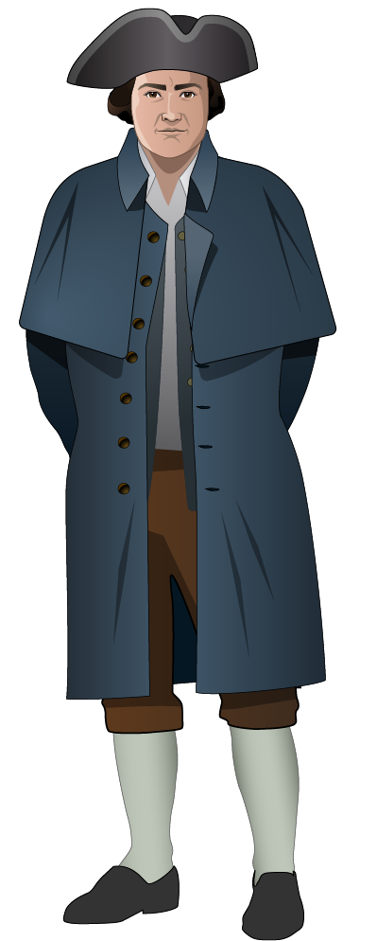
Paul Revere is best known for his famous “Midnight Ride” of April 1775, warning the colonists of the Massachusetts countryside that the British Army was coming. Revere was also a silversmith, Patriot, family man, Revolutionary War officer, and pioneer in the metal industry.

Paul Revere’s exact date of birth is unknown; it is believed that he was born in December 1734 and was baptized on January 1, 1735. The Revere family lived in Boston, and when Revere was 19 years old his father died, leaving him the family silver shop. Revere went on to fight in the French and Indian War, most notably serving in the battle to take the French fort at Crown Point in New York. After his service in the army, he returned to Boston, joined the Freemasons, and befriended many prominent members of the Patriot community.

Revere maintained a solid family life and a thriving career in Boston. In 1757 he married his first wife, Sarah Orne, with whom he had six surviving children. After Sarah died in 1773, Revere married Rachel Walker, with whom he had an additional five children. During this time Revere kept the family silver shop running, while also doing work as an illustrator, copperplater, and dentist. As tension increased between the colonies and the Crown, he became more and more involved in the Freemasons and the Sons of Liberty.

Revere is said to have been involved in both the Boston Massacre and the Boston Tea Party, although the extent to which he organized and participated in the events is not known. Revere’s famous engraving of the Boston Massacre was used in the trial of the British soldiers following the Boston Massacre. After the Boston Tea Party, Revere served as a messenger for the Boston Committee of Public Safety, carrying messages to New York and Philadelphia to alert them of British political and military activity.

Revere’s most famous service to the Sons of Liberty is his noted “Midnight Ride,” just prior to the battles of Lexington and Concord. On the night of April 18, 1775, Dr. Joseph Warren (a well-known Boston Patriot and Freemason) sent both Revere and William Dawes to warn John Hancock and Samuel Adams that the British army was starting to march toward Lexington. The route Revere took went over the Charles River, through Charlestown to Lexington; Dawes followed a longer land route.

As Revere rode to Lexington he warned fellow Patriots of the advancing British army. He likely did not shout the famous phrase – “The British are coming!” – but warned that “the regulars are coming out.” Revere arrived in Lexington at midnight, and William Dawes half an hour later. After warning Hancock and Adams, the two messengers continued toward Concord. They were joined by a third rider, Samuel Prescott, but all three were stopped by British troops at a roadblock. Dawes and Prescott managed to get away, but Revere was detained by the troops and escorted back to Lexington.

During the Revolution, Revere played a key role in the Patriot movement, and spent a year in Philadelphia. After returning to Boston he became a Major of Infantry in the Massachusetts Militia, and was soon promoted to the rank of Lieutenant Colonel. In 1779 he participated in the failed Penobscot Expedition, for which he was accused of disobedience, cowardice, and unsoldierly conduct. He left the military, and a later court-martial cleared him of the charges.

After the war, Revere went back to his silver shop, expanding his business to include iron and brass foundry work. He helped to establish the industry of copper plating, and opened the first copper mill in North America. Revere resigned from the Freemasons in 1809, and politically was a dedicated Federalist, closely following Alexander Hamilton. He died on May 10, 1818.

PHILLIS WHEATLEY

Phillis Wheatley was the first published African-American female poet. Enslaved by a wealthy Boston family, she received much acclaim for her work and was eventually freed from slavery. Once on her own, she married a free black man; however, they separated and she died at a young age in poverty.
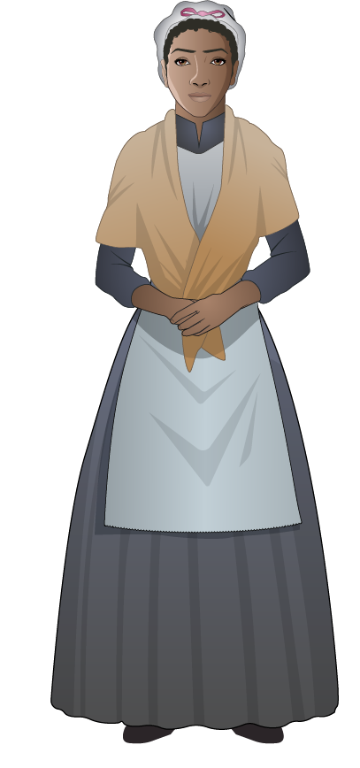
Phillis Wheatley was born around 1754 (the exact date is unknown), in Gambia, now Senegal. She was kidnapped at age seven and taken from Africa on a slave ship called “Phillis,” for which she was named. Upon arrival in Boston, she was purchased by John Wheatley, a wealthy merchant. The Wheatley family recognized Phillis's intelligence and talents and encouraged her education in subjects such as poetry, history, Latin, and religion and Bible studies.

Wheatley published her first poem at the age of twelve, “On Messrs. Hussey and Coffin.” In 1768 she wrote a poem praising England’s King George III for repealing the Stamp Act. She rose to fame in 1770 after writing a poem about a well-known Boston religious figure, George Whitefield, following his death. By writing a tribute to such a popular figure, Phillis earned recognition from many prominent members of Boston society and throughout the colonies. While the majority of her poetry focused on religious and moral themes, a small number referenced the institution of slavery and its injustices.

To most of the people living in Boston in the late 18th century, it was unthinkable that an enslaved black woman could create poetry at all, especially not of the caliber of Phyllis’s poetry. In 1772 her writing was questioned, and it was defended in court by John Wheatley before such prominent figures as John Hancock and the Governor of Massachusetts. It was decided that the poems were, in fact, written by Phillis. A declaration stating this was signed, and would later serve as the preface to her book. Despite winning the trial, no one in Boston would publish her book of poetry. With the help of the Wheatley family and a British noblewoman, Phillis traveled to London. In 1773 her volume of poetry, Poems on Various Subjects, Religious and Moral, was published there. The Wheatleys were impressed with Phillis’s success, and gave Phillis her freedom following the publication of her book.

Phillis’s talent was recognized by Americans and Europeans alike. In March of 1776 she appeared before George Washington and other founding fathers to read her poetry. The Revolutionary War naval hero John Paul Jones was a vocal fan of her work, and would send her some of his own writings. French writer and philosopher Voltaire openly praised her poetry, and contemporary African-American poet Jupiter Hammon wrote an ode to her.

Phillis stayed with the Wheatley family until John Wheatley’s death in 1778. A month later Phillis married a free black man named John Peters. The couple was forced to flee Boston during the British occupation to the town of Wilmington, Massachusetts. John Peters fell into debt, and left Wheatley with their one surviving child. Phillis found work as a servant, but ultimately died in poverty in 1784.

