A NOTE TO THE EDUCATOR:

On the following pages, you will find “flashcards” with terms and definitions (both combined and separate) that your students may encounter while playing Part 2 of “Flight to Freedom.” These terms and definitions can be introduced and practiced before or during the time students see or hear them in the context of Mission US or in their American history study. The discussion questions and writing prompts will provide further opportunities for students to have more practice with the words and terms.

Divide your students into small groups of four or five, and ask each group to review the terms and definitions.

After your students have had a chance to review and discuss the terms and definitions, distribute the excerpt from the reporter’s interview with Lucy. Review the directions with your students, and ask them to complete the text using the terms they studied.

Here are the terms which should be inserted into each paragraph of Lucy’s life story:
Paragraph 1- Ripley
Paragraph 2- Border State, border
Paragraph 3- fugitive, bounty
Paragraph 4- illiterate, slave catchers
Paragraph 5- ford
Paragraph 6- Licking River, Ohio River, ferry, surveillance

Ripley  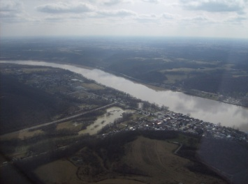  A town in Ohio, on the far side of the Ohio River from Kentucky, that served as a safe haven for fugitive slaves along the “underground railroad.” | Border State  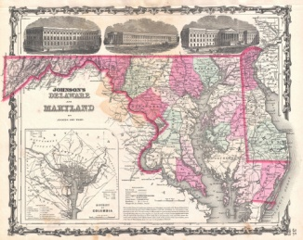  The states that were located between the “free” and “slave” states: Delaware, Maryland, Virginia, Kentucky, and Missouri. Although they were referred to as border states, each of them had slavery within their borders
border  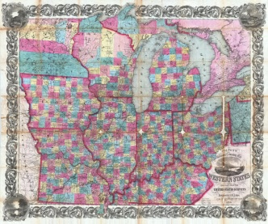  The line or area separating two geographic regions | fugitive  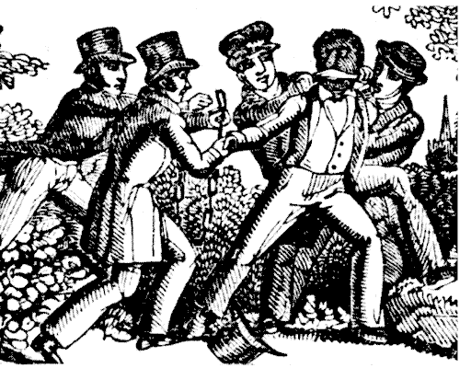  The term used to describe runaway slaves; also, a person who has escaped from a place (like a jail) and is hiding
bounty  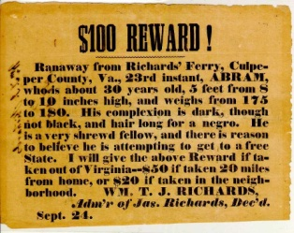  A reward put out for returning a lost item, such as a runaway slave | illiterate  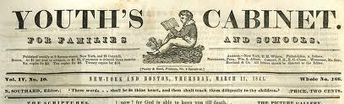  Unable to read.
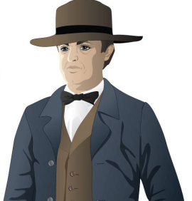  slave catchers  Men who were paid to travel in the North to find and bring back slaves who had run away | ford  A shallow place in a river where one can walk across (noun); to cross a river at a shallow place (verb)

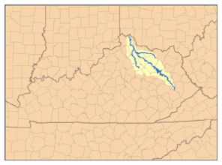  Licking River  Tributary of the Ohio river in Northeastern Kentucky | Ohio River  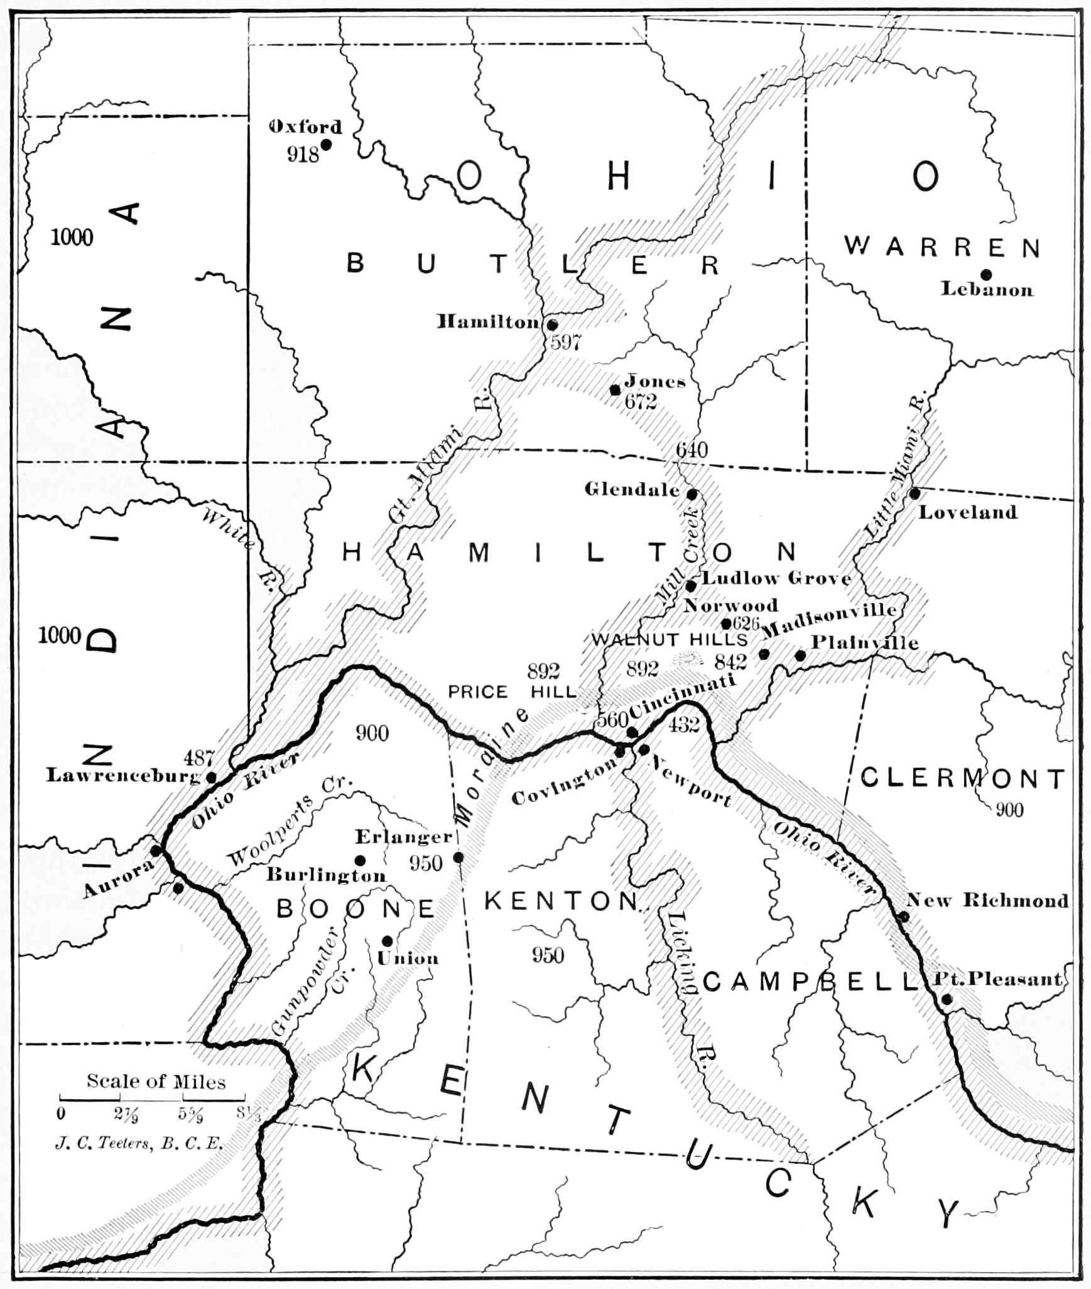  The river separating the states of Ohio and Kentucky. It begins in Pennsylvania, and is the largest tributary of the Mississippi River
ferry  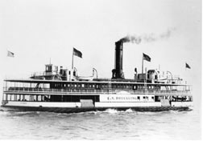  A boat or raft used to carry passengers and/or goods from one side of a body of water to another | 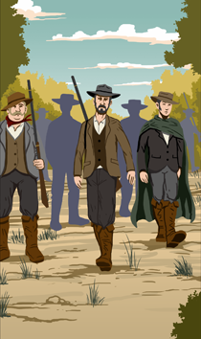  surveillance  The close observance of a person or people, especially if that person (or those people) are suspected of criminal behavior

Ripley  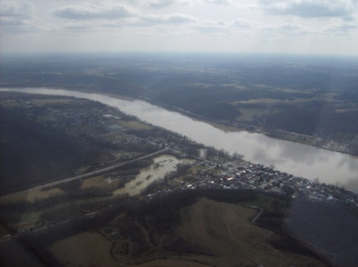 | Border State  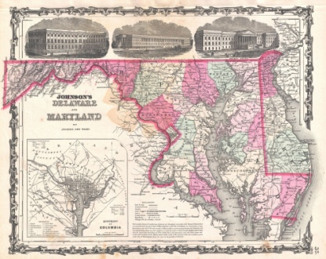
border  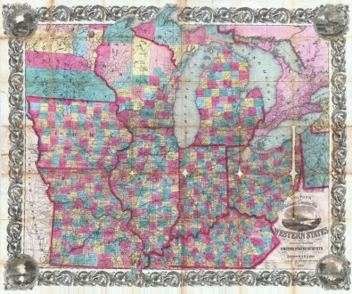 | fugitive
bounty  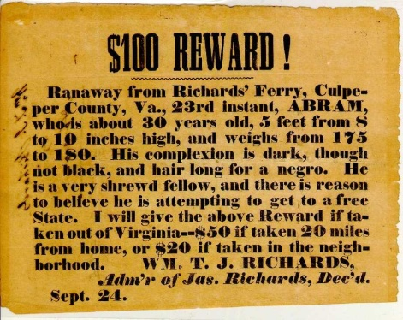 | illiterate
slave catchers  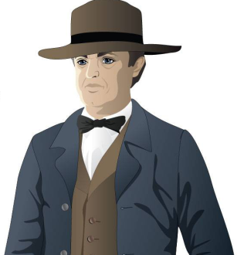 | ford

Licking River | Ohio River
ferry | surveillance  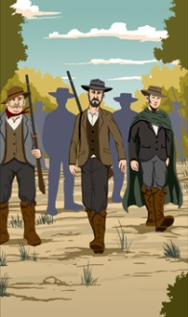

A town in Ohio, on the far side of the Ohio River from Kentucky that served as a safe haven for fugitive slaves along the “underground railroad” | The states that were located between the “free” and “slave” states: Delaware, Maryland, Virginia, Kentucky, and Missouri. Although they were referred to as Border States, each of them had slavery within their borders
The line or area separating two geographic regions | The term used to describe runaway slaves; also, a person who has escaped from a place (like a jail) and is hiding
A reward put out for returning a lost item, such as a runaway slave | Unable to read
Men who were paid to travel in the North to find and bring back slaves who had run away | A shallow place in a river where one can walk across (noun); to cross a river at a shallow place (verb)

Tributary of the Ohio river in Northeastern Kentucky | The river separating the states of Ohio and Kentucky. It begins in Pennsylvania, and is the largest tributary of the Mississippi River
A boat or raft used to carry passengers and/or goods from one side of a body of water to another | The close observance of a person or people, especially if that person (or those people) are suspected of criminal behavior

Name: Date:

Activity: In the years following the Civil War, former slaves celebrated the end of slavery with a holiday called “Juneteenth.” Juneteenth, held annually on June 19, commemorated the day on which slaves in Texas learned of slavery’s abolition.

This activity imagines Lucy is telling a reporter about her life and adventures at a Juneteenth picnic in 1868, twenty years after the beginning of “Flight to Freedom.”

After reading and talking about the words and terms on the flash cards, read this excerpt from Lucy’s interview with the reporter, describing what her life was like when she made her escape. Use the cards and your memory to help fill in the missing words and terms. Some words may be used more than once.

border  Border State  bounty  ferry | ford  fugitive  illiterate | Licking River  Ohio River  Ripley | slave catchers  surveillance

“It is only about seventy-five miles from Master King’s plantation in Kentucky to the little town of __________________, in Ohio. But back when I ran away, those two places could not have been more different.

Kentucky, you see, was a __________________. That meant there was slavery there, but in the state just to the north of it, Ohio, there was no slavery. It seems awfully foolish to me that a person’s freedom was decided by which side of an imaginary line, or __________________, they were standing on.

The minute I left Master King’s plantation, I was a __________________. I was also a criminal. There was a __________________ offered to anyone who could recapture me. I don’t know how much it was, but people could make a nice amount of money if they managed to catch an escaped slave back in those days.

Master King put up posters all over that part of the state, letting folks know I had run off. A lot of folks were __________________, and couldn’t read the posters. That helped some. I had to sleep in the woods and in caves, and spent a lot of my time trying to keep away from the __________________, who patrolled the roads looking for anyone who might be a runaway.

It seems like everywhere I turned, there was a new obstacle to prevent me from getting north. That country has more streams and rivers than I care to remember. Every time I turned around, there was a new river for me to __________________.

The first big river I had to cross was the __________________, but after I made it across, I was still in Kentucky. The ___________________ separates Kentucky from Ohio. These were big rivers, too. It would have been easiest to get across them on a _____________________, but it was often too dangerous for a runaway to try and do that. The Ohio River, especially, was under constant _______________________ by people looking for slaves.

When I made it to Ohio and the town of Ripley I thought I was free and my troubles were over. I was wrong.”

