A NOTE TO THE EDUCATOR:

On the following pages, you will find “flashcards” with terms and definitions (both combined and separate) that your students may encounter while playing Part 3 of “Flight to Freedom.” These terms and definitions can be introduced and practiced before or during the time students see or hear them in the context of Mission US or in their American history study. The discussion questions and writing prompts will provide further opportunities for students to have more practice with the words and terms.

Divide your students into small groups of four or five, and ask each group to review the terms and definitions.

After your students have had a chance to review and discuss the terms and definitions, distribute the excerpt from the reporter’s interview with Lucy. Review the directions with your students, and ask them to complete the text using the terms they studied.

Here are the terms which should be inserted into each paragraph of Lucy’s life story:
Paragraph 1- abolitionists
Paragraph 2- ruthless, affidavit, foolhardy
Paragraph 3- proprietress, stalwart
Paragraph 4- free papers, bankruptcy
Paragraph 5—embroidery, foundry

abolitionists  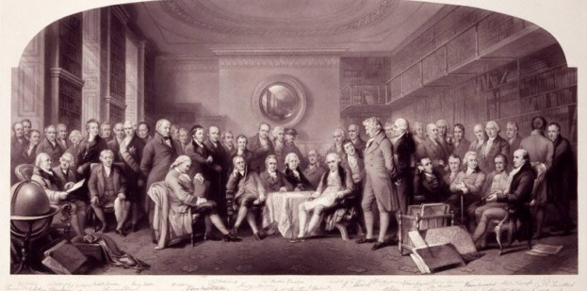  men or women who wanted the immediate end to slavery | 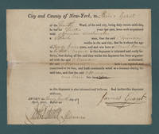  affidavit  a written statement used as evidence in court
bankruptcy  when a person can no longer pay the people who loaned him/her  money or goods | embroidery  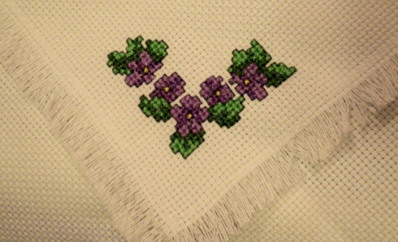  the art of stitching decoration onto cloth with thread or yarn
foolhardy  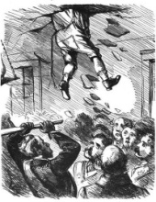  reckless; doing things without thinking | foundry  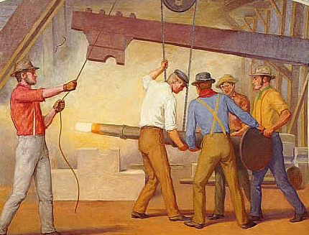  a workshop or factory where metal can be cast and shaped
free papers  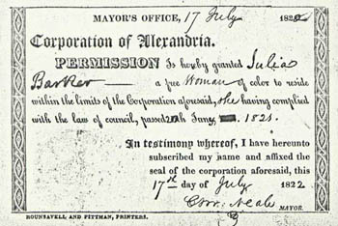  a pass that shows an African American was born free, not a  slave, to prevent slave catchers from taking him or her South | proprietress  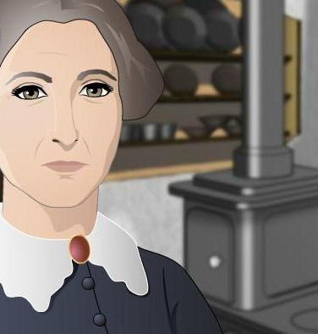  a woman who owns a business or property
ruthless  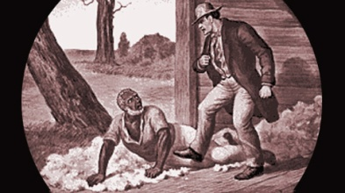  cruel, mean, heartless | stalwart  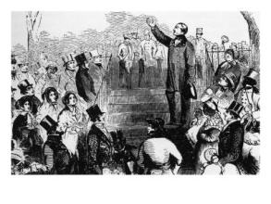  a loyal, hardworking member of a group, team, or cause

abolitionists | affidavit
bankruptcy | embroidery
foolhardy | foundry
free papers | proprietress
ruthless | stalwart

men or women who wanted the immediate end to slavery | a written statement used  as evidence in court
when a person can no longer pay the people who loaned him/her money or goods | the art of stitching decoration onto cloth with thread or yarn
reckless; doing things without thinking | a workshop or factory where metal can be cast and shaped

a pass used to show that an African American was born free, not a slave, to prevent slave catchers from taking him or her South | a woman who owns a  business or property
cruel, mean, heartless | a loyal, hardworking member of a group, team, or cause

Name: Date:

Activity: In the years following the Civil War, former slaves celebrated the end of slavery with a holiday called “Juneteenth.” Juneteenth, held annually on June 19th, commemorated the day on which slaves in Texas learned of slavery’s abolition.

This activity imagines Lucy is telling a reporter about her life and adventures at a Juneteenth picnic in 1868, twenty years after the beginning of “Flight to Freedom.”

After reading and talking about the words and terms on the flash cards, read this excerpt from Lucy’s interview with the reporter, describing what her life was like after she made her escape. Use the cards and your memory to help you fill in the missing words and terms. Some words may be used more than once.

abolitionists  affidavit | bankruptcy  embroidery | foolhardy  foundry | free papers  proprietress | ruthless  stalwart

“I thought once I crossed the Ohio River and made it north, I’d be safe. I was wrong. Although I was being helped by __________________, people who wanted to end slavery, I was still in danger. I wasn’t a slave anymore, but I lived with the fear of being sent back South.

One day, I met a ______________ slave catcher named TC Bercham. He had an ______________ for the capture of Henry, a friend of mine from the plantation. Henry had escaped from the King Planation! I was so worried about him. Bercham started asking me questions about who I was! I was so scared! I could tell he didn’t believe Abigail Wright was my real aunt. I knew I could not be _____________ with a man like Bercham around town. I didn’t want to be taken back to slavery.

I also met the _________________ of the Ripley hotel. She wasn’t very nice to me when I came to pick up laundry from the hotel. Overall, I was much luckier than most runaways. I had so many caring people around me who were sympathetic to me and other freedom seekers. People like the Reverend John Rankin, a _____________ of the antislavery movement, were so kind to me. They helped me find a place to live, a job and even helped me learn to read! How I longed to learn to read in those days. And these kind men and women also protected me from the dangerous slave catchers whenever they could.

But, they couldn’t help me with everything. Because I didn’t have any _____________, being born a slave and all, I was at constant threat of being discovered as a fugitive. I was also very worried about my mother and brother. Reverend Rankin told me that Master King was going to auction his slaves, because he needed the money and was facing ____________________.

I kept very busy, helping the Wrights with their laundry business. I also used my sewing and ________________ skills and made some pretty handkerchiefs for an anti-slavery fundraiser. I found out that Henry was actually in Ripley, being helped by the local antislavery community. He had been hurt badly during his escape. Mr. Parker, who works on metal in the local ____________, was helping hide him. I really wanted to see him and make sure he was okay.

