Map of the Slave Population of the Southern States, 1860

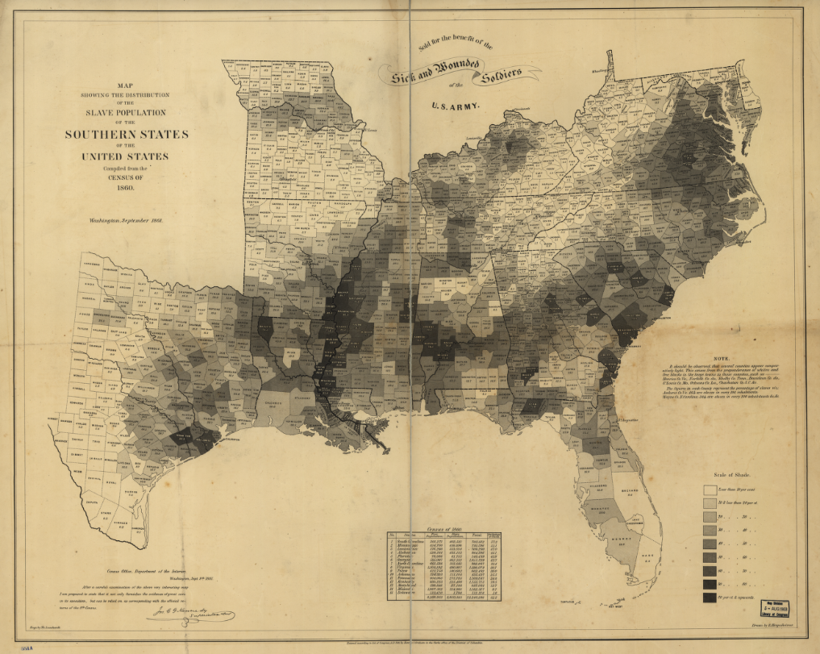

http://memory.loc.gov/cgi-bin/query/h?ammem/gmd:@field%28NUMBER+@band%28g3861e+cw0013200%29%2
http://lccn.loc.gov/99447026

