“Anti-Slavery Fair Poster” (1857)

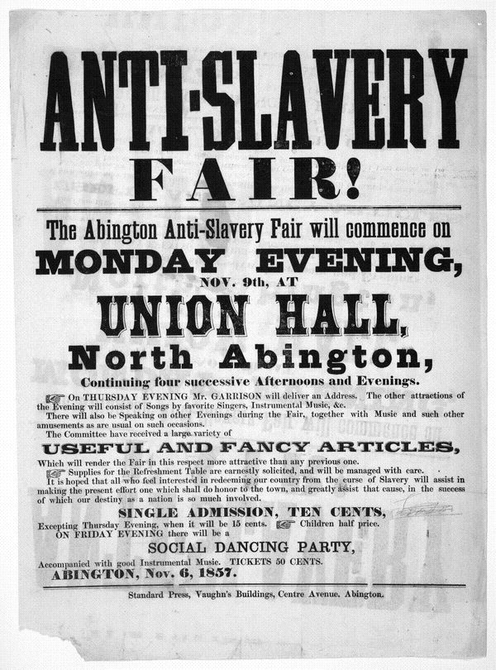
Description: Female abolitionists in Boston began organizing anti-slavery fundraisers in the 1830s. The fairs were a way to raise money and gain political support for their cause among middle-class northern whites. Fliers, such as the one below, advertised a wide selection of ladies accessories, household items, and refreshments.

Source: Library of Congress, American Memory Collection http://hdl.loc.gov/loc.rbc/rbpe.06203500

