A NOTE TO THE EDUCATOR:
On the following pages, you will find “flashcards” with terms and definitions (both combined and separate) that your students may encounter while playing Part 1 of “Prisoner in My Homeland.” These terms and definitions can be introduced and practiced before or during the time students see or hear them in the context of Mission US or in their American history study. The discussion questions and writing prompts will provide further opportunities for students to have more practice with the words and terms.

Divide your students into small groups of four or five, and ask each group to review the terms and definitions.

barbed wire  A variety of metal fencing wire made with sharp points or edges along the top of the fence. It is often used to secure property.  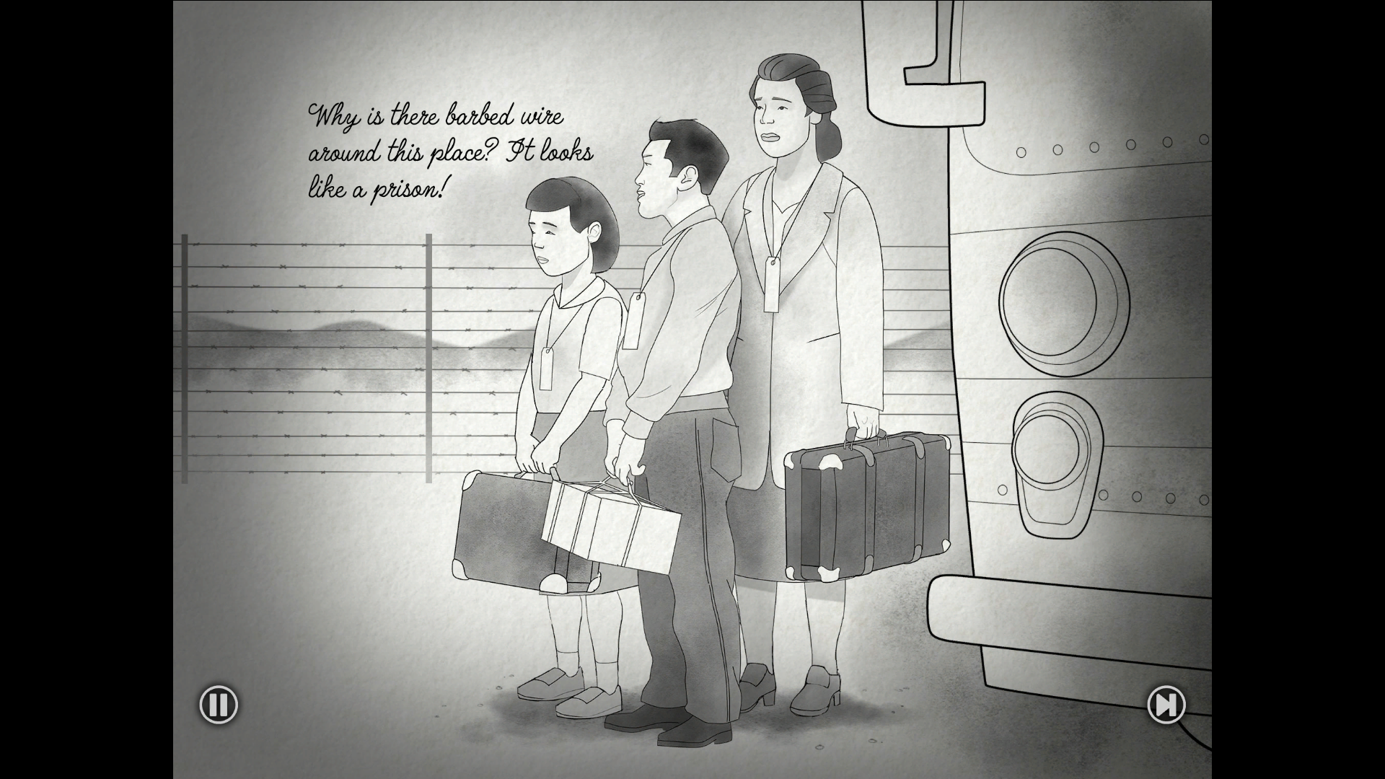 | barracks  Simple or primitive buildings (or a group of buildings) often built to house military personnel.  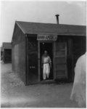
block building  Manzanar was arranged like a military camp. Building 15 in each block was an open barrack used for meetings and events.  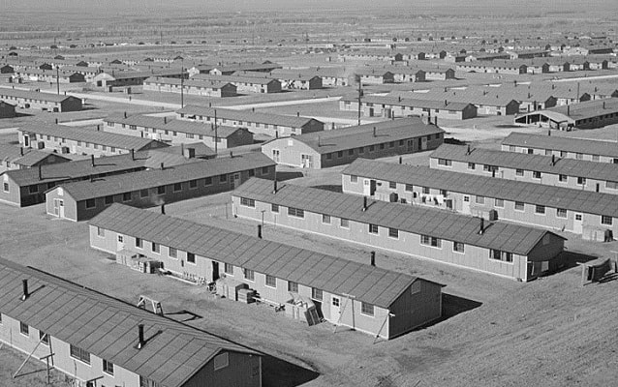 | FBI  The Federal Bureau of Investigation is a national intelligence organization focused on security, intelligence gathering, and law enforcement.  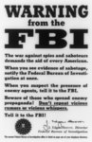
harvest  The process of collecting crops that are ready to eat or sell.  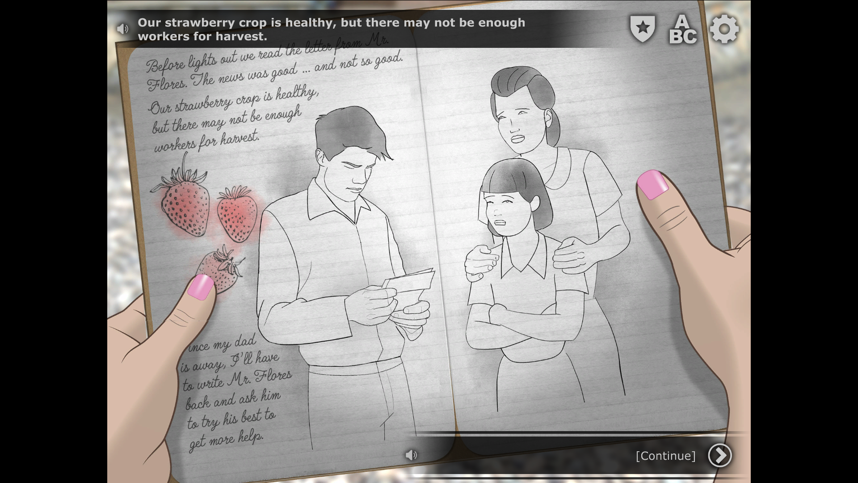 | hick  A derogatory term used to describe someone who is from a rural location (“the country”).
JACL  Japanese American Citizens League; a political organization that advocated for the interests of Nisei (second-generation Japanese Americans). | latrine  A communal toilet used at a camp or military barracks.  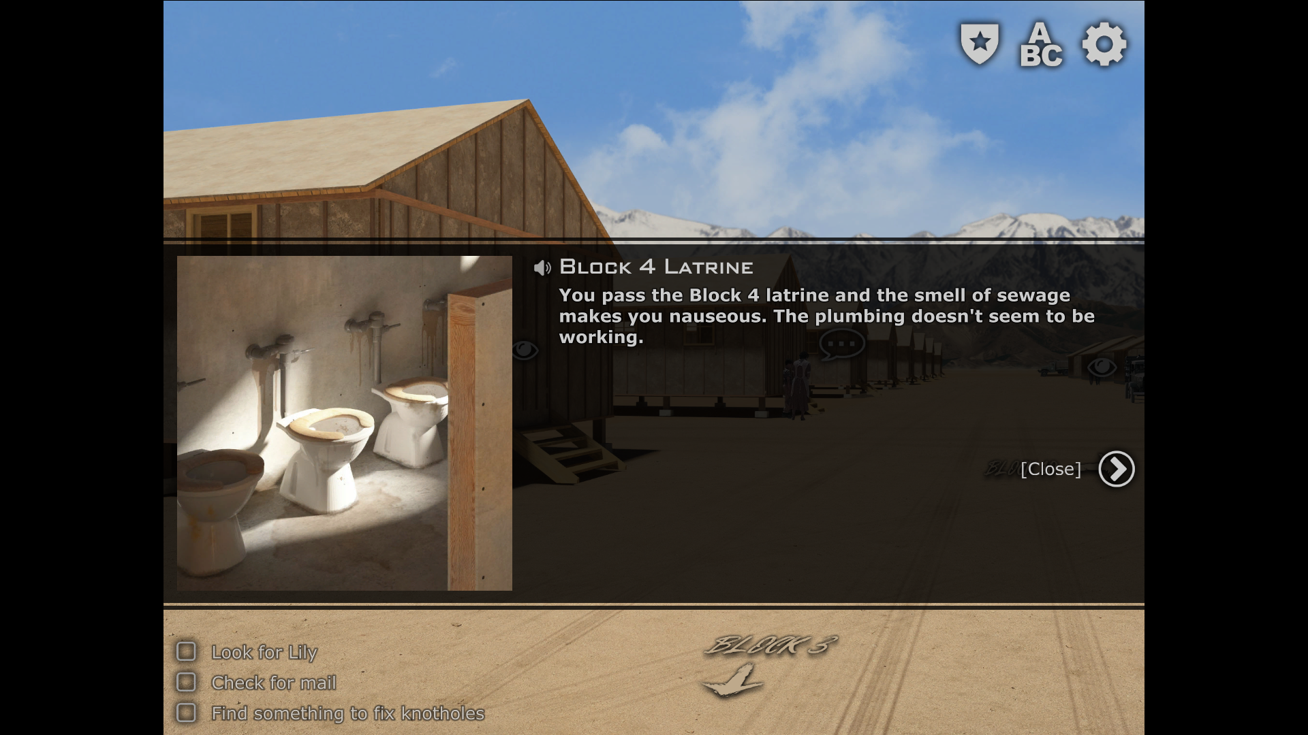
mess hall  A building or room built for military personnel to eat and socialize.  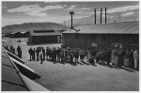 | Pullman train  Refers to the dining or sleeper train cars built and run on many railroads by the Pullman Company  from 1867 to 1968.  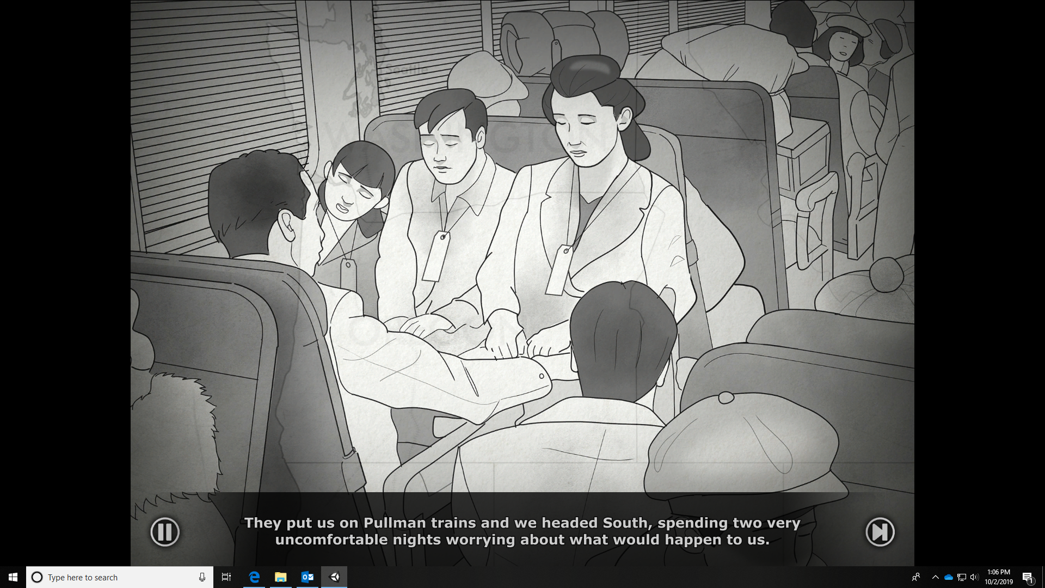
supervisor  A person who oversees or manages other workers. | tar paper  A strong, durable paper most often used in housing construction.  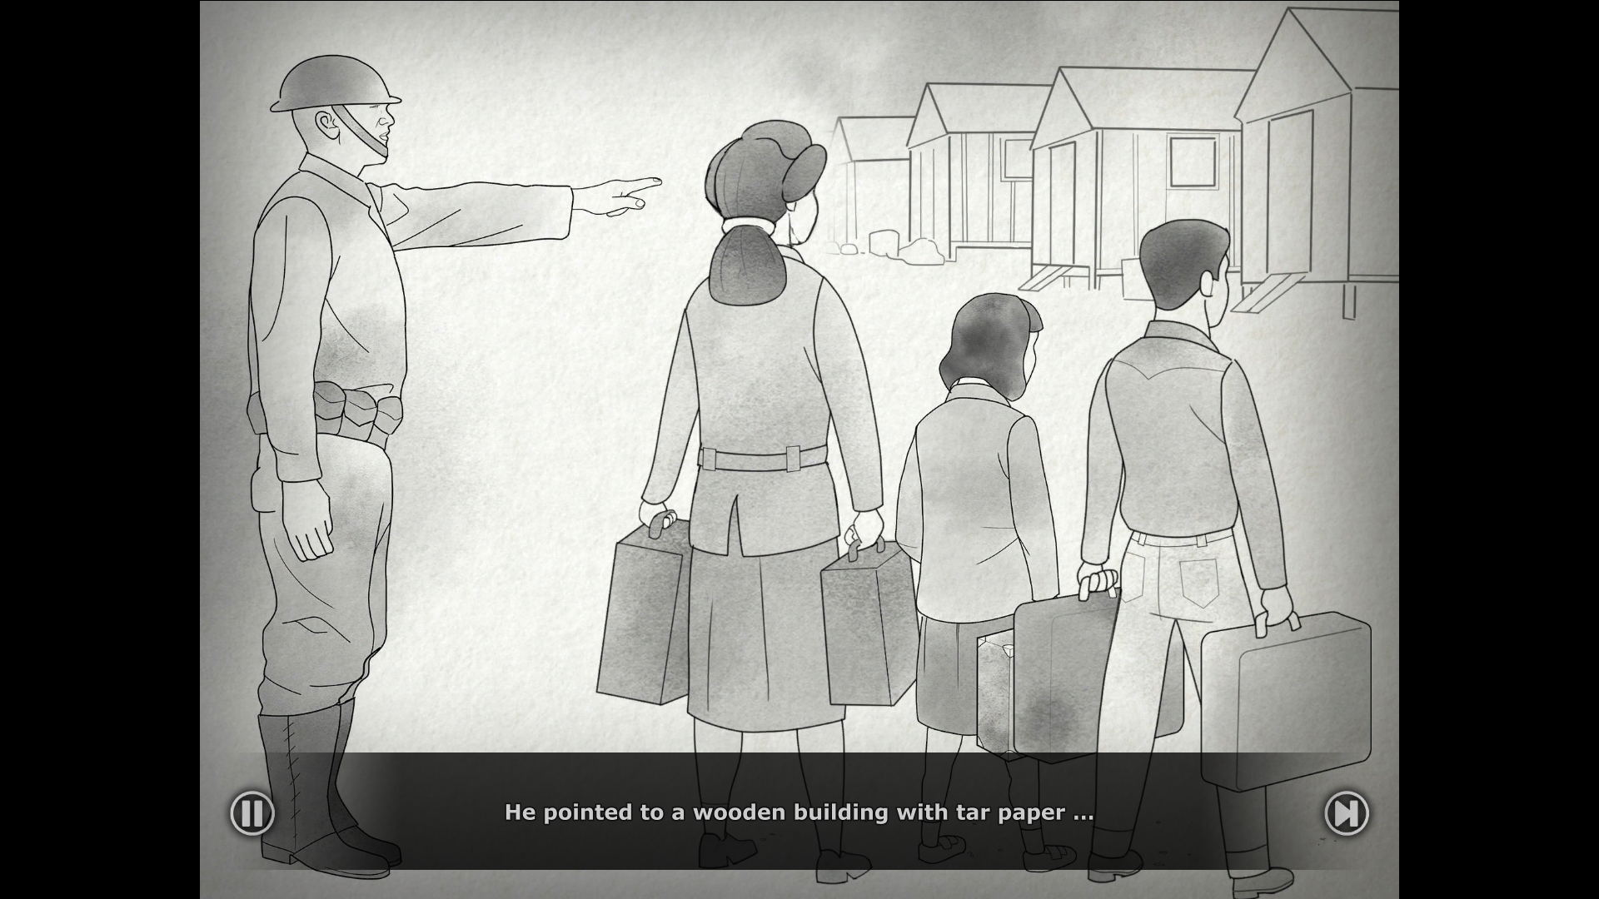

barbed wire | barracks
block building | FBI
harvest | hick
JACL | latrine
mess hall | Pullman train
supervisor | tar paper

A variety of metal fencing wire made with sharp points or edges along the top of the fence. It is often used to secure property. | Simple or primitive buildings (or a group of buildings) often built to house military personnel.
Manzanar was arranged like a military camp. Building 15 in each block was an open barrack used for meetings and events. | The Federal Bureau of Investigation is a national intelligence organization focused on security, intelligence gathering, and law enforcement.
The process of collecting crops that are ready to eat or sell. | A derogatory term used to describe someone who is from a rural location (“the country”).
Japanese American Citizens League; a political organization that advocated for the interests of Nisei (second-generation Japanese Americans). | A communal toilet used at a camp or military barracks.
A building or room built for military personnel to eat and socialize. | Refers to the dining or sleeper train cars built and run on many railroads by the Pullman Company  from 1867to 1968.
A person who oversees or manages other workers. | A strong, durable paper most often used in housing construction.

Name: _______________________ Date:_________________________

DIARY ENTRY ACTIVITY

Write a diary entry that Henry Tanaka would have written based on Part 1 of “Prisoner in My Homeland,” by completing the sentence prompts below. Describe how he would feel or wonder about the following situations:

- how Henry Tanaka’s family was split up and then forced to move to Manzanar
- what the living conditions were like
- the role of the Japanese American Citizens League (JACL) within the prison camp and how some people viewed them

The following vocabulary words from the flash cards should be used::
- FBI
- Pullman train
- barbed wire
- tar paper
- latrine
- barracks
- mess hall
- supervisor
- block building
- JACL

Sentence Prompts:

I can’t believe Dad isn’t with us and that so many other fathers were taken away too…

After packing up only what we could carry we were forced to move…

When Mom, Lily, and I arrived at Manzanar we couldn’t believe the conditions we had to live in…

It was interesting learning about Mr. Yamamoto being a block supervisor and talking to Harry Ueno and others about that organization…

