 | Part 1 Observations | Part 2 Observations | Part 3 Observations | Part 4 Observations | Part 5 Observations | Who are they FOR? | Who are they AGAINST?
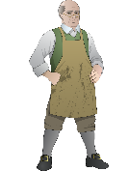
Mr. Edes
Constance
Mr. Lillie
Royce
Phillis
Hugh White
Solomon
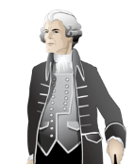
Customs Officer

