James Franklin’s Indenture Contract to his Uncle Benjamin Franklin, 1740
This contract indentures James Franklin, Benjamin Franklin’s nephew, to serve as an apprentice to his uncle, who in turn promises to teach James the trade of printing. The strict terms of the contract, as well as the period of indenture lasting seven years, were typical of the arrangements by which thousands of adolescent boys and young men apprenticed themselves to skilled tradesmen during the colonial period.

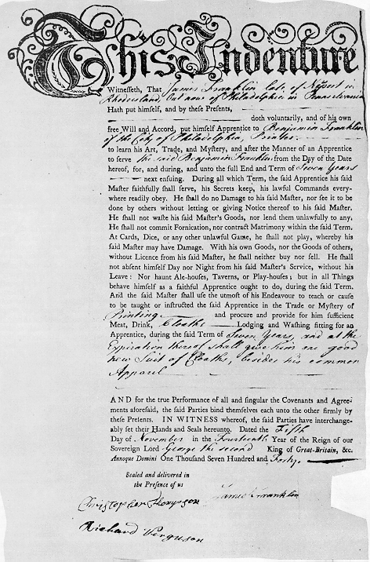

Transcript:
This Indenture
Witnessth, That James Franklin late of Newport in Rhode island, And now of Philadelphia in Pennsylvania Hath put himself, and by these Presents, doth voluntarily, and of his own Will and Accord, put himself Apprentice to Benjamin Franklin of the City of Philadelphia, Printer --------to learn his Art, Trade, and Mystery, and after the Manner of an Apprentice to serve the said Benjamin Franklin from the Day of the Date hereof, for, and during, and unto the full End and Term of Seven Years ----next ensuing. During all which Term, the said Apprentice his said Master faithfully shall serve, his Secrets keep, his lawfull Commands everywhere readily obey. He shall do no Damage to his said Master, norr see it to be done by others without lettting or giving Notice thereof to his said Master. He shall not waste his said Master's Goods, nor lend them unlawfully to any. He shall not commit Fornication, nor contract Matrimony within the said Term. At Cards, Dice, or any other unlawful Game, he shall not play, whereby his said Master may have Damage. With his own Goods, nor the Goods of others, without Licence from his said Master, he shall neither buy nor sell. He shall not absent himself Day nor Night from his said Master's Service, without his Leave: Nor haunt Ale-houses, Taverns, or Play-houses; but in all Things behave himself as a faithful Apprentice ought to do, during the said Term. And the said Master shall use the utmost of his Endeavour to teach or cause to be taught or instructed the said Apprentice in the Trade or Mystery of Printing and procure and provide for him sufficient Meat, Drink, Cloaths----- Lodging and Washing fitting to an Apprentice, during the said Term of Seven Years and at the Expiration thereof shall give him one good new Suit of Cloaths, besides his common Apparel.

AND for the true Performance of all and singular the Covenants and Agreements aforesaid, the said Parties bind themselves each unto the other firmly by these Pretents. IN WITNESS whereof, the said Parties have interchangeably set their Hands and Seals hereunto. Dated the Fifth Day of November in the Fourteenth Year of the Reign of our Sovereign Lord George the second King o Great-Britain, &c. Annoque Domini One Thousand Seven Hundred and Forty.

Sealed and delivered in
the presence of us

[Signatures of Christopher Thompson, James Franklin, and Richard Ferguson]

Source: Prof. Gerald Zahavi, Dept. of History, University at Albany-SUNY
http://www.albany.edu/faculty/gz580/His316/jf-ind-h.gif

