A NOTE TO THE EDUCATOR:

On the following pages, you will find “flashcards” with terms and definitions your students may have encountered while playing Part 2: A Death in Boston (February 22, 1770).

Divide your students into small groups of four or five, and ask each group to review the terms and definitions.

After your students have had a chance to review and discuss the terms and definitions, distribute the letter from Nat to his parents back home in Uxbridge. Review the directions with your students, and ask them to complete the letter using the terms they studied.

Here are the terms which should be inserted into each paragraph of Nat’s letter:
Paragraph 2- import, homespun, export, taxes, boycott
Paragraph 3- Loyalists, Townshend Acts
Paragraph 4- protest
Paragraph 5- effigy

IMPORT  As a verb: (im-PORT) to bring something in from another country, usually for trade.  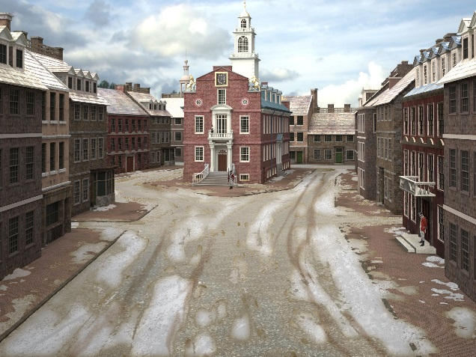  As a noun: (IM-port) something made or grown in another country that is then shipped here, usually so that it may be resold. | EXPORT  As a verb: to ship goods that are made or grown in one country to another country, where they will be sold.  As a noun: something made or grown in one country that is sent to another country for sale.  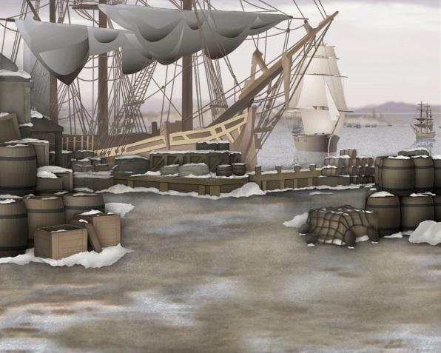
LOYALIST  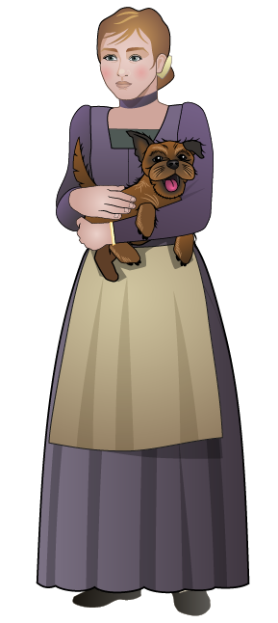  Literally, a loyalist is any person who is loyal to his or her king. In the dozen or so years leading up to the Revolutionary War, a Loyalist was a person who continued to support King George III and his policies in the American colonies. Loyalists were opposed to the growing movement that favored independence from the British Empire. | BOYCOTT  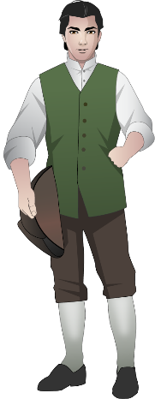  As a verb: to refuse to deal with a process, an organization or a company as a form or expression of protest against it. Usually, there is a group of people who agree to boycott rather than just one person. You could say, “Many colonists boycotted British tea.”  As a noun: the name of the process that is described above. So, you could say, “There is a boycott on British tea.”

HOMESPUN  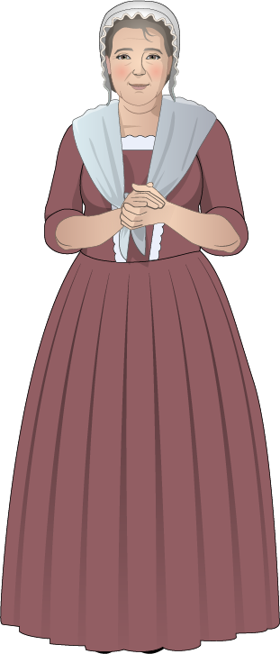  Literally, homespun is cloth that is made at home by spinning thread on a wheel and then weaving that thread into cloth on a loom. In general, though, it meant things that were made at home in America. Homespun contrasted with manufactured or other goods that were imported from England. | PROTEST  As a verb: (pro-TEST) to complain about or object to something. While individuals may protest (you might protest in a restaurant if your food takes too long to come to you), here is means to do it publicly, so that others see or hear. When you protest in this way, you are trying to alert others to the situation and influence them to join you.  As a noun: (PRO-test) the name of the process described above.  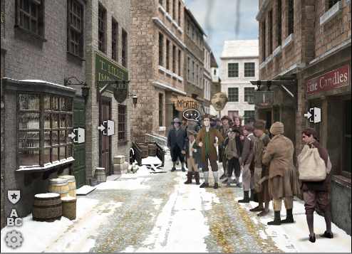
EFFIGY
An effigy is a dummy, often crudely made, that is supposed to represent a real person who is disliked. One form of protest in 1770s Boston was to make effigies of unpopular Loyalists, like tax collectors, and hang them by the neck from the Liberty Tree, to the cheers and huzzahs of the assembled crowd

TAXES  Taxes are monies that a government makes its citizens pay. Tax money is used for various things the government needs in order to operate. Taxes pay the salaries of the people who work for the government, and they are used to pay for roads, government buildings like post offices, the military, and so on. Taxes are collected in a variety of ways. One way is a sales tax, usually some fraction of the cost of something that you pay when you buy an item. Direct taxes are paid directly to the government. The Townshend Acts were a direct tax, that is, merchants had to pay it directly to a British tax collector. | TOWNSHEND ACTS  The Townshend Acts (or Duties) were laws passed by the British Parliament in June 1767. They placed a tax on common products imported to America such as lead, paper, paint, glass, and tea. The taxes collected would be used to pay British governors and other officials that were usually paid by local town assemblies. Since the taxes were on imports, merchants were the ones who had to pay them. Then they would have to increase the cost of the goods they sold here to pay themselves back. Also, the laws restated that Writs of Assistance, easy-to-get search warrants, were legal. This irritated Boston merchants because it gave the British military the right to invade the privacy of their homes to search for evidence they had been selling goods to France and other countries in Europe, which was illegal.

Name: Date:

Activity: After reading and talking about the words or terms on the flash cards, read this letter Nat Wheeler sent to his parents back in Uxbridge after his second day in Boston. Use the cards and your memory to help you fill in the missing words and terms.

import  homespun  taxes | export  protest | Loyalist  effigy | boycott  Townshend Acts

My dear Mother and Father,

You know that I have always been proud to be a British subject. I have even thought that some day I might visit England and see the king. But the events of the last few hours have awakened doubts I feel I must relate to you.

Mr. Edes made it clear to me that, in his opinion, to __________ British goods, even necessities like paper or tea, is in some way evil. I overheard a conversation in which Mrs. Edes said she would rather take the time and effort to make and wear clothing of ____________, rough as it is, than to enrich an Englishman who would ___________ fine cloth to America while the King collected ____________ from Americans on the trade. She feels there should be a ____________ of all British goods.

I found a newspaper article that identifies the American merchants who are ____________ and who continue to import British goods despite the taxes levied on them as a result of the hateful ____________. I must keep my distance from these men when I go out to sell because Mr. Edes would never accept a ha’penny’s business from them. I believe that for Mr. and Mrs. Edes, for a great many people in this city, the very word “Importer” has become a profanity!

Until today, I felt it was not my place to take sides. But now things have changed. Remember Mr. Lillie, about whom I wrote you yesterday? A crowd of people gathered near his store this morning to ____________ against his continued trade with England. A neighbor of his, Mr. Richardson, also a Loyalist, was roughed up by the crowd. His wife was hit by an egg. In response, he went to his roof, loaded his musket and snapped off a shot at the protestors. A boy younger than I am, Christopher Seider, was cut down, and later today, he died of his wounds, may G-d have mercy on his soul!

I have overheard talk of a further protest in which an ____________ of Mr. Richardson will be hung from a limb of the Liberty Tree. And I have heard some plans about Poor Christopher’s funeral about which I will write further after it is done.

I pray, Mother and Father, that you and Samuel are well, and that G-d is watching over our Christopher and keeping him safe, wherever he is.

Your loving son,
Nat

