A NOTE TO THE EDUCATOR:

On the following pages, you will find “flashcards” with terms and definitions your students may have encountered while playing Part 3 of “For Crown or Colony?”

Divide your students into small groups of four or five, and ask each group to review the terms and definitions.

After your students have had a chance to review and discuss the terms and definitions, distribute the letter from Nat to his parents back home in Uxbridge. Review the directions with your students, and ask them to complete the letter using the terms they studied.

Here are the terms which should be inserted into each paragraph of Nat’s letter:
Paragraph 1 - martyr
Paragraph 2 - pamphlet
Paragraph 3 – broadside, Liberty Tree, Stamp Act, Sons of Liberty
Paragraph 4 – King George III
Paragraph 5 – spinning bee, pennywhistle

LIBERTY TREE  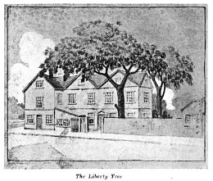  A regular meeting place for Patriots to express their viewpoints and protest the British interference in the colonies. The tree was also used for hanging effigies, posting broadsides, distributing pamphlets, and hanging flags. During the siege of Boston in 1775, a group of Loyalists cut down the tree and used it for firewood. | BROADSIDE  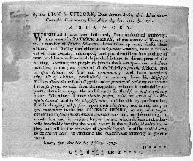  A printed poster or public announcement, designed to catch a reader’s attention and declare the latest news, government proclamations, public service announcements, opinions or advertisements.
PAMPHLET  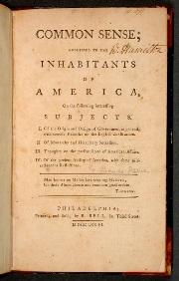  A printed leaflet or booklet, often containing political, philosophical or religious arguments, essays, and commentaries on current events. Pamphlets were usually printed and distributed quickly and cheaply. | MARTYR  One who suffers or sacrifices something of great value – often one’s own life – for refusing to renounce a belief or standing up for one’s principles.
SPINNING BEE  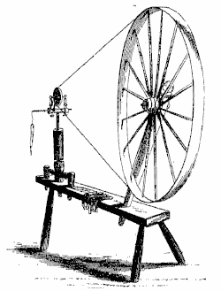  A gathering of people, usually women, to encourage the production of yarn as opposed to importation. Spinning bees were a popular forum for expressing opposition to heavily taxed British goods. | STAMP ACT  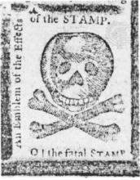  The Stamp Act of 1765, established by Parliament, imposed a tax on all public and legal documents including permits, contracts, newspapers, wills, pamphlets, and even playing cards. Colonists protested the Act, claiming that it was not fair for Parliament to impose taxes on the colonies if the colonies were not represented in Parliament. The Stamp Act was repealed on March 18, 1766.

SONS OF LIBERTY  A political group that originated in Boston following the Stamp Act in 1765, made up of Patriot men that resisted Crown laws. Groups calling themselves “Sons of Liberty” existed in every colony. In 1773, the Sons of Liberty organized the Boston Tea Party in response to England’s Tea Act.  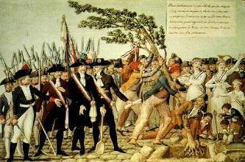 | KING GEORGE III  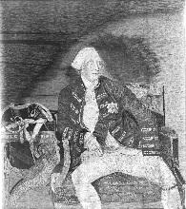  The King of Great Britain from 1760 to 1820. Imposed many different taxes on American colonies in an effort to pay for military efforts in North America and elsewhere. Viewed as the classic symbol of British sovereignty and tyranny – “The Crown.” Blamed by many for prolonging the conflict with the colonies and the American Revolution unnecessarily, and ultimately losing the colonies.
PENNYWHISTLE

A small, inexpensive woodwind instrument, also known as a tin whistle.

Name: Date:

Activity: After reading and talking about the words or terms on the flash cards, read this letter Nat Wheeler sent to his parents back in Uxbridge shortly before the funeral of Christopher Seider. Use the cards and your memory to help you fill in the missing words and terms.

King George III  pennywhistle | Liberty Tree  broadside  martyr | pamphlet  spinning bee | Stamp Act  Sons of Liberty

My dear Mother and Father,

I do not wish to alarm you, but tensions here in Boston are rising by the day. In my last letter I told you of the death of a young apprentice, Christopher Seider. Preparations for his funeral are now underway, and many people in Boston have strong feelings about the incident. I have heard several people call Christopher a __________, since his life was sacrificed in support of the Patriot cause. I must decide if I agree. It is a lot to think about.

My work does not provide me with much distraction, as Master Edes is busy printing information about the funeral. He printed a __________ to give to people at the funeral, with Patriot opinions and essays about the current state of affairs with Britain. Perhaps it will move the people of Boston to take further action.

Just a few days ago Master Edes had me post a __________ announcing information about the funeral to the people of Boston. I was told to put the paper at a popular gathering place for Patriots, the __________. I learned that it
has been an important location for the Patriots. After the __________ in 1765, when printed paper and documents were taxed, many gathered there to protest and voice their opinions. I heard that several men, known as the __________, met there to protest violently, and even burned effigies of British officials!

I cannot help but sometimes question the actions of the man who wears the crown, __________. It seems no matter what he does, the Boston is an unhappy town. I do not believe that he and the redcoats will back down any time soon, and I worry about what will come next.

But please, do not fear that my days are filled only with talk of conflict and death. Recently, Mrs. Edes allowed me to sit in on her __________, which was a great success. She and the other Patriot women are committed to make their own yarn and cloth to avoid importing British goods. In the few moments I have to myself, I am practicing new songs on my __________. I am becoming quite good, and will play a song or two when I see you next.

I pray that you and Samuel are well, and that all is well on the farm.

Your loving son,
Nat

