MISSION 1: “For Crown or Colony?”
Part 4: From Bad to Worse (March 5, 1770)
Document-Based Activity
Mr. Revere’s Engraving

A NOTE TO THE EDUCATOR:
At this point in “For Crown or Colony?” students have a good sense that the paths of their own different Nats are a consequence of the choices they have made, and many might know by now that their interpretations of events and their future actions may be affected by those choices.
In this activity, students will become agents of influence, creators of propaganda that is intended to move the people of Boston further toward the Patriot cause. Each student (or group of students) takes the part of Paul Revere as he is planning to create his now- famous engraving of the Boston Massacre.
Mr. Revere will gather information by reading several real accounts of the Massacre as well as Nat Wheeler’s account. Then, he will answer some questions that will guide the choices he makes about what to show, how to show it, and what not to show. Students are then directed to make their sketches in colored pencil.
We suggest they make the sketches on 8½ x 11 paper, so that an entire class’s work may be taped to the front board to be appreciated. You may use the template provided on page 9 of this document, or have students work on blank paper. Individual students or groups should be called upon to explain their choices.
After this is done, you might project Revere’s engraving and ask your students to look at and explain Revere’s choices.
By this time, you may not have to provide many prompts for discussion, but here are some:
1. What is similar or different about your own choices and Revere’s?
2. If you had to put Revere’s illustration into words, what would his story of the incident be?
3. Why do you think he is telling the story in this way?
4. Based on what you know about that night from the point-of-view of Nat and the other accounts, is Revere’s version true enough? Explain.
5. Is propaganda, the telling of one side or aspect of a story, fair? Explain.
6. Are ads propaganda? Explain why you think they are or are not.
7. Do you or people you know relate stories about their own lives one-sidedly? Why?
8. Is it possible to tell the truth, the whole truth, and nothing but the truth? Explain why or why not.

Here are some things to consider about how to proceed through the activity based on the needs of your group:
- Decide whether to read the directions aloud or to have students read them aloud.
- Decide whether all the students should read all the accounts, or whether you should divide the class into groups and have each read and report out about the one account they read.
- Decide what parts of the activity students can reasonably do at home and what might be better done in school. It might be, for example, that students should start the drawing together in school and finish is at home.
- Decide whether students should take notes to answer the questions, write more detailed full sentences or whether you feel it’s enough to have them think about the answers before they draw.
- If students have notes about their own responses to the deposition, they may use them. If not, each student may rely on his or her memory. If there are conflicts, the groups should compromise or try to converge on one version. Encourage them not to get bogged down at that point.

Mr. Revere’s Engraving

Directions: For this activity, you will play a different role: instead of Nathaniel Wheeler, printer’s apprentice, you will be Paul Revere, silversmith, maker of false teeth, Patriot, and engraver.
A week or so has passed since the night of March 5, 1770, and you are planning to make an engraving depicting that terrible night. Since you were not there yourself, you have gathered information from others about what happened and what it looked like. Below are some of the accounts of that event that you have to read.
You will want to represent most of what really happened, but you want to do so in a way that moves others to resent the presence of British troops and encourages their sympathy to the Patriots.
First, read the accounts. Next, answer the questions. Finally, make the sketch for your engraving.

Account #1. An Anonymous Account of the Boston Massacre
Standing | Benjamin Frizell, on the evening of the 5th of March, having taken his station near the west corner of the Custom-house in King street, before and at the time of the soldiers firing their guns, declares (among other things) that the first discharge was only of one gun, the next of two guns, upon which he the deponent thinks he saw a man stumble; the third discharge was of three guns, upon which he thinks he saw two men fall; and immediately after were discharged five guns, two of which were by soldiers on his right hand; the other three, as appeared to the deponent, were discharged from the balcony, or the chamber window of the Custom-house, the flashes appearing on the left hand, and higher than the right hand flashes appeared to be, and of which the deponent was very sensible, although his eyes were much turned to the soldiers, who were all on his right hand.

Account #2. George Robert Twelves Hewes, eyewitness
street | On receiving the message, [Captain Preston] came immediately with a small guard of grenadiers, and paraded them before the custom-house, where the British officers were shut up. Captain Preston then ordered the people to disperse, but they said they would not, they were in the king’s highway, and had as good a right to be there as he had. The captain of the guard then said to them, if you do not disperse, I will fire upon you, and then gave orders to his men to make ready, and immediately after gave them orders to fire. Three of our citizens fell dead on the spot, and two, who were wounded, died the next day; and nine others were also wounded.  George Robert Twelves Hewes, eyewitness

Account #3. Report in the Boston Gazette and Country Journal: An account of a late military massacre at Boston, or the consequences of quartering troops in a populous town, March 12, 1770.
…stabbed at some of them in different places; this caused the people to get angry and, it is said, they threw snow balls.  short, heavy club | Thirty or forty persons, mostly lads, being by this means gathered in King-street, Capt. Preston with a party of men with charged bayonets, came from the main guard to the Commissioner's house the soldiers pushing their bayonets, crying, Make way! They took place by the custom-house, and continuing to push, to drive the people off, pricked some in several places; on which they were clamorous, and, it is said threw snow balls. On this, the Captain commanded them to fire, and more snow balls coming he again said, Damn you, Fire, be the consequence what it will! One soldier then fired, and a townsman with a cudgel struck him over the hands with such force that he dropt his firelock; and rushing forward aimed a blow at the Captain's head, which graz'd? hat and fell pretty heavy upon his arm: However, the soldiers continued the fire, successively, till [?] or 8, or as some say 11 guns were discharged.

Account #4. Deposition of Captain Thomas Preston of the 29th Regiment
…I had so little intention of causing anyone’s death that I allowed the troops to go to the spot…  This careless behavior may deserve criticism.  I was determined not to act offensively.  …speaking with, and trying with all my might to persuade them to go away peacefully, but I didn’t get anywhere.  At this point  …pointing out that I was in front of the soldiers’ musket barrels, and if they fired, I’d get hit; | I immediately sent a non-commissioned officer and 12 men to protect both the sentry and the king's money, and very soon followed myself to prevent, if possible, all disorder, fearing lest the officer and soldiers, by the insults and provocations of the rioters, should be thrown off their guard and commit some rash act. They soon rushed through the people, and by charging their bayonets in half-circles, kept them at a little distance. Nay, so far was I from intending the death of any person that I suffered the troops to go to the spot where the unhappy affair took place without any loading in their pieces; nor did I ever give orders for loading them. This remiss conduct in me perhaps merits censure; yet it is evidence, resulting from the nature of things, which is the best and surest that can be offered, that my intention was not to act offensively, but the contrary part, and that not without compulsion. The mob still increased and were more outrageous, striking their clubs or bludgeons one against another, and calling out, come on you rascals, you bloody backs, you lobster scoundrels, fire if you dare, G-d damn you, fire and be damned, we know you dare not, and much more such language was used. At this time I was between the soldiers and the mob, parleying with, and endeavouring all in my power to persuade them to retire peaceably, but to no purpose. They advanced to the points of the bayonets, struck some of them and even the muzzles of the pieces, and seemed to be endeavouring to close with the soldiers. On which some well behaved persons asked me if the guns were charged. I replied yes. They then asked me if I intended to order the men to fire. I answered no, by no means, observing to them that I was advanced before the muzzles of the men's pieces, and must fall a sacrifice if they fired; that the soldiers were upon the half cock and charged bayonets, and my giving the word fire under those circumstances would prove me to be no officer. While I was thus speaking, one of the soldiers having received a severe blow with a stick, stepped a little on one side and instantly fired, on which turning to and asking him why he fired without orders, I was struck with a club on my arm, which for some time deprived me of the use of it, which blow had it been placed on my head, most probably would have destroyed me.  On this a general attack was made on the men by a great number of heavy clubs and snowballs being thrown at them, by which all our lives were in imminent danger, some persons at the same time from behind calling out, damn your bloods-why don't you fire. Instantly three or four of the soldiers fired, one after another, and directly after three more in the same confusion and hurry. The mob then ran away, except three unhappy men who instantly expired, in which number was Mr. Gray at whose rope-walk the prior quarrels took place; one more is since dead, three others are dangerously, and four slightly wounded. The whole of this melancholy affair was transacted in almost 20 minutes. On my asking the soldiers why they fired without orders, they said they heard the word fire and supposed it came from me. This might be the case as many of the mob called out fire, fire, but I assured the men that I gave no such order; that my words were, don't fire, stop your firing. In short, it was scarcely possible for the soldiers to know who said fire, or don't fire, or stop your firing.

Account #5. What Nathaniel Wheeler saw from the warehouse.
Describe what you saw on the night of March 5th when you were Nat Wheeler.

Name: Date:
Mr. Revere’s Engraving
Planning Questions

Now, Mr. Revere, you will decide how to make your engraving. Your decisions will be based on your answers to these questions:
1. According to the accounts, were the people standing around peacefully?

2. What was the role of snow?

3. At what time of day did the incident occur? In your opinion, would the incident have been less likely to happen four or five hours earlier? Why or why not?

4. How do the various accounts position Preston and the other soldiers? Why does that matter?

(continued next page)

5. What are the different accounts of how the shots were fired? Why does that matter?

6. How does Preston’s account differ from the others? How is it the same?

7. According to Hewes, who bears most of the responsibility? According to Preston? Why does it make sense that these two accounts of the incident do not agree?

8. Do you think that, from the point-of-view of either side (or both sides), the trouble was intentional? Why?

Now, using regular pencil and colored pencils, make your sketch of the incident that would become known as the Boston Massacre. Remember, you are not only a Son of Liberty, but one of the most influential Patriots in Boston. So, feel free to emphasize the aspects that favor your cause and to de-emphasize or omit those that do not.

_______________________’s Drawing of What Happened in King Street, March 5th:
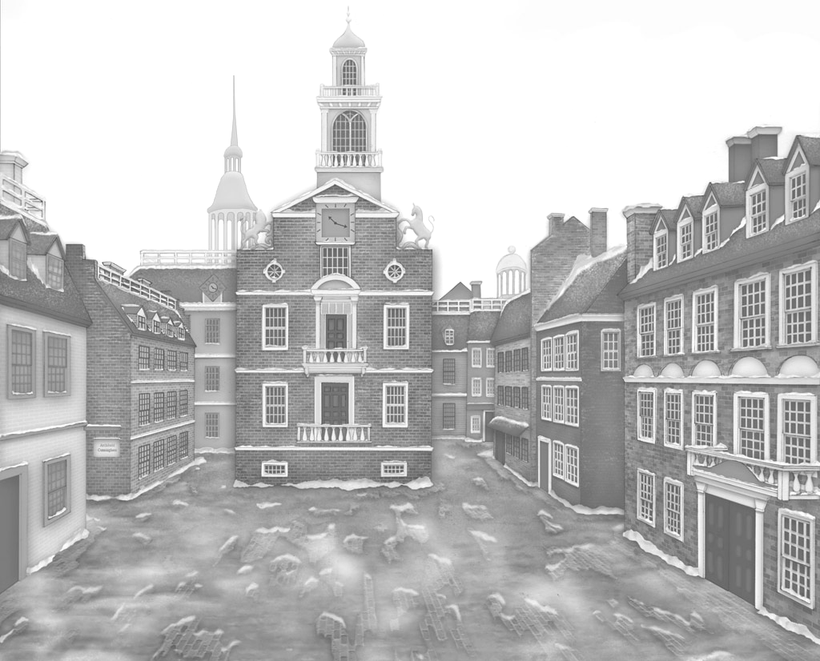

Title: _______________________________________________________________________________
Caption:__________________________________________________________________________________________________________________________________________________________________
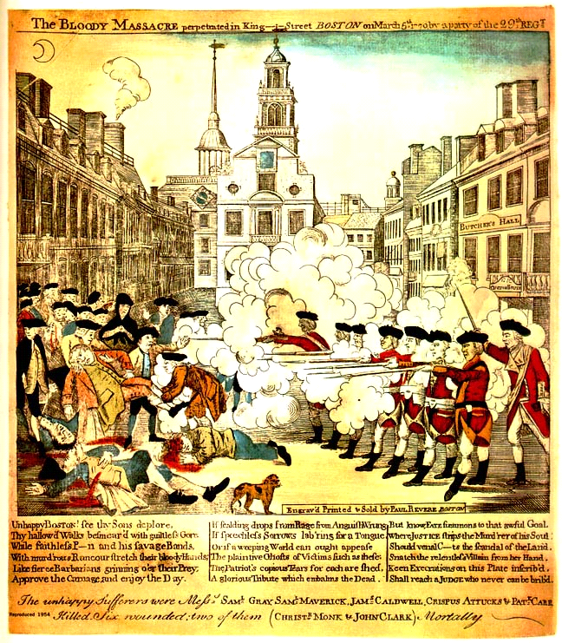
Source: Paul Revere, based on a design by Henry Pelham, The bloody massacre perpetrated in King Street Boston on March 5th 1770 by a party of the 29th Regt., engraving, on or about March 28th, 1770; from The Library of Congress Online, Prints and Photographs Division, http://www.loc.gov.

