“A History of the Amistad Captives” Advertising Broadside (1840)

In 1839, captive West Africans revolted and took control of the Spanish slave ship Amistad. They ordered the crew to return them to Africa, but were waylaid by a U.S. Navy vessel off the coast of New York. The Africans were charged with murdering the captain, and put in jail in New Haven, Connecticut. Abolitionists came to their support, and after a long legal battle, in 1841 the U.S. Supreme Court ruled that the men had acted in self-defense and should be freed. A year later the men returned to Africa
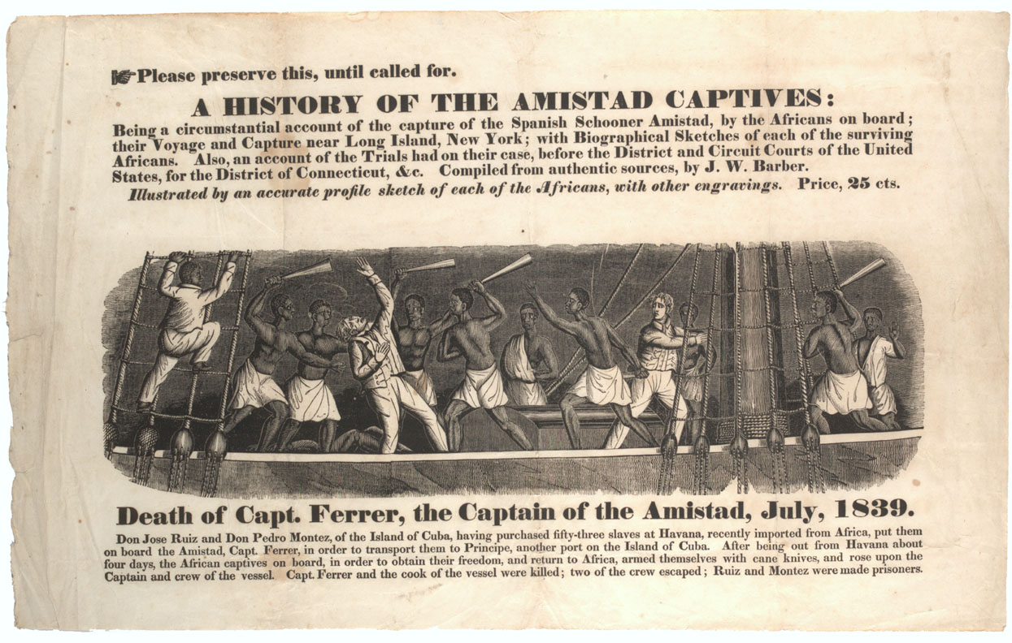
A HISTORY OF THE AMISTAD CAPTIVES:
Being a circumstantial account of the capture of the Spanish Schooner Amistad, by the Africans on board; their Voyage and Capture near Long Island, New York; with Biographical Sketches of each of the surviving Africans. Also, and account of the Trials had on their case, before the District and Circuit Courts of the United States, for the District of Connecticut, &c. Compiled from authentic sources, by J. W. Barber.
Illustrated by an accurate profile sketch of each of the Africans, with other engravings. Price, 25 cts.
Death of Capt. Ferrer, the Captain of the Amistad, July, 1839.
Don Jose Ruiz and Don Pedro Montez, of the Island of Cuba, having purchased fifty-three slaves at Havana, recently imported from Africa, put them on board the Amistad, Capt. Ferrer in order to transport them to Principe, another port on the Island of Cuba. After being out from Havana about four days, the African captives on board, in order to obtain their freedom, and return to Africa, armed themselves with cane knives, and rose upon the Captain and crew of the vessel. Capt. Ferrer and the cook of the vessel were killed; two of the crew escaped; Ruiz and Montez were made prisoners.
Source: Advertising broadside for J.W. Barber, "A History of the Amistad Captives," featuring woodcut, "The Death of Capt. Ferrer," 1840. Gilder Lehrman Institute of American History, New York, NY.

