Slave Pass (1852)

Slaves were often sent out on errands to other plantations, farms, or towns. Laws required slaves to carry a pass if they traveled without their owners. Unlike more official documents, such as certificates of freedom, passes were handwritten and informal. The pass below was for a slave named Barney in Missouri who tried to escape using the pass, but was captured.

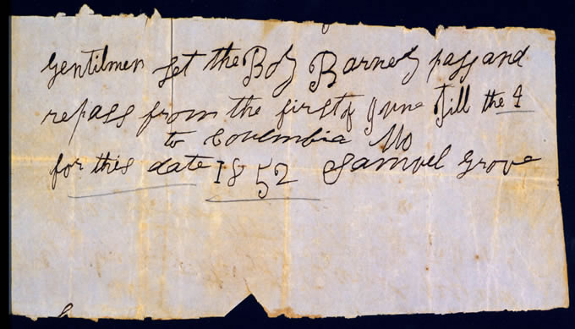

Text:
Gentilmen let the Boy Barney pass and repass from the first of June till the 4 to Columbia Mo for this date 1852 Samuel Grove

