A NOTe to the educator:

This chart can be used at any time while you are using “Flight to Freedom” with your students. It provides both teachers and students with an easy and visually accessible way to capture ideas and thoughts about the characters in the game. This chart could be printed out for each individual student or displayed for the entire class.

 | Part 1 Observations | Part 2 Observations | Part 3 Observations | Part 4 Observations | Part 5 Observations | Does s/he resist slavery? How? | What are the effects of her/his actions?
Henry
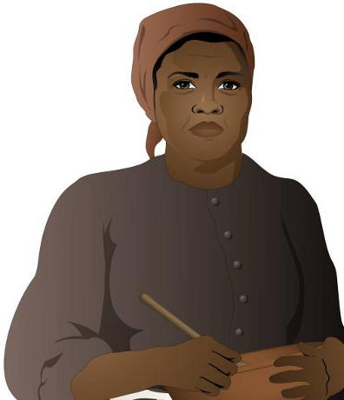
Esther
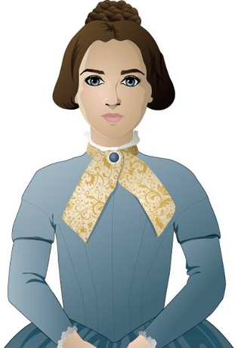
Sarah
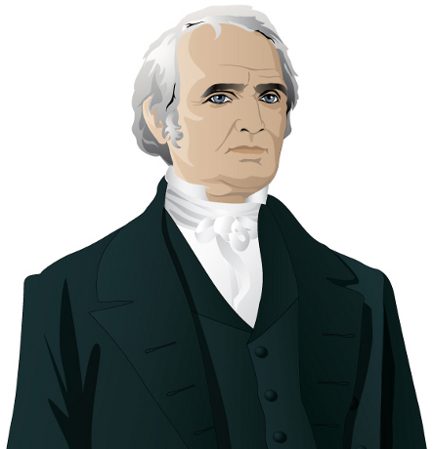
John Rankin
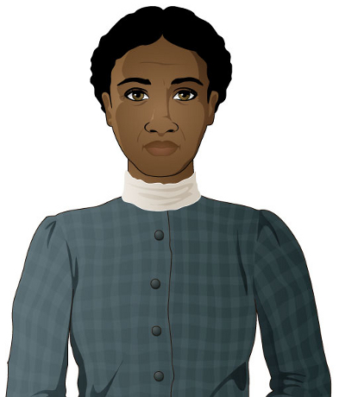
Abigail Wright
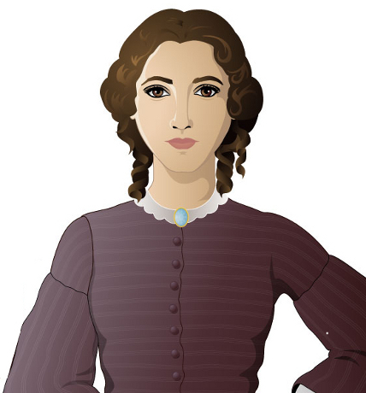
Millicent Hatcher
John Parker
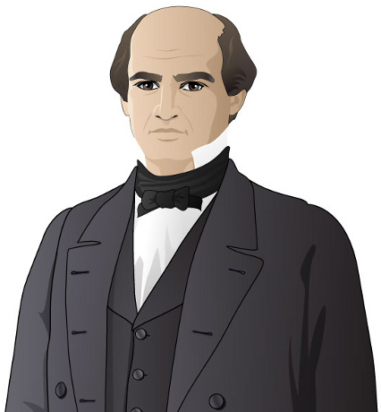
Benjamin Harrison
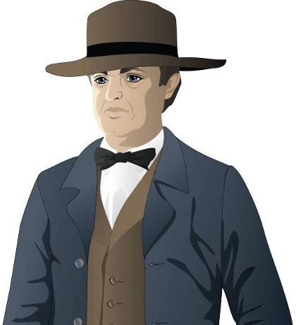
T.C. Bercham

