Oral History Excerpt from Bainbridge Island before World War Two

Yaeko Sakai Yoshihara was 12 years old and in the 7th grade when her family was forcibly removed from Bainbridge Island in March 1942. She was the youngest of six children. Her family had a strawberry farm before the war. This interview was recorded in December 2006.

Life on Bainbridge was pretty simple. Even where our house was located, there was no electricity. It was pretty primitive... outdoor plumbing, well water, kerosene lamps, wood stove. It was very simple. Socially, the Japanese, more or less, kind of stuck to themselves. There
was a Japanese community the Japanese Hall where people assembled. There was Japanese
language school. When the kids were in third grade they would start the Japanese language school as a first grader. That's how I began. In the third grade I started Japanese language school. Then with... we played with our friends. In school we mixed. we were able to, you
know, on the playground everybody played together. But when it came to kinda group things, it was always with our Japanese friends. We generally were not invited to the Caucasian parties or homes.

In the Japanese community, at that time, they had. like they would have annual bazaar. And
then from time to time, a person from Seattle would bring Japanese movies. We would watch that. Then, sometimes there would be a talent show or some program and the people participated. For some reason I was always nominated to sing. 'Cause I liked to sing. But, I don't know, I just picked to do that. Then the Japanese school would have a program. We had to sing Japanese songs or whatever we learned.

Source: Bainbridge Island Japanese American Community, https://www.bijac.org/index.php?p=HISTORYPre_LifeBefore

Oral History Excerpt from Bainbridge Island before World War Two

Jerry Nakata was 19 years old when his family was forcibly removed from Bainbridge Island in March 1942. He was the second youngest of six children. Jerry's parents both owned a barbershop in Winslow and farmed strawberries. In the late 1930s his older brother John started a small grocery business. Before the war Jerry was working for his brother. Jerry graduated from Bainbridge High School in 1941.
Following the war, the Nakata family returned to Bainbridge Island and re–built their grocery business in partnership with Ed Loverich. This interview was recorded in February, 2006

...growing up at the barber shop, mostly Caucasian trade, and I grew up with more Caucasian kids than I did with Japanese kids. I joined the Boy Scouts when I was 12 years old. . . Our class was fifty kids, eight, like I said, eight Japanese kids. I really had fun in high school. I didn't study much, and I got to be good buddies with a couple of kids, like this Reese Moran, he was probably my closest, and then Earl Hanson, I got involved with him, and Hal Champness. We were a real close–knit class, even after 65 years, we still get together, and I think that's, it's nice. It's nice when you get in your eighties and you hash out all, all the world problems. [Laughs]
I didn't like working on the farm, so I went to Japanese school, I think it was about four to six. But then when sports, basketball, just forget Japanese school. I didn't care to learn Japanese at that time. Of course, the war came along, it changed all that.

Source: Bainbridge Island Japanese American Community, https://www.bijac.org/index.php?p=HISTORYPre_LifeBefore

Photo of the Forced Removal From Bainbridge Island
On March 25, 1942, Soldiers began nailing up posters across Bainbridge Island. The posters contained the Civilian Exclusion Order No. 1 along with special instructions to all Japanese residents of the island telling them exactly how they were to comply with the new decree.
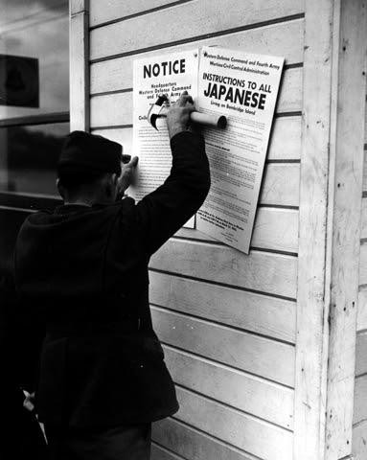
Source: Densho Digital Repository: ddr-densho-36-28 (Legacy UID: denshopd-i36-00028) Courtesy of the Seattle Post-Intelligencer Collection (number PI-28035), Museum of History & Industry

Photo of the Forced Removal From Bainbridge Island

On March 30, 1942, military troops arrived on Bainbridge Island to force the removal of all Japanese American residents. Kikuyo (back left) and Henry Takayoshi waited at the Eagledale ferry dock with their children. A special ferry transported them from Bainbridge Island to Seattle where they were placed on trains and sent to California.
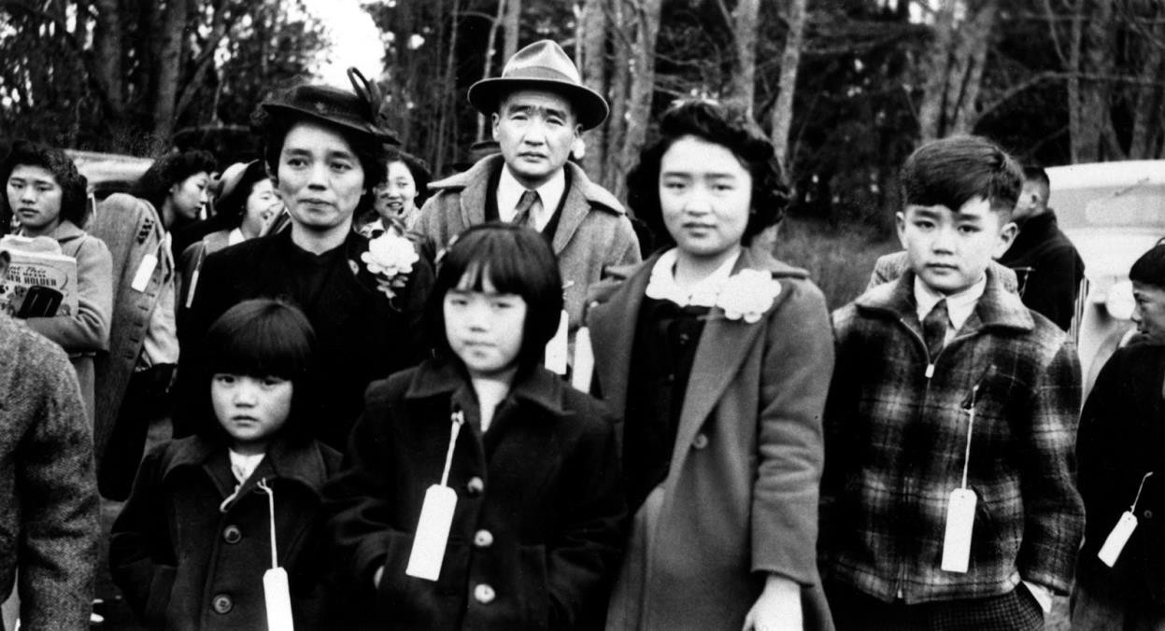

Source: Densho Digital Repository: ddr-densho-34-80 (Legacy UID: denshopd-i34-00080)

Photo of the Forced Removal From Bainbridge Island
On March 30, 1942, military troops arrived on Bainbridge Island to force the removal of all Japanese American residents. Mr. and Mrs. Moji (inside truck) and their dog, King were among those removed. Japanese Americans were not allowed to take family pets with them to prison camp, if they were lucky, they could leave the animals with friends or neighbors.
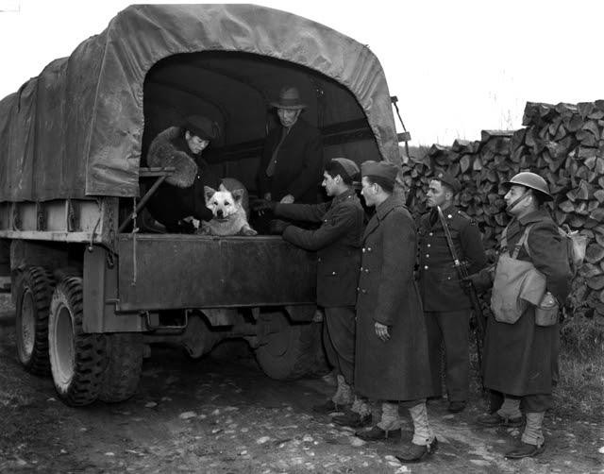

Source: Densho Digital Repository, ddr-densho-36-24 (Legacy UID: denshopd-i36-00024) Courtesy of the Seattle Post-Intelligencer Collection (number PI-28046), Museum of History &

Photo of the Forced Removal From Bainbridge Island
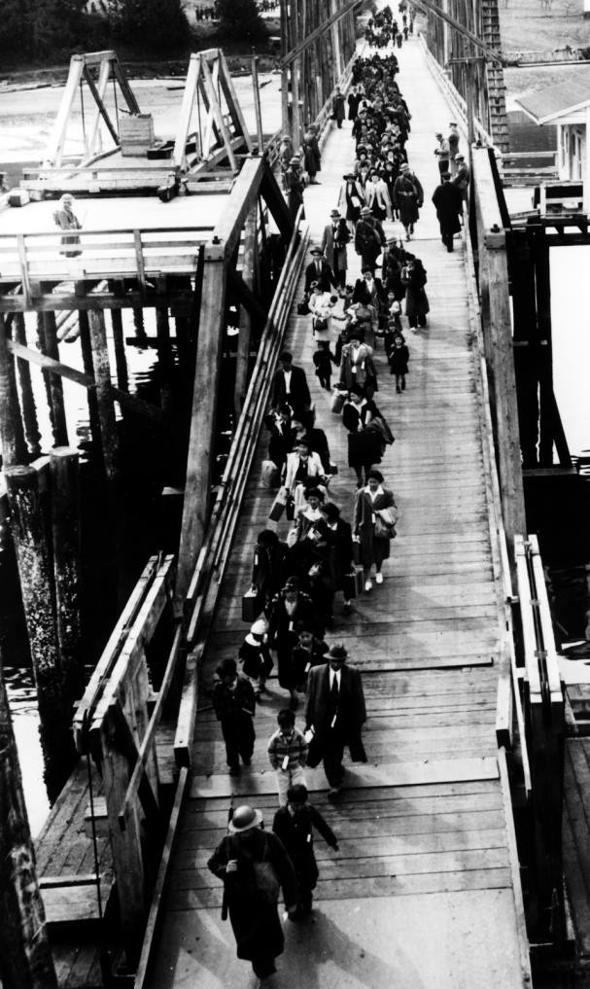
On March 30, 1942, military troops arrived on Bainbridge Island to force the removal of all Japanese American residents. A special ferry was docked at the Eagledale dock to transport the residents to Seattle where they were placed on trains and sent to California.

Source: Densho Digital Repository, ddr-densho-34-2 (Legacy UID: denshopd-i34-00002) Courtesy of the Bainbridge Island Japanese American Commun

Japanese American Citizens League of Seattle Statement, Excerpt
Founded in 1929, the Japanese American Citizens League (JACL) served as an advocate for citizenship for Japanese and Asian immigrants. In February 1942, the Seattle branch of the organization drafted a report to express its opposition to the forced removal of Japanese Americans. This document is an excerpt from that report.

STATEMENT BY EMERGENCY DEFENSE COUNCIL, SEATTLE CHAPTER, JAPANESE- AMEERICAN CITIZENS LEAGUE, SEATTLE, WASH.

REPORT PRESENTED TO TOLAN CONGRESSIONAL COMMITTEE, FEBRUARY 28, 1942.

For some time now there has been agitation for the evacuation of Japanese nationals as well as American citizens of Japanese descent from Pacific Coast States. Such evacuation has been proposed in a variety of forms.

We wish to go on record now that the safety and welfare of the United States is, has been, and will continue to be foremost in our minds. We, as American citizens, have a duty to this, our country, and the first tenet of that duty is complete and unshakeable loyalty.

For this very reason, we are opposed to the idea of indiscriminate, en masse evacuation of all citizens and loyal aliens of Japanese extraction. We are wholeheartedly in favor of complete cooperation with the military and other authorities on withdrawal of civilians from the immediate vicinity of defense projects and establishments. But we do not believe that mass evacuation is either desirable or feasible. We believe that the best interests of the United States will be served by other solutions to the problem.

We also desire the privilege of remaining here to fight shoulder to shoulder, and shed our blood, if necessary, in the defense of our country and our home together with patriotic Americans of other national extractions if that time should ever come.

If it is for the greater good that evacuation be decreed, we shall obey to the best of our ability. But we are convinced that here in our homes and in our community is where we belong, where we can lend every ounce of our strength, and every cent of our resources, in creating the sinews of war so necessary to total victory. We are Americans. We want to do our duty where we can serve best.

We believe the so-called Japanese problem is not so serious as certain vocal
exponents of mass evacuation profess to believe. We are sure that the benefits to be derived from large-scale evacuation of Japanese from the State of Washington are overwhelmingly overbalanced by the benefits to be derived by keeping them here under the proper supervision.

The Japanese problem is not going to be solved by evacuation. If they are a problem here, they will be a problem wherever they are sent. Since this is so, it is logical that they can be kept under better surveillance where they are now, concentrated as they are well-defined areas and where they can continue to do their bit for the national defense.

Source: Online Archive of California, Special Collections and Archives, The UC Irvine Libraries https://oac.cdlib.org/view?docId=hb8s2008kv&brand=oac4&doc.view=entire_text

Executive Order No. 9066

On February 19, 1942, President Franklin D. Roosevelt signed Executive Order 9066. This order gave the military broad powers to ban any citizen from a fifty- to sixty-mile-wide coastal area stretching from Washington state to California and extending inland into southern Arizona. The order also authorized transporting these citizens to assembly centers hastily set up and governed by the military in California, Arizona, Washington state, and Oregon.

Executive Order No. 9066
The President
Executive Order
Authorizing the Secretary of War to Prescribe Military Areas
Whereas the successful prosecution of the war requires every possible protection against espionage and against sabotage to national-defense material, national-defense premises, and national-defense
utilities as defined in Section 4, Act of April 20, 1918, 40 Stat. 533, as amended by the Act of November 30, 1940, 54 Stat. 1220, and the Act of August 21, 1941, 55 Stat. 655 (U.S.C., Title 50,
Sec. 104);
Now, therefore, by virtue of the authority vested in me as President of the United States, and Commander in Chief of the Army and Navy, I hereby authorize and direct the Secretary of War, and the Military Commanders whom he may from time to time designate, whenever he or any designated Commander deems such action necessary or desirable, to prescribe military areas in such places and of such extent as he or the appropriate Military Commander may determine, from which any or all persons may be excluded, and with respect to which, the right of any person to enter, remain in, or leave shall be subject to whatever restrictions the Secretary of War or the appropriate Military Commander may impose in his discretion. The Secretary of War is hereby authorized to provide for residents of any such area who are excluded therefrom, such transportation, food, shelter, and other accommodations as may be necessary, in the judgment of the Secretary of War or the said Military Commander, and until other arrangements are made, to accomplish the purpose of this order. The
designation of military areas in any region or locality shall supersede designations of prohibited and restricted areas by the Attorney General under the Proclamations of December 7 and 8, 1941, and shall supersede the responsibility and authority of the Attorney General under the said Proclamations in respect of such prohibited and restricted areas.
I hereby further authorize and direct the Secretary of War and the said Military Commanders to take such other steps as he or the appropriate Military Commander may deem advisable to

enforce compliance with the restrictions applicable to each Military area hereinabove authorized to be designated, including the use of Federal troops and other Federal Agencies, with authority to accept assistance of state and local agencies.
I hereby further authorize and direct all Executive Departments, independent establishments and other Federal Agencies, to assist the Secretary of War or the said Military Commanders in carrying out this Executive Order, including the furnishing of medical aid, hospitalization, food, clothing, transportation, use of land, shelter, and other supplies, equipment, utilities, facilities, and services.
This order shall not be construed as modifying or limiting in any way the authority heretofore granted under Executive Order No. 8972, dated December 12, 1941, nor shall it be construed as limiting or modifying the duty and responsibility of the Federal Bureau of Investigation, with respect to the investigation of alleged acts of sabotage or the duty and responsibility of the Attorney General and the Department of Justice under the Proclamations of December 7 and 8, 1941, prescribing regulations for the conduct and control of alien enemies, except as such duty and responsibility is superseded by the designation of military areas hereunder.
Franklin D. Roosevelt The White House, February 19, 1942.
[F.R. Doc. 42–1563; Filed, February 21, 1942; 12:51 p.m.]

Source: Executive Order No. 9066, February 19, 1942, General Records of the United States Government; Record Group 11; National Archives.

Bainbridge Review Editorial February 5, 1942

The Bainbridge Review was a small weekly newspaper published by Bainbridge Island residents Walter and Milly Woodward. It was one of the few newspapers along the West Coast to caution against anti- Japanese hysteria and oppose the removal of Japanese Americans from the coastal region. Even after the forced removal of all Japanese Americans from Bainbridge island, the newspaper continued to consider them as part of the Bainbridge community and hired a young Nisei to write weekly reports from the Manzanar prison camp.

More Plain Talk
The time has come to bear out the truth of our words, written two months ago in an extra edition of The review published the day after Hawaii was bombed. We spoke of an American recoil to Japanese treachery and wrote:
“And in such recoil of sentiment there is danger of a blind, wild, hysterical hatred of all
persons who can trace ancestry to Japan.”
Up and down the Pacific Coast, in the newspapers and in the halls of Congress are words of hatred now for all Japanese, whether they be citizens of America. These words reached a shrieking crescendo when Henry McLemore, with all the intelligence of a blind pig, wrote in the Seattle
Times: “Personally, I hate the Japanese. And that goes for all of them.”
That may be patriotism of a hysterical degree; but it certainly isn’t the kind of patriotism that will win the war. Let us think, for a moment, what would happen if the government should adopt Mr. McLemore’s fervid plea for the “immediate removal of every Japanese on the West Coast to a point deep in the interior. I don’t mean a nice part of the interior, either.”
Just who would grow our fruits and vegetables if Mr. McLemore’s advice is followed? We have no figures before us, but it certainly is an apparent fact that the bulk of our produce snd, we dare say, the bulk of the produce grown for our Army and Navy encampments on the West Coast, come from Japanese gardens. The economy of one-third of the nation would be thrown into utter confusion if all Japanese were herded into the interior.
But what of another factor--the wreckage that it would bring to lives of thousands and
thousands of loyal American citizens who can’t avoid ancestry in Japan!
For Who--besides those so blind as Mr. McLemore--can say that the big majority of our American-Japanese citizens are not loyal to the land of their birth--The United States! Their record bespeaks nothing but loyalty: Their sons are in our Army; they are heavy contributors to the Red Cross and to the defense bond drives. Even in Hawaii, was there any, record of any Japanese- American citizen being other than intensely loyal?

The Review argues only with Mr. McLemore and his ilk. It will not dispute the federal government if it, in its infinite wisdom, calls for the removal from the Coast of all Japanese. Such order--which we hope will not come--will be based on military necessities and not on hatred.
Japanese people, whether citizens or aliens, must prepare themselves for what may seem to them unfair and unreasoning treatment. But if they value their American citizenship and the right to live in this free nation, they must stand fast in their loyalty. American boys--including some of their sons--are giving their lives for Liberty. Any other sacrifice is not too great.
Source: Kipsap History Online, A Special Collection of Kipsap Regional Library. https://cdm16169.contentdm.oclc.org/digital/collection/p16169coll1/id/2185/rec/50

I Am An American
Dorothea Lange had photographed the plight of migrant families for the Farm Security Administration during the Great Depression in the 1930s. She was hired again in the early 1940s by the War Relocation Authority to document the forced removal of Japanese Americans from the West Coast. This photo was taken in March 1942 and shows the Wanto Co. store in Oakland, California. The business was owned by the Matsuda family. Tatsuro Matsuda, a University of California graduate, commissioned and installed the "I am an American" sign.
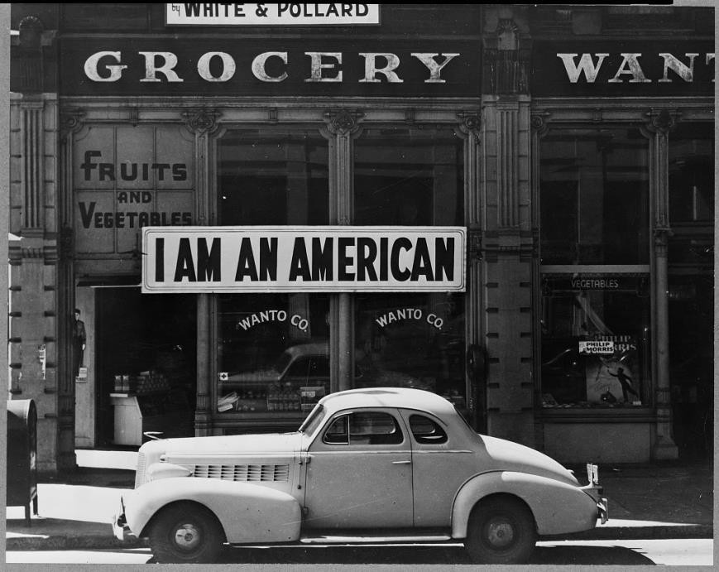

Photographer’s caption: Oakland, Calif., Mar. 1942. A large sign reading "I am an American" placed in the window of a store, at [401 - 403 Eighth] and Franklin streets, on December 8, the day after Pearl Harbor. The store was closed following orders to persons of Japanese descent to evacuate from certain West Coast areas. The owner, a University of California graduate, will be housed with hundreds of evacuees in War Relocation Authority centers for the duration of the war.

Source: Library of Congress Prints and Photographs Division, https://www.loc.gov/item/2004665381/

Dr. Seuss Cartoon, December 10, 1942

In the 1940s, children’s book author Theodor Seuss Geisel, known as Dr. Seuss, created political cartoons for PM, a daily newspaper published in New York. Although the newspaper’s mission statement claimed: “PM is against people who push other people around,” Dr. Seuss’s cartoons portrayed stereotyped and racist images of Japanese Americans.
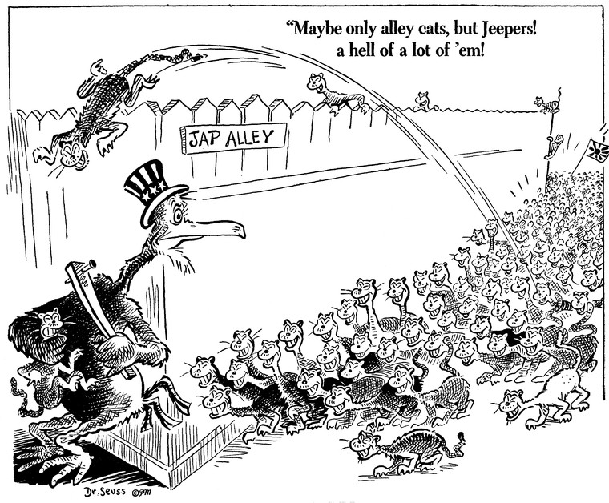

Source: Maybe only alley cats, but Jeepers! A hell of a lot of 'em!, December 10, 1941, Dr. Seuss Political Cartoons. Special Collection & Archives, UC San Diego Library. Digital object made available by Special Collections & Archives, UC San Diego, La Jolla, 92093-0175 (https://lib.ucsd.edu/sca)

Dr. Seuss Cartoon, February 13, 1942

In the 1940s, children’s book author Theodor Seuss Geisel, known as Dr. Seuss, created political cartoons for PM, a daily newspaper published in New York. Although the newspaper’s mission statement claimed: “PM is against people who push other people around,” Dr. Seuss’s cartoons portrayed stereotyped and racist images of Japanese Americans.
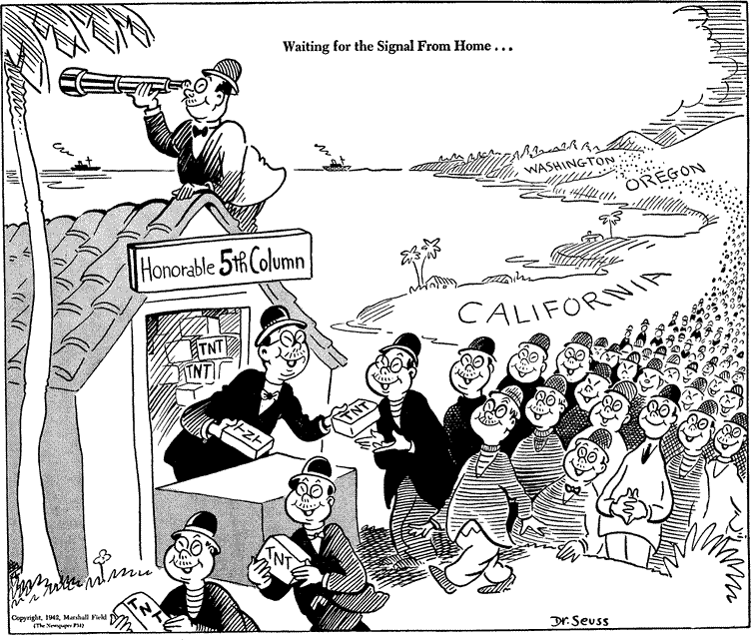

Source: Waiting for the signal from home..., February 13, 1942, Dr. Seuss Political Cartoons. Special Collection & Archives, UC San Diego Library. Digital object made available by Special Collections & Archives, UC San Diego, La Jolla, 92093-0175 (https://lib.ucsd.edu/sca)

Instructions to all Persons of Japanese Ancestry

These instructions for the removal of Japanese Americans living in Seattle, Washington were posted throughout Japanese American neighborhoods. In addition to these instructions, military troops posted flyers informing Japanese Americans of their imminent removal. These orders followed Executive Order 9066, which gave the Western Defense Command of the Department of War the authority to exclude anybody from what it deemed strategic areas.
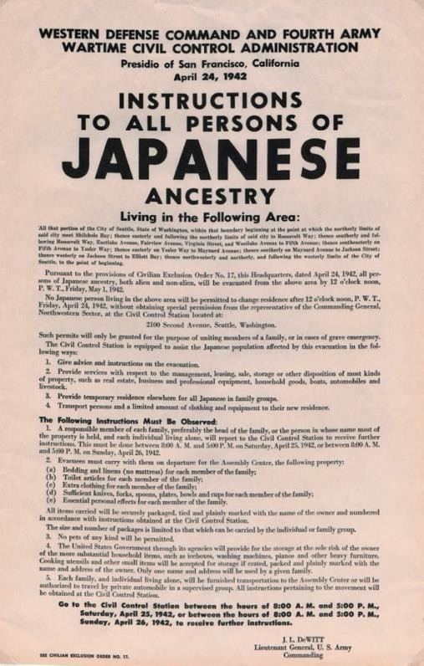

Source: Western Defense Command and Fourth Army Wartime Civil Control Administration, “Instructions to all persons of Japanese ancestry,” Washington State University, Digital Exhibits, accessed April 17, 2020, http://digitalexhibits.wsulibs.wsu.edu/items/show/4407.

WESTERN DEFENSE COMMAND AND FOURTH ARMY WARTIME CIVIL CONTROL ADMINISTRATION

Presidio of San Francisco, California April 24, 1942

INSTRUCTIONS TO ALL PERSONS OF
JAPANESE ANCESTRY

Living in the Following Area:

All that portion of the City of Seattle, State of Washington, within that boundary beginning at the point at which the northerly limits of said city meet Shilshole Bay; easterly and following the northerly limits of said city to Roosevelt Way; thence southerly and following Roosevelt Way, Eastlake Avenue, Fairview Avenue, Virginia Street, and Westlake Avenue to Fifth Avenue; thence southeasterly on Fifth Avenue to Yesler Way; thence easterly on Yesler Way to Maynard Avenue; thence southerly on Maynard Avenue to Jackson Street; thence westerly on Jackson Street to Elliot Bay; thence northwesterly and northerly, and following the westerly limits of the City of Seattle, to the point of beginning.

Pursuant to the provisions of Civilian Exclusion Order No. 17, this Headquarters, dated April 24, 1942, all persons of Japanese ancestry, both alien and non-alien, will be evacuated from the above area by 12 o'clock noon, P.W.T., Friday, May 1, 1942.

No Japanese person living in the above area will be permitted to change residence after 12 o'clock noon, P.W.T., Friday, April 24, 1942, without obtaining special permission from the representative of the Commanding General, Northwestern Sector, at the Civil Control Station located at:

2100 Second Avenue, Seattle, Washington.

Such permits will only be granted for the purpose of uniting members of a family, or in cases of grave emergency.

The Civil Control Station is equipped to assist the Japanese population affected by this evacuation in the following ways:
- Give advice and instructions on the evacuation.
- Provide services with respect to the management, leasing, sale, storage or other disposition of most kinds of property, such as real estate, business and professional equipment, household goods, boats, automobiles and livestock.
- Provide temporary residence elsewhere for all Japanese in family groups.
- Transport persons and a limited amount of clothing and equipment to their new residence.

The Following Instructions Must be Observed:

- A responsible member of each family, preferably the head of the family, or the person in whose name most of the property is held, and each individual living alone, will report to the Civil Control Station to receive further instructions. This must be done between 8:00 A. M. and 5:00 P. M. on Saturday, April 25, 1942, or between 8:00 A. M. and 5:00 P. M. on Sunday, April 26, 1942.

- Evacuees must carry with them on departure for the Assembly Center, the following property:
- Bedding and linens (no mattress) for each member of the family;
- Toilet articles for each member of the family;
- Extra clothing for each member of the family;
- Sufficient knives, forks, spoons, plates, bowls and cups for each member of the family;
- Essential personal effects for each member of the family.

All items carried will be securely packaged, tied and plainly marked with the name of the owner and numbered in accordance with instructions obtained at the Civil

Control Station. The size and number of packages is limited to that which can be carried by the individual or family group.

- No pets of any kind will be permitted.

- The United States Government through its agencies will provide for the storage at the sole risk of the owner of the more substantial household items, such as iceboxes, washing machines, pianos and other heavy furniture. Cooking utensils and other small items will be accepted for storage if crated, packed and plainly marked with the name and address of the owner. Only one name and address will be used by a given family.

- Each family, and individual living alone, will be furnished transportation to the Assembly Center or will be authorized to travel by private automobile in a supervised group. All instructions pertaining to the movement will be obtained at the Civil Control Station.

Go to the Civil Control Station between the hours of 8:00 A. M. and 5:00 P. M., Saturday, April 25, 1942, or between the hours of 8:00 A. M. and 5:00 P. M., Sunday, April 26, 1942, to receive further instructions.

J. L. DEWITT Lieutenant General, U. S. Army
Commanding

SEE CIVILIAN EXCLUSION ORDER NO. 17.

Stanley Hayami Diary Entries December. 1942
Stanley Kunio Hayami was sixteen in 1942 when his family was forcibly removed from Los Angeles, California and incarcerated at Heart Mountain Wyoming. Throughout his imprisonment at Heart Mountain, Hayami kept a diary filled with pen-and-ink drawings and he reported regularly on his daily activities such as studying for tests, listening to football games on the radio, or going to the movies. He also voiced his views on the incarceration and the military draft, and spoke of the importance of serving his country. As a high school student, he longed to pursue a career as an artist and writer. Stanley Hayami’s experiences and thoughts served as an inspiration for the Henry Tanaka character in A Prisoner in My Homeland
.
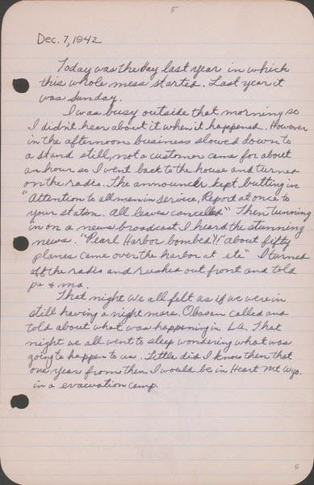

Dec. 7, 1942
Today was the day last year in which this whole mess started. Last year it was Sunday.
I was busy outside that morning so I didn’t hear about it when it happened. However in the afternoon business slowed down to a stand still, not a customer came for about an hour so I went back to the house and turned on the radio. The announcer kept butting in. “Attention to all men in service. Report at once to your station. All leaves cancelled.” Then tuning in on a news broadcast I heard the stunning news. “Pearl Harbor bombed!!” “About fifty planes came over the harbor at etc.” I turned off the radio and rushed out front and told pa & ma.

That night we all felt as if we were in [sic] still having a nightmare. Obasan called and told about what was happening in L.A. That night we all went to sleep wondering what was going to happen to us. Little did I know then that one year from then I would be in Heart Mountain Wyo. in a [sic] evacuation camp.
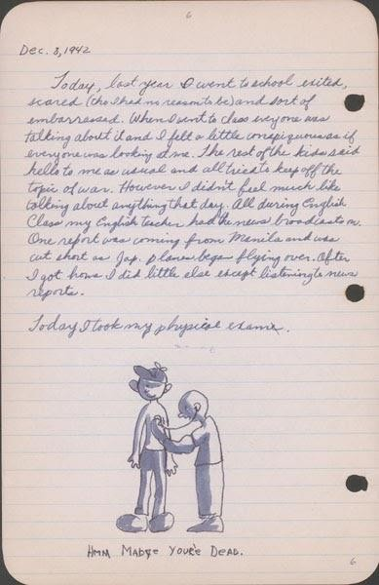

Dec. 8, 1942
Today, last year I went to school excited, scared (tho I had no reason to be) and sort of embarrassed. When I went to class everyone was talking about it and I felt a little conspicuous as if everyone was looking at me. The rest of the kids said hello to me as usual and all tried to keep off the topic of war. However I didn’t feel much like talking about anything that day. All during English class my English teacher had the news broadcasts on. One report was coming from Manila and was cut short as Jap. planes began flying over. After I got home I did little else except listening to the news reports.
Today I took my physical exam.

Source: Hayami (Stanley) Diary Collection, Japanese American National Museum. Accessed through Calisphere, April 20, 2020. Recto of page 10: https://calisphere.org/item/ark:/13030/tf267n98tj/ Verso of page 10: https://calisphere.org/item/ark:/13030/tf996nb3qv/

Gordon Hirabayashi Letter: “Why I Refused to Register for Evacuation,” May 13, 1942

In 1940, Gordon Hirabayshi was a college student in Seattle, Washington. He was a pacifist and had registered with the Selective Service as a conscientious objector. After President Roosevelt issued Executive Order 9066 and it became clear that Japanese Americans would be removed from the West Coast, Hirabayashi left school to work with the American Friends Service Committee, organized by Quakers, to assist Japanese American families. As a U.S. citizen, Hirabayashi assumed his rights would be respected, but when orders came first for the curfew and then the removal he chose to resist and turned himself into the FBI to create a test case for the constitutionality of those orders.
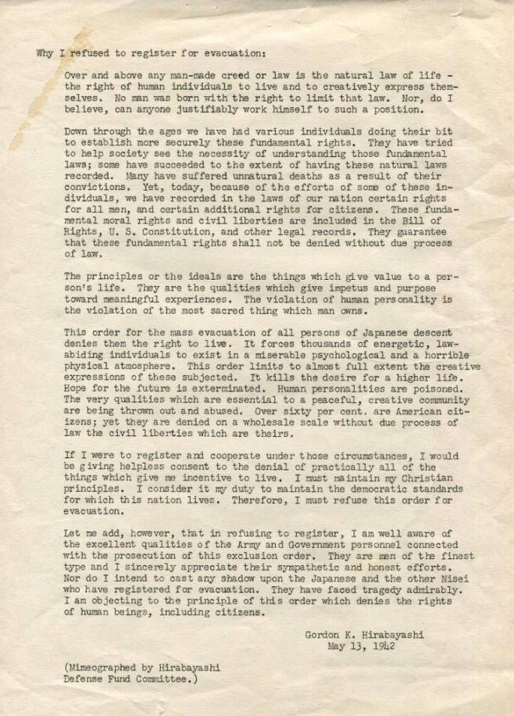
Source: University of Washington Libraries, Special Collections, https://digitalcollections.lib.washington.edu/digital/collection/pioneerlife/id/21356/

Why I refused to register for evacuation:

Over and above any man-made creed or law is the natural law of life – the right of human individuals to live and to creatively express themselves. No man was born with the right to limit that law. Nor, do I believe, can anyone justifiably work himself to such a position.

Down through the ages we have had various individuals doing their bit to establish more securely these fundamental rights. They have tried to help society see the necessity of understanding those fundamental laws; some have succeeded to the extent of having these natural law recorded. Many have suffered unnatural deaths as a result of their convictions. Yet, today, because of the efforts of some of these individuals, we have recorded in the laws of our ration certain rights for all men, and certain additional rights for citizens. These fundamental moral rights and civil liberties are included in the Bill of Rights,
U.S. Constitution, and other legal records. They guarantee that these fundamental rights shall not be denied without due process of law.

The principles or the ideals are the things which give value to a person’s life. They are the qualities which give impetus and purpose toward meaningful experiences. The violation of human personality is the violation of the most sacred thing which man owns.

This order for the mass evacuation of all persons of Japanese descent denies them the right to live. It forces thousands of energetic, law-abiding individuals to exist in a miserable psychological and horrible physical atmosphere. This order limits to almost full extent the creative expressions of those subjected. It kills the desire for a higher life. Hope for the future is exterminated. Human personalities are poisoned. The very qualities which are essential to a peaceful, creative community are being thrown out and abused. Over sixty per cent are American citizens; yet they are denied on a wholesale scale without due process of law the civil liberties which are theirs.

If I were to register and cooperate under these circumstances, I would be giving helpless consent to the denial of practically all of the things which give me incentive to live. I must maintain my Christian principles. I consider it my duty to maintain the democratic standards for which this nation lives. Therefore, I must refuse this order for evacuation.

Let me add, however, that in refusing to register, I am well aware of the excellent qualities of the Army and Government personnel connected with the persecution of this exclusion order. They are men of the finest type and I sincerely appreciate their sympathetic and honest efforts. Nor do I intend to cast any shadow upon the Japanese and the other Nisei who have registered for evacuation. They have faced tragedy admirably. I am objecting to the principle of this order which denies the rights of human beings, including citizens.

Gordon K. Hirabayashi May 13, 1942

"First impression of Manzanar" A Kango Takamura Painting

Kango Takamura was an Issei artist who had been a photo retoucher for RKO Studios in Hollywood before being incarcerated at the Manzanar prison camp. He documented his experiences at Manzanar in a series of watercolor paintings and drawings.
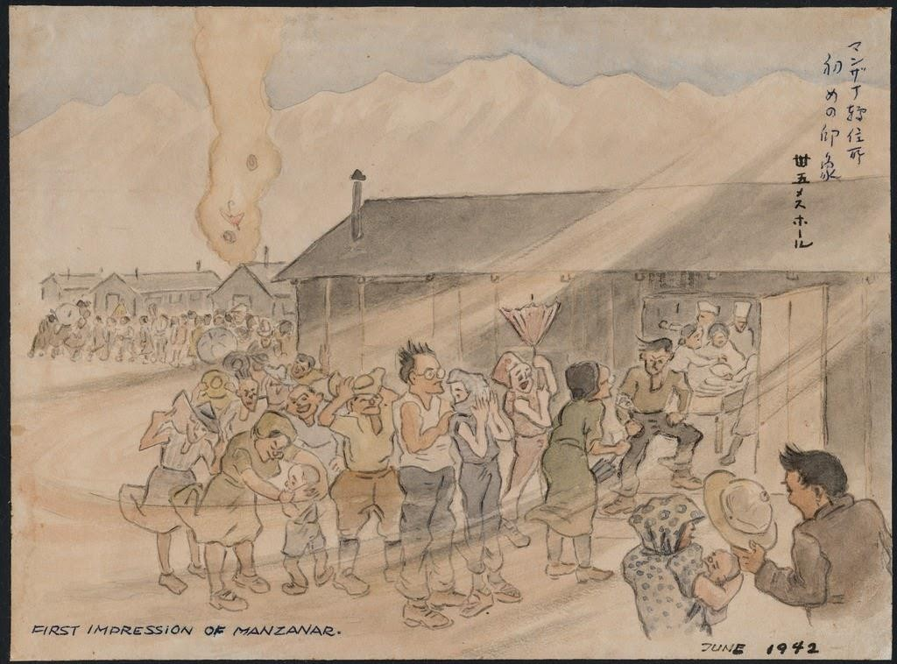

Courtesy of Manzanar National Historic Site and the Kango Takamura Collection http://ddr.densho.org/ddr-manz-2-42/
Copyright restricted

Dorothea Lange Photo - Hospital Latrines

Dorothea Lange had photographed the plight of migrant families for the Farm Security Administration during the Great Depression in the 1930s. She was hired again in the early 1940s by the War Relocation Authority to document the forced removal of Japanese Americans from the West Coast. Many of Lange’s photographs exposed the difficulties and harsh conditions in the camps, and were censored by the government during the war. The following image––taken in the first months at Manzanar––depicts temporary hospital beds and outdoor latrines (toilets) for patients.
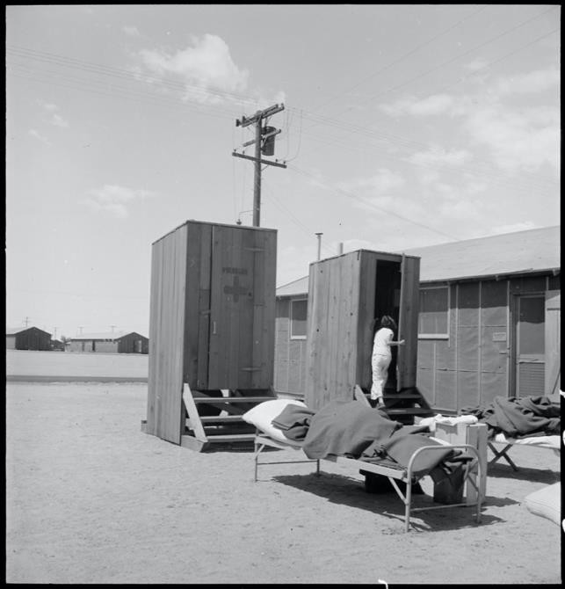

Caption: Manzanar Relocation Center, Manzanar, California. Hospital latrines, for patients, between the barracks, which serve temporarily as wards. For the first three months of occupancy medical facilities have been meager but the new hospital fully equipped, is almost ready for occupancy. 7/1942

Source: National Archives: Record Group 210: Records of the War Relocation Authority, 1941 - 1989 Series: Central Photographic File of the War Relocation Authority, 1942 - 1945 https://catalog.archives.gov/id/538149

Dorothea Lange Photo: Dust Storm at Manzanar

Dorothea Lange had photographed the plight of migrant families for the Farm Security Administration during the Great Depression in the 1930s. She was hired again in the early 1940s by the War Relocation Authority to document the forced removal of Japanese Americans from the West Coast. Many of Lange’s photographs exposed the difficulties and harsh conditions in the camps, and were censored by the government during the war. The following image shows a dust storm blowing through the Manzanar camp.
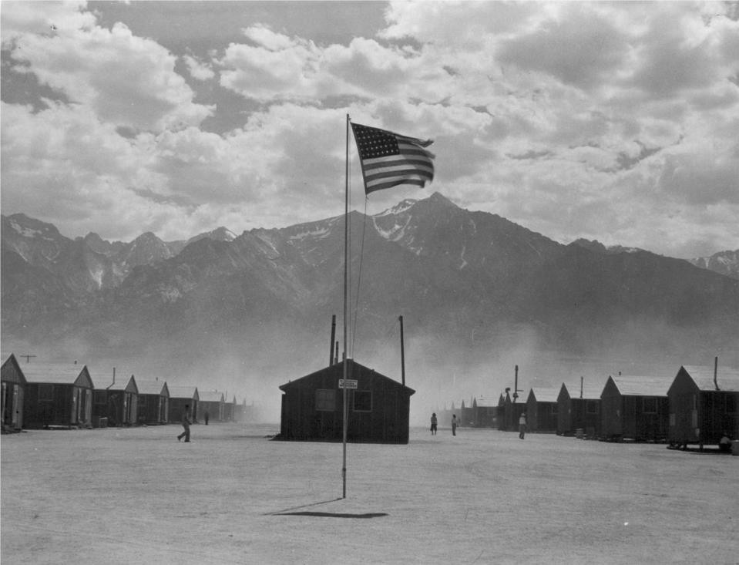

Caption: Manzanar, California. Dust storm at this War Relocation Authority center where evacuees of Japanese ancestry are spending the duration.

Source: National Archives: Record Group 210: Records of the War Relocation Authority, 1941 - 1989 Series: Central Photographic File of the War Relocation Authority, 1942 - 1945 https://catalog.archives.gov/id/539961

Dorothea Lange Photo: Elementary School
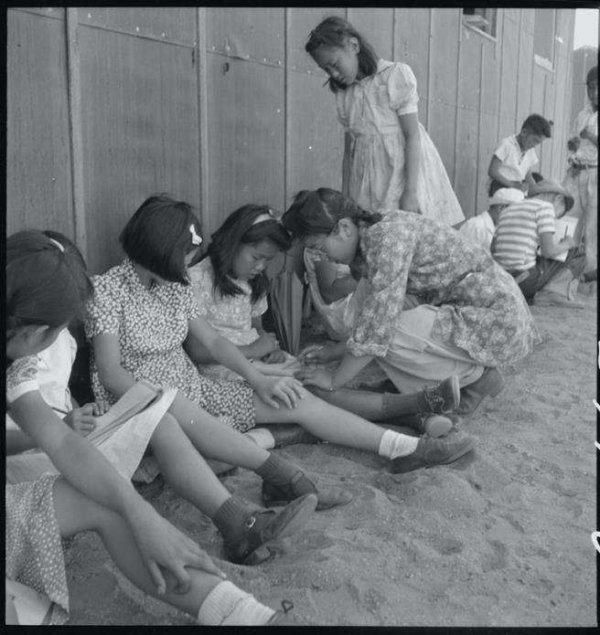
Dorothea Lange had photographed the plight of migrant families for the Farm Security Administration during the Great Depression in the 1930s. She was hired again in the early 1940s by the War Relocation Authority to document the forced removal of Japanese Americans from the West Coast. Many of Lange’s photographs exposed the difficulties and harsh conditions in the camps, and were censored by the government during the war. The following image shows an incarceree teaching children in a makeshift outdoor classroom.
Caption: Manzanar Relocation Center, Manzanar, California. An elementary school with voluntary attendance has been established with volunteer evacuee teachers, most of whom are college graduates. No school equipment is as yet obtainable and available tables and benches are used. However, classes are often held in the shade of the barrack building at this War Relocation Authority center. 1942.

Source: National Archives: Record Group 210: Records of the War Relocation Authority, 1941 - 1989 Series: Central Photographic File of the War Relocation Authority, 1942 -
1945 https://catalog.archives.gov/id/5379

Ansel Adams Photo: Nurse Aiko Hamaguchi
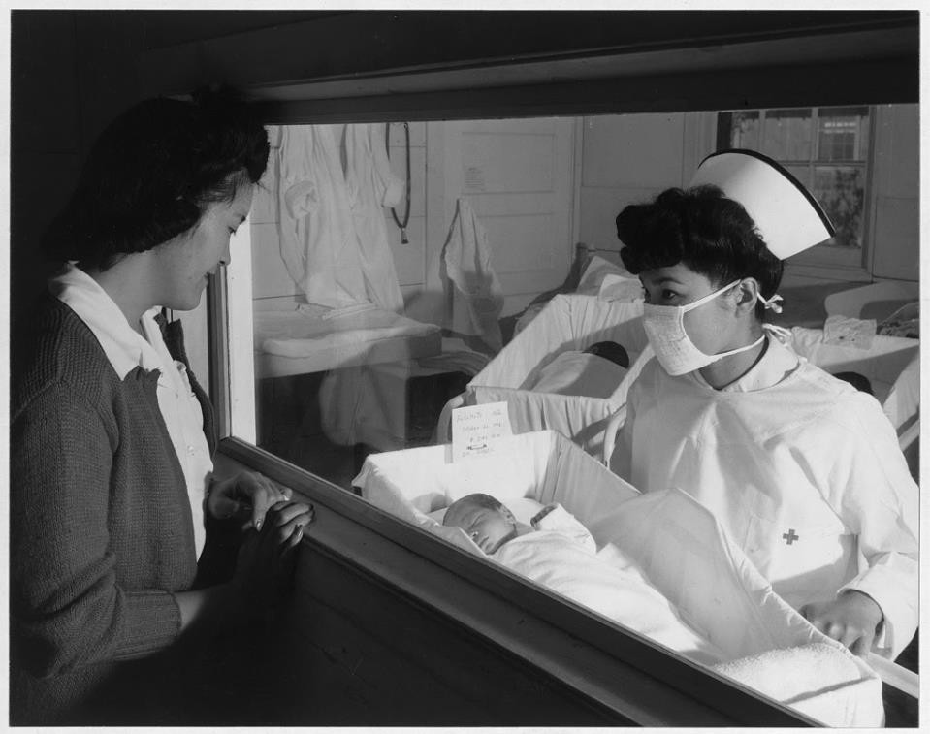
In the 1940s, Ansel Adams, one of the most famous photographers in the United States, went to the Manzanar to document the imprisoned Japanese Americans. He later described the purpose of this photo project as an effort “to show how these people, suffering under a great injustice, and loss of property, businesses and professions, had overcome the sense of defeat and despair by building for themselves a vital community in an arid (but magnificent) environment.” The following image from 1943 shows the newly- built maternity ward at Manzanar.

Caption: Nurse Aiko Hamaguchi, mother Frances Yokoyama, baby Fukomoto, Manzanar Relocation Center, California / photograph by Ansel Adams. 1943.

Source: Library of Congress, Prints and Photographs Division, Adams, Ansel, photographer. Nurse Aiko Hamaguchi, mother Frances Yokoyama, baby Fukomoto, Manzanar Relocation Center, California / photograph by Ansel Adams. California Manzanar, 1943. Photograph. https://www.loc.gov/item/2002697854/.

Ansel Adams Photo: School Children
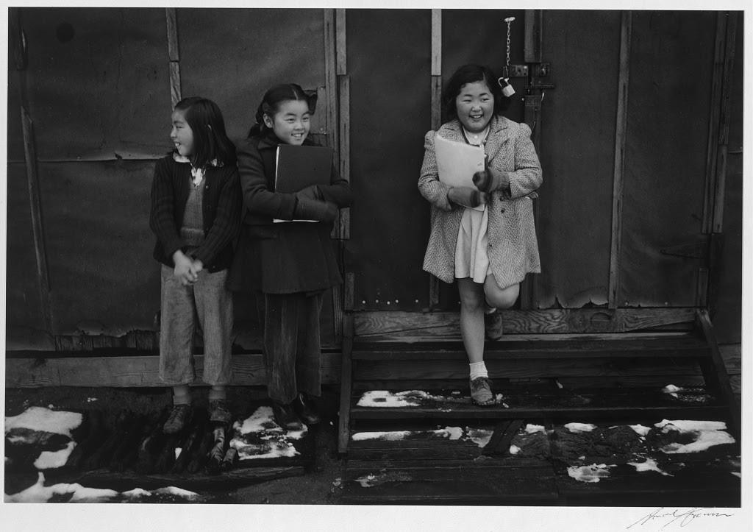
In the 1940s, Ansel Adams, one of the most famous photographers in the United States, went to the Manzanar to document the imprisoned Japanese Americans. He later described the purpose of this photo project as an effort “to show how these people, suffering under a great injustice, and loss of property, businesses and professions, had overcome the sense of defeat and despair by building for themselves a vital community in an arid (but magnificent) environment.” The following image shows Manzanar school children holding notebooks and leaning on the outside of a barrack.

Caption: School children, Manzanar Relocation Center, California / photograph by Ansel Adams, 1942

Source: Library of Congress, Prints and Photographs Division, Adams, Ansel, photographer. School children, Manzanar Relocation Center, California / photograph by Ansel Adams.
California Manzanar, 1943. Photograph. https://www.loc.gov/item/2002697874/.

Ansel Adams Photo: Manzanar Street Scene, Clouds
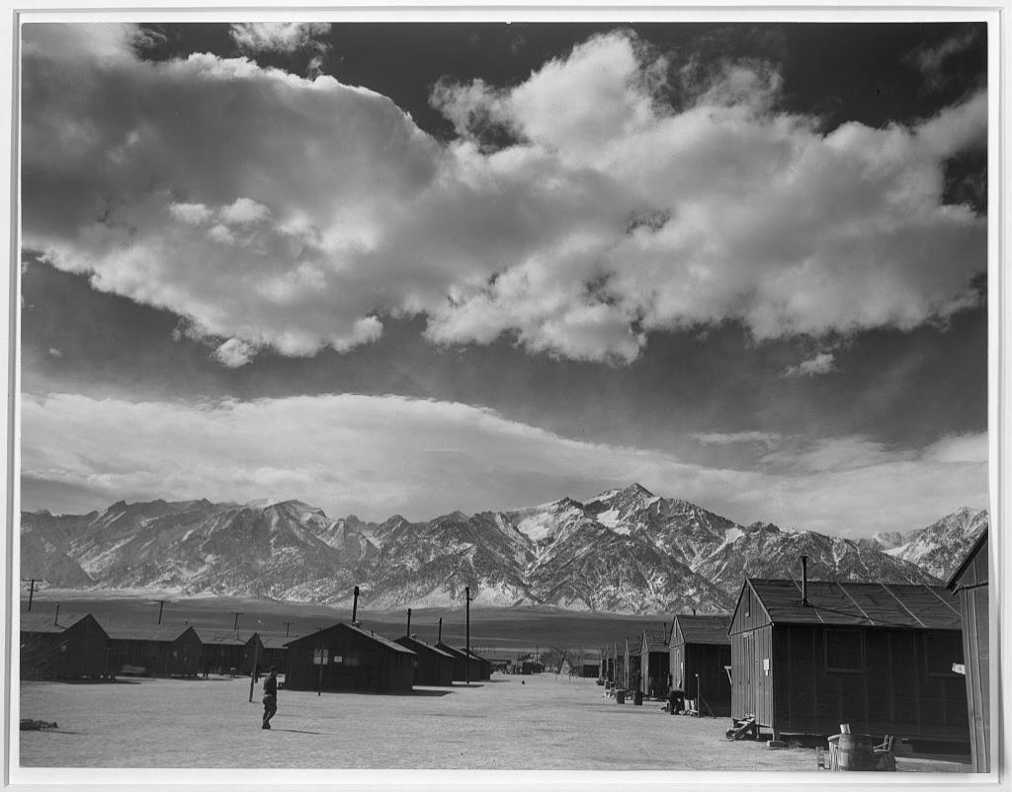
In the 1940s, Ansel Adams, one of the most famous photographers in the United States, went to the Manzanar to document the imprisoned Japanese Americans. He later described the purpose of this photo project as an effort “to show how these people, suffering under a great injustice, and loss of property, businesses and professions, had overcome the sense of defeat and despair by building for themselves a vital community in an arid (but magnificent) environment.” The following image depicts the barracks at Manzanar with the Sierra Nevada mountains in the background.

Caption: Manzanar street scene, clouds, Manzanar Relocation Center, California / photograph by Ansel Adams, 1943.

Source: Library of Congress, Prints and Photographs Division, Adams, Ansel, photographer. Manzanar street scene, clouds, Manzanar Relocation Center, California / photograph by Ansel Adams. California Manzanar, 1943. http://loc.gov/pictures/resource/ppprs.00284/

Manzanar Center Citizens Join Net Project en Masse

Various jobs paying minimal wages were available for the Japanese Americans imprisoned at Manzanar. The work included running the mess halls, delivering mail, farming, and caring for young children. One of the more controversial jobs was working on the military contract for camouflage nets, which was limited to U.S. citizens or nissei. This article from the prison camp newspaper, Manzanar Free Press reports on the camouflage work.
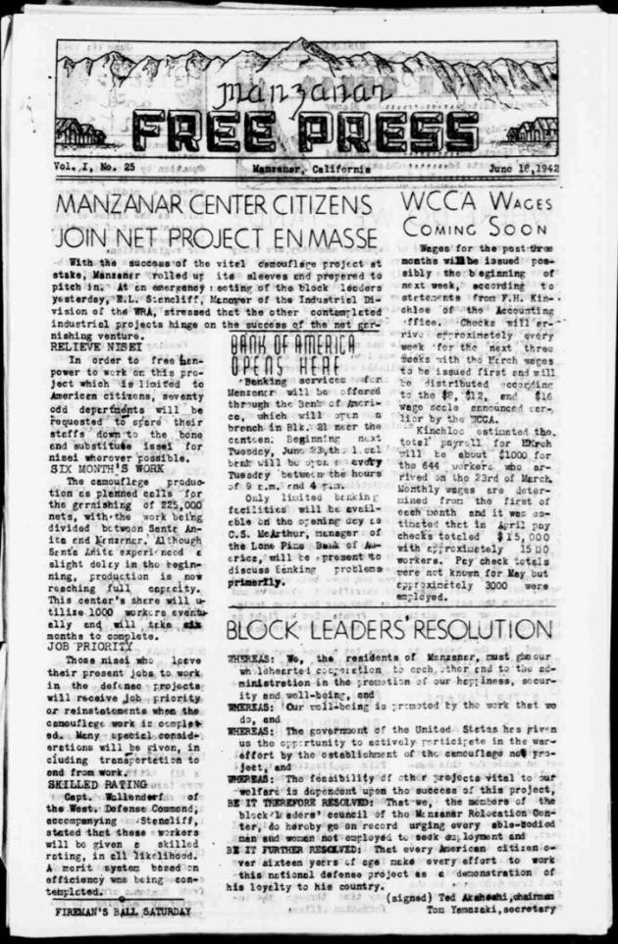

Manzanar Free Press, Vol. I, No. 25 June 18, 1942
https://lccn.loc.gov/sn84025948

MANAZAR CENTER CITIZENS JOIN NET PROJECT EN MASSE

With the success of the vital camouflage project at stake, Manzanar rolled up its sleeves and prepared to pitch in. At an emergency meeting of the block leaders yesterday, E.L. Stancliff, Manager of the Industrial Division of the WRA, stressed that the other contemplated industrial projects hinge on the success of the net garnishing venture.

RELIEVE NISEI
In order to free manpower to work on this project which is limited to American citizens, seventy odd departments will be requested to spare their staffs down to the bone and substitute issei for nisei wherever possible.

SIX MONTH’S WORK
The camouflage production as planned calls for the garnishing of 225,000 nets, with the work being divided between Santa Anita and Manzanar. Although Santa Anita experienced a slight delay in the beginning, production is now reaching full capacity. This center’s share will utilize 1000 workers eventually and will take six months to complete.

JOB PRIORITY
Those nisei who leave their present jobs to work in the defense projects will receive job priority or reinstatements when the camouflage work is completed. Many special considerations will be given, including transportation to and from work.

SKILLED RATING
Capt. Wallendorf of the West. Defense Command, accompanying Stancliff, stated that these workers will be given a skilled rating, in all likelihood. A merit system based on efficiency was being contemplated.

“The Years Between” by Kaizo Kubo
Kaizo was a high school junior at Poston Incarceration Camp in Arizona and won honorable mention for this essay in a national contest sponsored by Scholastic Magazine in 1945. This essay was printed in the Poston Chronicle, prison camp newspaper.

My name is Kaizo Kubo. I have a story to tell. It concerns three years of my past, years which will no doubt leave their marks on me to the end of my days. My name probably sounds strange, foreign; so will my story.
I am American, although for the last three long years I have been so in name only. I am writing these very words behind the shadows of barbed wire. I’ve done no wrong. My only crime is that my hair is black, my skin yellow, my eyes slant; because I am of Japanese ancestry. This is my personal account of prejudice and of human blindness. This is a plan for future justice and tolerance.
I was born in a small town in California not far from the Pacific Ocean. If not for an unfortunate quirk of fate, I would in all probability have never stirred from the scene of so many happy memories. That black day I read the news in the daily papers left me momentarily paralyzed. I stared in mute incredulity at the words emblazened in bold print: GOVERNMENT ORDERS MASS REMOVAL OF ALL JAPANESE FROM COAST HOMES TO INLAND WAR CENTERS.
I took it hard. It meant leaving the only life I knew, parting with my boyhood friends. It spelled goodbye to life. Was this what I had believed in? Was this democracy?
In the ensuing weeks I was spared little time to brood or to think. In the upheaval that followed, we lost our home. Our belongings were either discarded or at best sold at pitiful losses. Before my very eyes my world crumbled.
From the instant I stepped into the barbed wire enclosures of our destinantion, I felt that queer alienable presence within me. All the rash bravado I had saved for this precise moment vanished like a disembodied soul. I suddenly felt incredibly small and alone. So this was imprisonment.
The oppressive silhouette of the guard towers looming cold and dark in the distance affected me in only one way. They seemed to threaten, to challenge me. I hated their ugly hugeness, the power they symbolized. I hold only contempt for that for which they stand. They kept poignantly clear in my mind the unescapable truth that I was a prisoner.
Then my life as an evacuee began, with a government granted broom, a bucket, and a twelve by twenty foot room. We were quartered in converted horse stables which fairly reeked with evidence of recent occupation. Men, women, and children shared these discomforts alike. I

learned to eat with strangers, to wash and bathe side by side with unfamiliar faces, and I learned that to hear and not be heard was the best or at least the most healthful policy to follow.
At first I was inclined to think my imagination was provoking the well of silence that seemed to shroud my being, but it was real, as real as evacuation itself. An incomprehensible air of tension hung over the confines of the entire center. Twenty thousand souls brooding. It was not pleasant. The next abruptly discernable phase was a lifting of the silence and in a surprisingly short time, the atmosphere had changed to a noisy, equally unpredictable show of human emotions. Camp life is like that - uncertain.
Three years of a hard existence behind steel and armed guards, no matter what the conditions, cannot go without its ill effects. Our family, like most Japanese families prior to evacuation, was very alone. Today, after three years of communal living, I find myself stumbling over words as I make vain attempts to talk to my father. I don’t understand him; he doesn’t understand me. It is a strange feeling to find such a barrier between my father and myself.
The fixed routine existence offers little incentive for progress; homes, a gradual loss of individual enterprise and initiative is in evidence. I have undergone a similar period of lethargy myself. It is like living in a realm of forgotten people. It was a strange and disturbing malady developed under unusual circumstances, but I overcame it, and with the restoration I won back my faculty of logical and clear thinking.
Here is what I say: there is no need to be bitter. We are situated thus through no fault of our own, but there is nothing to gain by eternally brooding for things that might have been. I have exacted lessons from my past which I hope to put to advantage in my future.
I shall be on my own. It will be no new experience for me. Evacuation was a pioneering project; re-establishing myself into the American stream of life can be looked upon as another such enterprise. Now I stand on the threshold of freedom. I face the future unafraid, proud of my ancestry, but even prouder of my heritage as an American.

--Kaizo Kubo Honorable Mention
Scholastic Literary Contest

Poem: “Saga of a People” by Ruth Tanaka
Ruth Tanaka was a high school junior at Poston Incarceration Camp in Arizona and won fourth prize for a national contest sponsored by Scholastic Magazine in 1945. This poem was printed in the Poston Chronicle, the prison camp newspaper.

They have sprung from a race as old as Time,
Their backs are bent, their hands are wrinkled and brown, For they have toiled long years under a harsh master—Life; Each passing year has left its mark
Upon their seemed and weathered faces That show as other faces do,
A heart-deep yearning for a far-off land;
A land of frail houses, stunted trees, a sacred volcano Sleeping under a blanket of snow.
Traces of half-forgotten customs
A love for the life-giving sun, the freshening rain, the deep brown soil, Still lingers in their hearts.
Deep scars of pain and grief are etched on their worn faces And yet their wise twinkling eyes
Have looked on life and found it good.

They have come to a fabulous land,
While still dreaming the long thoughts of youth; They have sowed their seeds, weeded furrows, Hoed a sun-parched land, watered it and nursed it, Harvested their plentiful crops, built a home
And borne their children.
Lest they forget the islands of their fathers,
They have brought their little treasures with them - A miniature chest of drawers, lacquered dragon-red; Two dainty fans gay with dancing girls;
A bamboo screen with a tiny arched bridge A fragile lilies reflected in still water;
Little dolls in bright kimonos of hand-painted silk; Delicate tea cups get on a polished tray.

The seeds they sowed took root and sprouted; Grew tall and straight with bursting pods; Giving rich promise of fulfillment.
So grew their black-haired children
Straight and tall, drawing nourishment from the free soil Of this, their native land.
Their lives were like a deep, peaceful river The old familiar customs of their ancestors
Mixing with the new bewildering ones of their foster country And slowly giving way before them
Eating a breakfast of crisp bacon and scrambled eggs Instead of the hot soup and rice they had eaten
In the home of their fathers;
Raising a huge paper carp on Boys’ Day;
Awkwardly tying a silver star to the tip of the family Christmas tree; Reluctantly going to a movie with the children,
Leaving behind a friendly game of Go And a cup of steaming, green tea;
Driving to the beach and learning to roast hot dogs Over a driftwood fire,
And eating them with seed-covered rice cakes;
Passing on to their children the ceremonious courtesies That they had learned so long ago.
And so they lived out their lives Guided by their sons and daughters Through this strange new world,
Slowly changing their deep-rooted ways.

They have come to a new home Living in a single room Behind barbed wire -
They know that peace has been shattered throughout the world By heavily laden bombs of terror and destruction;
But they who love the deeply tranquil soil Are stunned, bewildered by it all,

By the cold wall which their American friends Have built about them.

Now they are standing on the beloved soil of their Western mother, Their wizened bodies huddled together
Against the bitter cold.
Rising they look toward the sea
Vainly striving through the mists of the past To live again the dreams of their youth,
Thinking of a pleasant land where cherry blossoms Warmed their hearts in spring,
Where placid goldfish lazily swam in sunny ponds, Where all the contented and peaceful;
They turn towards the red glow of a sinking sun
Seeing through the distant hills, seeing over all the land The rolling hills and valleys of their western mother.
Then they turn towards each other with eyes full, Unshamedly,
Understandingly;
For deep in their almond, brown eyes,
Deep in the innermost depths of their souls (?) There shall always glow a hope,
A hope that peace shall come one day
A peace forging with understanding and friendship, The islands of their long-lost youth
And the far stretching land of their children’s birth.

Stanley Hayami Essay: My Viewpoint of the Evacuation

Stanley Kunio Hayami was sixteen in 1942 when his family was forcibly removed from Los Angeles, California and incarcerated at Heart Mountain Wyoming. Throughout his imprisonment at Heart Mountain, Hayami kept a diary filled with pen-and-ink drawings and he reported regularly on his daily activities such as studying for tests, listening to football games on the radio, or going to the movies. He also voiced his views on the incarceration and the military draft, and spoke of the importance of serving his country. As a high school student, he longed to pursue a career as an artist and writer. Stanley Hayami’s experiences and thoughts served as an inspiration for the Henry Tanaka character in A Prisoner in My Homeland.

First page:
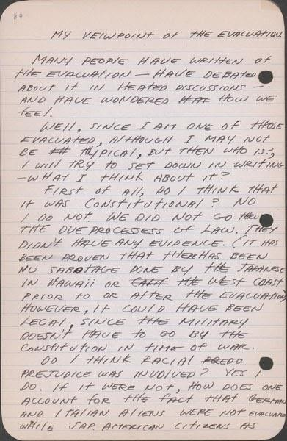
http://www.oac.cdlib.org/ark:/13030/tf6k40056s/?brand=oac4

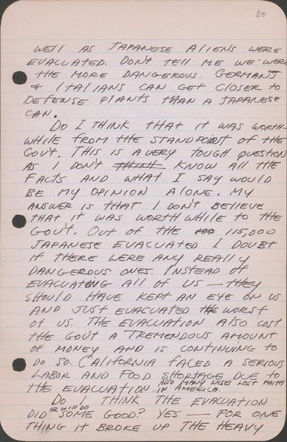
Second page: http://www.oac.cdlib.org/ark:/13030/tf3489n632/?brand=oac4

Third page:
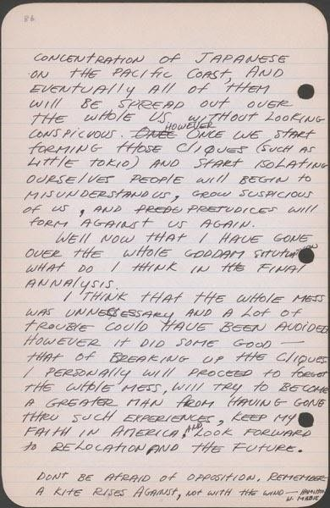
http://www.oac.cdlib.org/ark:/13030/tf2r29n604/?brand=oac4

"Making Rice Cakes" A Kango Takamura Painting

Kango Takamura was an Issei artist who had been a photo retoucher for RKO Studios in Hollywood before being incarcerated at the Manzanar prison camp. He documented his experiences at Manzanar in a series of watercolor paintings and drawings.
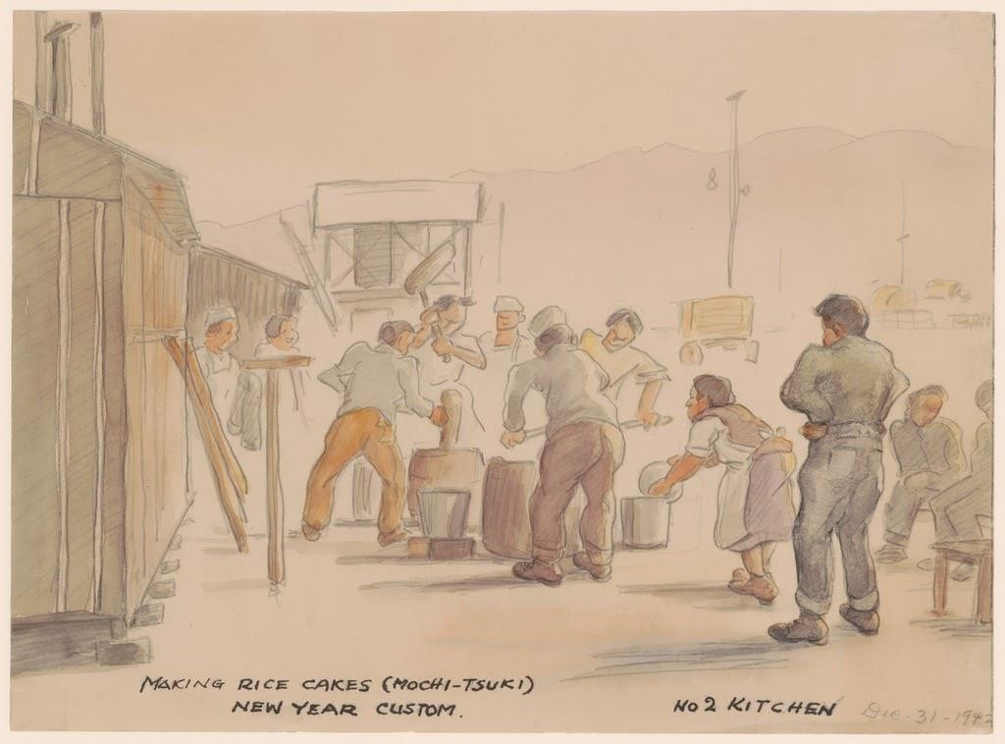

Caption: "Making rice cakes (mochi-tsuki). New Year custom. No 2 kitchen. Dec. 31 - 1942."

Courtesy of Manzanar National Historic Site and the Kango Takamura Collection http://ddr.densho.org/ddr-manz-2-5/
Copyright restricted

“Saturday Afternoon Spring Scene” A Kango Takamura Painting

Kango Takamura was an Issei artist who had been a photo retoucher for RKO Studios in Hollywood before being incarcerated at the Manzanar prison camp. He documented his experiences at Manzanar in a series of watercolor paintings and drawings.
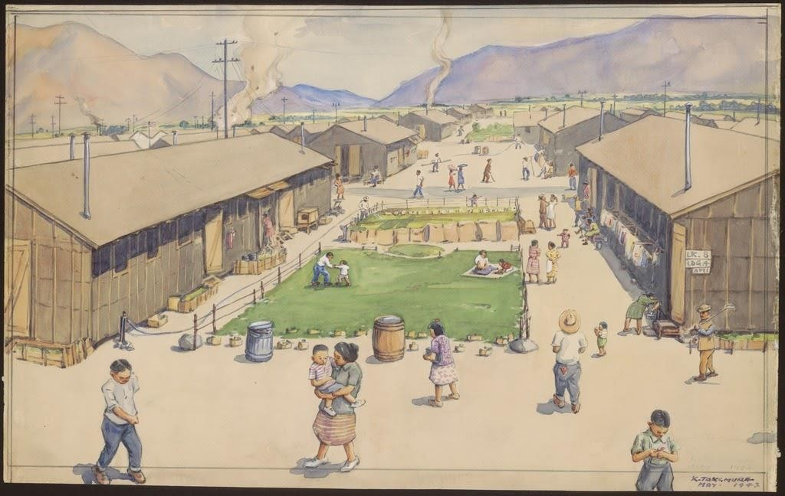
Caption: "Saturday afternoon spring scene looking south from Block 8; quiet inside, sand pillars outside Manzanar."

Courtesy of Manzanar National Historic Site and the Kango Takamura Collection http://ddr.densho.org/ddr-manz-2-16/
Copyright restricted

Mess Hall Workers Meeting on Sugar Shortages

Sugar was an important commodity at Manzanar: it was used to sweeten beverages, as an ingredient in baking, and as a way to preserve other foods. The war made sugar very difficult to obtain, however, leading to widespread shortages and rationing. In the following meeting minutes of the Mess Hall Workers Union at Manzanar, incarcerees discuss the sugar rations as yet another example of their unfair treatment within the camp.

The meeting of the Manzanar Mess Hall Workers Association was called by Mr. Amano on Friday evening, November 5, 1942 at Mess Hall #22 from 7:30 p. m. . . .

The question of rationing and distribution of the food was discussed. The question in reference to the distribution of meat was: How much meat is allotted to each person per week? This question will be brought up with Mr. Winchester by the negotiation committee. Sugar rationing was next brought up. At a Block Leaders meeting recently, Mr. Winchester has stated that the people within the Center should be given more sugar than those outside for the reason that we are not supplied with pastry of any kind, or any other form of sweets. At present only seven ounces of sugar is being given to each person in the Center, while the rate of ration outside is eight ounces per person per week. Sugar used in the baking of the pastries must be taken out of the seven ounces allotted to each individual. Therefore, the members felt that we should receive a better rate of ration than the seven ounces a person per week in order that the people may have baked foods more frequently than at present. . .

With no further business, the meeting was adjourned by Mr. Amano at 9:35 p. m.

Source: Minutes for Meetings of the Mess Hall Workers’ Union, Ueno Papers, JARP, UCLA Reprinted in Manzanar Martyr : An Interview with Harry Y. Ueno, by Harry Y Ueno; Sue Kunitomi Embrey; Arthur A Hansen; Betty Kulberg Mitson. Fullerton, Calif.: Oral History Program, California State University, ©1986.

Notes on the Manzanar Shooting

Morton Grodzins was a political scientist. In the aftermath of the violent uprising at Manzanar in December, 1942, Grodzins visited the camp and wrote down his own impressions and observations. In this section of his report draft, Grodzins disputes the argument that the violence stemmed from pro- Japanese and anti-American forces within the camp during a celebration of Pearl Harbor––an argument picked up by numerous newspapers at the time––and instead insisted that frustration with camp administration was more to blame. In 1949, Grodzins wrote a book on the mistreatment of Japanese Americans during the war called Americans Betrayed.

The Manzanar shooting incident was attributed by Camp Director Ralph Merritt, in his statement to the newspapers, to “a celebration of Pearl Harbor by the pro-axis group among the Japanese.” This entire report points to the doubtful validity of this statement. From the evidence at hand, there is no indication that a celebration of Pearl Harbor had anything to do with the affair. It would be crediting the Japanese with over-abundant prophetic powers to believe that they could foresee that Uyeno [Harry Ueno] would be removed from the camp following the beating of Tayama. Uyeno did not come forward and confess, thus setting up cause for reaction. Rather, the evidence indicates that he was identified by Tayama’s wife on tenuous evidence, and removed from the camp over his own protest.  Furthermore, there is little evidence to corroborate the view that pro- axis sentiment was the main factor in creating the riot situation. Pro- axis elements appear to have been the catalysts at work. But the main dynamics are anti-administration rather than anti-American. The basis of this anti-administration feeling has been traced chronologically to at least the early part of August, and quantitatively to all segments of the Manzanar population, old and young, American and non- American. That the anti-administration feeling came to a head on December 6 is pure chance. If it had come to a breaking point on December 25, Mr. Merritt, with equal validity, could have called it a Christmas celebration. | validity: accuracy  prophetic powers:  predicting the future  tenuous: weak  catalysts: causing something the happen quickly  quantitatively: measuring the numbers of

Source: Grodzins, Morton. " The Manzanar Shooting, Jan. 10, 1943. " The Japanese American Evacuation and Resettlement: A Digital Archive, Bancroft Library, University of California. BANC MSS 67/14 c, folder O10.04.
https://digitalassets.lib.berkeley.edu/jarda/ucb/text/cubanc6714_b210o10_0004.pdf

“Snow in January 1944” A Kango Takamura Painting

Kango Takamura was an Issei artist who had been a photo retoucher for RKO Studios in Hollywood before being incarcerated at the Manzanar prison camp. He documented his experiences at Manzanar in a series of watercolor paintings and drawings.
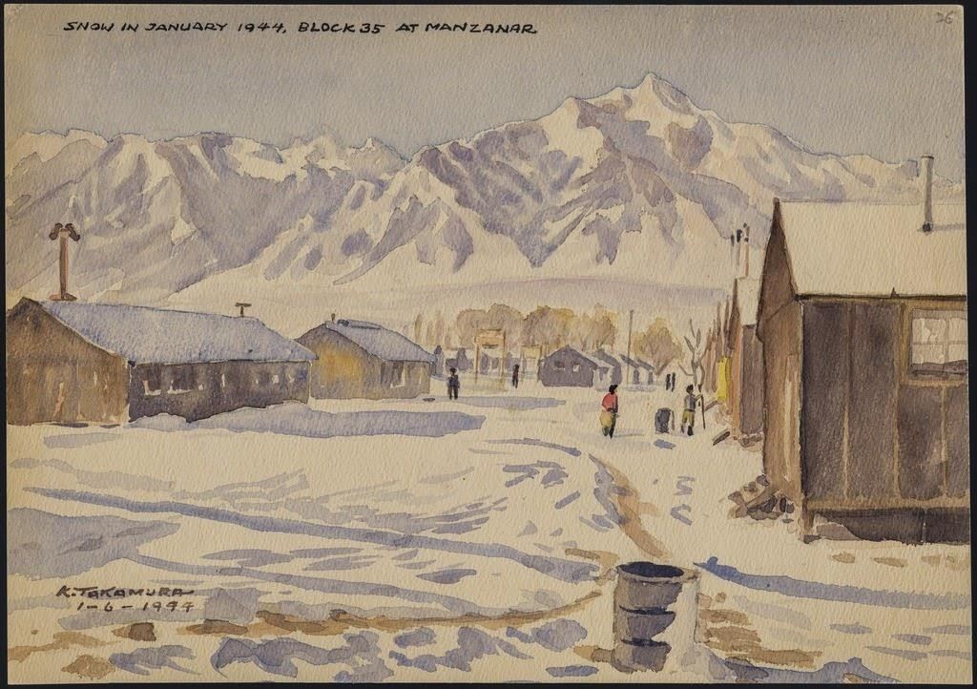

Caption: "Snow in January 1944, block 35 at Manzanar."
Courtesy of Manzanar National Historic Site and the Kango Takamura Collection http://ddr.densho.org/ddr-manz-2-65/
Copyright restricted

Statement of United States Citizen of Japanese Ancestry: Joe Yamikido

In 1943, the U.S. military required all draft-age Nisei to fill out a “Statement of United States Citizen of Japanese Ancestry.” This form would be informally known as the loyalty questionnaire, as two of the more controversial questions on the document (questions 27 and 28) asked participants if they would serve in the armed forces, and if they would pledge allegiance to the United States. The questionnaire created a good deal of confusion, fear, and anger throughout the camps, as Nisei were being asked to swear allegiance to their own country while they were being simultaneously incarcerated by the government.
The following completed form shows how one incarceree responded to these controversial questions. When asked in Question 27 if he would serve in the armed forces if ordered, Joe Yamakido responded, “Yes, if drafted [and] provided I am given equal rights and opportunity as caucasians.” Yamakido was arrested for resisting the draft, but served in the army after World War II.

Full Completed Form
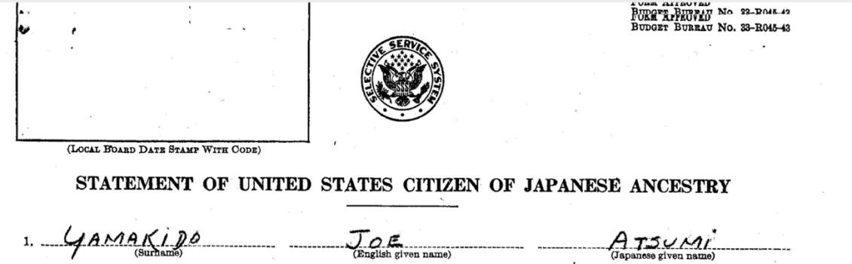
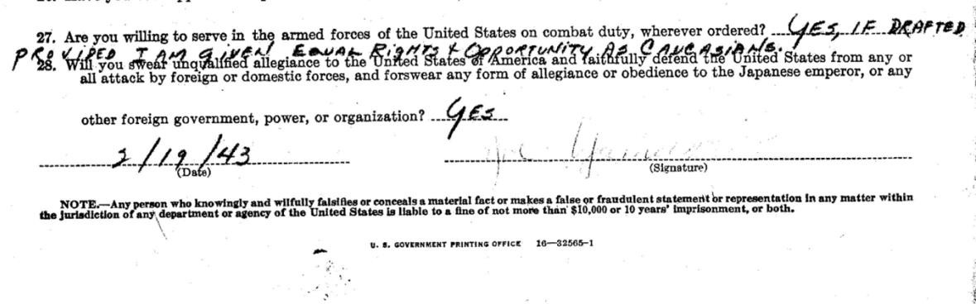

Source: Joe Yamakido, “Statement of United States Citizen of Japanese Ancestry.” National Archives, Records of the War Relocation Authority 210.3

The WRA Application for Leave Clearance

The following form was developed by the War Relocation Authority (WRA) and given to incarcerated Japanese Americans. The WRA created the questionnaire to serve a similar purpose as the U.S. army’s questionnaire for draft-age Nisei and many of the questions are identical, including the controversial question 28. However, the WRA’s intention was to determine whether incarcerees could be trusted to leave the camps. As with the army’s questionnaire, there was widespread fear and confusion as to the form’s purpose and how it would be used.

Full Form
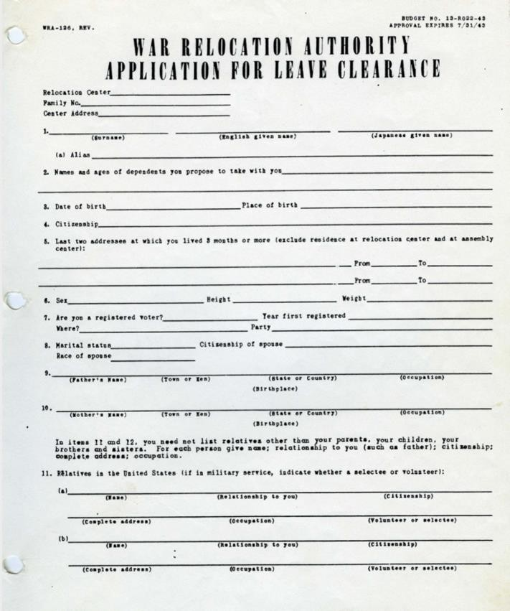

Source: WRA, “Application for Leave Clearance,” 1943, Courtesy of K. Morgan Yamanaka,
Densho Digital Repository, ddr-densho-188-5. https://ddr.densho.org/ddr-densho-188-5/

The Fair Play Committee Bulletin
In response to the questions asked on the “loyalty questionnaire,” incarcerees at the Heart Mountain camp in Wyoming formed The Fair Play Committee, an organization dedicated to restoring Japanese American civil rights. The Committee believed that Nisei should not be drafted into the army until their rights as American citizens were restored. When the military reinstated the draft, the group resisted, and 85 members were arrested. Those convicted were later pardoned by President Truman in 1947. The following is an excerpt from a Fair Play Committee bulletin describing the organization and its positions and goals.
Q. What’s this Fair Play Committee about?
A. The Fair Play Committee (FPC) is organized to inject justice in all the problems pertaining to our evacuation, concentration, detention and pauperization without hearing or due process of law, and oppose all unfair practices within our center, State, or Union...
Q. What does the FPC think is the right thing for any loyal American citizen to do in our present status?
A. The FPC believes that the first duty as loyal American citizens is to protect and uphold the Constitution of the United States THE CORNERSTONE OF THIS INSTRUMENT OF OUR GOVERNMENT IS INJUSTICE, LIBERTY, FREEDOM AND THE
PROTECTION OF HUMAN RIGHTS, AND THE DESECRATION OF ANY ONE OF THESE IS A DIRECT ATTACK ON THE FUNDAMENTALS THAT MOLDED OUR DEMOCRATIC INSTITUTION.
Q. Is this an objectors group?
A. No. It definitely is not an objectors group, but we would like to present both sides of this draft issue.
Q. What does the FPC think about this present draft program?
A. The FPC believes we have a right to ask that the discriminatory features in regards to this selective service be abolished, out status be clarified, and full restoration of our rights of our before being drafted. THIS ABSENCE OF CLARIFICATION OF OUR STATUS, RESTORATION OF OUR RIGHTS, AND THE LIFTING OF DISCRIMINATORY RESTRICTIONS IS THE KEYSTONE OF OUR ATTITUDE TOWARDS THE PRESENT PROGRAM OF DRAFTING US FROM THIS CONCENTRATION CAMP.
Q. Why can’t we contest the whole issue after the war?
A. Because if we knew of a cause and a country worthy of our blood, then we need never feel ashamed to look the enemy in the eye. And by the granting of these it will not only liquidate the injustices of the past, but it will guarantee against any future inroads upon the Constitution and its principles. It will guarantee assurance to the minorities who otherwise may face a similar fate in the future.

Source: “Fair Play Committee Bulletin #2,” ca. 1944, Courtesy of Frank Abe, Densho Digital
Repository, ddr-densho-122-400. http://ddr.densho.org/ddr-densho-122-400/

Honor Roll Sign at Minidoka Prison Camp

The following image of Japanese Americans looking at the camp's honor roll, was taken in 1944. The honor roll listed all of the Japanese Americans from the Minidoka concentration camp who volunteered for military service during World War II. Minidoka had the highest number of volunteers from the mainland United States.
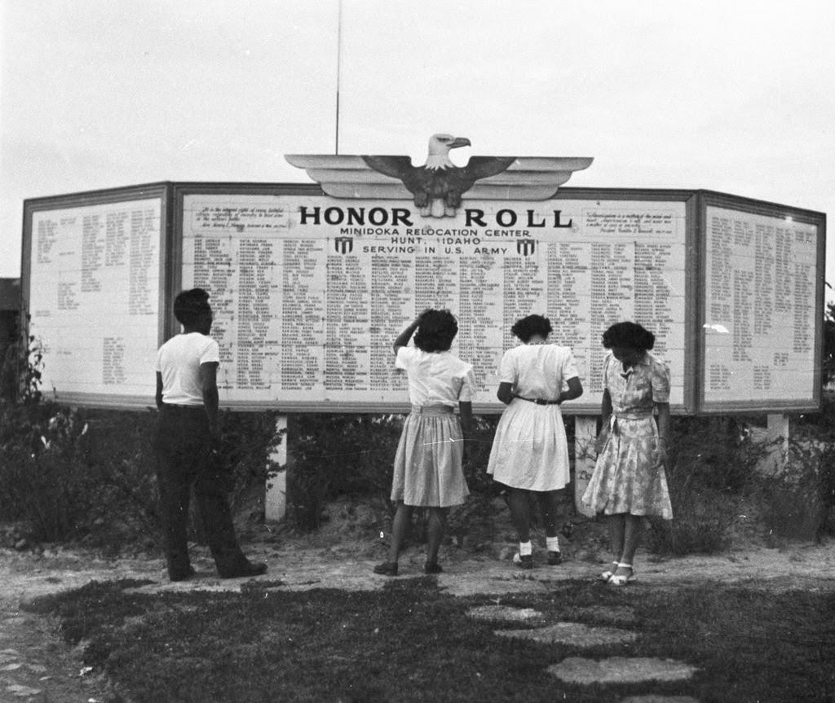

Source: Densho Digital Repository, Courtesy of the Mitsuoka Family Collection https://ddr.densho.org/ddr-densho-15-82/

Excerpt from “A Nisei Who Said No”
The following excerpts are from interviews with a Nisei in camp who answered “no” to Question 28 on the “Statement of United States Citizen of Japanese Ancestry” questionnaire. Question 28 asked incarcerees if they would swear allegiance to the United States and disavow allegiance to the Emperor of Japan. The first section is part of an exchange between the Manzanar Hearing Board and the Nisei who responded “no.” The second section is a longer statement later collected from the incarceree.

Hearing Board Member: Don’t you want to tell us? Perhaps there is something that we can do. If you say “No” you are giving away your citizenship. Is that what you want to do? Feel free to talk. We’re not here to argue with you but we want to help you.

Nisei: What I was thinking. I thought that since there is a war on between Japan and America, since the people of this country have to be geared up to fight against Japan, they are taught to hate us. So they don’t accept us. First I wanted to help this country, but they evacuated us instead of giving us a chance. Then I wanted to be neutral, but now that you force a decision, I have to say this. We have a Japanese face. Even if I try to be American I won’t be entirely accepted…

Nisei: If I would say “Yes”, I’d be expected to say that I’d given up my life for this country. I don’t think I could say that because this country has not treated me as a citizen. I could go three-quarters of the way but not all the way after what has happened.

HBM: Would you be willing to be drafted?

Nisei: No I wouldn’t do that.

Later I contacted this young man and asked him for a fuller statement of his views. The following is what he told me:

...I don’t know Japan. I’m not interested in Japan. That’s another thing that worries me. I don’t know what will become of me and people like me if we have to go to Japan...[My father] doesn’t tell me what to do but I know what he wants me to do about this answer. I can sense it from the way he talks.

In order to go out prepared and willing to die, expecting to die, you have to believe in what you are fighting for. If I am going to end the family line, if my father is going to lose his only son, it should be for some cause we respect. I believe in democracy as I was taught it in school. I would have been willing to go out forever before evacuation. It’s [not] that I’m a coward or afraid to die. My father would have been willing to see me go out at one time. But my father can’t feel the same after this evacuation and I can’t either . . .
I’m sick right now. Right now while I’ve been talking to you I’ve had a cramp in the pit of my
stomach.
I appreciate this talk with you. But my mind is made up. I know my father is planning to return to Japan. I know he expects me to say “No” so there will be no possibility that the family will be separated. There isn’t much I can do for my father [anymore]; I can’t work for him the way I used to. But I can at least quiet his mind on this.

Source: War Relocation Authority, Community Analysis Notes: From a Nisei who said “no.”, January 15, 1944. Densho Digital Repository, https://ddr.densho.org/ddr-csujad-2-84/.

Justice Murphy’s Dissent in Korematsu v. United States

In 1942, Fred Korematsu defied the mandate to be forcibly removed from his home in California. He was arrested and later sued the federal government for violating his constitutional rights. The case went all the way to the Supreme Court, where in 1944 the court decided 6-3 against Korematsu. Justice Frank Murphy––one of the three judges who ruled in favor of Korematsu––wrote the following dissenting opinion. In 1983, Korematsu challenged his conviction and the ruling was overturned.

This exclusion of "all persons of Japanese ancestry, both alien and non-alien," from the Pacific Coast area on a plea of military necessity in the absence of martial law ought not to be approved. Such exclusion goes over "the very brink of constitutional power," and falls into the ugly abyss of racism...

I dissent, therefore, from this legalization of racism. Racial discrimination in any form and in any degree has no justifiable part whatever in our democratic way of life. It is unattractive in any setting, but it is utterly revolting among a free people who have embraced the principles set forth in the Constitution of the United States. All residents of this nation are kin in some way by blood or culture to a foreign land. Yet they are primarily and necessarily a part of the new and distinct civilization of the United States. They must, accordingly, be treated at all times as the heirs of the American experiment, and as entitled to all the rights and freedoms guaranteed by the Constitution.

Source: Korematsu v. United States, 323 U.S. 214. December 18, 1944 (Murphy, Frank, dissenting).

Looking for Work after the Camps

After incarceration ended, some Japanese Americans were unable to return to their pre-war lives: they had lost their homes, their jobs, their savings, and their property while imprisoned. Facing difficult employment opportunities and prejudice, one-third of former incarcerees were forced to move to a different state. In response, the War Relocation Authority (WRA) created a resettlement program for those Japanese Americans. In the following photograph from 1945, three former incarcerees of the Heart Mountain camp in Wyoming look over a bulletin board of possible job opportunities at the WRA headquarters in Philadelphia, Pennsylvania.
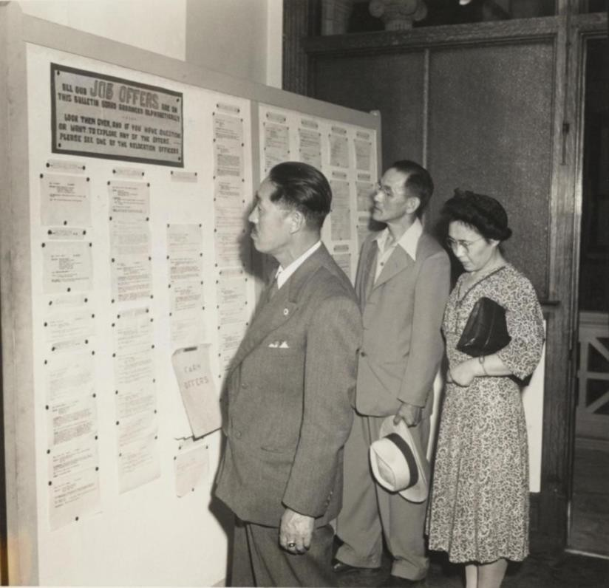

Source: Gretchen Van Tassel, “Mr. and Mrs. Tomatsu Gorai and Mr. Ushimatsu Kubota looking over the job bulletin board in the Philadelphia WRA office,” photograph, July, 1945. WRA no. G-932, War Relocation Authority Photographs of Japanese-American Evacuation and Resettlement, Bancroft Library, UC Berkeley. https://oac.cdlib.org/ark:/13030/ft4779n99z/?order=3&brand=oac4

Presidential Apology Letter

The passage of the Civil Liberties Act in 1988 granted financial compensation and a formal apology by the President of the United States to all Japanese Americans who were incarcerated during World War II. However, two years passed before the funds were distributed as the following apology letter by President George HW Bush (dated October 1990) shows. When completed, 82,219 people received an apology and
compensation for the “serious injustices” done to them or their heirs during the war.
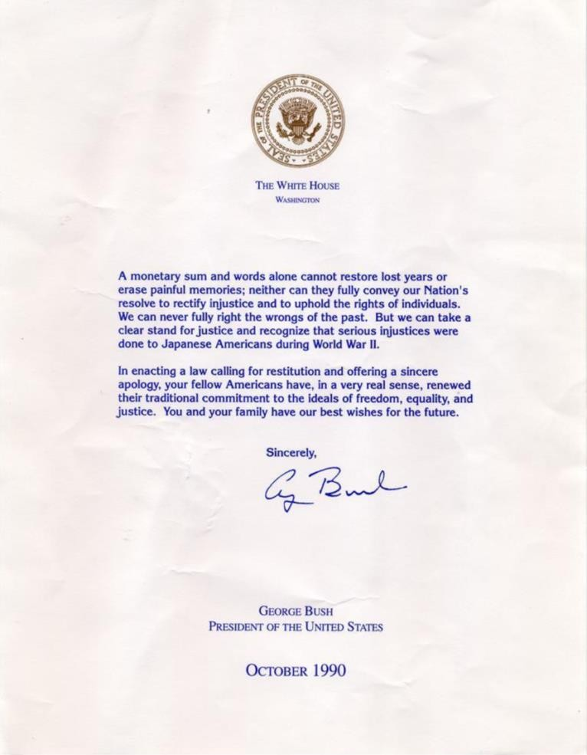

Source: George Bush, Presidential Apology Letter, 1990. Densho Digital Repository, ddr-densho- 153-20. Courtesy of Majorie Matsushita. http://ddr.densho.org/ddr-densho-153-20/

Fumiko Hayashida Advocates for the Bainbridge Island Japanese American Memorial

In 2006, Fumiko Hayashida was the oldest living Bainbridge Islander who had been forcibly relocated to the Manzanar internment camp. In the following excerpt, Hayashida testifies to the U.S. House of Representatives Subcommittee on National Parks in favor of erecting a memorial to those forcibly removed from the island. The bill passed the following year, and the Bainbridge Island Japanese American Exclusion Memorial officially opened in 2011. Hashida passed away in 2014 at the age of 103.
...When the war finally ended and we were freed from Minidoka, no one wanted to talk about our painful years in internment camps. We buried our pain, suffering and shame, choosing to try to forget the past, persevere and for the sake of the children move forward with our lives. We returned to Bainbridge Island to find that we lost everything. Our farm and strawberries were not well maintained and we had to start from scratch. We tried to make a go of it, but having three young and growing children, we had to find a more stable income. After a year my husband got a job at Boeing in Seattle, but the long ferry and bus commute from Bainbridge Island became too taxing. We decided to leave Bainbridge Island and buy a home in Seattle, where I have lived to this very day.
The years we experienced in Minidoka and Manzanar changed not only our lives, but the years of internment during World War II changed the lives of all 120,000 Japanese Americans who were forcibly exiled by the United States government.
I am grateful that Presidents Ronald Reagan, Gerald Ford, George H.W. Bush and Bill Clinton have apologized for this shameful period in American history, and that the US Congress passed the Civil Liberties Act of 1988 and the modest reparations that followed. These are powerful statements from our nation of healing and honor.
As the very first place where the World War II internment story literally began, the passage of
H.R. 5817, the Bainbridge Island Japanese American Monument Act of 2006 would be another powerful statement by the United States of America that we must learn and never forget the lessons from this unfortunate chapter in American history.
Only a small fraction of the Japanese Americans who experienced the internment are still alive. My husband died in 1983. We never celebrated our golden anniversary. Only my youngest sister and two of my children are alive today from my immediate family.

I am an old woman in the 95th year of my life. I hope to live long enough to see the Bainbridge Island Japanese American Memorial earn the honor and recognition from our federal government and become a unit of the National Parks Service. I urge you to please urgently pass

this measure so that all Americans can learn from and take to heart the spirit of the memorial’s name: “Nidoto Nai Yoni – Let it not happen again.”
Source: Fumiko Hayashia, Testimony Before the Committee on Resources, Subcommittee on National Parks, United States House of Representatives. Congressional Records, Hearing on H.R. 5817: The Bainbridge Island Japanese American Monument Act of 2006. September 28, 2006.

George Takei: Internment, America’s Great Mistake

George Takei is an Japanese American actor and activist most known for his portrayal of Sulu on the original Star Trek television series. As a young boy, however, Takei and his family were incarcerated in the Rohwer, Arkansas and Tule Lake, California incarceration camps. In the following excerpt from an opinion piece written in 2017, Takei reflects on his experiences, details the importance of pilgrimages back to the camps, and compares the events of his childhood with modern-day American politics.

...I was 7 years old when we were transferred to another camp for “disloyals.” My mother and father’s only crime was refusing, out of principle, to sign a loyalty pledge promulgated by the government. The authorities had already taken my parents’ home on Garnet Street in Los Angeles, their once thriving dry cleaning business, and finally their liberty. Now they wanted them to grovel; this was an indignity too far.

A pilgrimage to Tule Lake also occurs every year, symbolically on July 4. I have gone three times. I remember a terrifying moment while I was held there when armed military police burst into the barracks and hauled away several young men.

On the pilgrimages, I finally saw where they had been taken: a concrete cell block called the stockade. On the concrete walls, there was graffiti, now made illegible by the passage of time. Also fading were brown splotches I was told were blood stains. This was what could happen in an America that had become un-American.

It has been the lifelong mission of many to ensure we remember the internment. Our oft- repeated plea is simple: We must understand and honor the past in order to learn from and not repeat it. But in the 75 years since President Franklin D. Roosevelt signed Executive Order 9066 authorizing the internment of Japanese-Americans, never have we been more anxious that this mission might fail.

It is imperative, in today’s toxic political environment, to acknowledge a hard truth: The horror of the internment lay in the racial animus the government itself propagated. It whipped up hatred and fear toward an entire group of people based solely on our ancestry...

My way of remembering the cruelties of the past was to help found the Japanese American National Museum, as well as to turn my family’s experience into a Broadway show, “Allegiance,” in the hope that more will heed the warning. The pilgrimages to camps like

Manzanar, Rohwer and Tule Lake are another way of honoring those who suffered, and lost, and had to rebuild shattered lives. They remind us all today of the threat to American values from cynically manufactured fear and the deliberate targeting of a vulnerable minority.

Source: George Takei, “Interment, America’s Great Mistake,” The New York Times, April 28, 2017. https://www.nytimes.com/2017/04/28/opinion/george-takei-japanese-internment- americas-great-mistake.html

California Legislature Apologizes for Japanese Incarceration

While the Federal Government began issuing apologies for the incarceration of Japanese Americans during World War II in the 1980s, the state of California (in which both the Manzanar and Tule Lake prison camps were located) did not officially acknowledge these wrongs until 2020, seventy-eight years after Executive Order 9066. In the following excerpt from the California legislature, the state outlines the damage caused by forced relocation and incarceration, and formally apologizes for the failure of the state to “defend the civil rights and civil liberties of Japanese Americans.”

WHEREAS, On February 19, 1942, President Franklin Delano Roosevelt signed Executive Order No. 9066 (EO9066), under which more than 120,000 people of Japanese ancestry were incarcerated in 10 concentration camps scattered throughout western states and the State of Arkansas during World War II; and
WHEREAS, EO9066 inflicted upon more than 120,000 Americans and residents of Japanese ancestry a great human cost of abandoned homes, businesses, farms, careers, professional advancements, disruption to family life, and public humiliation...
WHEREAS, The year 2020 marks the 76th anniversary of the Supreme Court of the United
States’ decisions in the Japanese American incarceration cases. While the Supreme Court ordered Mitsuye Endo released from incarceration, it denied, in Korematsu v. United States, that EO9066 reflected racial prejudice and upheld EO9066 in light of the “strategic imperative” to keep the west coast secure from invasion; now, therefore, be it
Resolved by the Assembly of the State of California, That the Assembly apologizes to all Americans of Japanese ancestry for its past actions in support of the unjust exclusion, removal, and incarceration of Japanese Americans during World War II, and for its failure to support and defend the civil rights and civil liberties of Japanese Americans during this period...

Source: California State Legislature, HR-77 “Relative to World War II Japanese American concentration camps” Revised February 20, 2020. http://leginfo.legislature.ca.gov/faces/billTextClient.xhtml?bill_id=201920200HR77

