Mission 4:
“City of Immigrants”

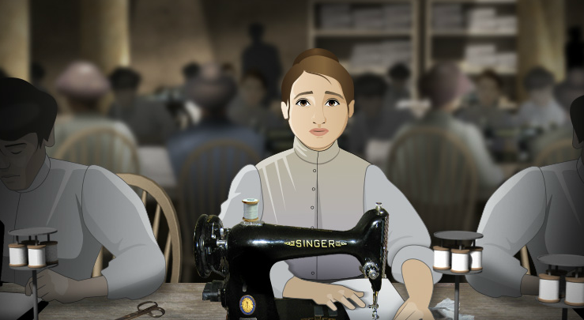


COMPLETE CLASSROOM GUIDE
Table of Contents

Overview
About Mission 4: “City of Immigrants” 5
Mission 4 At A Glance 9
Essential Questions 13
Models of Instruction 15
Learning Goals 19
National Standards Alignment 22

Background
Timeline of Events Before, During, and After the Mission 27
Educator’s Primer on the Historical Period 33
Glossary of Smartwords and Other Vocabulary 40
Character Overview and Historical Figure Profiles 47
Myths and Misconception 55
Top 5 Things To Know Before You Play 57

Activities
Prologue Writing Prompts 58

Part 1: Finding Home
Part 1 Document Based Activity: The Immigrant Journey 60
Part 1 Vocabulary Activity 68
Part 1 Writing Prompts 77
Part 1 Review Questions 79
Part 1 Review Questions Answer Key 83

Part 2: Family First
Part 2 Document Based Activity: Family Economy 87
Part 2 Vocabulary Activity 95
Part 2 Writing Prompts 104
Part 2 Review Questions 106
Part 2 Review Questions Answer Key 110

Part 3: A Night to Remember
Part 3 Document Based Activity: “Popular Culture” 114
Part 3 Vocabulary Activity 126
Part 3 Writing Prompts 134
Part 3 Review Questions 136
Part 3 Review Questions Answer Key 140

Part 4: Factory Girls
Part 4 Document Based Activity: Factory Life 143
Part 4 Vocabulary Activity 152
Part 4 Writing Prompts 163
Part 4 Review Questions 165
Part 4 Review Questions Answer Key 169

Part 5: Uprising of the 20,000
Part 5 Document Based Activity: Strike 173
Part 5 Vocabulary Activity 186
Part 5 Writing Prompts 195
Part 5 Review Questions 197
Part 5 Review Questions Answer Key 201

Epilogue
Epilogue Writing Prompts 205

Resources
Additional Media Resources 207
Character and Scene Printables 219

Primary Source Documents
Part 1
List of the Passengers on the Batvia 246
Pauline Newman Describes Her Family’s Journey to New York City 247
Ellis Island Eye Inspection Photo 249
Sylvia Bernstein on Arriving at Ellis Island 250
Table of Immigrant Origins, 1880-1920 252
“The High Tide of Immigrant – A National Menance” 253
“The Surrender of New York Town” Cartoon 254

Part 2
An Immigrant Writes to the Bintel Brief for Advice 255
Report on Food Expenses for a Working Family in 1909 256
Garment Workers in a Home Sweatshop Photo 257
Floor Plan of a Typical Tenement, c. 1905 258
“Immigration and the Public Health” Article 259
Hebrew Immigrant Aid Society Magazine Cover 260

Part 3
Lillian Ward on Establishing the Henry Street Settlement 261
A Journalist Warns of the Dangers of Dance Halls 263
“Far from the Fresh Air Farm” Painting 264
“The Story of a Sweatshop Girl” 265

Part 4
Interior of a Garment Factory, photo 267
“The Return from Toil” 268
Clara Lemlich Describes Life in the Shop 269
Report on the Clothing Industry in New York, 1905 270
A Journalist Defends the New Picture Shows 272
Luna Park Photo 274
Coney Island Postcard 275

Part 5
“30,000 Waist Makers Declare Big Strike” Article Excerpt 276
Rules for Pickets 278
Striking Garment Workers Holding “The Call” Photo 279
“Incident in the Shirtwaist Strike” 280
“Women in a Labor War” Article 281
“Record of Police Persecution in the Waist Makers’ Strike” 284

Epilogue
Triangle Fire Survivors’ Accounts 285
“Placing the Responsibility” Article 289
Factory Safety Report, 1912 290
Results of the New York State Factory Investigating Commission, 1915 292
Interior of Triangle Shirtwaist Factory after the Fire, photo 294

The mission immerses young people in the dynamic, modern, and sometimes dangerous world of New York City in the early twentieth century. The game is divided into five parts, with a prologue offering background information and an epilogue that extends the story of the main characters.

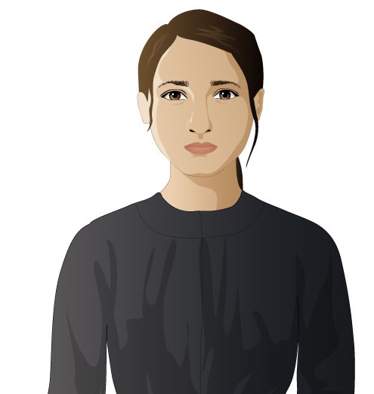
Students playing the game assume the role of Lena Brodsky, a fourteen year-old Jewish immigrant from Minsk, Russia who arrives in the United States in 1907. As the game begins, Lena is in the midst of a life-changing transatlantic journey on a ship bound for New York City. She joins her brother and his wife in their tenement apartment on the Lower East Side, and finds work in the burgeoning garment industry. Lena’s meager wages makes an essential contribution to her family’s economy. Life in the garment industry is difficult and dull, and Lena seeks out other opportunities and adventures. Players can improve Lena’s prospects by attending classes at the local settlement house, or finding fun and possible romance. Eventually, Lena finds work at the Triangle Shirtwaist factory, where her earnings increase. However, working conditions remain dismal, and some of the young women begin organizing. When a general strike breaks out, Lena must decide whether or not to join the picket lines with her fellow workers. The strike represents one of the many turning points that shape Lena’s life and reveal, in turn, how the story of America was shaped by immigrants.

When students are reading a traditional text, such as the chapter of a book or a magazine article, they are all presented with the same information. However, as students play “City of Immigrants,” their experiences may differ slightly based on the choices they make and their behavior as Lena. As students make their way through the mission, they receive badges signifying the characteristics, values, and skills of their particular version of “Lena Brodsky.”

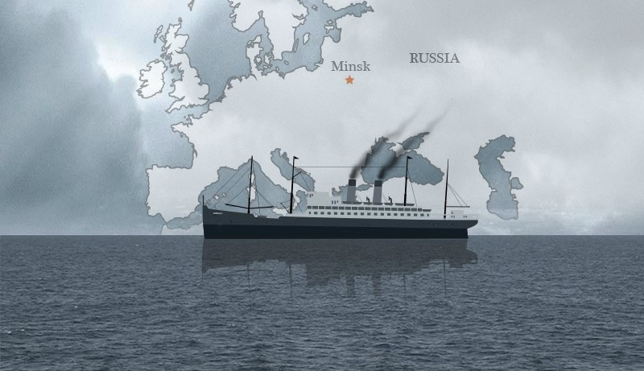
As the Prologue begins, Lena is aboard the SS Amerika in the spring of 1907. As the ship makes its way across the Atlantic, Lena recounts the events which have led to her immigration. Anti-Jewish sentiment in Minsk has greatly threatened her family’s lives and livelihood. After her aunt and uncle were killed in a pogrom, Lena’s brother Isaac journeyed to New York. He has been sending money back to Russia in an effort to reunite his family. When Lena’s brother Jacob was drafted into the tsar’s army, Lena took his steamer ticket and set sail for America, leaving her parents behind. Lena worries about whether or not she will make it past the customs officials in New York, and hopes that her entire family will be together again someday.

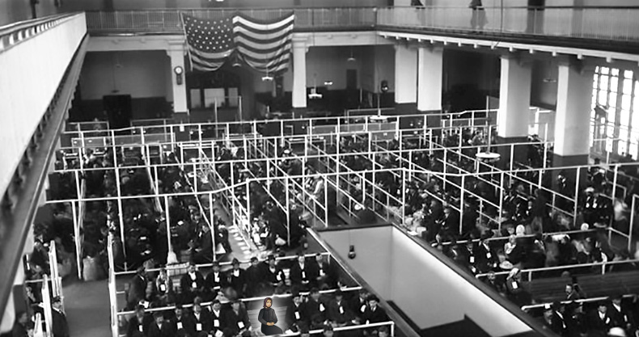
In Part 1, “Finding Home,” Lena arrives in New York City after seven awful days in steerage. When the ship docks, Lena is placed on a ferry that takes her to Ellis Island. She is inspected by immigration and customs officials who assess her health and question her. She makes it through all of the inspections, but is sent to a detention room to wait until Isaac can come get her. Hungry and tired from the long journey, she faints on the way to the detention room. She wakes in the Ellis Island infirmary, where Isaac is standing by her side. Isaac is confused and upset when he learns of Jacob’s fate. Lena reassures him that she will not be a burden, and insists she has valuable skills. Isaac and Lena make their way to the Battery, and hurry to get to Isaac’s apartment so as not to be late for the Jewish Sabbath. They are separated in the crowds of people, and Lena has to find her own way through the teeming streets of the City of Immigrants to her new home.

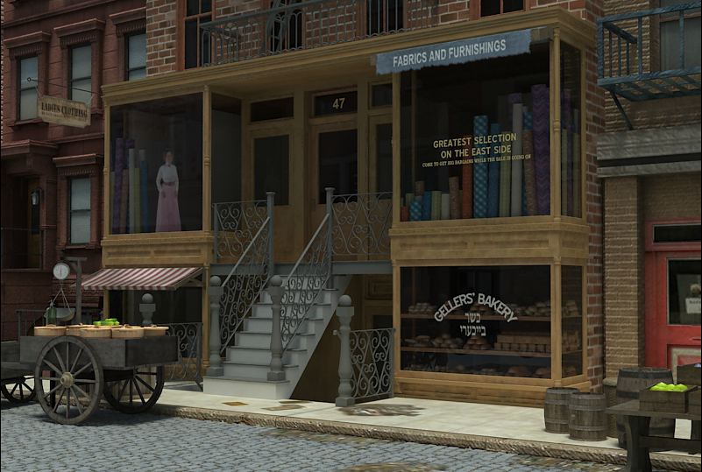
Part 2, “Family First,” begins in August, three months after Lena’s arrival. Lena is living with Isaac, his wife Sonya, their infant son, and two boarders in a three-room tenement apartment on Orchard Street. Lena has no privacy and very little time to herself. Isaac has found Lena a job sewing men’s suits in a sweatshop located in one of the apartments in the building. The work is tedious and exhausting, but Lena’s wages contribute to the family’s survival, and are also being put into savings for steamship tickets for her parents. Because summer is the slow season in the garment trade, work has been uneven. To make matters worse, Sonya is pregnant again and having difficulty. A visiting nurse from the Henry Street Settlement has prescribed bed rest for her. Lena must take on more responsibilities than ever to ensure the Brodsky family’s livelihood. Though she does not know it at the time, how Lena chooses to “step up” to a new set of challenges will impact her relationships and opportunities for the remainder of the game.

In Part 3, “A Night to Remember,” Sonya is preoccupied with paying the rent, while Lena and Isaac are each trying to improve the family’s future fortunes. In the evenings, Lena goes to the Henry Street Settlement, where she can attend sewing classes (and nurture an existing talent), or join the Drama Club (and cultivate a new one). Lena has also been taking English classes at Henry Street. She becomes friends with Rosa Leone, an Italian girl. Meanwhile, Isaac, a pushcart peddler, pursues his dream of opening his own store. To finance the venture, he has borrowed money from a local gang, and, more alarming to Lena, taken the family’s entire savings to buy a stock of goods for the store. Zev, a low-ranking gang member who Lena met on her first day in New York, resurfaces as the middle man between Isaac and the gang. Lena, tasked with taking Isaac’s pushcart to Hester Street for the day, may wrangle money and information out of Zev, and even accept his invitation to go to the dancehall, where she will hear American popular music for the first time. But on a pivotal evening, Lena learns that not all paths can be followed, and that she must decide how, and with whom, to invest her energy and precious time.

Part 4, “Factory Girls,” begins one year later, in September 1908. Lena is now reasonably fluent in English and a proficient seamstress. Her friend Rosa Leone has gotten a job uptown at the Triangle Shirtwaist Factory, and she offers to get Lena an interview. On her first day, Lena must prove her sewing skills to Mrs. Sherman, the forelady. How well she performs on the sewing machine determines her position and wages in the factory. Working conditions at Triangle are difficult - the factory is noisy, rushed, and the bosses exploit the young workers in a number of ways, including charging them for electricity, needles, and soiled fabrics, fining them for being a few minutes late or talking on the job, and general harassment. Lena now also must work on the Sabbath. She meets James Poole, a muckraking journalist, and can choose to tell him about her working conditions. Despite the misery of working at Triangle, Lena now has resources from her weekly pay to indulge in little luxuries and entertainments, from trips to Coney Island to visits to the Yiddish theatre to “American” fashions. Can Lena enjoy a little amusement and still save enough money to bring her parents to New York?

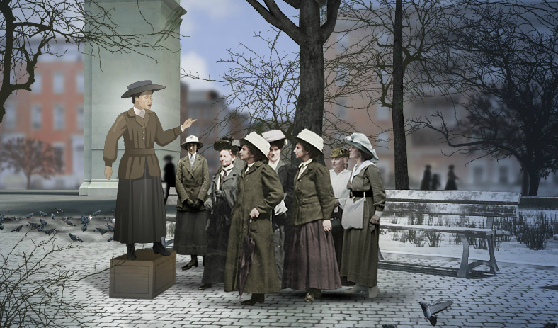
As Part 5, “The Uprising of the 20,000” begins, it is one year later, in the autumn of 1909. Lena is still working at the Triangle Factory. Shirtwaist workers across the city have called for a general strike, asking workers to walk out of all the factories. The workers are being led by Clara Lemlich, a girl not much older than Lena. Lena and Rosa are caught up in the excitement of the possibilities of improving their work and pay, but also terrified of the prospect of losing their income, exacerbating family tensions, and facing the brutality of police and factory thugs. 20,000 workers join the strike and walk the picket lines. Police arrest and harass the young women. Lena must choose to align herself with the more radical, socialist leaders of the movement, or the more moderate, middle-class Progressive reformers. During the strike, Lena can be arrested, jailed, sentenced to the workhouse, or attacked by scabs as she pickets.

The strike, and Lena’s critical decisions in its aftermath, set the stage for the Epilogue. What will her future life in America be? Will she operate a successful family business with her brother? Move away from the Lower East Side and start a family of her own? Remain a garment worker? Become a leading lady on Broadway? The path Lena follows is determined by the player’s previous choices, achievements, and behavior.

During the Mission, students play through several “days” of Lena’s life the course of two and a half years. Each student playing “City of Immigrants” will have a unique gameplay experience based on individual choices, skill, and understanding of the period.

 | PROLOGUE & PART 1:  Finding Home  1907 | PART 2:  Family First  1907 | PART 3:  A Night to Remember  1907 | PART 4:  Factory Girls  1908 | PART 5:  Uprising of the 20,000  1909-1910 | EPILOGUE  1911 – 1930
Playing Time | 15-20 minutes | 10-13 minutes | 10-13 minutes | 15-17 minutes | 15 minutes | 5-10 minutes
Story | In the prologue, Lena describes why and how she left Minsk, Russia to live in New York City with her brother.  Lena enters Ellis Island and must answer the immigration inspector’s questions. She is met by her brother, becomes separated from him, and must find her way to his New York tenement on her own. | Lena is getting used to life in America. She gives her family the wages she earns sewing clothes in a sweatshop, and does grocery shopping and laundry for her sister-in-law. She must spend money wisely, so they can save enough to bring her parents to America.  If she has time, she can go to the Settlement house. | Lena sells goods from her brother’s pushcart, and continues working in the sweatshop. She also goes to the Settlement house and practices English with her Italian friend, Rosa. Lena’s brother is trying to expand his business, but will it help or hurt the family? Lena must decide how to spend her free time: helping her family or pursuing her own interests. | Lena gets a new sewing job at a large factory. She is earning more money than at her previous job, but working conditions are difficult. Outside of the factory, she encounters a reporter who wants to interview her for an exposé about factory work, and also hears socialists in the park talking about workers’ rights. At home, Lena negotiates with her family to keep some of her wages as pocket money. | Many factory girls have gone on strike, and Lena seeks advice on whether she should join the strike too.  Once she joins the strike, Lena raises funds to help the striking workers, joins a picket outside of her factory, and is arrested for disturbing the peace. Ultimately, Lena must decide if she will continue striking or return to work. | Look through Lena’s scrapbook of the 1910s and 1920s to find out what happened to her after the 1909 strike.
Lena’s Tasks | Answer immigration questions.  Find her way through Lower Manhattan. | Buy groceries and do the laundry. | Sell goods from the pushcart.  Go to classes at the settlement house. | Sew five sleeves for the forelady at the factory. | Seek advice about joining the strike.  Raise funds for the strike.
Badges/Turning Points | Throughout the game, the player will have opportunity to earn badges in two categories: Achievements and Turning Points.  • The Achievement Badges correspond to actions, skills, and attitudes that Lena can earn in the game: Sewing Sensation, Star Power, Market Maven, Solidarity, Balabusta, Mensch, Good Sabbath, Urban Explorer, Intrepid, and Reunited.  • The Turning Point Badges represent significant choices that Lena makes in Parts 1, 3, and 5 of the game that help determine her future: Voice of Gold, Nimble Fingers, Head for Numbers, Sisterhood, Family First, Stepping Out, New Woman, Factory Girl, Fashionista, Leading Lady, Union Rep, and Family Business.
Target Concepts | Pogroms and discrimination against Jews in Russia spurred the departure of millions of Jewish Immigrants.  Many immigrants traveled in crowded steerage quarters across the Atlantic.  The Ellis Island immigrant processing was intimidating, but not overly difficult.  New York City at the turn-of-the-century was a large and modern urban center with elevated railroads, streetcars, and many recently-arrived immigrants. | Many immigrant families relied on the income of all family members, as well as boarders, to make ends meet. Most available jobs were low-paid, irregular, and unskilled.  Educated middle-class women started Settlement Houses in many immigrant neighborhoods to offer residents in need social services such as visiting nurses and English classes.  Immigrant ghettos were known for their overcrowding and poverty, yet these ethnic enclaves benefitted immigrants through formal and informal networks of support, such as finding apartments and jobs, and fostering community institutions such as synagogues, banks, and aid societies. | Settlement houses served as a force for Americanizing new immigrants, as well as assisting with basic social services.  Many Italians immigrated with the goal of earning enough money to secure land ownership in Italy. | In addition to small, tenement-based garment shops, large garment factories hired hundreds of young women as sewing machine operators.  As young immigrant women earned more money in factories, they became attracted to new commercial amusements such as Coney Island, nickelodeon films, and dance halls. They also were able to afford the new ready-made fashions of the era.  As part of the Progressive reform movement of the 1910s, many newspaper reporters uncovered corruption and greed in the urban economy. Their writings raised awareness and calls for government regulation and reform. | Young immigrant women embraced the labor movement in large numbers at the turn of the century, often engaging in brief unorganized work stoppages to protest their conditions and also joining established unions.  In 1909, shirtwaist makers, mostly young women workers, went on strike in massive numbers. The strike became known as the Uprising of the 20,000.  The striking women were supported by male union members, Socialist Party activists, and community organizations. The strikers’ other key ally was the  Women’s Trade Union League (WTUL), a group of college students and prominent New York women. | Crowded and unsafe working conditions in the Triangle  Shirtwaist Company factory led to a disastrous fire.  Public outcry and pressure from labor unions led the state of New York to issue new laws regulating safety in the workplace.  With the start of World War I, the United States began restricting immigration from Europe.
Classroom  Activities | Part 1 Document-Based Activity: Immigrant Journey  Part 1 Vocabulary Activity  Part 1 Writing Prompts  Part 1 Review Questions | Part 2 Document-Based Activity: Family Economy  Part 2 Vocabulary Activity  Part 2 Writing Prompts  Part 2 Review Questions | Part 3 Document-Based Activity: Popular Culture  Part 3 Vocabulary Activity  Part 3 Writing Prompts  Part 3 Review Questions | Part 4 Document-Based Activity: Factory Life  Part 4 Vocabulary Activity  Part 4 Writing Prompts  Part 4 Review Questions | Part 5 Document-Based Activity: Uprising of the 20,000  Part 5 Vocabulary Activity  Part 5 Writing Prompts  Part 5 Review Questions | Epilogue Writing Prompts
Key Vocabulary | Smartwords:  almshouse  anarchist  boarders  bourgeois  capitalists  ghetto  greenhorn  kosher  peddler  rabbi  Sabbath  socialism  synagogue  Talmud  Tsar  Yiddish  Related vocab  Customs inspection  Ellis Island  Ferries  Shabbos | Smartwords:  chutzpah  ghetto  gogol mogol  knish  kvetch  ledger  nudge  schlep  seam  shtetl  sweatshop  tenement  treyf  Yiddish  Related vocab:  boarders  Settlement House  wages | Smartwords:  balabusta  bodice  greenhorn  inquisition  ledger  peddler  suffrage  synagogue  yente  Yiddish  Related vocab:  Babka  bank teller  bubaleh  colanders  funnels  Hester Street  Jarmulowsky’s bank  Kodak Brownie  merchandise  pushcarts  stable  steerage  sweatshop | Smartwords:  adamant  discourage  excessive  exposé  firebrand  forelady  grievances  ILGWU  negotiate  operator  pay envelope  schmoozing  serfs  shirtwaist  socialist  strike  synagogue  underestimate  Related vocab:  Nickelodeon  Press  sashes  suffrage | Smartwords:  exposé  goy  ILGWU  knish  muckrakers  negotiate  peddler  picketing  rabbi  scabs  socialites  strike  suffrage  synagogue  toughs  vigilant  Related vocab:  organize  picket line  union | Related vocab:  American Federation of Labor  beau  campaign  Great War  literacy test  National Women's Party  Organizer  procession  reform
Related Primary Documents | List of Passengers on the Batavia —Ship Manifest, 1907  Pauline Newman Describes her Family’s Journey to NYC — Oral History  Ellis Island eye inspection — Photo  Sylvia Bernstein on Arriving at Ellis Island — Oral History  Table of Immigrant Origin, 1880-1920  High Tide of Immigration — Cartoon, 1903  The Surrender of New York Town — Cartoon, 1910 | Immigrant Girls Writes to the Bintel Brief for Advice, Letter, 1910  Report on Food Expenses for Working Family, 1909  Garment Workers in Home Sweatshop — Photo  Floor plan of a typical tenement, 1905  Immigration and the Public Health — Article, 1904  Hebrew Immigrant Aid Society — Magazine Cover, 1909 | Lillian Wald on Establishing the Henry Street Settlement — Memoir, 1915  A Journalist Warns of the Dangers of Dance Halls — Article, 1911  "Far From the Fresh Air Farm” — Painting, 1911  “Story of a Sweatshop Girl” — Article, 1902 | Interior of a Garment Factory — Photo  “The Return from Toil,” — Magazine Cover, 1913  Clara Lemlich Describes Life in the Shop — Oral History  Report on the Clothing Industry in New York, 1905  A Journalist Defends the New Picture Shows — Article and Illustration, 1911  Luna Park — Photo, 1910  Dancing in the Sand — Postcard, 1905 | 30,000 Waist Makers Declare Big Strike — Article, 1909  Rules for Pickets — Leaflet, 1909  Striking garment workers holding The Call — Photo, 1909  “Incident in the Shirtwaist Strike” — Cartoon, 1909  “Women in a Labor War” — Article, 1910 | Triangle Fire Survivors’ Accounts – Oral History, 1957  “Placing the Responsibility” — Article, 1911  Factory Safety Report, 1912  Results of the NY State Factory Investigating  Commission, 1915  Interior of Triangle shirtwaist Factory after the Fire — Photo

Mission 4: “City of Immigrants” is designed to help students think about the following questions, among others. Keep them in mind as your students play the game.

1. What was the experience of young immigrants coming to New York in the early twentieth century?
- Why did so many people leave eastern and southern Europe?
- What were the immigrants’ hopes for life in America?
- Where did they settle in New York?
- What kinds of homes and businesses did they find in the immigrant neighborhoods?
- What kinds of community support did immigrants find in the city?
- How did immigrant families find ways to prosper?
- Did the immigrant experience differ depending on gender?

2. How did immigrants adapt to life in the United States and what aspects of American culture attracted young immigrants?
- What was the appeal of nickelodeons, amusement parks, and dance halls?
- How did young immigrants view American fashion?
- What cultural activities from Europe continued in immigrant communities in America?

3. What were the working conditions for immigrant workers and how did they try to improve them?
- What jobs did immigrant women find in the city?
- In the clothing industry, how did small sweatshops differ from factories?
- What were some of the problems that workers in sweatshops and factories faced?
- How did the workers try to improve conditions? Were they successful?
- What was unusual about the 1909 Shirtwaist Strike?

4. What was the importance of the Progressive Reform movement?
- What were Settlement houses and what services did they provide?
- How did newspaper and magazine writers influence reform?
- How did the Triangle Shirtwaist fire bring about reform?
- What role did government play in reform?

5. How was women’s role in society changing during this period?
- What role did middle-class women play in the labor movement and the Settlement house movement?
- How did young immigrant women establish new social norms?
- What were some key issues for women reformers in the 1910s

The creators of “City of Immigrants” have designed the game and accompanying classroom materials for educators and students to use in a variety of ways. The game’s flexible format allows for use in the classroom, at home, in the library or media center, or anywhere there is a computer with an Internet connection. The game can be played in a one-computer classroom, a multiple-computer classroom, or in a lab setting. Students playing the game can work alone, in pairs, or in groups. Educators using the game can decide just much classroom time they wish to dedicate to gameplay, in-class activities, and accompanying assignments.

Your students will gain the most from “City of Immigrants” if their gameplay experiences are supported by classroom activities, discussions, and writing exercises guided by your teaching expertise. “City of Immigrants” curriculum available on the MISSION US website provides a wealth of materials to connect the game to your own goals and objectives related to teaching about the immigrant experience at the turn of the Twentieth Century.

This document provides you with some planning questions to help you map out your classroom implementation of “City of Immigrants,” as well as three different “models” for low, medium, and high utilization of the game and the accompanying materials.
The Test of Time
If a student were to sit down at a computer and play “City of Immigrants” from beginning to end without stopping, the entire gameplay experience would take approximately 90 minutes. However, we do NOT suggest you use this approach with students. The game is divided into five separate “parts” (think of them as chapters in a historical novel). Your students’ learning will be maximized if you take the time to use the gameplay as a “point of departure” or inspiration for classroom instruction.

As a first step: Play the game yourself and briefly review the curricular materials available accompanying “City of Immigrants” on the MISSION US website. Think about how much classroom time you usually dedicate to the events and concepts presented in the game. What other curricular goals do the game and accompanying materials support? What are the dominant themes of your social studies instruction (vocabulary, writing and reaction, social issues, analysis of primary source documents)?

*Make a rough estimate of how much classroom time you’d like to dedicate to “City of Immigrants.”

Location, Location, Location
As mentioned above, “City of Immigrants” can be played in a variety of settings with a variety of technology set-ups. Your students can play as a class, in small groups, in pairs, or individually, or you can mix and match these approaches. Depending on accessibility of technology, students can play in class, at home, or both – since their online accounts will save their game data wherever they play, and allow them to continue playing in any setting where a computer with an Internet connection is available.

As a second step: Consider the technology available to you and your students. Do you want to play the game entirely in class? Assign some sections as homework? Split student play between in-class and at home? Ask your students to play the game entirely at home, and dedicate class time to activities?

*Determine how and where you and your students will play the different sections of the game.

Classroom Activities, Discussion, and Reflection
The classroom activities accompanying “City of Immigrants” on the MISSION US website offer an extensive set of resources to support instruction. The activities roughly fall into four broad categories:

- Document-based Activities
- Vocabulary Activities
- Writing Prompts
- Review Questions

Other activities and resources provide additional primary sources, background information on the characters and setting, historical essays, and printable artwork from the game.

As a third step: Review the available classroom materials and activities, and identify those most strongly aligned to your educational objectives and curriculum. Plan to use the activities “as-is,” or make adaptations or changes to them. The resources provided may also inspire you to create your own “City of Immigrants” activities. If you do, please share them with the MISSION US team! Post your ideas, thoughts, and suggestions to the MISSION US Facebook page at www.facebook.com/MissionUS, or to the MISSION US Twitter feed at www.twitter.com/Mission_US.

*Create a preliminary list of the activities you and your students will complete during your use of “City of Immigrants.”

Planning
Because of their flexibility, teachers may opt for low, medium, or high integration of the game and its accompanying materials. There is no “right” or “wrong” way to use “City of Immigrants.” Below are some ideas on what the different levels of integration might look like in a classroom.

“High” Integration (using the game as context for classroom learning)
Estimated Number of 45-minute class periods: 8-10 (excluding homework time)
• Students play the different parts of “City of Immigrants” in the classroom or computer lab, individually or in pairs.
• Before, during, and after playing each part of the game, students process what they are doing through discussion, writing, and other activities facilitated by the teacher.

A teacher working in this mode might begin a class by asking students to share what they learned in the prior part of the game about the main characters, what the keywords for the day mean, or what they predict will happen in the episode they are about to play.

During game play, the teacher might walk around and look over students’ shoulders, asking them to explain a choice they’ve made, and perhaps pose a question to the room – “What questions did the customs inspector ask Lena?” or “What special instruction does Sonya give Lena about buying food?”

Right after game play and/or for homework, the teacher would engage students in one of the follow-up activities available on the MISSION US website – discussion and writing prompts, vocabulary exercises, primary source analyses, or reviewing change and continuity– all of which deepen students’ understanding of the period by connecting game experiences to more formal curriculum knowledge and skills. Students might end the unit by making presentations, drawings, writing, or completing other multimedia projects.

Medium Integration (using the game as supplement to classroom learning)
Estimated number of 45-minute class periods: 5 (excluding homework time)
• Students split game play between in the classroom or lab and as homework
• Game play is complemented with in-class and homework activities in which students write and talk about what is happening in the game, using materials from the website.
• Game play alternates with non-game-related classwork.

A teacher working in this mode might introduce students to the game via a class playing of Part 1 on a Friday afternoon, and asking students to play Part 2 for weekend homework.

A portion of the following Monday’s class period would focus on student reactions and thoughts about the game, as well as a brief vocabulary activity. Students would be asked to play Part 3 of the game before class on Tuesday.

In Tuesday’s class, students would complete a document-based activity related to Part 1, 2, or 3 of the game.

In Wednesday’s class, students would be assigned to play Part 4 and respond to a writing prompt or review questions as homework.

In Thursday’s class, students would play Part 5, and complete one of the activities related to those portions of the game in class.

In Friday’s class, students would review terms, phrases, and events from “City of Immigrants” and be assigned to respond to a writing prompt or review question as homework.

Low Integration (using the game as an extra or enhancement)
Estimated number of 45-minute class periods: 1 (excluding homework time)
• Teacher introduces the game to students (perhaps using a projector), and assigns students to play the entire game as homework, giving students several days to complete the task.
• Teacher assigns one or two of the “City of Immigrants” writing activities to students for homework, and/or holds a class discussion about the events in the game, connecting those events to what students are learning about through traditional study.

Follow MISSION US on Facebook (www.facebook.com/MissionUS) and Twitter (www.twitter.com/Mission_US) to share and discuss your experiences and learn how other educators are using the game in their classrooms across the country.

MISSION 4: “City of Immigrants” provides rich content, context, and learning experiences to students. In addition to supporting the standards listed in the National Standards Alignment document, the game has also been constructed to help students achieve the following learning goals:

MISSION US OVERALL LEARNING GOALS
Students will:
- Learn the story of America and the ways Americans struggled to realize the ideals of liberty and equality.
- Understand the role of ordinary men and women—including young people—in history.
- Develop historical thinking skills that increase historical understanding and critical perception.

MISSION 4: “CITY OF IMMIGRANTS” LEARNING GOALS
Young people and their families left difficult conditions in southern and eastern Europe and immigrated to the United States in large numbers during the early twentieth century. Most settled in large cities like New York. Crowded into urban neighborhoods, immigrants navigated an unfamiliar society and banded together to support each other.

Most immigrant workers were forced to take jobs with low pay, long hours, and poor working conditions. They tried to improve their working conditions by organizing unions.

By the early twentieth century, a Progressive Reform movement, in which women reformers took a leading role, drew attention to the social problems caused by industrial capitalism and urbanization, and sought to improve the housing, health, and education of new immigrants.
Young immigrants were attracted to new forms of American popular culture and amusement (such as nickelodeons, amusement parks, and dance halls), although many familiar cultural activities from their home countries were also available to them.

Historical Thinking: Turning Points in History
Historical thinking involves the ability to categorize events into discrete historical periods and to identify key developments or events that shape these historical eras. While recognizing that life in the United States is always experiencing both change and continuity, there are some events as well as social, economic, or technological developments that irrevocably shift the nation’s way of life. Mass urbanization and immigration in the early twentieth century were among such developments. As the nation became more urban than rural and the population more ethnically diverse, social life changed dramatically including the nature of work, leisure time, family activities, and politics. But turning points exist on a variety of levels, from the national to the local, and from the technological to the personal. In MISSION 4, students in the role of Lena will experience many small turning points, as well as several larger events that created what historians often refer to as “modern America.”
By playing the game and completing the accompanying lessons, students will develop skills in analyzing turning points in history. Specifically, students should be able to:
- Identify the personal turning points that young immigrants and their families faced as they decided when to make choices that would help them become more American and when to retain their traditional ways.
- Describe how the garment workers’ strike was a new experience for women (especially immigrant women), as they fought publicly for their rights as workers.
- Connect the passage of laws regulating factories with the circumstances of the Triangle Shirtwaist Company fire.
Historical Understandings | Key Related Vocabulary and Events
The 1890s-1910s was an era of mass immigration to the United States. Millions of immigrants from eastern and southern Europe passed through Ellis Island in order to enter the United States. | anarchist  Customs inspection  ferries  inspector
The industrial era spurred the growth of cities, such as  New York and Chicago, which were densely populated  by working-class immigrant neighborhoods. | ghetto  shtetl  settlement house  tenement
Everyone in an immigrant family was expected to  contribute to the family’s economic survival; it was a  struggle for immigrant families to “make ends meet.” | boarders  sweatshop  wages
The jobs available to many immigrants were low paid,  irregular, and unskilled. | peddler  pushcart  sweatshop
Most immigrants lived with people of the same ethnic  group. While living conditions in crowded tenement apartments were difficult, they also provided social  support. | boarders  ghetto  shtetl  tenement
Lacking in other professional opportunities, small family  businesses provided a way for immigrants to improve  their economic circumstances. | peddler  pushcart  merchandise  housewares
Reformers established Settlement Houses in working-  class immigrant neighborhoods to meet the desperate  health needs of residents and provide educational, social,  and cultural opportunities. | settlement house  Drama Club
In addition to the small sweatshops located in tenement  buildings, the clothing industry relied on large factories  located uptown. These factories employed hundreds of  workers and became the site of union organizing in the  early twentieth century. | Triangle Shirtwaist factory  muckraking journalism
America’s turn-of-the-century cities were the birthplace  of a commercial culture filled with new amusements. Immigrants, especially young working women and  men, were drawn to the freedom and romance promised  by new fashions, moving picture shows, and dance halls. | Coney Island  dance halls  nickelodeons
Young immigrant women embraced the labor movement  in large numbers at the turn of the century, often engaging in brief unorganized work stoppages to protest their  conditions, but also joining established unions. | International Ladies’ Garment  Workers’ Union (ILGWU)  picket  strike  Uprising of the 20,000 (1909-10)
The striking women were supported by male union  members, Socialist Party activists, and community organizations. The strikers’ other key ally was the  Women’s Trade Union League (WTUL), a group of college students and prominent New York women. | International Ladies’ Garment  Workers’ Union (ILGWU)  Socialists
Crowded and unsafe working conditions in the Triangle Shirtwaist Company factory led to a disastrous fire.  Public outcry and pressure from labor unions led the  state of New York to issue new laws regulating safety  in the workplace. | Triangle Shirtwaist Company  fire (1911)

RELATED STANDARDS:
Common Core Standards: English/Language Arts
National Standards for History Basic Education
Partnership for 21st Century Skills

The MISSION US: “City of Immigrants” interactive game and accompanying curriculum are designed to teach students about the experience of being a new immigrant in an American city in the early twentieth century, and to simultaneously develop their historical thinking, problem solving, and literacy skills.By integrating the game and rich collection of activities and documents into their classrooms, teachers can address the following standards and student outcomes.
___________________________________________________________________________

From the Common Core Standards: English Language Arts, available online at
http://www.corestandards.org/ELA-Literacy:

Common Core Standards, now adopted in over 40 states, are designed to help educators prepare students for success in college and careers by focusing on core knowledge and skills. The English Language Arts standards reflect the need for young people “to read, write, speak, listen, and use language effectively in a variety of content areas,” including history/social studies.

MISSION US: “City of Immigrants” and the accompanying curriculum provide students with multiple opportunities to develop literacy skills through (1) reading and listening to game dialogue, (2) learning “smartword” vocabulary terms in the game and utilizing them in classroom activities, (3) comprehension and analysis of primary documents, and (4) written performance tasks in the classroom activities.

MISSION US: “City of Immigrants” is most closely aligned with the following Common Core Standards:

RH.6-8.2. Determine the central ideas or information of a primary or secondary source; provide an accurate summary of the source distinct from prior knowledge or opinions.

RH.6-8.4. Determine the meaning of words and phrases as they are used in a text, including vocabulary specific to domains related to history/social studies.

RH.6-8.7. Integrate visual information (e.g., in charts, graphs, photographs, videos, or maps) with other information in print and digital texts.

WHST.6-8.2. Write informative/explanatory texts, including the narration of historical events.

From the National Standards for History Basic Education, available online at http://www.sscnet.ucla.edu/nchs/standards/:

The National Standards for History feature Historical Thinking Standards (skills) and U.S. History Standards (content).

“City of Immigrants” aligns most closely with the following Historical Thinking Standards:
- Assessment of continuity and change
- Chronological Thinking
- Historical Comprehension
- Historical Analysis and Interpretation

Both the game and the accompanying activities ask students to take on the role of Little Fox, a fictional Northern Cheyenne boy, and then consider the consequences of Little Fox’s actions on his own life and community.

“City of Immigrants” also addresses the following content area:

Era 6: Development of the Industrial United States (1870-1900)
Standard 2: Massive immigration after 1870 and how new social patterns, conflicts, and ideas of national unity developed amid growing cultural diversity.
Standard 2A: The student understands the sources and experiences of the new immigrants.
5-12 | Trace patterns of immigrant settlement in different regions of the country and how new immigrants helped produce a composite American culture that transcended group boundaries.
5-12 | Assess the challenges, opportunities, and contributions of different immigrant groups.
Standard 2C: The student understands how new cultural movements at different social levels affected American life.
5-12 | Investigate new forms of popular culture and leisure activities at different levels of American society.

Standard 3: The rise of the American labor movement and how political issues reflected social and economic changes.
Standard 3B: The student understands the rise of national labor unions and the role of state and federal governments in labor conflicts.
5-12 | Analyze the causes and effects of escalating labor conflict.

Era 7: The Emergence of Modern America (1890-1930)
Standard 1: How Progressives and others addressed problems of industrial capitalism, urbanization, and political corruption.
Standard 1A: The student understands the origin of the Progressives and the coalitions they formed to deal with issues at the local and state levels.
5-12 | Explain how the Progressives drew upon the American past to develop a notion of democracy responsive to the distinctive needs of an industrial society.
5-12 | Evaluate Progressive reforms to expand democracy at the local and state levels.
5-12 | Evaluate Progressive attempts at social and moral reform.
(See the MISSION 4: Learning Goals for additional historical understandings).

From the Partnership for 21st Century Skills, available online at http://www.p21.org/index.php?option=com_content&task=view&id=254&Itemid=120:

This framework advocates for teachers and learners to master the knowledge, skills, and expertise needed to live and work in the 21st century. P21 brings together resources and tools for educators to integrate the “four Cs” (critical thinking and problem solving, communication, collaboration, creativity and innovation) into their core curriculum. P21 is also focused on the crucial role of support systems (professional development, learning environments, curriculum) in assisting educators in developing an approach to 21st century learning.

MISSION US is an interactive and immersive game experience that promotes critical thinking and problem solving. “City of Immigrants” asks students to construct their own understanding of immigrant experiences and labor issues in the early twentieth century. By playing the game and constructing a historical narrative, students also engage in critical thinking that requires them to reason effectively, use systems thinking, make judgments and decisions, and reflect on their learning experiences.

MISSION US: “City of Immigrants” is most closely aligned with the following Twenty-First Century Student Outcomes:

Critical Thinking and Problem Solving

Reason Effectively
- Use various types of reasoning (inductive, deductive, etc.) as appropriate to the situation

Use Systems Thinking
- Analyze how parts of a whole interact with each other to produce overall outcomes in complex systems

Make Judgments and Decisions
- Effectively analyze and evaluate evidence, arguments, claims and beliefs
- Analyze and evaluate major alternative points of view
- Synthesize and make connections between information and arguments.
- Interpret information and draw conclusions based on the best analysis
- Reflect critically on learning experiences and processes

Solve Problems
- Solve different kinds of non-familiar problems in both conventional and innovative ways
- Identify and ask significant questions that clarify various points of view and lead to better solutions

Communication and Collaboration

Communicate Clearly
- Articulate thoughts and ideas effectively using oral, written, and nonverbal communication skills in a variety of forms and contexts
- Listen effectively to decipher meaning, including knowledge, values, attitudes and intentions
- Use communication for a range of purposes (e.g. to inform, instruct, motivate and persuade)
- Utilize multiple media and technologies, and know how to judge their effectiveness as well as assess their impact
- Communicate effectively in diverse environments (including multi-lingual)

Collaborate with Others
- Demonstrate ability to work effectively and respectfully with diverse teams
- Exercise flexibility and willingness to be helpful in making necessary compromises to accomplish a common goal
- Assume shared responsibility for collaborative work, and value the individual contributions made by each team member
Information and Communications Technology (ICT) Literacy

Apply Technology Effectively
- Use technology as a tool to research, organize, evaluate and communicate information
- Use digital technologies (computers, PDAs, media players, GPS, etc.), communication/networking tools and social networks appropriately to access, manage, integrate, evaluate, and create information to successfully function in a knowledge economy
- Apply a fundamental understanding of the ethical/legal issues surrounding the access and use of information technologies

1600-1800—The first wave of immigrants who were not enslaved arrive in the American colonies. Initially, most immigrants are from England, although people came from other parts of Europe as well. By the Revolutionary War, there are approximately 2,800,000 colonists; of these, 400,000 were foreign born.

1790—The Naturalization Act of 1790 limits the ability to become a naturalized citizen to immigrants who are “free white persons of good character.” It is the first U.S. law that specifies how a person can become a naturalized citizen and excludes American Indians, indentured servants, the enslaved, free blacks, or Asians. The law requires two years of residency before a person can apply for citizenship.

1795—The Naturalization Act of 1795 increases the residency requirement to five years. In 1798, the residency requirement is extended to 14 years. In 1802, the residency requirement is revised back to five years.

1808—The Act Prohibiting Importation of Slaves goes into effect. Approximately 375,000 enslaved Africans had been brought to the United States by this time. After 1808, some Africans are illegally imported as slaves. Slavery continues in the United States until 1865.

1820s—The second wave of immigration begins. Over the next fifty years, approximately seven million people will arrive in America. Most of the immigrants are from Northern and Western Europe, and most settle on the East Coast.

1836—Massachusetts becomes the first state to regulate child labor when it mandates that children under 15 working in factories must attend school for three months per year.

1835—Twenty thousand workers strike in Philadelphia, PA for increased pay and a ten-hour workday. It is the first general strike in North America in which workers from many different industries participate. As a result of the strike, the ten-hour work day becomes standard in Philadelphia.

1840—The population of New York City is 312,710. It will increase by more than 60% in just ten years.

1842-1852—Ireland’s Great Famine occurs after disease destroys the potato crop, which was the main source of food for most people there. Large numbers of people emigrate, with the U.S. as a popular destination.

1848—Many Germans begin to immigrate to the U.S. following the Revolution of 1848 in the German states.

Circa 1850—Many of the new immigrants from Ireland and Germany have settled in downtown Manhattan in the Five Points and Kleindeutschland (“Little Germany”) neighborhoods. These neighborhoods are filled with multi-family residences, or tenements, and become very densely populated. The area will later become known as the Lower East Side.

1850—The population of New York City is 515,547. It will increase by 58% over the next ten years.

1850s—Large numbers of Chinese workers immigrate to the United States. They work on the construction of railroads across the continent and in mines and factories.

1862—New York State fire safety law requires buildings to have fire escape doors between apartments, brick walls between buildings, and fire escapes.

1867—New York State law defines a tenement as a building housing two or more families. The law requires each tenement to have a fire ladder and one toilet for every 20 residents. In many tenements, the toilets are located behind the building and they are not always connected to a sewage system. The law is often ignored.

1879—New York State law requires tenements built after this date to provide every room with access to air. Air shafts in tenements are often polluted and filthy.

Circa 1880—The third wave of immigration begins. Over the next forty years, approximately 23 million immigrants will enter the United States. Although immigrants come from all over, the majority emigrate from southern and eastern Europe.

1882—Congress passes the Chinese Exclusion Act. The act suspends the immigration of Chinese laborers for 10 years. This is the first time in its history that the United States enacts a broad restriction on immigration and targets immigrants from a particular nation.

1889— Jane Addams establishes Hull House on Chicago’s near west side. It brings together a community of educated, upper class women to provide social and educational opportunities for recent European immigrants and becomes a model for settlement houses in cities across the nation.

January 1, 1892— Ellis Island is opened as a federal immigration processing station; previously, states were responsible for regulating immigration. Ellis Island Immigration officially opens. Annie Moore, a 15 year old girl from County Cork, Ireland, is the first person to pass through Ellis Island. Nearly 450,000 immigrants enter the country through Ellis Island that year.

1893— Lillian Wald opens the Henry Street Settlement House to provide assistance to recent immigrants in New York’s Lower East Side neighborhood.

1898—Progressive reformers in New York City establish the Outdoor Recreation League in order to build parks and playgrounds in crowded immigrant neighborhoods.

1900—30 million people, or 30% of the U.S. population, live in urban areas.

1901— Leon Czolgosz (an anarchist) assassinates President William McKinley; shortly thereafter Congress enacts the Anarchist Exclusion Act, which denies entry into the U.S. to people judged to be anarchists and political extremists.

1901—New York State law requires that every tenement must have indoor plumbing and lighting. Older buildings must be renovated in order to comply. Many building have toilets in the hallway that are shared by all the residents.

1902—Congress renews the Chinese Exclusion Act, first passed in 1882, and makes it permanent. The law bans most Chinese from immigrating to the U.S. and prevents Chinese immigrants already in the country from becoming U.S. citizens.

1903—Luna Park, one of the first modern amusement parks, opens at Coney Island, New York, with spectacular rides and attractions.

1903—The Women’s Trade Union League is founded by a coalition of working-class and elite women.

1905—First theater dedicated to moving pictures opens in Pittsburgh, Pennsylvania and charges customers five cents to watch “The Great Train Robbery.” By 1910, twenty-six million Americans attend weekly shows at ten thousand nickelodeon movie theaters (named for their five cent admission price), many located in immigrant neighborhoods.

1906—The Naturalization Act of 1906 standardizes procedures for becoming a naturalized citizen, makes some knowledge of the English language a requirement for citizenship, and establishes the Bureau of Immigration and Naturalization in the Commerce Department to oversee national immigration policy.

1907— 1,004,756 immigrants are processed in the busiest year at Ellis Island.

1907—Congress establishes the Dillingham Commission to investigate the effects of immigration on the United States.

1907—YMCA offers English language and temperance (anti-alcohol) lessons to immigrant workers.

1909—The Uprising of 20,000 begins when female textile workers in New York City go on strike demanding safer working conditions and the right to unionize. As a result, most factories become union shops and the workweek is limited to 52 hours.

1909— National Association for the Advancement of Colored People (NAACP) is established to fight for civil rights for African Americans.

1910— Thousands of immigrant garment workers go on strike in New York and Chicago, leading to major union victories in the clothing industry.

1910— Angel Island Immigration Station opens on the west coast near San Francisco.

1910—40% of the population of New York City is foreign born.

1901-1910—8,795,386 immigrants arrive in the United States, five million more than arrived the previous decade.

March 25, 1911—A fire breaks out in the 8th, 9th, and 10th floors of the Triangle Waist Company factory in New York City. Rescue efforts are hindered by locked doors, fire department ladders that cannot reach above the 6th floor, and the collapse of a fire escape. Of the 500 workers employed at the factory, 146 workers perish in the fire. Most of the victims are young women between the ages of 14 and 23, many of whom are recent immigrants. Public outcry after the fire leads to factory safety and health reforms.

December 4, 1911—The trial of Max Blank and Isaac Harris, the owners of the Triangle Waist Company, begins. Blank and Harris are charged with manslaughter stemming from allegations that factory doors had been illegally locked during the fire on March 25, 1911. The jury finds both men innocent.

1914—World War I breaks out in Europe; immigration from Europe to U.S. slows dramatically.

1917—Congress enacts a literacy requirement for immigrants by overriding President Woodrow Wilson’s veto. The law requires immigrants to be able to read 40 words in some language and bans immigration from Asia, except for Japan and the Philippines.

1911-1920—5,735,811 immigrants arrive in the United States, including 2 million Italians, during the peak of Italian immigration.

1920—More than 50% of the U.S. population lives in urban areas.

1920—Nineteenth amendment to the Constitution is ratified, giving women the right to vote.

1921—The Emergency Quota Act restricts the number of immigrants from any country to 3% of the number of residents from that country that were living in the U.S. during the 1910 census. Immigration decreases from around 800,000 in 1920 to around 310,000 in 1921-22.

1924—Immigration Act of 1924 modifies the Emergency Quota Act, decreasing the number of people admitted per year from any country to 2% of the number that were living in the U.S. in 1890. The law greatly restricts immigration of Southern Europeans, Eastern Europeans, and Jews as well as prohibiting immigration of Arabs and Asians.

1924—The U.S. Border Patrol is created to combat smuggling and illegal immigration.

1929—New York State law requires that all residences built after this date must have a private toilet and bathtub in each apartment.

1934—New York State law requires all wooden stairs in tenements to be replaced by fireproof material such as stone or brick. Many owners board up their tenements instead of paying for costly renovations.

1938—The Fair Labor Standards Act prohibits most employment of minors, limits the workweek to 40 hours, and establishes a national minimum wage.

1965—The Immigration and Nationality Act of 1965 changes the quota system that had been in place since 1921. A person’s skills and family relationships with people in the U.S. becomes more important in determining if they get a visa, although limits are still in place so that immigrants do not all come from the same country.

1970—Congress passes the Occupational Health and Safety Act, which is designed to make sure that work environments are free from known hazards. The Occupational Health and Safety Administration (OSHA), part of the Department of Labor, is formed to set and enforce workplace health and safety standards.
America at the Turn of the Twentieth Century
In the aftermath of a major economic depression in the 1890s, the United States embarked on an era of remarkable economic growth and prosperity that brought rapid change throughout society. With the continent settled, population growing, and imperial expansion in the Caribbean and Philippines underway, the US became a major global power. By 1910, the nation’s industrial base was the largest in the world as the mass production of consumer goods transformed production. Large farms and mechanized agriculture displaced small farmers and a new demand grew for labor in factories in cities across the country.

This economic growth drew millions of new immigrants to US cities as the nation shifted from a largely rural population (80% in 1860) to a majority urban population by 1920. Cities themselves were transformed by new technologies that ushered in skyscraper buildings, electric streetcars and trolleys, the light bulb, telephones, and new forms of mass entertainment, such as amusement parks and motion pictures. A new middle class of white-collar workers carried out the clerical and administrative work increasingly required by industries large and small.

Industrialists such as Andrew Carnegie and John D. Rockefeller accumulated vast fortunes from the economic activity of the late 19th Century. Mark Twain coined the term “The Gilded Age” to refer to this period in which excessive wealth by some masked large social problems. By the turn of the century, many Americans—wageworkers, members of the middle class, elite humanitarians—believed that corporate power was out of control and that the industrial order needed fundamental reform.

The years between 1890 and 1920 became known as the Progressive Era. Progressivism was not a single movement, nor simply a matter of presidential politics, but rather a network of overlapping and sometimes competing organizations and coalitions that campaigned to reform American society between 1890 and 1914. Several themes and forces defined progressivism of the era—its focus on ending corruption, improving efficiency, and promoting technical expertise; its strong support among the middle classes; its disdain for traditional political parties; its optimistic faith in the power of the state; its international character; and its limited success.

Millions of Americans from all walks of life marched under the progressive banner—from working people battling for better pay and control over their lives to urban reformers striving to improve living and working conditions in the slums. Some reformers were actually what we might now consider conservative in their goals—they wanted to “Americanize” millions of new immigrants, to close working-class saloons, to make city government more businesslike, or to make American society more “orderly.” Progressive politicians set goals of breaking up large corporations that stifled competition (“trust- busting”), regulating corporate activity, and conserving the natural environment. Some parts of the movement addressed issues specific to a certain gender, race, or social group, such as women campaigning for the right to vote and African Americans protesting disfranchisement and lynching.

Immigrants in New York City
At the turn of the twentieth century, unprecedented numbers of immigrants flowed into the United States, bringing their languages, religions, and culture into US cities. Millions arrived from Italy and Eastern Europe with distinct reasons for leaving and goals for their future. While their experiences in their homelands were widely different, these “new” immigrants found themselves living and working in close proximity in New York City, where soon the foreign-born made up more than half of the population.

In Eastern Europe, Christian majorities pushed Jews to the fringes of society and antisemitic laws restricted land ownership and work options. Most Jewish men were artisans or peddlers in market towns or “shtetls.” Some were religious scholars whose studying was considered of utmost value. Others believed in socialism and took up political resistance to the Russian tsar. Like many women during this period, Jewish women managed the household. Jewish mothers and daughters also worked as small merchants, taking part in the market life of bustling, but ghettoized, communities.

Economic turmoil in Eastern Europe, coupled with brutal repression and “pogroms” (state-sanctioned massacres) prompted a mass exodus of Jews to America. Sons or daughters often emigrated first, finding jobs and paying the passage for other family members.

Immigrants from southern Italy were often peasants who were uprooted from their land by an agricultural depression and sought economic relief in the US. Elites in Italy’s industrial north scorned the less educated and darker-skinned peasants of the underdeveloped south who comprised the majority of Italian immigrants. At first, eight out of ten Italian immigrants were men who came to the US without their families. Many planned to earn enough to maintain their homes and families in Italy, and more than half of these immigrants returned to Italy. Italian families had worked together on the land for centuries. Most families were highly patriarchal and formal education was minimal, as all children had to help in the fields. Women also did sewing, spinning, and cooking.

The pace and size of US cities were different than anything Italian and Jewish immigrants had ever experienced. Whether they came from villages or small cities, little in their past prepared them for the crowded streets, blaring traffic, towering skyscrapers, and roaring subways of New York. There was a huge gap between the lifestyles of the rich and the poor. Electricity, natural gas, telephones, central heating, and indoor plumbing were common among the urban upper classes by the turn of the century.

At the other end of the scale, poor tenement-dwellers fueled their kitchen stoves with scavenged scraps of coal and wood, lit kerosene lamps, and drew water from hydrants located in courtyards near foul-smelling privies. A new tenement building might include a hallway toilet shared by residents, and possibly even hot water, but most immigrant housing had neither heating nor lighting systems.

New York’s chief immigrant neighborhood, the Lower East Side, was dark, dirty and crowded, with one of the highest population densities in the world. Survival depended on mutual support. The streets teemed with peddlers selling goods and ethnic foods. Down every street were immigrant clubs, theaters, and cafes. Lower East Siders shopped, gossiped, debated politics, and sought entertainment. Neighborhood ties and kinship networks helped immigrants preserve old cultures while adapting to new realities. But not all immigrants shared the same self-interests, nor the same vision of American life. Socialist organizers, small businessmen, and Democratic Party politicians competed for the allegiance of new immigrants. Jewish and Italian gangsters exploited immigrants’ ignorance and vulnerability.

Meanwhile, Progressive reformers established settlement houses to aid new immigrants and instill “American middle class” values. Some social workers, such as Lillian Wald, founder of the Henry Street Settlement House, and Mary Simkhovitch of Greenwich House, were sympathetic to the immigrants’ problems and helped publicize their plight. Others were critical of immigrant cultures and sought to cleanse newcomers of what they saw as backward customs.

Urban Mass Culture, Leisure, and the Working Class
Immigrant life was not all drudgery and hard times. America’s turn-of-the-century cities were the birthplace of a new commercial culture, filled with new amusements. Immigrants were drawn to the freedom and romance promised by new fashions, moving picture shows, and dance halls. Despite their economic differences, millions of New Yorkers read some of the same newspapers, saw the same movies, laughed at the same comic strips, mixed in public spaces like Coney Island, and wore mass-produced fashions that blurred class distinctions. The new commercial culture also brought with it class-based cultural conflicts. Middle-class arbiters of morality tried to regulate “disorderly” amusements and direct working-class audiences into what they considered to be more uplifting forms of recreation.

By the 1910s, greater New York had more than five hundred dance halls. “The town is dance mad,” complained one reformer. Dance halls ranged from the respectable to the tawdry. Young working women were the mainstays of the dance halls, even though they were expected to contribute most of the little they earned to their families. They stretched their pennies by “dating” young men, who paid for an evening’s food, drink, and entertainment in return for female companionship and the possibility of sexual experimentation. These young working women were the pioneers of a new mixed-sex realm of leisure; previously, women’s entertainment had been restricted largely to family outings or activities meant for women only. Dance halls and amusement parks offered young people a place to meet and enjoy each other’s company unsupervised. Seeking excitement and independence, young immigrant women and men established the norms of modern romantic companionship.

Dancing could also be found at commercial amusement parks, which developed during the late 1890s. By 1919, at least 1,500 parks nationally took their place alongside vaudeville shows, movies, and professional sports events, offering diversion to people who were not wealthy. By 1910, every major city had at least one park that could be reached by trolley. These parks featured picnic groves, dance halls, skating rinks, pony and boat rides, penny arcades, carousels, ferris wheels, roller coasters, and other rides in addition to nightly entertainment like fireworks, band concerts, or musical shows. Elaborately decorated and highly mechanized, amusement parks like the Chutes in San Francisco, Pittsburgh’s Kennywood Park, Boston’s Revere Beach, and Denver’s Manhattan Beach offered release from the dullness of the workaday world. “It is just like what I see when I dream of heaven,” one young woman exclaimed on her first visit to Brooklyn’s Coney Island. The Tunnel of Love had distinctly sexual overtones: “Will she throw her arms around your neck and yell?” advertisements asked. Coney Island hotels, beaches, and boardwalks catered to a range of pocketbooks; one 1899 guidebook claimed the area was “divided equally amongst the rich and the poor.” Luna Park, Coney Island’s fantasy land of minarets, turrets, and 250,000 electric lights, had a relatively high admission price and was aimed at the respectable middle class. Steeplechase Park, with its fun houses, circuslike sideshows, and rougher rides, attracted working-class youths.

An outing to an amusement park was an occasional treat, but plenty of everyday entertainment was also available, and at popular prices. The theater was a lively part of immigrant neighborhoods, from participatory, hiss-at-the-villain melodrama to Shakespeare. By the 1890s, vaudeville was competing with other forms of live entertainment by offering “something for everybody”: beautiful women for the men, romantic singers for the women, slapstick comedians for the boys, animal acts for young children. Vaudeville ran almost nonstop—six days a week, from around noon to near midnight—at prices that most could afford.

Moving picture technology evolved quickly, from the hand-wound Kinetoscopes of 1893 to the large-screen projection cinema that was perfected a mere three years later. By 1905 entrepreneurs were setting up small storefront theaters featuring continuous shows composed entirely of one-reel silent films. These “nickelodeons,” so named because the price of admission was a nickel, were an instant success. By 1907 there were more than two thousand nickelodeons in the United States. Three years later, about twenty-six million Americans were attending weekly shows at ten thousand nickelodeons.
New York City’s Garment Industry
Immigrants were the backbone of the industrial workforce. Though poorly paid, their jobs supported their families and communities and opened the way for the growth of the new commercial culture. The nature of immigrants’ work lives depended, in part, on where they lived. Many American cities were known for particular industries. For example, Pittsburgh was a steel town, Chicago’s economy centered on meatpacking, and the garment (or clothing industry) dominated New York’s economy. In the garment industry, unlike steel or meatpacking, there was not a giant company towering over all rivals, controlling pay scales and working conditions. Instead, the garment trade was characterized by a few large firms and hundreds of small shops, most located in lower Manhattan, competing for a share of the clothing market.

Concentrated in New York City, the ready-made clothing industry was relatively new. For most of the nineteenth century, women had made their own and their children’s clothing at home, with or without the help of hired seamstresses, and men with money had used tailors.

The way the garments were produced underwent a major organizational shift with the introduction of the sweatshop system. Sweatshops employed a handful of workers, almost all of whom were immigrant Jewish or Italian women. The workers were supervised by contractors of their own nationality, mostly men, who received materials on credit from manufacturers, bought sewing machines on the installment plan, and rented lofts or tenement apartments for factories. In 1902, about 25,000 to 30,000 women did piecework in New York City. Thousands of small, marginal firms competed with a few large manufacturers. Shops were hot in summer, cold in winter; workers were charged for needles, thread, and electricity. Workers were paid by the piece rather than by the hour, and at low piecework rates, they pushed themselves hard and worked long days to make a living. Competing with other small shops and meeting seasonal deadlines, these contractors operated with little capital. Their profits depended on speeding up production, ignoring safety, stretching already long working hours, and paying low wages. Many workers participated in short, spontaneous strikes, but lasting labor organizations were rare.

Most garment workers were young immigrant women. By 1910 the workforce was 70 percent women. Over 56 percent were Jewish and 34 percent were Italian. About 50 percent of the women were under the age of 20. Men dominated higher paying positions like cutting and pressing, while women toiled at lower paying jobs of assembling and finishing work. African American women were a small percentage of garment workers, and most worked at home, barred from factory work by racism.

Uprising of 20,000
In the fall of 1909, the industry exploded. Wage cuts and other grievances sparked a wave of small walkouts by workers who produced shirtwaists, the blouses urban working-class and middle-class women wore. The workers were mostly young women whose earnings not only helped to support their families but also gave them a small measure of independence. In November 1909, they turned out for a huge meeting in the Great Hall of New York City’s Cooper Union. The most dramatic and inspiring speaker that night was Clara Lemlich, a young Ukrainian-born activist who called for a general strike against all the companies in the industry. Within two days, between twenty thousand and thirty thousand workers had walked off their jobs. A month later, the strike, which became known as The Uprising of the Twenty Thousand, spread to Philadelphia.

When the strike began, the garment workers’ union—the International Ladies’ Garment Workers’ Union (ILGWU)—was tiny and weak. Many labor leaders thought that organizing a union among women was futile. But the strike proved this notion false. The female strikers’ courage as they confronted police arrests and beatings by hired thugs won the public’s heart. Employers hired prostitutes to taunt picketers, knowing that working women feared falling into the brutalized life of the streets. Police and judges also preyed on the young women’s fears through sexual harassment and severe prison sentences.

Male members of the ILGWU, Socialist party activists, and community organizations that helped strikers’ hungry families all supported the striking women. The strikers’ other key ally was the Women’s Trade Union League (WTUL). Founded in 1903, the WTUL was a coalition of women—some from the working class, some college-educated reformers like Lillian Wald and Jane Addams, and some extremely wealthy women—devoted to bringing women into trade unions as a means of empowerment. League members believed that working women were more oppressed as workers than as women, but that women of all classes shared important connections because they were women. The elite WTUL members provided funds for strikers, spoke to the press, and arranged for volunteer lawyers, but they also did their share of picket duty and even went to jail. Not everyone trusted the wealthy WTUL members or their financial support. Trade unionist Leonora O’Reilly complained that strikers were reluctant to voice their own opinions because they felt bound to agree with the society women who donated money. Still, despite disputes between women of different classes, the women shared a commitment to making the WTUL a genuine arena for working-class feminism.

The industry-wide strikes of garment workers during 1909 and 1910 brought tens of thousands of women into the International Ladies’ Garment Workers’ Union (ILGWU), which had been established a decade earlier. Most of these new members were Jewish, but some were from other ethnic groups. Both in Philadelphia and New York, some African-American women joined the union and the strike. The conflict dragged on until February 1910, when the ILGWU reached an arbitrated settlement with manufacturers. The strikers and the union held together enough of a coalition to win important gains from 300 companies. At Triangle Shirtwaist, one of the biggest shops, women won a 52-hour week and a 12-15 percent wage increase. But Triangle and other large companies rejected workers’ safety demands and refused to recognize the union as the workers’ representative. Later strikes (and the 1911 Triangle Shirtwaist fire) led to union recognition and the passage of state and city laws forcing industry-wide reform. Within months of the February victory, thousands of garment workers in Chicago and cloakmakers in New York began their own strikes. By the eve of World War I, unions had made deep inroads into the clothing, fur, and millinery industries. Nearly four hundred thousand clothing workers became union members between 1909 and 1913.

The Triangle Fire and Its Legacy
On the warm spring afternoon of March 25, 1911, a small fire broke out in a bin of rags at the Triangle Shirtwaist Company, a crowded garment factory on New York City’s Lower East Side. The factory’s fire escapes were faulty and the exits were locked or blocked by foremen fearful that workers would sneak out to rest or leave with stolen needles and thread. As the fire spread, the workers were trapped. In less than an hour, 146 people—most of them young Italian and Jewish women who had recently arrived in America—perished from smoke inhalation or from injuries sustained in a desperate ten-story leap to escape the flames. Many more workers were injured.

The Triangle fire horrified Americans and focused public attention on the human costs of industrialization. In the aftermath of the tragedy, middle-class reformers, socialists, and working people, including survivors of the fire, united to pressure lawmakers for factory regulation. New York State established a Factory Commission, whose members included American Federation of Labor (AFL) president Samuel Gompers and Consumers’ League of New York representative Frances Perkins. Crucial to the commission’s success were two politicians allied with the Democratic political machine known as Tammany Hall, Robert Wagner and Alfred E. Smith, who served as its chairman and vice chairman. Over the course of four years, hundreds of workers testified to the commission about unsafe working conditions. To improve wages and protect the health and safety of New York workers, the commission sponsored fifty-six laws, many of which were passed by Democrats eager not only to wrap themselves in the banner of reform but also to undercut the growing influence of socialists among working-class constituents.

As students play MISSION 4: “City of Immigrants,” they will encounter many of the terms below. Some of the terms, listed in this document in purple, are included as “smartwords” in the game. See the MISSION 4 “At A Glance” document in the Overview section of the Teacher Materials for information on when the smartwords are included in gameplay. Additional terms are included for teacher and student reference.

English Terms

adamant—inflexible; refusing to bend or change one’s mind.

almshouse—a place for poor or sick people to stay, funded by private charity.

almshouse—a place for poor or sick people to stay, funded by private charity.

assault—a threat or attempt to physically attack another person.

battery—a group of large military guns or cannons. May also refer to places where the large guns once were located.

beau—a woman's sweetheart.

boarders—persons who pay for a place to sleep and meals.

bodice—the part of a dress (excluding sleeves) that is above the waist.

bourgeois—belonging to the middle class and concerned about material wealth.

cantor—an official who sings religious music and leads the prayers in a synagogue.

capitalists—wealthy persons who use money to invest in trade and industry for profit.

coincidence—two things that happen at the same time.

congregation—the people who regularly attend religious services at a place of worship.

consent—to agree to something or to give permission for something to happen.

corruption—dishonest or illegal activity by people in power.
customs—relates to governments controlling items that can be moved between countries. Some items may be banned or have limits placed on the quantity that can be brought in or taken out of a country.

delegation—a group of people who represent a larger group and either vote or act for them.

dignified—behaving in a serious or formal manner.

discourage—to prevent something by showing disapproval or creating difficulties.

drafted—selected to serve in the military.

elevated tracks—a type of transportation in which rails are built above street level on overhead structures.

escort—a person that goes with another person to give protection.

excessive—more than is necessary or desired.

exploitation—to use someone or something unfairly for your own benefit.

exposé—news reporting that reveals scandal or corruption especially in government or business.

firebrand—a person who passionately and aggressively promotes a cause and tries to lead others to action.

forelady—a female worker who supervises other workers.

gentiles—persons who are not Jewish.

ghetto—a part of a city in which members of a minority group are forced to live; it originally described an area where Jews were required to live in Venice (Italy) in the 1500s.

gogol mogol—a Russian Jewish home remedy made with egg yolks, warm milk, cinnamon and sometimes brandy.

greenhorn—a newly arrived immigrant who is still unfamiliar with city life and American ways.

grievances—reasons for complaint or protest, especially unfair treatment.

herring sandwich—a sandwich made from herring, a type of fish.

housewares—items for the home such as pots or cooking supplies.

ILGWU—the International Ladies’ Garment Workers Union; an organization that represented workers in the women’s clothing industry in New York City in discussions with their employers.

inconsolable—very upset; incapable of being comforted.

injustice—a situation in which the rights of a person or group of people are not recognized.

inquisition—harsh and intensive questioning or investigation, references tactics used by the Spanish church against Jews in the 15th century.

knish—an Eastern European food made of a filling such as baked potato or spinach covered with baked or fried dough.

kosher—food that adheres to Jewish religious dietary rules.

ledger—a book in which financial accounts are recorded.

loitering—to wait or stay in a public place without a purpose.

magistrate—a judge who may conduct trials and impose penalties for minor criminal offenses.

Minsk—formerly a major trading city in Russia and the Soviet Union, Minsk is now the capital of Belarus in Eastern Europe.

muckrakers—American journalists at the turn of the Twentieth Century who searched for and exposed problems or other unpleasant facts in order to make them public.

nauseous—feeling sick, like you may vomit.

negotiate—to try to reach an agreement or compromise through discussion with others.

nudnik—an irritating or boring person.

operator—a sewing machine worker.

pay envelope—an envelope containing an employee’s weekly wages on which employers record the work completed and amount earned by the employee that week.

peddler—a person who sells goods on the street or door to door.

picketing—standing outside a location (e.g., a factory) and attempting to persuade others not to enter the location for a specific reason, such as a strike.

pushcart—a cart that can be pushed around the street and from which food or goods can be sold.

rabbi—Jewish religious leader or teacher.

Sabbath—a day of rest and religious observance; called “Shabbos” in Yiddish. For Jews, the day starts at sundown on Friday evening and continues until sundown on Saturday.

scabs—a disparaging (negative) word for workers who refuse to strike or who help company management during a strike. Also referred to as “strike breakers.”

seam—a line where two pieces of fabric are sewn together.

serfs—in a feudal system, landless peasants who are forced to work for the landowners.

settlement house—places in low-income neighborhoods where the poor could receive services such as daycare, education, and healthcare. Middle class volunteers worked, and often lived, in settlement houses. Settlement houses began to appear in the 1880s and peaked in popularity in the 1920s.

shirtwaist—a women’s blouse or shirt that could easily be worn with any skirt and was popular with American working women in the early twentieth century.

socialism—a political or economic theory that promotes a more equal society and the elimination of extreme wealth or poverty through collective ownership of industries or distribution of goods.

socialist—a person who advocates socialism (a theory of creating a more equal society and the elimination of extreme wealth).

socialites—persons in upper-class society who are well-known for hosting or participating in social events such as parties and fundraisers.

starvation wages—wages that are too low to pay for necessities such as food and shelter.

streetcar—a vehicle that runs on rails along city streets.

strike—a form of protest in which a group of employees refuses to work as part of an attempt to get their employer to agree to make certain changes.

strikebreakers—a person who continues to work during a strike or is hired to take the place of an employee on strike. A more negative term is "scab."

suffrage—the right to vote in political elections.

sweatshop—a clothing workshop at the turn of the twentieth century in which workers work long hours in poor conditions for little pay.

synagogue—a Jewish house of worship and place for religious instruction.

Talmud—the collected writings of Jewish law and tradition, a central religious text in Judaism.

tenement—a small low-cost apartment built for working-class families. Also refers to the multi-storied building in which the apartment is located.

toughs—groups of men hired by company management to assist scabs and physically intimidate or restrain picketers. Also referred to as “thugs” or “scab chaperones.”

Tsar—the emperor of Russia prior to the 1917 revolution.

Tsar's Army—the Imperial Russian Army, active from 1721-1917. Many of the members were enrolled by force, not by choice.

underestimate—to think that something is smaller or less important than it actually is.

uprising—an effort by many people to change the leadership.

vigilant—keeping careful watch for possible danger or difficulties.

workhouse—a house of correction where people found guilty of minor crimes would be required to work as part of their sentence.

Yiddish—a language, based on German, that is written with Hebrew characters and was originally used by Jews in central and eastern Europe.

Yiddish Terms

balabusta—the woman of the house or a good homemaker.

bubaleh—term of endearment, similar to "sweetie."

chutzpah—bravery or self-confidence that borders on rudeness.

gonif—term for a thief or rascal.

goy—a person who is not Jewish.

kvetch—to complain.

maidel—girl.

mitzveh—a good deed.

nudge—a person who bothers or annoys others.

oy vey iz mear—phrase meaning "woe is me."

schlep—to carry something heavy or to walk a long distance.

schmoozing—idle chatting or gossiping.

Shabbos—a day of rest and religious observance. For Jews, the day starts at sundown on Friday evening and continues until sundown on Saturday. Called "Sabbath" in English.

shalom alchiem—greeting meaning "Peace be upon you." Response "alcheim shalom" means "Upon you be peace."

shtetl—a town; usually referred to small towns in Eastern Europe with large Jewish populations.

treyf—food that does not meet the requirements of Jewish religious dietary rules; not kosher.

yente—a person who likes to gossip or interfere.
Much of “City of Immigrants” is based on actual events, places, and people. While some characters are fictional and serve to illustrate the various components of New York City in the early twentieth century, others are based on actual historical figures. Brief background information is included here on the MISSION’s fictional characters, biographical information on the historical figures, and background on the real places featured in the game.

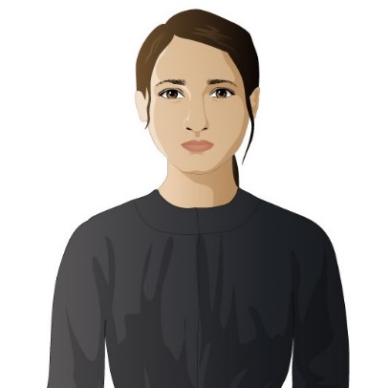
Lena Brodsky (fictional character)
Fourteen-year-old Lena was born in Minsk, Russia, where her family suffered from the anti-Jewish violence of the pogroms. Her older brother leaves for America and sends money back for another ticket. When Lena’s younger brother was unexpectedly drafted into the Czar’s army, Lena takes his place and travels on her own to meet her older brother in New York. She hopes to save enough money to pay for tickets for her parents to leave Russia as well. In New York, many different social, educational, and work opportunities and challenges await her.



Isaac Brodsky (fictional character)
Lena’s older brother, who came to the United States three years earlier and is now married and living on the Lower East Side. He sells household goods from a cart on Hester Street but dreams of becoming a successful businessman with his own store.

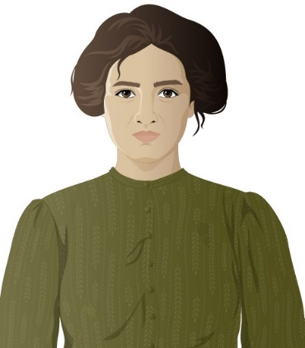

Sonya Brodsky (fictional character)
Isaac’s wife, who is also from Russia but met Isaac in New York. She manages the Brodsky household, caring for their baby, shopping, cleaning, and providing meals and laundry services for two boarders.

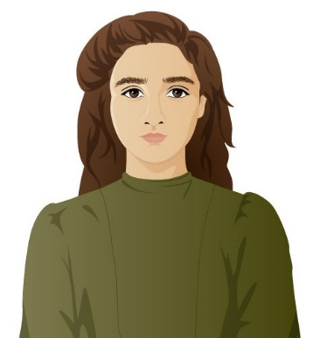
Rosa Leone (fictional character)
Lena’s friend, a fourteen-year old immigrant from Naples, Italy, who came to America with her family. Her family runs a small grocery store on the Lower East Side. She helps in the store and studies English at the Henry Street Settlement, all while being chaperoned by her brother. Her family plans to make money in America and then return to Italy, but Rosa is not sure that is she wants to do that. Eventually she gets a job at the Triangle Shirtwaist Company factory. Rosa and Lena meet at an English class at Henry Street.
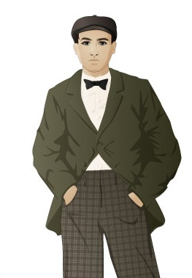

Zev (fictional character)
A young Russian immigrant trying to make his way in New York by helping Jewish gang members collect debts. He enjoys dancing to American popular music and hopes to take Lena to the dancehall.

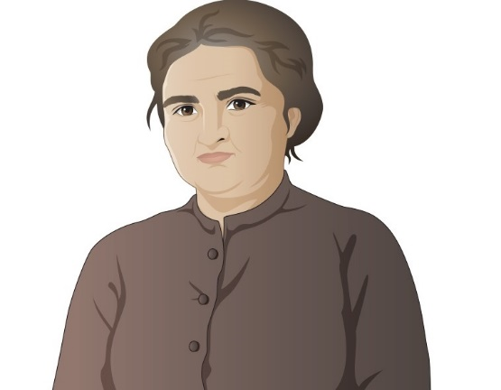

Mrs. Orloff (fictional character)
Lives in the same tenement as the Brodsky family and also came from Minsk. She pays close attention to the lives of all her neighbors and is a good source of neighborhood gossip.

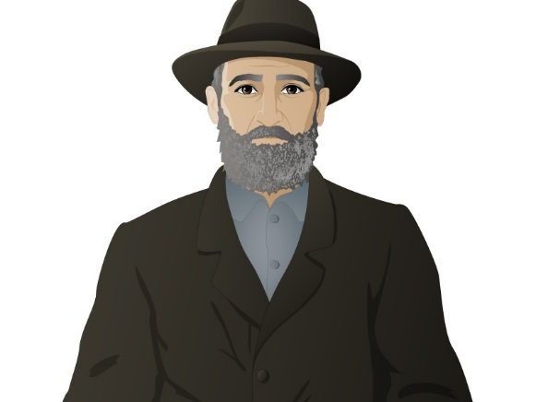
Mr. Bernstein (fictional character)
Arrived in New York at the same time as Lena, and they met at Ellis Island. He sells soda water at Hester Street Market and helps Lena when he can.

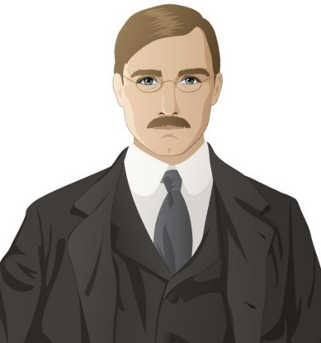

James Poole (fictional character)
A young reporter for one of New York City’s “muckracking” newspapers. He is college educated and a pro-union reformer.

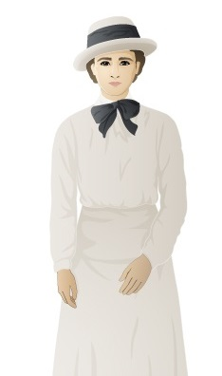

Abigail Walker (fictional character)
A young reformer and suffragist who chose to live and work with immigrants in the Lower East Side after completing college. She is an idealist who believes that Progressive women can improve life for immigrants by helping them to assimilate.

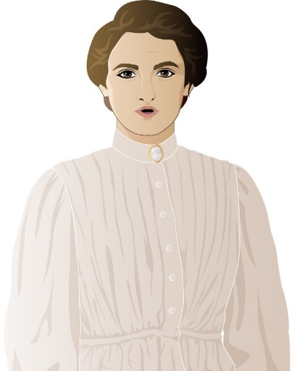
Miss Sherman (fictional character)
A former garment factory operator who has been promoted to forelady. She is strict and supports the factory owners in their efforts to keep young women workers focused on increasing their production.

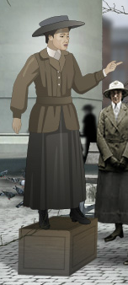

Clara Lemlich (historical figure c. 1886 – 1982)
A Ukrainian immigrant, Clara Lemlich came to the United States with her family in 1903 when she was seventeen years old. She worked in the garment industry and, appalled by the working conditions in garment factories, became involved with the International Ladies’ Garment Workers’ Union (ILGWU). On November 22, 1909, Lemlich spoke to a meeting of female garment workers and urged them to strike, setting off what became known as the Uprising of 20,000, the 1909 shirtwaist workers strike in New York. A committed socialist, Lemlich fought her entire career for workers’ rights.

Locations in MISSION 4: “City of Immigrants”

Ellis Island
Opened in 1892, Ellis Island (located in New York harbor) was the nation’s busiest immigration processing station in the early twentieth century. More than 12 million immigrants passed through its doors before it closed in 1954, most during the peak years of 1900-1914. Arriving immigrants were subjected to medical and legal inspections to determine if they could enter the country. On average, the inspection process took approximately 3-7 hours, and most immigrants were allowed to enter the United States. Some, however, were detained for days or weeks and could be sent back to their home countries.

Lower East Side
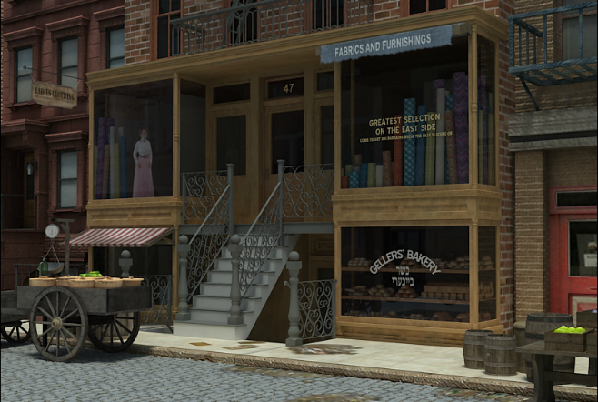
This New York City neighborhood, located in lower Manhattan, was for much of its history the first home in America for a variety of immigrant groups. In the mid-nineteenth century, it was known as Kleinedeutschland (“Little Germany”) because of the large numbers of German immigrants who lived there. By the late nineteenth and early twentieth centuries, Germans gave way to large numbers of immigrants from southern and eastern Europe (Italian, Russian, Hungarian, Slovakian, and Polish) who occupied its tenement apartments.

Tenement
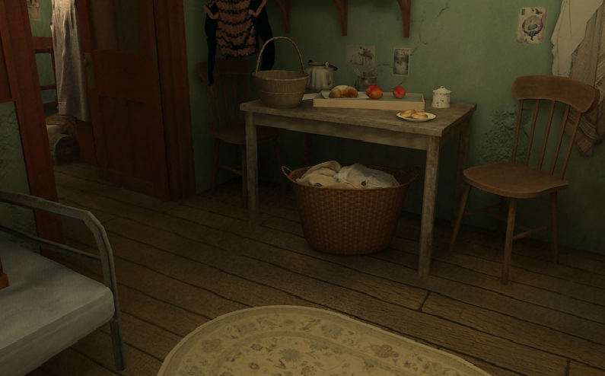
A tenement was a small apartment in a multi-unit apartment building, occupied by poor, often immigrant, families and their boarders. Tenements had few windows and little natural light, and they also lacked running water. Residents shared outhouses (known as privies) for toilets and drew their water from shared wells in the building’s rear yard. In an attempt to improve living conditions for tenement dwellers, New York state passed a series of laws (in 1867, 1879, and 1901) that required tenements to have more air and light, more space between buildings, and eventually running water, toilets, and a window in every room.
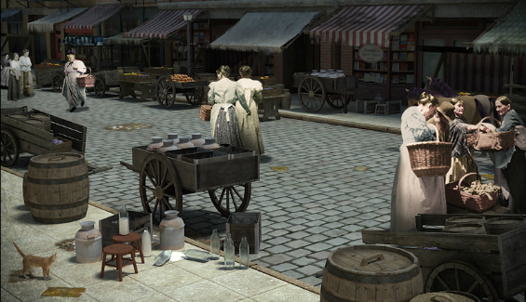
Hester Street
A main street in New York’s Lower East Side neighborhood, where pushcart vendors sold food, clothing, and household goods to the immigrant, largely Jewish, residents.

Sweatshop
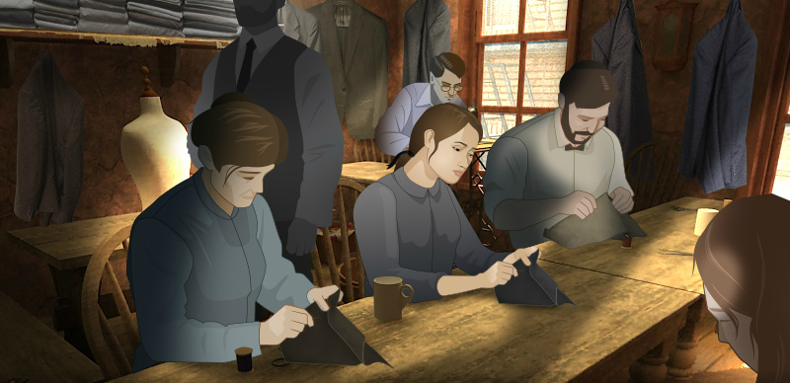
A sweatshop is a factory or home workshop in the garment industry where workers are paid low wages and work long hours. In New York City in the early twentieth century, most sweatshop workers were immigrant Jewish or Italian women. They were supervised by contractors of their own nationality, mostly men, who got materials on credit from manufacturers, bought sewing machines on installment plans, and rented lofts or tenement apartments for factories.

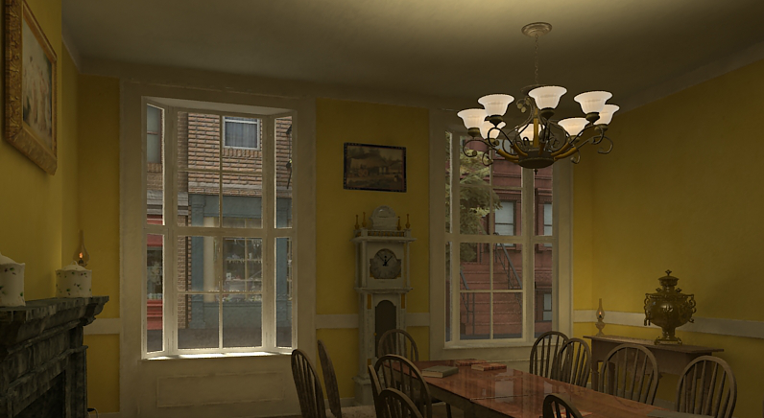
Henry Street Settlement
Founded in 1895 by Lillian Wald and Mary Brewster, Henry Street Settlement was established to provide nursing care at home for poor residents of the Lower East Side. The nurses and social workers of the settlement house movement were college-educated women who lived in the neighborhoods where they worked and sought to improve the lives of immigrants. In addition to nursing services, Henry Street Settlement expanded to provide classes for immigrants, a dance school, one of the nation’s first playgrounds, a kindergarten, literary societies, and a cooperative food store.

Places of Amusement
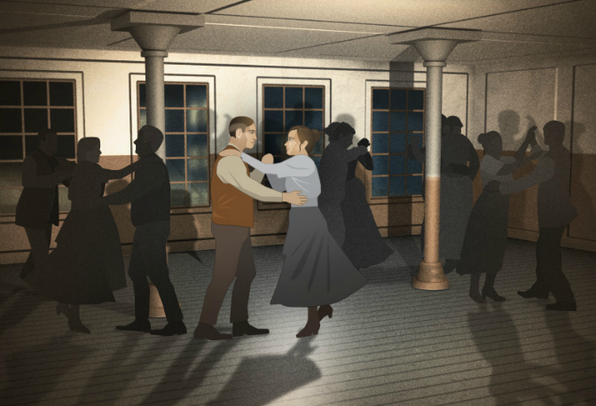
America’s turn-of-the-century cities were the birthplace of a new commercial culture, filled with new amusements. Nickelodeons (early movie theaters named for their five cent price of admission) and dance halls gave young people the chance to seek pleasure and independence away from their families. Amusement parks were also popular in the early 1900s, especially among the many young immigrant men and women who flocked to parks and beaches on their days off. New York's Coney Island was the most famous of the new resorts, attracting more than 20 million visitors a year.

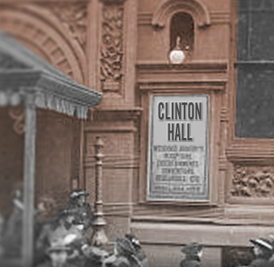

Clinton Hall
Located at 96 Clinton Street on the Lower East Side, Clinton Hall was the headquarters of the International Ladies’ Garment Workers’ Union Local 25, which organized the 1909 shirtwaist makers’ strike.

Jefferson Market Courthouse and Jail
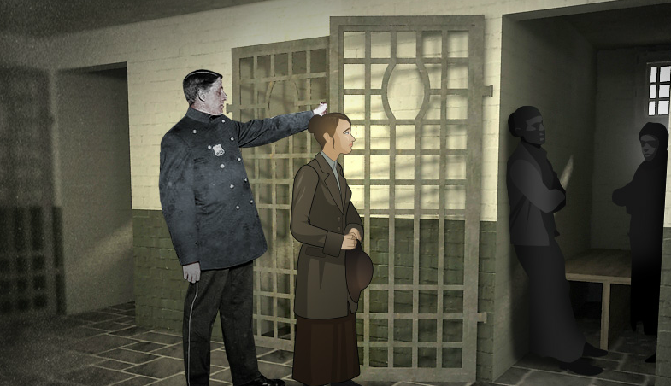
The Jefferson Market Courthouse was built in 1873 on the southwest corner of 10th Street and Sixth Avenue in the Greenwich Village neighborhood, on the site of a former public market. The building included the courthouse, a fire station, a new market, and a small jail. During the 1909 garment workers’ strike, strikers and their supporters picketing the garment factories were regularly arrested and brought to Jefferson Market Courthouse to be charged and fined, and sometimes held in the jail.
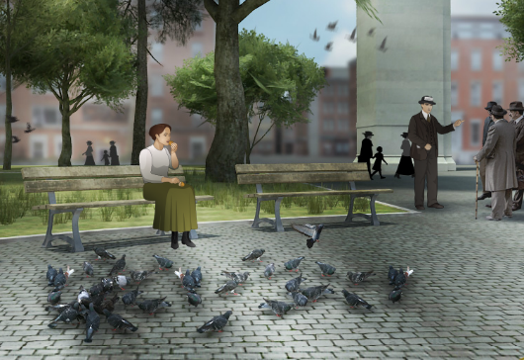
Washington Square
Located in Greenwich Village, Washington Square was a small park and gathering place. Several garment factories, including the Triangle Shirtwaist Company, were located nearby, and the factory girls ate lunch and heard soapbox speakers here.

Triangle factory
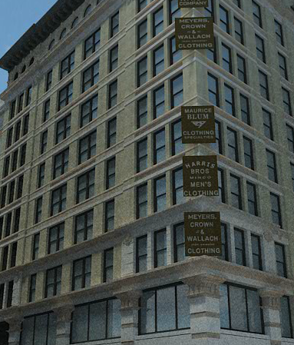
The Triangle Shirtwaist Company factory occupied the top three floors of a ten-story building at the corner of Washington and Greene streets in downtown Manhattan. Five hundred workers, mostly women, labored at Triangle to cut, baste, sew, and finish shirtwaists (women’s blouses). On March 25, 1911, a fire broke out shortly after 4:30 pm on the eighth floor and rapidly spread. Locked exit doors, a fire escape collapse, and fire ladders that reached only as high as the sixth floor left many workers unable to escape the blaze. In all, 146 workers died, most of them young Italian and Jewish women.

- Immigrants all came to the United States for the same reason: financial gain and prosperity.
It is widely believed that people immigrated to the United States primarily in order to improve their economic situation, fueled by the vision that American “streets were paved with gold.” However, financial gain was not the predominant motive for all immigrants. At the turn of the twentieth century in Eastern Europe, Jewish residents were being persecuted, ranging from restrictions on where they could live, work and go to school to harassment and increasing violence. From 1881 to 1884 and again from 1903 to 1906, Russian mobs and soldiers attacked Jewish communities, destroyed homes, and massacred hundreds of Jews. Over 2 million Russian Jews fled for the United States joined by many more from other countries in Eastern Europe facing similar discrimination.

- All immigrants wanted to permanently stay in the United States.
While data on the total number of immigrants are relatively easy to find, the number of immigrants who returned to Europe is less definitive and varies according to nationality. For example, some Italians immigrated with the goal of earning enough money to secure land ownership back in Italy. In some years, repatriation rates – or the act of returning back to one’s country of origin - were as high as 73 percent. In many cases, male immigrants traveled back and forth on a regular basis, working for a year or two at a stretch in order to return back to their families and home countries with their wages. While more Jewish immigrants came as families without plans to return to their homelands, historians now estimate at least 15 percent did return, especially in the years prior to 1900.
- Immigrants had to comply with many regulations to be admitted to the United States.
In comparison with present day restrictions on immigration, arrivals prior to 1924 faced few obstacles to entering the United States - with the major exception of the legal exclusion of Chinese immigrants in 1882. The vast majority of Eastern and Southern European immigrants from 1880 to 1924 were admitted with only the basic and minimal information they provided to the steamship companies upon departure. Once in the United States, new immigrants were screened for disease, disabilities, and, after 1901, for anarchism or political extremism—they could be denied entry for any of these reasons. Even with these barriers, very few immigrants were turned away. At Ellis Island, only two percent were excluded prior to World War I. More federal regulations were introduced starting in 1917 to limit immigration by adding more barriers to entry, starting with a literacy requirement and later through quota systems. These quota systems limited the number of immigrants from each country allowed entry into the United States. The quotas remained in place until 1965.

- Ethnic names were often changed at Ellis Island.
Family lore often claims that immigrant names were “Americanized” as ancestors entered through Ellis Island, but there is no evidence to support these claims and significant evidence to refute it. Immigration officers at Ellis Island did not record the names of new arrivals; they simply checked the names of immigrants against the ship’s manifest list. Immigrants provided their names to the steamship companies upon departure, usually with no form of identification required. Ticket agents in the immigrant’s country of origin may have misspelt names, especially as names were translated from one language or alphabet to another. Once in the United States, Ellis Island immigration inspectors would only correct those misspellings if requested by the immigrant.
- Immigrants at the turn-of-century all wanted to Americanize.
Present day opponents of immigration often claim that current immigrants want to retain their language and customs to resist Americanizing, while citing earlier immigrant groups as wanting to “Americanize.” This comparison, however, does not show the whole picture. At the turn of the twentieth century, immigrants from southern and eastern Europe often lived in ethnic enclaves allowing them to retain their native languages and customs for decades. Ethnic newspapers, radio stations, theatres and other cultural venues thrived well into the 1920s and 1930s. “Americanization” came largely with the children of immigrants or with immigrants who arrived as children.
- All ethnic neighborhoods (or ghettos) were bad for immigrants.
The Lower East Side, New York’s main immigrant neighborhood, became known for its extreme overcrowding and poverty. Middle-class reformers at the turn of the century viewed the neighborhood as a negative influence on the residents and a problem that needed to be solved by encouraging immigrants to settle elsewhere. However, there were also some benefits to the ethnic neighborhoods. The density of these ethnic enclaves benefitted immigrants through formal and informal networks of support that could assist newcomers in finding an apartment and a job, help locate relatives or friends, and establish cultural, social, and religious institutions that could serve the needs of recent immigrants.

Before you begin playing MISSION US: “City of Immigrants,” here are five important pieces of information to consider. This information may or may not help you as Lena makes her way through life in New York City in the 1900s.

1. Between 1880 and 1924, more than 25 million immigrants entered the United States. Most came through Ellis Island in New York harbor, the nation’s major entry point for European immigration. Many came from Eastern Europe and Italy, driven by persecution or economic hardship and drawn by the opportunities offered by America’s expanding economy. By 1910,
41 percent of New York City’s almost five million residents were foreign born.
2. By 1920, immigration and industrialization had transformed the nation from a largely rural population to a majority urban population. America’s industrial growth attracted large numbers of immigrants who provided labor for the new factories. The emergence of skyscrapers, streetcars, electric lights, telephones, amusement parks, and motion pictures theaters transformed cities. The bustle and wonders of its cities symbolized America’s growth and economic power, but cities also contained great inequality and disparities of wealth and poverty.

3. The years between 1890 and 1920 are known as the Progressive Era, a period when reformers strove to improve the living and working conditions of the poor. Progressivism sought to reduce corruption and increase the efficiency of government and to enact laws that regulated big businesses. Some reformers focused on directly assisting workers and the poor. One progressive institution founded by middle-class women, the settlement house, sought to teach immigrants skills along with American social and cultural customs.

4. The garment, or clothing, industry dominated New York’s economy. The garment trade was characterized by a few large firms and hundreds of small shops, with each workplace setting its own work rules and pay rates. Most garment workers were young immigrant women, with about half of workers under the age of twenty. By 1910 more than 56 percent of the workers were Jewish and 34 percent were Italian.

5. With the rise of factories in the early nineteenth century, working men and women organized labor unions to demand better conditions and pay. Union members went on strike—withheld their labor—to force employers to meet their demands. Strikes were often unsuccessful because of violent resistance, repeated economic depressions, and divisions among workers in skill level as well as ethnicity, race, and gender. By the late nineteenth century, national unions and groups of local unions united more workers and fought for the eight-hour working day. The vast influx of a new immigrant workforce during the early twentieth century enabled the union movement to continue to expand, even though many goals such as the eight-hour working day were not obtained.

A NOTE TO THE EDUCATOR:

You will need to decide how best to share these writing prompts with your students. You might share them all, and ask students to choose one to respond to. You may assign one or more to the entire group. You might make one or more of the topics the basis for in-class discussions. Where there are multiple questions in a single prompt, choose the question or questions that best suit your students. Make your decisions according to the needs of your group.

You may notice that many of the topics contain some version of the phrase, “Write about a time in your life…” The intention of these prompts is twofold: first, since students remember the content of their own lives, they can more easily respond to the questions, and are more likely to want to express themselves if they feel competent to do so; second, these questions can form a meaningful bridge between what happens in the lives of ordinary people today and the lives of people in history or in historical events. For these reasons, you might decide to use some of the prompts before students encounter the history, because thinking about them sets the students up to understand and relate to the material better.

Since students vary in their degree of comfort and writing skill, you should decide when and how much students should write. We suggest that since students need to share their writing with each other to make personal and historical connections, you should encourage them to focus on content rather than mechanical skills. Pieces can be revised and edited later if you decide they should be shared formally, such as on a bulletin board or in a newsletter.

Read through all the topics first, and then choose one of them to write about. Write the title of the piece at the top of your page. Write in complete sentences. After you are finished, proofread your work for correctness.

IMMIGRATION STORY. Nearly every American family has an immigration story. What is Lena’s family’s story? What caused her brother and her to immigrate to America? Does your family have an immigration story? Talk to your family and find out how they came to live in America. Write your family’s story describing where they came from and what events caused them to embark on their immigrant journey.

JOURNEYS. The prologue provides the background to Lena’s journey from Minsk to New York City. Have you ever made a journey on your own? Even if you haven’t traveled halfway around the world like Lena, you have probably journeyed somewhere. Write about a time when you had to make a journey. Describe how you felt, your destination, and what you learned along the way.

EXAM PRESSURE. When the prologue begins, we meet Lena as she nervously studies and prepares for the questions she will be asked at immigration processing. What strategies does Lena use to prepare for her immigration test? Have you ever felt pressure when studying for an exam? Describe the strategies you use to prepare for a stressful test. What were the consequences of failure?

FAMILY DYNAMICS. Every member of a family plays an important role. Who are the members of Lena’s family? Consider your own family and how each member contributes to your family’s survival. Describe the different roles each person plays. Do you feel responsibility towards your family? What are you willing to do to help? What wouldn’t you be willing to take on?

The Immigrant Journey
A NOTE TO THE EDUCATOR
What was the process of emigrating from Eastern Europe to the United States at the turn of the twentieth century? While Lena’s journey to America is fictional, her experience is based on the actual process millions of immigrants went through at the beginning of the twentieth century. In this activity, students examine primary source documents exploring the different phases of the immigrant journey. A Yiddish advertisement for a ticket examines the ticket purchasing process. The experience of steerage is depicted in an account of a traveler in 1905. A ship manifest reveals the confusion and uncertainty related to the processing of immigrants at Ellis Island. Together, these three sources complement Lena’s story and provide a historical framework for understanding the phases of the journey immigrants embarked upon prior to creating a new life in America. Background information and guiding questions are provided for each document.

Activity Components
- Three Primary Sources
  - Document 1: Ticket Advertisement
If he were a historical figure, Lena’s brother Isaac might have purchased her ticket to New York from Sender Jarmulowsky’s bank on the Lower East Side, which was near his tenement apartment on Orchard Street. In addition to New York City, S. Jarmulowsky and Co. also had offices in the German cities of Hamburg and Bremen. This newspaper advertisement encourages Jewish immigrants to buy steerage tickets at the cheapest prices, and includes text in both English and Yiddish. The Yiddish language, which is written in the Hebrew alphabet, was brought to America by Jewish immigrants.
  - Document 2: Selections from a 1905 Account of Steerage
Steerage refers to the lowest decks of a ship and was the cheapest ticket option available. Unlike first class passengers who enjoyed fresh air, plentiful food, and private cabins on the upper decks, travel in steerage class was typified by crowded conditions, poor food, inadequate ventilation, and limited toilet use. This account from a traveler in 1905 describes steerage, and highlights the discrepancy between the journey of a first class passenger and one in steerage.
  - Document 3: Ship Manifest
A ship's manifest is a document listing the passengers of a ship for use by officials. Manifests were used by legal inspectors at Ellis Island to cross-examine each immigrant during a legal inspection prior to the person being permitted to enter the United States. This manifest records members of the Confino family who sailed to New York on the SS Argentina from Patras, Greece and were processed at Ellis Island in 1911.The family’s journey began in Kastoria, which was part of the Ottoman Empire until it became part of Greece in 1913, and ended with their move to 97 Orchard Street in New York City’s Lower East Side. The ship manifest records the travels of Rachel, Victoria, David, Saul, and Isaac Confino, and affirms that the family did not all travel together as a unit. As was common with many Jewish immigrants, Abraham Confino, the patriarch of the family, arrived in New York earlier to prepare for the rest of the family. The nationality of the Confino family members is listed on the manifest as Turkish, Greek, and Castorian, while their race is listed as Hebrew.

Steps to Complete:
The following procedure is recommended for this activity and can be adapted based on your curricular goals and timing constraints.

- Distribute primary source document(s) to students. You may choose to share as many or as few of the documents as you wish.

- Have students work independently or in small groups to investigate the document(s) with the goal of learning as much as they can about the stage of the immigrant journey it represents.

- Select the corresponding guiding questions to help your students investigate each primary source. You can give your students all of the guiding questions for each document, or choose a few for them to respond to.

- Have students present their findings to the class or a fellow student and share what was learned about the stage of the immigrant journey they explored.

Ask students to use the information they uncovered from the primary source document(s) and their playing of Part 1 to write a postcard from Lena to a friend in Russia who is about to embark on the immigrant journey. The letter should include information and advice regarding all the stages of the journey, from purchasing a ticket, to travelling in steerage and being processed at Ellis Island. The Postcard Template can be used for this portion of the activity, or students can write/type the letter.

The Immigrant Journey
Guiding Questions
The Prologue and Part 1 of “The City of Immigrants” provide an introduction to the immigrant experience at the turn of the twentieth century, and introduce the main character of the game, Lena Brodsky, who is journeying to New York City from Minsk, Russia. Part 1 and the primary sources in this activity illustrate the different phases of the immigrant journey. You will be assigned one or several of these sources to review. As you review each source, use these questions to analyze it. Remember to look closely at the source and think deeply about what it tells you about immigrant life.

Document 1: Ticket Advertisement
- Look carefully at the advertisement. Notice the images, text, and languages used. What can you infer about what is advertised? Who do you think the advertisement is intended for? Why?
- The advertisement emphasizes the business qualities of “solid, secure, and honest.” Why do you think these words were included? What words would help you to make a decision about where to buy a ticket for a long journey?
- Why might tickets from Europe to America be advertised in New York City? What does this tell us about who was purchasing the tickets?
- What questions does this document raise for you?
- In what ways can this document inform our understanding of Lena’s journey to America?

Document 2: Selections from 1905 Account of Steerage
- Read the account. Whose perspective is presented and what experience is described?
- What are the pros and cons of traveling in steerage?
- Compare and contrast the experience of cabin passenger and a steerage passenger.
- What factors might motivate an immigrant to travel in steerage despite its terrible reputation?
- What questions does this document raise for you?
- In what ways can this document inform our understanding of Lena’s journey to America?

Document 3: Ship Manifest
- Analyze the document. What type of information about immigrant passengers does it provide?
- How might the experience of traveling alone versus traveling with part of a family have impacted the experience of steerage?
- Consider how labels provide historians information about persons, but also present challenges. What labels would apply to your family if your travels were documented in a manifest? To what extent do geography and culture, two of the things noted on the manifest, define the family?
- What questions does this document raise for you?
- In what ways can this document inform our understanding of Lena’s journey to America?

The Immigrant Journey
Phases of the Journey: Ticket Purchase

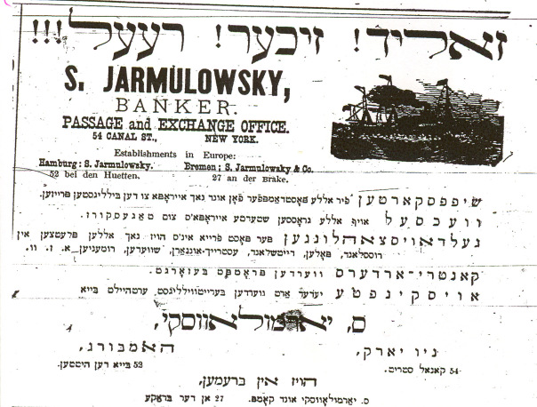

The translation of the Yiddish text included in this advertisement reads:

Solid! Secure! Honest!
Boarding Passes for all crossings to and from Europe at the lowest prices.
Schedules are available to localities in Russia, Poland, Germany, Austria Sweden, Romania, etc. in our office. Country orders are promptly taken care of.
Find out about all locations by visiting out offices:
S. Jarmulowsky
New York, Hamburg,
54 Canal Street 52 Bei den Huetten
Bremen
S, Jarmulowsky and Co., 27 an der Brake

The Immigrant Journey
Phases of the Journey: Steerage
Source: Steiner, Edward A. On the Trail of the Immigrant, Fleming H. Revell Company, New York, 1906. Excerpt from Chapter III, “The Fellowship of the Steerage.”
Selections from a 1905 Account of Steerage | Glossary Terms
The day of embarkation finds an excited crowd with heavy packs and heavier hearts, climbing the gangplank. An uncivil crew directs the bewildered travelers to their quarters, which in the older ships are far too inadequate, and in the newer ships are, if anything, worse. | embarkation: to go on board a ship  gangplank: the wooden plank that makes a bridge from land to the ship  uncivil: having bad manners  bewildered: confused  quarters: rooms on the ship  inadequate: not good enough
Clean they are; but there is neither breathing space below nor deck room above, and the 900 passengers crowded into the hold of so elegant and roomy a steamer as the Kaiser Wilhelm II, of the North German Lloyd line, are positively packed like cattle, making a walk on deck when the weather is good, absolutely impossible, while to breathe clean air below in rough weather, when the hatches are down is an equal impossibility. The stenches become unbearable, and many of the emigrants have to be driven down; for they prefer the bitterness and danger of the storm to the pestilential air below. The division between the sexes is not carefully looked after, and the young women who are quartered among the married passengers have neither the privacy to which they are entitled nor are they much more protected than if they were living promiscuously. | steamer: large ship powered by steam engines  cattle: farm animals like cows and bulls  hatches: covering of an opening, like a curtain  stenches: bad smells  unbearable: too bad to live with  emigrants: people who leave their country to move to another country  bitterness: extreme cold  pestilential: unhealthy, causing disease  sexes: men and women  entitled: to have a right to something  promiscuously: not being very careful
The food, which is miserable, is dealt out of huge kettles into the dinner pails provided by the steamship company. When it is distributed, the stronger push and crowd, so that meals are anything but orderly procedures. On the whole, the steerage of the modern ship ought to be condemned as unfit for the transportation of human beings; and I do not hesitate to say that the German companies, and they provide best for their cabin passengers, are unjust if not dishonest. | miserable: really bad  kettles: pots for boiling water and soup  dinner pails: dinner bowls  distributed: handed out  crowd: push into a small space  orderly: well-behaved  ought: should  condemned: to declare something too bad to be used  cabin: rooms on a ship for passengers that have first and second class tickets
Two to four sleep in one cabin, which is well and comfortably furnished; while in the [steerage] from 200 to 400 sleep in one compartment on bunks, one above the other, with little light and no comforts. In the second cabin the food is excellent, is partaken of in a luxuriantly appointed dining-room, is well cooked and well served; while in the steerage the unsavory rations are not served, but doled out, with less courtesy than one would find in a charity soup kitchen. | compartment: small division  bunks: beds on a ship  comforts: comfortable things, comforter  partaken of: eaten, consumed  second cabin: section of the ship used by passengers with second class tickets  luxuriantly: very luxurious, fancy  appointed: chosen  unsavory: not tasty  rations: the amount of food every person is allowed to have every day  doled out: given in small amounts
The steerage ought to be and could be abolished by law. It is true that the Italian and Polish peasant may not be accustomed to better things at home and might not be happier in better surroundings nor know how to use them; but it is a bad introduction to our life to treat him like an animal when he is coming to us. He ought to be made to feel immediately, that the standard of living in America is higher than it is abroad, and that life on the higher plane begins on board of ship. Every cabin passenger who has seen and smelled the steerage from afar, knows that it is often indecent and inhuman; and I, who have lived in it, know that it is both of these and cruel besides. | courtesy: good manners  abolished by law: made illegal  peasant: worker with little education or money  accustomed to: used to  surroundings: environment  abroad: countries outside the US  life on the higher plane: a better life  afar: far away  indecent: not decent, not proper  inhuman: not good enough for human beings  cruel: very mean
On the steamer Noordam, sailing from Rotterdam three years ago, a Russian boy in the last stages of consumption was brought upon the sunny deck out of the pestilential air of the steerage. I admit that to the first cabin passengers it must have been a repulsive sight -- this emaciated, dirty, dying child; but to order a sailor to drive him down-stairs, was a cruel act, which I resented. Not until after repeated complaints was the child taken to the hospital and properly nursed. On many ships, even drinking water is grudgingly given, and on the steamer Staatendam, four years ago, we had literally to steal water for the steerage from the second cabin, and that of course at night. On many journeys, particularly on the Fürst Bismark, of the Hamburg American line, five years ago, the bread was absolutely uneatable, and was thrown into the water by the irate emigrants. | consumption: tuberculosis, a dangerous lung disease  first cabin: or first class, the nicest section of the ship, used by passengers with first class tickets  repulsive: disgusting  emaciated: extremely skinny, usually from starvation  resented: was angry or upset about  nursed: taken care of if sick, like a nurse  grudgingly: doing or giving something when you don't want to  irate: very angry
At last the passengers are stowed away, and into the excitement of the hour of departure there comes a silent heaviness, as if the surgeon's knife were about to cut the arteries of some vital organ. Homesickness, a disease scarcely known among the mobile Anglo-Saxons, is a real presence in the steerage; for there are the men and women who have been torn from the soil in which through many generations their lives were rooted. | stowed away: stored, put away  arteries: blood vessels from the heart  vital organ: organs you need to survive, like your heart and lungs  mobile: moves a lot  Anglo-Saxons: people from England  torn from the soil: removed from the land  generations: average length of time between birth of parents and children  rooted: has strong roots, have been for a long time
The Immigrant Journey
Phases of the Journey: Processing of Ship Manifest at Ellis Island

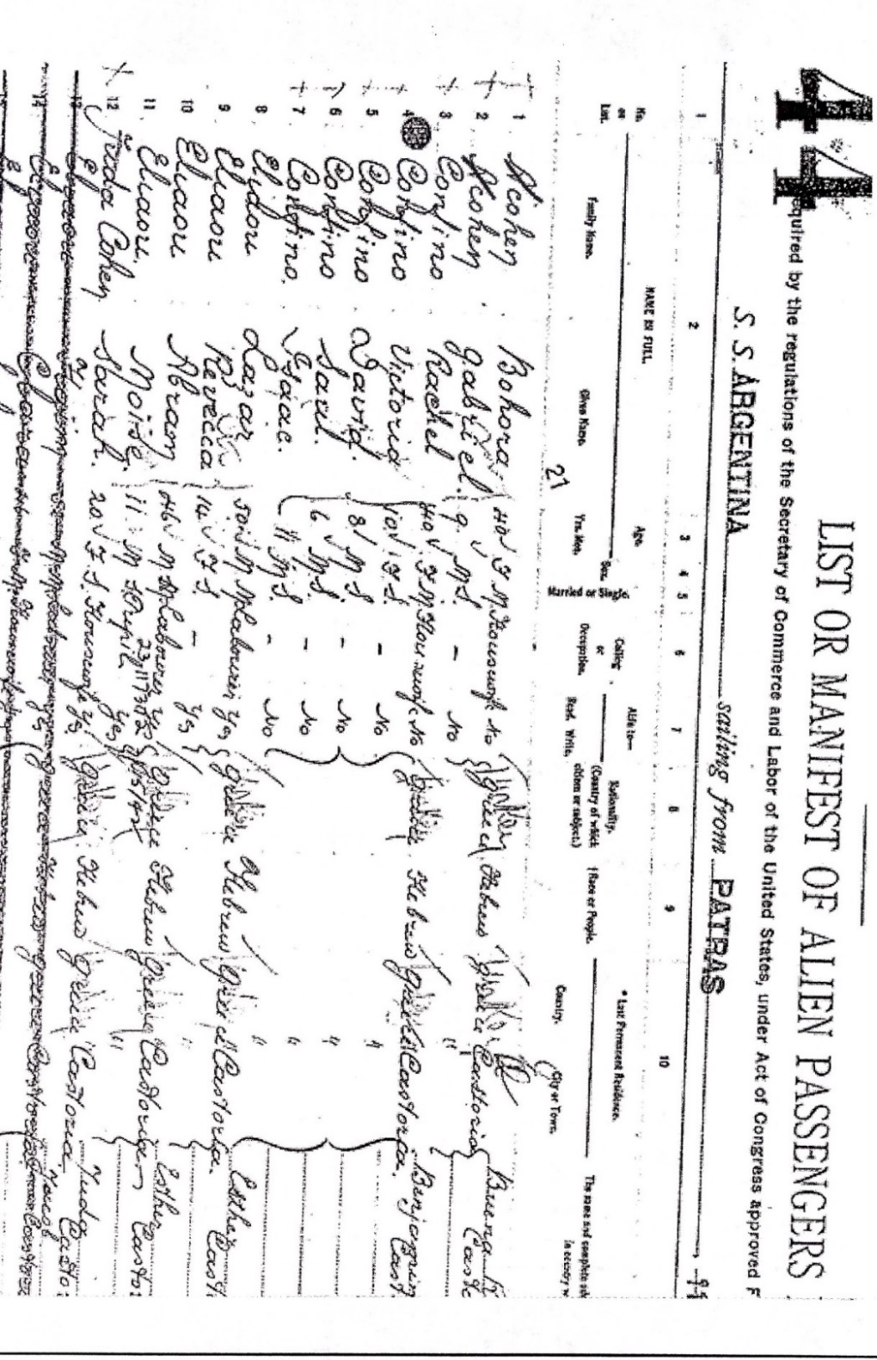


Write a postcard from Lena to a friend who is about to embark on their immigrant journey. Include information and advice in your letter regarding all the stages of the immigrant journey, from purchasing a ticket, to traveling in steerage, to being processed at Ellis Island. Use information from the primary source documents and playing Part 1 of the game to complete your postcard.

A NOTE TO THE EDUCATOR:

On the following pages, you will find “flashcards” with terms and definitions (both combined and separate) that your students may encounter while playing Part 1 of “City of Immigrants.” These terms and definitions can be introduced and practiced before or during the time students see or hear them in the context of MISSION US or in their American history study. The discussion questions and writing prompts will provide further opportunities for students to have more practice with the words and terms.

Divide your students into small groups of four or five, and ask each group to review the terms and definitions.

After your students have had a chance to review and discuss the terms and definitions, distribute the excerpt from Lena’s speech. Review the directions with your students and ask them to complete the text using the terms they studied.

Here are the terms which should be inserted into each paragraph of Lena’s life story:
Paragraph 1- Yiddish

Paragraph 2- almshouse, anarchist, Tsar

Paragraph 3- peddler

Paragraph 4- Sabbath, greenhorn, socialism, capitalists

Paragraph 5- ghetto, synagogue, rabbi

Photography Credits
Almshouse: Vicky Male
Rabbi: KerenKehila
almshouse  A place for poor or sick people to stay, funded by private charity.  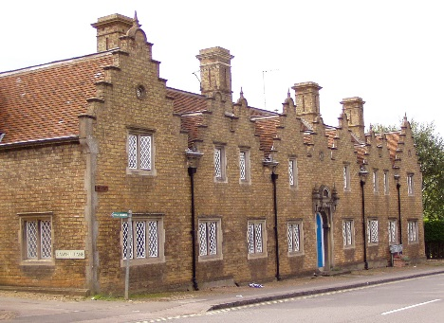 | anarchist  A person who thinks all forms of government are oppressive and supports the idea of voluntary cooperation.    No Government
capitalists  Wealthy persons who use money to invest in trade and industry for profit.   | ghetto  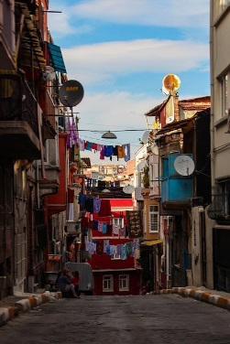  A part of a city in which members of a minority group are forced to live; it originally described an area where Jews were required to live in Venice (Italy) in the 1500s.
greenhorn    A newly arrived immigrant who is still unfamiliar with city life and American ways. | peddler  A person who sells food or items, either door to door or by using a pushcart.  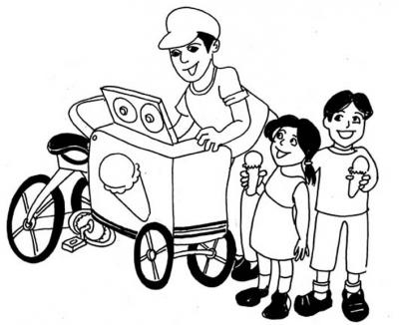
rabbi  Jewish religious leader or teacher.  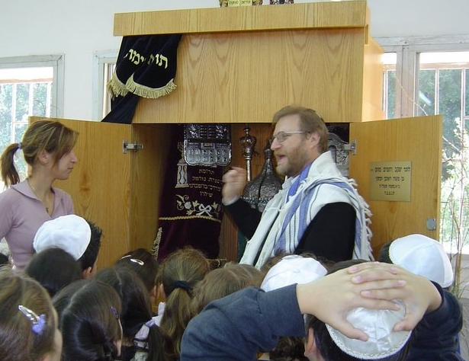 | Sabbath  A day of rest and religious observance; called “shabbos” in Yiddish. For Jews, the day starts at sundown on Friday evening and continues until sundown on Saturday.  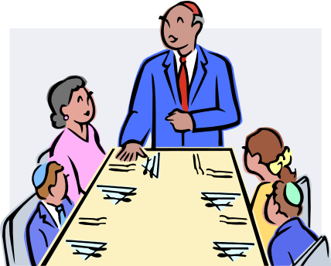
socialism  A political or economic theory that promotes a more equal society and the elimination of extreme wealth or poverty through collective ownership of industries or distribution of goods.   | synagogue  A Jewish house of worship and place for religious instruction.  
Tsar  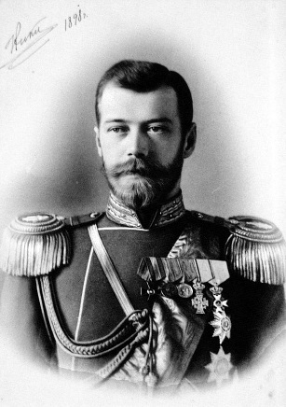  The emperor of Russia prior to the 1917 revolution. | Yiddish  A language, based on German, which is written with Hebrew characters and was originally used by Jews in central and eastern Europe.  
almshouse | anarchist  No Government
capitalists | ghetto
greenhorn | peddler
rabbi | Sabbath
socialism   | synagogue
Tsar | Yiddish

A place for poor or sick people to stay, funded by private charity. | A person who thinks all forms of government are oppressive and supports the idea of voluntary cooperation.
Wealthy persons who use money to invest in trade and industry for profit. | A part of a city in which members of a minority group are forced to live; it originally described an area where Jews were required to live in Venice (Italy) in the 1500s.
A newly arrived immigrant who is still unfamiliar with city life and American ways. | A person who sells food or items, either door to door or by using a pushcart.
Jewish religious leader or teacher. | A day of rest and religious observance; called “shabbos” in Yiddish. For Jews, the day starts at sundown on Friday evening and continues until sundown on Saturday.
A political or economic theory that promotes a more equal society and the elimination of extreme wealth or poverty through collective ownership of industries or distribution of goods. | A Jewish house of worship and place for religious instruction.
The emperor of Russia prior to the 1917 revolution. | A language, based on German, which is written with Hebrew characters and was originally used by Jews in central and eastern Europe.

Name: Date:

This activity imagines that Lena is making a speech to New York City students and community residents in 1982, seventy years after the events in “City of Immigrants.” Lena is discussing what life was like on the Lower East Side in the early twentieth century.

Instructions: After reading and talking about the words and terms on the flash cards, read this excerpt from Lena’s speech. Use the cards and your memory to help fill in the missing words and terms. Some words may be used more than once.

almshouse  anarchist  capitalists | ghetto  greenhorn  peddler | rabbi  Sabbath  socialism | synagogue  Tsar  Yiddish

“After seven days on the ship, I was ready to walk on land again. I was so excited when we came into New York harbor and I saw the Statue of Liberty! We got off the boat in Manhattan, and then got on a ferry that took us to Ellis Island. Ellis Island was very crowded. Inspectors looked us over to make sure we were healthy. I only spoke __________________ at that time, but so had Isaac, and he had made it through.

The customs inspector finally called my name. He asked me some of the questions I had been practicing, like what my name was and where I was from. He also wanted to know if I had ever been in an __________________, because he wanted to make sure I would have enough money to support myself. He also wanted to know if I was an __________________. I didn’t think that the Jews were treated well under the __________________ in Russia, but I didn’t know anyone wanted to get rid of all governments.

It had been such a long day, and I was so hungry, I actually fainted waiting for my brother Isaac to come and get me. I learned that Isaac was working as a __________________.

We took another ferry back to Manhattan. Isaac was rushing home because he didn’t want to be late for __________________ dinner. I got lost in the crowd. I felt like such a __________________; I didn’t know where to go. There were so many strange sights, such as taller buildings. I hear a man talking about politics. He was in favor of __________________. He thought things would be better if __________________ didn’t have so much money.

At first, I was very worried, but eventually I was able to find my way to Isaac’s apartment on Orchard Street. Some people called it a __________________ since so many Jews lived there. I passed a large __________________ where Jews from Minsk worshiped. I wondered if the __________________ would be as kind as the one from home.”

A NOTE TO THE EDUCATOR:

You will need to decide how best to share these writing prompts with your students. You might share them all, and ask students to choose one to respond to. You may assign one or more to the entire group. You might make one or more of the topics the basis for in-class discussions. Where there are multiple questions in a single prompt, choose the question or questions that best suit your students. Make your decisions according to the needs of your group.

You may notice that many of the topics contain some version of the phrase, “Write about a time in your life…” The intention of these prompts is twofold: first, since students remember the content of their own lives, they can more easily respond to the questions, and are more likely to want to express themselves if they feel competent to do so; second, these questions can form a meaningful bridge between what happens in the lives of ordinary people today and the lives of people in history or in historical events. For these reasons, you might decide to use some of the prompts before students encounter the history, because thinking about them sets the students up to understand and relate to the material better.

Since students vary in their degree of comfort and writing skill, you should decide when and how much students should write. We suggest that since students need to share their writing with each other to make personal and historical connections, you should encourage them to focus on content rather than mechanical skills. Pieces can be revised and edited later if you decide they should be shared formally, such as on a bulletin board or in a newsletter.

Read through all the topics first, and then choose one of them to write about. Write the title of the piece at the top of your page. Write in complete sentences. After you are finished, proofread your work for correctness.

NEW EXPERIENCES. When Lena’s family makes the choice to send her to New York City in place of her brother, her life drastically changes. Do you think Lena wanted to leave her friends and family in Minsk? How do you think she felt about traveling alone to a foreign country? Describe a time that you had a new experience; for example, moving to a new school or traveling to a new place. How did you prepare yourself for the new experience?

PACKING DILEMMAS. If you were going to travel around the world, what would you want to take with you? Consider Lena’s packing choices and how they would compare to your own. Select five items that you would pack in your suitcase. For each item, describe how you selected it and what makes it important enough to pack.

STRANGER DANGER. Throughout Part 1, Lena encounters a variety of strangers. Consider all the people she met in Ellis Island and in the Lower East Side. How does she decide who to talk to and who to trust? How would you describe the different encounters? Have you ever been in a situation in which you needed to decide whether or not you could trust a stranger? How did you determine who was trustworthy?

HOME SWEET HOME. Isaac and Sonya live in a tenement apartment located at 47 Orchard Street on the Lower East Side. Describe their neighborhood and compare and contrast its appearance to your own. Consider the buildings, transportation, and people within your answer. What is the same? What is different?

LENA’S DIARY. Through Lena’s eyes, think about your circumstances from the beginning to the end of this part of “City of Immigrants.” Share your emotions and feelings about each step of the journey. Think about the people with whom you interacted, and what you learned from them. Think about the choices you made and the consequences of those choices. Now write a diary entry from Lena’s point-of-view summarizing what happened to you in Part 1. You may choose to illustrate one aspect of your entry.

A NOTE TO THE EDUCATOR:

The purpose of these questions is to check the students’ understanding of the action of the game and the history embedded in that action. Since the outcome of gameplay can vary depending on the choices the student makes, the answers to the questions might also vary.

Some students might learn information later than others, or not at all. If you choose to discuss students’ responses as a whole group, information can be shared among all your “Lenas.”

There may be more questions here than you want your students to answer in one sitting or in one evening. In that case, choose the questions you feel are most essential for their understanding of Part 1.

Feel free to copy the following pages of this activity for your students.

If you are not planning to have your students write the answers to the questions, you’ll need to modify the directions.

Name: ___________________________ Date:_____________________

Directions: After you play Part 1, read and answer these questions from the point of view of your character, Lena. You may not know all the answers, so do the best you can. Write in complete sentences and proofread your work.

1) What was the trip to America like? How did Lena feel after being on the ship for seven days?

2) How did the passengers know that they were close to land? What were the first things that they saw?

3) Officers were checking the people as they arrived at Ellis Island. What were they looking for?

4) What questions did the customs inspector ask Lena?

5) What happens to Lena as she is going to the waiting room? Why?

6) What is Isaac’s job?

7) Why is Isaac in a hurry to get home?

8) What happened to Lena after she left Ellis Island?

9) What does Lena see on her way to find Isaac’s house?

10) On this day, you may have met the following people. Make a note or two about them next to each name. For this question, your notes don’t have to be in complete sentences.
a. The customs inspector -
b. Isaac –
c. Mr. Bernstein –
d. Zev –

A NOTE TO THE EDUCATOR:

The purpose of these questions is to check the students’ understanding of the action of the game and the history embedded in that action. Since the outcome of gameplay can vary depending on the choices the student makes, the answers to the questions might also vary.

Some students might learn information later than others, or not at all. If you choose to discuss students’ responses as a whole group, information can be shared among all your “Lenas.”

There may be more questions here than you want your students to answer in one sitting or in one evening. In that case, choose the questions you feel are most essential for their understanding of Part 1.

Feel free to copy the following pages of this activity for your students.

If you are not planning to have your students write the answers to the questions, you’ll need to modify the directions.

Name: ___________________________ Date:_____________________

Directions: After you play Part 1, read and answer these questions from the point of view of your character, Lena. You may not know all the answers, so do the best you can. Write in complete sentences and proofread your work.

1) What was the trip to America like? How did Lena feel after being on the ship for seven days?
The ship was crowded, and the air smelled. Lena felt sick from the constant rocking.

2) How did the passengers know that they were close to land? What were the first things that they saw?
The passengers knew they were close to land when they saw birds. They could see the harbor and the Statue of Liberty.

3) Officers were checking the people as they arrived at Ellis Island. What were they looking for?
The officers were looking to see if people were healthy.

4) What questions did the customs inspector ask Lena?
The inspector asked Lena her name, age, and nationality. He wanted to know if she had ever been in prison or in an alms house and if she was an anarchist. He wanted to know where she was going to live and if she had any money.

5) What happens to Lena as she is going to the waiting room? Why?
Lena faints as she is going to the waiting room. She had not had much food on the ship and she had been waiting all day.

6) What is Isaac’s job?
He is a peddler. He sells things from a pushcart.

7) Why is Isaac in a hurry to get home?
He wants to get home before the Shabbos dinner starts.

8) What happened to Lena after she left Ellis Island?
Lena gets lost in the crowd. She meets two men that want to help her. She walks through the streets of New York and finds her way to where Isaac lives.

9) What does Lena see on her way to find Isaac’s house?
Lena sees tall buildings, like the Singer Building, and a Jewish cemetery.

10) On this day, you may have met the following people. Make a note or two about them next to each name. For this question, your notes don’t have to be in complete sentences.
a. The customs inspector- He is not friendly. He must talk to many people each day.
b. Isaac – He is worried about taking care of his family.
c. Mr. Bernstein – He is kind and is a good listener.
d. Zev – He is helpful and likes Lena.

Family Economy
In a family economy, multiple members of a family unit contribute to the household income. Historically, family economies have been particularly prevalent in immigrant families, where children’s wages proved essential. In this activity, students investigate first-hand accounts of immigrants living in New York City at the turn of the twentieth century, which describe how the family economy impacted their families. The selected excerpts highlight the variety of ways family members contribute to family life, and will help students to understand why children their age might have to go to work. An excerpt from Zalmen Yoffeh’s autobiography provides insight into his mother’s role within the family economy and her tremendous effort to support their family. Selections from Rose Cohen’s autobiography, Out of the Shadow, describe her experiences when she and her sister joined the workforce as children. Two letters from the Bintel Brief, an advice column in the Jewish Daily Forward, one of most popular Yiddish daily newspapers at the time, describe the challenges immigrants faced navigating the family economy. Together, these sources create a context for students to understand the structure of a family economy, and consider its impact on immigrant life in the Lower East Side at the turn of the century.

A NOTE TO THE EDUCATOR
The decision for Lena to work and contribute to her brother’s household was typical for Russian Jewish immigrants living on the Lower East Side at that time. The primary source documents included in this activity represent a range of perspectives on how the family economy impacted family life, and provide a historic framework for understanding the structure and challenge of a family economy. The activity culminates with a creative writing assignment where students apply their learning from the analysis of the document(s) to Lena’s family and explore how the necessity of a family economy influenced decisions regarding Lena’s future.

Activity Components
- Four Primary Source Documents:
  - Document 1: Excerpt from “The Passing of the East Side” by Zalmen Yoffeh
  - Document 2: Excerpt from the autobiography, “Out of the Shadow: A Russian Jewish Girlhood on the Lower East Side” by Rose Cohen
  - Document 3: 1907 Bintel Brief Letter
  - Document 4: 1906 Bintel Brief Letter
- Perspectives on the Family Economy Chart: For students to record the perspectives of the different members of the family that are mentioned in the document(s) and how the family economy impacted each of their lives.
Steps to Complete
The following procedure is recommended for this activity and can be adapted based on your curricular goals and timing constraints.

- Ask students to share the ways they help their family (chores, watching siblings, etc.). Write their responses on the board. Then, ask students to brainstorm how different members of their family contribute to the smooth operation of their household (mother, father, siblings, etc.). Use the list to help students consider the different kinds of work involved in family life, both wage work that provides income and “home” work like cooking and laundry. This will help student understand the variety of ways that family members support each other and create a basis for them to understand the concept of a family economy.

- Distribute primary source document(s) to students. You can give your students all of the documents or choose a selection for them to respond to.

- Have students work independently or in small groups to investigate the document(s) with the goal of learning as much as they can about different perspectives that family members have on the family economy. Students can record their findings in the Perspectives on the Family Economy Chart.

- Have students present their findings to the class or a fellow student and share out what was learned about the family economy. Student can respond to the following prompts:
  - How did the families in the document(s) work together to create a family economy?
  - How did the members of the families feel about their roles within the family economy?
  - How did the family’s decisions impact the lives of the different members of the family?

- Now that students understand the structure and necessity of the family economy at the turn of the twentieth century, they can apply their learning to Lena’s family in one of the following scenarios:
  - Students should create a dialogue between Lena’s brother and sister-in-law regarding the decision to send Lena to work or to school. Lena’s brother would like her to have the opportunity to attend school, while his wife thinks she should go straight to work and help cover the expenses incurred by taking her in. Students can write the conversation using the perspectives uncovered in the documents to help them craft the arguments that each would raise.
  - Students can be assigned to take on the role of the brother, his wife, and Lena, with each detailing their unique perspective on Lena’s role within the family economy. Students should be able to articulate whether they think Lena should go to work or to school and why.

Family Economy
Perspectives on the Family Economy Chart

Use this chart to record the different members of the family that are mentioned in each document, and their perspective on their role within the family economy.
Family Member | What is their role within the family economy? | How do they feel about their role?

Family Economy
Document 1: Excerpt from “The Passing of the East Side” by Zalmen Yoffeh
“The Passing of the East Side” was written in 1929 by Zalmen Yoffeh, a journalist that grew up in the Lower East Side, and details memories of his childhood. The text was originally published in the Menorah Journal, December 1929 and has been reprinted in How We Lived: A Documentary History of Immigrant Jews in America 1880-1930, edited by Irving Howe and Kenneth Libo.

With… one dollar a day [our mother] fed and clothed an ever-growing family. She took in boarders. Sometimes this helped; at other times it added to the burden of living. Boarders were often out of work and penniless; how could one turn a hungry man out? She made all the clothes. She walked blocks to reach a place where meat was a penny cheaper, where bread was a half cent less. She collected boxes and old wood to burn in the stove instead of costly coal. Her hands became hardened and the lines so begrimed that for years she never had perfectly clean hands. One by one she lost her teeth – there was no money for the dentist– and her cheeks caved in. Yet, we children always had clean and whole clothing. There was always bread and butter in the house, and, wonder of wonders, there was usually a penny apiece for us to buy candy with. On a dollar and a quarter, we would have lived in luxury.
Family Economy
Document 2: Excerpt from “Out of the Shadow: A Russian Jewish Girlhood on the
Lower East Side” by Rose Cohen
Rose Cohen came to the United States in 1892 as a 12 year old girl. She traveled from Russia with an aunt to join her father in New York City. Shortly after arriving, she worked with her father sewing men’s suits, but soon moved to work on her own. Rose ultimately wrote a book about her experiences of tenement life.

About the same time that the bitter cold came, father told me one night that he had found work for me in a shop where he knew the presser. I lay awake long that night. I was eager to begin life on my own responsibility, but was also afraid. We rose earlier than usual that morning, for father had to take me to the shop and not be over late for his own work. I wrapped my thimble and scissors, with a piece of bread for breakfast, in a bit of newspaper, carefully stuck two needles into the lapel of my coat and we started.
“Don’t look so frightened,” he said. “You need not go in until seven. Perhaps if you start in at this hour, he will think you have been in the habit of beginning at seven and will not expect you to come in earlier. Remember, be independent. At seven o’clock rise and go home no matter what the others do or say.”
He began to tell me something else but broke off suddenly and said “goodbye” over his shoulder and went away quickly. I watched him until he turned into Monroe Street.
Now only I felt frightened, and waiting made me nervous, so I tried the knob. The door yielded heavily and closed slowly. I was halfway up when it closed entirely, leaving me in darkness. I groped my way to the top of the stairs and hearing a clattering noise of machines. I felt about, found a door and pushed it open and went in. A tall, dark, beardless man stood folding coats at a table. I went over and asked him for the name (I don’t remember what it was). “Yes,” he said crossly. “What do you want?”
I said, “I am the new feller hand.” He looked at me from head to foot. My face felt so burning hot that I could scarcely see.
“It is more likely,” he said, “that you can pull bastings than fell sleeve lining.” Then, turning from me he shouted over the noise of the machine: “Presser, is this the girl?” The presser put down the iron and looked at me. “I suppose so,” he said, “I only know the father.”
The cross man looked at me again and said, “Let’s see what you can do.” He kicked a chair, from which the back and been broken off, to the finisher’s table, threw a coat upon it and said, raising the corner of his mouth: “Make room for the feller hand.”
Then I stumbled a bit into the bit of space made for me at the table, and sat down. The men were so close to me on each side I felt the heat of their bodies and could not prevent myself from shrinking away. All at once the thought came: “If I don’t do this coat quickly and well, he will send me away at once.” I picked up the coat, threaded my needle, and began hastily, repeating the lesson father impressed upon me. “Be careful not to twist the sleeve lining, take small false stitches.”

My hands trembled so that I could not hold the needle properly. It took me a long while to do the coat. But at last, it was done. I took it over to the boss and stood at the table waiting while he was examining it. He took long, trying every stitch with his needle. Finally he put it down and without looking at me gave me two other coats. I felt very happy! When I sat down at the table, I drew my knees close together and stitched as quickly as I could.
[In a later part of the book, Rose gets sick and is unable to go to work]
In the autumn I had to stay at home altogether, what little I had earned was badly missed. Winter was coming, and none of us had even half warm enough clothing. So father decided that sister would take my place.
She had just learned to read and write a little, and of course she could speak English. It was thought that she had made good progress in the short time, considering the drawback she had had, in not knowing the language. We felt sad, mother particularly, that her education should end here. Sister herself took it in a way characteristic of her. Her days at school had been happy ones. She had been known and loved by teachers and pupils throughout the little Henry Street School. And like the rest of us, she did not look upon “free schooling in America” in a matter-of-fact way. She, a little Jewish girl from an out-of-the-way Russian village of which no one ever heard, was receiving an education! It seemed a wonderful privilege. But when she saw that this was not to be after all, she did not utter a single word of protest or complaint.
On the first morning of going to the shop, for she was starting in as a finisher on buttonholes, she rose very early, as I had once done. I lay on the couch in the front room, which was my place now, and watched her. This morning reminded me of the first one when I left for the strange shop. Sister was about the same age, there were the same preparations, the same grey light in the room. The only difference was that now mother was here to put the thimble and scissors into her little coat pocket, and tuck the little bundle of lunch under her arm, and close the door after her, and then stand so still with her face pressed against it.
I stayed in the house all day. I felt despondent. This illness was such a long, drawn- out affair. It had had no definite beginning and promised to have no end. [Father] saw that I suffered no pain, I was merely pale and not overly strong. What of that? He himself was not strong. He found sitting in the shop harder and harder as the years were passing. He had been working as a tailor since he had been twelve years old. And just now his eyes were troubling him. For he has inherited his grandmother’s weak eyes. And so he felt, no doubt, that just when I should have been a greater help to him I became a care and expense.
Family Economy
Document 3: 1906 Bintel Brief Letter
“The Bintel Brief” was an advice column in the Jewish Daily Forward, the most popular Yiddish daily newspaper in America at the turn of the twentieth century. “Bintel Brief” means “bundle of letters,”and refers to the letters the Forward published from Jewish immigrants seeking advice on their new life in America. Letters ranged from dealing with tough bosses at work, to decisions about school, to matters of love lives. The Bintel Brief became an important source of advice for Jewish immigrants. This 1906 letter was translated from Yiddish to English, and included in “A Bintel Brief: Sixty Years of Letters from the Lower East Side to The Jewish Daily Forward,” edited by Isaac Metzker, 1971.

Worthy Editor,
We are a small family who came recently to the “Golden Land.” My husband, my boy, and I are together, and our daughter lives in another city.
I had opened a grocery store here, but soon lost all my money. In Europe, we were in business; we had people working for us and paid them well. In short, there we made a good living, but here we are badly off.
My husband became a peddler. The “pleasure” of knocking on doors and ringing bells cannot be known by anyone but a peddler. If anybody does buy anything “on time,” a lot of the money is lost, because there are some people who never intend to pay. In addition, my husband has trouble because he has a beard, and because of the beard he gets beaten up by the hoodlums.
Also, we have problems with our boy, who throws money around. He works every day till late at night in a grocery for three dollars a week. I watch over him and give him the best because I’m sorry that I have to work so hard. But he costs me plenty and he borrows money from everybody. He has many friends and owes them all money. I get more and more worried as he takes here and borrows there. All my talking doesn’t help. I am afraid to chase him away from home because he might get worse among strangers. I want to point out that he is well versed in Russian and Hebrew, and he is not a child any more, but his behavior is not that of an intelligent adult.
I don’t know what to do. My husband argues that he doesn’t want to continue peddling. He doesn’t want to shave off his beard, and it’s not fitting for such a man to do so. The boy wants to go to his sister, but that’s a twenty-five-dollar fare. What can I do? I beg you for a suggestion.
Your constant reader,
F.L.
ANSWER:
Since her husband doesn’t earn a living anyway, it would be advisable for all three of them to move to the city where the daughter is living. As for the beard, we feel that if the man is religious and the beard is dear to him because the Jewish law does not allow him to shave it off, it’s up to him to decide. But if he is not religious, and the beard interferes with his earnings, it should be sacrificed.

Family Economy
Document 4: 1907 Bintel Brief Letter
“The Bintel Brief” was an advice column in the Jewish Daily Forward, the most popular Yiddish daily newspaper in America at the turn of the twentieth century. “Bintel Brief” means “bundle of letters,”and refers to the letters the Forward published from Jewish immigrants seeking advice on their new life in America. Letters ranged from dealing with tough bosses at work, to decisions about school, to matters of love lives. The Bintel Brief became an important source of advice for Jewish immigrants. This 1906 letter was translated from Yiddish to English, and included in “A Bintel Brief: Sixty Years of Letters from the Lower East Side to The Jewish Daily Forward,” edited by Isaac Metzker, 1971.

Worthy Editor,
Allow me a little space in your newspaper and, I beg you, give me some advice as to what to do.
There are seven people in our family – parents and five children. I am the oldest child, a fourteen-year-old girl. We have been in the country two years and my father, who is a frail man, is the only one working to support the whole family.
I go to school, where I do very well. But since times are hard now and my father earned only five dollars this week, I began to talk about giving up my studies and going to work in order to help my father as much as possible. But my mother didn’t even want to hear of it. She wants me to continue my education. She even went out and spent ten dollars on winter clothes for me. But I didn’t enjoy the clothes, because I think I am doing the wrong thing. Instead of bringing something into the house, my parents have to spend money on me.
I have a lot compassion for my parents. My mother is now pregnant, but she still has to take care of the three boarders we have in the house. Mother and Father work very hard and they want to keep me in school.
I am writing to you without their knowledge, and I beg you to tell me how to act. Hoping you can advise me, I remain,
Your reader,
S.

ANSWER:
The advice to this girl is that she should obey her parents and further her education, because in that way she will be able to give them greater satisfaction than if she went out to work.

A NOTE TO THE EDUCATOR:

On the following pages, you will find “flashcards” with terms and definitions (both combined and separate) that your students may encounter while playing Part 2 of “City of Immigrants.” These terms and definitions can be introduced and practiced before or during the time students see or hear them in the context of MISSION US or in their American history study. The discussion questions and writing prompts will provide further opportunities for students to have more practice with the words and terms.

Divide your students into small groups of four or five, and ask each group to review the terms and definitions.

After your students have had a chance to review and discuss the terms and definitions, distribute the excerpt from the reporter’s interview with Lena. Review the directions with your students, and ask them to complete the text using the terms they studied.

Here are the terms which should be inserted into each paragraph of Lena’s life story:
Paragraph 1- tenement, seams, kvetch
Paragraph 2- boarders, ledger
Paragraph 3- schlep, tenement, nudge
Paragraph 4- kosher, treyf
Paragraph 5- shtetl, gogol mogul, knishes

Photography Credits
Tenement: The Tenement Museum

boarders  In order to make rent more affordable, people would take in boarders - other people who would pay for a bed, food, and laundry.  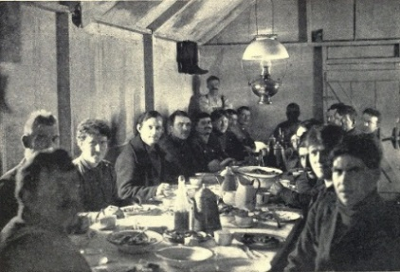 | gogol mogol  A Russian Jewish home remedy made with egg yolks, warm milk, cinnamon and sometimes brandy.  
Knish  An Eastern European food made of a filling such as baked potato or spinach covered with baked or fried dough.   | kosher  Food that adheres to Jewish religious dietary rules.  
ledger  A book in which financial accounts are recorded.   | nudge  Yiddish word for a person who bothers or annoys others.  
schlep  Yiddish word meaning to carry something heavy or to walk a long distance.   | seam  A line where two pieces of fabric are sewn together.  
shtetl  Yiddish word for town; usually referred to small towns in Eastern Europe with large Jewish populations.  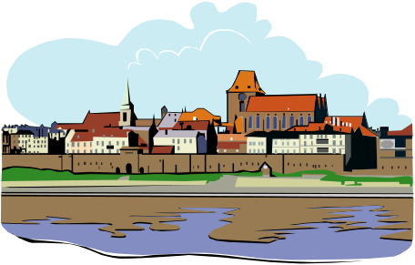 | kvetch  Yiddish word meaning to complain.  
tenement  A small low-cost apartment built for working-class families. Also refers to the multi-storied building in which the apartment is located.  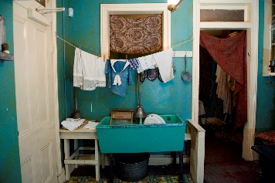 | treyf  Yiddish word meaning food that does not meet the requirements of Jewish religious dietary rules; not kosher.  

boarders | gogol mogol  
knish   | kosher
ledger | nudge
schlep   | seam  
shtetl | kvetch
tenement  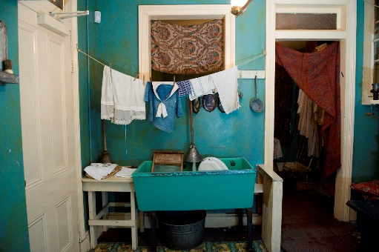 | treyf

In order to make rent more affordable, people would take in boarders - other people who would pay for a bed, food, and laundry. | A Russian Jewish home remedy made with egg yolks, warm milk, cinnamon and sometimes brandy.
An Eastern European food made of a filling such as baked potato or spinach covered with baked or fried dough. | Food that adheres to Jewish religious dietary rules.
A book in which financial accounts are recorded. | Yiddish word for a person who bothers or annoys others.
Yiddish word meaning to carry something heavy or to walk a long distance. | A line where two pieces of fabric are sewn together.
Yiddish word for town; usually referred to small towns in Eastern Europe with large Jewish populations. | Yiddish word meaning to complain.
A small low-cost apartment built for working-class families. Also refers to the multi-storied building in which the apartment is located. | Yiddish word meaning food that does not meet the requirements of Jewish religious dietary rules; not kosher.

Name: Date:

This activity imagines that Lena is making a speech to New York City students and community residents in 1982, seventy years after the events in “City of Immigrants.” Lena is discussing what life was like on the Lower East Side in the early twentieth century.

Instructions: After reading and talking about the words and terms on the flash cards, read this excerpt from Lena’s speech. Use the cards and your memory to help fill in the missing words and terms. Some words may be used more than once.

boarders  gogol mogul  knishes | kosher  kevetch  ledger | nudge  schlep  seams | shtetls  tenement  treyf

“Our family depended on each other in order to survive. Isaac sold items from his pushcart. I had a job sewing in the sweatshop in our __________________ . With so much practice sewing, my __________________ were always straight! I don’t want to __________________ , but they really should have paid me more money!

Sonya cooked, cleaned, and took care of the __________________ that lived with us. She kept a __________________ that showed how much money we made and how much money we spent each week. Some weeks we barely had any money left over to save.

We didn’t have supermarkets like we do now. We would buy the items we needed from vendors or small shops. We had to __________________ everything back to the __________________. I didn’t want to be a __________________, so I helped out as much as I could.
I remember having to buy __________________ meat. We could have bought cheaper meat, but there was no way Isaac would let us eat __________________ ! It was important to continue to practice our religion.

Many of our neighbors were also Jewish. Many people had fled the __________________after the pogroms. They continued to practice some customs, like making __________________ when somebody was ill. Some of the food was different than what we had in Minsk. __________________ were popular and were a very filling snack.”

A NOTE TO THE EDUCATOR:

You will need to decide how best to share these writing prompts with your students. You might share them all and ask students to choose one to respond to. You may assign one or more to the entire group. You might make one or more of the topics the basis for in-class discussions. Make your decisions according to the needs of your group.

You may notice that many of the topics contain some version of the phrase, “Write about a time in your life…” The intention of these prompts is twofold: first, since students remember the content of their own lives, they can more easily respond to the questions and they are more likely to want to express themselves if they feel competent to do so; second, these questions can form a meaningful bridge between what happens in the lives of ordinary people today and the lives of people in history or in historical events. For these reasons, you might decide to use some of the prompts before students encounter the history, because thinking about them sets the students up to understand and to relate to it better.

Since students vary in their degree of comfort and skill in writing, you should decide when and how much students should write. We suggest that since students need to share their writing with each other to make personal and historical connections, you should encourage them to focus on content rather than mechanical skills. Pieces can be revised and edited later if you decide they should be shared formally, such as on a bulletin board or in a newsletter.

Read through all the topics first, and then choose one of them to write about. Write the title of the piece at the top of your page. Write in complete sentences. After you are finished, proofread your work.

MORING ROUTINE. Lena starts each day at 5:30am. Describe her morning routine and compare it to your own. In what ways is her morning routine similar or different from your daily habits?

MEDICAL SCARE. After meeting with the nurse from Henry Street Settlement, Sonya has a medical scare and is worried about her baby’s health. Have you ever been scared about going to the doctor? Write about a time you experienced a medical scare and how your family helped you to get through it.

BEING AMERICAN. Isaac tells Lena that she is starting to sound like a real American. What do you think Isaac means? Can you describe what an American sounds like?

SHOP TILL YOU DROP. Lena needs to make careful decisions about what to purchase and how to spend Sonya’s shopping money. Consider your own financial habits. How do you make decisions about what to spend your money on and how much of it to save? What is something that you are currently saving for?

BUDGET BEHAVIOR. Sonya keeps a ledger to track the family’s finances. What are some of their expenses? What are they saving for? If you were to make a ledger for your family, what would you include?

FAMILY CHORES. Throughout Part 2, Lena is busy doing many chores, including the laundry and shopping. How does Lena feel about doing the chores? How do you think she would prefer to spend her time? Write about the chores you do and how they contribute to your family. Make sure to also include how doing the chores makes you feel.

KVETCH. Kvetch is a Yiddish word meaning to complain. What are some of the things that Lena and Sonya kvetch about in Part 2? Have you ever complained about similar things? Record some of your own kvetches. How would you want to someone to respond to your kvetches?

A NOTE TO THE EDUCATOR:

The purpose of these questions is to check the students’ understanding of the action of the game and the history embedded in that action. Since the outcome of gameplay can vary depending on the choices the student makes, the answers to the questions might also vary.

Some students might learn information later than others, or not at all. If you choose to discuss students’ responses as a whole group, information can be shared among all your “Lenas.”

There may be more questions here than you want your students to answer in one sitting or in one evening. In that case, choose the questions you feel are most essential for their understanding of Part 2.

Feel free to copy the following pages of this activity for your students.

If you are not planning to have your students write the answers to the questions, you’ll need to modify the directions.

Name: ___________________________ Date:_____________________

Directions: After you play Part 2, read and answer these questions from the point of view of your character, Lena. You may not know all the answers, so do the best you can. Write in complete sentences and proofread your work.

1) Describe the work Lena does in the shop.

2) Where is the shop located?

3) How many days each week does Lena work in the shop?

4) What does Lena do with her wages?

5) What is the purpose of the ledger?

6) What were the nurse’s instructions to Sonya?

7) How does Lena do the laundry?
8) What special instruction does Sonya give Lena about buying food?

9) Where did you buy food?

10) How long do the chores take you? What else do you do that day?

11) On this day, you may have met the following people. Make a note or two about them next to each name. For this question, your notes don’t have to be in complete sentences.
a. boss –

b. neighbor –

b. Miss Walker –

A NOTE TO THE EDUCATOR:

The purpose of these questions is to check the students’ understanding of the action of the game and the history embedded in that action. Since the outcome of gameplay can vary depending on the choices the student makes, the answers to the questions might also vary.

Some students might learn information later than others, or not at all. If you choose to discuss students’ responses as a whole group, information can be shared among all your “Lenas.”

There may be more questions here than you want your students to answer in one sitting or in one evening. In that case, choose the questions you feel are most essential for their understanding of Part 2.

Feel free to copy the following pages of this activity for your students.

If you are not planning to have your students write the answers to the questions, you’ll need to modify the directions.

Name: ___________________________ Date:_____________________

Directions: After you play Part 2, read and answer these questions from the point of view of your character, Lena. You may not know all the answers, so do the best you can. Write in complete sentences and proofread your work.

1) Describe the work Lena does in the shop.
Lena sews pieces of men’s suits.

2) Where is the shop located?
In the basement of the tenement building that Lena lives in.

3) How many days each week does Lena work in the shop?
Lena works every day except Saturday, which is Shabbos.

4) What does Lena do with her wages?
Lena gives her wages to Sonya so that they can pay rent.

5) What is the purpose of the ledger?
The ledger shows how much money the family makes and how much they spend each week.

6) What were the nurse’s instructions to Sonya?
The nurse told her that she couldn’t climb the stairs.

7) How does Lena do the laundry?
Lena washes the laundry by hand in the kitchen sink. She hangs it to dry on the roof.

8) What special instruction does Sonya give Lena about buying food?
Lena has to buy Kosher meat. She needs to make sure the food is fresh.

9) Where did you buy food?
Fruits, vegetables, milk, and soda water were bought from pushcarts. Meat was bought from a butcher.

10) How long do the chores take you? What else do you do that day?
The chores took all day. There was no extra time.

11) On this day, you may have met the following people. Make a note or two about them next to each name. For this question, your notes don’t have to be in complete sentences.
a. boss – He smells like pickles and makes Lena feel uncomfortable.

b. neighbor – She doesn’t like Lena’s singing and says that Isaac should sell jars for canning.

b. Miss Walker – She is well-dressed and encourages Lena to do activities at the settlement house.

Popular Culture
Ideas of leisure were transformed at the beginning of the twentieth century. With more teenagers entering the workforce as part of the family economy and earning wages, opportunities and ideas about recreation grew. Like Lena, many young immigrant women would have discovered new forms of entertainment including the Yiddish theater, moving pictures, dance halls, and Coney Island. These new forms of entertainment challenged traditional notions of behavior for both young men and women, and created opportunities for them to mix in public spaces. The commercialization of leisure also transformed notions of what it meant to be working class and American. In this activity, students examine primary sources describing these new forms of entertainment. As they explore the pros and cons of each kind of amusement, students also consider how different people might have perceived amusement activities based on their particular point-of-view.

A NOTE TO THE EDUCATOR
While Lena’s journey to America is fictional, her experience is based upon the actual process millions of immigrants went through at the beginning of the twentieth century. The primary source documents included in this activity complement Lena’s story and will introduce your students to historic records documenting the leisure activities that gained popularity at that time. Each primary source highlights one new form of entertainment that immigrant teens living in the Lower East Side were exposed to. Information about each source and guiding questions are also included to focus student exploration of each document.

Activity Components
- About the Documents: Information about each source to help you prepare to use it in the classroom
- Guiding Questions: Prompts to focus student exploration of each document
- Primary Sources:
  - Document 1: Dance Madness
  - Document 2: Moving Pictures
  - Document 3: Coney Island
  - Document 4: Yiddish Theater
- “Perspectives on New Forms of Entertainment” organizer
This activity is designed for you to select how many components you will use with your students. The following procedure is recommended and can be adapted based on your curricular goals and timing constraints.
Steps to Complete
The following procedure is recommended for this activity and can be adapted based on your curricular goals and timing constraints.

- Distribute primary source document(s) to students.
- Have students work independently or in small groups to investigate the document(s) with the goal of learning as much as they can about each new form of entertainment.
- Select guiding questions to help your students investigate each source. You can give your students all of the guiding questions or choose a few for them to respond to.
- Distribute the “Perspectives on New Forms of Entertainment” organizer to help students record the pros and cons noted for each type of entertainment.
- Have students present their findings to the class or a fellow student and share what was learned.
Assign students to use the information they uncovered from the primary source document(s) to determine how Lena should spend her Sunday. Lena has saved up enough money to join her friends from the sweatshop at the dancehall, Yiddish theater, nickelodeon, or Coney Island. She can also choose to stay home and give Sonya the money to help with the household needs. Students should write a persuasive essay detailing which choice is the best one, highlighting the pros and cons that each represents. For this assignment, students can be given a particular perspective from which to approach the question. Half the class can be assigned Lena’s perspective, while the other half should articulate Sonya’s point of view. You may wish to discuss with students that thus far in the game, Sonya has been very focused on the family’s financial needs. Sonya is more likely to be focused on practical, adult concerns than frivolous entertainment.
About the Documents

Document 1: Dance Madness
Dance halls became increasingly popular in working class neighborhoods around the turn of the twentieth century, and then peaked between the years 1910 and 1915. A major reason for their popularity was the opportunity they presented for boys and girls to mix in a public space. In 1910, most of New York City’s 195 dance halls were located on the Lower East Side. Lena would have likely considered visiting a dance hall like the Grand Central Palace, which could hold up to 3,000 young men and women, and featured professional musicians.

Document 2: Moving Pictures
The first “nickelodeon,” named for the five-cent price of admission, opened in the United States in 1905. Empty storefronts were converted to picture-shows with a projector, some folding seats, and a sheet. Within a few years, there were thousands of nickelodeons across the country, especially on the Lower East Side of New York City. The new form of entertainment was particularly popular among working-class immigrants. The price was right, and everyone could follow the simple storylines despite language barriers. As new technology developed, nickelodeons ultimately became today’s modern movie theaters.

Document 3: Coney Island
Located in the New York City borough of Brooklyn, Coney Island was a popular entertainment destination that offered a wide range of amusements including beaches, amusement parks, concert halls, arcades, and shows. These new forms of entertainment gave visitors the opportunity to take a break from the demands of their daily lives. Boys and girls of all ages were welcomed to experience a new world of carnivals, mechanical rides, and exotic exhibits together. By 1895, a five cent trolley ride took one from the Lower East Side to Coney Island, making it a popular attraction. The popular mass culture that emerged in Coney Island became part of a larger debate on what kind of mass culture should dominate American life.

Document 4: Yiddish Theater
Yiddish theater was incredibly popular on the Lower East Side in the 1910s. The theater dramatized the hopes and dreams of immigrant Jews and highlighted the conflicts between the old world and the new. On-stage characters grappled with the same challenges faced by every immigrant: what did it mean to be both an American and a Jew? Yiddish theatre provided insight and comic relief into this shared quandary.
Guiding Questions

Document 1: Dance Madness
- Read the account. What information does it provide about the dance hall phenomenon?
- What are the pros and cons of visiting a dance hall for a young immigrant woman?
- What might motivate an immigrant to go to the dance hall?
- What questions does this document raise for you?
- In what ways can this document inform our understanding of Lena’s experience in America?

Document 2: Moving Pictures
- Read the account. What information does it provide?
- Examine the illustration. What can be learned from it about who was going to the moving pictures, by looking carefully at who is waiting on line for tickets?
- What are the pros and cons of going to moving pictures shows?
- What might motivate an immigrant to go to a moving pictures show?
- What questions does this document raise for you?
- In what ways can this document inform our understanding of Lena’s experience in America?

Document 3: Coney Island
- What does this postcard tell us about Coney Island?
- Based on the postcard, how would you describe Coney Island to somebody who has never visited?
- What might motivate an immigrant to go to Coney Island?
- What questions does this document raise for you?
- In what ways can this document inform our understanding of Lena’s experience in America?

Document 4: Yiddish Theater
- Read the account by Hutchins Hapgood. What information does it provide?
- Who attended Yiddish Theater?
- Examine the sheet music. What can be learned about the play based on the pictures and text included?
- What are the pros and cons of Yiddish theater?
- What might motivate an immigrant to go see the play Chantshe in Amerika?
- What questions does this document raise for you?
In what ways can this document inform our understanding of Lena’s experience in America?
Popular Culture
Perspectives on New Forms of Entertainment Chart

As you examine and analyze the primary sources, use this chart to describe the pros and cons of each new form of entertainment. For each type of entertainment, consider the perspective or point-of-view of both Lena and her sister-in-law Sonya.
Type of Entertainment  (Dance Hall, Moving Pictures, Coney Island, Yiddish Theater) | Lena’s Perspective (teenager) |  | Sonya’s Perspective  (adult)
 | Pros | Cons | Pros | Cons
Popular Culture
Document 1: Dance Madness
Source: Excerpt from “Diverting a Pastime: How Are We To Protect the City's Youth and Yet Provide for the Natural Demand for Entertainment?” By Belle Lindner Israels. Leslie's Weekly, July 27, 1911, p. 94.

In all large cities, in every place where there is work for young people, there are also places for these young people to play. Play is not a special prerogative of little children. The desire for it is human, and, while it has specialized forms in playgrounds and theatres, it finds its simplest expression in the daily recreative life of adolescent young women and young men. Modern conditions do everything that can be done to create a desire and a need for relaxation. Our industries are monotonously narrowed and specialized. The home conditions under which the average young working girl and boy live are as such as to demand outside resources. . . .

The choice is narrow. You can't walk the street all evening, especially in cold weather. The park is tiresome. The theater is expensive. The motion-picture show offers but a half hour's amusement. For the same expenditure that it costs to go to the moving picture show or a very little more, and sometimes for nothing at all, a delightful evening can be spent at a pastime that never fails to interest. The dance hall is always ready for visitors. . . .

The storm of dance madness has come over the young people of New York. Streets in which the dance halls are located are picturesque enough externally. The hall is usually up one or two flights of stairs and has as much street frontage as possible, framed in big windows of plate glass. Brilliant lights shine through. The sounds of a waltz or two-step pounded on the piano and emphasized by an automatic drum flow out to the passer-by. Boys and girls flit past the windows or slip into the doorway in twos and threes, and sometimes competing managers remain outside, announcing the special features of their halls. The noise, the lights, the air of excitement and good time all attract.

In studying the dance hall one comes continually against the liquor problem, so that it is claimed with much reason that the liquor interests control the amusement. In the small saloon dance hall, which is open nightly without an admission fee, it is understood that the dancing is permitted simply as a feeder to the sale of liquor. The music plays for three or four minutes, and there are intermission covering a period of from fifteen to twenty minutes between the dances. During these times the people at the tables are constantly importuned to buy drinks. Girls not being entertained at the tables rush over to the dressing-rooms to avoid being seen on the floor.

Popular Culture
Document 2: Moving Pictures
Source: Excerpt from “Some Picture Show Audiences” by Mary Heaton Vorse. Illustrated by Wladyslaw T. Benda. Outlook 98, 24 June 1911, p. 442.
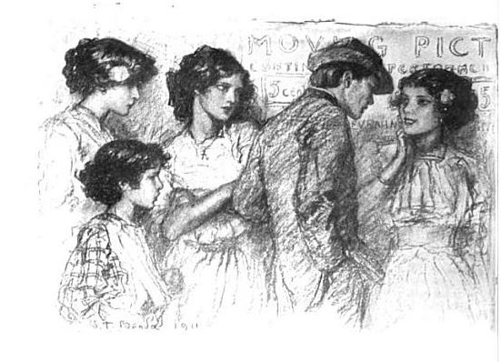
THE LINE AT THE TICKET OFFICE

It is drama, and it is travel, and it is even beauty, all in one. A wonderful thing it is, and to know how wonderful I suppose you must be poor and have in your life no books and no pictures and no means of travel or seeing beautiful places, and almost no amusements of any kind; perhaps your only door of escape or only means of forgetfulness is more drink than is good for you. Then you will know what a moving-picture show really means, although you will probably not be able to put it into words.

We talk a good deal about the censorship of picture shows, and pass city ordinances to keep the young from being corrupted by them: and this is all very well, because a great amusement of the people ought to be kept clean and sweet; but at the same time this discussion has left a sort of feeling in the minds of people who do not need to go to the picture show that it is a doubtful sort of a place, where young girls
and mean scrape undesirable acquaintances, and where the prowler lies in wait for the unwary, and where suggestive films of crime and passion are invariably displayed. But I think that this is an unjust idea, and that any one who will take the trouble to amuse himself with the picture show audiences for an afternoon or two will see why it is that the making of films has become a great industry, why it is that the picture show has driven out the vaudeville and the melodrama.

You cannot go to any one of the picture shows in New York without having a series of touching little adventures with the people who sit near you, without overhearing chance words of a naiveté and appreciation that make you bless the living picture book that has brought so much into the lives of the people who work.

Popular Culture
Document 3: “Dancing in the Sand at Coney Island, New York”
“Dancing in the Sand at Coney Island, New York.” Published by S. Hirschberg, ca. 1905. Collection of the Museum of the City of New York.
http://collections.mcny.org/Collection/Dancing-in-the-Sand-at-Coney-Island,-N.-Y.-2F3HRG2LZ1R.html

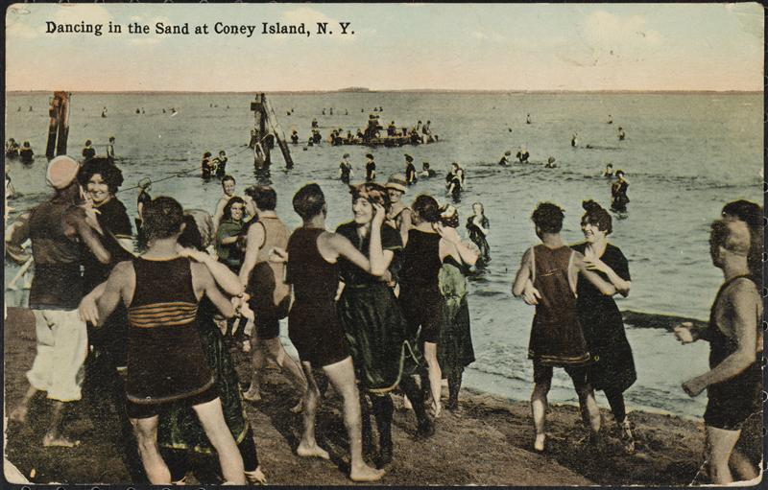

Popular Culture
Document 4: Yiddish Theater, Description by Hutchins Hapgood
Hutchins Hapgood, a keen observer of the culture of the Lower East Side, wrote about the Jews of the Lower East Side attending the theater in his book “The Spirit of the Ghetto: Studies of the Jewish Quarter of New York.”

In the three Yiddish theatres on the Bowery is expressed the world of the Ghetto-that New York City of Russian Jews, large, complex, with a full life and civilization… The theaters of the chosne people alone present the serious as well as the trivial interests of an entire community. In these three buildings crowd the Jews of all the ghetto classes - the sweatshop woman with her baby, the day laborer, the small Hester Street shopkeeper, the Russian Jewish anarchist and socialist, the Ghetto Rabbi and scholar, the poet, the journalist. The poor and ignorant are in the great majority, but the learned, the intellectual, and the progressive are also represented…

Popular Culture
Document 4: Yiddish Theater, “Chantshe in Amerika”
In one notable play from the 1910s, “Chantshe in Amerika,” Bessie Thomashefsky played the independent-minded Hannah, an assimilating immigrant woman who championed women’s rights. In the play, Chantshe dreams of being a pickpocket, a hero, and even a chauffeur. Although this may seem like a strange dream for a Jewish immigrant woman, Hannah argued, "What is the good of being in America if one couldn’t drive a car?" The lyrics, published in 1913 by the Hebrew Publishing Company, detailed many of Chantshe’s ideas of what a modern American woman can look like.

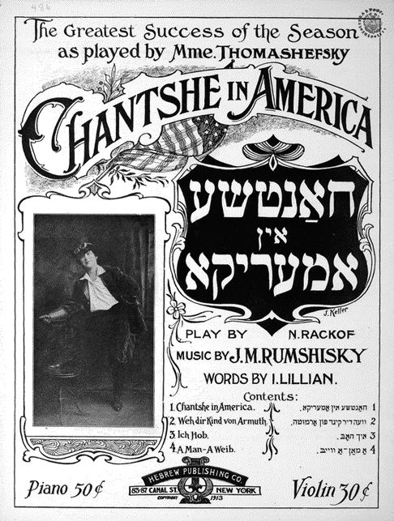

“Chantshe in Amerika” song. Sheet Music. Source: Library of Congress. Excerpt of lyrics with Yiddish transliteration & English translation courtesy of Jane Peppler from http://www.museumoffamilyhistory.com/yt/chantshe-in-america.htm.You can also listen to the song being performed in Yiddish at http://mappamundi1.bandcamp.com/track/khantshe
Refrain in Yiddish:  Chantshe is a lady shoin a gantze,  Oi! Oi! Oi! Chantshe a chvat, a held,  Nit geshpet, plein geredt.  Hoibt die hend far Chantshe.  Chantshe, nor wu a policeman shpant sie  Oi! Oi! Oi! Chantshe, or Chantshe,  Nor Chantse,  Beinheint die gantze welt. |  | Refrain in English:  Khantshe is a now quite the lady.  Oy, she's audacious, a hero,  Not mocked, plain to say.  Lift your hands for Khantshe.  Khantshe, wherever a policeman hitches her  Oy, Khantshe, only Khantshe lights up the world.
Chantshe gehmt kein blof nit  Un sie kempft far frauen-recht,  Dos is a plan.  Far a frau un far a man  Sol gleiche rechte sein.  Aruster mit die hoisen, un  Aruster mit dem man – git sie a kwitsh.  Wen sie shteht un halt a speech.  Chantshe is a regule peach.  Meidel, weibel, sie a man! – zushreit sich Chantshe,  Nit dershrek sich far a berdel mit a wontze,  Mir hoben auch recht  Zu shpielen gantze necht  Poiker – es is nit shlecht. |  | You can't catch Khantshe in a bluff  And she fights for women's rights  That is a plan:  for a woman and her husband to be equal.  Down with trousers and down with the husband.  She gives a squeak when she stands and gives a speech.  Khantshe is a regular peach.  "Girls, women, man up!" cries Khantshe,  Don't be afraid of a beard and moustache,  "We, too, have the right  To play all night every night  Drummer - this isn't bad!"

A NOTE TO THE EDUCATOR:

On the following pages, you will find “flashcards” with terms and definitions (both combined and separate) that your students may encounter while playing Part 3 of “City of Immigrants.” These terms and definitions can be introduced and practiced before or during the time students see or hear them in the context of MISSION US or in their American history study. The discussion questions and writing prompts will provide further opportunities for students to have more practice with the words and terms.

Divide your students into small groups of four or five, and ask each group to review the terms and definitions.

After your students have had a chance to review and discuss the terms and definitions, distribute the excerpt from the reporter’s interview with Lena. Review the directions with your students and ask them to complete the text using the terms they studied.

Here are the terms which should be inserted into each paragraph of Lena’s life story:
Paragraph 1- sweatshop, yente
Paragraph 2- balabusta, bubeleh
Paragraph 3- bodice, suffrage, chutzpa
Paragraph 4- inquisition

Photography Credits
Inquisition: Dejan Miladinovic

inquisition  Harsh and intensive questioning or investigation.  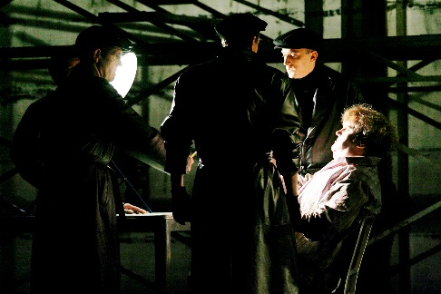 | bodice  The part of a dress (excluding sleeves) that is above the waist.  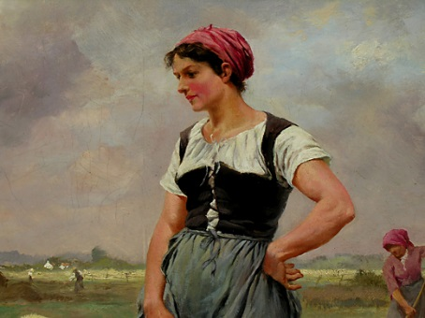
balabusta  Yiddish for mistress of the house or a good homemaker.  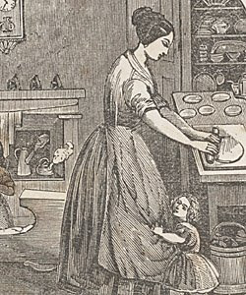 | bubaleh  Yiddish term of endearment, similar to calling someone “sweetie.”  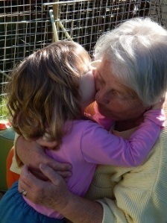
chutzpah  Yiddish word meaning bravery or self-confidence that borders on rudeness.   | sweatshop  A clothing workshop at the turn of the twentieth century in which workers work long hours in poor conditions for little pay.  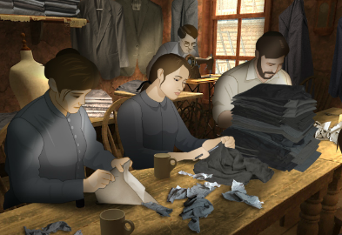
suffrage  The right to vote in political elections.  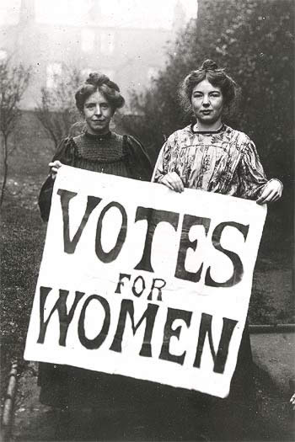 | yente  Yiddish word for a person who likes to gossip or interfere.  

inquisition | bodice
balabusta | bubaleh  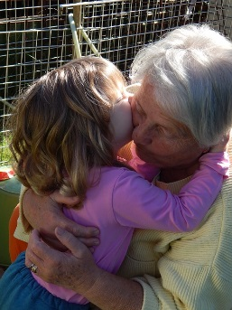
chutzpah | sweatshop  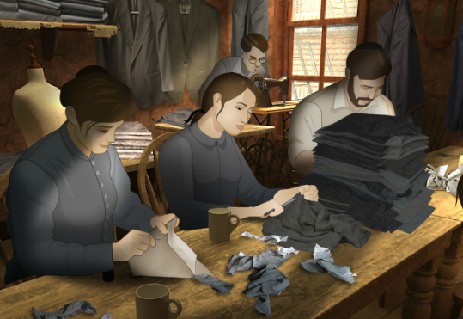
suffrage | yente

Harsh and intensive questioning or investigation. | The part of a dress (excluding sleeves) that is above the waist.
Yiddish for mistress of the house or a good homemaker. | Yiddish term of endearment, similar to calling someone “sweetie.”
Yiddish word meaning bravery or self-confidence that borders on rudeness. | A clothing workshop at the turn of the twentieth century in which workers work long hours in poor conditions for little pay
The right to vote in political elections | Yiddish word for a person who likes to gossip or interfere.

Name: Date:

This activity imagines Lena is making a speech to New York City students and community residents in 1982, seventy years after the events in “City of Immigrants.” Lena is discussing what life was like on the Lower East Side in the early twentieth century.

Instructions: After reading and talking about the words and terms on the flash cards, read this excerpt from Lena’s speech. Use the cards and your memory to help fill in the missing words and terms. Some words may be used more than once.

balabusta  bodice | bubeleh  chutzpa | inquisition  sweatshop | suffrage  yente

“My first job was in the __________________ that was in our building. I spent many hours sewing clothes for low wages. Most of the people who worked there lived nearby. The lady who sat next to me was a real __________________. She was always talking about the other workers and the boss when he wasn’t there.

One day I had to take Isaac’s place and take the pushcart. Isaac had the pushcart stocked with housewares, so I would look for a nice __________________ who might need something for her kitchen. Some of the customers thought I was too young to be a peddler. They’d say, “__________________, what are you doing out here all alone?”

I often went to the Henry Street Settlement House to practice English and to learn other skills. There were many different things you could do there. You could be in a play. Or you could practice your sewing and learn how to make a __________________. Some of the people were even working to try to pass women’s __________________. I heard some people say that it took __________________ to fight for the right of women to vote.

When I had some free time, I would try to do something fun. I had to ask Isaac and Sonya first. They’d ask so many questions that I’d wonder if it was an __________________. But I know they just wanted to make sure I was safe.

A NOTE TO THE EDUCATOR:

You will need to decide how best to share these writing prompts with your students. You might share them all and ask students to choose one to respond to. You may assign one or more to the entire group. You might make one or more of the topics the basis for in-class discussions. Make your decisions according to the needs of your group.

You may notice that many of the topics contain some version of the phrase, “Write about a time in your life…” The intention of these prompts is twofold: first, since students remember the content of their own lives, they can more easily respond to the questions, and they are more likely to want to express themselves if they feel competent to do so; second, these questions can form a meaningful bridge between what happens in the lives of ordinary people today and the lives of people in history or in historical events. For these reasons, you might decide to use some of the prompts before students encounter the history because thinking about them sets the students up to understand and relate to it better.

Since students vary in their degree of comfort and skill in writing, you should decide when and how much students should write. We suggest that since students need to share their writing with each other to make personal and historical connections, you should encourage them to focus on content rather than mechanical skills. Pieces can be revised and edited later if you decide they should be shared formally, such as on a bulletin board or in a newsletter.

Read through all the topics first, and then choose one of them to write about. Write the title of the piece at the top of your page. Write in complete sentences. After you are finished, proofread your work.

SINK OR SWIM. When Part 3 begins, Lena takes over for her brother as a peddler at the Hester Street Market. How do you imagine she felt taking on this new responsibility? Have you ever had to take on a new task without training? Describe what you think is the best way to learn something new. Is it best to jump in and try it or to learn from or watch someone else?

MAKING FRIENDS. At the settlement house Lena becomes friends with Rosa, an Italian immigrant who is also learning English. Think about how you made your friends. What are some tips you have for someone who is new to place and doesn’t yet have any friends?

NEW FOODS. Lena and Rosa tell each other about some of their favorite foods while practicing their English in class. Have you ever tried Rosa’s favorite of olives or Lena’s favorite of babke? If you were going to share a food with a new friend, what kind of food would you select for them to try? Why?

FAMILY FIRST. Throughout Part 3, Lena needs to decide if she should put her family first or her own personal wishes. Do you think she should help Sonya and Isaac or should she enjoy some free time? Should she buy herself something or save all of her money to help pay the rent? Have you ever had to make a decision between your own interests and your family’s? How would you decide when to put yourself first or your family first?

DEAR MAMA. Lena wants to write a letter to her Mama back in Minsk, but doesn’t know where to start. Think carefully about everything that has happened to Lena since she arrived in America. What events do you think are important for her to share with her mother? Now write a letter from Lena’s point-of-view summarizing her experiences.

LENA’S DIARY. Through Lena’s eyes, think about your circumstances from the beginning to the end of this part of “City of Immigrants.” Share your emotions and feelings about each step of the journey. Think about the people with whom you interacted, and what you learned from them. Think about the choices you made and the consequences of those choices. Now write a diary entry from Lena’s point-of-view summarizing what happened to you in Part 3. You may choose to illustrate one aspect of your entry.

A NOTE TO THE EDUCATOR:

The purpose of these questions is to check the students’ understanding of the action of the game and the history embedded in that action. Since the outcome of gameplay can vary depending on the choices the student makes, the answers to the questions might also vary.

Some students might learn information later than others, or not at all. If you choose to discuss students’ responses as a whole group, information can be shared among all your “Lenas.”

There may be more questions here than you want your students to answer in one sitting or in one evening. In that case, choose the questions you feel are most essential for their understanding of Part 3.

Feel free to copy the following pages of this activity for your students.

If you are not planning to have your students write the answers to the questions, you’ll need to modify the directions.

Name: ___________________________ Date:_____________________

Directions: After you play Part 3, read and answer these questions from the point of view of your character, Lena. You may not know all the answers, so do the best you can. Write in complete sentences and proofread your work.

1) What items are for sale on the pushcart?

2) Were you successful at selling items from the pushcart? How did you get people to buy things?

3) What activities are offered at the settlement house? What do you choose to do?

4) What does Isaac’s letter to Lena say to do?

5) What did Lena and Rosa Leone talk about when they were practicing English together?

6) Where is Rosa from? What does she plan to do in the future?

7) What did Lena hope to do when she went to the bank? What did she discover when she got there?

8) What did Isaac do with all of their savings? What is his plan?

9) What did you choose to do on Thursday night?

10) On this day, you may have met the following people. Make a note or two about them next to each name. For this question, your notes don’t have to be in complete sentences.
a. Zev –

b. Rosa –

A NOTE TO THE EDUCATOR:

The purpose of these questions is to check the students’ understanding of the action of the game and the history embedded in that action. Since the outcome of gameplay can vary depending on the choices the student makes, the answers to the questions might also vary.

Some students might learn information later than others, or not at all. If you choose to discuss students’ responses as a whole group, information can be shared among all your “Lenas.”

There may be more questions here than you want your students to answer in one sitting or in one evening. In that case, choose the questions you feel are most essential for their understanding of Part 3.

Feel free to copy the following pages of this activity for your students.

If you are not planning to have your students write the answers to the questions, you’ll need to modify the directions.

Name: ___________________________ Date:_____________________

Directions: After you play Part 3, read and answer these questions from the point of view of your character, Lena. You may not know all the answers, so do the best you can. Write in complete sentences and proofread your work.

1) What items are for sale on the pushcart?
The pushcart has funnels, colanders, and cameras.

2) Were you successful at selling items from the pushcart? How did you get people to buy things?
Yes, I sold two funnels and one camera. I made bargains with people.

3) What activities are offered at the settlement house? What do you choose to do?
Some of the activities at the settlement house include practicing English, rehearsing for a play, or practicing sewing. I decided to rehearse for a play.

4) What does Isaac’s letter to Lena say to do?
Isaac tells Lena to work in the shop or Mr. Pickles will find a replacement for her.

5) What did Lena and Rosa Leone talk about when they were practicing English together?
They talked about their favorite foods and where they were from.

6) Where is Rosa from? What does she plan to do in the future?
Rosa is from Italy. She hopes to return there someday.

7) What did Lena hope to do when she went to the bank? What did she discover when she got there?
Lena hoped that there would be enough money to buy tickets for her parents to come to America. She found out that Isaac took all of the family’s savings out of the bank before she got there.

Factory Life
With the growth of New York’s garment industry at the turn of the twentieth century, many immigrants found work in the city’s sweatshops. Like Lena, immigrants might have worked in both tenement sweatshops and the larger factories. Large garment factories grew in the early 1900s as a result of technological advances including the electric sewing machine and the subway system. Sweatshops and many factories worked under a contractor system model, in which individual contractors received components of garments that they in turn assembled according to manufacturer designs. These finished products were then returned to the manufacturers, who paid a set price per finished garment. Consequently, contractors, in order to make any profits, forced longer hours and lower wages on their workers. Many young immigrant women preferred to work in the more established factories that offered greater job stability, often higher wages, and a larger community of young women workers. In this activity, students examine primary sources exploring the experiences of garment factory workers.

A NOTE TO THE EDUCATOR
While Lena’s journey to America is fictional, her story is based upon the actual experience that millions of immigrants went through at the turn of the twentieth century. The primary source documents included in this activity complement Lena’s story and will introduce your students to historic records exploring the garment industry. Each primary source highlights an aspect of the experience of sweatshop work. Information about each source and guiding questions are also included to support student exploration of each document.

Activity Components
- About the Documents: Information about each source to help you prepare to use it in the classroom
- Guiding Questions: Prompts to support student exploration of each document.
- Primary Sources:
  - Document 1: “Life in the Shop” by Clara Lemlich
  - Document 2: “Days and Dreams” by Sadie Frowne
  - Document 3: Photographs of Sweatshops
  - Document 4: “The Sweatshop” poem by Morris Rosenfeld
- Organizer to record primary source investigations.
- Culminating Activity to help students connect the documents to gain a deeper insight on what it meant to be a garment shop worker.

This activity is designed for you to determine how many components you use with your students. The following procedure is recommended and can be adapted based on your curricular goals and timing constraints.

Steps to Complete
The following procedure is recommended for this activity and can be adapted based on your curricular goals and timing constraints.
- Distribute primary source document(s) to students.
- Have students work independently or in small groups to investigate the document(s) with the goal of learning as much as they can about the experiences of garment factory workers. Students can record their findings in the included organizer.
- Select guiding questions to help your students investigate each source. You can give your students all of the guiding questions, or choose a few to which they can respond.
- Have students present their findings to the class or a fellow student and share what was learned.
- Assign students to use the information they uncovered from the primary source document(s) to write a “day in the life” essay detailing what it is like to be a garment factory worker at the turn of the twentieth century. Students should incorporate aspects of all the documents investigated within their essay in order to accurately describe the factory worker’s schedule, feelings, and activities during a given day.

About the Documents

Document 1: “Life in the Shop” by Clara Lemlich
Clara Lemlich was born to a Jewish family in the Ukrainian village of Gorodok in 1886. She immigrated with her family to the United States in 1903, and became an important figure in the fight for reform of New York City’s garment industry. She famously called a strike and a walkout of shirtwaist makers in 1909. In this testimonial, Clara describes garment factory conditions.

Document 2: “Days and Dreams” by Sadie Frowne
Sadie Frowne arrived in America with her mother at the age of thirteen. Her mother died shortly after, and Sadie went to work in a sweatshop to support herself. This excerpt from an interview she conducted for The Independent magazine in 1902 describes her life as a garment worker, and gives insight into the experiences of immigrant teenage girls in America at the turn of the twentieth century. Like many young women, Sadie worked hard, budgeted, and enjoyed the amusements the city offered.

Document 3: Photographs of Sweatshops
Photographers and reporters in the early twentieth century used cameras as tools for social reform. Photographs became instrumental in changing the child labor laws in the United States. The photographs included here depict typical factory sweatshops in New York City.

Document 4: “The Sweatshop,” poem by Morris Rosenfeld
Morris Rosenfeld was born in 1862 in Russian Poland, and ultimately immigrated to New York City. Rosenfeld wrote poetry based on his experience as a garment worker, and became one of the famous Yiddish “sweatshop poets.” This poem documents the harsh conditions of working in a garment shop, most notably the feeling of losing one’s self and becoming a machine.

Guiding Questions

Document 1: “Life in the Shop” by Clara Lemlich
- Read the account. What information does it provide about working in a garment shop?
- Describe the daily schedule of a factory worker.
- What might motivate an immigrant to work at a garment factory?
- What are the pros and cons of working in a garment factory?
- What is the difference between salary work and piecework?
- What might make the girls feel like machines? What might make them feel human?
- What questions does this document raise for you?
- In what ways can this document inform our understanding of Lena’s experience in America?

Document 2: “Days and Dreams” by Sadie Frowne
- Read the account. What information does it provide about working in a garment shop?
- Describe the daily schedule of a factory worker.
- What might motivate an immigrant to work in a garment factory?
- What are the pros and cons of working in a garment factory?
- How does Sadie spend her earnings? Do you agree with her choices? Why or why not?
- What might make the girls feel like machines? What might make them feel human?
- What questions does this document raise for you?
- In what ways can this document inform our understanding of Lena’s experience in America?

Document 3: Photographs of Sweatshops
- What do these images tell us about the garment factory?
- Compare and contrast the two images. What is similar about the two factories and what is different?
- Describe the people working in the factory. What can we learn about them from the image (age, gender, etc.)?
- If you could “enter” the photograph, what might you hear, see, and smell in the factory?
- Based on the image, how would you describe a garment factory to somebody who had never visited?
- What questions does this document raise for you?
- In what ways can this document inform our understanding of Lena’s experience in America?

Document 4: “The Sweatshop,” poem by Morris Rosenfeld
- Read the poem. What information does it provide?
- How would you describe the physical experience of working in a garment shop?
- How would you describe the emotional experience of working in a garment factory?
- What does the clock symbolize?
- What might make the worker feel like a machine? What might make them feel human?
- What questions does this document raise for you?
- In what ways can this document inform our understanding of Lena’s experience in America?
Factory Life
Perspective on Factory life
Use the organizer to record your findings about the experience of being a factory worker.
What is it like to be a garment worker?

What is it like to work in a factory?

What does a factory worker earn? How is this money spent?

Factory Life
Document 1: “Life in the Shop” by Clara Lemlich
Source: Leon Stein, ed., Out of the Sweatshop: The Struggle for Industrial Democracy (New York: Quadrangle/New Times Book Company, 1977)
http://trianglefire.ilr.cornell.edu/primary/testimonials/ootss_ClaraLemlich.html?sto_sec=sweatshops

First let me tell you something about the way we work and what we are paid. There are two kinds of work - regular, that is salary work, and piecework. The regular work pays about $6 a week and the girls have to be at their machines at 7 o'clock in the morning and they stay at them until 8 o'clock at night, with just one-half hour for lunch in that time.

The shops. Well, there is just one row of machines that the daylight ever gets to - that is the front row, nearest the window. The girls at all the other rows of machines back in the shops have to work by gaslight, by day as well as by night. Oh, yes, the shops keep the work going at night, too.

The bosses in the shops are hardly what you would call educated men, and the girls to them are part of the machines they are running. They yell at the girls and they "call them down" even worse than I imagine the Negro slaves were in the South.

There are no dressing rooms for the girls in the shops. They have to hang up their hats and coats - such as they are - on hooks along the walls. Sometimes a girl has a new hat. It never is much to look at because it never costs more than 50 cents. That means that we have gone for weeks on two-cent lunches - dry cake and nothing else.

The shops are unsanitary - that's the word that is generally used, but there ought to be a worse one used. Whenever we tear or damage any of the goods we sew on, or whenever it is found damaged after we are through with it, whether we have done it or not, we are charged for the piece and sometimes for a whole yard of the material.

At the beginning of every slow season, $2 is deducted from our salaries. We have never been able to find out what this is for.

Factory Life
Document 2: “Days and Dreams” by Sadie Frowne
Source: Beth S. Wenger. The Jewish Americans. (New York: Doubleday, 2007), pp. 147-149).

I get up at half-past five o'clock every morning and make myself a cup of coffee on the oil stove. I eat a bit of bread and perhaps some fruit and then go to work. Often I get there soon after six o'clock so as to be in good time, though the factory does not open till seven…

At seven o'clock we all sit down to our machines and the boss brings to each one the pile of work that he or she is to finish during the day--what they call in English their "stint." This pile is put down beside the machine and as soon as a skirt is done it is laid on the other side of the machine. Sometimes the work is not all finished by six o'clock, and then the one who is behind must work overtime...

The machines go like mad all day because the faster you work the more money you get. Sometimes in my haste I get my finger caught and the needle goes right through it. It goes so quick, though, that it does not hurt much. I bind the finger up with a piece of cotton and go on working. We all have accidents like that…

All the time we are working the boss walks around examining the finished garments and making us do them over again, if they are not just right. So we have to be careful as well as swift. But I am getting so good at the work that within a year I will be making $7 a week, and then I can save at least $3.50 a week. I have over $200 saved now.

The machines are all run by foot-power, and at the end of the day one feels so weak that there is a great temptation to lie right down and sleep. But you must go out and get air, and have some pleasure. So instead of lying down I go out, generally with Henry. Sometimes we go to Coney Island, where there are good dancing places, and sometimes we go to Ulmer Park to picnics. I am very fond of dancing and, in fact, all sorts of pleasure. I go to the theatre quite often, and like those plays that make you cry a great deal. "The Two Orphans" is good. The last time I saw it I cried all night because of the hard times that the children had in the play...

I am going back to night school again this winter. Plenty of my friends go there. Some of the women in my class are more than forty years of age. Like me, they did not have a chance to learn anything in the old country. It is good to have an education; it makes you feel higher…

Some of the women blame me very much because I spend so much money on clothes. They say that instead of a dollar a week I ought not to spend more than twenty-five cents a week on clothes, and that I should save the rest. But a girl must have clothes if she is to go into high society at Ulmer Park or Coney Island or the theatre. Those who blame me are the old country people who have old-fashioned notions, but the people who have been here a long time know better. A girl who does not dress well is stuck in a corner, even if she is pretty and Aunt Fanny says that I do just right to put on plenty of style.
Factory Life
Document 3: Photographs of Sweatshops
These images depict New York City sweatshops. Photographers and reporters used cameras to document the conditions of people’s work and the need for reform. These images depicts typical garment factories.
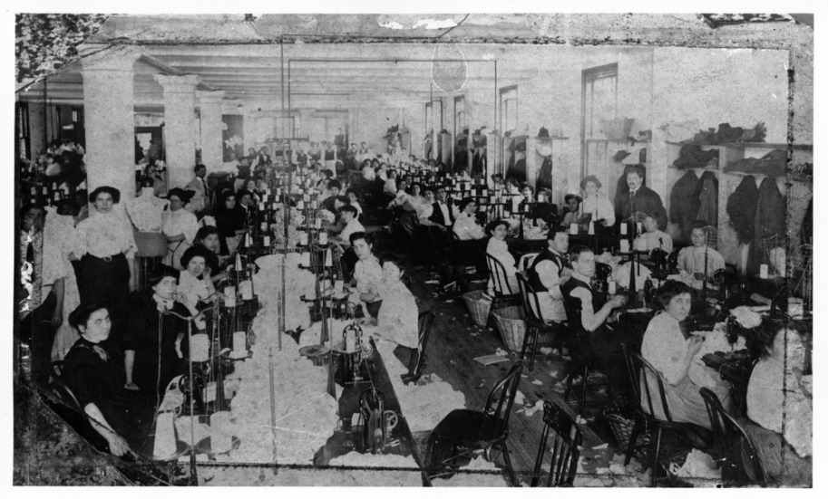
Interior of a garment factory c. 1910
Source: ILGWU Archives, Kheel Center, Cornell University
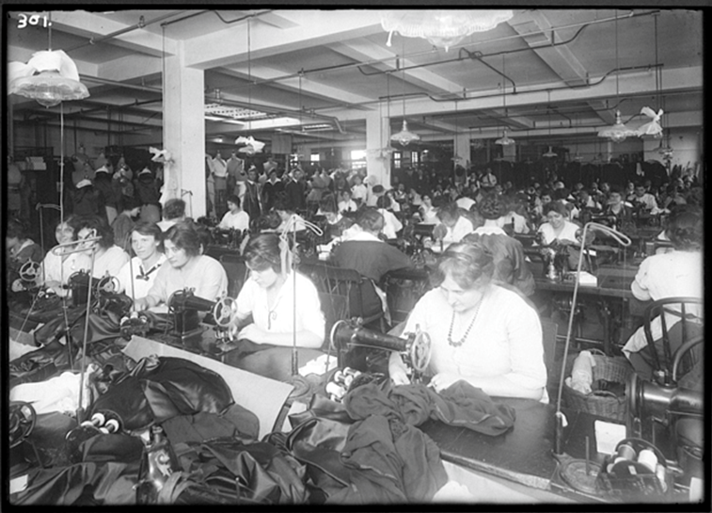

Garment Workers/Sweatshop. Lewis Hine ca. 1930
Source: http://www.geh.org/ar/strip10/htmlsrc/m198501270005_ful.html

Factory Life
Document 4: “The Sweatshop,” poem by Morris Rosenfeld
Source:http://blogs.forward.com/the-arty-semite/135013/morris-rosenfelds-sweatshop-songs/#ixzz3MqE1MfO9

The machines are so wildly noisy in the shop  That I often forget who I am.  I get lost in the frightful tumult —  My self is destroyed, I become a machine.  I work and work and work endlessly —  I create and create and create  Why? For whom? I don’t know and I don’t ask.  What business has a machine thinking?  I have no feelings, no thoughts, no understanding.  The bitter, bloody work suppresses  The noblest, most beautiful, best, richest,  Deepest, and highest things that life possesses.  Seconds, minutes, and hours go by — the days and nights sail past quickly.  I run the machine as if I wanted to overtake them —  I race mindlessly, endlessly.  The clock in the shop never rests —  It shows everything, strikes constantly, wakes us constantly.  Someone once explained it to me:  “In its showing and waking lies understanding.”  But I seem to remember something, as if from a dream:  The clock awakens life and understanding in me,  And something else — I forget what. Don’t ask!  I don’t know, I don’t know! I’m a machine! | At times, when I hear the clock,  I understand its showing and its language quite differently;  It seems to me that the pendulum urges me:  “Work, work, work a lot!”  I hear in its tones only the boss’s anger, his dark look.  The clock, it seems to me, drives me,  Gnashes its teeth, calls me “machine,” and yells at me: “Go!”  But when the wild tumult dies down  And the boss goes away for his lunch hour,  Dawn begins to break in my mind  And things tug at my heart.  Then I feel my wound,  And bitter, burning tears  Soak my meager lunch, my bread.  I feel choked up and I can’t eat any more — I can’t!  Oh, frightful toil! Oh, bitter poverty!  The human being that is sleeping within me  begins to awake —  the slave that is awake in me  seems to fall asleep.  Now the right hour has struck!  An end to loneliness — let there be an end to it!  But suddenly the whistle, the “boss,” sounds an alarm!  I lose my mind, I forget who I am.  There’s tumult and struggling — my self is lost.  I don’t know, I don’t care — I am a machine!

A NOTE TO THE EDUCATOR:

On the following pages, you will find “flashcards” with terms and definitions (both combined and separate) that your students may encounter while playing Part 4 of “City of Immigrants.” These terms and definitions can be introduced and practiced before or during the time students see or hear them in the context of MISSION US or in their American history study. The discussion questions and writing prompts will provide further opportunities for students to have more practice with the words and terms.

Divide your students into small groups of four or five, and ask each group to review the terms and definitions.

After your students have had a chance to review and discuss the terms and definitions, distribute the excerpt from the reporter’s interview with Lena. Review the directions with your students and ask them to complete the text using the terms they studied.

Here are the terms which should be inserted into each paragraph of Lena’s life story:
Paragraph 1- shirtwaist, operator, gentiles
Paragraph 2- forelady, discourage, excessive, pay envelope,
Paragraph 3- socialist, serfs, exposé
Paragraph 4- firebrand, adamant, underestimate
Paragraph 5- grievances, negotiate, strike

Photography Credits
Underestimate: Nevit Dilmen

adamant  Inflexible; refusing to bend or change one’s mind.  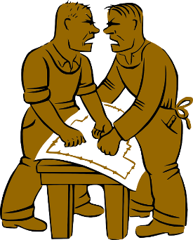 | discourage  To prevent something by showing disapproval or creating difficulties.  
excessive  More than is necessary or desired.   | exposé  News reporting that reveals scandal or corruption, especially in government or business.  
firebrand  A person who passionately and aggressively promotes a cause and tries to lead others to action.  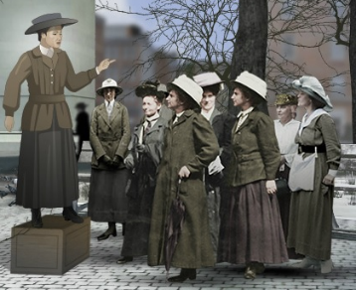 | forelady  A female worker who supervises other workers.  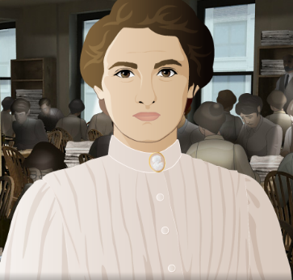
gentiles  Persons who are not Jewish.   | grievances  Reasons for complaint or protest, especially unfair treatment.  
negotiate  To try to reach an agreement or compromise through discussion with others.   | operator  A sewing machine worker.  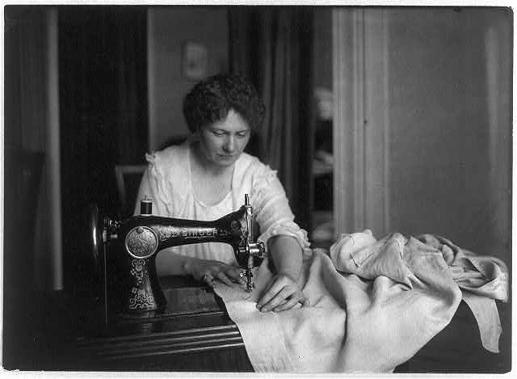
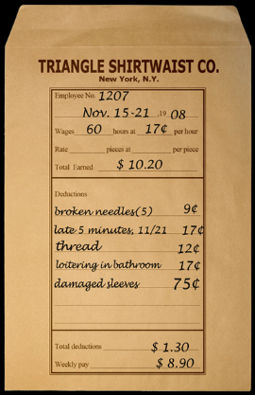  pay envelope  An envelope containing an employee’s weekly wages on which employers record the work completed and amount earned by the employee that week. | serfs  Landless peasants who are forced to work for the landowners; part of the feudal system in Europe and Russia.  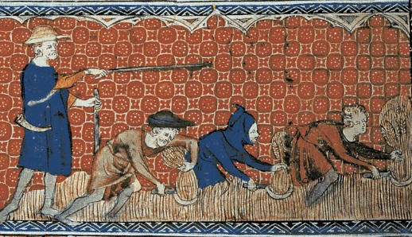

shirtwaist  A women’s blouse or shirt that could easily be worn with any skirt and was popular with American working women in the early twentieth century.  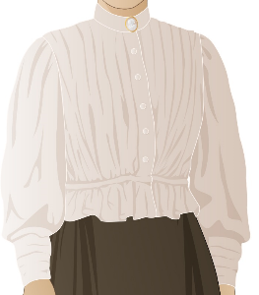 | socialist  A person who advocates socialism (a theory of creating a more equal society and the elimination of extreme wealth).  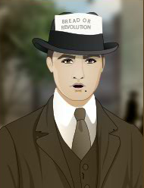
strike  A form of protest in which a group of employees refuses to work as part of an attempt to get their employer to agree to make certain changes.  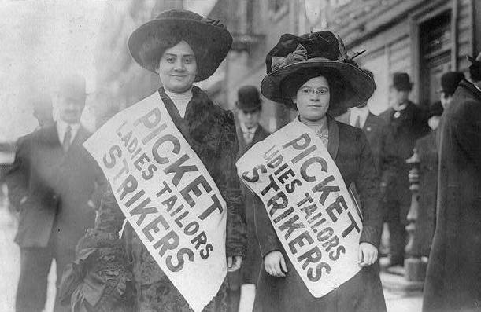 | underestimate    To think that something is smaller or less important than it actually is.

adamant | discourage
excessive | exposé
firebrand | forelady
gentiles | grievances
negotiate | operator
pay envelope  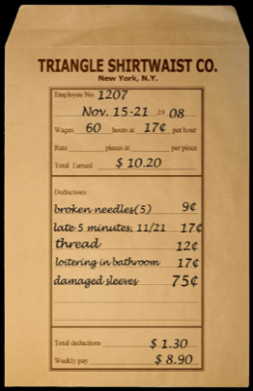 | serfs
shirtwaist | socialist
strike | underestimate

Persons who are not Jewish. | Reasons for complaint or protest, especially unfair treatment.
To try to reach an agreement or compromise through discussion with others. | A sewing machine worker.
An envelope containing an employee’s weekly wages on which employers record the work completed and amount earned by the employee. that week. | Landless peasants who are forced to work for the landowners; part of the feudal system in Europe and Russia.
A women’s blouse or shirt that could easily be worn with any skirt and was popular with American working women in the early twentieth century. | A person who advocates socialism (a theory of creating a more equal society and the elimination of extreme wealth).
A form of protest in which a group of employees refuses to work as part of an attempt to get their employer to agree to make certain changes. | To think that something is smaller or less important than it actually is.

Name: Date:

This activity imagines Lena is making a speech to New York City students and community residents in 1982, seventy years after the events in “City of Immigrants.” Lena is discussing what life was like on the Lower East Side in the early twentieth century.

Instructions: After reading and talking about the words and terms on the flash cards, read this excerpt from Lena’s speech. Use the cards and your memory to help fill in the missing words and terms. Some words may be used more than once.

adamant  discourage  excessive  exposé | firebrand  forelady  gentiles  grievances | negotiate  operator  pay envelope  serfs | shirtwaist  socialist  strike  underestimate

“After my friend Rosa got a good job in a factory, I tried to get a job there, too. It was at the Triangle Shirtwaist Factory. __________________ were all the rage back then--all the women were wearing them. I got a job as an __________________. I was surprised that they weren’t closed for Shabbos, but maybe it was because so many __________________ worked there.

The __________________ was very strict. She would __________________ us from using the restroom when it wasn’t a break. If she thought you were in the restroom for an __________________ amount of time, you would get a deduction from your __________________. You could get money taken away for making mistakes, being late, and money other reasons. So, even though I was making more money, I was always worried about how much money I’d get to take home.

Many people were unhappy about the conditions in the factory. I heard a __________________ talking about how the factory owners treated us like __________________. I met a reporter who wanted to write an __________________ about the factory. Many people wanted the factory to change.

I heard about Clara Lemlich. She was a real __________________! She was __________________ that the factory owners would __________________ the power of the workers joining together.

Some workers became active in the ILGWU, the International Ladies’ Garment Workers Union. The factory owners wouldn’t listen to a single worker, but maybe the union would be able to discuss our __________________. The union would try to __________________ for better working conditions and more pay. Some people thought conditions in the factory were so bad that it was time to walk out in a __________________. It was exciting, but also a little scary. Nobody knew what would come next.”

A NOTE TO THE EDUCATOR:
You will need to decide how best to share these writing prompts with your students. You might share them all and ask students to choose one to respond to. You may assign one or more to the entire group. You might make one or more of the topics the basis for in-class discussions. Make your decisions according to the needs of your group.

You may notice that many of the topics contain some version of the phrase, “Write about a time in your life…” The intention of these prompts is twofold: first, since students remember the content of their own lives, they can more easily respond to the questions and they are more likely to want to express themselves if they feel competent to do so; second, these questions can form a meaningful bridge between what happens in the lives of ordinary people today and the lives of people in history or in historical events. For these reasons, you might decide to use some of the prompts before students encounter the history, because thinking about them sets the students up to understand and relate to it better.

Since students vary in their degree of comfort and skill in writing, you should decide when and how much students should write. We suggest that since students need to share their writing with each other to make personal and historical connections, you should encourage them to focus on content rather than mechanical skills. Pieces can be revised and edited later if you decide they should be shared formally, such as on a bulletin board or in a newsletter.

Read through all the topics first, and then choose one of them to write about. Write the title of the piece at the top of your page. Write in complete sentences and proofread your work.

HAIR STYLE. When Rosa begins a new job, she changes her hair style to look like a girl in the magazine. Where do you get ideas about your own hair style? Describe some of your own styling inspirations. Have you ever changed your look based on something you saw in a magazine?

TO WORK OR NOT TO WORK. Lena must decide if she will be willing to break her tradition of not working on the Jewish Sabbath (Shabbos) in order to keep her job at the Triangle factory. Do you agree with her decision? Why or why not?

FACTORY BLUES. When Lena started her job at the factory she did not know how anything worked. She was unsure about how to act, when to talk, and even where the bathroom was located. Write about a time where you were in a new place and felt unsure about how things worked. Describe where you were, how you felt, and what helped you to become comfortable.

REPORTING THE STORY. When approached by a reporter, Lena must decide if she will share her experience as a garment worker for the expose. What are the pros and cons of Lena sharing her story? If you were going to write an expose about the garment industry that Lena works in, what would you include in your story? What questions would you want to ask Lena if you could interview her?

PAY DAY. At the end of Part 4, Lena decides how to spend her earnings. How did you to determine what Lena should spend her money on? Think about a time you earned money. What did you spend it on and what helped you make your decisions.

LENA’S DIARY. Through Lena’s eyes, think about your circumstances from the beginning to the end of this part of “City of Immigrants.” Share your emotions and feelings about each step of the journey. Think about the people with whom you interacted, and what you learned from them. Think about the choices you made and the consequences of those choices. Now write a diary entry from Lena’s point-of-view summarizing what happened to you in Part 3. You may choose to illustrate one aspect of your entry.

A NOTE TO THE EDUCATOR:

The purpose of these questions is to check the students’ understanding of the action of the game and the history embedded in that action. Since the outcome of gameplay can vary depending on the choices the student makes, the answers to the questions might also vary.

Some students might learn information later than others, or not at all. If you choose to discuss students’ responses as a whole group, information can be shared among all your “Lenas.”

There may be more questions here than you want your students to answer in one sitting or in one evening. In that case, choose the questions you feel are most essential for their understanding of Part 4.

Feel free to copy the following pages of this activity for your students.

If you are not planning to have your students write the answers to the questions, you’ll need to modify the directions.

Name: ___________________________ Date:_____________________

Directions: After you play Part 4, read and answer these questions from the point of view of your character, Lena. You may not know all the answers, so do the best you can. Write in complete sentences and proofread your work.

1) What happened to Lena’s family in Minsk?

2) What happened to Lena’s family in New York City?

3) How did you find out about the job at the factory?

4) How did you get to the factory on the first day?

5) What did you have to do in order to get a job?

6) What rules must the workers at the factory follow?

7) What was happening in the park while you and Rosa were eating lunch?

8) How much money did you make in your first week at the factory? Was any money deducted from your wages? If so, for what?

9) Did you talk to the reporter in front of the factory? Why or why not? What did he say?

10) What did you do with your wages?

11) On this day, you may have met the following people. Make a note or two about them next to each name. For this question, your notes don’t have to be in complete sentences.
a. Miss Sherman –

b. James Poole –

A NOTE TO THE EDUCATOR:

The purpose of these questions is to check the students’ understanding of the action of the game and the history embedded in that action. Since the outcome of gameplay can vary depending on the choices the student makes, the answers to the questions might also vary.

Some students might learn information later than others, or not at all. If you choose to discuss students’ responses as a whole group, information can be shared among all your “Lenas.”

There may be more questions here than you want your students to answer in one sitting or in one evening. In that case, choose the questions you feel are most essential for their understanding of Part 4.

Feel free to copy the following pages of this activity for your students.

If you are not planning to have your students write the answers to the questions, you’ll need to modify the directions.

Name: ___________________________ Date:_____________________

Directions: After you play Part 4, read and answer these questions from the point of view of your character, Lena. You may not know all the answers, so do the best you can. Write in complete sentences and proofread your work.

1) What happened to Lena’s family in Minsk?
The family’s shop was burned but nobody was hurt.

2) What happened to Lena’s family in New York City?
Isaac opened a shop, Brodsky’s Hone Goods. Sophie was born.

3) How did you find out about the job at the factory?
Rosa started working there and told me about it.

4) How did you get to the factory on the first day?
I took the streetcar because I didn’t know how to get to the factory.

5) What did you have to do in order to get a job?
I had to show them that I could sew.

6) What rules must the workers at the factory follow?
Factory workers are not allowed to talk to each other. They must ask permission to go to the bathroom.

7) What was happening in the park while you and Rosa were eating lunch?
A man was giving a speech about socialism.

8) How much money did you make in your first week at the factory? Was any money deducted from your wages? If so, for what?
I made ten dollars, but almost three dollars was deducted for being late one day, breaking needles, and loitering in the bathroom.

9) Did you talk to the reporter in front of the factory? Why or why not? What did he say?
I talked to the reporter to find out why he was there. He said that the workers should work together to negotiate for better wages and hours.

10) What did you do with your wages?
I saved most of it for bringing my parents over from Minsk. I spent some of it on a ticket to the Yiddish theater.

11) On this day, you may have met the following people. Make a note or two about them next to each name. For this question, your notes don’t have to be in complete sentences.
a. Miss Sherman – She is the forelady at the shop. She is very strict.

b. James Poole – He is a reporter. He is interested in the working conditions inside of the factory.

Strike
On November 23, 1909, twenty thousand young Jewish immigrant women launched a strike in New York’s shirtwaist industry. Shirtwaists, or blouses, became popular in the 1890s and became a symbol of the independent, working woman. Like Lena and Rosa, the women who worked in the shirtwaist factories shared a variety of workplace grievances, including low wages, long hours, arbitrary fines, and forced overtime. In what became known as the Uprising of the 20,000, the strikers courageously picketed for eleven weeks, while facing opposition from the manufacturers, the courts, and even the police. The strikers’ cause was supported by a variety of progressives, including the Women’s Trade Union League, a group of middle-and upper-class women who supported the reform efforts. Although not a complete victory, by February 1910, many employers had signed union contracts. The uprising became a powerful symbol within the garment industry, signaling the strength of women organizing. In this activity, students examine a variety of primary sources exploring the strike from different perspectives: the garment workers, their employers, and some of the strike’s supporters.

A NOTE TO THE EDUCATOR
While Lena’s journey to America is fictional, her story is based upon the actual experience that millions of immigrants went through at the turn of the twentieth century. The primary source documents included in this activity complement Lena’s story and will introduce your students to historic records exploring the Uprising of the 20,000. Each primary source highlights an aspect of the strike experience. Information about each source and guiding questions are also included to support student exploration of each document.

Activity Components
- About the Documents: Information about each source to help you prepare to use it in the classroom
- Guiding Questions: Prompts to support student exploration of each document.
- Primary Sources:
  - Document 1: The Cooper Union Meeting of 1909
  - Document 2: “Miss Morgan Aids Girl Waiststrikers”
  - Document 3: Statement of Shirtwaist Employers
  - Document 4: Photographs documenting the Uprising
  - Document 5: “Women in a Labor War” Article
- Culminating Activity to help students explore the multiple perspectives surrounding the strike.

This activity is designed for you to determine how many components to use with your students. The following procedure is recommended and can be adapted based on your curricular goals and timing constraints.
Steps to Complete
The following procedure is recommended for this activity and can be adapted based on your curricular goals and timing constraints.
- Distribute primary source document(s) to students.
- Have students work independently or in small groups to investigate the document(s) with the goal of learning as much as they can about the Uprising of the 20,000. Students can record their findings in the included chart.

- Select guiding questions to help your students investigate each source. You can give your students all of the guiding questions or choose a few for them to respond to.

- Have students present their findings to the class or a fellow student and share what was learned.
- Assign students to take on the perspective of the people involved in the Uprising of the 20,000. Divide students into three categories: garment workers, employers, and wealthy supporters. Students should use the information they uncovered from the primary source document(s) to determine their group’s argument regarding the merits of the strike. Students can share their views in the form of a live debate or as a written statement articulating their ideas regarding the strike.
About the Documents

Document 1: The Cooper Union Meeting of 1909
On November 22, 1909, Samuel Gompers and other political activists and labor leaders gathered at Cooper Union for a mass meeting to address the shirtwaist workers. While many leaders like Gompers noted the terrible working conditions faced by workers, they also urged workers to consider the impact of a strike in light of the loss of pay it would bring. During the meeting, 19-year old Clara Lemlich interrupted the speeches and addressed the crowd. In Yiddish, Lemlich appealed for united action against manufacturers in the form of a general strike by the shirtwaist workers in New York. Her motion was unanimously approved and sparked the beginning of the Uprising of the 20,000.

Document 2: “Miss Morgan Aids Girl Waiststrikers”
Anne Tracy Morgan became a member of the Women’s Trade Union League (WTUL), a group of educated women that supported the struggles of working class women, which some newspapers dubbed “The Mink Brigade.” Anne, the daughter of the powerful financier J.P. Morgan, used her family's wealth and connections to support the Uprising of the 20,000. The WTUL was organized in 1903 by middle and upper class women to help working women unionize and improve their working conditions. They helped fund the strike, picketed with the workers in the hopes that their presence would limit police brutality, and provided legal representation for women who were arrested.

Document 3: Statement of Shirtwaist Employers
Shirtwaist Employers did not want to make concessions to the strikers. As employers, they did not want to have regulations regarding wages, work conditions, and hours their employees could work as this would limit their profit. In this editorial, George S. Lewy, a representative of the Dress and Waist Manufacturers' Association, wrote to the New York Times to clarify the view of the shirtwaist employers and why a strike was bad for business and for all New Yorkers.

Document 4: Photographs of the Strike
Throughout the Uprising of the 20,000, women united to fight for the right to organize the shirtwaist industry even when threatened with police brutality and the risk of unemployment. These images show women raising their hands to pledge support for the strike, picketing on the streets, and being taken to Jefferson Market Prison after being arrested for their involvement.

Document 5: “Women in a Labor War” Article
This article was published in Munsey’s Magazine, a popular weekly magazine, in April 1910. The article describes the shirtwaist strike and the young women’s efforts to win better working conditions and the right to organize labor unions. The article aims to show the women’s strength and commitment—that they went without wages and sometimes even food, and refused to stop striking before all of their demands were met

Guiding Questions
Document 1: The Cooper Union Meeting of 1909
- Read the account. What information does it provide about the meeting?
- Look carefully at the photograph. What can you learn about the people in the audience and on stage, (gender, clothing, appearance, numbers)?
- Based on the article, what are the pros and cons of going on strike?
- Compare and contrast Samuel Gompers’ speech with Clara Lemlich’s?
- Why were the workers motivated to strike after Clara Lemlich’s speech?
- What questions does this document raise for you?
- In what ways can this document inform our understanding of Lena’s experience as a garment worker?

Document 2: “Miss Morgan Aids Girl Waiststrikers”
- Read the account. What information does it provide about the strike?
- What does this document tell us about Miss Morgan?
- Why does Miss Morgan support the strike?
- In what ways will the strike protect the workers according to Miss Morgan?
- What questions does this document raise for you?
- In what ways can this document inform our understanding of Lena’s experience in America?

Document 3: Statement of Shirtwaist Employers
- Read the account. What information does it provide about the strike?
- What tone does this article take? Can you provide examples?
- What are the pros and cons of the strike from the perspective of the employers?
- How do the employers view the strikers?
- According to the owners, what are the consequences of the strike for New York City?
- What questions does this document raise for you?
- In what ways can this document inform our understanding of Lena’s experience in America?

Document 4: Photographs of the Strike
- What do these images tell us about the Uprising of the 20,000?
- Describe the people striking? What can we learn about them from the images (age, gender, etc.)?
- If you were an employer, how would you feel about the strikers in the pictures?
- If you were a worker, how would you feel about the strikers in the pictures?
- If you could “enter” a photograph, what might you hear, feel, and smell?
- Based on an image, how would you describe the experience of being a shirtwaist striker?
- What are the risks of being a striker?
- What questions do these documents raise for you?
- In what ways can these documents inform our understanding of Lena’s experience in America?

Document 5: “Women in a Labor War” Article
- Read the account. What information does it provide about the strike?
- Based on the article, how would you describe the experience of being a shirtwaist striker?
- What are the risks of being a striker?
- What were the terms offered by the employers?
- Why was union recognition important?
- Why were the workers motivated to continue to strike after the older man spoke?
- In what ways have women changed based on the article?
- What questions do these documents raise for you?
- In what ways can these documents inform our understanding of Lena’s experience in America?
Strike
Uprising of the 20,000
Use the organizer to record your findings on the Uprising of the 20,000
Arguments in support of the strike

Arguments against the strike

Strike
Document 1: “The Cooper Union Meeting of 1909” The Call, November 23, 1909
The Uprising of the 20,000 began with a mass meeting at Cooper Union where the decision to strike was made. This photograph shows the labor leader Samuel Gompers addressing the great crowd. This excerpt is from an article, first published in The Call, a pro-union newspaper, on November 23, 1909.

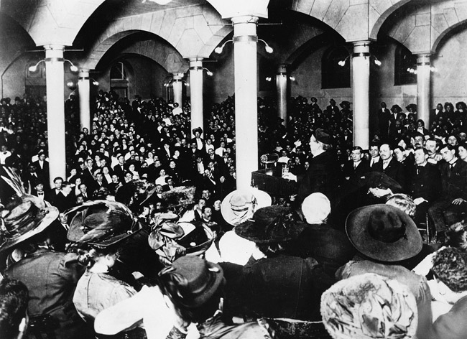

Cooper Union Meeting, taken by Brown Brothers, November 22, 1909, Kheel Center Collection

The decision to strike was reached yesterday at the Cooper Union meeting which was addressed by Samuel Gompers, president of the AFL. Gompers was given an ovation when he was introduced by Chairman Benjamin Feigenbaum. The vast crowd rose to its feet and cheered him very enthusiastically for several minutes.
Gompers said: "I have never declared a strike in all my life. I have done my share to prevent strikes, but there comes a time when not to strike is but to rivet the chains of slavery upon our wrists."
Speaking of the possibility of a general strike, Gompers said: "Yes, Mr. Shirtwaist Manufacturer, it may be inconvenient for you if your boys and girls go out on strike, but there are things of more importance than your convenience and your profit. There are the lives of the boys and girls working in your business."
Appealing to the men and women to stand together, he declared: 'If you had an organization before this, it would have stood there as a challenge to the employers who sought to impose such conditions as you bear.
"This is the time and the opportunity, and I doubt if you let it pass whether it can be created again in five or ten years or a generation. I say, friends, do not enter too hastily but when you can't get the manufacturers to give you what you want, then strike. And when you strike, let the manufacturers know you are on strike!
"I ask you to stand together," said Gompers in conclusion, "to have faith in yourselves, to be true to your comrades. If you strike, be cool, calm, collected and determined. Let your watchword be: Union and progress, and until then no surrender!" This was greeted with a storm of applause.
Clara Lemlich, who was badly beaten up by thugs during the strike in the shop of Louis Leiserson, interrupted Jacob Panken just as he started to speak, saying: "I wanted to say a few words." Cries came from all parts of the hall, "Getup on the platform!" Willing hands lifted the frail little girl with flashing black eyes to the stage, and she said simply: "I have listened to all the speakers. I would not have further patience for talk, as I am one of those who feels and suffers from the things pictured. I move that we go on a general strike!"
As the tremulous voice of the girl died away, the audience rose en masse and cheered her to the echo. A grim sea of faces, with high purpose and resolve, they shouted and cheered the declaration of war for living conditions hoarsely.

Strike
Document 2: “Miss Morgan Aids Girl Waiststrikers”
Source: New York Times, December 14, 1909

Anne Morgan was the daughter of the powerful financier J.P. Morgan. She used her family's wealth and connections to bring attention to the plight of immigrant women workers. In 1909, she joined the Women's Trade Union League (WTUL), which helped mobilize worker strikes across the city during the Uprising of the 20,000.

MISS MORGAN AIDS GIRL WAISTSTRKERS
We Can’t Live Our Own Lives, She Says, Without Doing Something to Help Them

Miss Anne Morgan, daughter of J. Pierpont Morgan, is a recent applicant for membership in the Women’s Trade Union League and when her name has been passed upon she will become a regular member, paying $1 a year, which is the fee. This is the league to which the striking shirtwaist makers belong, and the application for membership means that Miss Morgan is interested in the attempt these girls are making for their own betterment. In Joining the league she gives her moral support. . . .

Miss Morgan Tells of Strike,

“I have only known something of this strike for a short time,” said Miss Morgan to a Times reporter last night, “and I find other people to whose attention it has not been brought do not know anything about it. If we come to fully recognize these conditions we can’t live our own lives without doing something to help them, bringing them at least the support of public opinion.

“We can see from the general trade conditions how difficult it must be for these girls to get along. Of course, the consumer must be protected, but when you hear of a women who presses forty dozen skirts for $8 a week something must be very wrong. And fifty-two hours a week seems little enough to ask.

“Rose Schniederman told me of a woman who had worked in box shop in Chicago for thirty years and could not get in ten hours a day make enough to live on-she could only do by working twelve to fourteen hours. Those conditions are terrible, and the girls must be helped to organize and to keep up the organizations, and if public opinion is on their side they will be able to do it.”

Strike
Document 3 : Statement of Shirtwaist Employers, Editorial by George S. Lewy
Source: The New York Times, December 18, 1909

SHIRTWAIST EMPLOYERS
Their Statement of the Issues Involved In the Strike.

To the Editor of the New York Times:
…The employers are not ready to make practically all the concessions asked for. They will not agree to employ only union labor; they will not agree to give up their right to employ and to discharge whom they see fit; they will not consent to having prices for work established without having a voice in the matter, nor will they allow a delegate to interfere in the running of their factories.

They cannot agree to keep at work employees for whom there is no work to do, as they are not running eleemosynary [supported by charity] institutions, nor are they able to regulate the law of supply and demand which governs the waistmaking industry as it does all other. If the workers will so regulate the demand of the consumer that it shall run evenly through the year instead of being divided in “seasons,” as at present, the employers will be glad to keep everyone at work all the time….

The strikers cannot win if they refrain from intimidation and violence, as the shops are gradually filling up with satisfied workers. That they do not refrain is evidenced by the by the nightly riots in the district occupied by the waistmaking industry and the Police Court records. They attack workers, not only as they leave the shops, but as they leave and arrive at their homes. And we manufacturers are practically requested to sit supinely and have our working people beaten without attempt to give them protections.

The ultimate result of the strikers’ present tactics, if successful, would be to drive from New York to other cities an industry employing over $75,000,000 capital…
Strike
Document 4: Photographs of the Uprising of the 20,000
Source: The Kheel Center for Labor-Management Documentation and Archives

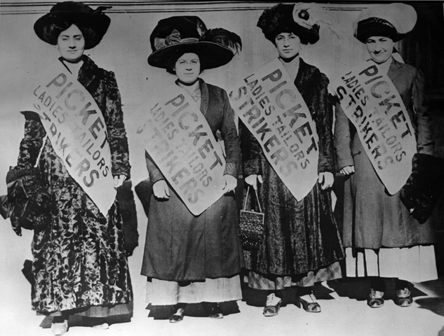
During the Uprising of the 20,000, women fought for the right to organize the shirtwaist industry. These images show women raising their hands to pledge their support for the strike, picketing on the streets, and being taken to Jefferson Market Prison after being arrested for their involvement.
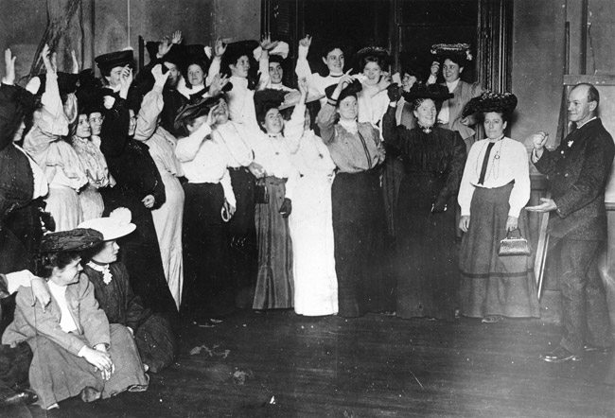

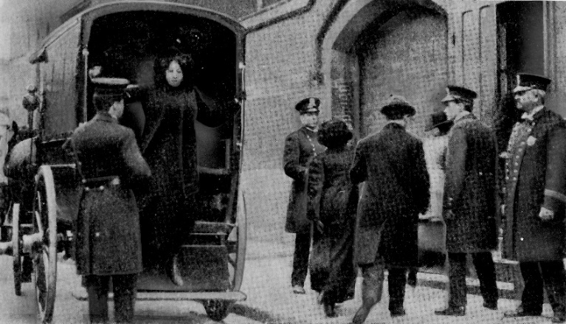

Strike
Document 5: “Women in a Labor War” Article
SOURCE: Allan L. Benson, “Women in a Labor War,” Munsey’s Magazine xliii:1 (April 1910): 68-76.

Women In a Labor War: How the Working Girls of the New York East Side Have Learned to Use Men’s Weapons in a Struggle for Better Conditions

When they “picketed” the factories and tried to prevent other women from taking their
places, there were excitement and some disorder in the streets. In the scuffling, some of the girls were grabbed by the hair, and their heads were bumped against the curbstones. Never mind—let the strike go on!

More than six hundred were arrested, and a score were sent to the workhouse. What of it?
Merely incidents of industrial warfare—let the strike proceed!

The six thousand who stayed out to the bitter end after the other twenty-four thousand had won their victory were actually starving. One day, on a single street, out of thirty pickets, twenty-eight fell in their tracks. It was not magnificent—just industrial war. Forget it, and remember the strike!

Then came the day when the employers of the remaining six thousand offered terms of peace. Back to the Cooper Union—read the terms. What were they?

As terms go, they were liberal. Every demand was granted except one. But that one rejected grievance—no union! Not recognized! Spurned, ignored, thrown out of court!

Starving girls were called upon to say what they would do. They filled the hall. A patriarchal Jew of seventy began to speak. He told his hearers that he was one of the few men engaged in the shirtwaist industry. He was the father of nine children. he knew what hunger was; he knew what cold was; he knew what work was. Also, he knew what visions were made of, for he himself had dreamed of a happier day when the union should protect them all. . . .

Some of them had only an apple for breakfast, and nothing afterward. If the strike were to be ended upon the proffered terms, conditions would be better than they had ever been before. If the strike were to go on, there would be an indefinite continuation of bread and soup—and, in a little while, there might be no bread. An advance (progress) of twenty years had been made in the last two months; wouldn’t it be better to rest content for a while—even without the union?

When he finished speaking, no one replied. Three thousand girls sat in stunned silence. For twenty full seconds, there was not the rustling of a foot nor the sound of a voice. Then, in unison, as if the three thousand girls had been trained for a month to do what they were about to do, there swept over the hall a mighty sob. . . . But the assembled girls had not yet spoken. Having sobbed, they were ready to speak. And, what was the order that these starving strikers unanimously gave? Here it is:

“Burn the [offered] terms of the employers and go on with the strike.”

And they went out again into the cold, with their shivering bodies, their empty stomachs, and their heavy hearts. They had kept their oath.

Yes, indeed, women have changed.

Fifty years ago, women would never have waged such a desperate fight, in mid-winter, against five hundred employers. They hadn’t been prepared. They hadn’t learned to fight the world as men fight it for a living. But they are learning—learning in the same school in which man learned.

A NOTE TO THE EDUCATOR:

On the following pages, you will find “flashcards” with terms and definitions (both combined and separate) that your students may encounter while playing Part 5 of “City of Immigrants.” These terms and definitions can be introduced and practiced before or during the time students see or hear them in the context of MISSION US or in their American history study. The discussion questions and writing prompts will provide further opportunities for students to have more practice with the words and terms.

Divide your students into small groups of four or five, and ask each group to review the terms and definitions.

After your students have had a chance to review and discuss the terms and definitions, distribute the excerpt from the reporter’s interview with Lena. Review the directions with your students and ask them to complete the text using the terms they studied.

Here are the terms which should be inserted into each paragraph of Lena’s life story:
Paragraph 2- picketing, goys
Paragraph 3- socialites, muckrakers
Paragraph 4- toughs
Paragraph 5- scabs, vigilant, magistrate

Photography Credits
Socialites: New York Times

goy  Yiddish word meaning a person who is not Jewish. | magistrate    A judge who may conduct trials and impose penalties for minor criminal offenses.
muckrakers  American journalists at the turn of the century who searched for and exposed problems or other unpleasant facts in order to make them public.  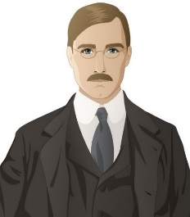 |   picketing  Standing outside a location (e.g., a factory) and attempting to persuade others not to enter the location for a specific reason, such as a strike.
scabs  A disparaging (negative) word for workers who refuse to strike or who help company management during a strike. Also referred to as “strike breakers.”  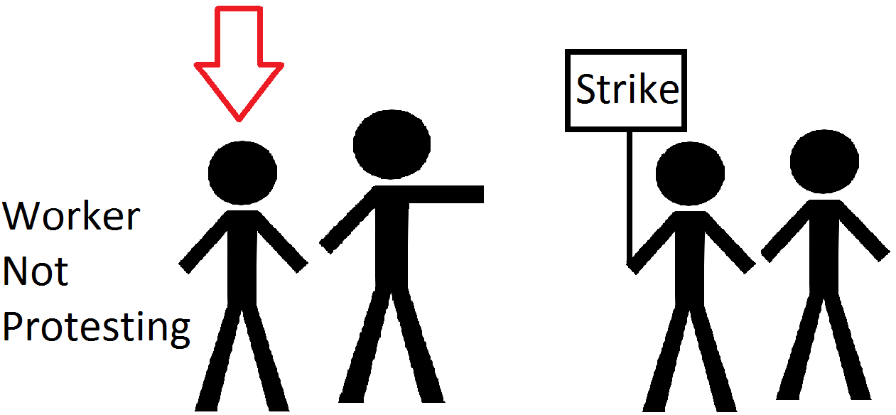 | socialites  Persons in upper-class society who are well-known for hosting or participating in social events such as parties and fundraisers.  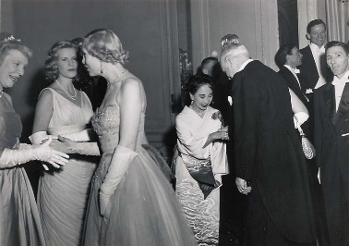
toughs  Groups of men hired by company management to assist scabs and physically intimidate or restrain picketers. Also referred to as “thugs” or “scab chaperones.”  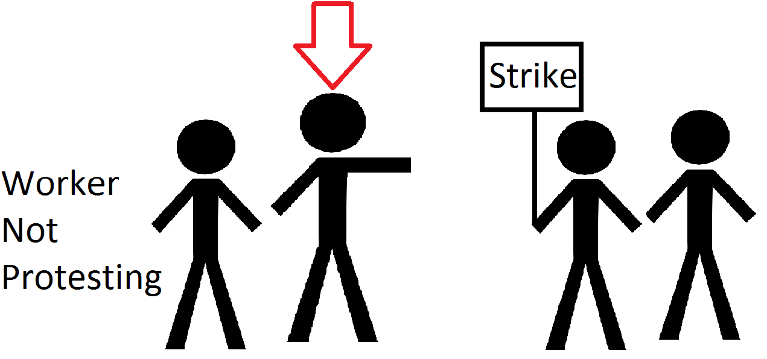 | vigilant  Keeping careful watch for possible danger or difficulties.  

goy | magistrate  
muckrakers  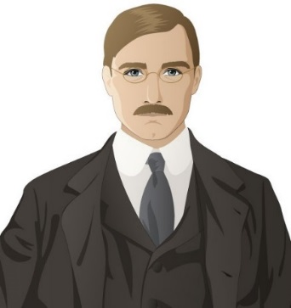 | picketing
scabs | socialites  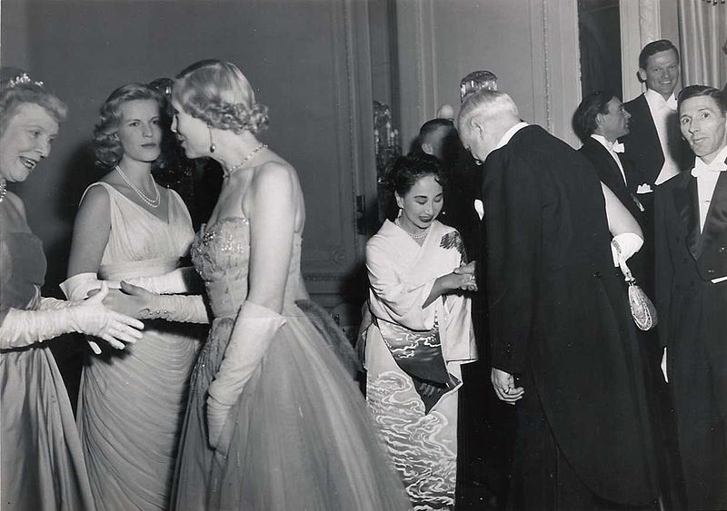
toughs | vigilant

Yiddish word meaning a person who is not Jewish. | A judge who may conduct trials and impose penalties for minor criminal offenses
American journalists at the turn of the century who searched for and exposed problems or other unpleasant facts in order to make them public. | Standing outside a location (e.g., a factory) and attempting to persuade others not to enter the location for a specific reason, such as a strike.
A disparaging (negative) word for workers who refuse to strike or who help company management during a strike. Also referred to as “strike breakers.” | Persons in upper-class society who are well-known for hosting or participating in social events such as parties and fundraisers
Groups of men hired by company management to assist scabs and physically intimidate or restrain picketers. Also referred to as “thugs” or “scab chaperones.” | Keeping careful watch for possible danger or difficulties.

Name: Date:

This activity imagines Lena is making a speech to New York City students and community residents in 1982, seventy years after the events in “City of Immigrants.” Lena is discussing what life was like on the Lower East Side in the early 20th century.

Instructions: After reading and talking about the words and terms on the flash cards, read this excerpt from Lena’s speech. Use the cards and your memory to help fill in the missing words and terms. Some words may be used more than once.

goys  magistrate | muckrakers  picketing | scabs  socialites | toughs  vigilant

“One day I woke up and learned that the ILGWU had voted to go on strike. At first I wasn’t sure what to do. My family needed me to work. At the same time, maybe the strike would make things better at the factory.

When I got to the factory, I saw that some people had signs and were __________________. The strike made all types of women join together. Both Jews and __________________ stood on the picket lines.

It wasn’t just workers, either. Some wealthy __________________ were there supporting the strike. A few __________________ were trying to find out information for the newspapers.

Not all the workers had joined the strike, however. I saw some people go into the factory to work. The factory had hired __________________ to make sure they got into the factory. You had to be careful.

I learned not to call the people still working __________________. If a policeman heard you do that you could get arrested. You could also get in trouble if you weren’t __________________ and if you accidently touched a worker. If you got arrested you’d be sent to jail and you’d have to appear in front of the __________________. It was difficult deciding the right things to do!”

A NOTE TO THE EDUCATOR:

You will need to decide how best to share these writing prompts with your students. You might share them all and ask students to choose one to respond to. You may assign one or more to the entire group. You might make one or more of the topics the basis for in-class discussions. Make your decisions according to the needs of your group.

You may notice that many of the topics contain some version of the phrase, “Write about a time in your life…” The intention of these prompts is twofold: first, since students remember the content of their own lives, they can more easily respond to the questions, and they are more likely to want to express themselves if they feel competent to do so; second, these questions can form a meaningful bridge between what happens in the lives of ordinary people today and the lives of people in history or in historical events. For these reasons, you might decide to use some of the prompts before students encounter the history, because thinking about them sets the students up to understand and relate to it better.

Since students vary in their degree of comfort and skill in writing, you should decide when and how much students should write. We suggest that since students need to share their writing with each other to make personal and historical connections, you should encourage them to focus on content rather than mechanical skills. Pieces can be revised and edited later if you decide they should be shared formally, such as on a bulletin board or in a newsletter.

Read through all the topics first, and then choose one of them to write about. Write the title of the piece at the top of your page. Write in complete sentences. After you are finished, proofread your work.

CHANGING TIMES. Upon turning sixteen, Lena remarks that her mother was already married at this age. Think about your own parent’s lives or talk to them about what it was like for them when they were your age. Describe how your life is different from what their life was like at your age.

STRIKE? In Part 5, Lena must decide whether or not she will strike. Write about the pros and cons of joining the strike and determine whether or not you think Lena should strike and why.

MEMBERSHIP. Lena and Rosa must decide if they will go to a meeting and become members of the union. Have you ever been a member of a club? Describe the club you were part of and what made you want to join. What was it like to be part of the group?

SOAPBOX STAND. In Washington Square Park, people used to stand on a soapbox and talk about what was important to them. In the game, Clara Lemelich stood on a soapbox to talk about her belief in the union. If you could stand on a soapbox, what issue would you want to discuss? Describe what you would say and how you would teach others about the issue.

GOD AND NATURE. The judge told the women strikers that their strike was “against God and nature.” Why do you think the judge views the women’s actions as something that is against the natural order of how the world works? Today, there continues to be issues that are seen differently between the public and lawmakers. Write about a contemporary issue for which there is a contrasting view between some lawmakers and the public. Explain the point of view of each group on the issue you choose to write about.

LENA’S DIARY. Through Lena’s eyes, think about your circumstances from the beginning to the end of this part of “City of Immigrants.” Share your emotions and feelings about each step of the journey. Think about the people with whom you interacted, and what you learned from them. Think about the choices you made and the consequences of those choices. Now write a diary entry from Lena’s point-of-view summarizing what happened to you in Part 5. You may choose to illustrate one aspect of your entry.

A NOTE TO THE EDUCATOR:

The purpose of these questions is to check the students’ understanding of the action of the game and the history embedded in that action. Since the outcome of gameplay can vary depending on the choices the student makes, the answers to the questions might also vary.

Some students might learn information later than others, or not at all. If you choose to discuss students’ responses as a whole group, information can be shared among all your “Lenas.”

There may be more questions here than you want your students to answer in one sitting or in one evening. In that case, choose the questions you feel are most essential for their understanding of Part 5.

Feel free to copy the following pages of this activity for your students.

If you are not planning to have your students write the answers to the questions, you’ll need to modify the directions.

Name: ___________________________ Date:_____________________

Directions: After you play Part 5, read and answer these questions from the point of view of your character, Lena. You may not know all the answers, so do the best you can. Write in complete sentences and proofread your work.

1) What is the ILGWU?

2) Many people offered advice about whether you should join the strike or continue working. Who did you agree with the most? Why?

3) How did the workers support themselves while they were on strike?

4) What were two rules the picketers had to follow?

5) What happened when you joined the picket line?

6) How did the union support you?

7) Did Rosa join the union? What influenced her decision?

8) How was your family affected by the strike?

9) What did you decide to do after coming home and talking to Isaac?

10) On this day, you may have met the following people. Make a note or two about them next to each name. For this question, your notes don’t have to be in complete sentences.
a. Zev –

b. Miss Walker–

c. The Union Representative –

d. Helena –

A NOTE TO THE EDUCATOR:

The purpose of these questions is to check the students’ understanding of the action of the game and the history embedded in that action. Since the outcome of gameplay can vary depending on the choices the student makes, the answers to the questions might also vary.

Some students might learn information later than others, or not at all. If you choose to discuss students’ responses as a whole group, information can be shared among all your “Lenas.”

There may be more questions here than you want your students to answer in one sitting or in one evening. In that case, choose the questions you feel are most essential for their understanding of Part 5.

Feel free to copy the following pages of this activity for your students.

If you are not planning to have your students write the answers to the questions, you’ll need to modify the directions.

Name: ___________________________ Date:_____________________

Directions: After you play Part 5, read and answer these questions from the point of view of your character, Lena. You may not know all the answers, so do the best you can. Write in complete sentences and proofread your work.

1) What is the ILGWU?
The ILGWU stands for the International Lady’s Garment Workers Union.

2) Many people offered advice about whether you should join the strike or continue working. Who did you agree with the most? Why?
I agreed with Sonya. Joining the strike was risky, but it might make things better for everyone.

3) How did the workers support themselves while they were on strike?
The union had a strike fund that gave money to people on strike.

4) What were two rules the picketers had to follow?
Don’t walk in groups of more than two or three. Don’t call anyone a “scab” or use abusive language.

5) What happened when you joined the picket line?
I tried to obey the rules but I still got arrested for disrupting the peace.

6) How did the union support you?
The union offered to pay the fine after I was arrested. They gave me money from the strike fund.

7) Did Rosa join the union? What influenced her decision?
Rosa joined the union after Lena was arrested.

8) How was your family affected by the strike?
The Brodsky’s had little food. They couldn’t afford electricity.

9) What did you decide to do after coming home and talking to Isaac?
I decided to go back to work at the Triangle Shirtwaist Factory. They increased our pay, so the strike was successful.

10) On this day, you may have met the following people. Make a note or two about them next to each name. For this question, your notes don’t have to be in complete sentences.
a. Zev – Zev is working as a tough, trying to help strike breakers get to work.

b. Miss Walker– She didn’t work at the factory but she still joined the strike.

c. The Union Representative – He encouraged me to join the union and told me what to do when I am picketing.
d. Helena – She is a girl who is younger than Lena and recently joined the strike.

A NOTE TO THE EDUCATOR:

You will need to decide how best to share these writing prompts with your students. You might share them all, and ask students to choose one to respond to. You may assign one or more to the entire group. You might make one or more of the topics the basis for in-class discussions. Where there are multiple questions in a single prompt, choose the question or questions that best suit your students. Make your decisions according to the needs of your group.

You may notice that many of the topics contain some version of the phrase, “Write about a time in your life…” The intention of these prompts is twofold: first, since students remember the content of their own lives, they can more easily respond to the questions, and are more likely to want to express themselves if they feel competent to do so; second, these questions can form a meaningful bridge between what happens in the lives of ordinary people today and the lives of people in history or in historical events. For these reasons, you might decide to use some of the prompts before students encounter the history, because thinking about them sets the students up to understand and relate to the material better.

Since students vary in their degree of comfort and writing skill, you should decide when and how much students should write. We suggest that since students need to share their writing with each other to make personal and historical connections, you should encourage them to focus on content rather than mechanical skills. Pieces can be revised and edited later if you decide they should be shared formally, such as on a bulletin board or in a newsletter.

Read through all the topics first, and then choose one of them to write about. Write the title of the piece at the top of your page. Write in complete sentences. After you are finished, proofread your work.

TROUBLEMAKER. Lena is able to go back to work because she was not considered a “troublemaker” by her boss at the Triangle Factory. Write about a time when someone labeled you negatively. How did it make you feel to be called the name? Were there ways that you could change the way people saw you?

WORST DAY. Lena calls the day of the Triangle Factory Fire the worst day of her life. What do you think made this day so terrible? Think about a time where you had a terrible day. Describe the circumstance of your worst day and how you were able to get through it.

CONTEMPORARY CONNECTIONS. During the game, garment workers stand up for their rights as workers. Ultimately, their efforts help pass legislation that improves the conditions for all workers in America. Think about the issues of today. When you think about your own city, are their problems that you think need to be addressed? Write about an issue you think is important and what lessons you learned from Lena’s experience 100 years ago that can help you to solve it.

LENA’S DIARY. Through Lena’s eyes, think about your circumstances from the beginning to the end of this part of “City of Immigrants.” Share your emotions and feelings about each step of the journey. Think about the people with whom you interacted, and what you learned from them. Think about the choices you made and the consequences of those choices. Now write a diary entry from Lena’s point-of-view summarizing what happened to you in the epilogue. You may choose to illustrate one aspect of your entry.

The creators of MISSION US have assembled the following list of websites, fiction, and non-fiction to enhance and extend teacher and student learning about the people, places, and historical events depicted in the game.

I. WEB RESOURCES
Portals and Collections
Library of Congress Exhibitions on Immigration
http://www.loc.gov/teachers/classroommaterials/themes/immigration/exhibitions.html Online Library of Congress exhibitions chronicling the immigration stories of different ethnic groups throughout American history.

America’s Library http://www.americaslibrary.gov/jb/index.php Library of Congress site for kids, containing information about events in U.S. history.

The New Immigrants: NYC 1880-1924
https://itunes.apple.com/us/app/new-immigrants-nyc-1880-1924/id892259397?mt=8
iOS app developed by New York City Department of Education featuring a large collection of primary sources.

Timeline of U.S. Immigration Reform http://ocp.hul.harvard.edu/immigration/timeline.html Presents key dates and landmarks in the history of U.S. immigration from 1800-1940.

Scholastic, Inc. Immigration Web Page
http://teacher.scholastic.com/activities/immigration/
Web resource presenting contemporary youth accounts of U.S. immigration as well as an in-depth exploration and virtual tour of Ellis Island at the turn of the 20th century.

American Memory from the Library of Congress
htttp://memory.loc.gov/ammem/index.html
Access to written and spoken word, sound recordings, still and moving images, prints, maps, and more documenting the American experience.

Digital History Webpage on the Progressive Era http://www.digitalhistory.uh.edu/era.cfm?eraID=11&smtID=1
Provides an overview of the important historical events, documents, music, and films of 1890-1914.

Remember the Triangle Fire Webpage http://rememberthetrianglefire.org/resources/ Contains extensive list of web, literary, and scholarly resources about the Triangle Fire and the events surrounding it.

The Triangle Shirtwaist Fire Trial Webpage http://law2.umkc.edu/faculty/projects/ftrials/triangle/trianglefire.html Includes newspaper accounts, court testimonies and timelines, of the trial of Isaac Harris and Max Blanck, the owners of the factory, whose acquittal sparked a storm of labor outrage and new factory regulations.

Links, Resources, and Videos on Demand
HERB: Social History for Every Classroom
http://herb.ashp.cuny.edu
Search “Ellis Island” for numerous primary source documents and lesson plans.

Gilder Lehrman Institute of American History
http://gilderlehrman.org/teachers/index.html
A variety of American history resources for teachers and students.

Library of Congress “American Dream” Lesson Plan http://www.loc.gov/teachers/classroommaterials/lessons/american-dream/ Includes primary sources and key questions for exploring the motivations of immigrants in coming to America.

Interview with David Von Drehle, author of Triangle: The Fire that Changed America http://www.npr.org/templates/story/story.php?storyId=1416870 NPR’s Bob Woodward interviews the author of the acclaimed work. Web page also includes 1984 report on the working conditions of the victims.

History.com Tenements Webpage http://www.history.com/topics/tenements Reviews the history of tenement housing in America and includes video links to presentations on Ellis Island and Jacob Riis, the author of the famous exposé on tenement housing called How the Other Half Lives.
Tenement Museum Main Webpage http://www.tenement.org/ Provides virtual tours, interactive quizzes and primary source documents pertaining to the Lower East Side, tenement housing, and the New York immigrant experience.

Ellis Island Foundation Website http://www.ellisisland.org/genealogy/ellis_island.asp A comprehensive description of the various aspects of the Ellis Island immigration experience, replete with photographs and video interviews with people who immigrated in the early 20th century.
Primary Source Documents
Tenement Museum Photo Search http://photos.tenement.org/mwebcgi/mweb.exe?request=ks Allows students to search by keyword from among the Tenement Museum’s vast collection of archived photos of tenement housing, immigrants and the Lower East Side in the early 20th century.

The Golden Door: Immigrant Images from the Keystone-Mast Collection http://138.23.124.165/collections/permanent/projects/stereo/immigration/ellisisland.html An archive of images of Ellis Island and of immigrants undergoing the process of entering America.

New York Times article on the Triangle Fire http://www.pbs.org/wgbh/americanexperience/features/primary-resources/triangle-nyt/
The original New York Times article on the fire from March 26, 1911.

How the Other Half Lives (1890). Jacob A. Riis. http://depts.washington.edu/envir202/Readings/Reading01.pdf T This seminal exposé of the dangerous living conditions of immigrants in the tenement houses of New York City helped launch the movement for greater regulation of urban housing, which culminated in the Tenement House Act of 1901.

Cornell Triangle Fire Website http://www.ilr.cornell.edu/trianglefire/
This comprehensive resource for exploring the conditions and events surrounding the Triangle Fire contains rare primary sources from The Kheel Center at Cornell’s School of Industrial and Labor Relations, an archive of sources on labor and industrial relations.

II. BOOKS
Non-Fiction for Students
The Triangle Shirtwaist Company Fire of 1911 (2001). Gina De Angelis. Grades 6-9. Tells the story of the building code violations that contributed to the deaths of 146 workers during the fire, as well as the movements demanding safer working conditions and higher wages that arose in the aftermath of the fire.

Island of Hope: Ellis Island and the Journey to America (2004). Martin W. Sandler. Grades 3-6. A thorough volume of firsthand accounts, photographs and detailed historical facts about the Ellis Island facility and the massive wave of immigrants that went through it at the turn of the 20th century.

We Shall Not Be Moved: The Women’s Factory Strike of 1909 (1996). Joan Dash. Grades 6-8. Focuses on key individuals in the unprecedented 13 week-long women’s strike of 1909 that led to the formation of the International Ladies Garment Workers Union.

The Triangle Fire: A Brief History with Documents (2009). Jo Ann Argersinger. Grades 8 and up. This introductory textbook includes a comprehensive variety of primary source documents to illustrate the perspective of the victims and the labor activists who were inspired by the disaster.

Ellis Island (True Books: American History) (2008). Elaine Landau. Grades 3-5. A lively introduction to the history of Ellis Island and the difficult examination process immigrants faced as they entered New York City.

I Was Dreaming to Come to America: Memories from the Ellis Island Oral History Project (1997). Veronica Lawlor. Grades 4-6. Collects 15 interviews from men and women who immigrated through Ellis Island as children from 1900-1925 into a stunning picture book.

The Ledgerbook of Thomas Blue Eagle (1994). Gay Matthaei et al. Grade level: 4 and up. Based on historical facts, and inspired by the richly detailed picture stories of the Plains Indians, this fictional account tells of a young Sioux warrior's childhood adventures on the Plains, and his journey east to the white man's school.

Shutting Out the Sky: Life in the Tenements of New York 1880-1924 (2003). Deborah Hopkinson. Grades 4-7. Relying on oral history and autobiographies, this work of non-fiction brings to life the experiences of five young immigrants struggling to chart their own way through poverty. Includes numerous historical photographs and a section on resources for young readers.
Non-Fiction for Teachers
From Ellis Island to JFK: New York’s Two Great Waves of Immigration (2000). Nancy Foner. An insightful comparison between the waves of Jewish and Italian immigrants at the turn of the 20th century and the waves of Asian, Latino and former Soviet immigrants at the turn of the 21st century.

The Transplanted: A History of Immigrants in Urban America. (1985). John Bodnar. Focuses on the enduring yet modified traditions of immigrant families which helped them cope with industrial America.

Impossible Subjects: Illegal Aliens and the Making of Modern America (2005). Mae Ngai. Examines the United States’ history of permitting yet stigmatizing undocumented workers, primarily from non-European nations, and how immigration policy has evolved since the 1920s.

Dividing Lines: The Politics of Immigration Control in America (2002). Daniel Tichenor. Treats the breadth of United States immigration policy shifts since the late 19th century and the unchanging attitudes underlying the politics.

Emerging Metropolis: New York Jews in the age of Immigration, 1840-1920 (2012). Annie Polland and Daniel Soyer. A scholarly examination of New York City as a center of Jewish culture and Jewish immigrants role in shaping the city.

Women of Courage: Jewish and Italian Immigrant Women in New York (1999). Rose L. Coser, Laura S. Anker, Andrew J. Perrin. Presenting 100 in-depth interviews with Jewish and Italian women who immigrated to New York City at the turn of the 20th century, this interdisciplinary study examines the similarities and differences in family structure and cultural pressures that the two groups faced as they adapted to life in the city.

Immigrant Women in the Land of Dollars: Life and Culture on the Lower East Side, 1890-1925 (1985). Elizabeth Ewen. Italian and Jewish women's lives and experiences of acculturation.

Little Big Man. Arthur Penn, 1970. A picaresque comedy about a Caucasian boy raised by the Cheyenne in the 19th century.

Windtalker. Kieth Merrill, 1980. A Cheyenne chief relates his life memories to his grandchildren, depicting American Indian life with careful attention to authenticity and detail.
Daughters of the Shtetl: Life and Labor in the Immigrant Generation (1991). Susan A. Glenn. This study examines the attitudes toward labor of women in Eastern European Jewish communities and how these attitudes shaped their fight for worker’s rights and the recognition that women could be legitimate breadwinners.

World of Our Fathers: The Journey of the East European Jews to America and the life They Found and Made (1976). Irving Howe. Winner of the 1976 National Book Award, this mammoth study brings to life the world of Ashkenazi Jewry as they chose to leave their homes in Eastern Europe and adapt to America yet also sustain the Yiddish traditions that bound them together.

Common Sense and a Little Fire: Women and Working-Class Politics in the United States, 1900-1965 (1995). Annelise Orleck. Highlights the lives of four immigrant women activists whose achievements in organizing labor unions, pushing for welfare programs and shaping the modern women’s rights movement have far outshone their personal fame.

America’s Working Women: A Documentary History, 1600 to the Present (1995). Edited by Rosalyn Baxandall and Linda Gordon. This landmark work of women’s and labor studies presents a wide selection of personal letters, poems, and other literary artifacts of the female members of America’s labor force—of diverse ethnicities and experiences—since the Colonial Era.

The House on Henry Street. (1915). Lillian Wald. A memoir by the founder of the pioneering New York settlement.

As Equals and Sisters: Feminism, the Labor Movement and the Women’s Trade Union League of New York (1981). Nancy Schrom Dye. Illuminates the difficult choices women’s rights groups, especially the Women’s trade Union League, were forced to make as they struggled with internal disparities in race and class.

Going Out: The Rise and Fall of Public Amusements (1993). David Nasaw. Chronicles how cheap public amusements flourished with the rise of American cities between 1870 and 1920, but declined thereafter.

Cheap Amusements: Working Women and Leisure in Turn-of-the-Century New York (1986). Kathy Peiss. Working women's experiences in nickelodeons, dance halls and amusement parks.

Standing at Armageddon: the United States, 1877-1919 (1989). Nell Irvin Painter. This vigorous survey of America’s transition from an agrarian to an industrial economy in the Progressive Era evokes the tensions that arose between the promoters of increased rights for organized labor and the defenders of the status quo of class hierarchy.
Triangle: The Fire That Changed America (2004). David von Drehle. This acclaimed work of social history documents the lives of the victims and survivors of the Triangle Fire, relying heavily on interviews with survivors, as well as the trial that ensued after the disaster.

The Triangle Fire (1962; 2001). Leon Stein. Paints an enduring picture of the chaos of the Triangle Fire itself by presenting interviews with dozens of survivors and eyewitnesses and drawing on a wealth of primary source material.

Fiction for Students
Ashes of Roses (2002). Mary Jane Auch. Grades 4 and up. Sixteen-year-old Irish immigrant Margaret Nolan must decide whether to stay in New York City following the Triangle Shirtwaist Factory fire in 1911.

City of Orphans (2011). Avi. Grades 5 and up. Thirteen-year old newspaper boy Maks must find a way to prove that his sister is innocent of stealing a watch from the Waldorf hotel. To do this, he enlists the help of an eccentric cast of characters living on the vibrant streets of the Lower East Side in 1893.

East Side Story (1993). Bonnie Bader. Grades 4 and up. Two teenager sisters from the Jewish immigrant community working in the Triangle Shirtwaist Factory join their fellow laborers to demand better and safer working conditions.

The Triangle Factory Fire (1995). Victoria Sherrow. Grades 5-8. Presents a concise chronological history of the events leading up to the Factory fire and highlights the fire as a pivotal event in American history.

Uprising (2007). Margaret Peterson Haddix. Grades 6-8. Explores three perspectives of young women living at the time of the fire: Bella and Yetta, two workers in the Triangle Shirtwaist Factory, and Jane, the daughter of a successful businessman. Gives a well-rounded picture of the forces that set different sectors of society in motion following the fire of 1911.

The Museum of Extraordinary Things: A Novel (2014). Alice Hoffman. Grades 8 and up. Two worlds come together as Coralie Sardie, the daughter of a Coney Island boardwalk museum proprietor, falls in love with Eddie Cohen, a poor Jewish Russian immigrant photographer, in the midst of the Triangle Shirtwaist scandal.

Dreams in the Golden Country: The Diary of Zipporah Feldman, a Jewish Immigrant Girl, New York City, 1903 (1998). Kathryn Lasky. Grades 4-7. Presents the fictional diary of a recent Jewish immigrant whose family struggles to adapt to America while holding fast to their cultural practices.
Voyage (1983). Adele Geras. Grades 7 and up. A colorful group of characters from Eastern Europe travels for 2 weeks across the Atlantic on the SS Danzig, while seeking to justify for themselves their decision to leave their homelands.

At Ellis Island: A History in Many Voices (2007). Louise Peacock & Walter L. Krudop. Grades 4-7. Presents factual content about Ellis Island side by side with a fictional series of letters written by 10-year-old Armenian immigrant Sera to her mother facing persecution back in Armenia, as well as archived letters from real immigrants through Ellis Island in the early 1900s.

The Dragon’s Child: A Story of Angel Island (2011). Laurence Yep. Grades 3-7. Gim Lew, a 10 year old Chinese boy, must follow his father from their home in China to California’s Angel Island in 1922 while beset with worries that he will not pass the strict immigration test administered there.

When Jessie Came Across the Sea (2003). Amy Hest. Grades 3-5. Thirteen-year-old Jessie is selected by the rabbis of her poor village in Russia to immigrate to America. This story illustrates the painful process of leaving one’s family and home for the promise of a better life across the sea.

All of a Kind Family series (2005). Sydney Taylor. Grades 4-7. Award-winning series that follows five sisters from an immigrant family in turn-of-the-century New York City as they learn their family’s history and go on adventures around the city.

Rebecca series (American Girl Collection) (2009). Jacqueline Green. Grades 4-8. Aspiring young actress Rebecca decides to put on a performance in her neighborhood to raise money for her cousin Ana and her family to escape Russia and come to the United States.

The Rise of David Levinsky (1993). Abraham Cahan. Grades 8 and up. This groundbreaking work of American Jewish literature depicts the life of a young Talmudic scholar after he immigrates to America: his gradual ascent to millionaire status in the garment industry, and his simultaneous disenchantment with religion and society.

General Fiction/Fiction for Teachers
Payday at the Triangle (2001). Ruth Daigon. Small poetry collection presenting dramatic poems combined with newspaper photographs and clippings to provide a vivid perspective of the laborers who fell victim to the fire.

Away: A Novel (2008). Amy Bloom. Russian immigrant Lillian Leyb comes to America on a mission to find her 3-year-old daughter Sophie, who was separated from her during a violent pogrom. Her journey takes her through the Jewish community of the Lower East Side, Seattle’s African American community and eventually the wilderness of Alaska as Bloom skillfully weaves together Yiddish culture and the American landscape.

Unterzakhn (2012). Leela Corman. With illustrations inspired by Russian folk art, this black-and-white graphic novel follows two Jewish sisters Esther and Fanya living in the Lower East Side circa 1910. Unterzakhn (Underthings) starkly depicts the humble jobs immigrants took on and the difficult sacrifices they had to make to survive in the overcrowded city.

The Diary of a Shirtwaist Striker (1910). Theresa S. Malkiel. The diary is fictional, though written by an eyewitness to the actual shirtwaist strike at turn of the century in New York City.

Passages to America: Oral Histories of Child Immigrants from Ellis Island and Angel Island (2009). Emmy E. Werner. Adapts 50 firsthand accounts from children who immigrated to America from all over the world to paint a portrait of the hardships they fled from and how they coped with the culture shocks and language barriers of their new lives.

The Triangle Factory Fire Project (2005). Christopher Pielher and Scott Alan Evans. A play that combines eyewitness accounts, court transcripts and other primary source material to produce a compelling account of the fire and the social upheaval that followed it.

Rivington Street (1982). Meredith Tax. Depicts the plight of four courageous Russian women fleeing to America and striving to form new lives for themselves in the Lower East Side.

Triangle: A Novel (2006). Katharine Weber. The granddaughter of a survivor of the Triangle Shirtwaist Fire goes on a quest to discover the truth of how her grandmother survived the tragedy 106 years earlier.

By the Waters of Manhattan (1930; 2009). Charles Reznikoff. This acclaimed novel chronicles the story of a courageous family as they flee from pogrom-riddled Russia to settle in Brooklyn at the turn of the 20th century.

Dreamland (2006). Kevin Baker. Brings together an eclectic range of characters, from strikers and gangsters to Freud and Jung, in turn-of-the-century New York as they pursue their own definitions of the American Dream.

Christ in Concrete (1939). Pietro di Donato. Brings to life the world of Italian blue-collar immigrant workers in the 1920s, as a bricklayer stuggles to make a living following his father’s death in a construction accident.

The Breadgivers (1925). Anzia Yezierska. Presents a vivid, semi-autobiographical account of a young Jewish immigrant’s quest to Americanize herself and the tension that ensues between her and her father, who maintains a rigid definition of Jewish orthodoxy.

Call it Sleep (1934; 2005). Henry Roth. This seminal work of immigrant fiction captures the plight and success of the East Side Jewish community through the perspective of 10-year-old David Schearl, as he comes of age in the slums of New York.

III. FILM AND TELEVISION RESOURCES:
Documentaries:
Island of Hope, Island of Tears Documentary (1989). https://archive.org/details/gov.ntis.ava15996vnb1 Short film produced by the National Park Service on the history of Ellis Island as a focal point of U.S. immigration

Documentary Webcast “Haven to Home” from Library of Congress Exhibit “Haven to Home” http://www.loc.gov/today/cyberlc/feature_wdesc.php?rec=3712 Tells the story of two renowned Jewish figures from immigrant families: Emma Lazarus, the author of the famous poem “The Colossus,” and Irving Berlin, the celebrated creator of such songs as “White Christmas” and “God Bless America.”

HBO Documentary Triangle: Remembering the Fire (2011). Daphne Pinkerson, NR. http://www.hbo.com/documentaries/triangle-remembering-the-fire#/ Documentary released in honor of the 100th anniversary of the fire. Includes a lesson guide and further resources.

The Century, America’s Time—Seeds of Change https://www.youtube.com/watch?v=jEcpJQxtswA&list=PLC8D9DC28C3EC5223 ABC documentary that covers the political and social movements that helped shape America into a great power from 1900-1914.

Weekend All Things Considered Interview with the Granddaughter of Rose Freedman http://www.npr.org/programs/watc/features/2001/010325.triangle.html WALC host Lisa Simeone talks with Dana Walden in honor of Rose Freedman, the last survivor of the Triangle Fire who passed away at the age of 107 in 2001.

New York: A Documentary Film (1999). Ric Burns, G. An exhaustive treatment of the 400-year history of New York City, focusing on its ascent to become the preeminent city in America.

Ellis Island History Channel Series (1997). Narrated by Mandy Patinkin, this documentary features interviews with immigrants who experienced the tumult of Ellis Island firsthand, and presents rare film and photography footage of the immigration process on the island.

Narratives
The Immigrant, 2013. James Gray, NR. An acclaimed portrayal of the desperation immigrant women without families faced upon entering New York.

Avalon, 1990. Barry Levinson, PG. A Polish-Jewish family comes to America at the beginning of the 20th century and tries to forge a new life in Baltimore.

Ellis Island (1984). TV Mini-series tracking the parallel lives and struggles of immigrants arriving in Ellis Island in the late 19th century.

Hester Street, 1975. Joan Micklin Silver, PG. Based on Abraham Cahan’s 1896 novella Yekl: A Tale of the New York Ghetto, this movie tells the story of Jewish immigrants who try to assimilate into American culture while living on the Lower East Side in 1896.

IV. PBS PROGRAMS AND RESOURCES
Forgotten Ellis Island PBS Series (2009). Lorie Conway, NR. http://www.pbs.org/program/forgotten-ellis-island/ Documents the once-abandoned Ellis island hospital, where 350 babies were born and ten times that many immigrants died. Full of primary source accounts of the harsh conditions in the hospital and the limitations of medicine at the turn of the 20th century.

The Jewish Americans (2008). David Grubin, NR.
A PBS documentary series chronicling the Jewish American experience as they immigrated to New York, gradually thrived and assimilated into American culture in the 20th century.

American Experience: Triangle Fire (2011). http://www.pbs.org/wgbh/americanexperience/films/triangle/player/ Episode of acclaimed documentary series American Experience detailing the conditions leading up to the Triangle Shirtwaist Factory Fire and the social repercussions that followed the disaster.

New York: A Documentary Film (2003).Rick Burns, NR.
Eight-part series tracing the history of New York City. Includes episodes covering immigration and labor.

History Detectives
http://www.pbs.org/opb/historydetectives
Episodes deal with different topics throughout history, including immigration.

Faces of America: Becoming American (2010) NR.
http://www.pbs.org/wnet/facesofamerica/video/episode-2-becoming-american/194
Part of the series Faces of America with Henry Louis Gates, Jr., this episode explores the many journeys to becoming American that defined the "Century of Immigration" (1820s - 1924) and transformed the United States from a sleepy agrarian country into a booming industrial power.

Mission 4:
“City of Immigrants”

Character and Scene Printables
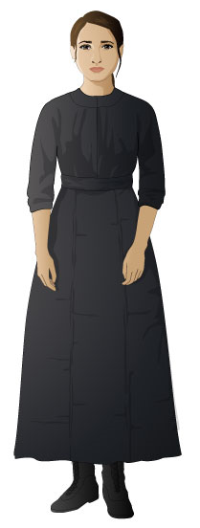
Lena Brodsky

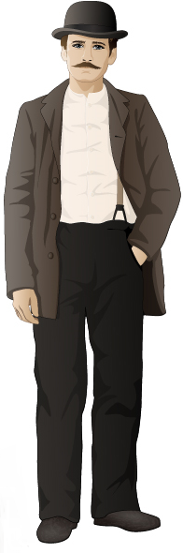
Isaac Brodsky

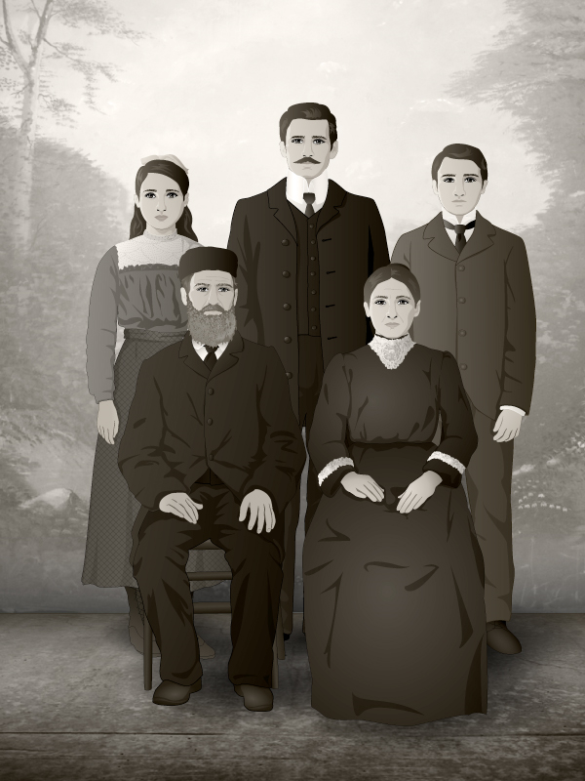
The Brodsky Family
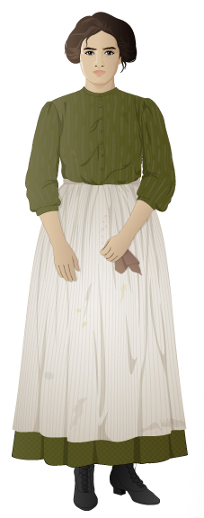
Sonya Brodsky

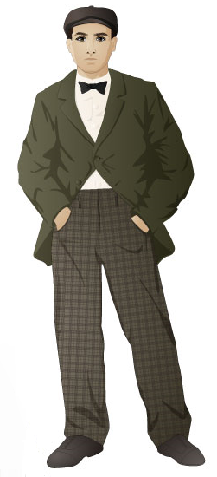
Zev

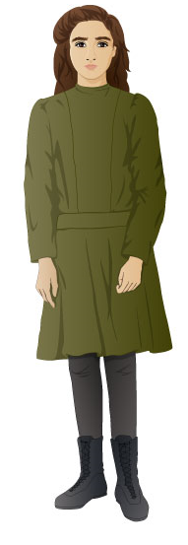
Rosa Leone


Abigail Walker

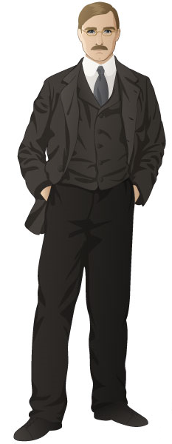
James Poole

Clara Lemlich


Miss Sherman

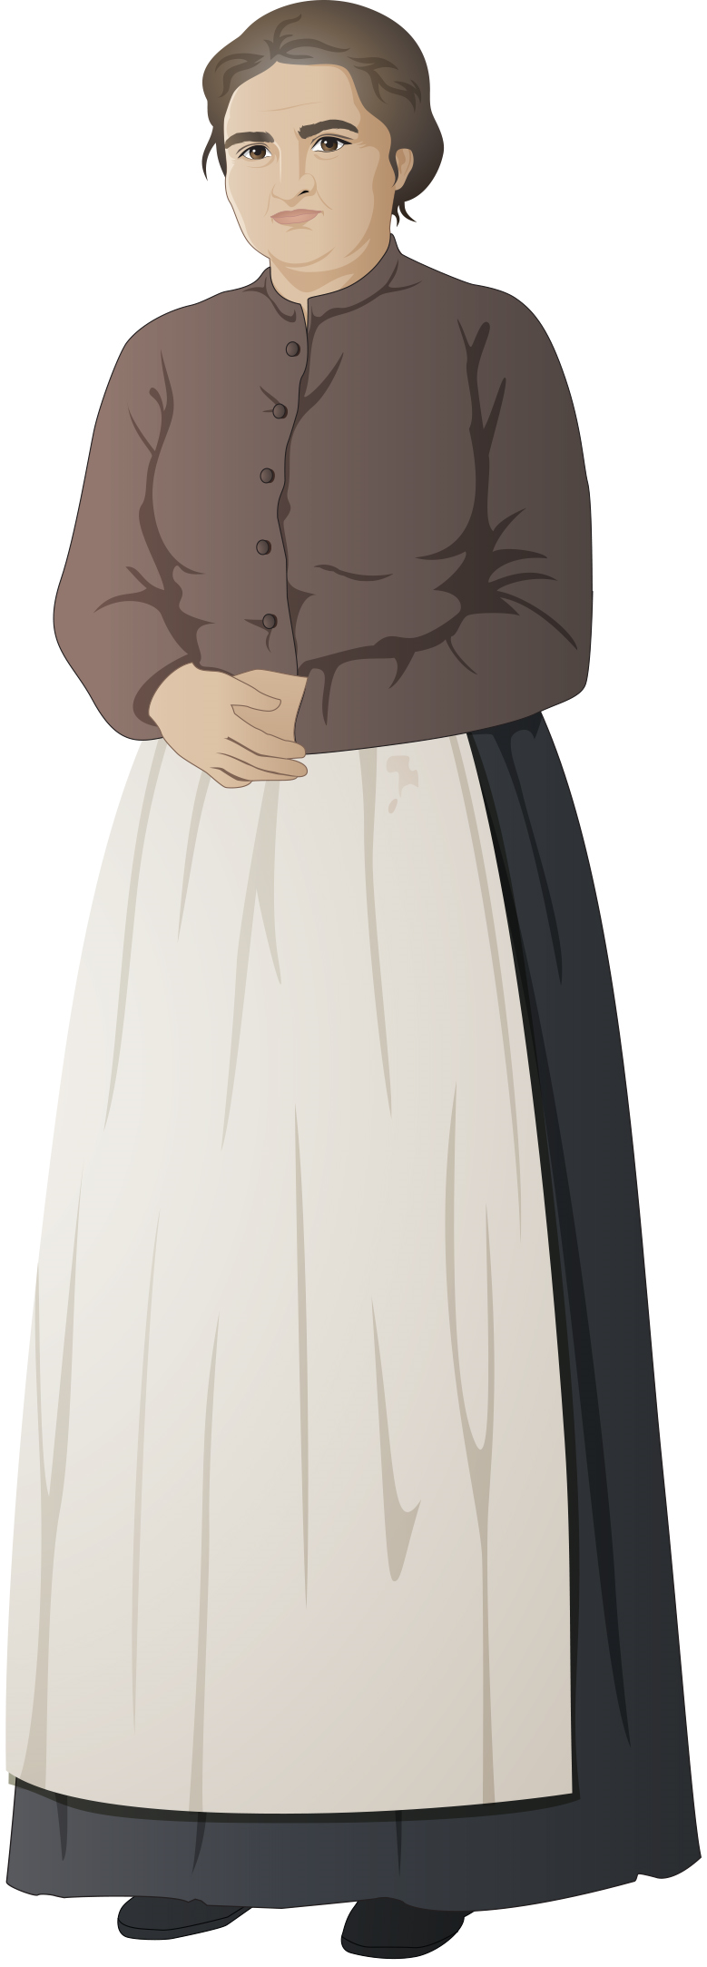
Mrs. Orloff

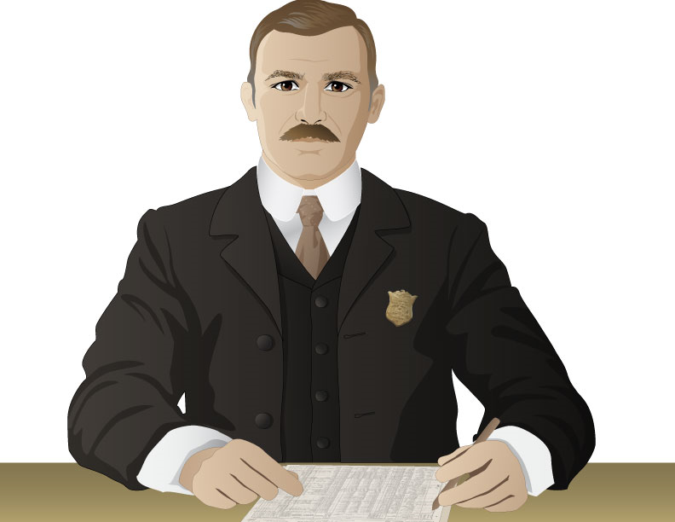
U.S. Customs Official

COMING TO AMERICA

ELLIS ISLAND

KING STREET
LOWER EAST SIDE

TENEMENT

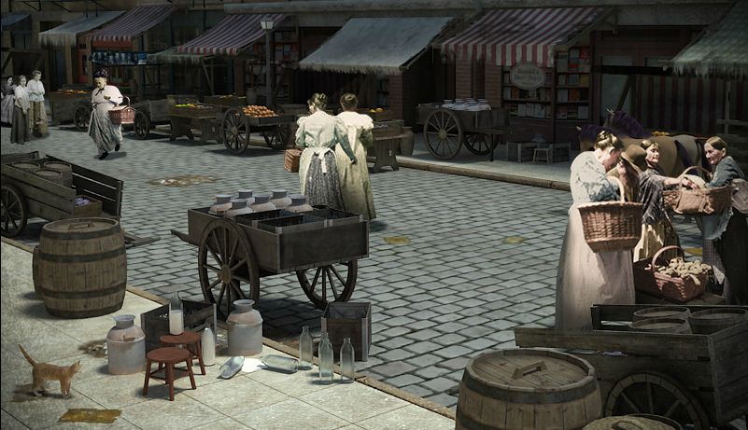
HESTER STREET MARKET

HESTER STREET MARKET

SWEATSHOP

NORTH END

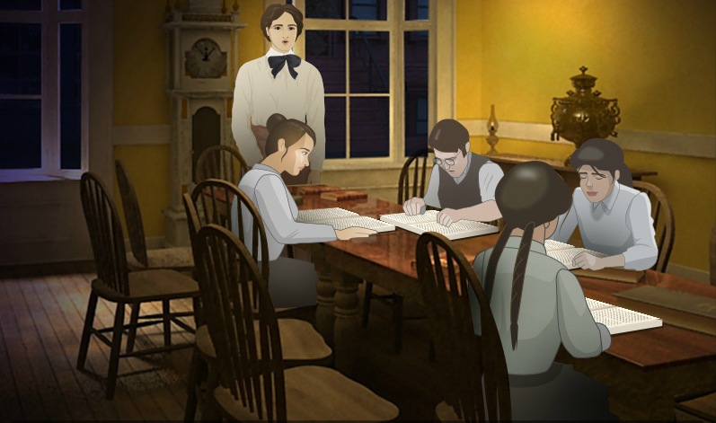
SETTLEMENT HOUSE

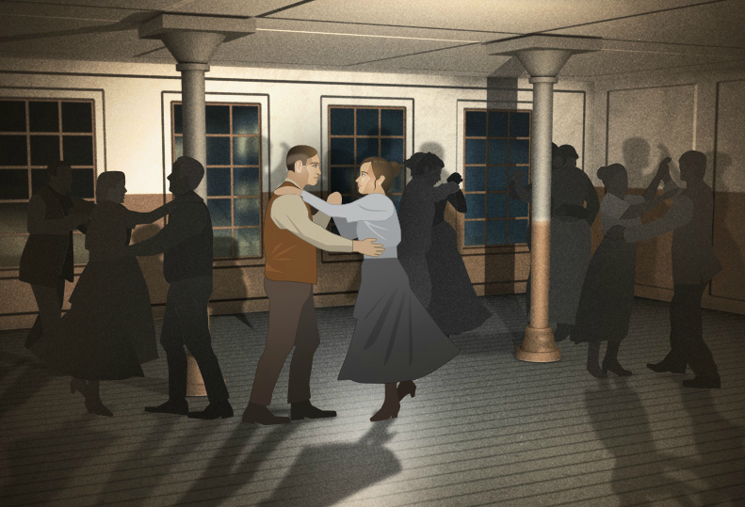
DANCE HALL

TRIANGLE SHIRTWAIST FACTORY

RED CLOUD AGENCY

FACTORY WORK

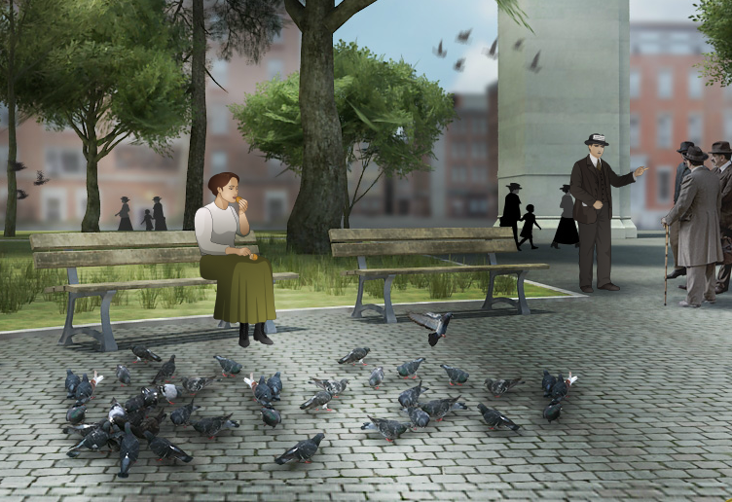
WASHINGTON SQUARE PARK

UNION ORGANIZATION
CLINTON HALL
JEFFERSON MARKET
List of Passengers on the Batavia

Between 1880 and 1924, approximately three million Eastern European Jews emigrated to the United States. Many of them left from ports in Germany, such as Hamburg. The following document is a list of passengers on the S. S. Batavia, a ship that sailed from Hamburg to New York, arriving on July 9, 1907. The list records passengers’ names, destinations, health conditions, finances, and other traits.

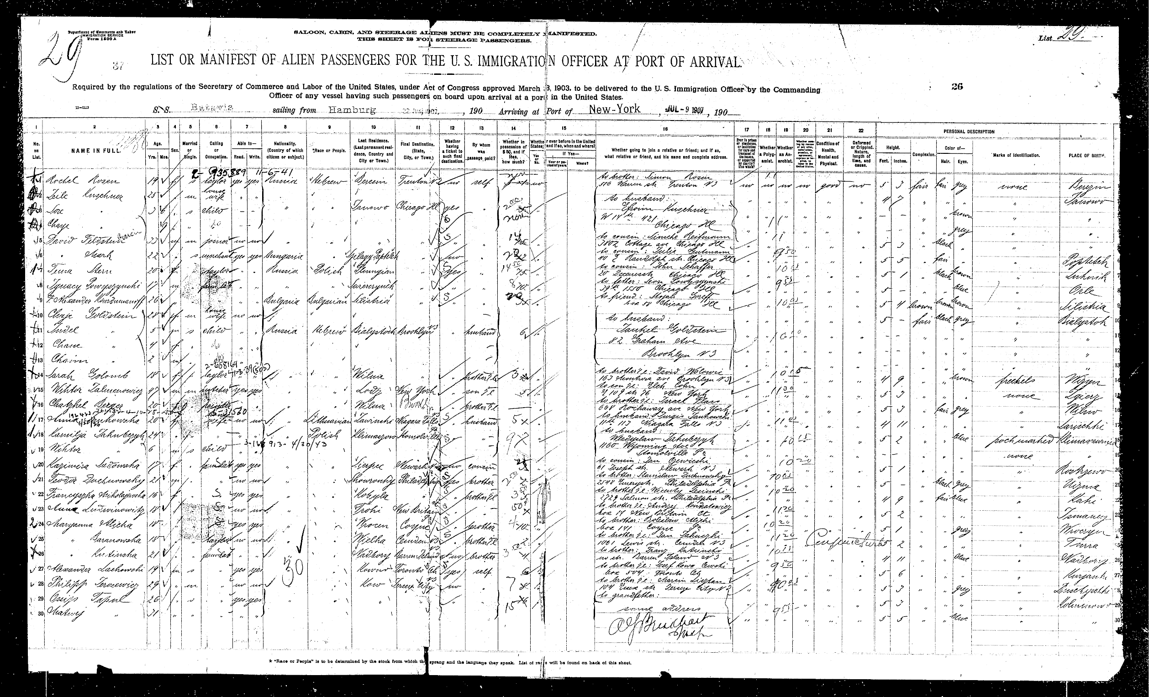

Source: The Statue of Liberty – Ellis Island Foundation, Inc. (www.libertyellisfoundation.org)
Pauline Newman Describes Her Family’s Journey to New York City

In 1901, Pauline Newman left her native village in Lithuania and came to the United States. In the following account, she explains why her family left and describes the difficult conditions of their journey aboard a ship bound for New York.

The village I came from was very small. One department store, one synagogue, and one church. There was a little square where the peasants would bring their produce, you know, for sale. And there was one teahouse where you could have a glass of tea for a penny and sit all day long and play checkers if you wanted.

In the winter we would skate down the hilltop toward the lake and in the summer we’d walk to the woods and get mushrooms, raspberries. The peasants lived on one side of the lake, and the Jewish people on the other, in little square thatched-roof houses. In order to go to school you had to own land and we didn’t own land, of course. Very few Jews did.

That was the time, you see, when America was known to foreigners as the land where you’d get rich. There’s gold on the sidewalk—all you have to do is pick it up. So people left that little village and went to America. My brother first and then he sent for one sister, and after that, a few years after that, my father died and they sent for my mother and my other two sisters and me. I was seven or eight at the time. I’m not sure exactly how old, because the village I came from had no registration of birth, and we lost the family Bible on the ship and that was where the records were.

Of course we came steerage. That’s the bottom of the ship and three layers of bunks. One, two, three, one above the other. If you were lucky, you got the first bunk. Of course you can understand that it wasn’t all that pleasant when the people on the second bunk or the third bunk were ill. You had to suffer and endure not only your own misery, but the misery from the people above you.

My mother baked rolls and things like that for us to take along, because all you got on the boat was water, boiled water. If you had tea, you could make tea, but otherwise you just had the hot water. Sometimes they gave you a watery soup, more like a mud puddle than soup. It was stormy, cold uncomfortable. I wasn’t sick, but other members of my family were.

When we landed at Ellis Island our luggage was lost. We inquired for it and they said, “Come another time. Come another time. You’ll find it. We haven’t got time now.” So we left and we never saw our luggage again. We had bedding, linen, beautiful copper utensils, that sort of thing.

From Ellis Island we went by wagon to my brother’s apartment on Hester Street. Hester Street and Essex on the Lower East Side. We were all bewildered to see so many people. Remember we were from a little village. And here you had people coming and going and shouting. Peddlers, people on the streets. Everything was new, you know.

Source: Joan Morrison and Charlotte Fox Zabusky, American Mosaic: The Immigrant Experience in the Words of Those Who Lived It, 8-9.

Ellis Island Eye Inspection Photo

When immigrants arrived at Ellis Island, United States officials examined them for evidence of contagious diseases such as tuberculosis and trachoma (an eye disease). Although relatively few were turned away, it was a nerve-wracking experience for new arrivals. This photograph depicts an immigrant couple undergoing an eye examination at the hands of a United States Public Health Service officer.
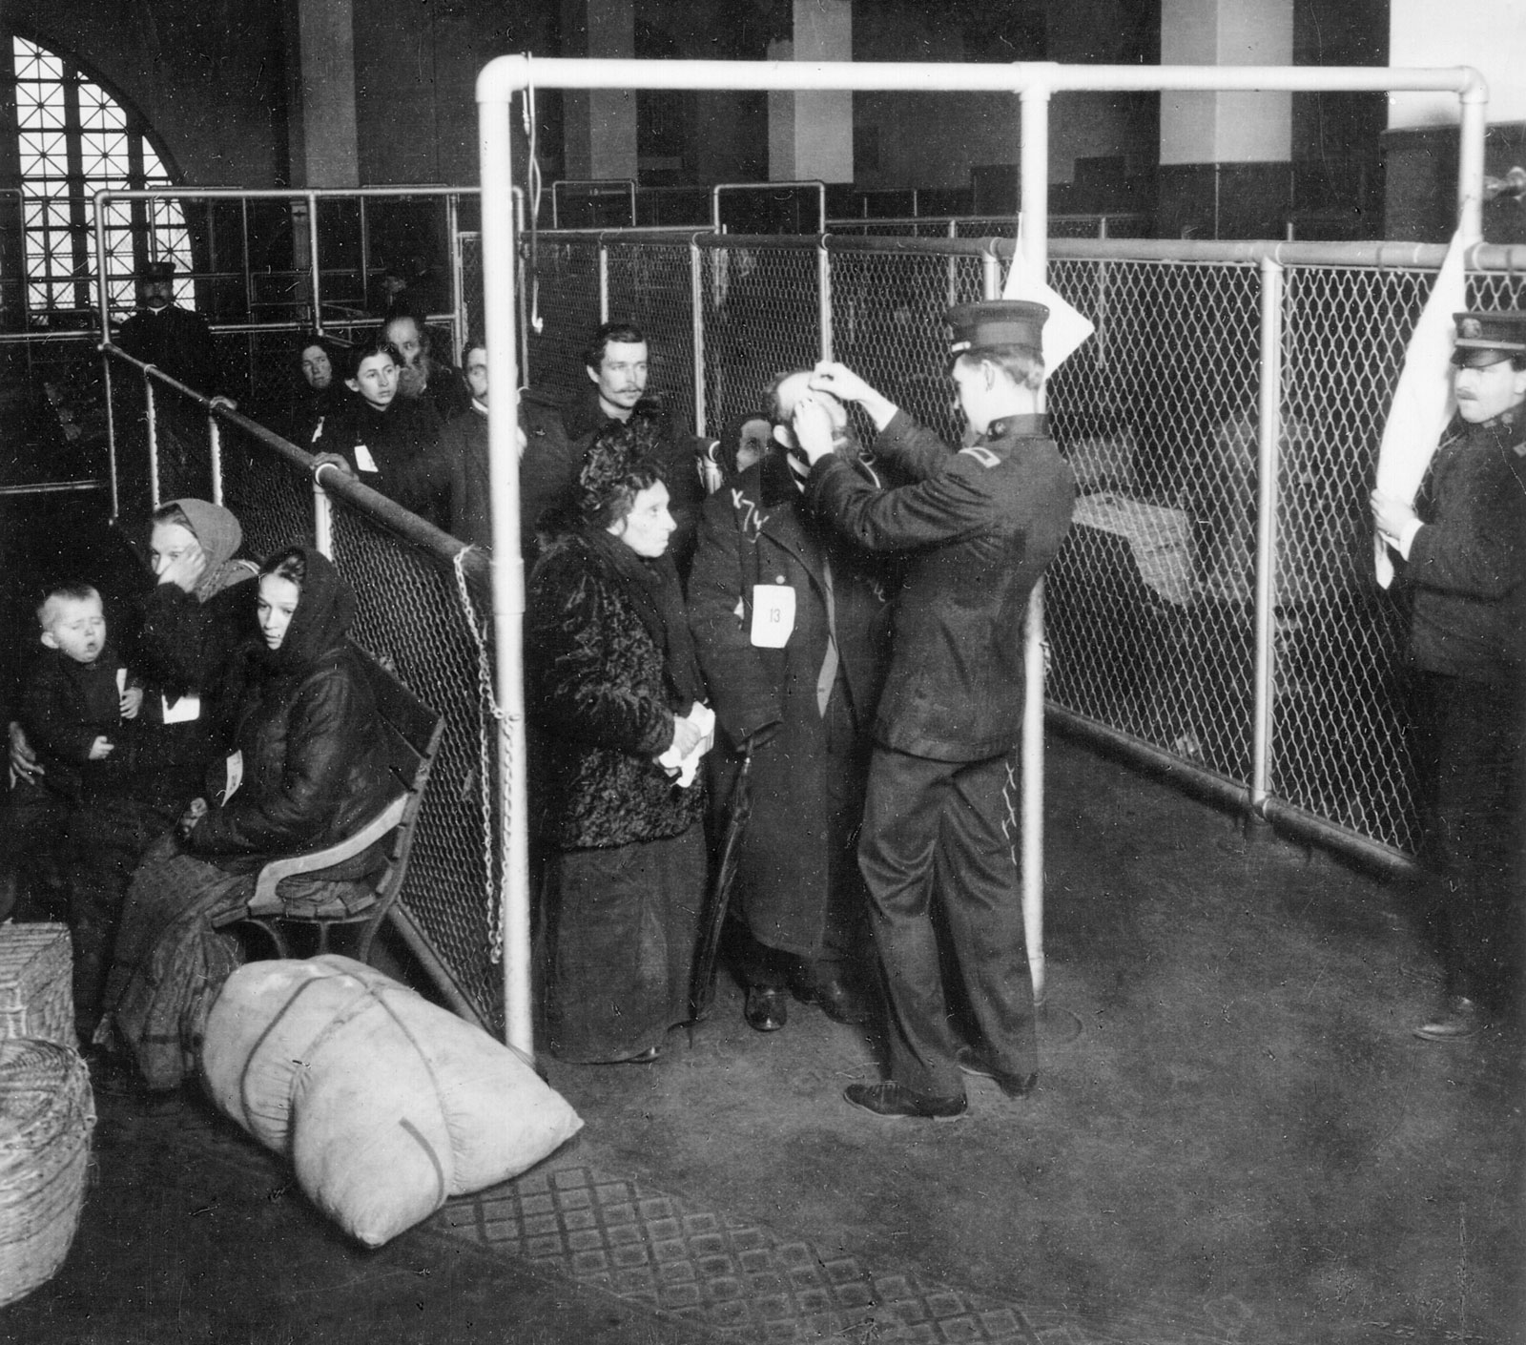

Source: “U.S. inspectors examining eyes of immigrants, Ellis Island, New York Harbor,” Prints and Photographs Division, Library of Congress. (http://www.loc.gov/pictures/item/97501532/)
Sylvia Bernstein on Arriving at Ellis Island

In 1914 Sylvia Bernstein left Austria to join her brother in New York City. In this interview, she recounts her experiences at Ellis Island, the main immigrant inspection station for New York City and the busiest in the United States. The term “white slavery” referred to the practice of forcing young girls into prostitution.

I had a brother that came here in 1911. He was a tailor in New York. So I wrote to my brother, he should send me money, a ticket, I’ll be glad to pay him back. I was fourteen years old. But you must remember, at fourteen they wouldn’t leave you in without parents. You have to be sixteen. I says, “I’ll try to pass for sixteen.”

So I come on the boat, I can’t speak English. It’s sas—you don’t understand what they say, only by the faces.

In Ellis Island it was very exciting. There you can talk Jewish (Yiddish) and you can talk Polish and you can talk everything. I came on a Friday. They go into a big room, and they feed you and they watch you. They give you a room with another girl—after all, it wasn’t a hotel, darling! But it was of comfort. You’re constantly watched. They watch you. If you go out, there’s a woman go after you. “Where do you want to go?” You should excuse me, you have to go to the bathroom, and you don’t know . . . I come from a very small town. So they show you—and they were very nice.

But they’re very strict; because that time was white slavery. An agent came over to me and says, “How old are you?”

I says, “I’m sixteen.” And I had a big head of hair, so I made braids I should look taller.

He says, “You’re sixteen? Where is your sixteen years? You’re so little. You’re going to a brother?”

“Yes, I’m going to a brother.”

“How long you didn’t see your brother?”

I says, “Two years.”

“Would you recognize your brother, if you see him?”

“Yes.”

They bring in a man, they say, “Is this your brother?”
“No.”

They know who my brother was—they did this more or less to see. They were very careful and very cautious, very nice.

Sunday my brother picked me up, Monday I got a job, and Tuesday I went to work in a dry-goods store, a haberdashery.

Source: Joan Morrison and Charlotte Fox Zabusky, American Mosaic: The Immigrant Experience in the Words of Those Who Lived It, 85-86.
Table of Immigrant Origins, 1880-1920

This chart shows the numbers of immigrants that came to the United States by country of origin for each of the census years between 1880 and 1920.

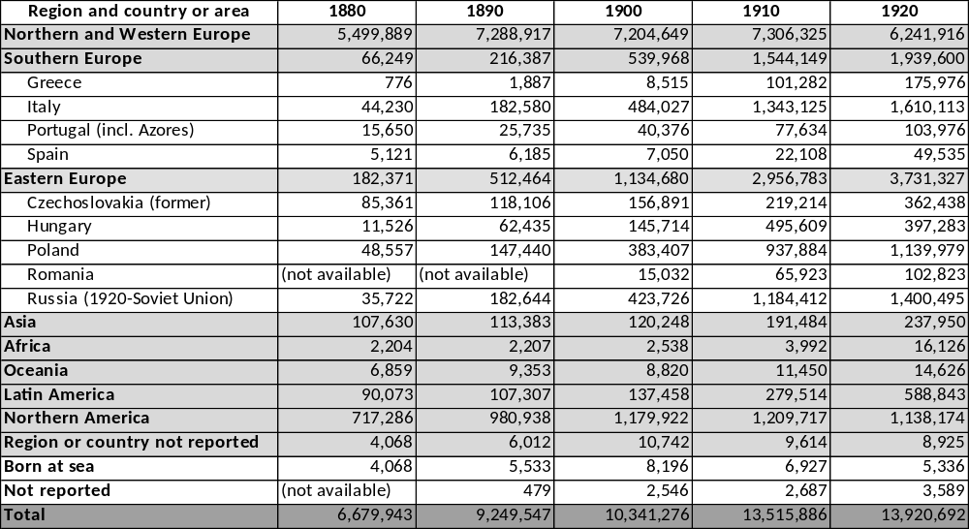
Source: U.S. Census Bureau, Population Division (http://www.census.gov/population/www/documentation/twps0029/tab04.html)

“The High Tide of Immigration—A National Menace” Cartoon

This cartoon appeared in the weekly humor magazine, Judge, in 1903. It reflects the alarm among some Americans at the growing number of immigrants from countries in Southern and Eastern Europe (such as Italy, Russia, and Austria-Hungary) and the declining number of immigrants from countries in Northern and Western Europe (such as Ireland and Germany).

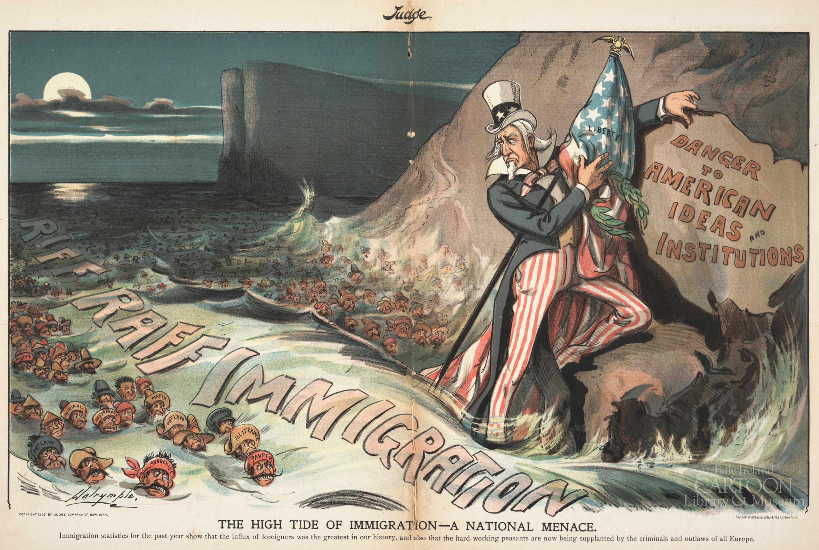

Source: Louis Dalrymple, “The High Tide of Immigration—A National Menace,” Judge Magazine, August 22, 1903, OSUCGA – The Ohio State University Billy Ireland Cartoon Library & Museum, https://cartoonimages.osu.edu/MbVmUnGXa
“The Surrender of New York Town” Cartoon

This cartoon, published in 1910, depicts a fictional “surrender” of New York to Jewish immigrants. The Jewish figures are portrayed according to common anti-semitic (anti-Jewish) stereotypes of the time about what Jewish immigrants looked like and what occupations they dominated.
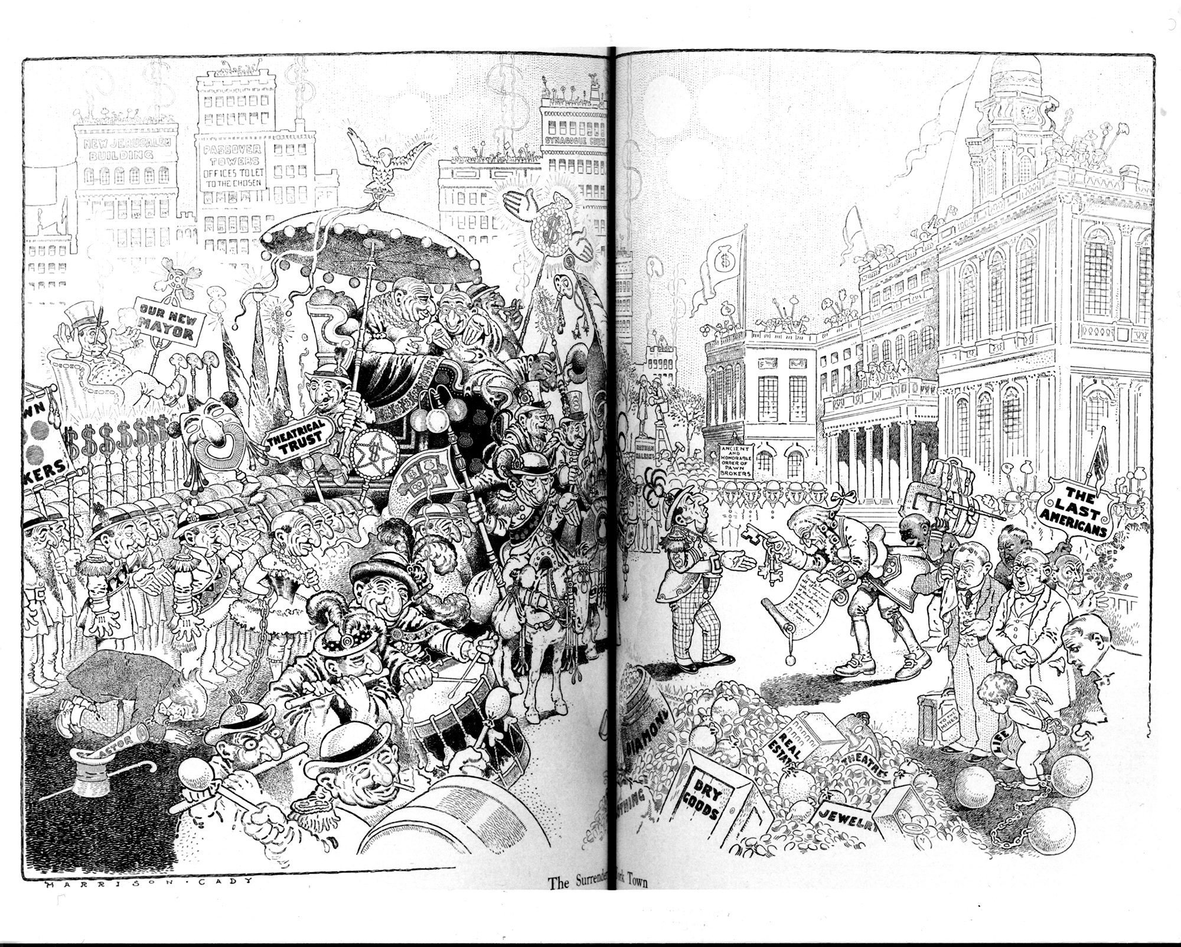

Source: Harrison Cady, “The Surrender of New York Town,” Life, May 12, 1910.
An Immigrant Girl Writes to the Bintel Brief for Advice

The Jewish Daily Forward was a Yiddish-language newspaper established in 1897 by a group of Jewish socialists. By 1912 the paper had a circulation of 120,000. The “Bintel Brief” (“Bintel” means “bundle” in Yiddish; “Brief” means “letter”) was the paper’s advice column. In the following document, a young girl writes to the paper’s editors seeking advice on whether she should go to work or stay in school.

1907
Worthy Editor,

Allow me a little space in your newspaper and, I beg you, give me some advice as to what to do.
There are seven people in our family—parents and five children. I am the oldest child, a fourteen-year-old girl. We have been in the country two years and my father, who is a frail man, is the only one working to support the whole family.

I go to school, where I do very well. But since times are hard now and my father earned only five dollars this week, I began to talk about giving up my studies and going to work in order to help my father as much as possible. But my mother didn’t even want to hear of it. She wants me to continue my education. She even went out and spent ten dollars on winter clothes for me. But I didn’t enjoy the clothes, because I think I am doing the wrong thing. Instead of bringing something into the house, my parents have to spend money on me.

I have a lot of compassion for my parents. My mother is now pregnant, but she still has to take care of the three boarders we have in the house. Mother and Father work very hard and they want to keep me in school.

I am writing to you without their knowledge, and I beg you to tell me how to act. Hoping you can advise me, I remain,

Your reader, S.

Answer:
The advice to the girl is that she should obey her parents and further her education, because in that way she will be able to give them greater satisfaction than if she went out to work.

Source: Isaac Meltzer, ed., A Bintel Brief: Sixty Years of Letters from the Lower East Side to the Jewish Daily Forward (New York: Schocken Books, 1971).
Report on Food Expenses for a Working Family in 1909

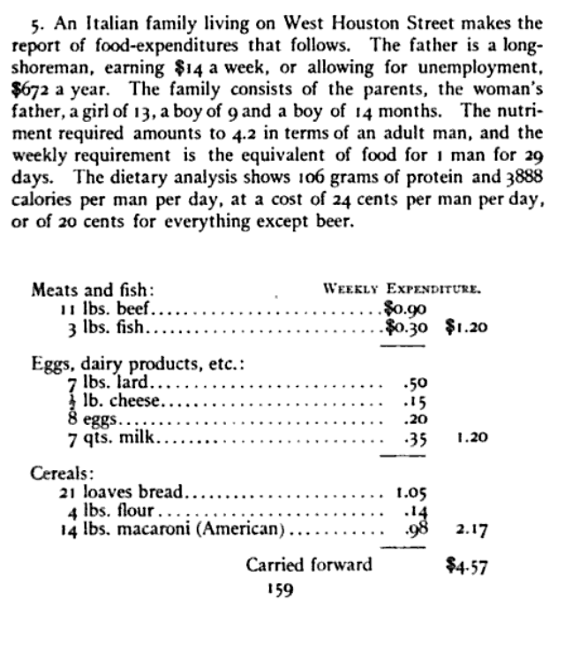
In 1909, a charitable foundation compiled a report on food expenses for working-class families in New York City. This document details the weekly expenses for an Italian family living on West Houston Street. The father of this family worked as a longshoreman (a person who loads and unloads ships).

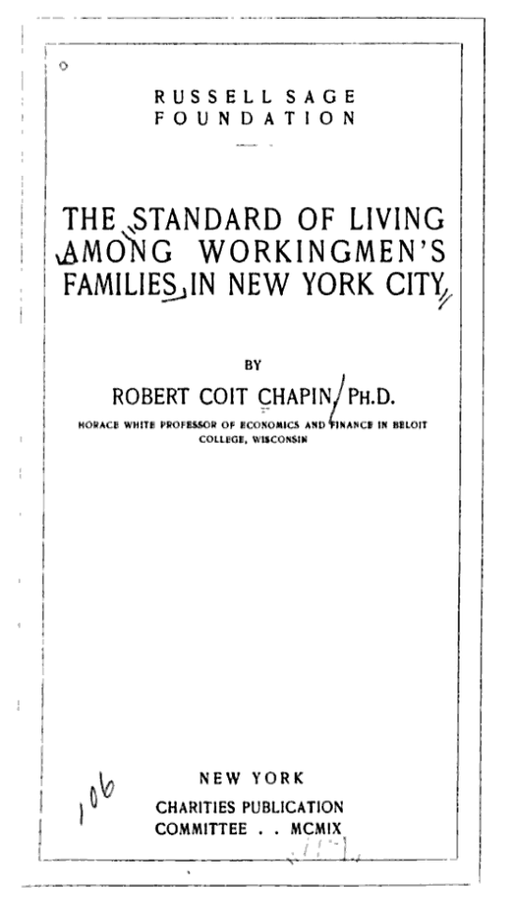

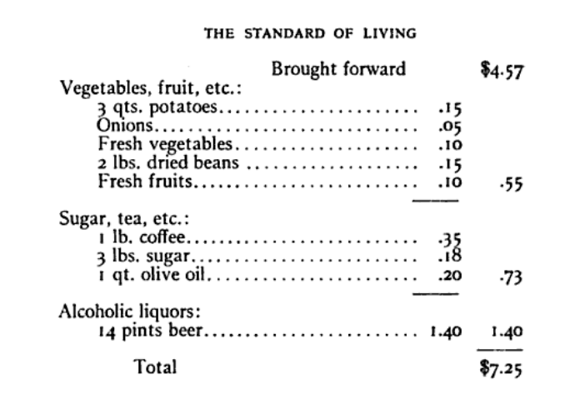

Source: Robert Coit Chapin, “The Standard of Living Among Workingmen’s Families in New York City,” Russell Sage Foundation, 1909.
Garment Workers in a Home Sweatshop Photo

Many Jewish immigrants found work in New York’s booming garment industry. Often they worked in “sweatshops,” like this one, where they assembled garments under the supervision of a contractor. Most sweatshops were located in people’s homes, and the workers were paid a “piece work” rate (according to how many items they finished). The work was difficult and low paid.

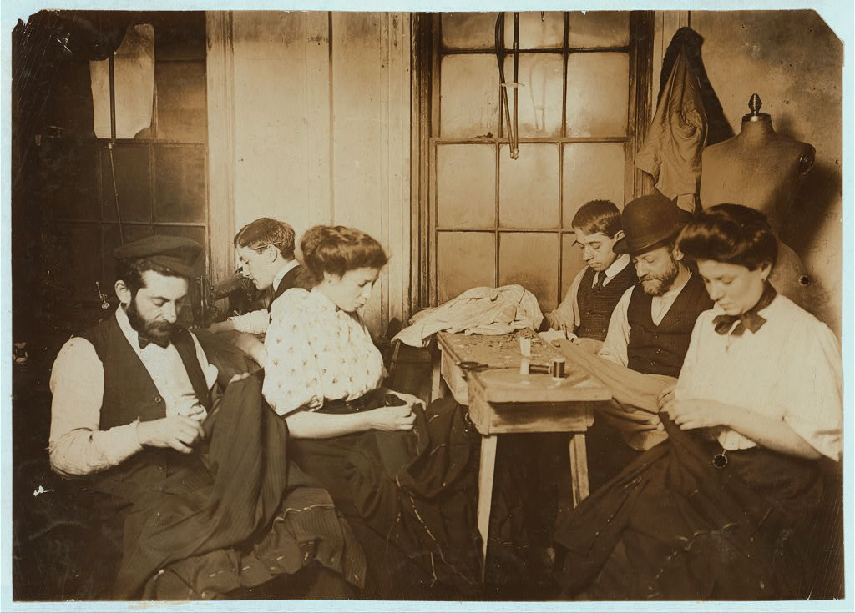

Source: Lewis Hine, “Group in Sweatshop,” 1908. Prints and Photographs Division, Library of Congress (http://www.loc.gov/pictures/item/ncl2004000050/PP/)
Floor Plan of a Typical Tenement, c. 1905

This diagram depicts the changes in tenement house construction mandated by the Second Tenement House Act of 1879. On the left is a diagram of a “Pre-Law” tenement; the right side contains a diagram of a post-1879 “Old Law” tenement. Major changes include the addition of an air shaft for light and ventilation, extra windows, hallway toilets, and slop sinks for the kitchen.

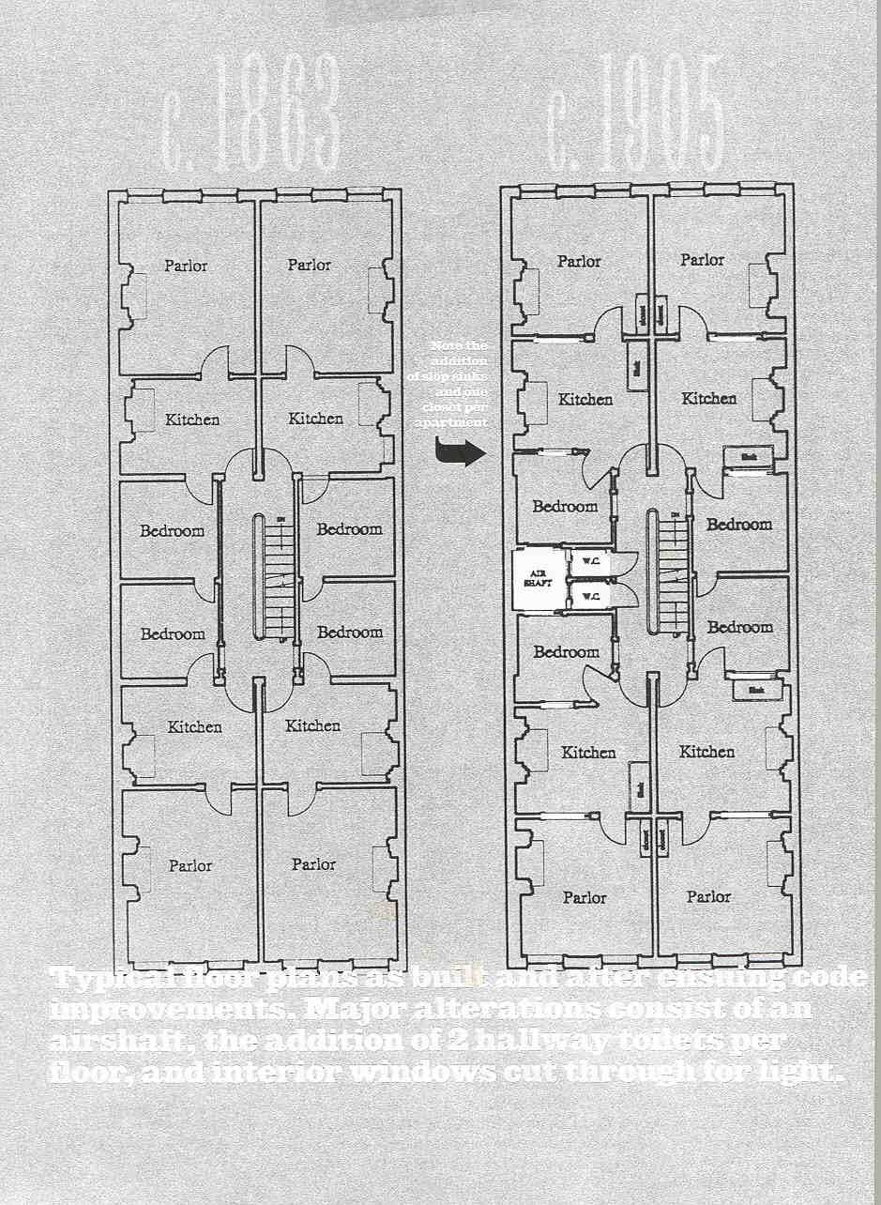
Source: Unknown
“Immigration and the Public Health” Article

Some Americans feared new immigrants, believing that the way they lived in crowded neighborhoods spread disease. In this 1904 article from a popular magazine, a doctor specifically blames the new immigrants—“Hebrews, Syrians, Greeks, and southern Italians”—for spreading disease and being a “menace to the public health.”

Thousands of immigrants of poor physique (body type) are recorded as such by the medical inspectors at Ellis Island, and a card to this effect sent to the registry clerk or immigrant inspector with the immigrant, but this mere note of physical defect carries little significance under the present law, and the vast majority of them are admitted by the immigration authorities, because it does not appear that the physical defect noted will make the immigrant a public charge. . . .

The real danger to the public health from immigration lies in that class of immigrants whose physique is much below American standards, whose employment is in the sweat-shop, and whose residence is the East Side tenement in New York City. The Mediterranean races, Syrians, Greeks and southern Italians, who are unused to a cold climate, and who often have insufficient clothing, also establish in their crowded quarters [neighborhoods] splendid for the dissemination [spread] of disease. The Hebrews, Syrians, Greeks, and southern Italians invariably crowd the most unsanitary quarters of the great centers of population. And the various filthy and infected, though perhaps picturesque, foreign quarters constitute to-day the greatest existing menace to the public health.

Source: Dr. Allan McLaughlin, “Immigration and the Public Health,” Popular Science (January 1904), 232, 236-237

Hebrew Immigrant Aid Society Magazine Cover

The Hebrew Immigrant Aid Society was established in 1881 in New York City to assist Jews who had fled pogroms (massacres) in Russia and Eastern Europe. The Society helped new immigrants in a number of ways—providing food, shelter, and transportation; locating relatives; and helping new arrivals understand United States laws. This cover of the Society’s magazine, The Jewish Immigrant, includes the organization’s motto and a drawing of Jewish immigrants entering the United States.
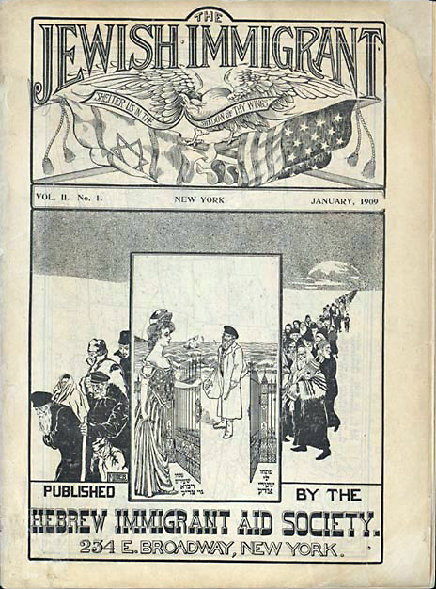
Source: The Jewish Immigrant. Vol. 2, no. 1 (January 1909). New York: Hebrew Immigrant Aid Society, 1909 (http://www.loc.gov/exhibits/haventohome/haven-century.html#obj7)
Lillian Wald on Establishing the Henry Street Settlement

In the 1890s, Lillian Wald was working as a nurse in New York City. When she visited a patient in the immigrant neighborhood of the Lower East Side, she was shocked at the poor living conditions residents were forced to endure. With a friend, she decided to move to the neighborhood and soon opened the Henry Street Settlement, an organization dedicated to providing social services to the urban poor. Henry Street Settlement was not the only institution of its kind; other settlement houses emerged across England and the United States during this period. In her memoir, Wald describes the experiences that prompted her to establish Henry Street Settlement.

Two decades ago the words “East Side" called up a vague and alarming picture of
something strange and alien: a vast crowded area, a foreign city within our own, for whose conditions we had no concern. Aside from its exploiters, political and economic, few people had any definite knowledge of it, and its literary discovery " had but just begun. The lower East Side then reflected the popular indifference—it almost seemed contempt—for the living conditions of a huge population. And the possibility of improvement seemed, when my inexperience was startled into thought, the more remote because of the dumb acceptance of these conditions by the East Side itself. Like the rest of the world I had known little of it, when friends of a philanthropic institution asked me to do something for that quarter. . . .

From the schoolroom where I had been giving a lesson in bed-making, a little girl led me one drizzling March morning. She had told me of her sick mother, and gathering from her incoherent account that a child had been born, I caught up the paraphernalia of the bed-making lesson and carried it with me.

The child led me on through a tenement hallway, across a court where open and unscreened closets were promiscuously used by men and women, up into a rear tenement, by slimy steps whose accumulated dirt was augmented that day by the mud of the streets, and finally into the sickroom. . . . [A]lthough the sick woman lay on a wretched, unclean bed, soiled with a hemorrhage two days old, they were not degraded human beings, judged by any measure of moral values. In fact, it was very plain that they were sensitive to their condition, and when, at the end of my ministrations, they kissed my hands (those who have undergone similar experiences will, I am sure, understand), it would have been some solace if by any conviction of the moral unworthiness of the family I could have defended myself as a part of a society which permitted such conditions to exist. That morning's experience was a baptism of fire. Deserted were the laboratory and the academic work of the college. I never returned to them.

To the first sympathetic friend to whom I poured forth my story, I found myself presenting a plan which had been developing almost without conscious mental direction on my part. It was doubtless the accumulation of many reflections inspired by acquaintance with the patients in the hospital wards, and now, with the Ludlow Street experience, resistlessly impelling me to action. Within a day or two a comrade from the training-school, Mary Brewster, agreed to share in the venture. We were to live in the neighborhood as nurses, identify ourselves with it socially, and, in brief, contribute to it our citizenship. That plan contained in embryo all the extended and diversified social interests of our settlement group to-day. . . .

The mere fact of living in the tenement brought undreamed-of opportunities for widening our knowledge and extending our human relationships. That we were Americans was wonderful to our fellow-tenants. They were all immigrants—Jews from Russia or Roumania. . . .

From this first house have since developed the manifold activities in city and country now incorporated as the Henry Street Settlement. I should like to make it clear that from the beginning we were most profoundly moved by the wretched industrial conditions which were constantly forced upon us. In succeeding chapters I hope to tell of the constructive programmes that the people themselves have evolved out of their own hard lives, of the ameliorative measures, ripened out of sympathetic comprehension, and, finally, of the social legislation that expresses the new compunction of the community.

Source: Lillian D. Wald, The House on Henry Street (New York: Henry Holt and
Company, 1915), 2-25.
A Journalist Warns of the Dangers of Dance Halls

During the late-nineteenth and early-twentieth centuries, dance halls became increasingly popular hangouts for young people, in part because they offered an opportunity to mingle and flirt away from parental supervision. But not all New Yorkers approved of the dance-hall craze. In this article, published in 1911, a journalist warns of the “dance madness” sweeping over New York City and points out the perils of the new establishments, especially for young women.

Diverting a Pastime: How Are We To Protect the City's Youth and Yet Provide for the Natural Demand for Entertainment? By Belle Lindner Israels (Excerpt)

The storm of dance madness has come over the young people of New York. Streets in which the dance halls are located are picturesque enough [on the outside]. The hall is usually up one or two flights of stairs and [is] framed in big windows of plate glass. Brilliant lights shine through. The sounds of a waltz or two-step pounded on the piano and emphasized by an automatic drum flow out to the passer-by. Boys and girls flit past the windows or slip into the doorway in twos and threes, and managers remain outside, announcing the special features of their halls. The noise, the lights, the air of excitement and good time all attract.

In studying the dance hall one comes continually against the liquor problem, so that it is claimed with much reason that the liquor interests control the amusement. In the small saloon dance hall, which is open nightly without an admission fee, it is understood that the dancing is permitted simply as a [way to get people to buy] liquor. The music plays for three or four minutes, and there are intermissions covering a period of from fifteen to twenty minutes between the dances. During these times the people at the tables are constantly [pestered] to buy drinks. Girls not being entertained at the tables rush over to the dressing-rooms to avoid being seen on the floor.

The city, the town, the village must all recognize that playgrounds for children solve only half the problem. The dangerous period in the life of the young girl is during adolescence, between fourteen and twenty. If she can be guided through these years with proper [opportunities] for the wholesome expression of her emotional and mental needs, she will add to the glory of our American womanhood. If she is forced into the [streets] guided by the lowest types of commercialized amusements, there is small hope for her.

Source: Leslie's Weekly July 27, 1911 p. 94.
“Far From the Fresh Air Farm” Painting

As New York’s immigrant districts became more and more crowded, reformers worried that without places to play, children would either be denied a healthy upbringing or be forced to play in the street, exposed to its numerous dangers. This 1911 painting carries the subtitle:“The Crowded City Street, with its Dangers and Temptations, is a Pitiful Makeshift Playground for Children.”
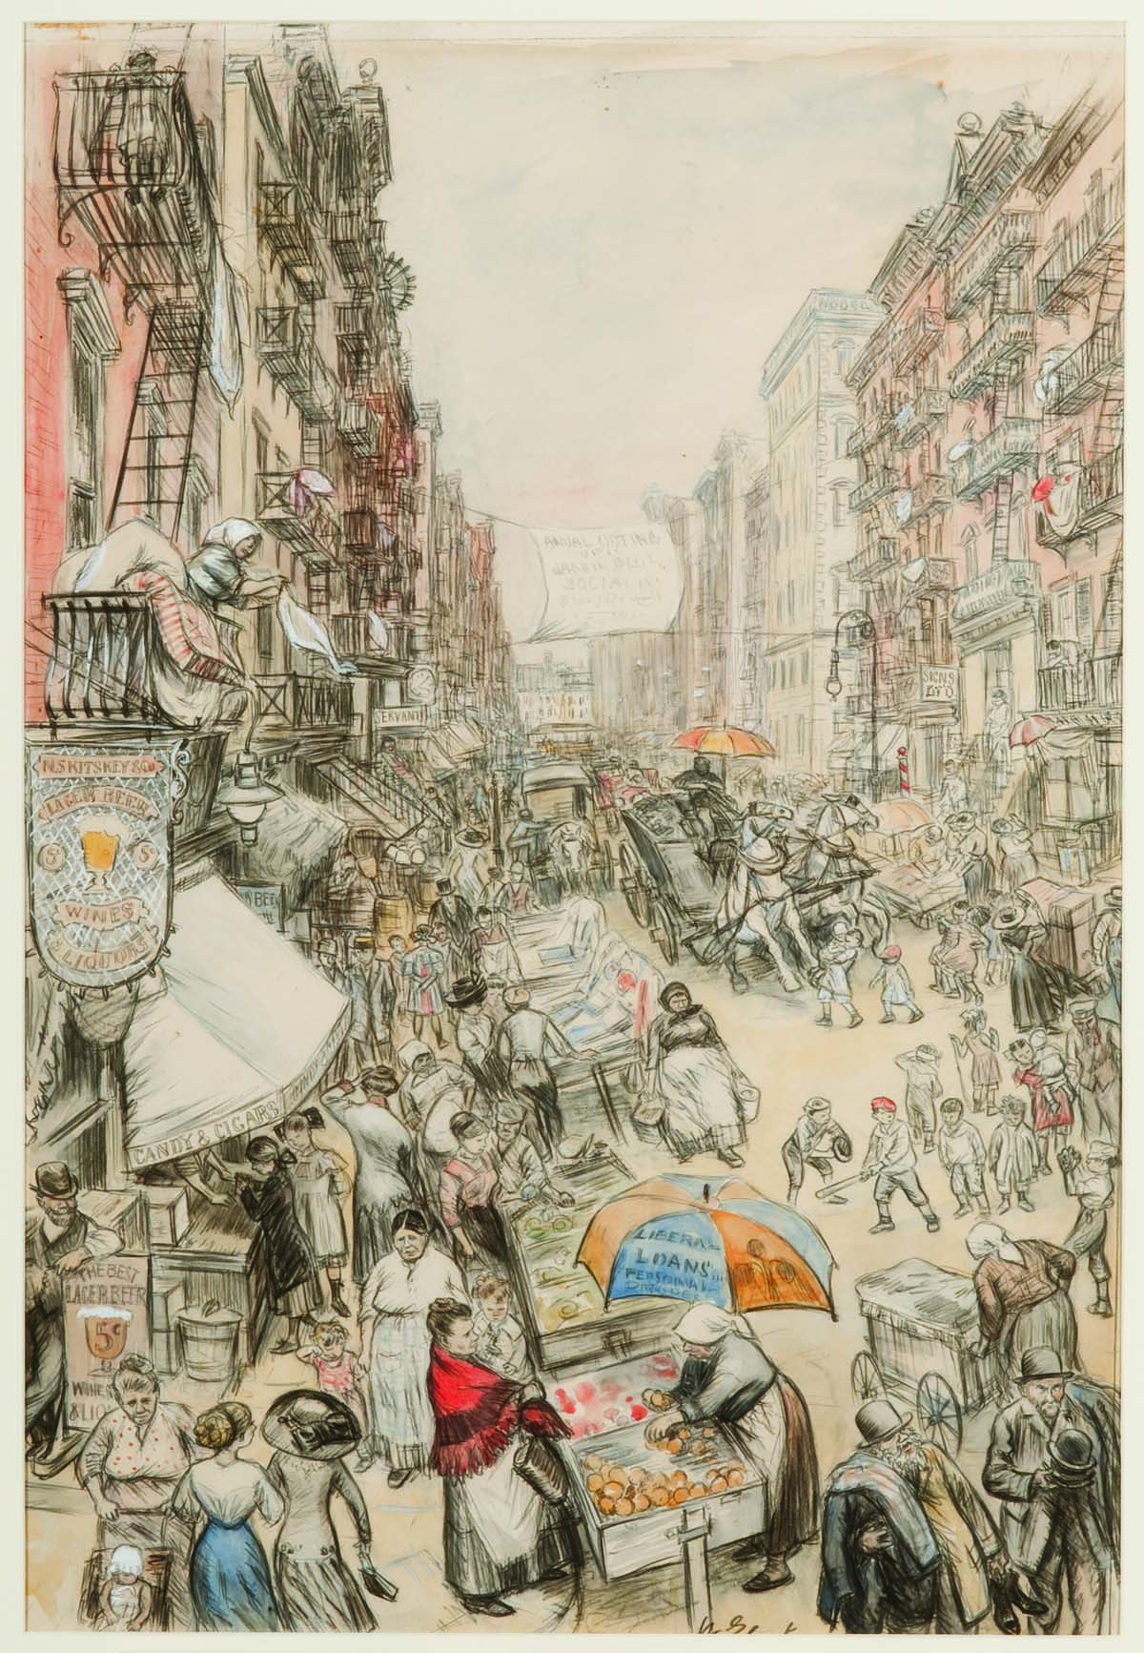

Source: William Glackens, “Far From the Fresh Air Farm: The Crowded City Street, with its Dangers and Temptations, is a Pitiful Makeshift Playground for Children.” 1911, crayon heightened with watercolor on paper. Museum of Art, Fort Lauderdale, Nova Southeastern University. Bequest of Ira Glackens.

“The Story of a Sweatshop Girl”

Immigrant worker Sadie Frowne's story was originally published the New York Independent, a reform-minded newspaper, and later collected into the 1906 book The Lives of Undistinguished Americans as Told by Themselves. The book was remarkable in a time when most biographies or memoirs were by and about political leaders, prominent writers, or wealthy industrialists. In this section, she describes her life outside of work, including a very busy social life.

Aunt Fanny had always been anxious for me to get an education, as I did not know how to read or write, and she thought that was wrong. Schools are different in Poland from what they are in this country, and I was always too busy to learn to read and write. So when mother died I thought I would try to learn a trade and then I could go to school at night and learn to speak the English language well.

It cost me $2 a week to live, and I had a dollar a week to spend on clothing and pleasure, and saved the other dollar. I went to night school, but it was hard work learning at first as I did not know much English. Sometimes we go to Coney Island, where there are good dancing places, and sometimes we go to Ulmer Park to picnics. I am very fond of dancing, and, in fact, all sorts of pleasure. I go to the theater quite often, and like those plays that make you cry a great deal "The Two Orphans" is good. Last time I saw it I cried all night because of the hard times that the children had in the play. I am going to see it again when it comes here.

For the last two winters I have been going to night school at Public School 84 on Glenmore avenue. I have learned reading, writing and arithmetic. I can read quite well in English now and I look at the newspapers every day. I read English books, too, sometimes. The last one that I read was "A Mad Marriage," by Charlotte Braeme. She's a grand writer and makes things just like real to you. You feel as if you were the poor girl yourself going to get married to a rich duke.

I am going back to night school again this winter. Plenty of my friends go there. Some of the women in my class are more than forty years of age. Like me, they did not have a chance to learn anything in the old country. It is good to have an education; it makes you feel higher. Ignorant people are all low. People say now that I am clever and fine in conversation.

I pay 25 cents a month to the union, but I do not begrudge that because it is for our benefit. The next strike is going to be for a raise of wages, which we all ought to have. But tho I belong to the union I am not a Socialist or an Anarchist I don't know exactly what those things mean. There is a little expense for charity, too. If any worker is injured or sick we all give money to help.

Some of the women blame me very much because I spend so much money on clothes. They say that instead of a dollar a week I ought not to spend more than twenty five cents a week on clothes, and that I should save the rest But a girl must have clothes if she is to go into high society at Ulmer Park or Coney Island or the theatre. Those who blame me are the old country people who have old-fashioned notions, but the people who have been here a long time know better. A girl who does not dress well is stuck in a corner, even if she is pretty, and Aunt Fanny says that I do just right to put on plenty of style.

I have many friends and we often have jolly parties. Many of the young men like to talk to me, but I don't go out with any except Henry.

Lately he has been urging me more and more to get married — but I think I'll wait.

Source: “The Story of a Sweatshop Girl,” Independent, 25 September 1902, 2279-82.

Interior of a garment factory, photo

During the first years of the twentieth century, garment manufacturing began to shift from the tenements of the Lower East Side to factories located in other parts of lower Manhattan. This photograph shows one such factory, which could accommodate a far greater number of workers than the average home-based sweatshop.

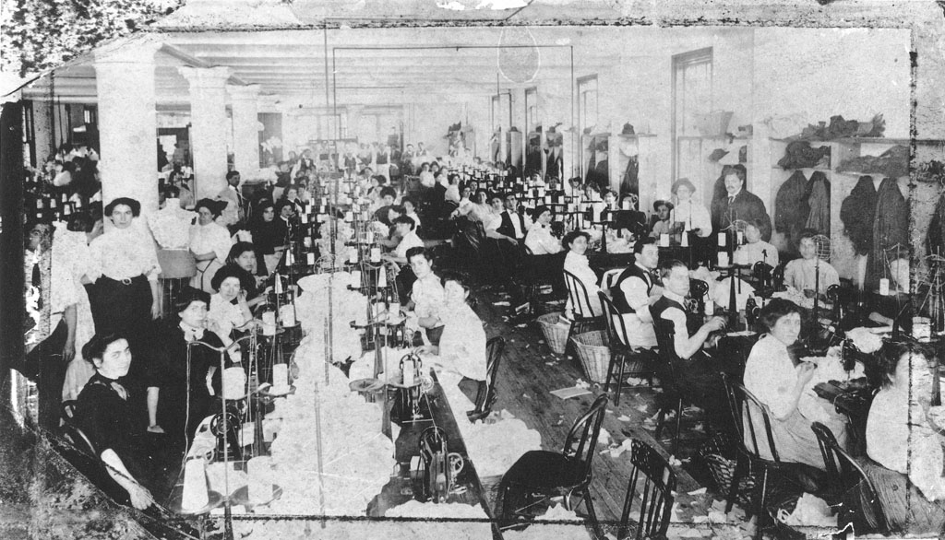

Source: Unknown.

“The Return from Toil”

The Masses was an illustrated radical magazine based in New York and published between 1911 and 1917. The magazine was notable for its striking artwork. This cover, by the American artist John Sloan, depicts a group of women walking home from work. Sloan presents these working girls as strong, independent, and exuberant individuals.

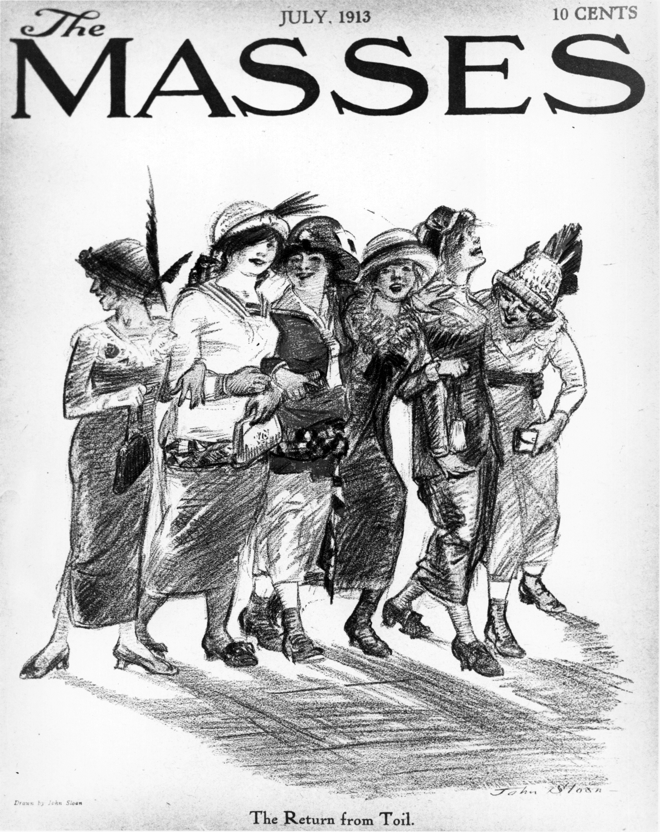

Source: John Sloan, “The Return from Toil,” The Masses, July 1913, Front Cover. Prints and Photographs Division, Library of Congress.
Clara Lemlich Describes Life in the Shop

Clara Lemlich sparked the 1909 walkout of shirtwaist makers when she called for a strike at a mass meeting of garment factory workers. This piece was first published in the New York Evening Journal on November 28, 1909, four days after the strike began.
First let me tell you something about the way we work and what we are paid. There are two kinds of work - regular, that is salary work, and piecework. The regular work pays about $6 a week and the girls have to be at their machines at 7 o'clock in the morning and they stay at them until 8 o'clock at night, with just one-half hour for lunch in that time.
The shops. Well, there is just one row of machines that the daylight ever gets to - that is the front row, nearest the window. The girls at all the other rows of machines back in the shops have to work by gaslight, by day as well as by night. Oh, yes, the shops keep the work going at night, too.
The bosses in the shops are hardly what you would call educated men, and the girls to them are part of the machines they are running. They yell at the girls and they "call them down" even worse than I imagine the Negro slaves were in the South.
There are no dressing rooms for the girls in the shops. They have to hang up their hats and coats - such as they are - on hooks along the walls. Sometimes a girl has a new hat. It never is much to look at because it never costs more than 50 cents, that means that we have gone for weeks on two-cent lunches - dry cake and nothing else.
The shops are unsanitary - that's the word that is generally used, but there ought to be a worse one used. Whenever we tear or damage any of the goods we sew on, or whenever it is found damaged after we are through with it, whether we have done it or not, we are charged for the piece and sometimes for a whole yard of the material.
At the beginning of every slow season, $2 is deducted from our salaries. We have never been able to find out what this is for.
Source: Leon Stein, ed., Out of the Sweatshop: The Struggle for Industrial Democracy (New York: Quadrangle/New Times Book Company, 1977)
Report on the Clothing Industry in New York, 1905
Clothing manufacturers constantly sought ways to pay workers less. One way was to divide the task of assembling a garment into a series of small, repetitive operations. This report describes how one manufacturer divided the assembly of a coat into thirty-nine separate steps.
There is a constant tendency in industry to make use of cheaper labor where it is possible. In England the custom grew up of subdividing the work . . . Male labor was still largely retained to do the operating work, but the greater subdivision [of tasks] made it possible to employ a lower grade of that labor, not controlled by the union. . . .
The principle of this system has been widely adopted but the extent to which the division of labor has been carried varies greatly. The extreme of this division is seen in one of the leading contractor's shops in New York City, where thirty-nine different processes, carried on by the same number of people, are represented in the manufacture of a coat.
This shop turns out a very high grade of work, and two-thirds of its employees are women. Those who carry on the processes of manufacture spoken of above are as follows:
(1.) The fitter, who also cuts the linings, marks the pockets, and puts on tickets,
(2.) pocket maker,
(3.) canvas baster,
(4.) padder of lapel,
(5.) bar tacker (on pockets),
(6.) seam presser,
(7.) lining maker,
(8.) lining operator,
(9.) sleeve maker,
(10.) lining presser,
(11.) sleeve presser,
(12.) collar padder,
(13.) shaper,
(14.) baster and fuller of stay tape,
(15.) lining baster, prepares for machine,
(16.) operator,
(17.) presser,
(18.) edge cutter,
(19.) edge baster,
(20.) lining baster for shoulders,
(21.) operator for shoulders,
(22.) sleeve baster around edge,
(23.) collar and sleeve baster, prepares for operator,
(24.) presser on sleeve,
(25.) joiner of collar to lapel,
(26.) arm-hole baster,
(27.) operator who sews in sleeves,
(28.) garment examiner,
(29.) J collar finisher,
(30.) lining finisher, around arm-hole,
(31.) basting puller,
(32.) edge presser,
(33.) button hole cutter,
(34.) button-hole maker,
(35.) general busheler and hanger sewer,
(36.) presser of entire coat,
(37.) button marker,
(38.) button sewer,
(39.) busheler.
With the single exception of the pocket maker, a highly skilled mechanic, every one of these workers can become proficient in his line within a few months.
Source: Jesse Eliphalet Pope, The Clothing Industry in New York (University of Missouri), September 1905, pp. 69-71.
A Journalist Defends the New Picture Shows
At the beginning of the twentieth century, movies, still in their infancy, began to replace stage shows as favorite sources of entertainment for the working classes. In this article, published in 1911, a journalist explains the allure of the “picture shows” for young, working-class audiences.
It is drama, and it is travel, and it is even beauty, all in one. A wonderful thing it is, and to know how wonderful I suppose you must be poor and have in your life no books and no pictures and no means of travel or seeing beautiful places, and almost no amusements of any kind; perhaps your only door of escape or only means of forgetfulness more drink than is good for you. Then you will know what a moving-picture show really means, although you will probably not be able to put it into words.

We talk a good deal about the censorship of picture shows, and pass city ordinances (laws) to keep the young from being corrupted by them: and this is all very well, because a great amusement of the people ought to be kept clean and sweet; but at the same time this discussion has left a sort of feeling in the minds of people who do not need to go to the picture show that it is a doubtful sort of a place, where young girls and men [make] undesirable acquaintances, and where the prowler lies in wait for the unwary, and where suggestive films of crime and passion are invariably displayed. But I think that this is an unjust idea, and that any one who will take the trouble to amuse himself with the picture show audiences for an afternoon or two will see why it is that the making of films has become a great industry, why it is that the picture show has driven out the vaudeville and the melodrama.

You cannot go to any one of the picture shows in New York without having a series of touching little adventures with the people who sit near you, without overhearing chance words of a naiveté and appreciation that make you bless the living picture book that has brought so much into the lives of the people who work.

Source: Excerpt from Mary Heaton Vorse, “Some Picture Show Audiences,” illustrated by Wladyslaw T. Benda. Outlook 98, 24 June 1911, p. 442.
Fort Laramie Treaty, 1868
Luna Park, photo
Amusement parks (built at the end of trolley lines to stimulate traffic) achieved broad appeal in the early 1900s, especially among the legions of young immigrant men and women who flocked to parks and beaches on their days off. New York's Coney Island (which included the amusement parks Steeplechase Park, Luna Park, and Dreamland) was the most famous of the new resorts, attracting more than 20 million visitors a year. The photo below depicts Luna Park during its heyday.

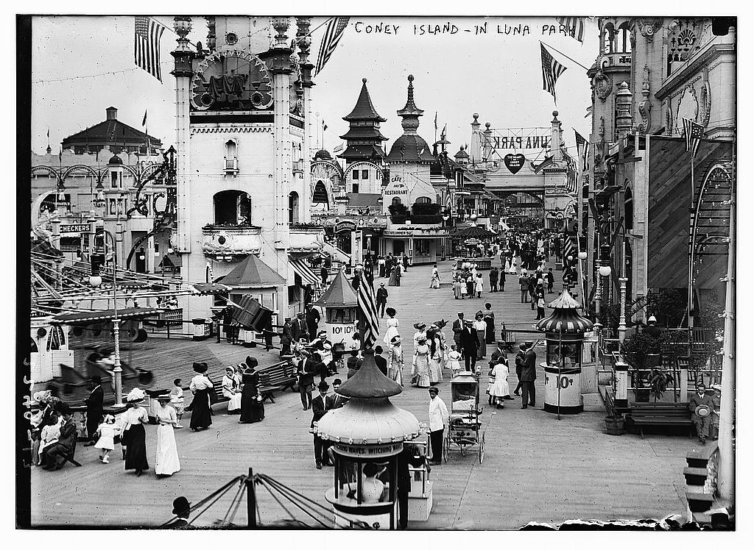

Source: “Coney Island, in Luna Park.” Bain News Service. ca. 1910 and ca. 1915]. Library of Congress. http://loc.gov/pictures/resource/ggbain.09490/
Coney Island Postcard

While men and women had once amused themselves separately, new entertainment districts like Coney Island offered beachgoers an opportunity to mingle with the opposite sex. This postcard presents one instance of the new mixed recreation.

Source: Dancing in the Sand at Coney Island, N. Y., 1905. Published by S. Hirschberg. http://collections.mcny.org/Collection/Dancing in the Sand at Coney Island, N. Y.-2F3HRG2LZ1R.html
“30,000 Waist Makers Declare Big Strike” Article Excerpt

This 1909 newspaper article describes a gathering of thousands of female shirtwaist makers. During the meeting, the workers made the decision to go on strike from their jobs to demand better working conditions. The article features quotations from strike supporters Samuel Gompers, the head of the American Federation of Labor union and Clara Lemlich, a young female worker.

Thirty thousand ladies waist makers, driven to desperation by the in tolerable conditions prevailing in their trade, voted to go on a general strike last night at four enormous mass meetings which packed Cooper Union, Astoria Hall, Beethoven Hall, and Manhattan Lyceum.

The decision to strike was first reached at the Cooper Union meeting, which was addressed by Samuel Gompers, president of the A.F. of L (American Federation of Labor Union).

Gompers said: "I have never declared a strike in all my life. I have done my share to prevent strikes, but there comes a time when not to strike is but to rivet (fasten) the chains of slavery upon our wrists."

"This is the time and the opportunity, and I doubt if you let it pass whether it can be created again in five or ten years or a generation. I say, friends, do not enter too hastily but when you can't get the manufacturers to give you what you want, then strike. And when you strike, let the manufacturers know you are on strike!

"I ask you to stand together," said Gompers in conclusion, "to have faith in yourselves, to be true to your comrades. If you strike, be cool, calm, collected and determined. Let your watchword be: Union and progress, and until then no surrender!"

This was greeted with a storm of applause.

Clara Lemlich, who was badly beaten up by thugs during the strike in the shop of Louis Leiserson, interrupted Jacob Panken just as he started to speak, saying: "I wanted to say a few words." Cries came from all parts of the hall, "Getup on the platform!" Willing hands lifted the frail little girl with flashing black eyes to the stage, and she said simply: "I have listened to all the speakers. I would not have further patience for talk, as I am one of those who feels and suffers from the things pictured. I move that we go on a general strike!"

As the tremulous voice of the girl died away, the audience rose en masse and cheered her to the echo. A grim sea of faces, with high purpose and resolve, they shouted and cheered the declaration of war for living conditions hoarsely

Source: “30,000 Waist Makers Declare Big Strike,” The Call, November 23, 1909, in Leon Stein, ed., Out of the Sweatshop: The Struggle for Industrial Democracy (New York: Quadrangle/New Times Book Company, 1977), 68-70

Rules for Pickets

During the 1909 strike, picketers marched outside of the factories where they worked to draw attention to poor working conditions and to try and keep others from going into work. Written in both English and Yiddish, the strikers distributed this circular (flier) to tell picketers how to behave, and what to do to keep from being arrested.
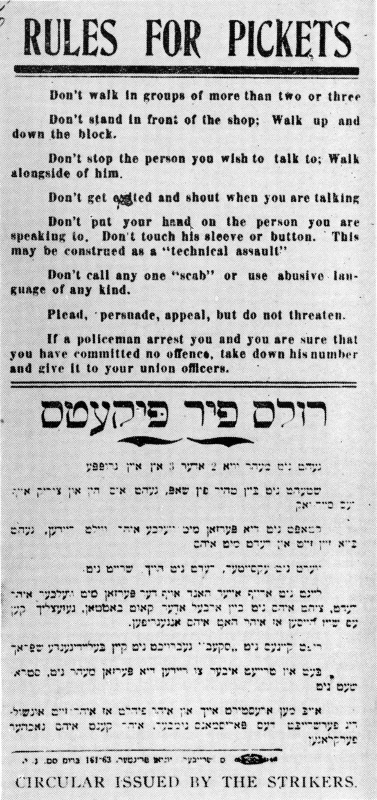
Source: Morris U. Schappes, The Jews in the United States: A Pictorial History 1654-present (Tercentenary Book Committee, 1958).
Striking Garment Workers holding The Call photo

The Socialist Party, which supported improved conditions for workers, donated a special edition of “The New York Call” newspaper to the strikers so that they could sell it to raise money for the strike fund. The special edition described the strike from the union’s perspective, and women raised awareness of the strike by selling the paper all across Manhattan. This photograph from 1910 shows the shirtwaist workers, wearing sashes that identify them as strikers, selling copies of the newspaper.

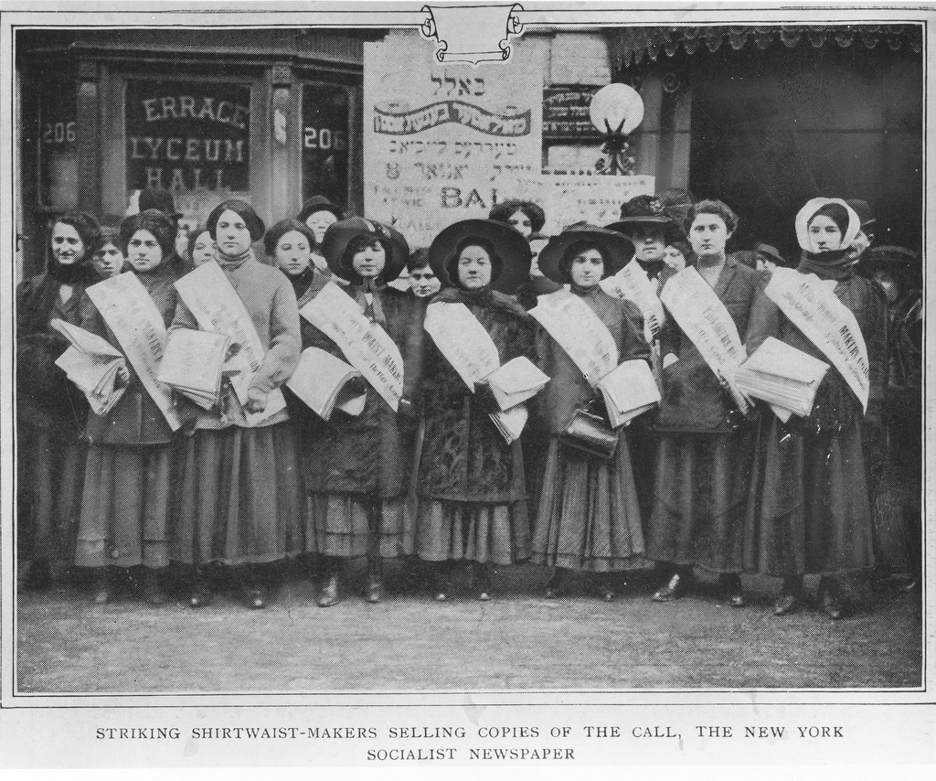

Source: Kheel Center, Cornell

“Incident in the Shirtwaist Strike”

This cartoon appeared in the Socialist newspaper The Call, which supported the shirtwaist strike, in 1909. During the strike, some women were arrested and fined on charges of beating up male scabs (people who worked during the strike). The caption below the cartoon reads, in part: “Rebecca Taylor, a striker, was fined, on the statement of Joseph Lillie, a scab of Solomon & Leffler, that she had tried to assault him—notwithstanding that Miss Taylor had a black eye herself!”
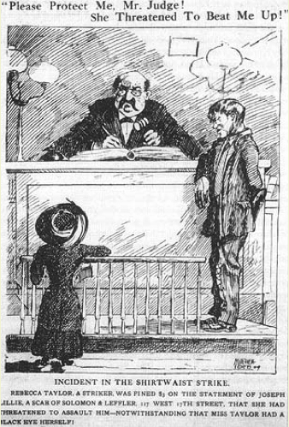

Source: “Incident in the Shirtwaist Strike,” New York Call, December 29, 1909.
“Women in a Labor War” Article

This article was published in “Munsey’s Magazine,” a popular weekly magazine, in April 1910. The article describes the shirtwaist strike and the young women’s efforts to win better working conditions and the right to organize labor unions. The article aims to show the women’s strength and commitment—that they went without wages and sometimes even food, and refused to stop striking before all of their demands were met.

Women Using Men’s Weapons
Times had changed, and women had been changed by them. The invention of the steam-engine and the introduction of machinery had compelled many women to seek to earn their living in a new way. They found themselves in a tight corner—pressed by hunger, pressed by cold, pressed by unfulfilled desires of many sorts. Concerted action promised the only hope of success. None could win unless all would stand together; and these Jewish girls fitted the old weapon to the new emergency. They invoked the subtle power of the ancient oath of their race.

Some of the richest women in the country felt it. Mrs. O.H.P. Belmont, mother of the Duchess of Marlborough, felt it. Miss Anne Morgan, daughter of J. Pierpont Morgan, felt it. Mrs. Belmont sat up nearly all night in the night court to save some accused strikers from the necessity of spending Sunday in the Tombs, and, at three o’clock in the morning gave her Fifth Avenue mansion as security for the appearance of the girls in court the following day.

The daughter of another rich woman induced (convinced) her mother to deed (transfer ownership of) the family mansion to her in order that she might sit in court, day after day, and give bail for arrested girls. Miss Morgan showed her interest by attending a demonstration given in honor of a poor girl returned from the workhouse. Girls from Vassar… showed their interest by giving up their holiday vacations, going on picket duty, and doing everything else that they could do to promote the cause of their suffering sisters.

But the spur [of economic necessity] did more. It caused the women whom it had driven into factories to act like men who work in factories. Men who thus work do not weep or mourn when things in the factories pass beyond what they conceive to be their endurance. They strike. Not only do they strike, but they stick to their colors and battle for their cause as long as they have strength to do so. Yet no man ever gave a greater exhibition of dogged determination to persevere in the end than did these girls not yet out of their teens.

A Typical Labor War
When they “picketed” the factories and tried to prevent other women from taking their places, there were excitement and some disorder in the streets. In the scuffling, some of the girls were grabbed by the hair, and their heads were bumped against the curbstones. Never mind—let the strike go on!

More than six hundred were arrested, and a score were sent to the workhouse. What of it? Merely incidents of industrial warfare—let the strike proceed!

The six thousand who stayed out to the bitter end after the other twenty-four thousand had won their victory were actually starving. One day, on a single street, out of thirty pickets, twenty-eight fell in their tracks. It was not magnificent—just industrial war. Forget it, and remember the strike!

Then came the day when the employers of the remaining six thousand offered terms of peace. Back to the Cooper Union—read the terms. What were they?

As terms go, they were liberal. Every demand was granted except one. But that one rejected grievance—no union! Not recognized! Spurned, ignored, thrown out of court!

Starving girls were called upon to say what they would do. They filled the hall. A patriarchal Jew of seventy began to speak. He told his hearers that he was one of the few men engaged in the shirtwaist industry. He was the father of nine children. he knew what hunger was; he knew what cold was; he knew what work was. Also, he knew what visions were made of, for he himself had dreamed of a happier day when the union should protect them all.

In the same simple Yiddish that Clara Lemlich had employed at the beginning of the strike, he counseled the most careful consideration. They had struck for the union, it was true; but winter had come. The valiant remnant of the strikers had been reduced to bread and soup. Some of them had only an apple for breakfast, and nothing afterward. If the strike were to be ended upon the proffered terms, conditions would be better than they had ever been before. If the strike were to go on, there would be an indefinite continuation of bread and soup—and, in a little while, there might be no bread. An advance (progress) of twenty years had been made in the last two months; wouldn’t it be better to rest content for a while—even without the union?

When he finished speaking, no one replied. Three thousand girls sat in stunned silence. For twenty full seconds, there was not the rustling of a foot nor the sound of a voice. Then, in unison, as if the three thousand girls had been trained for a month to do what they were about to do, there swept over the hall a mighty sob. . . . But the assembled girls had not yet spoken. Having sobbed, they were ready to speak. And, what was the order that these starving strikers unanimously gave? Here it is:

“Burn the [offered] terms of the employers and go on with the strike.”

And they went out again into the cold, with their shivering bodies, their empty stomachs, and their heavy hearts. They had kept their oath.

Yes, indeed, women have changed.

Fifty years ago, women would never have waged such a desperate fight, in mid-winter, against five hundred employers. They hadn’t been prepared. They hadn’t learned to fight the world as men fight it for a living. But they are learning—learning in the same school in which man learned.

Source: Allan L. Benson, “Women in a Labor War,” Munsey’s Magazine xliii:1 (April 1910): 68-76.
“Record of Police Persecution in the Waist Makers’ Strike”

The “New York Evening Call” newspaper was sympathetic to the cause of the shirt waist strikers, who began their strike on November 23, 1909. After five weeks of striking, as the year 1909 drew to a close, the Call published a day-by-day listing of the number of strikers arrested and fined by police, the number discharged (let go), the number held in jail, the total amount of fines collected, and the number of strikers sentenced to the workhouse (a prison where offenders are required to work).
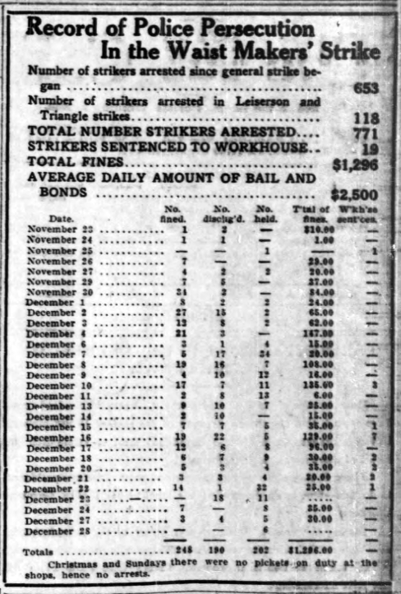
Source: New York Evening Call, December 29, 1909.

Triangle Fire Survivors’ Accounts

These four interviews were done in 1957 with four women who had worked at the Triangle Shirtwaist Factory and survived the fire of March 25, 1911. In the interviews the women describe what happened on the day of the fire, and how they were able to escape. The doors on each floor of the factory were kept locked so that workers could not leave without permission, leaving many women trapped inside the factory during the fire because of the locked doors.

Dora Appel Skalka

Job: Blouse Maker, 8th floor
Interview: July 31, 1957
I worked at the Triangle Shop for nine weeks before the fire.
I came up to work with my girl friend named Pauline and I worked together with her. I remember on the day of the fire she said to me let's stop early today and let's go home earlier. We got paid at a quarter to four and I said why should we lose an hour work but she would not listen. She went home early and left me to work alone. This time because she went home earlier I decided to stop earlier too. So I went to the dressing room earlier than I usually did. I was at the door of the dressing room and was about to go in when I heard screaming in the back of me.
I turned around and saw that the fire was already burning at the cutting table. My machine was in the first row next to the cutting table and if my girl friend did not go home earlier, I am sure I would have been one of the first victims.
But I was standing at the door of the dressing room with two or three other girls and we ran to the door of the Greene St. staircase. It was closed. All around me there was hollering. In a split second the place filled up with black smoke. I remained at the door. I did not move. I could not holler. I thought to myself at least I want to die by the door.
I don't remember exactly how it happened but somebody opened the door from the outside. It was either a fireman or policeman who smashed in the door, which was always locked. He grabbed us and told us to go down the staircase and he took us down to the 6th floor and left us there. He must have gone back upstairs.
When I finally came downstairs in the lobby they were crying and hysterical but they would not let us out. There were maybe 20 or 30 people in the lobby. Some were crying and hysterical but they would not let us out. When we finally got out of the lobby into the street I could see why - because there, smashed on the sidewalk, were the beautiful faces of those who were my neighbors at the machines.

Rose Indursky

Job: Sleeve Setter, 9th floor
Interview: September 19, 1957
I was a sleeve setter. That day everybody couldn't wait to go home. There was a Ball or something and everybody was going. When I went out into the hall staircase I bent down and looked downstairs and I could see the fire come up. In the shop the girls were running around with their hair burning.
First I ran into the dressing room with the machinist and some of the others. Then the walls in the dressing room began to smoke. The machinist had a wild look in his eye. We ran back into the shop; girls were lying on the floor, fainted, and people were stepping on them. Some of the other girls were trying to climb over the machines. I remember the machinist ran to the window and he smashed it to let the smoke that was choking us go out. Instead, the flames rushed in. I stood at the window; across the street people were hollering "don't jump, don't jump." I turned around and ran to the hall staircase door. My hair was smoldering -- my clothes were torn. I put my two hands on my smoldering hair and ran up the stairs. I went into the 10th floor. Nobody was there except one man, bookkeeper. He was picking up papers and he hollered to me, can you come to the roof, can you come to the roof. By that time, all the windows on the 10th floor were burning. My life was saved on account of the bookkeeper. I didn't know that the next floor was the roof. I think if not for him I would have stayed on the 10th floor and maybe had been killed.

Rose Hauser

Job: Unknown, 9th floor
Interview: September 4, 1958
On the floor a gong used to ring when the day was over. About five minutes before quitting time I sneaked into the dressing room. There were a few girls in the dressing room. I used to sing a lot in the shop, some of the girls asked me to sing a song while we were getting dressed. They asked me to sing -- I still remember the name of the song -- "Every Little Movement Has a Meaning of Its Own". They insisted that I sing so I did my little act in the dressing room. As soon as I finished the song I heard the bell ring but it seemed to me that it was a little bit too soon.
We were never allowed to go down the front way -- either by elevator or staircase. We always went by the freight [elevator], which was in the back. When I got out of the dressing room I looked toward the freight elevator and I saw smoke pouring up. The smoke was also coming out of the staircase. I ran with some of the other girls to the front door. I put my hand on the knob and tried to open it and I stood there screaming that the door was locked. I tried to force it open with all my strength but it would not move.
I looked around and I saw the flames coming in all the windows. The fire was in the shop and was coming toward us. There was a fire escape at the windows near the freight side. The fire escapes had iron doors and shutters. Everybody was running and hollering and people were choking from the heavy smoke. I took my muff (a warm, fur covering for the hands) and put it over my head. I ran back to the front elevator and there was no chance there. I kept my muff on my head and ran toward the freight side again. I found that the door to the back staircase was open and that is how I got out.
When I began to go down to the 8th floor, I was choking. The fire was in the hall on the 8th floor. I put my muff around my head tightly and I ran right through the fire. The fur caught on fire. When we got down stairs they kept us in the hall and they wouldn't let us go into the street because the bodies were falling down.

Celia Walker Friedman

Job: Examiner, 9th floor
Interviewed: August 8, 1957
On the day of the fire I had gotten my clothes. I stood at my table ready to leave. I looked across the shop. In front of me I saw flames on the outside of the windows shooting up. The flames were climbing up from the 8th floor. I was scared and it seemed to me that even before I could move, everybody in the shop started to scream and holler. The girls at the machines began to climb up on the machine tables maybe because it was that they were frightened or maybe they thought they could run to the elevator doors on top of the machines. The aisles were narrow and blocked by the chairs and baskets. They began to fall in the fire. I know now that there was a fire escape in back of me but I ran to the elevator because that was the only place to run to.
The door to the stairway was completely blocked by the big crates of blouses and goods. The fire crept closer to us and we were crowded at the elevator door banging and hollering for the elevator. The first time it came up, the girls rushed in and it was crowded in a half a second. The elevator driver struggled with the door and finally closed it and went down with the screaming girls. I was left with those who didn't make the first trip. Then the elevator came up a second time. The girls were all squeezing against the door and the minute it was opened they rushed again. This time I was sure I would be lucky and get in. I rushed with the other girls but just as I came to the door of the elevator it dropped down right in front of me. I could hear it rush down and I was left standing on the edge trying to hold myself back from falling into the shaft. I held on to the two sides of the open door. Behind me the girls were screaming and I could feel them pushing me more and more. I knew that in a few seconds I would be pushed into the shaft and I made a quick decision. Maybe through panic or maybe through instinct I saw the center cable of the elevator in front of me. I jumped and grabbed the cable. That is all I remember.
My next thing I knew was when I opened my eyes and I was lying on my back and I looked up into the faces of a priest and a nun who were trying to help me. I was in St. Vincent's Hospital. Everybody thought I was going to die. They found me at the bottom of the [elevator] shaft. I had saved myself by my jumping. I was very lucky. My head was injured and I had a broken arm and a broken finger. I had a large searing scar down the middle of my body, burned by the friction of the cable, which had cut through my clothing. In the hospital, later, I was shown a large ripped piece of fur and fabric.
One of the nurses said she thought it was wonderful that I had enough presence of mind when I jumped to wrap something around my hands in order to save them and to be able to hold on to the cable. I know it was not presence of mind or courage. I think the right word is vanity (too much pride in one’s appearance). This was a new muff (warm, fur covering for the hands) that I had bought after saving for it many weeks and fire or no fire, something in me made me hold on to it even while I jumped to save my life. I don't know how long I stayed in St. Vincent's but when I was well the Red Cross came with my clothing which they got from my family and took me straight to the mountains for a rest. At the same time, the Red Cross paid my family $10 a week for 10 weeks. I never got a dime's worth of help from the company.
Source: Survivor Interviews, Remembering the 1911 Triangle Fire and Its Aftermath website, Kheel Center, School of Industrial and Labor Relations, Cornell University (http://trianglefire.ilr.cornell.edu/primary/survivorInterviews/)
“Placing the Responsibility” Article

This newspaper article, published in 1911 one month after the Triangle Shirtwaist Factory fire, describes the findings of the Grand Jury in the cases of two women who died in the fire. The jury decided that conditions in the factory, such as locked doors and cramped work areas, prevented women from escaping the fire. The jury also urged new laws and reforms, such as regular inspections by the Fire Department, to be made to make factories safer for workers in the future.
Harris and Blanck, who comprise the firm whose employees were burned, and who had been already indicted (charged) by the Grand Jury, were declared responsible for the death of the two women whose cases were presented to the coroner's jury, because of culpable and criminal negligence (lack of care or attention) in leaving a door locked which should have permitted these women to escape.
Furthermore, the jury declared that no attention had been given or means provided for quick exit of the employees, but that, on the contrary, their safety had been utterly disregarded. The crowding of tables and lack of passageways are instanced, as well as the locking of doors.
The jury declared that the conditions obtaining in this factory were such that, if they were not forbidden by law, such a law should be instantly framed (proposed).
The jury recommends that fire-escapes should be regularly inspected by the Fire Department and reported to the Bureau of Buildings, and that then the latter should order changes made and have power to enforce such orders.
Concentration of responsibility is strongly urged, and there are specific recommendations for improvement of the laws or practice as regards inspection of factory buildings, the construction of stairways, the use of automatic sprinklers, and the posting of rules in the buildings.
The public continues to take the strongest possible interest in the investigation as to the cause of this fire, and will agree with the coroner (public official who determines the cause of death when people die in sudden or violent ways) in his thanks to the jury for doing a work of great benefit to the public, and also in his hope that the jury's recommendation will result in immediate and practical reform.
Source: “Placing the Responsibility,” The Outlook, April 29, 1911, p. 949.
Factory Safety Report, 1912
Published by the New York State Factory Investigating Commission in 1912, and in response to the Triangle Shirtwaist fire, this report calls for new laws that will make factory work safer and healthier, and will prevent future tragedies. The report notes that factory work is more dangerous and leads to more disease than other types of work, and that making factories safer will not only save lives, but will be less expensive for companies than paying for damages after another fire.
REPORT to the LEGISLATURE OF THE STATE OF NEW YORK
By the NEW YORK STATE FACTORY INVESTIGATING COMMISSION (EXCERPT)
On Saturday afternoon, March 25, 1911, a fire took place in the business establishment of the Triangle Waist Company, at No. 23-29 Washington Place, in the Borough of Manhattan, City of New York, in which 145 employees, mainly women and girls lost their lives.
This shocking loss of life aroused the community to a full sense of its responsibility. A superficial (quick) examination revealed conditions in factories and manufacturing establishments that constituted a daily menace to the lives of the thousands of working men, women and children. Lack of precautions to prevent fire, inadequate fire-escape facilities, insanitary (sic) conditions that were insidiously undermining (harmful to) the health of the workers were found existing everywhere. The need of a thorough and extensive investigation into the general conditions of factory life was clearly recognized.
The commission was authorized by the Legislature to inquire into the existing conditions under which manufacturing was carried on in so-called loft buildings and otherwise, including matters affecting the health and safety of the operatives (workers) as well as the security and best interests of the public.
IMPORTANCE OF INVESTIGATION
Health is the principal asset of the working man and the working woman. The state is bound to do everything in its power to preserve the health of the workers who contribute so materially to its economic wealth and its industrial prosperity.
Aside from the humanitarian aspect of the situation, economic considerations demand from the State the careful supervision and protection of its workers. Failure to perform this obligation will produce serious results in the workers of the future. It will affect the working capacity of the future generation.
The State not only possesses the power and the right, but it is charged with the sacred duty of seeing that the worker is properly safeguarded (protected) in case of fire; that he is protected from accidents caused by neglect or indifference; that proper precautions are taken to prevent poisoning by the materials and processes of his industry, and that he works under conditions conducive to good health, and not such as breed disease.
Factory workers particularly need protection and supervision. Among them disease more easily finds its victims than among other classes of workers. Statistics show the greater mortality of those engaged in factory work, as compared with those in other occupations.
Fires and industrial accidents are fortunately only occasional and extraordinary events. Their effects are visible and immediate so they are impressed forcibly upon our minds. But the common, everyday incidents of industrial life, the lack of ventilation (fresh air), the long hours of labor amid insanitary (sic) surroundings, these work unnoticed, but the toll of human life they exact (take) is very great.
A general awakening has taken place throughout the State. A far larger number of inspections by authorities have been made than ever before. No great reliance, however, can be placed upon such a momentary or spasmodic awakening. When its cause is no longer present, conditions relapse into their former state, and there is little real improvement.
To improve the industrial situation permanently, clear, concise and comprehensive legislation (law-making) is needed.
Source: New York (State) Factory Investigating Commission, Preliminary Report of the Factory Investigating Commission, 1912. (Albany, New York: The Argus Company, 1912), vol. 1, pp. 13-20.
Results of the New York State Factory Investigating Commission, 1915
This report, published by the New York State Factory Investigating Commission in 1915, lists the laws enacted by the New York State Legislature from 1912-1914 (in response to the Triangle Shirtwaist fire) to make factory work safer and healthier.
Results of the New York State Factory Investigating Commission, 1915
Laws Enacted as a Result of the Commission's First Year's Work
The following bills recommended by the Commission in its preliminary report were passed by the Legislature during the session of 1912, and became laws:
- Registration of factories.
- Physical examination of children before employment certificate is issued.
- Fire drills.
- Automatic sprinklers.
- Fire prevention; removal of rubbish; fire-proof receptacles for waste material; protection of gas jets; prohibition of smoking in factories.
- Prohibition of the eating of lunch in rooms where poisonous substances are prepared or generated in the process of manufacture; adequate hot and cold washing facilities for such establishments.
- Employment prohibited of women within four weeks after child-birth.
- Summary power of Commissioner of Labor over unclean and unsanitary factories.
Laws Passed as a Result of the Commission's Second Year's Work
The following bills recommended by the Commission in its second report were enacted into law by the Legislature during the session of 1913:
- Reorganization of Labor Department; Industrial Board.
- Penalties for violation of Labor Law and Industrial Code.
- Fire-proof receptacles; gas jets; smoking.
- Fire alarm signal system and fire drills.
- Fire escapes and exits; limitation of number of occupants; construction of future factory buildings.
- Amendment to Greater New York charter with reference to the Fire Prevention Law.
- Prohibition of employment of children under fourteen, in cannery sheds (factory for the canning of foods) or tenement houses; definition of factory building; definition of tenement house.
- Manufacturing in tenements.
- Hours of labor of women in canneries.
- Housing conditions in labor camps maintained in connection with a factory.
- Physical examination of children employed in factories.
- Amendment to Child Labor Law; physical examination before issuance of employment certificate; school record; supervision over issuance of employment certificate.
- Amendment to Compulsory Education Law; school record.
- Night work of women in factories.
- Seats for women in factories.
- Cleanliness of workrooms.
- Cleanliness of factory buildings.
- Ventilation; general; special.
- Washing facilities; dressing rooms; water closets.
- Accident prevention; lighting of factories and workrooms.

Laws Passed as a Result of the Commission's Third Year's Work

The following laws, recommended by the Commission in its third report, were passed by the Legislature in 1914 and have become laws:
- Sanitation in mercantile establishments. This covered provisions for seats for female employees; cleanliness of rooms; cleanliness of buildings; size of rooms; ventilation; drinking water; wash rooms and dressing rooms; and water closets.
- Hours of labor of women in mercantile establishments limited to fifty-four hours a week in the entire State.
- Hours of labor of children between fourteen and sixteen in mercantile establishments reduced from fifty-four to forty-eight hours a week and their employment prohibited for more than eight hours a day or after 6 o'clock in the evening of any day.

Source: New York (State) Factory Investigating Commission, Fourth Report of the Factory Investigating Commission, 1915. 5 vols. Albany, J.B. Lyon company, printers, 1915, vol. 1, pp. 2-11; https://archive.org/details/fourthreportoffa01newyiala

Interior of Triangle Shirtwaist Factory after the Fire Photo

On March 25, 1911, a fire spread through the Triangle Shirtwaist Factory. This photograph, taken shortly after the fire, shows the destruction done to the factory.

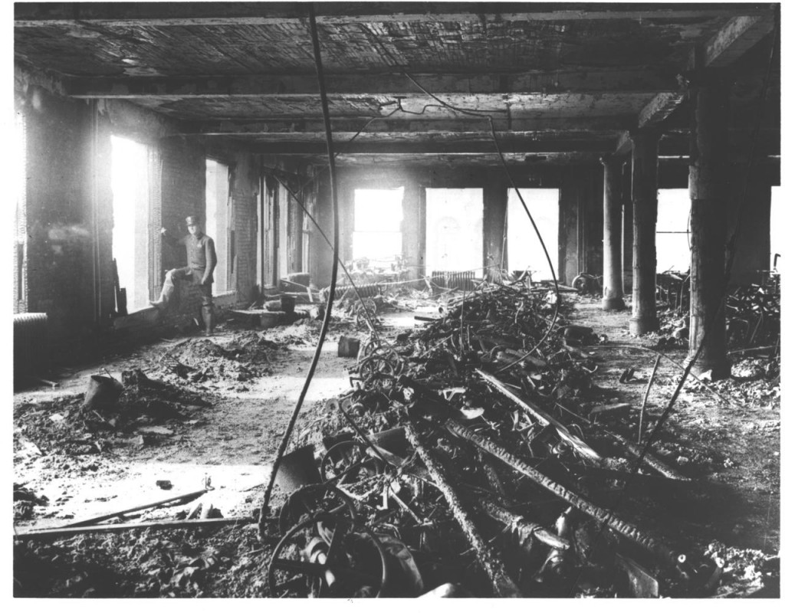

Source: National Archives and Records Administration

