A NOTE TO THE EDUCATOR:

On the following pages, you will find “flashcards” with terms and definitions (both combined and separate) that your students may encounter while playing Part 2 of “A Cheyenne Odyssey.” These terms and definitions can be introduced and practiced before or during the time students see or hear them in the context of Mission US, or in their American history study. The discussion questions and writing prompts will provide further opportunities for students to have more practice with the words and terms.

Divide your students into small groups of four or five, and ask each group to review the flashcards containing the combined terms and definitions. Then, have students used the flashcards that have the meanings separated from the images, and ask them to match each word/image to its corresponding meaning.

After your students have had a chance to review and discuss the terms and definitions, distribute the excerpt from Little Fox, featured at the end of this document. Review the directions with your students and ask them to complete the text using the terms they studied.

Here are the terms which should be inserted into each paragraph of Little Fox’s story:
Paragraph 1 – favor, trade, fort
Paragraph 2 – sign language, negotiate, buffalo robes, trading post, kettle
Paragraph 3 – war face, ambush

ambush  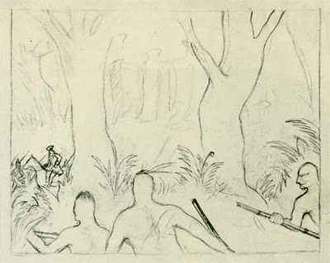  a surprise attack | buffalo robe  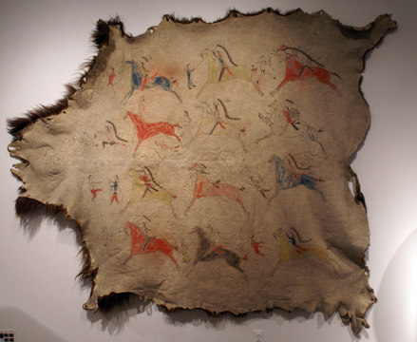  the fur and hide of a buffalo; Plains Indians often decorated the robes for use as clothing
favor  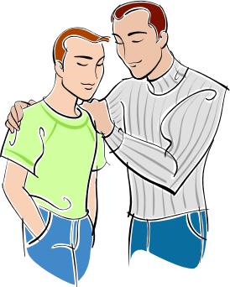  approval | fort  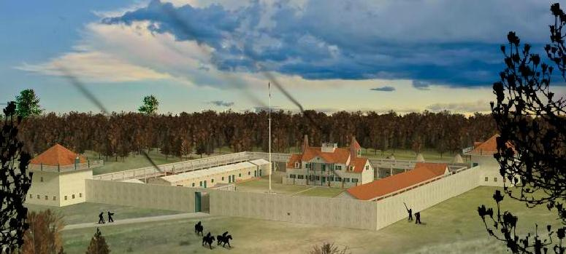  a strong or fortified place occupied by troops; a permanent army post
kettle  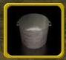  a pot for boiling liquids | negotiate  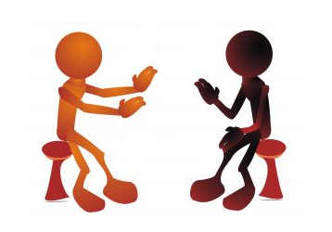  to deal or bargain with others when  preparing a treaty, sale, or contract
sign language  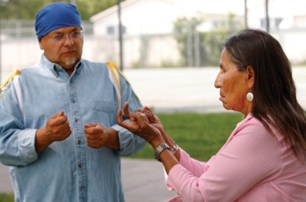  a set of hand signals used by Plains Indians to communicate with different tribes and with European explorers as early as the 1530s | trade  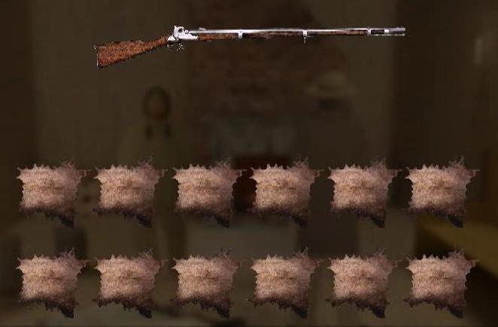  an exchange of goods, usually without money
trading post  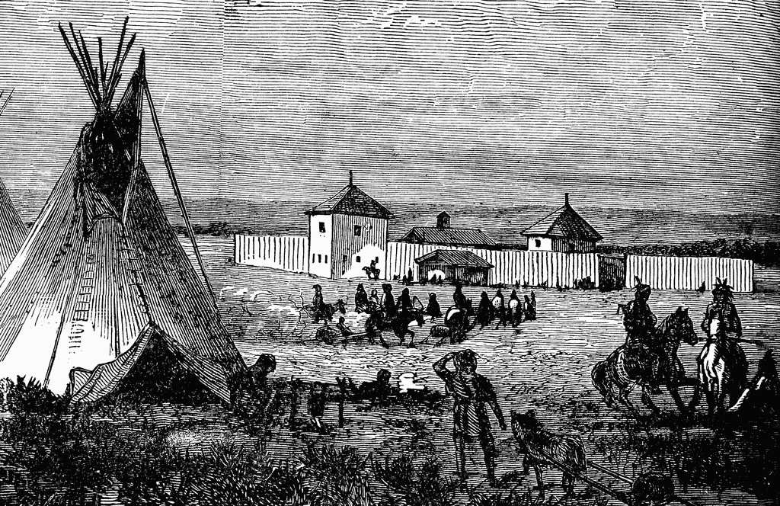  a station or store where traders exchange goods, usually without money | war face  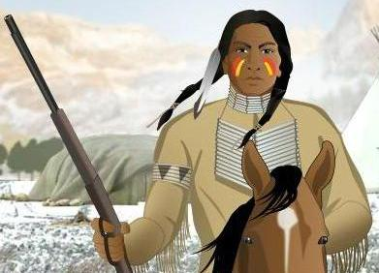  the painted face of an Indian warrior going into battle; each tribe’s war paint featured different colors, shapes, and symbols

ambush | buffalo robe
favor | fort
kettle | negotiate
sign language | trade
trading post | war face

a pot for boiling liquids | the painted face of an Indian warrior going into battle; each tribe’s war paint featured different colors, shapes, and symbols
an exchange of goods, usually without money | a surprise attack
a set of hand signals used by Plains Indians to communicate with different tribes and with European explorers as early as the 1530s | a station or store where traders exchange goods, usually without money
a strong or fortified place occupied by troops; a permanent army post. | approval
to deal or bargain with others when preparing a treaty, sale, or contract | the fur and hide of a buffalo; Plains Indians often decorated the robes for use as clothing

Name: Date:

After Little Fox grew up and had children and grandchildren of his own, he continued the Northern Cheyenne tradition of passing along family history through storytelling. This activity imagines Little Fox is sitting around a fire as an old man, telling his grandchildren about his life and adventures growing up.

Instructions: After reading and talking about the words and terms on the flash cards, read the excerpt below from Little Fox’s story, describing what his life was like when he was growing up. Use the cards and your memory to help you fill in the missing words and terms.

ambush  buffalo robes  favor  fort | kettle  negotiate  sign language  trade | trading post  war face

“When I was growing up, my sister Calling Bird had two suitors who wanted to marry her. Each wanted to gain the ___________________ and approval of my uncle, so that he would agree to let my sister marry him. These men were very nice to me, too. Many Horses took me on my first trip to __________________ some items for some of the white man’s things. I had never met a white man before. On our trip, we rode to a large ____________________ where white soldiers lived. They didn’t live in tipis like we did.

When I went on my first trip with Many Horses, I wasn’t sure how I would talk with the white men, since I didn’t know their language. Fortunately, it was pretty easy, since they knew some of our ____________________, which was a way that we spoke with other tribes, using our hands. Many Horses also taught me some of the white man’s words too. At first, the trader didn’t want to give me what I wanted, but we were able to _____________________ with each other and compromise until we came up with a good deal. The white men got several of our ______________________________, which could keep them very warm in the cold winter
months. Many Horses and I left the _______________________________ where the white men exchange their goods, and headed home with a lot of nice things, including a very sturdy iron ____________________, which my mother asked me to get so that she could boil water.

After my father died, my uncle helped take care of me. I learned a lot from him and loved hearing of stories when he went into battle. Before he would leave to fight, he would put on his ______________________, which had Northern Cheyenne painted designs. I was very proud of him. He was a brave warrior. I liked hearing about his stories of battle, like the time where he and other warriors hid and then did a surprise attack, an _________________________, and attacked with their bows and arrows. I knew that when I got older, I also wanted to be a brave warrior like my uncle and my father. “

