Garment Workers in a Home Sweatshop Photo

Many Jewish immigrants found work in New York’s booming garment industry. Often they worked in “sweatshops,” like this one, where they assembled garments under the supervision of a contractor. Most sweatshops were located in people’s homes, and the workers were paid a “piece work” rate (according to how many items they finished). The work was difficult and low paid.

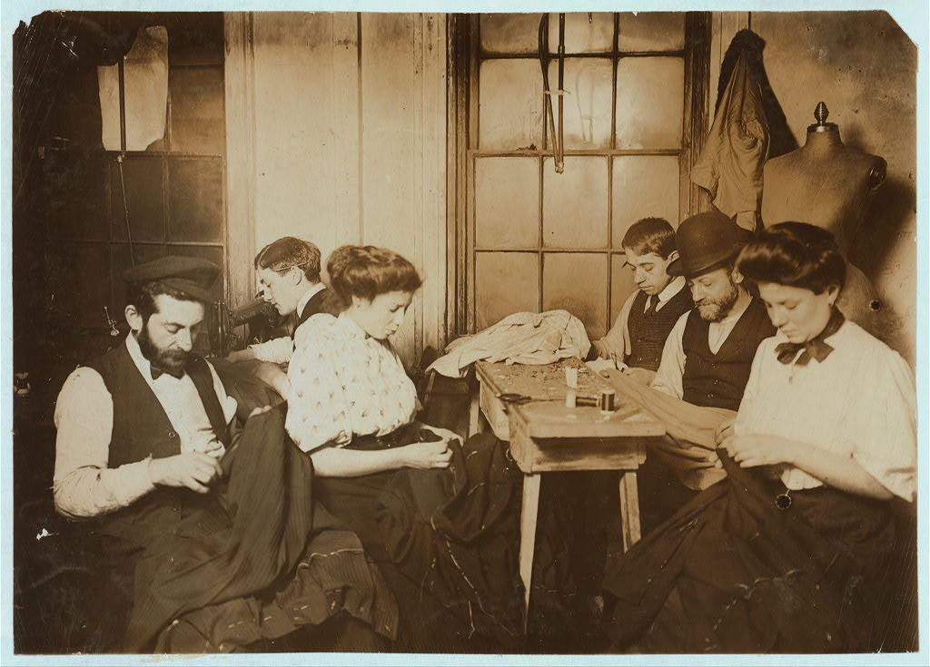

Source: Lewis Hine, “Group in Sweatshop,” 1908. Prints and Photographs Division, Library of Congress (http://www.loc.gov/pictures/item/ncl2004000050/PP/)

