Annual Rainfall in Wheat-Producing States, 1910-1940
This graph shows the annual rainfall in the Great Plains wheat-producing areas (including the Texas Panhandle) from 1910-1940, and includes the average annual rainfall in the region during that period as reference.
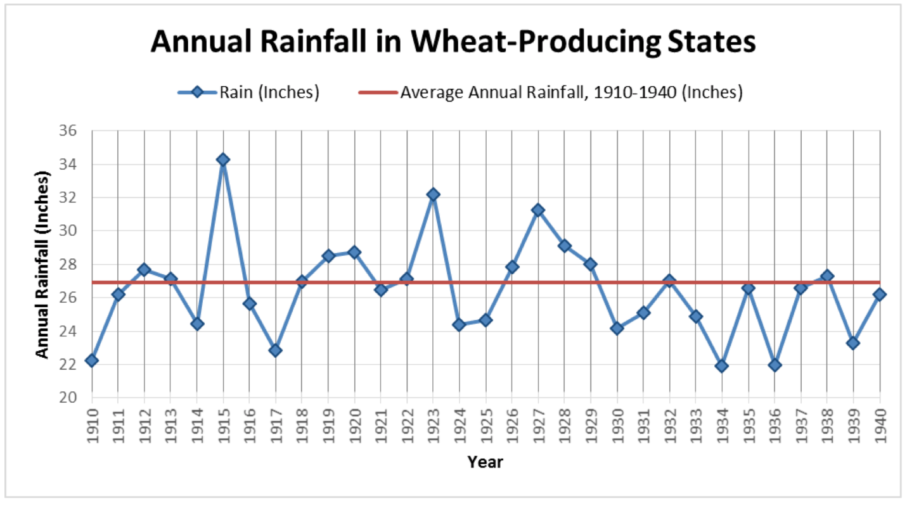

Source: National Oceanic and Atmospheric Administration, National Centers for Environmental Information. http://www.ncdc.noaa.gov/cag/time-series/us/

