Father Cox on the Breadline

Father James Renshaw Cox was a Catholic priest from Pittsburgh, Pennsylvania, who arranged private charity donations through his church during the Depression. In this image from 1930, Cox helps to pass out loaves of bread to needy families. In 1932, Cox earned national recognition when he and thousands of protesters marched to Washington D.C. to demand jobs for the unemployed.
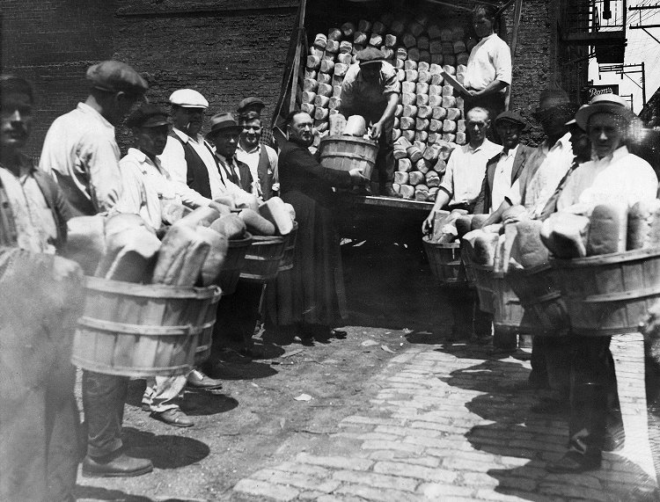

Source: “A view of bread being unloaded and passed down the line,” ca. 1930, James R. Cox Papers, 1923-1950, University of Pittsburgh
http://images.library.pitt.edu/cgi-bin/i/image/image-idx?rgn1=hpicasc_ci;med=1;q1=AIS.1969.05;size=20;c=hpicasc;back=back1455894304;subview=detail;resnum=10;view=entry;lastview=thumbnail;cc=hpicasc;entryid=x695.0829.fc;viewid=0829FCTIF

