Statement of United States Citizen of Japanese Ancestry: Joe Yamikido

In 1943, the U.S. military required all draft-age Nisei to fill out a “Statement of United States Citizen of Japanese Ancestry.” This form would be informally known as the loyalty questionnaire, as two of the more controversial questions on the document (questions 27 and 28) asked participants if they would serve in the armed forces, and if they would pledge allegiance to the United States. The questionnaire created a good deal of confusion, fear, and anger throughout the camps, as Nisei were being asked to swear allegiance to their own country while they were being simultaneously incarcerated by the government. The following completed form shows how one incarceree responded to these controversial questions. When asked in Question 27 if he would serve in the armed forces if ordered, Joe Yamakido responded, “Yes, if drafted [and] provided I am given equal rights and opportunity as caucasians.” Yamakido was arrested for resisting the draft, but served in the army after World War II.

Full Completed Form

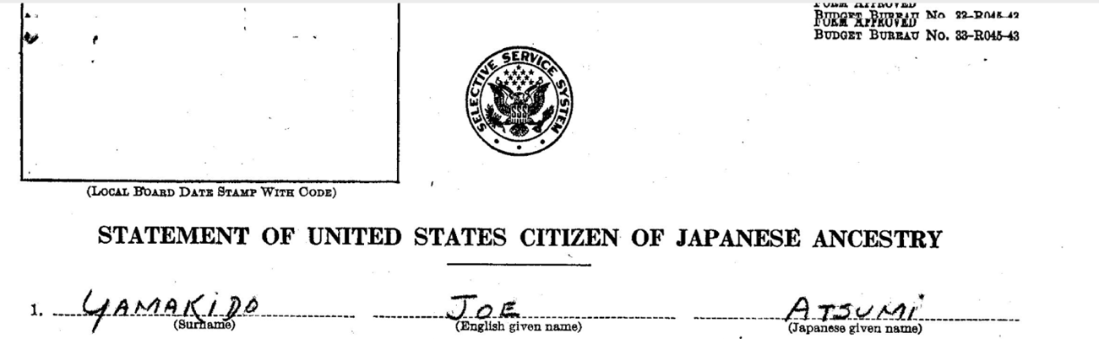

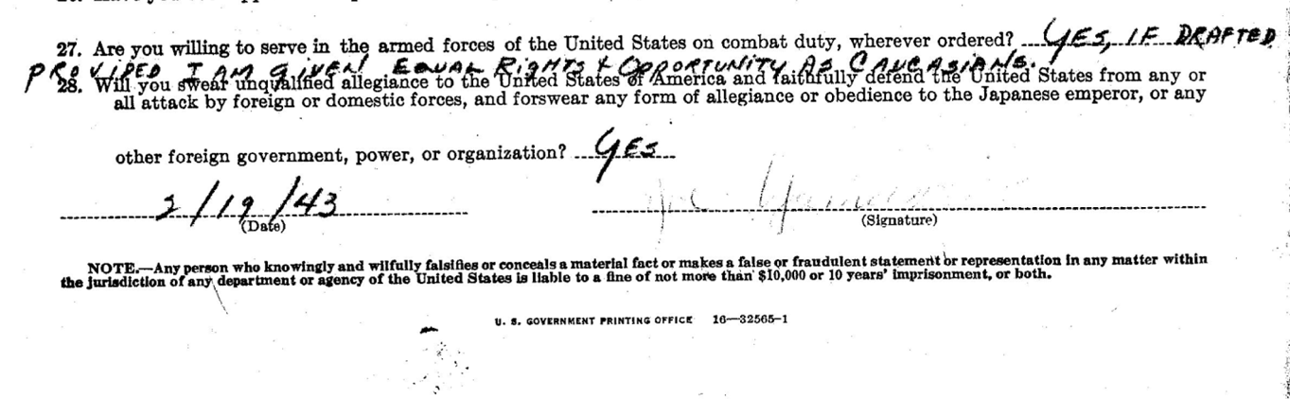
Source: Joe Yamakido, “Statement of United States Citizen of Japanese Ancestry.” National Archives, Records of the War Relocation Authority 210.3.4.

