Dr. Seuss Cartoon, December 10, 1942

In the 1940s, children’s book author Theodor Seuss Geisel, known as Dr. Seuss, created political cartoons for PM, a daily newspaper published in New York. Although the newspaper’s mission statement claimed: “PM is against people who push other people around,” Dr. Seuss’s cartoons portrayed stereotyped and racist images of Japanese Americans.

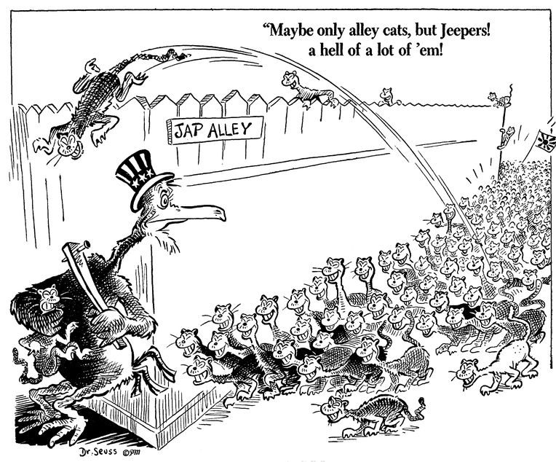

Source: Maybe only alley cats, but Jeepers! A hell of a lot of 'em!, December 10, 1941, Dr. Seuss Political Cartoons. Special Collection & Archives, UC San Diego Library. Digital object made available by Special Collections & Archives, UC San Diego, La Jolla, 92093-0175 (https://lib.ucsd.edu/sca)

