Photo of the Forced Removal From Bainbridge Island

On March 30, 1942, military troops arrived on Bainbridge Island to force the removal of all Japanese American residents. A special ferry was docked at the Eagledale dock to transport the residents to Seattle where they were placed on trains and sent to California.

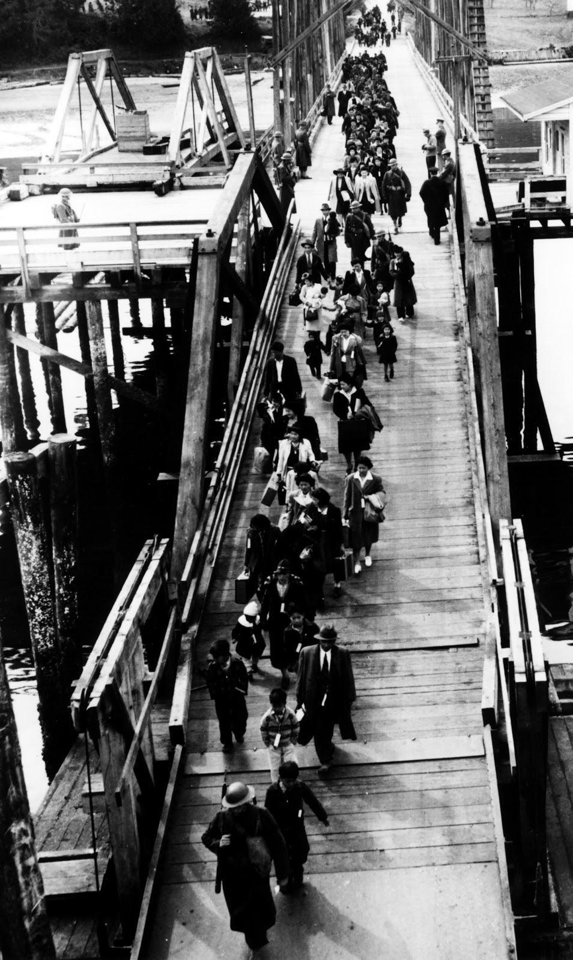
Source: Densho Digital Repository, ddr-densho-34-2 (Legacy UID: denshopd-i34-00002) Courtesy of the Bainbridge Island Japanese American Community

