Photo of the Forced Removal From Bainbridge Island

On March 30, 1942, military troops arrived on Bainbridge Island to force the removal of all Japanese American residents. Kikuyo (back left) and Henry Takayoshi waited at the Eagledale ferry dock with their children. A special ferry transported them from Bainbridge Island to Seattle where they were placed on trains and sent to California.

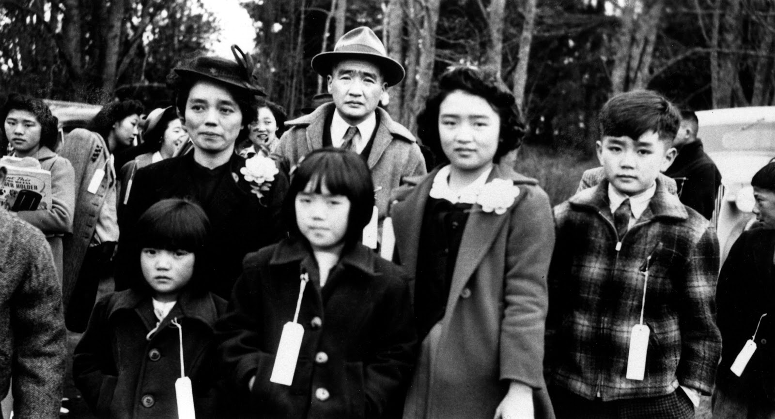

Source: Densho Digital Repository: ddr-densho-34-80 (Legacy UID: denshopd-i34-00080)

