Photo of the Forced Removal From Bainbridge Island

On March 25, 1942, Soldiers began nailing up posters across Bainbridge Island. The posters contained the Civilian Exclusion Order No. 1 along with special instructions to all Japanese residents of the island telling them exactly how they were to comply with the new decree.

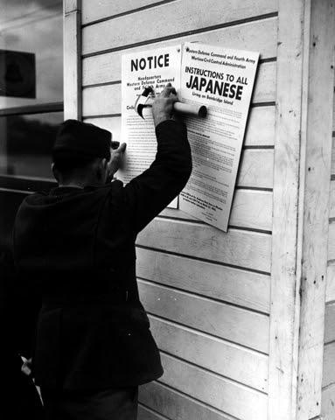

Source: Densho Digital Repository: ddr-densho-36-28 (Legacy UID: denshopd-i36-00028) Courtesy of the Seattle Post-Intelligencer Collection (number PI-28035), Museum of History & Industry

