Manzanar Center Citizens Join Net Project en Masse

Various jobs paying minimal wages were available for the Japanese Americans imprisoned at Manzanar. The work included running the mess halls, delivering mail, farming, and caring for young children. One of the more controversial jobs was working on the military contract for camouflage nets, which was limited to U.S. citizens or nissei. This article from the prison camp newspaper, Manzanar Free Press reports on the camouflage work.

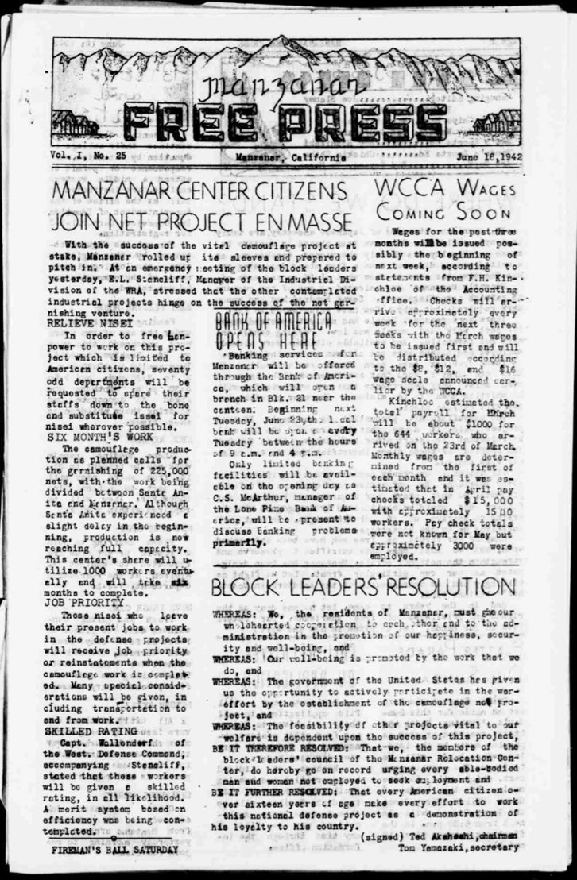

Manzanar Free Press, Vol. I, No. 25
June 18, 1942
https://lccn.loc.gov/sn84025948

MANAZAR CENTER CITIZENS JOIN NET PROJECT EN MASSE

With the success of the vital camouflage project at stake, Manzanar rolled up its sleeves and prepared to pitch in. At an emergency meeting of the block leaders yesterday, E.L. Stancliff, Manager of the Industrial Division of the WRA, stressed that the other contemplated industrial projects hinge on the success of the net garnishing venture.

RELIEVE NISEI
In order to free manpower to work on this project which is limited to American citizens, seventy odd departments will be requested to spare their staffs down to the bone and substitute issei for nisei wherever possible.

SIX MONTH’S WORK
The camouflage production as planned calls for the garnishing of 225,000 nets, with the work being divided between Santa Anita and Manzanar. Although Santa Anita experienced a slight delay in the beginning, production is now reaching full capacity. This center’s share will utilize 1000 workers eventually and will take six months to complete.

JOB PRIORITY
Those nisei who leave their present jobs to work in the defense projects will receive job priority or reinstatements when the camouflage work is completed. Many special considerations will be given, including transportation to and from work.

SKILLED RATING
Capt. Wallendorf of the West. Defense Command, accompanying Stancliff, stated that these workers will be given a skilled rating, in all likelihood. A merit system based on efficiency was being contemplated.

