Ansel Adams Photo: School Children
In the 1940s, Ansel Adams, one of the most famous photographers in the United States, went to the Manzanar to document the imprisoned Japanese Americans. He later described the purpose of this photo project as an effort “to show how these people, suffering under a great injustice, and loss of property, businesses and professions, had overcome the sense of defeat and despair by building for themselves a vital community in an arid (but magnificent) environment.” The following image shows Manzanar school children holding notebooks and leaning on the outside of a barrack.
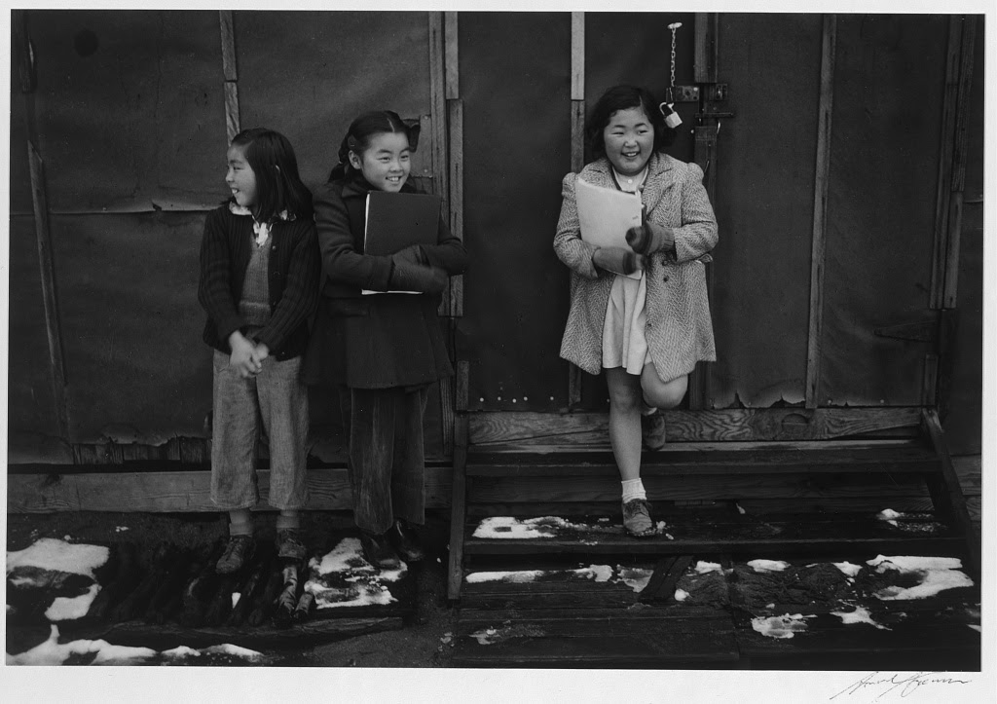

Caption: School children, Manzanar Relocation Center, California / photograph by Ansel Adams, 1942

Source: Library of Congress, Prints and Photographs Division, Adams, Ansel, photographer. School children, Manzanar Relocation Center, California / photograph by Ansel Adams. California Manzanar, 1943. Photograph. https://www.loc.gov/item/2002697874/.
https://www.loc.gov/resource/ppprs.00357/

