Ansel Adams Photo: Nurse Aiko Hamaguchi
In the 1940s, Ansel Adams, one of the most famous photographers in the United States, went to the Manzanar to document the imprisoned Japanese Americans. He later described the purpose of this photo project as an effort “to show how these people, suffering under a great injustice, and loss of property, businesses and professions, had overcome the sense of defeat and despair by building for themselves a vital community in an arid (but magnificent) environment.” The following image from 1943 shows the newly-built maternity ward at Manzanar.
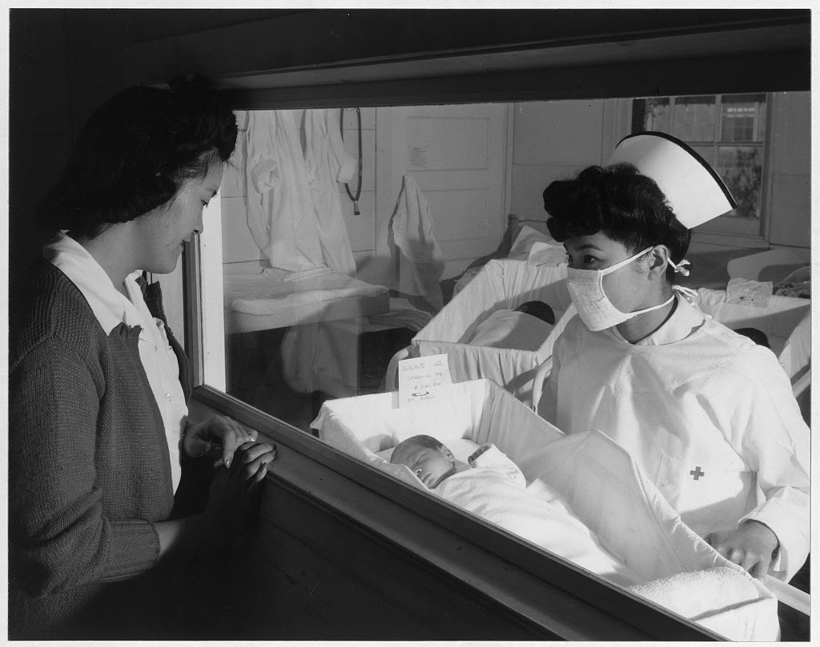

Caption: Nurse Aiko Hamaguchi, mother Frances Yokoyama, baby Fukomoto, Manzanar Relocation Center, California / photograph by Ansel Adams. 1943.

Source: Library of Congress, Prints and Photographs Division, Adams, Ansel, photographer. Nurse Aiko Hamaguchi, mother Frances Yokoyama, baby Fukomoto, Manzanar Relocation Center, California / photograph by Ansel Adams. California Manzanar, 1943. Photograph. https://www.loc.gov/item/2002697854/.
https://www.loc.gov/resource/ppprs.00343/

