Dorothea Lange Photo: Dust Storm at Manzanar

Dorothea Lange had photographed the plight of migrant families for the Farm Security Administration during the Great Depression in the 1930s. She was hired again in the early 1940s by the War Relocation Authority to document the forced removal of Japanese Americans from the West Coast. Many of Lange’s photographs exposed the difficulties and harsh conditions in the camps, and were censored by the government during the war. The following image shows a dust storm blowing through the Manzanar camp.

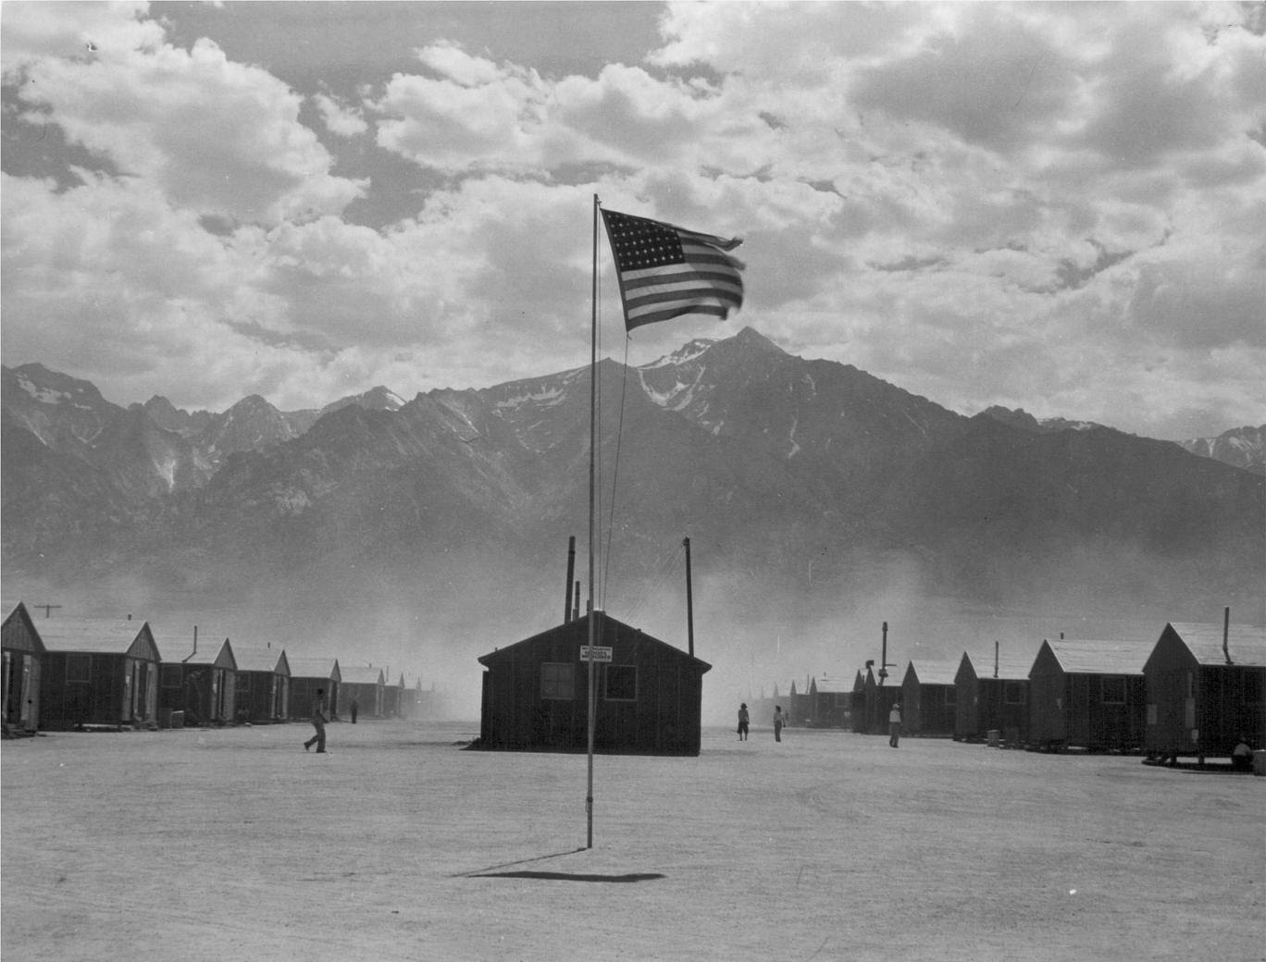

Caption: Manzanar, California. Dust storm at this War Relocation Authority center where evacuees of Japanese ancestry are spending the duration.

Source: National Archives: Record Group 210: Records of the War Relocation Authority, 1941 - 1989 Series: Central Photographic File of the War Relocation Authority, 1942 - 1945 https://catalog.archives.gov/id/539961

