"First impression of Manzanar" A Kango Takamura Painting

Kango Takamura was an Issei artist who had been a photo retoucher for RKO Studios in Hollywood before being incarcerated at the Manzanar prison camp. He documented his experiences at Manzanar in a series of watercolor paintings and drawings.

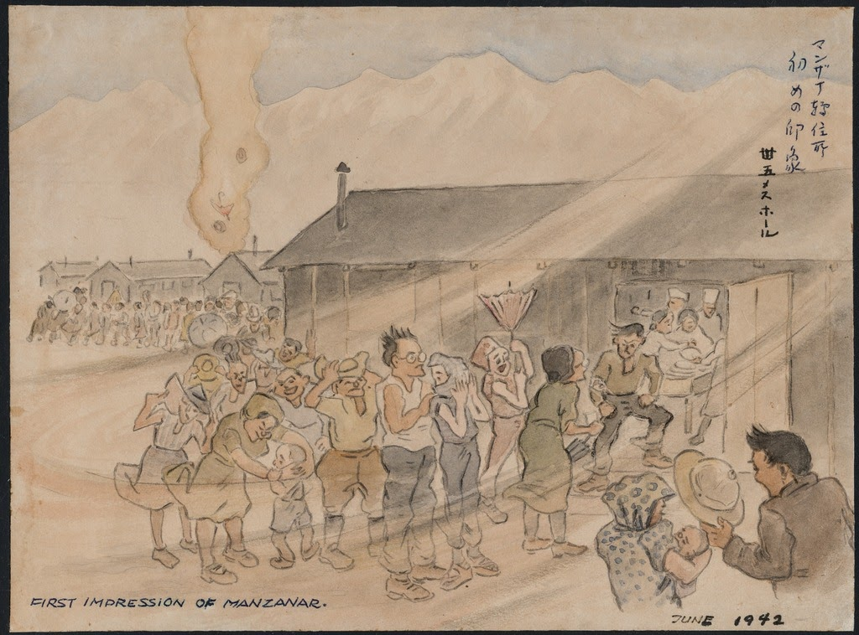

Courtesy of Manzanar National Historic Site and the Kango Takamura Collection http://ddr.densho.org/ddr-manz-2-42/
Copyright restricted

