Gordon Hirabayashi Letter: “Why I Refused to Register for Evacuation,” May 13, 1942

In 1940, Gordon Hirabayshi was a college student in Seattle, Washington. He was a pacifist and had registered with the Selective Service as a conscientious objector. After President Roosevelt issued Executive Order 9066 and it became clear that Japanese Americans would be removed from the West Coast, Hirabayashi left school to work with the American Friends Service Committee, organized by Quakers, to assist Japanese American families. As a U.S. citizen, Hirabayashi assumed his rights would be respected, but when orders came first for the curfew and then the removal he chose to resist and turned himself into the FBI to create a test case for the constitutionality of those orders.
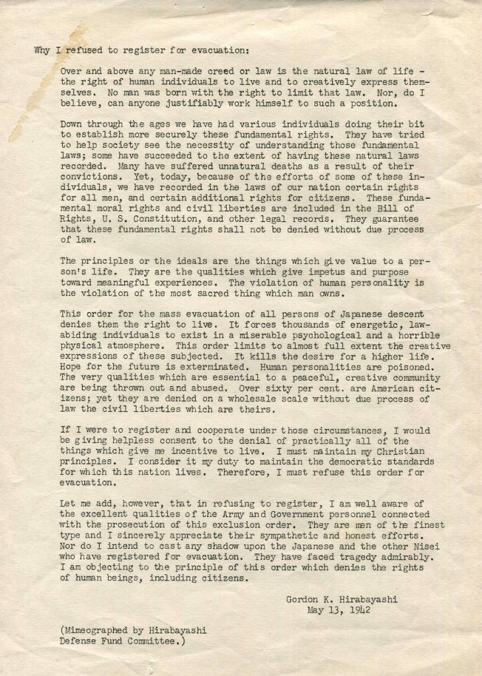
Source: University of Washington Libraries, Special Collections, https://digitalcollections.lib.washington.edu/digital/collection/pioneerlife/id/21356/
Why I refused to register for evacuation:

Over and above any man-made creed or law is the natural law of life – the right of human individuals to live and to creatively express themselves. No man was born with the right to limit that law. Nor, do I believe, can anyone justifiably work himself to such a position.

Down through the ages we have had various individuals doing their bit to establish more securely these fundamental rights. They have tried to help society see the necessity of understanding those fundamental laws; some have succeeded to the extent of having these natural law recorded. Many have suffered unnatural deaths as a result of their convictions. Yet, today, because of the efforts of some of these individuals, we have recorded in the laws of our ration certain rights for all men, and certain additional rights for citizens. These fundamental moral rights and civil liberties are included in the Bill of Rights, U.S. Constitution, and other legal records. They guarantee that these fundamental rights shall not be denied without due process of law.

The principles or the ideals are the things which give value to a person’s life. They are the qualities which give impetus and purpose toward meaningful experiences. The violation of human personality is the violation of the most sacred thing which man owns.

This order for the mass evacuation of all persons of Japanese descent denies them the right to live. It forces thousands of energetic, law-abiding individuals to exist in a miserable psychological and horrible physical atmosphere. This order limits to almost full extent the creative expressions of those subjected. It kills the desire for a higher life. Hope for the future is exterminated. Human personalities are poisoned. The very qualities which are essential to a peaceful, creative community are being thrown out and abused. Over sixty per cent are American citizens; yet they are denied on a wholesale scale without due process of law the civil liberties which are theirs.

If I were to register and cooperate under these circumstances, I would be giving helpless consent to the denial of practically all of the things which give me incentive to live. I must maintain my Christian principles. I consider it my duty to maintain the democratic standards for which this nation lives. Therefore, I must refuse this order for evacuation.

Let me add, however, that in refusing to register, I am well aware of the excellent qualities of the Army and Government personnel connected with the persecution of this exclusion order. They are men of the finest type and I sincerely appreciate their sympathetic and honest efforts. Nor do I intend to cast any shadow upon the Japanese and the other Nisei who have registered for evacuation. They have faced tragedy admirably. I am objecting to the principle of this order which denies the rights of human beings, including citizens.

Gordon K. Hirabayashi
May 13, 1942

