Stanley Hayami Diary Entries December. 1942

Stanley Kunio Hayami was sixteen in 1942 when his family was forcibly removed from Los Angeles, California and incarcerated at Heart Mountain Wyoming. Throughout his imprisonment at Heart Mountain, Hayami kept a diary filled with pen-and-ink drawings and he reported regularly on his daily activities such as studying for tests, listening to football games on the radio, or going to the movies. He also voiced his views on the incarceration and the military draft, and spoke of the importance of serving his country. As a high school student, he longed to pursue a career as an artist and writer. Stanley Hayami’s experiences and thoughts served as an inspiration for the Henry Tanaka character in A Prisoner in My Homeland
.
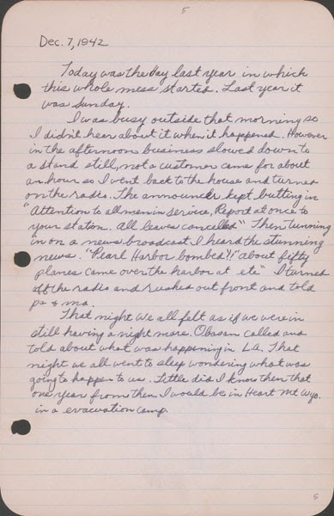
Dec. 7, 1942
Today was the day last year in which this whole mess started. Last year it was Sunday.
I was busy outside that morning so I didn’t hear about it when it happened. However in the afternoon business slowed down to a stand still, not a customer came for about an hour so I went back to the house and turned on the radio. The announcer kept butting in. “Attention to all men in service. Report at once to your station. All leaves cancelled.” Then tuning in on a news broadcast I heard the stunning news. “Pearl Harbor bombed!!” “About fifty planes came over the harbor at etc.” I turned off the radio and rushed out front and told pa & ma.
That night we all felt as if we were in [sic] still having a nightmare. Obasan called and told about what was happening in L.A. That night we all went to sleep wondering what was going to happen to us. Little did I know then that one year from then I would be in Heart Mountain Wyo. in a [sic] evacuation camp.

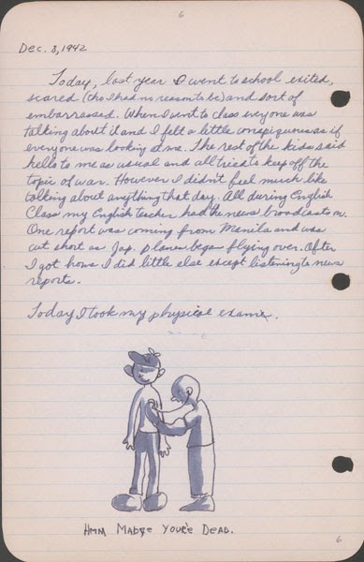

Dec. 8, 1942
Today, last year I went to school excited, scared (tho I had no reason to be) and sort of embarrassed. When I went to class everyone was talking about it and I felt a little conspicuous as if everyone was looking at me. The rest of the kids said hello to me as usual and all tried to keep off the topic of war. However I didn’t feel much like talking about anything that day. All during English class my English teacher had the news broadcasts on. One report was coming from Manila and was cut short as Jap. planes began flying over. After I got home I did little else except listening to the news reports.
Today I took my physical exam.

Source: Hayami (Stanley) Diary Collection, Japanese American National Museum. Accessed through Calisphere, April 20, 2020. Recto of page 10: https://calisphere.org/item/ark:/13030/tf267n98tj/ Verso of page 10: https://calisphere.org/item/ark:/13030/tf996nb3qv/

