"Making Rice Cakes" A Kango Takamura Painting

Kango Takamura was an Issei artist who had been a photo retoucher for RKO Studios in Hollywood before being incarcerated at the Manzanar prison camp. He documented his experiences at Manzanar in a series of watercolor paintings and drawings.

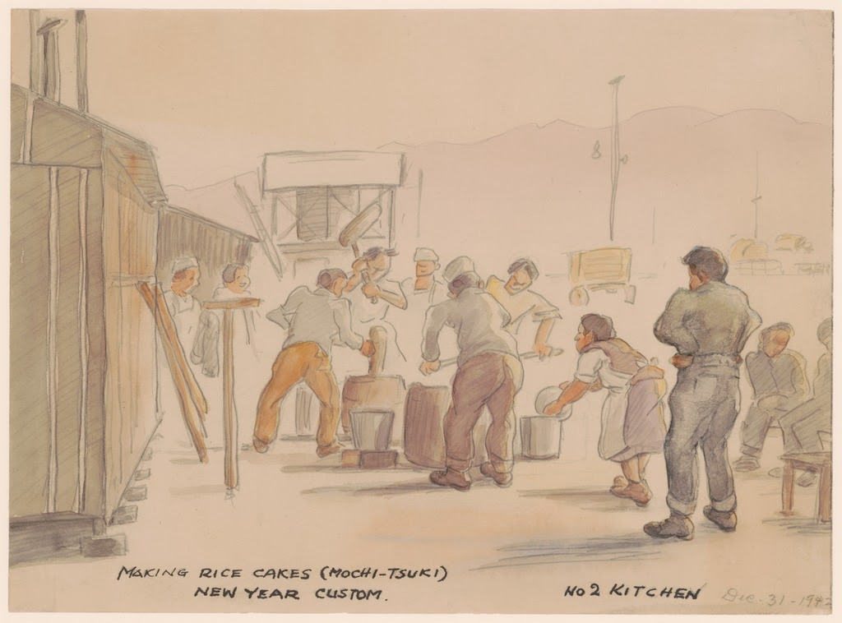

Caption: "Making rice cakes (mochi-tsuki). New Year custom. No 2 kitchen. Dec. 31 - 1942."

Courtesy of Manzanar National Historic Site and the Kango Takamura Collection
http://ddr.densho.org/ddr-manz-2-5/
Copyright restricted

