Honor Roll Sign at Minidoka Prison Camp

The following image of Japanese Americans looking at the camp's honor roll, was taken in 1944. The honor roll listed all of the Japanese Americans from the Minidoka concentration camp who volunteered for military service during World War II. Minidoka had the highest number of volunteers from the mainland United States.

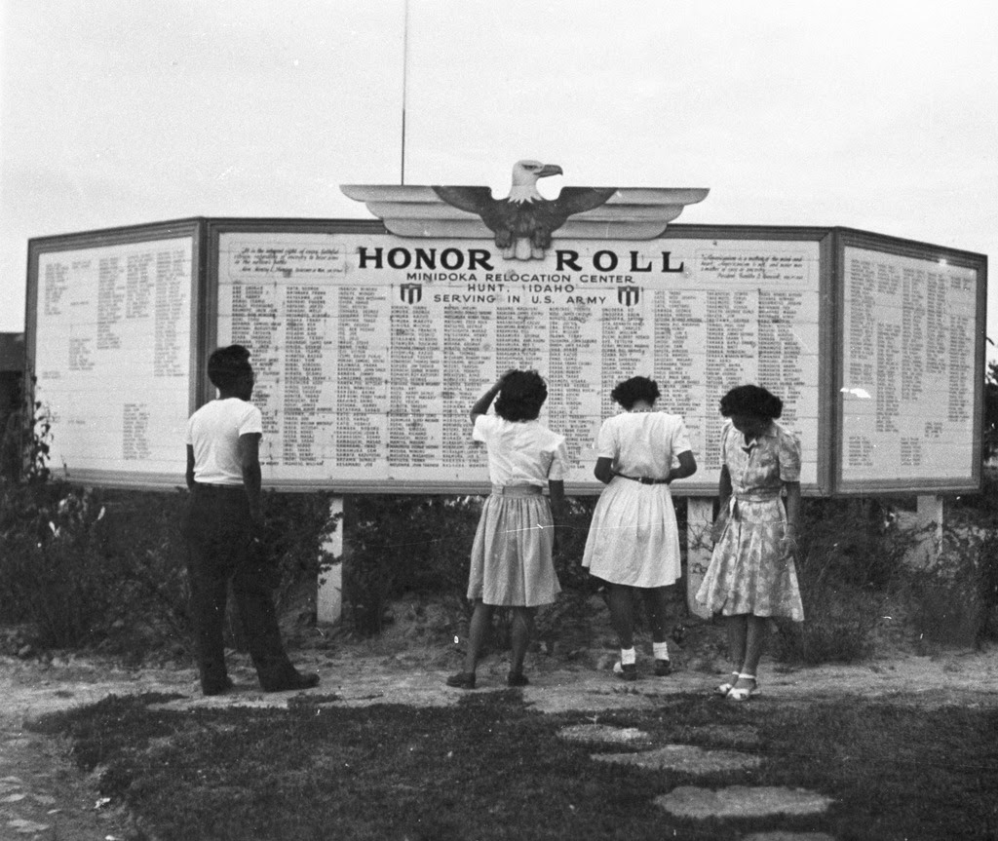

Source: Densho Digital Repository, Courtesy of the Mitsuoka Family Collection https://ddr.densho.org/ddr-densho-15-82/

