A NOTE TO THE EDUCATOR:
On the following pages, you will find “flashcards” with terms and definitions (both combined and separate) that your students may encounter while playing “Prisoner in My Homeland.” These terms and definitions can be introduced and practiced before or during the time students see or hear them in the context of Mission US or in their American history study. The discussion questions and writing prompts will provide further opportunities for students to have more practice with the words and terms.

Divide your students into small groups of four or five, and ask each group to review the terms and definitions.

After your students have had a chance to review and discuss the terms and definitions, distribute the excerpt from an imagined talk between Maya Tanaka and a class of middle school American history students. Review the directions with your students, and ask them to complete the text using the terms they studied. Here is the order in which the vocabulary terms should be inserted into the blanks within Maya’s talk with students:

Pearl Harbor
Executive Order 9066
forced removal
heirlooms
temporary detention centers
citizens
Issei
incarceration
internment
residents
concentration camp
euphemism

American concentration camp  A place where a large number of people are imprisoned, usually because of prejudice against their identities, wartime fears, or state security.  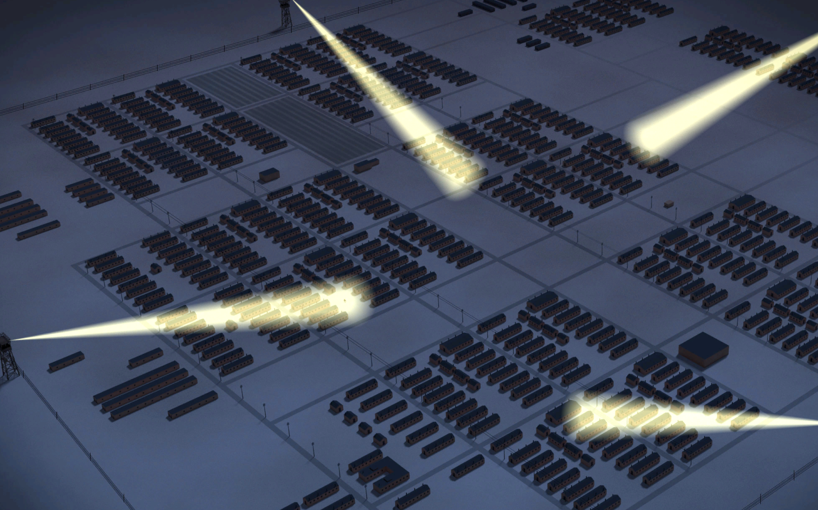 | bento  Single-portion home-packed meal, commonly a boxed lunch.  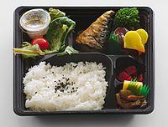
citizen  A person who legally belongs to a country and has the rights and protection of that country.  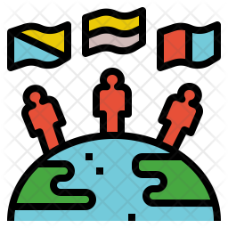 | Civilian Exclusion Orders  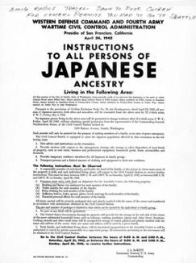  A series of orders issued by General John L. DeWitt as head of the Western Defense Command (WDC) in response to Executive Order 9066. It was used to remove all Japanese Americans from the West Coast and confine them to prison camps.
Congress  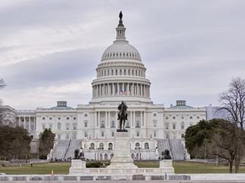  The two chambers of the United States federal government consisting of the Senate and the House of Representatives. | euphemism  A mild word or phrase that is used in place of an unpleasant or offensive word.  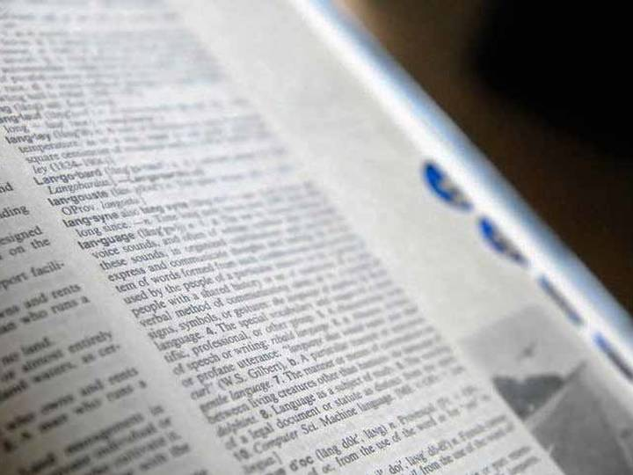
Executive Order 9066  An order signed by President Franklin D. Roosevelt in February 1942 authorizing the military to prescribe areas "from which any or all persons may be excluded," that was used to remove all Japanese Americans from the West Coast and confine them to prison camps.  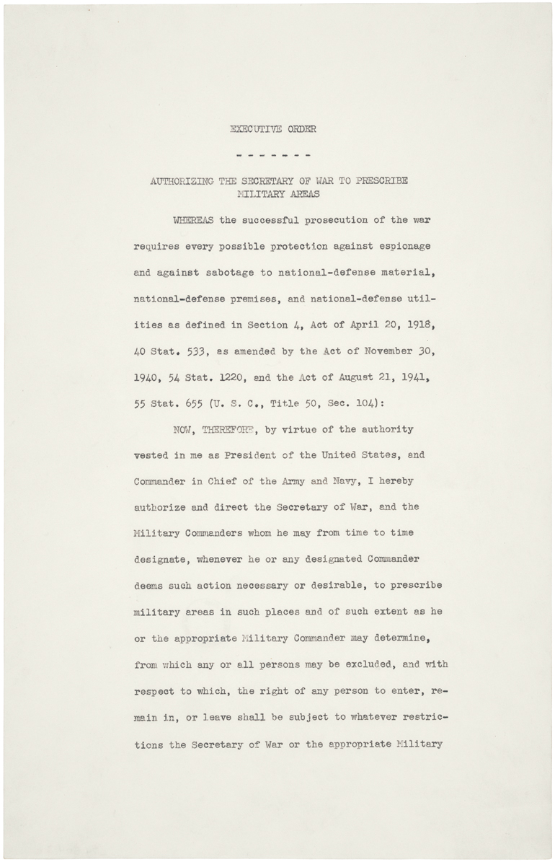 | FBI  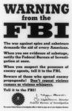  The Federal Bureau of Investigation is the domestic intelligence agency and secret police service of the United States and its principal federal law enforcement agency.
First-generation  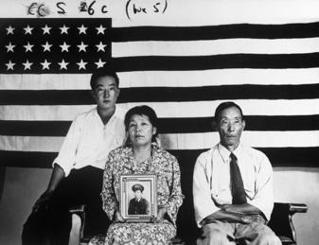  A resident who was born in another country and relocated to a new country with the plan to become a citizen. | forced removal  To be required to leave a place without any choice or say in the matter.  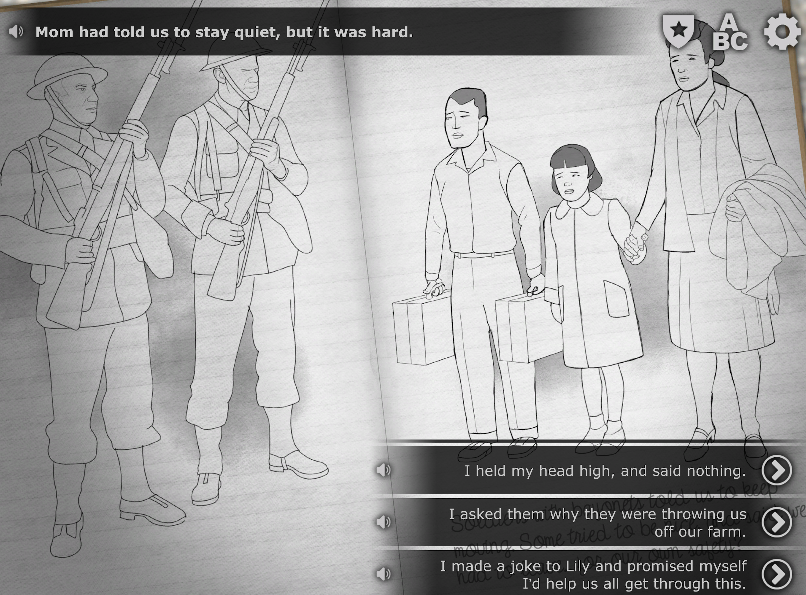
harvest  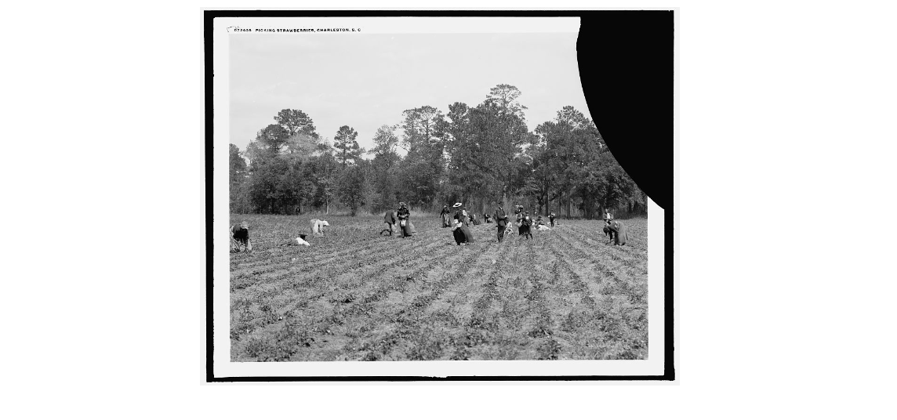  The process of collecting crops that are ready to eat or sell. | . heirloom  Valued personal possessions passed down in a family from one generation to another.  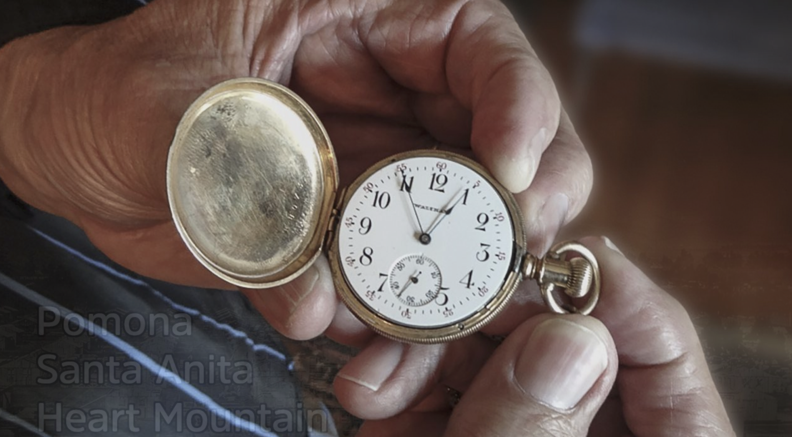

incarceration  To confine or imprison as  a form of punishment.  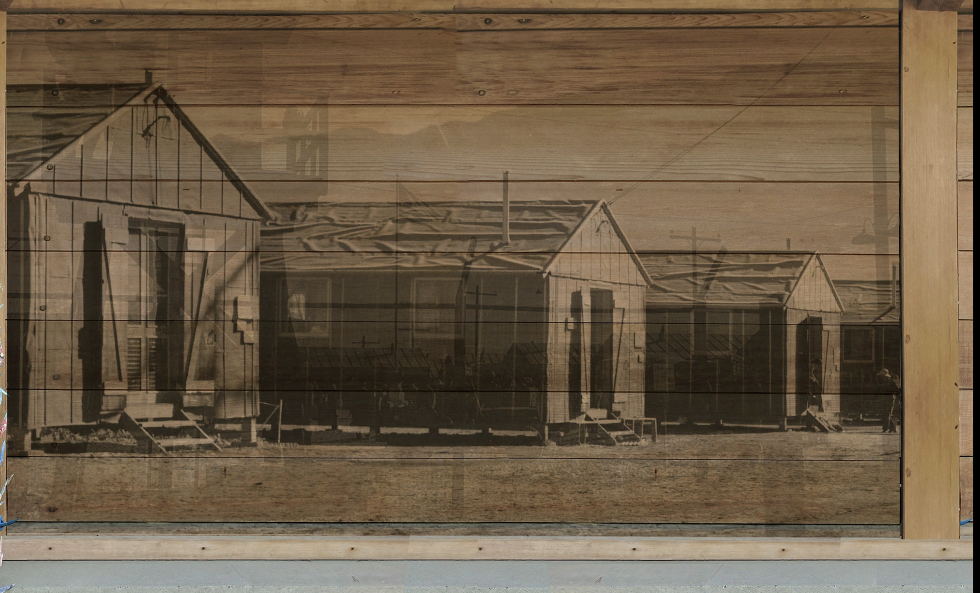 | Internment  Imprisoning people from another country, typically for political or military reasons.  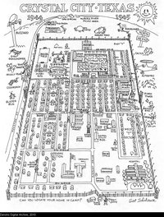
Issei  First-generation Japanese immigrants to the United States.  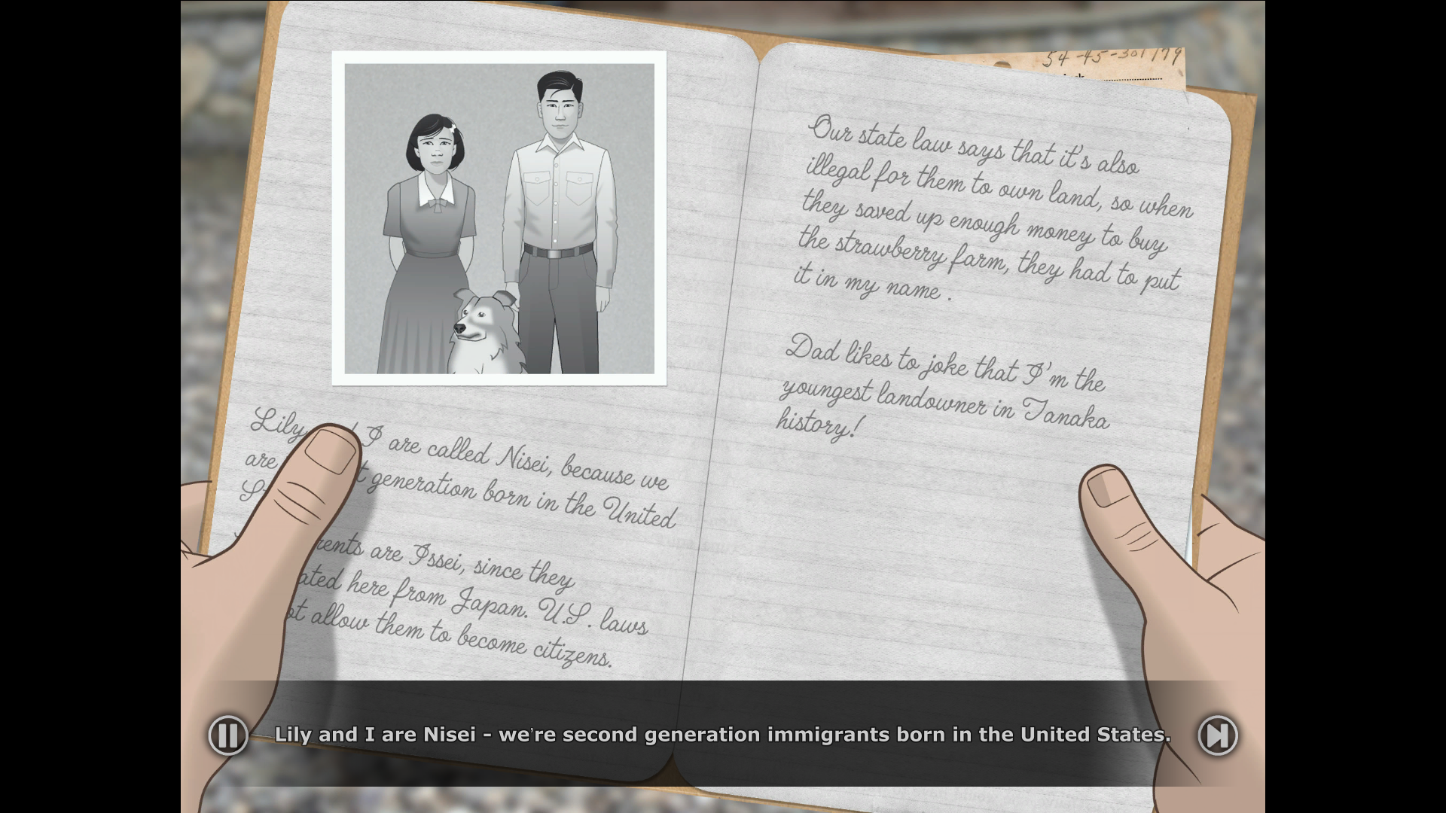 | majorette  A female who performs baton twirls and stunts while marching, typically in a parade.  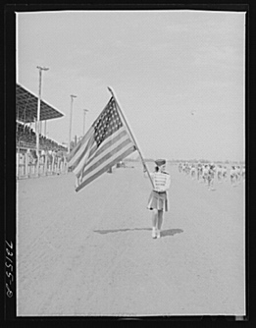
New Deal  A series of government programs and financial reforms enacted in the United States during the first administration of President Franklin D. Roosevelt, from 1933 to 1936, in response to the Great Depression.  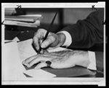 | Nisei  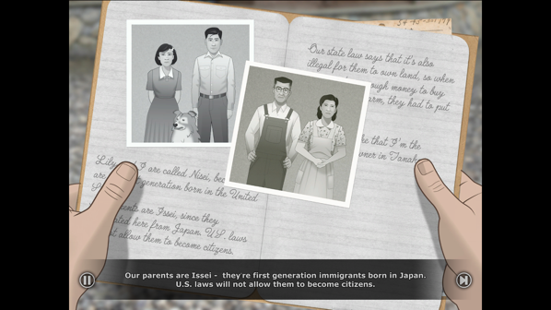  American citizens by birth whose Japanese immigrant parents were prevented from becoming U.S. citizens.

Pearl Harbor  Refers to a surprise military attack by the Imperial Japanese Navy Air Service against the United States. The attack occurred on December 7, 1941 at the naval base at Pearl Harbor in Honolulu, Hawaii. The United States entered World War II the following day.  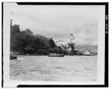 | Picture bride  An arrangement in which a matchmaker paired a bride (in Japan) with a groom (in America) using only photographs and family recommendations.  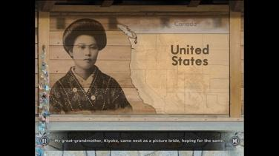
resident  A person who lives  somewhere long-term.  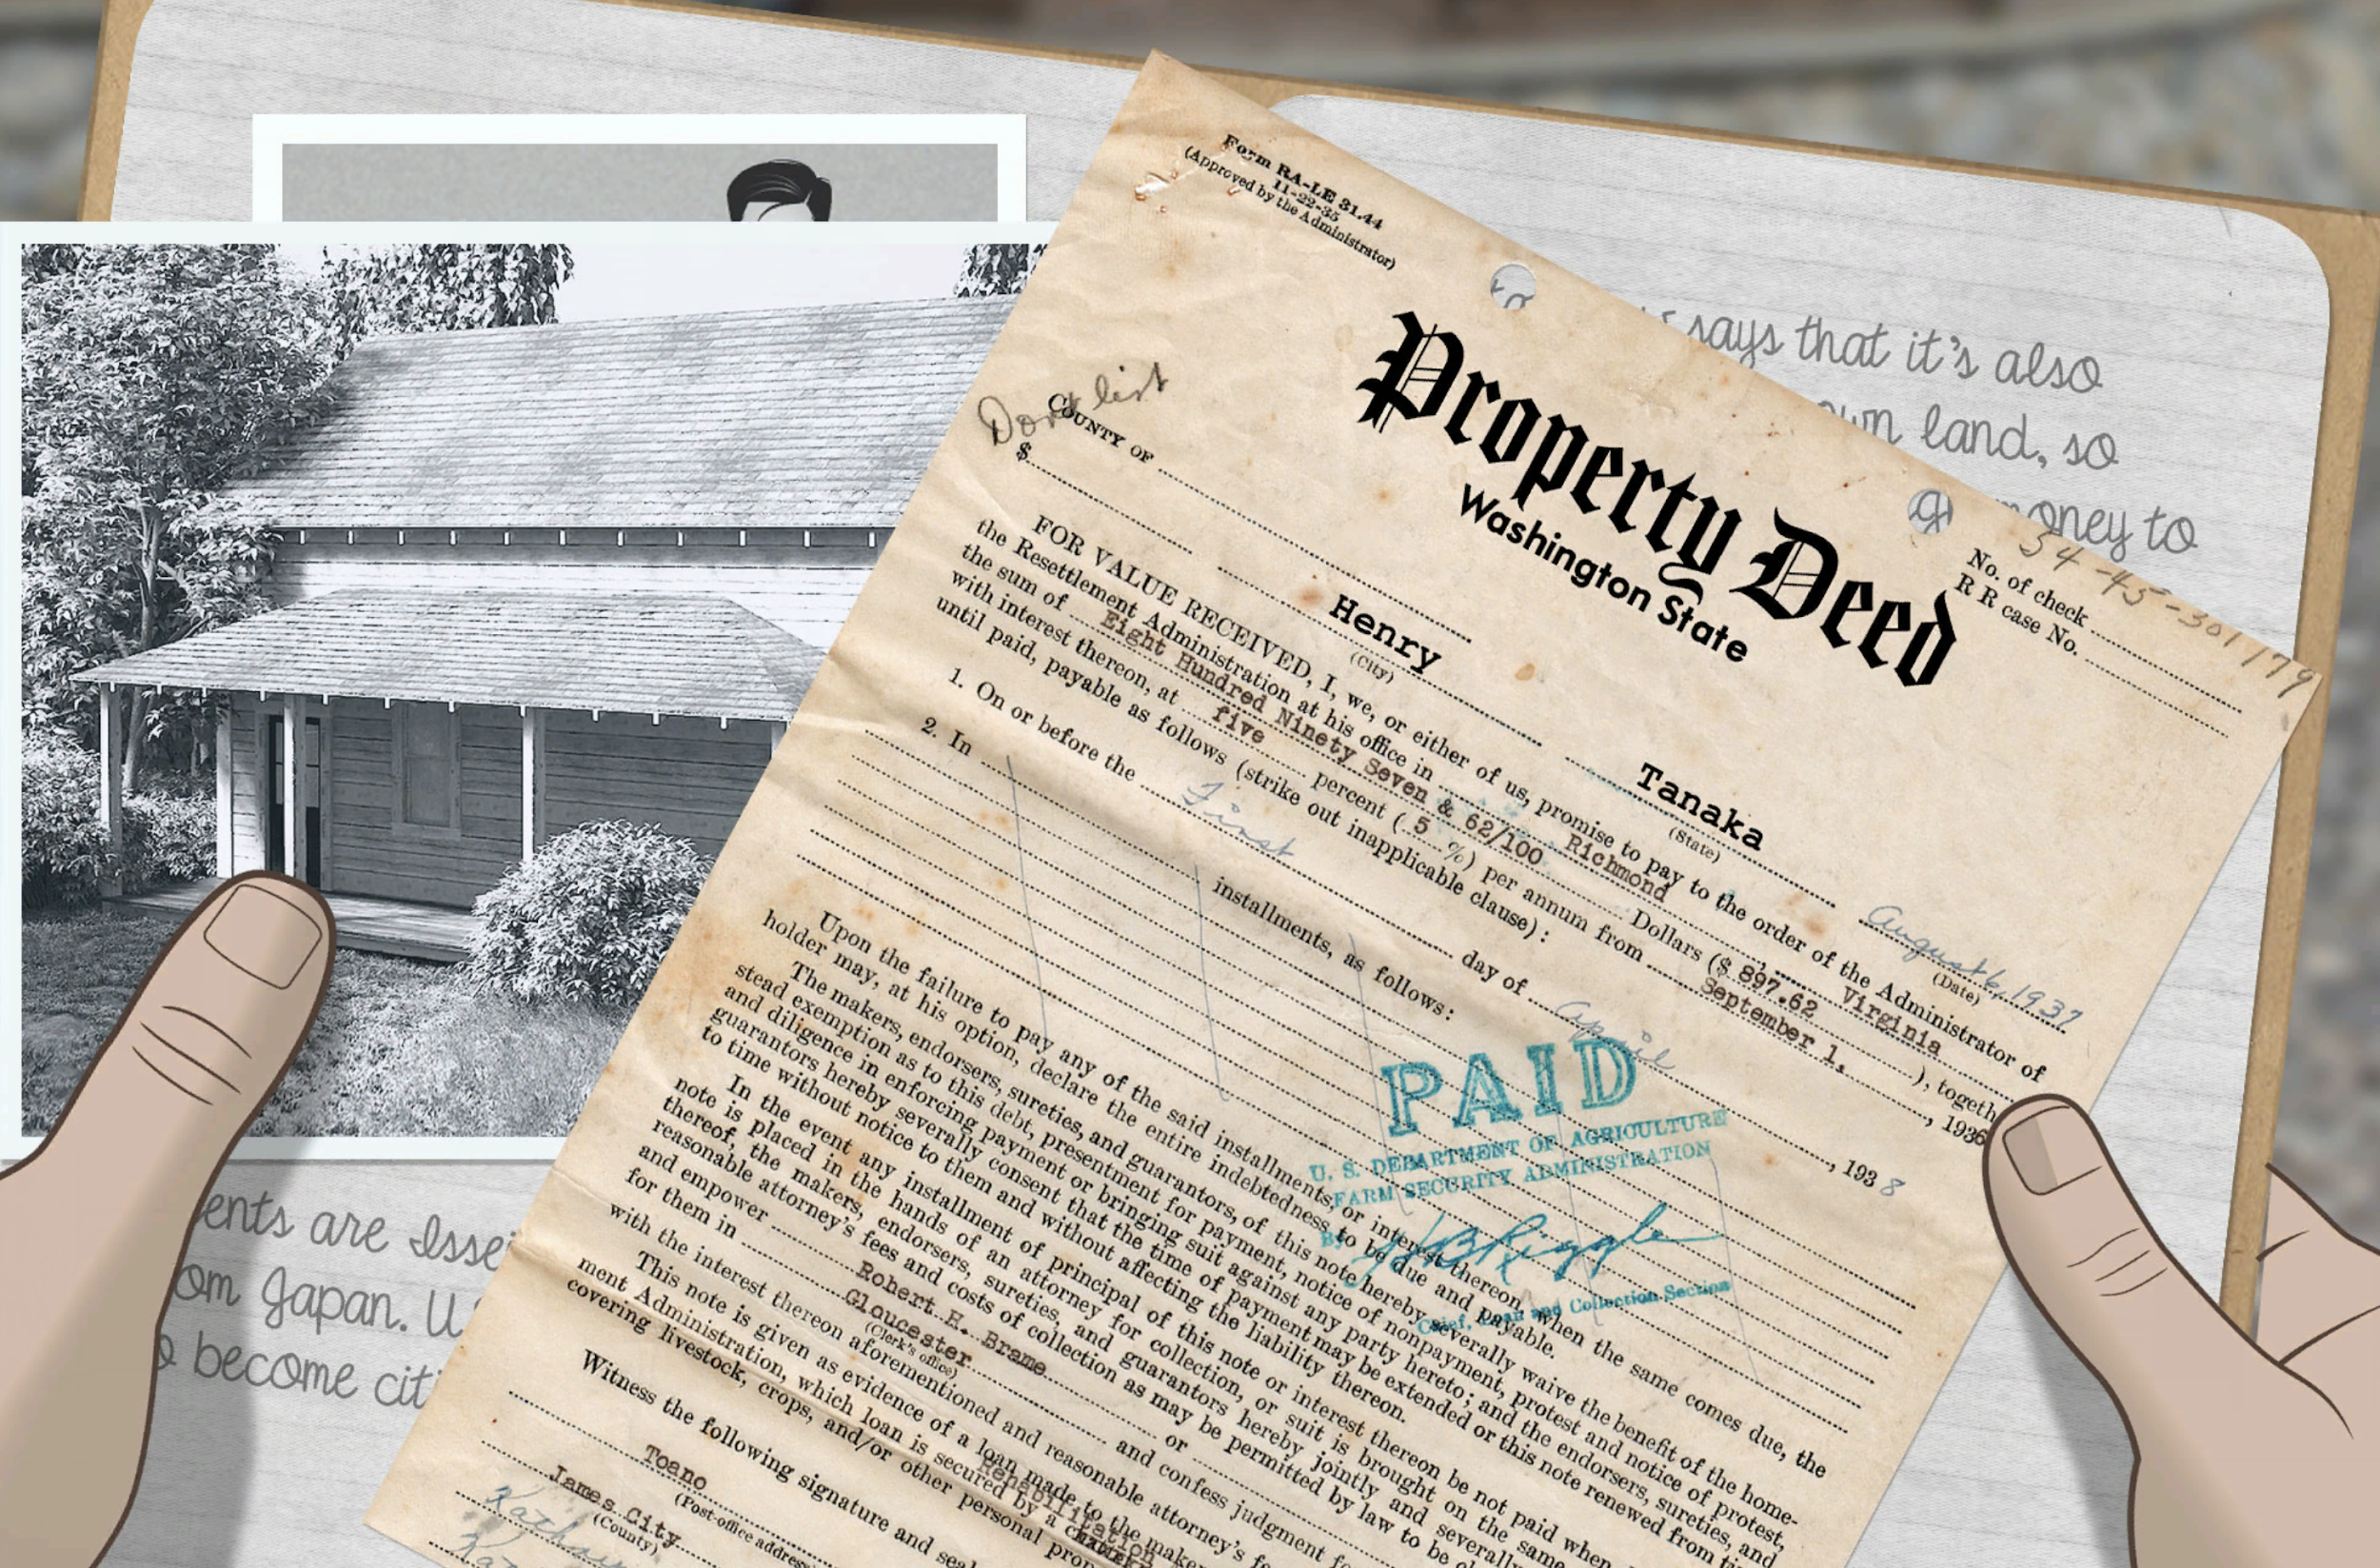 | Second-generation  The children of immigrants  who are citizens.  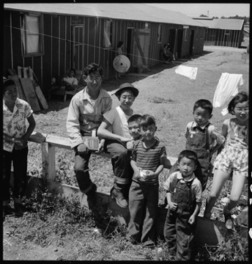
temporary detention center  The Federal Bureau of Investigation is the domestic intelligence agency and secret police service of the United States and its principal federal law enforcement agency.  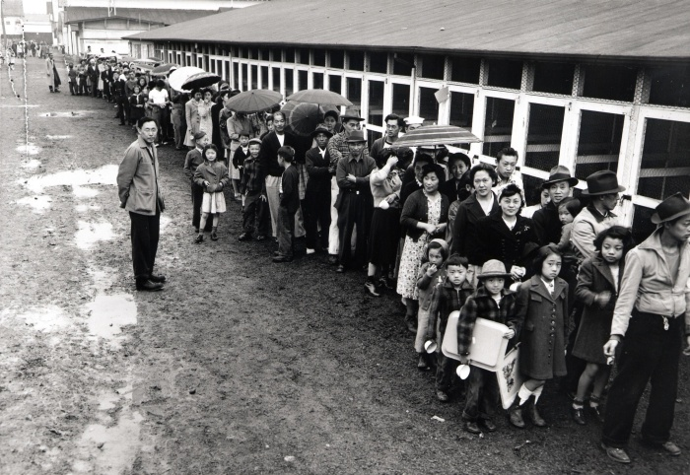 | tradition  Customs or beliefs passed  down from one generation  to the next.  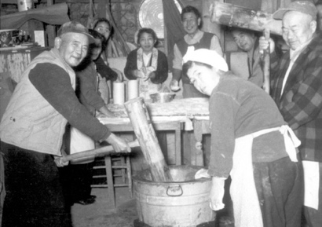

American concentration camp | bento
citizen | Civilian Exclusion Orders  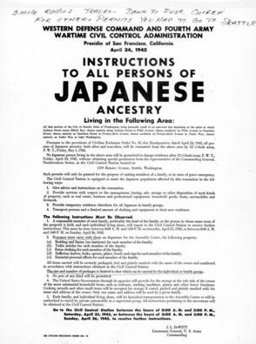
Congress  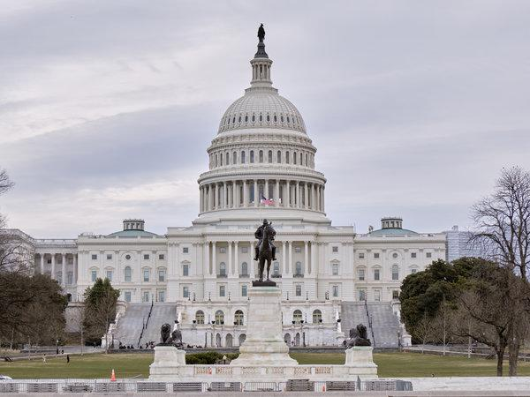 | euphemism
Executive Order 9066 | FBI
First-generation  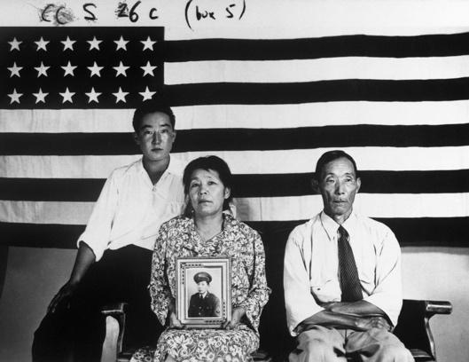 | forced removal
harvest | heirloom

incarceration | Internment
Issei | majorette  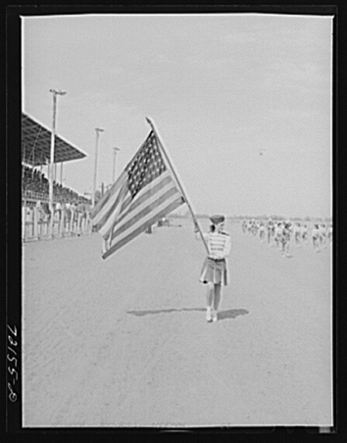
New Deal | Nisei

Pearl Harbor | Picture bride  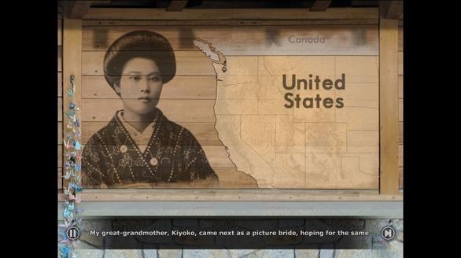
resident | Second-generation  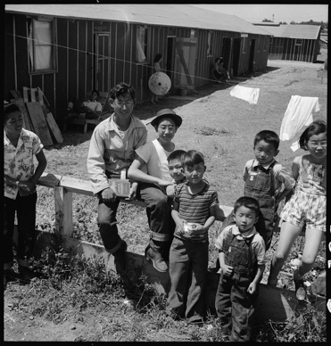
temporary detention center | tradition  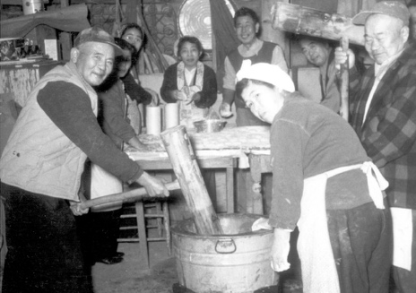

A place where a large number of people are imprisoned, usually because of prejudice against their identities, wartime fears, or state security. | Single-portion home-packed meal, commonly a boxed lunch.
A person who legally belongs to a country and has the rights and protection of that country. | A series of orders issued by General John L. DeWitt as head of the Western Defense Command (WDC) in response to Executive Order 9066. It was used to remove all Japanese Americans from the West Coast and confine them to prison camps.
The two chambers of the United States federal government consisting of the Senate and the House of Representatives. | A mild word or phrase that is used in place of an unpleasant or offensive word.
An order signed by President Franklin D. Roosevelt in February 1942 authorizing the military to prescribe areas "from which any or all persons may be excluded," that was used to remove all Japanese Americans from the West Coast and confine them to prison camps. | The Federal Bureau of Investigation is the domestic intelligence agency and secret police service of the United States and its principal federal law enforcement agency.
A resident who was born in another country and relocated to a new country with the plan to become a citizen. | To be required to leave a place without any choice or say in the matter.
The process of collecting crops that are ready to eat or sell | Valued personal possessions passed down in a family from one generation to another.
To confine or imprison as  a form of punishment. | Imprisoning people from another country, typically for political or military reasons.

First-generation Japanese immigrants to the United States. | A female who performs baton twirls and stunts while marching, typically in a parade.
A series of government programs and financial reforms enacted in the United States during the first administration of President Franklin D. Roosevelt, from 1933 to 1936, in response to the Great Depression. | American citizens by birth whose Japanese immigrant parents were prevented from becoming U.S. citizens.

Refers to a surprise military attack by the Imperial Japanese Navy Air Service against the United States. The attack occurred on December 7, 1941 at the naval base at Pearl Harbor in Honolulu, Hawaii. The United States entered World War II the following day. | An arrangement in which a matchmaker paired a bride (in Japan) with a groom (in America) using only photographs and family recommendations.
A person who lives  somewhere long-term. | The children of immigrants  who are citizens.
The Federal Bureau of Investigation is the domestic intelligence agency and secret police service of the United States and its principal federal law enforcement agency. | Customs or beliefs passed  down from one generation  to the next.

Name: _______________________ Date:_________________________

Activity: More than seventy-five years after the events of “Prisoner In My Homeland,” Maya Tanaka, Henry Tanaka’s present-day 20-something granddaughter, is invited to give a talk to a local middle school history class. Maya is introducing them to the World War II-era Japanese American incarceration. The following is a portion of her interactions with the students.

After reading and discussing the words and terms on the flashcards, read this excerpt from her talk with the students, and use your memory to fill in the missing words and terms.

concentration camps  forced removal  temporary detention centers | citizens  residents  Issei | Executive Order 9066  euphemism  Pearl Harbor | incarceration  heirlooms  internment

Maya Tanaka: “Today, I’m going to talk to you about events that occurred during World War II that affected my family, the Tanakas. On Sunday, December 7, 1941, the Japanese Navy attacked ______________. Immediately afterwards, President Roosevelt issued ________________, which ordered for the ____________ of nearly 120,000 Japanese Americans from their homes in California, Oregon, and Washington.

Many had to quickly sell their property or find someone to care for their homes and farms. They could bring very little with them. They gave away or burned cherished family _______________, like photos or treasured objects. At first, most families reported to __________________, often fairgrounds or racetracks ill-suited to hold so many people. These places held Japanese Americans for a little while until they were moved into more permanent prisons in harsh places across the U.S.

In the case of my grandfather and his family, they did not go to one of these centers. They were taken directly to a prison at Manzanar. They lived on Bainbridge Island near Seattle, Washington and were the first Japanese Americans to be forcibly removed.

Nearly two-thirds of Japanese American prisoners were U.S. ___________, meaning that they were born in the U.S. and were supposed to have protections and rights. Some of these people, the ___________, were first-generation immigrants and were prevented from even becoming citizens under U.S. law.

Currently, we refer to these events as the_______________ of Japanese Americans.

Student: “In our history textbook, the events are called the ‘Japanese American internment camps.’ Why do you use a different term?”

Maya Tanaka: Yes, some history textbooks still refer to these events using this incorrect term. But an_______________ camp refers to a place where prisoners of war are sent as captives, like German or Italian soldiers. Japanese Americans weren’t prisoners of war; most were hardworking, long-time ____________ of U.S. cities and towns.

Student: “What’s the right word to use for the camps?”

Maya Tanaka: “The largest prisons that held Japanese Americans during World War II are called ‘American _____________________.’ That’s when people are held in masses, usually because of some wartime fears or policies.”

Student: Why is it so important to use the right words?

Maya Tanaka: “That’s a great question. I think it’s because words have so much power. Today, we want to use the most accurate terms to describe what happened. The U.S. government wanted to make the camps seem less harmful than they actually were. So they used words like ‘internment’ or ‘evacuation’ to make their actions seem necessary during a time of war. When people use words to make something that is harmful seem less so, we call it a ______________.

Student: I see, so in changing the words, we change the way we see these events. We describe them clearly.

Maya Tanaka: Yes, words shape the way we understand history.

