MISSION US:
Prisoner in My Homeland

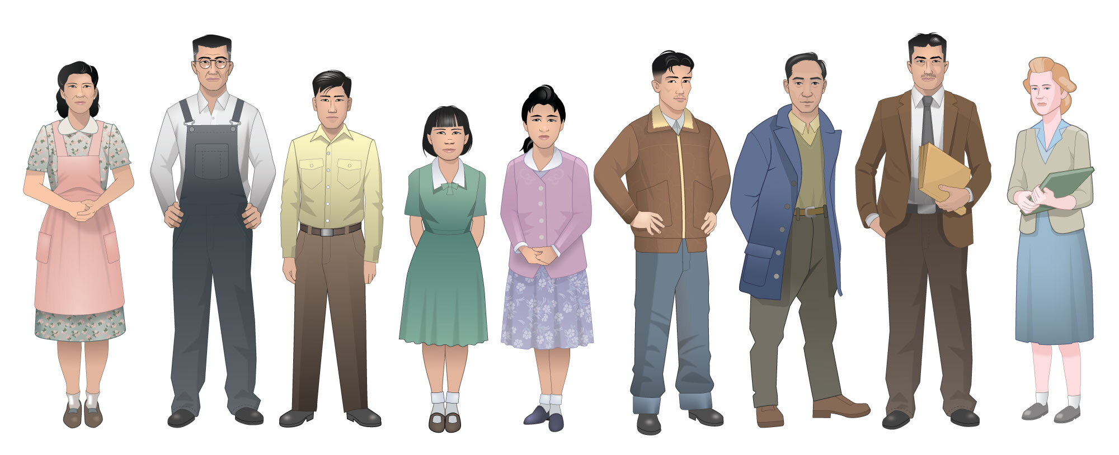

COMPLETE CLASSROOM GUIDE

TABLE OF CONTENTS
- Teaching This Mission
About the Mission. . . . . . . . . . . . . . . . . . . . . . . . . . . . . . . . . . . . . . . . 1
Top 5 Things to Know Before You Play . . . . . . . . . . . . . . . . . . . . . . . . . . . . 4
Mission at a Glance. . . . . . . . . . . . . . . . . . . . . . . . . . . . . . . . . . . . . . . 5
Essential Questions . . . . . . . . . . . . . . . . . . . . . . . . . . . . . . . . . . . . . . 9
Models of Instruction . . . . . . . . . . . . . . . . . . . . . . . . . . . . . . . . . . . . . 11
Learning Goals . . . . . . . . . . . . . . . . . . . . . . . . . . . . . . . . . . . . . . . . 15
National Standards Alignment . . . . . . . . . . . . . . . . . . . . . . . . . . . . . . . . 22
- Historical Background
Timeline of Historical Events . . . . . . . . . . . . . . . . . . . . . . . . . . . . . . . . . 27
Full Historical Background . . . . . . . . . . . . . . . . . . . . . . . . . . . . . . . . . . 33
Character and Place Overview. . . . . . . . . . . . . . . . . . . . . . . . . . . . . . . . . 42
Glossary of Key Terms . . . . . . . . . . . . . . . . . . . . . . . . . . . . . . . . . . . . . 46
Myths and Misconceptions. . . . . . . . . . . . . . . . . . . . . . . . . . . . . . . . . . . 51
Educator’s Primer on the Historical Period. . . . . . . . . . . . . . . . . . . . . . . . . . . 54
- Activities
Activities for Use Throughout the Game
Badge Tracker . . . . . . . . . . . . . . . . . . . . . . . . . . . . . . . . . . . . . . . . . . 58
Cultural Artifacts Memory Box. . . . . . . . . . . . . . . . . . . . . . . . . . . . . . . . . 61
Prologue
Pre-Mission Activity . . . . . . . . . . . . . . . . . . . . . . . . . . . . . . . . . . . . . . 66
Prologue Document-Based Activity . . . . . . . . . . . . . . . . . . . . . . . . . . . . . . 70
Prologue Vocabulary Activity. . . . . . . . . . . . . . . . . . . . . . . . . . . . . . . . . . 84
Prologue Writing Prompts. . . . . . . . . . . . . . . . . . . . . . . . . . . . . . . . . . . 102
Prologue Review Questions. . . . . . . . . . . . . . . . . . . . . . . . . . . . . . . . . . . 104

Part 1: Behind Barbed Wire
Part 1 Document-Based Activity . . . . . . . . . . . . . . . . . . . . . . . . . . . . . . . 105
Part 1 Vocabulary Activity . . . . . . . . . . . . . . . . . . . . . . . . . . . . . . . . . . 115
Part 1 Writing Prompts . . . . . . . . . . . . . . . . . . . . . . . . . . . . . . . . . . . 126
Part 1 Review Questions . . . . . . . . . . . . . . . . . . . . . . . . . . . . . . . . . . . 129
Part 2: Finding a Way
Part 2 Document-Based Activity . . . . . . . . . . . . . . . . . . . . . . . . . . . . . . . 136
Part 2 Vocabulary Activity. . . . . . . . . . . . . . . . . . . . . . . . . . . . . . . . . . 148
Part 2 Writing Prompts. . . . . . . . . . . . . . . . . . . . . . . . . . . . . . . . . . . . 160
Part 2 Review Questions . . . . . . . . . . . . . . . . . . . . . . . . . . . . . . . . . . . 163
Part 3: Allegiance
Part 3 Document-Based Activity . . . . . . . . . . . . . . . . . . . . . . . . . . . . . . . 170
Part 3 Vocabulary Activity . . . . . . . . . . . . . . . . . . . . . . . . . . . . . . . . . . 185
Part 3 Writing Prompts . . . . . . . . . . . . . . . . . . . . . . . . . . . . . . . . . . . 194
Part 3 Review Questions . . . . . . . . . . . . . . . . . . . . . . . . . . . . . . . . . . . 197
Epilogue
Final Project . . . . . . . . . . . . . . . . . . . . . . . . . . . . . . . . . . . . . . . . . .206
Epilogue Writing Prompts . . . . . . . . . . . . . . . . . . . . . . . . . . . . . . . . . . 211
- Additional Resources
Additional Resources Guide. . . . . . . . . . . . . . . . . . . . . . . . . . . . . . . . . . .214
Research Bibliography . . . . . . . . . . . . . . . . . . . . . . . . . . . . . . . . . . . . . 225
Character Printables . . . . . . . . . . . . . . . . . . . . . . . . . . . . . . . . . . . . . . 228
- Primary Sources
Primary Source Collection. . . . . . . . . . . . . . . . . . . . . . . . . . . . . . . . . . . 237

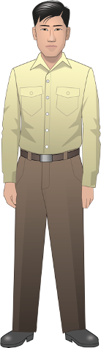
Informed by a generation of new research and writing, Prisoner in My Homeland offers young people a nuanced and illuminating understanding of the choices and challenges faced by Japanese Americans in the WWII era. The game is played from the perspective of Henry Tanaka, a fictional 16-year-old Japanese American boy whose family is forced to leave its home on Bainbridge Island, WA, for a military prison camp in Manzanar, CA. Players must make choices that reflect broader strategies of survival and resistance: will they help their community, focus on family, support the war effort, resist injustice? The game seeks to help correct the image of the incarcerees as passive victims by highlighting instances of resistance, and to place the events within the larger context of Asian immigration to the West Coast and Asian communities’ longer-term struggle to be accepted as American.

“Prisoner in My Homeland” is divided into five parts:
● an interactive prologue that establishes the Tanaka family backstory and historical context of Japanese American immigration and settlement;
● three playable “Parts,” consisting of dialogues, minigames, and other interactions with a variety of historically-based characters, covering 1941 to 1945; and
● an epilogue that reveals the fates of the main characters and summarizes the legacy of Japanese American incarceration for both individuals and the nation.

The prologue establishes the main character’s (Henry Tanaka’s) parents’ journey to America and their life in a small farming community of Bainbridge Island in Washington State before and after the attack on Pearl Harbor. In the wake of the United States’ declaration of war on Japan, President Roosevelt issues Executive Order 9066, and the U.S. military designates Bainbridge Island as the first community to have all inhabitants with Japanese ancestry “excluded." Henry’s father is questioned by the FBI and then arrested. Henry, his mother, and his little sister must leave their farm and dog behind and be escorted by soldiers with bayonets onto a ferry.

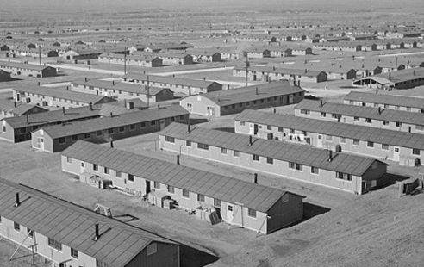
In Part 1, Henry travels to the prison camp at Manzanar, a remote desert wilderness. As he orients himself to his new circumstances, he is required to interact with, and adjust to the presence of, a variety of different Japanese Americans who have been sent to live in close and uncomfortable quarters. In his father’s absence, Henry must help his family adapt in creative ways, such as by finding tin can lids to block holes in the floorboards. Henry can also help his family through taking a job in the camp, which will give him options to improve their barrack furnishings or assist in saving their farm by helping to pay taxes.

In Part 2, school is finally in session, and Henry encounters different ways that young people cope with and resist their displacement, discomfort, and boredom. Henry has the opportunity to deepen relationships with his peers Meiko and Tadashi, and with historical figure Harry Ueno, who is organizing an investigation of missing sugar rations from the mess halls. After his father’s sudden return from detention by the FBI, Henry can help him transition by encouraging him to take up judo again. Tensions sharpen when members of the Japanese American Citizens League (JACL) seek to demonstrate their patriotism by advocating for Nisei to be drafted into the U.S. armed forces, or at least be permitted to serve.

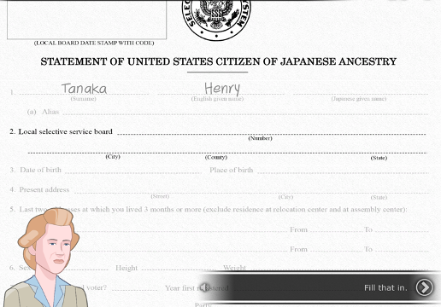
At the start of Part 3, a JACL leader is beaten up by a masked group and Harry Ueno is arrested and jailed for the crime. A large protest of his arrest by incarcerees leads to a military response in which ten people are shot and two killed. A couple of months later, at the age of 17, Henry learns that all incarcerees must complete a “loyalty questionnaire,” and he will have to defend his answers before an army draft board. He grapples with different perspectives on how to answer two questions in particular: one about his willingness to serve in the U.S. armed forces “wherever ordered” and the other swearing unqualified allegiance to the United States and renouncing “allegiance or obedience to the Japanese emperor.”

The player’s choices open up or foreclose different potential paths to be explored in the game’s epilogue. Depending on his response to the questionnaire, Henry transfers with other Bainbridge Islanders to Minidoka or, if he is deemed “disloyal,” is sent to Tule Lake. Subsequent possible paths include enlisting in the U.S. army, attending college in the East, or returning to Bainbridge Island to help his parents resettle. The epilogue also narrates the family’s experiences after incarceration and the history of the decades that followed, including the redress movement and eventual passing of the Civil Liberties Act of 1988
There is never just one story.
Like any work of history, Mission US games are interpretations of what
happened in the past based on careful research. Since they can’t capture the whole story, we encourage you to learn more about this history by checking out the additional resources for each mission.
1
Mission US is a role-playing game (RPG).
In each mission you’ll step into the shoes of a young person during an important time period in US history. While your character and many of the characters in the game are fictional, they are based on the experiences of real people. (You will also encounter some actual historical figures and witness historical events in the game!)
TOP 5 THINGS TO KNOW BEFORE YOU PLAY

You will encounter difficult and challenging
moments in US history.
Mission US covers some troubling topics, including racism, injustice, and war, many of which remain challenges today. We think learning about such historical moments is essential for understanding both the past and present. We encourage you to reach out to a parent, teacher, or other adult you trust if you have any questions about the content you encounter in the game.
You decide your character’s fate.
Like other choose-your-own-adventure stories, the fate of your character is based on your choices in the game. Some of the choices you make will unlock different badges, which will also impact the outcome of your character’s story in the game epilogue. You can replay the game and make different choices to see how your character’s story might have turned out differently.
There are no right or wrong answers.
The goal of Mission US is to understand history, not to win. In each mission, you’ll meet a range of people with very different viewpoints, explore historical settings, and witness key past events -- and will have to make difficult decisions. All of the decisions represent real alternatives that people might have encountered.
5
4
3
2

 | PROLOGUE | PART 1:  BEHIND BARBED WIRE | PART 2:  FINDING A WAY | PART 3:  ALLEGIANCE | EPILOGUE
Playing Time | 15-20 minutes | 25-30 minutes | 20-25 minutes | 20-25 minutes | 15 minutes
Story | Present Day. Henry’s granddaughter Maya discovers his diary, in which he tells his family’s history.  December 1941. Henry experiences an ordinary day on Bainbridge Island (the day before the attack on Pearl Harbor).  Maya and Great Aunt Lily recount the attack on Pearl Harbor and subsequent months. Henry’s father is arrested and sent to a DOJ camp in New Mexico. Executive Order 9066 triggers the forced removal and incarceration of Henry, his mother, and his sister (along with tens of thousands of other Japanese Americans). | April 1942. Henry, his mother, and his sister are sent to Manzanar, which is still under construction. Henry helps his family adjust to spartan conditions and new neighbors (the Yamamoto family in the same barrack, including Meiko, a daughter his age; and the Terminal Islanders in nearby barracks, including Tadashi).  He also befriends the historical figure Harry Ueno, who is trying to improve camp conditions. As the months wear on, Henry gets a job and prepares for the opening of school. | November 1942. Henry writes to his father, who is still in New Mexico. It’s getting cold in Manzanar and there is still no heat in the Manzanar “high school” barrack. Henry is confronted with different approaches to being a “loyal American.” He must also choose between focusing on his studies or investigating missing rations. Just before Thanksgiving, Henry’s father suddenly returns but has trouble adjusting to camp life. Can Henry help him? And should he ask Meiko to the big dance?  At the dance, Tadashi bursts in with news of Harry Ueno’s arrest. | February 1943. Several months after Harry Ueno’s arrest, the subsequent riot at Manzanar, and its aftermath, the Tanaka family has to respond to a series of events: A proposed move to a new camp, the formation of the 442nd all-Japanese battalion, and the so-called Loyalty Questionnaire.  Henry must decide how he feels about looming military service. How will he answer the Questionnaire, including the infamous questions #27 and #28? | Henry’s choices have consequences. Based on his final set of badges and his answers to the Questionnaire, he will experience one of four paths (resistance, enlistment, the draft, college) each with many unique moments. In the end, Henry will have a son, who is the father of Maya, the modern-day narrator.  In the second part of the Epilogue, Maya and Great Aunt Lily will narrate the decades-long effort to seek justice and reparations from the government.
Tasks | Choose Henry’s morning and afternoon activities during his day on Bainbridge Island (these impact the rest of the game)  Choose what Henry says to a soldier during his forced removal. | Find something to cover the holes in the barrack floor.  Visit the post office to see if a letter has arrived.  (Optional) Find Lily (Henry’s sister).  Choose a job and spend earnings. | Complete a history assignment with Meiko or help Harry Ueno investigate missing rations  Convince Henry’s father to attend judo practice.  Attend the dance. | Learn about, discuss, and fill out the government’s Questionnaire.  Appear before an Army Sergeant to answer questions #27 and #28.
Badges | Throughout the game, the player will have the opportunity to earn achievement badges in stages (represented by stars). The badges, ranging from 0-3 stars, are as follows: Stoic, Duty Calls, Question Authority, Community Builder, Family Matters, Scholar, and Athlete.
Target Concepts | History of Japanese immigration to the U.S.  Anti-Asian immigration laws in the U.S.  Americanization of Nisei combined with retaining Japanese cultural traditions  Executive Order 9066 and U.S. government policy of forced removal | Living conditions in the Manzanar Prison Camp  Japanese American strategies for coping with or resisting incarceration  Social comparisons between different groups of Japanese Americans in the camps  Work options and working conditions in the prison camp | Role of the Japanese American Citizens League in prison camp life  Possible opportunities for college students to leave the prison camps  Experience of Issei imprisoned in Department of Justice camps  Growing tensions within the Manzanar Prison Camp | Problems with the government use of the “loyalty questionnaire”  U.S. military recruitment of Japanese American soldiers  Japanese American men, even those imprisoned on the west Coast become subject to the military draft | Role of Japanese American soldiers in World War II  Relocation and hardships for Japanese American families after leaving the prison camps  The long Japanese American struggle for redress and recognition of the wrongs committed against them.
Classroom  Activities | Badge Tracker (full game activity)  Memory Box (full game activity)  Prologue Writing Prompts  Prologue Review Questions | Part 1 Document-Based Activity:  Part 1 Vocabulary Activity  Part 1 Writing Prompts  Part 1 Review Questions | Part 2 Document-Based Activity:  Part 2 Vocabulary Activity  Part 2 Writing Prompts  Part 2 Review Questions | Part 3 Document-Based Activity:  Part 3 Vocabulary Activity  Part 3 Writing Prompts  Part 3 Review Questions | Final Project  Epilogue Writing Prompts
Key Vocab | Smartwords:  Issei  Executive Order 9066  Glossary Words:  picture bride  heirlooms  New Deal  bento  onigiri  nihongo gakkō  takuan  kanji  obāchan  osuwari  kāsan  okāsan  tōsan  otōsan  judogi, gi  shōguns  shōgunate  sasae  majorette | Smartwords:  Nisei  shikata ga nai  JACL  block manager  Glossary Words:  block building  firebreak  Terminal Island  rat out  inu  redox reactions  kibei  guayule | Smartwords:  Tule Lake  WRA  rations  Glossary Words:  shodan  nikyū  randori  Kanō sensei  sensei  ganbari nasai  waza  draft  enlist | Smartwords:  questionnaire  General DeWitt  Glossary Words:  mochi  sugoi  Selective Service System  WAAC

Mission US: “Prisoner in My Homeland” is designed to help students think about the following questions, among others. Keep them in mind as your students play the game.

- What was the history of Japanese immigration to the United States and how did anti-Asian discrimination shape the experience of and opportunities available to Japanese immigrants and their descendants?
• What were the limitations on Issei on obtaining citizenship?
• What was the impact of state laws forbidding Issei to own property?
• How did Japanese immigrants create strong ethnic communities as well assimilate
into U.S. society?

2. With the start of World War II, who did the government force into prison camps and how did the government attempt to explain the constitutionality of this policy?
• How many of the incarcerated Japanese were American citizens?
• What was the government’s justification for forcibly removing and imprisoning
people of Japanese descent?
• How did this policy reflect anti-Asian racism?

3. What were the living, working, and educational conditions in the prison camps and how did they impact the lives of those incarcerated?
• How was family life impacted by life in crowded barracks and mess halls?
• What could be some of the effects of the lack of privacy and limited space on
individuals and families?
• How were students impacted by the forced removal and incarceration?
• How did the forced removal and multi-year incarceration impact Japanese
Americans’ businesses, livelihoods, careers?

4. How did different Japanese groups or individuals of Japanese descent resist or try to
alleviate the conditions of their incarceration?
• What legal objections were raised to the forced removal and incarceration?
• What was the outcome of the court cases?
• How did some families or individuals try to make life in the prison camps more
bearable?

5. Why did the U.S. government require Japanese and Japanese Americans in the prison
camps to take a “loyalty oath” and what was the impact of that oath?”
• What tensions and issues did the loyalty oath raise within the prison camps?
• What happened to those who refused to resist the “loyalty oath?”
• How did some Japanese and Japanese Americans choose to prove their loyalty?
• What role did Japanese Americans play in the army during WWII?

6. How was the Japanese American experience prior to and during World War II similar
to other groups who faced racism and discrimination in the U.S.?
• What civil rights were denied to Japanese immigrants?
• How did social, economic, and legal discrimination limit opportunities for Japanese
immigrants?
• How did government propaganda and popular culture visual portrayals of Japanese
reinforce stereotypes?
The creators of “Prisoner in My Homeland” have designed the game and accompanying classroom materials for educators and students to use in a variety of ways. The game’s flexible format allows for use in the classroom, at home, in the library or media center, or anywhere there is a computer with an Internet connection. The game can be played in a one-computer classroom, a multiple-computer classroom, or remotely at-home. Students playing the game can work alone, in pairs, or in groups. Educators can decide how much classroom time they wish to dedicate to gameplay, in-class activities, and accompanying assignments.

Your students will gain the most from “Prisoner in My Homeland” if their gameplay experiences are supported by classroom activities, discussions, and writing exercises guided by your teaching expertise. “Prisoner in My Homeland” curriculum available on the MISSION US website provides a wealth of materials to connect the game to your own goals and objectives related to teaching about Japanese American incarceration during World War II.

This document provides you with some planning questions to help you map out your classroom implementation of “Prisoner in My Homeland,” as well as three different “models” for low, medium, and high utilization of the game and the accompanying materials.

The Test of Time
If a student were to sit down at a computer and play “Prisoner in My Homeland” from beginning to end without stopping, the entire gameplay experience would take 90 minutes to two hours. However, we do NOT suggest you use this approach with students. The game is divided into three separate “parts” (think of them as chapters in a historical novel). Your students’ learning will be maximized if you take the time to use the gameplay as a “point of departure” or inspiration for classroom instruction.

As a first step: Play the game yourself and briefly review the curricular materials available accompanying “Prisoner in My Homeland” on the MISSION US website. Think about how much classroom time you usually dedicate to the events and concepts presented in the game. What other curricular goals do the game and accompanying materials support? What are the dominant themes of your social studies instruction (vocabulary, writing and reaction, social issues, analysis of primary source documents)?

*Make a rough estimate of how much classroom time you’d like to dedicate to “Prisoner in My Homeland.”

Location, Location, Location
As mentioned above, “Prisoner in My Homeland” can be played in a variety of settings with a variety of technology set-ups. Your students can play as a class, in small groups, in pairs, or individually, or you can mix and match these approaches. Depending on accessibility of technology, students can play in class, at home, or both – since their online accounts will save their game data wherever they play, and allow them to continue playing in any setting where a computer with an Internet connection is available.

As a second step: Consider the technology available to you and your students. Do you want to play the game entirely in class? Assign some sections as homework? Split student play between in-class and at home? Ask your students to play the game entirely at home, and dedicate class time to activities?

*Determine how and where you and your students will play the different sections of the game.

Classroom Activities, Discussion, and Reflection
The classroom activities accompanying “Prisoner in My Homeland” on the MISSION US website offer an extensive set of resources to support instruction. The activities roughly fall into four broad categories:

● Document-based Activities
● Vocabulary Activities
● Writing Prompts
● Review Questions

Other activities and resources provide additional primary sources, background information on the characters and setting, historical essays, and printable artwork from the game.

As a third step: Review the available classroom materials and activities, and identify those most strongly aligned to your educational objectives and curriculum. Plan to use the activities “as-is,” or make adaptations or changes to them. The resources provided may also inspire you to create your own “Prisoner in My Homeland” activities. If you do, please share them with the MISSION US team! Post your ideas, thoughts, and suggestions to the MISSION US Facebook page at www.facebook.com/MissionUS, or to the MISSION US Twitter feed at www.twitter.com/Mission_US.

*Create a preliminary list of the activities you and your students will complete during your use of “Prisoner in My Homeland.”

Planning
Because of their flexibility, teachers may opt for low, medium, or high integration of the game and its accompanying materials. There is no “right” or “wrong” way to use “Prisoner in My Homeland.” Below are some ideas on what the different levels of integration might look like in a classroom.

“High” Integration (using the game as context for classroom learning)
Estimated Number of 45-minute class periods: 8-10 (excluding homework time)
● Students play the different parts of “Prisoner in My Homeland” in the classroom or computer lab, individually or in pairs.
● Before, during, and after playing each part of the game, students process what they are doing through discussion, writing, and other activities facilitated by the teacher.

A teacher working in this mode might begin a class by asking students to share what they learned in the prior part of the game about the main characters, what the keywords for the day mean, or what they predict will happen in the episode they are about to play.

During game play, the teacher might walk around and look over students’ shoulders, asking them to explain a choice they’ve made, and perhaps pose a question to the class.

Right after game play and/or for homework, the teacher would engage students in one of the follow-up activities available on the MISSION US website—discussion and writing prompts, vocabulary exercises, or primary source analysis, or reviewing change and continuity– all of which deepen students’ understanding of the period by connecting game experiences to more formal curriculum knowledge and skills. Students might end the unit by making presentations, drawings, writing, or completing other multimedia projects.

Medium Integration (using the game as supplement to classroom learning)
Estimated number of 45-minute class periods: 5 (excluding homework time)
•Students split game play between in the classroom or lab and as homework
•Game play is complemented with in-class and homework activities in which students write and talk about what is happening in the game, using materials from the website.
•Game play alternates with non-game-related classwork.

A teacher working in this mode might introduce students to the game via a class playing of the Prologue and Part 1 on a Friday afternoon, and asking students to play Part 2 for weekend homework.

A portion of the following Monday’s class period would focus on student reactions and thoughts about the game, as well as a brief vocabulary activity.

In Tuesday’s class, students would complete a document-based activity related to Part 1 or 2 of the game.

In Wednesday’s class, students would play Part 3 and then be assigned a writing prompt or review questions as homework.

In Thursday’s class, students would play the Epilogue, and complete one of the activities related to those portions of the game in class.

In Friday’s class, students would review terms, phrases, and events from “Prisoner in My Homeland and be assigned to respond to a writing prompt or review question as homework.

Low Integration (using the game as an extra or enhancement)
Estimated number of 45-minute class periods: 1 (excluding homework time)
● Teacher introduces the game to students (perhaps using a projector), and assigns students to play the entire game as homework, giving students several days to complete the task.
● Teacher assigns one or two of the “Prisoner in My Homeland” writing activities to students for homework, and/or holds a class discussion about the events in the game, connecting those events to what students are learning about through traditional study.

Follow MISSION US on Facebook (www.facebook.com/MissionUS) and Twitter (www.twitter.com/Mission_US) to share and discuss your experiences and learn how other educators are using the game in their classrooms across the country.

Mission US: “Prisoner in My Homeland” provides rich content, context, and learning experiences to students. In addition to supporting the standards listed in the National Standards Alignment document, the game has also been constructed to help students achieve the following learning goals:

MISSION US OVERALL LEARNING GOALS
Students will:
- Learn the story of America and the ways Americans struggled to realize the ideals of liberty and equality.
- Understand the role of ordinary men and women—including young people—in history.
- Develop historical thinking skills that increase historical understanding and critical perception.

“PRISONER IN MY HOMELAND” LEARNING GOALS
The long history of anti-Asian immigration policies shaped Japanese immigrant experiences in the United States. The incarceration of Japanese and Japanese Americans during World War Two was the outgrowth of this pattern of long-term de jure and de facto injustice directed at Japanese Americans, rather than an “aberration.”

The majority of those forcibly removed and incarcerated in remote prison camps by President Franklin Delano Roosevelt’s Executive Order 9066 were American citizens. Despite protests and legal challenges to the constitutionality of this mass incarceration and the lack of any evidence that Japanese in the United States were disloyal, the actions of the government were deemed legal until 1988 when the government acknowledged that the imprisonment was unjust and issued an apology.

The imprisoned people of Japanese descent lost much of their property during the forced removal and experienced harsh living and working conditions in the prison camps for the duration of the Second World War. Individuals, families, and organizations adopted a variety of strategies to try to alleviate the worse effects of imprisonment and maintain family and community dignity and structures.
Despite the physical, social, and economic deprivation of the prison camps, the anti-Japanese propaganda prevalent in the popular media, and the total disregard of their civil rights, the vast majority of people of Japanese descent in the United States maintained their loyalty to the United States. When the government imposes the military draft on Japanese Americans in the prison camps in 1944, thousands fought heroically in defense of the U.S., while those who chose civil disobedience and refused the draft were imprisoned.

Historical Thinking: Using the Past, Through Their Eyes, Cause and Effect, and Turning Points
Historical thinking involves the ability to understand how past events have multiple causes and effects and explain the relationships among historical events. Historical thinking also requires the capacity to recognize how people in the past viewed their world and how those worldviews influenced their choices. In the mission, students in the role of Henry Tanaka will experience the forced removal and imprisonment of people of Japanese descent and the impact of life in a prison camp as well as a range of responses from individuals, families, and organizations to the injustices imposed by the federal government during World War Two.
By playing the game and completing the accompanying lessons, students will develop skills in “using the past” to understand immigration and discrimination then and now; understanding the past “through the eyes” of those incarcerated; analyzing “cause and effect” and “turning points” in history. Specifically, students should be able to:
- Identify how anti-Asian immigration policies impacted Japanese immigrants and the role of discrimination in setting government policies
- Understand the grave injustices of the government policy of forcibly removing and imprisoning people of Japanese descent
- Describe how people of Japanese descent took individual and collective action to resist and try to alleviate the worst impacts of the incarceration

Historical Understandings | Key Related Vocabulary and Mission Events
In 1904, U.S. courts deemed that Japanese immigrants were not a “free white person,” thus they were not allowed to become citizens of the United States. In addition, many western states passed laws to forbidden people of Japanese descent the right to purchase property. | Henry’s granddaughter Maya discovers his diary, in which he tells his family’s history.  Issei  Nisei  First-generation  Second-generation
Despite the legal restrictions and discrimination, Japanese American communities developed along the west coast of the United States. In Washington state, many people of Japanese descent were farmers and on Bainbridge Island a large number of were strawberry farmers. The Japanese community maintained some Japanese cultural traditions while assimilating into American society. | Henry experiences an ordinary day on Bainbridge Island.  heirloom  tradition  harvest
With the bombing of Pearl Harbor and the U.S. entry into WWII, life dramatically changed for Japanese Americans on Bainbridge Island, especially the Issei. The government required that they register as enemy aliens, searched their homes, and arrested many community leaders. Then the military declared the west coast as an exclusion zone and began the forced removal of all people of Japanese descent. Japanese Americans on Bainbridge Island were the first community to be removed and given six days to prepare to leave. | Maya and Great Aunt Lily recount the attack on Pearl Harbor and subsequent months. Henry’s father is arrested and sent to a DOJ camp in New Mexico. Executive Order 9066 triggers the forced removal and incarceration of Henry, his mother, and his sister (along with tens of thousands of other Japanese Americans)  Pearl Harbor  Executive Order 9066  Civilian Exclusion Orders  forced removal  citizens  concentration camp
Bainbridge residents were taken to the Manzanar prison camp where they remained for almost one year before they were moved to Minidoka Camp in Idaho. In the newly constructed Manzanar prison camp conditions were harsh — crowded barracks with minimal heat or privacy, constant dust storms, minimal sanitation or health facilities, no schools in place, limited options for work or recreation. | Henry, his mother, and his sister are sent to Manzanar, which is still under construction. Henry helps his family adjust to spartan conditions and new neighbors (the Yamamoto family in the same barrack, including Meiko, a daughter his age; and the Terminal Islanders in nearby barracks, including Tadashi).  He also befriends the historical figure Harry Ueno, who is trying to improve camp conditions. As the months wear on, Henry gets a job and prepares for the opening of school  WRA  incarceration  internment  barracks  latrine  mess hall
Individuals, families, and organizations developed a variety of strategies to either resist the incarceration or alleviate the worst of the conditions. Tensions emerged between social groups as well as among those who cooperated with the prison administration and those who sought to expose corruption and injustices. In December 1942, when a large crowd gathered to protest the arrest of a workers’ union leader U.S. military troops opened fire, shot nine and killed two inmates. | Henry is confronted with different approaches to being a “loyal American.” He must also choose between focusing on his studies or investigating missing rations.  Just before Thanksgiving, Henry’s father suddenly returns but has trouble adjusting to camp life.  At the dance, Tadashi bursts in with news of Harry Ueno’s arrest.  shikata ga nai  ganbari nasai  JACL  sensei  rations
By the beginning of 1943, the government revised its policy concerning Japanese Americans in the military and reevaluated the program of imprisonment. It developed a loyalty questionnaire designed to determine which Japanese Americans could be recruited into the army or moved out of the prison camps to jobs in cities in the mid-west or east. The questionnaire was badly worded and highly contested among the imprisoned Japanese Americans. | The Tanaka family has to respond to a series of events: A proposed move to a new camp, the formation of the 442nd all-Japanese battalion, and the so-called Loyalty Questionnaire.  Henry must decide how he feels about looming military service. How will he answer the Questionnaire, including the infamous questions #27 and #28?  questionnaire  Selective Service System  WAAC  General Dewitt
After the loyalty questionnaire was administered, those who protested, resisted, or gave negative or qualified responses to the questionnaire were segregated at Tule Lake prison camp and the draft was imposed on Japanese American men including those in the prison camps. The vast majority complied with the draft, but a few hundred resisted and were sent to federal penitentiaries. The Japanese American soldiers were placed into segregated unit that became one of the most decorated units in the war. | Tule Lake  unqualified allegiance  draft  enlist
As the war wound down, the government announced the end of the west coast exclusion order and allowed Japanese and Japanese American to return. Many who were forcibly removed had no homes or jobs to return to and faced severe anti-Japanese hostility and discrimination. At the war’s end, those remaining in the camps were given $25 and a bus ticket to rebuild their lives. Over half of the Japanese families from Bainbridge Island returned and were successful in rebuilding their lives and businesses. | Henry’s choices have consequences. Based on his final set of badges and his answers to the Questionnaire, he will experience one of four paths (resistance, enlistment, the draft, college) each with many unique moments. In the end, Henry will have a son, who is the father of Maya, the modern-day narrator.
Legal battles over the constitutionality of the mass incarceration and the staggering loss of property and livelihood continued for decades after the war. Finally, in the 1980s, the Supreme Court overturned the wartime convictions of those who had defied and legally fought the incarceration orders and President Reagan signed an act to acknowledge that the forced removal and imprisonment of people of Japanese descent was unjust and offered an apology and reparation payments. | In the second part of the Epilogue, Maya and Great Aunt Lily will narrate the decades-long effort to seek justice and reparations from the government.

RELATED STANDARDS:
Common Core Standards: Literacy in History/Social Studies
College, Career & Civic Life C3 Framework (National Council on Social Studies)
National Standards for History Basic Education
Partnership for 21st Century Skills

The MISSION US: “Prisoner in My Homeland” interactive game and accompanying curriculum are designed to teach students about the experience of Japanese Americans during World War Two, and to simultaneously develop their historical thinking, problem solving, and literacy skills. By integrating the game and rich collection of activities and documents into their classrooms, teachers can address the following standards and student outcomes.
______________________________________________________________________
From the Common Core Standards in English Language Arts: Grades 6-12 Literacy in History/Social Studies, available online at http://www.corestandards.org/ELA-Literacy
Common Core Standards, now adopted in over 40 states, are designed to help educators prepare students for success in college and careers by focusing on core knowledge and skills. The English Language Arts standards reflect the need for young people “to read, write, speak, listen, and use language effectively in a variety of content areas,” including history/social studies.

MISSION US: “Prisoner in My Homeland” and the accompanying curriculum provide students with multiple opportunities to develop literacy skills through (1) reading and listening to game dialogue, (2) learning “smartword” vocabulary terms in the game and utilizing them in classroom activities, (3) comprehension and analysis of primary documents, and (4) written performance tasks in the classroom activities and Scene Study in-game tool.

MISSION US: “Prisoner in My Homeland” is most closely aligned with the following Common Core Standards:

RH.6-8.2. Determine the central ideas or information of a primary or secondary source; provide an accurate summary of the source distinct from prior knowledge or opinions.
RH.6-8.4. Determine the meaning of words and phrases as they are used in a text, including vocabulary specific to domains related to history/social studies.

RH.6-8.7. Integrate visual information (e.g., in charts, graphs, photographs, videos, or maps) with other information in print and digital texts.

WHST.6-8.2. Write informative/explanatory texts, including the narration of historical events.

From the National Council on Social Studies C3 Framework, available online at:
http://www.socialstudies.org/c3
The College, Career, and Civic Life (C3) Framework is designed to strengthen social studies education by enhancing the rigor of the social studies disciplines (including History) and building students’ critical thinking, problem solving, and participatory skills to become engaged citizens.

MISSION US: “Prisoner in My Homeland” most closely align with the following standards:
Change, Continuity, and Context: (D2. His.1.6-8) Analyze connections among events and developments in broader historical contexts. (D2.His.2.6-8) Classify series of historical events and developments as examples of change and/or continuity. (D2.His.3.6-8) Use questions generated about individuals and groups to analyze why they, and the developments they shaped, are seen as historically significant.
Perspectives: (D2.His.4.6-8) Analyze multiple factors that influenced the perspectives of people during different historical eras. D2.His.5.6-8. Explain how and why perspectives of people have changed over time.
Causation and Argumentation :(D2.His.14.6-8) Explain multiple causes and effects of events and developments in the past. (D2.His.15.6-8) Evaluate the relative influence of various causes of events and developments in the past.

From the National Standards for History Basic Education, available online at http://www.nchs.ucla.edu/history-standards
The National Standards for History feature Historical Thinking Standards (skills) and U.S. History Standards (content).
MISSION US: “Prisoner in My Homeland” aligns most closely with the following Historical Thinking Standards:
- Assessment of continuity and change
- Chronological Thinking
- Historical Comprehension
- Historical Analysis and Interpretation
“Prisoner in My Homeland” also addresses the following content area:

ERA 8: THE GREAT DEPRESSION AND WORLD WAR II (1929-1945)
Standard 3C: The student understands the effects of World War II at home.
5-12 | Evaluate the internment of Japanese Americans during the war and assess the implication for civil liberties.
(See the Learning Goals for additional historical understandings).
From the Partnership for 21st Century Skills, available online at http://www.p21.org/index.php?option=com_content&task=view&id=254&Itemid=120
This framework advocates for teachers and learners to master the knowledge, skills, and expertise needed to live and work in the 21st century. P21 brings together resources and tools for educators to integrate the “four Cs” (critical thinking and problem solving, communication, collaboration, creativity and innovation) into their core curriculum. P21 is also focused on the crucial role of support systems (professional development, learning environments, curriculum) in assisting educators in developing an approach to 21st century learning.
MISSION US is an interactive and immersive game experience that promotes critical thinking and problem solving. “Prisoner in My Homeland” asks students to construct their own understanding of the impact of the incarceration of Japanese Americans, the ways the community worked to maintain their dignity and livelihood, and the legal and civil rights struggles that ensued. By playing the game and constructing a historical narrative, students also engage in critical thinking that requires them to reason effectively, use systems thinking, make judgments and decisions, and reflect on their learning experiences.
MISSION US: “Prisoner in My Homeland” is most closely aligned with the following Twenty-First Century Student Outcomes:

Critical Thinking and Problem Solving
Reason Effectively
- Use various types of reasoning (inductive, deductive, etc.) as appropriate to the situation

Use Systems Thinking
- Analyze how parts of a whole interact with each other to produce overall outcomes in complex systems

Make Judgments and Decisions
- Effectively analyze and evaluate evidence, arguments, claims and beliefs
- Analyze and evaluate major alternative points of view
- Synthesize and make connections between information and arguments
- Interpret information and draw conclusions based on the best analysis
- Reflect critically on learning experiences and processes

Solve Problems
- Solve different kinds of non-familiar problems in both conventional and innovative ways
- Identify and ask significant questions that clarify various points of view and lead to better solutions

Communication and Collaboration
Communicate Clearly
- Articulate thoughts and ideas effectively using oral, written, and nonverbal communication skills in a variety of forms and contexts
- Listen effectively to decipher meaning, including knowledge, values, attitudes and intentions
- Use communication for a range of purposes (e.g. to inform, instruct, motivate and persuade)
- Utilize multiple media and technologies, and know how to judge their effectiveness as well as assess their impact
- Communicate effectively in diverse environments (including multi-lingual)

Collaborate with Others
- Demonstrate ability to work effectively and respectfully with diverse teams
- Exercise flexibility and willingness to be helpful in making necessary compromises to accomplish a common goal
- Assume shared responsibility for collaborative work, and value the individual contributions made by each team member

Information and Communications Technology (ICT) Literacy
Apply Technology Effectively
- Use technology as a tool to research, organize, evaluate and communicate information
- Use digital technologies (computers, PDAs, media players, GPS, etc.), communication/networking tools and social networks appropriately to access, manage, integrate, evaluate, and create information to successfully function in a knowledge economy
- Apply a fundamental understanding of the ethical/legal issues surrounding the access and use of information technologies
Prologue

1882—U.S. passed the Chinese-Exclusion Act, stopping the flow of Chinese laborers to the West Coast, and increasing the immigration of Japanese workers.

1880s—The first mass Japanese immigration to the United States began. Japanese arrived on Bainbridge Island in the 1880s and worked with European immigrants at the Port Blakely sawmill. Japanese workers gradually brought wives from Japan, and established the Yama Village settlement, near the mill.

1890s-1920s—Economic hardships in Japan spurred Japanese peasants and workers to emigrate to the United States to find jobs in mining, logging, agricultural, railroad, and canning industries.

1908—U.S. and Japan signed the so-called "Gentleman's Agreement:" under which Japan stopped the immigration of laborers to U.S.; Japanese began to establish strawberry farms on Bainbridge Island.

1913—California passed the Alien Land Law which prohibited aliens ineligible for citizenship from owning land, or from possessing long-term leases.

1919—Anti-Japanese League formed by Seattle businessmen.

1921—California and Washington passed additional laws prohibiting Asians from owning land.

1922—In Takao Ozawa v. United States, the Supreme Court upheld the ban on Japanese immigrants from becoming naturalized U.S. citizens. This ban lasted until 1952.

1924—The Asian Exclusion Act (included in the Immigration Act of 1924) banned all immigration from China and Japan.

November 7, 1941—Roosevelt administration received an intelligence report written by Carl Munson, which concluded that people of Japanese ancestry living in the U.S. were loyal Americans and did not pose a threat to national security.
December 7, 1941—Japanese bombed Pearl Harbor

December 1941—Actions taken on Bainbridge Island to restrict the activities of Japanese American residents: FBI agents confiscated “contraband” goods (radios, dynamite, cameras, binoculars, etc.); Issei restricted from leaving the island, Nisei required to show proof of citizenship to take the ferry, Issei bank accounts frozen.

December 8, 1941—The United States declared war on Japan.

February 4, 1942—FBI raids occurred on Bainbridge Island -- 34 islanders arrested. The FBI, state and county police conducted a surprise search of all Japanese homes and businesses. Japanese Americans with leadership roles and/or membership in Japanese cultural and business associations were targeted. But no arrests were made on the basis of actual disloyal or criminal activities.

February 19, 1942—President Franklin Roosevelt signed Executive Order 9066, authorizing the military to exclude civilians from any area designated as sensitive by the military; the order led to the incarceration of 120,000 Japanese Americans, two-thirds of whom were U.S. citizens. The order did not mention Japanese Americans by name, but they were the only group to be forcibly removed and incarcerated as a result of this order.

March 24, 1942—John DeWitt, Western Defense Commander, issued an exclusion order against Japanese Americans on Bainbridge Island (citing close proximity to the Puget Sound Navy Yard). Residents are informed that they had to register and prepare for removal from the island in six days

March 30, 1942—Japanese Americans, including citizens, were boarded on to army trucks and marched at bayonet point onto the ferry, Kehloken, embarking on a 1,000 mile journey to Manzanar, California.

Part 1

April 1, 1942—Japanese Americans from Bainbridge Island arrived in Manzanar in early April before construction was completed on the barracks and other buildings.
JACL members were placed in control of the camp newspaper, the Manzanar Free Press, and published articles in “appreciation” of how the government handled their “situation.”

Part 2:

May 1, 1942—Incarcerees began to be transferred to permanent WRA incarceration facilities or "camps."

May 1942—“Americanization” Program began at Manzanar: internees taught classes for adults on English language, Democracy, and U.S. History. Around the same time, Japanese Americans organized classes in judo and flower arranging to maintain their culture.

May 28, 1942—Gordon Hirabayashi refused to follow curfew, and continued living as a law-abiding citizen. When it came time to register for "relocation," he turned himself in to the FBI with the intention of creating a test case of the government's right to incarcerate Japanese Americans without due process of law. He lost his case before the Supreme Court of the U.S. in June 1943.

May 29, 1942—The National Japanese American Student Relocation Council (NJASRC) was created to help resettle inmates from WRA incarceration facilities into colleges in the Midwest and East. The Quaker sponsored group eventually enrolled 4,300 students in more than 600 higher education institutions.

May 30, 1942—Fred Korematsu refused to comply with the military orders for removal and was arrested. His case would go to the Supreme Court in 1944.

June 1942—The 100th Infantry Battalion was formed and initially was made up almost entirely of Japanese Americans who already belonged to the Hawai'i Army National Guard. The 100th represented the first group of Japanese Americans to see combat during World War II.

July 1942—Lawyers filed a writ of habeas corpus on behalf of a Mitsuye Endo, a Japanese American incarceree at Tule Lake - a favorable verdict in her case in December 1944 helped bring an end to the incarceration camps;
July 1942—Two Japanese incarcerees in New Mexico were shot to death by camp guards for allegedly trying to escape.

September 15, 1942—Nursery schools, elementary schools, and a high school opened in Manzanar, with classes held in barracks. The government hired qualified incarcerees as teacher’s aides.

December 6, 1942—Manzanar “Riot” occurred when a representative from the JACL was beaten up and camp officials arrested Harry Ueno, a leader of the Mess Hall Workers Union. The next day incarcerees protested his arrest and military police opened fire on the crowd. Nine were shot and two killed. Martial law was imposed at Manzanar.

Part 3

January 1943—Internees were given a loyalty questionnaire to determine their eligibility for the military draft of clearance to leave the campus. The War Department began recruiting volunteers from the camps, and Hawai’i, to serve in the 442nd Regimental Combat Team, made up entirely of Japanese Americans.

February 1943—About 12,000 out of the 78,000 people over the age of 17 who received the questionnaire refused to answer, gave qualified answers, or answered negatively.

March 1943—10,000 Japanese American men volunteered for the armed services from Hawai’i (where Japanese Americans were not incarcerated). 1,200 volunteered out of the camps, about 20 % of the 23,600 who were eligible.

Epilogue

February 26, 1943—Most Bainbridge Island families were transferred from Manzanar to Minidoka

September 13, 1943—Tule Lake is designated as a “segregation center” for “dissenters” or “No-Nos” who were called “disloyal” based on their objections to answering the Loyalty questionnaire.
January, 1944—U.S. government announced that Japanese Americans were eligible for the draft.

December 17, 1944—West Coast exclusion order rescinded -- Japanese and Japanese Americans were allowed to return to west coast areas; the government also announced that camps would close in one year.

December 18, 1944—The U.S. Supreme Court ruled in Korematsu v. United States, with a 6-3 decision upholding the constitutionality of Executive Order 9066; also in December, the court ruled in favor of Mitsuye Endo.

August 6, 1945—The U.S. dropped an atomic bomb on Hiroshima; three days later, it bombed Nagasaki.

May 7, 1945—Germany surrendered, ending the war in Europe.

August 1, 1945—Around 44,000 Japanese Americans remained in camps, unable to leave because of anti-Japanese hostility and without homes or jobs to which they could return.

December 23, 1946—President Harry S. Truman issued Executive Order 9814, which pardoned 284 Nisei draft resisters, including 36 from Minidoka. Later evidence identified additional draft resisters from Heart Mountain who were omitted from this list. The actual number is now estimated as 315 draft resisters (not all of whom were officially pardoned).

June, 1952—The Senate and House overrode President Truman’s veto and voted the McCarran-Walter Act into law. Among other effects, this bill allowed a token number of immigrants to enter the U.S. from Japan each year and allowed Japanese immigrants to become naturalized U.S. citizens.

1980—The Commission on Wartime Relocation and Internment of Civilians was established to investigate the detention program and the constitutionality of Executive Order 9066.

1983—The Commission on Wartime Relocation and Internment of Civilians issued its report, Personal Justice Denied, on February 24 and its Recommendations, on June 16. The Commission recommended a presidential apology and a $20,000 payment to each of the approximately 60,000 surviving persons excluded from their places of residence pursuant to Executive Order 9066.

August 10, 1988—President Ronald Reagan signed HR 442 into law. It acknowledged that the incarceration of more than 110,000 individuals of Japanese descent was unjust, and offered an apology and reparation payments of $20,000 to each person incarcerated.

March 3, 1992— Public Law 102-248 established the Manzanar National Historic Site, making Manzanar the first former Japanese American concentration camp site to become a National Park Service Unit. Subsequently, Minidoka (2001), Tule Lake (2008), and Honouliuli (2015) became NPS units.

Timeline Sources:
PBS Children of the Camps, http://www.pbs.org/childofcamp/history/timeline.html
Densho, http://www.densho.org/photo-essay-bainbridge-island/
Lawson Fusao Inada (ed.), Only What We Could Carry: The Japanese American Internment Experience (2000)
Teaching Tolerance, http://www.tolerance.org/supplement/timeline
Catherine Reef, Education and Learning in America (2009)

.
Japanese Immigration
After the 1868 overthrow of the Tokugawa shogunate and the Meiji Restoration in Japan, immigration to the Territory of Hawaii and the continental United States began in significant numbers. Prior to 1850, Japan had remained closed to most foreign trade and influence, but U.S. pressure to open trade and diplomatic relations forced wide-ranging changes throughout Japanese society, especially in the rural countryside. Economic conditions in the 1880s pushed many rural families into poverty and into urban centers within Japan; as jobs proved scarce, migration to Hawaii or the west coast of the U.S. became an appealing option. These changes in Japan coincided with the industrial and economic expansion of the United States as well as its imperialistic westward expansion. Prior to the 1880s, most Japanese emigrants traveled to Hawaii as contract laborers, indentured to work on sugar plantations, while a smaller number traveled to the mainland U.S. to seek education or business opportunities. Most Japanese immigrants were men who intended to return to Japan once they had earned sufficient funds abroad. Nevertheless many settled permanently in the U.S. and began to establish communities that supported Japanese social and cultural life and assisted new immigrants in acclimating to life in America.

Within the U.S., work opportunities for Japanese immigrants increased after Congress passed the Chinese Exclusion Act in 1882. Agricultural, lumber, and mining interests in the western U.S. began seeking Japanese immigrants to replace Chinese immigrants. From the 1880s until 1907 (when the Gentlemen’s Agreement limited migration from Japan) over 130,000 Japanese immigrated to Hawaii and the U.S. Many initially found work in Hawaii and then moved to the mainland for better wages. By the turn of the twentieth century, Japanese immigrants had formed communities in the major western cities and had established themselves as successful small farmers as far east as Colorado. As their numbers increased, Japanese workers experienced anti-Asian prejudice and discrimination similar to that faced by the Chinese. Widespread economic anxiety and racism within the American labor movement helped sweep a brutal anti-Chinese movement across the western U.S. in the 1870s, leading to the first racially based immigration restriction law and highly visible racist propaganda which painted all Asians as morally suspect, socially undesirable, and even dangerous. Issei (Japanese-born U.S. residents) and Nisei (U.S.-born children of immigrants) responded by forming civic organizations to fight against discrimination and represent Japanese American interests. In 1929, a number of these organizations joined to form the Japanese American Citizens League (JACL) which would become the largest and most influential association.

Anti-Japanese Discrimination
In 1905, The Asiatic Exclusion League formed in San Francisco. The group represented a wide range of individuals and perspectives, but white laborers who blamed Asians for increased unemployment and decreased wages were among the most vocal adherents. The League’s political and media campaign dramatically affected the Japanese American community and forced changes in U.S. law. In 1906, the organization fought to create a segregated school for Japanese students in San Francisco, which Japanese residents argued would violate an 1894 treaty between Japan and the U.S. that guaranteed immigrants equal rights. Seeking to avoid a diplomatic crisis, the U.S. government and Japan in 1907 signed the Gentlemen’s Agreement. In it, Japan agreed to stop granting passports to Japanese laborers intending to emigrate to the United States, and the U.S. would allow immigrants who were previously established in the U.S. to return and to bring a parent, spouse, or child to join them. While limiting future migration, the agreement allowed previous immigrants to bring over their so-called “picture brides” and establish families in the United States.
The success of many Japanese American families in small scale farming on land that was often subpar sparked fears of competition and resentment among exclusionists who then began to propose legislation to prohibit or limit Japanese immigrants’ access to land. From 1913 to the end of World War II twelve western states, from Arkansas to Washington, passed Alien Land Laws that prohibited Japanese immigrants and those of Japanese descent from owning land. Some states even restricted the leasing of land by immigrants ineligible for citizenship, which included all Asian immigrants. The Immigration Act of 1924 prohibited immigration from most of Asia, set quotas on the number of immigrants from the Eastern Hemisphere, and established the U.S. Border Patrol and a system for enforcing immigration restrictions. Many of these restrictions remained in force until 1965. Some of the public leaders active in the exclusionist movement played a role in the later decision to remove Japanese Americans from the west coast during World War II. In addition, by treating Issei and Nisei residents as undesirable and undeserving of the rights of citizens, the exclusionary laws helped establish a foundation for the war-time measures

Bainbridge Island Japanese American Community
In Puget Sound near Seattle, Washington, Bainbridge Island was home to a vibrant Japanese American community prior to World War II. The island and the surrounding region’s first settlers were Native Americans of the Squamish nation. The impressive stands of old growth Douglass fir trees along with deep water ports attracted commercial shipbuilders and lumber companies to the island, and in 1863 the Port Blakely sawmill opened. Workers from around the globe found employment at the sawmill including a number of Japanese who arrived in the 1880s. With stable mill jobs, immigrants brought wives from Japan. By the time the sawmill closed in the 1920s, over fifty Japanese American families had settled on Bainbridge Island. Many branched out from mill work to strawberry farming. Unlike the segregated Japanese American neighborhoods of some of the west coast urban centers, Japanese Americans on Bainbridge Island were integrated with the white community and owned businesses, including farms, greenhouses, nurseries, a grocery store, and a hotel. In 1941, 227 Japanese Americans lived on Bainbridge Island. There were also several military installations on and near the island, which raised fears among some government leaders.

Japan’s Entry into World War II
Thanks to rapid industrialization and militarization from the Meiji Restoration in 1868 through the 1910s, the Empire of Japan emerged as an economic world power and a colonial power in Asia. The Meiji Constitution established a parliamentary form of government, and granted the Emperor extensive power and responsibility. During the 1920s, Japan strengthened its democratic system of government, but in the 1930s the international economic crisis sharply reduced Japan’s exports and generated mass unemployment, creating political instability and increasing the power of the military. Japan’s authoritarian government also scrambled to maintain access to raw materials and bolster its regional economic strength by diminishing Europe’s and the U.S.’s economic influence in Asia. In 1931, the Japanese Imperial Army occupied Manchuria and then gradually extended control over all of northern China. Although the League of Nations condemned the invasion, it imposed no sanctions. In 1937, full-scale war broke out between Japan and China. That year, the Japanese captured the Chinese capital of Nanking, slaughtering close to 300,000 civilians. In China, a civil war between Communists, led by Mao Zedong, and Jiang Jieshi’s (Chiang Kai-shek’s) nationalists weakened resistance to the Japanese occupation.
Japan’s victories in China led it to proclaim a "New Order in East Asia," and in September 1940, Japan signed the Tripartite Pact with Germany and Italy. The agreement sought to "establish and maintain a new order of things" within countries’ spheres of influence, with Germany and Italy in Europe, and Japan in Asia. The signatories also agreed to provide mutual protection and economic and technological cooperation. Although the U.S. had allied with Japan during World War One and its invasion of Siberia, the invasion of China pushed public opinion against Japan and strained diplomatic relations. When Japan invaded French Indochina (Vietnam, Laos and Cambodia) and occupied former French airfields, the U.S. government froze all Japanese assets in the U.S. and imposed an oil embargo on Japan. Faced with serious shortages as a result of the oil embargo, and convinced that the U.S. officials had given up on diplomatic solutions, Japan’s leaders decided to attack the U.S. Despite rumors of an imminent attack, U.S. leaders had disregarded Japan’s military strength and were surprised when Japanese planes bombed the U.S. fleet at Pearl Harbor on December 7, 1941. The U.S. declared war on Japan the next day.

Executive Order 9066
The U.S. government’s view of the threat posed by “enemy aliens” -- non-citizen residents in America from warring countries -- revealed inconsistent policies that changed over time and reflected the deep-seated anti-Asian views that had shaped earlier immigration laws. Military intelligence agencies and the FBI had been monitoring foreign nationals from Germany, Japan, and Italy since the 1930s to thwart potential acts of espionage, sabotage, or so-called fifth-column activities. In 1939, the FBI created a Custodial Detention list that targeted German and Italian nationals and citizens of German and Italian ancestry along with those with Communist sympathies for arrest and internment if the situation should require such action. Japanese and Japanese American organizations were added to the list in October 1941, although there was no evidence that any Japanese Americans were saboteurs or spies for the Japanese government. Soon after the attack on Pearl Harbor, FBI agents and local law enforcement officers arrested 2,300 so-called “enemy aliens” of whom some 1,300 were Japanese. On Terminal Island, a Japanese fishing community in Los Angeles, the FBI rounded up all the male Japanese nationals. In December the Justice Department approved searches of Japanese American households without a search warrant if "the time is insufficient in which to procure a warrant." Hundreds of households were raided, and Justice Department and local law enforcement agents confiscated a wide range of innocuous items including radios, photographic equipment, and farming materials.

U.S. government and military leaders debated other responses to the perceived threat posed by Japanese immigrants and Japanese Americans. Although no evidence of sabotage had surfaced, General John DeWitt of the Western Defense Command successfully argued for a rapid and extensive forced removal of all Japanese along the West Coast. Some in the Justice Department questioned the legality of the removal and arrest of American citizens of Japanese descent as well as Japanese nationals (who were prohibited by law from becoming citizens) without proof of disloyalty, but a growing anti-Japanese campaign among politicians and journalists convinced the department to concede. President Franklin Roosevelt signed Executive Order 9066 on February 19, 1942. Executive Order 9066 authorized the forced removal and incarceration of approximately 120,000 Japanese Americans who lived in the designated military zone comprised of all of California, southern Arizona, and western portion of Oregon, and Washington. In March, the government imposed a curfew in these areas requiring anyone of Japanese ancestry to remain at home from 8 p.m. to 6 a.m. About two-thirds of this group (80,000 people) were U.S. citizens whose parents or grandparents had come earlier in the century. The JACL worked hard to persuade the government that Japanese Americans were loyal citizens and opposed the removal and incarceration. After the Order went into effect, the JACL tried to help make the removal as orderly as possible. The JACL’s cooperation with the U.S. government was controversial within the Japanese American community.

Following the attack on Pearl Harbor, Japanese Americans already serving in the U.S. military were discharged or disarmed and given menial tasks. In early 1942, the Selective Service excluded Japanese Americans from the wartime draft, claiming their ancestry made them unacceptable. Japanese in Hawaii were able to continue in the service and many served in intelligence units and as translators. In 1943, the U.S. military reversed these earlier restrictions and instead required a new loyalty questionnaire. All Nisei males of draft age in the prison camps had to complete this questionnaire and respond to loyalty questions before a military draft board. All Issei and Nisei women filled out a separate loyalty questionnaire to determine if they could leave the camps for work or education. In February 1943, President Roosevelt announced the creation of an all-Japanese army battalion, and began recruiting volunteers. While over 10,000 Japanese Americans from Hawaii (who, for the most part, had not been removed from their homes and imprisoned) volunteered for the 442nd Infantry Regiment, fewer than 1,000 of those in the prison camps enrolled. The all-Japanese American 442nd fought in the European Theater mostly in Italy, southern France, and Germany and became the most decorated military unit in U.S. history for its size and length of service

Racist Anti-Japanese Propaganda
As the U.S. military ramped up for war, the government and military created new agencies to build support for the war, mobilize citizens, and denounce the enemy. Japan was singled out as more threatening to the U.S. than either Germany or Italy. Recalling the earlier anti-Japanese messages, posters, films, comic books, popular songs, news articles, and other propaganda, depicted Japanese people as foreign, grotesque and uncivilized; often they were pictured as subhuman apes, insects, rats, or reptiles. American propagandists portrayed the Japanese as blindly fanatic and ruthless, with a history of desiring overseas conquest. Anti-Japanese messages became applied to Japanese Americans as well as to enemy troops. Even Dr. Seuss used vicious racial stereotypes to depict Japanese Americans as dangerous pests and saboteurs in a series of political cartoons that he created for a New York newspaper. Such images and rhetoric supported the government plans to remove and incarcerate thousands of Japanese Americans and fomented vehement hatred of the Japanese that was not equally directed at the German or Italian enemies.

Resistance to Removal and Incarceration
Some Japanese Americans evaded the forced removal by moving east of the exclusion zone or hiding their ethnic identity, but most had no options but to cooperate with Executive Order 9066. However some Nisei sought to use their status as citizens to test the legality of the initial curfew or removal orders. Gordon Hirabayashi of Seattle refused to follow the initial imposition of curfew for all Japanese Americans. Then when required to register for "relocation," he refused and turned himself in to the FBI in order to test the government's right to incarcerate Japanese Americans without due process of law. In June 1942, Hirabayashi’s lawyer went to court arguing that both the exclusion law and curfew were racially prejudiced and unconstitutional. But the judge ruled against him. His lawyers then appealed his case to the Supreme Court, which upheld his conviction in a unanimous ruling in Hirabayashi v. United States, on June 21, 1943.
Fred Korematsu lived in Oakland, California and was 22 when the U.S. declared war on Japan. His parents and three brothers reported to the Assembly Center, but Korematsu refused to comply with the exclusion order and was arrested in May 1942. The American Civil Liberties Union offered to represent him and Korematsu agreed to challenge the constitutionality of President Roosevelt's Executive Order 9066. After the federal district court in San Francisco found him guilty of violating military orders, his case went to the U.S. Supreme Court in 1944. The high court upheld the lower court's ruling in a 6-3 vote.
Minoru Yasui was the first Japanese American to graduate from the University of Oregon's law school. Unable to find work as a lawyer, he took a position at the Japanese Consulate General of Chicago. After Japan bombed Pearl Harbor, Yasui quit his consular job immediately and returned to the West Coast. He had been an ROTC cadet in college and was commissioned as a second lieutenant in the Army Reserves after he graduated. He reported for duty at Fort Vancouver in Washington but was turned away on account of his Japanese ancestry. Back in Portland, he opened a law practice dedicated to helping the Japanese community, but he grew outraged at the injustices being imposed by the government. He decided to test the new travel restrictions and curfews imposed on Japanese Americans by walking through downtown Portland after 8 pm. Yasui was arrested and convicted of violating the curfew and after taking his case to the Supreme Court lost his appeal. He spent nine months in solitary confinement before being imprisoned in the Minidoka camp in Idaho.
Mitsuye Endo lost her job when California fired all Japanese Americans state employees after the Japanese attack on Pearl Harbor. With the aid of the Japanese American Citizens League (JACL), Endo and sixty-two other employees sued the state of California to protest their termination. In the meantime, Endo was sent with her family to the Tule Lake, California, prison camp. With the case against the firings made moot by the removal and incarceration, the JACL recruited Endo to challenge the incarceration through a habeas corpus petition that was filed in July 1942, in federal district court in San Francisco. On December 18, 1944, the Supreme Court ruled in Ex Parte Endo that the federal government could no longer detain loyal American citizens against their will. This landmark lawsuit ultimately led to the closing of the prison camps and the return of Japanese Americans to the West Coast in 1945.

,Japanese Americans also resisted the degradation and demoralization of incarceration through many individual and group actions within the prison camps. Some organized unions and social clubs that represented them in negotiations with camp administrators. They demanded better food, the right to produce their own Japanese food such as soy sauce and mochi, improvements to the living barracks, and constructed their own rock and vegetable gardens. In 1943, many Japanese Americans used the loyalty questionnaire and the army recruitment as an opportunity to point out the violation of their civil liberties. Approximately 12,000 answered “no” to the two loyalty questions and were labeled as “disloyal” and segregated at Tule Lake camp where they suffered even greater restrictions and harsher treatment. Nearly 300 incarcerated Japanese American men refused to register for the draft after it was imposed in 1943, claiming that the government had deprived them of their citizenship rights when they and their families had been imprisoned. Draft resisters were charged with a federal crime and most served terms of three years in federal penitentiaries.

Life in the Prison Camps
Executive Order 9066 stripped Japanese Americans of many rights and authorized their relocation, first to assembly centers and then inland to a system of prison camps in California, Wyoming, Utah, Idaho, Arizona and as far away as Arkansas. For members of this community, the initial news of Executive Order 9066 and the forced removal from their homes caused shock, fear, and anxiety about their future. The stress of forced dislocation and the loss of their homes, possessions, and businesses was coupled with a lack of information about where they would be taken, what the government would do to them, how they would be detained, and what they could hope for in the future. In addition, facing discrimination and harassment, losing all civil rights, and being labeled as disloyal despite years of building their lives and communities as Americans caused extreme pain for many Japanese Americans.
Officially termed “relocation centers,” the desolate encampments were essentially prisons. Incarcerated Japanese were held behind barbed wires, under the watchful eyes of guards and unable to come and go at will. Daily life in the camps was harsh and dehumanizing with overcrowding in poorly constructed barracks, inadequate sanitation and medical resources, poor food, insufficient privacy, and inadequate schools. For the duration of the war, Japanese Americans were treated as prisoners in their homeland, often at the mercy of white administrators and government policies determined by expediency. In many families, the communal living and eating arrangements strained parental authority and family ties, with young people eating and socializing more on their own than before the war.
The negative consequences of incarceration continued long after the camps began closing in 1945. Japanese Americans were released from the camps with a bus ticket and $25. Most returned to the West Coast but in many cases their homes had been seized by neighbors or lost because they could not keep up with their property taxes. Some Japanese Americans formed organizations to help the community find housing and employment and ease the transition. But many of the Issei were too old to restart their careers or businesses and became dependent on their children. The Nisei lost valuable years preparing for careers and many lost confidence in the American dream of working hard to achieve a better life for one’s family. Almost all felt like second-class citizens. Many families carried a sense of shame for being imprisoned and were reluctant to speak about it publicly or even with children and grandchildren.

Throughout this time of hardship, the Japanese American community demonstrated its resilience and strength. Incarcerees created gardens, built furniture, organized classes and events to support Japanese arts and culture as well as athletics, and civic engagement. For some women, life in the camps lessened their family obligations and they gained satisfaction through working, socializing with other women, or taking classes. The gross violation of civil rights and extreme discrimation the Japanese Americans faced encouraged many to become more sensitive to issues of social justice and a willingness to mobilize to redress injustices.

The Redress Movement
A movement to redress the injustice of wartime incarceration and to obtain full restitution of civil rights, an apology, and reparations began shortly after the war. The JACL lobbied for the 1948 Evacuation Claims Act that provided minimal compensation for loss of property, the 1952 McCarran-Walter Act giving Issei the right to become naturalized citizens, and the repeal of state laws denying Issei the right to own land. Community activism increased in the 1960s and 1970s resulting in the official rescission of Executive Order 9066 in 1976. In 1980, Japanese American lobbying and organizing led Congress to create a bipartisan Commission on Wartime Relocation and Internment of Civilians (CWRIC). The Commission convened 20 days of hearings at which more than 500 former detainees testified. Their accounts of pain and suffering galvanized redress support from Japanese Americans. The JACL leaders and members, along with a wide range of organizations and individuals urged the Commission to recommend that Congress provide an apology and compensation of $25,000 to each person who suffered incarceration. In its 1983 report, the Commission acknowledged the injustice of mass detention and concluded these policies were caused not by "military necessity" but by "race prejudice, war hysteria, and a failure of political leadership." The Commission recommended that Congress and the President issue a national apology, establish a foundation to educate the public, and provide $20,000 to each surviving detainee. In 1987, Congress finally passed legislation granting the Commission’s recommendations. In addition, Gordon Hirabayashi, Minoru Yasui, and Fred Korematsu and a legal team of third generation Japanese American lawyers successfully nullified the wartime convictions on the basis of newly discovered evidence that the U.S. military lied to the Supreme Court in the original proceedings.

Since 1969, Japanese Americans who were formerly incarcerated, their families, friends, and other activists have turned many of the World War II Japanese American prison camps into sites of conscience where they can gather to remember and honor the past, and to educate the public about this chapter in U.S. history. This grassroots movement inspired annual walks of remembrance, national historic sites, museums, commemorative exhibitions, and memorials across eleven states. More than fifty sites, including assembly centers, prison camps, and prisoner isolation centers, are now preserved and opened to the public in order to teach about the injustices of the World War II incarceration and inspire a commitment to equal justice under the law.

Much of “Prisoner in My Homeland” is based on actual events, places, and people. While some characters are fictional and serve to illustrate the various components of Japanese American incarceration, others are based on actual historical figures. Brief background information is included here on the Mission’s fictional characters, as well as biographical information on the historical figures included in the game.

Fictional Game Characters
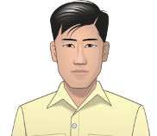
Henry Tanaka (fictional character) is a sixteen-year-old Nisei Japanese American when “Prisoner in My Homeland” begins. He was born and raised on a strawberry farm on Bainbridge Island, a short ferry ride from Seattle, Washington. He attends the local high school where his favorite subject is Chemistry. He is expected to attend Japanese school, and also help out on the farm by weeding the fields, planting and harvesting strawberry plants, and doing other chores. He keeps a diary which he illustrates with sketches. His family has a dog named Clark (named for Clark Kent, aka Superman).

Lily Tanaka (fictional character) is Henry’s thirteen-year-old younger sister. She lives with her family on the strawberry farm on Bainbridge Island. When incarcerated at Manzanar, she joins the majorettes and practices baton throwing. Lily also appears in the game as “Great Aunt Lily,” who reads Henry’s diary along with Maya, Henry’s granddaughter.
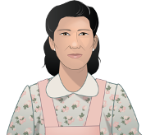
Kiyoko Tanaka (fictional character), Henry and Lily’s mother, is an Issei Japanese American in her early 40s. She manages the household and helps with the farm. When she emigrated to the United States to get married, she brought several family heirlooms including a kimono and a tea set. She expects Henry to attend Japanese school, watch after his sister, and work on the farm.

Maya Tanaka (fictional character) is Henry’s granddaughter. In the present day, after Henry’s death, she finds his diary while cleaning out his attic. Surprised by her discovery -- her grandfather had never spoken about his incarceration during World War II -- she reaches out to Great-Aunt Lily (Henry’s sister, Lily, now an elderly woman) to learn more and is inspired to dig deeper into the past.

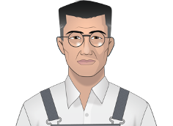
Kinzo Tanaka (fictional character), Henry and Lily’s father, is an Issei Japanese American in his late 50s. He is the head of the Tanaka household, and spends most of his time working on the strawberry farm. He is also a judo instructor at the local Japanese community center. His mother lives in Nagasaki. He hopes that Henry is the first member of the Tanaka family to go to college, and encourages him to develop both his mental and physical abilities.

Mr. Flores (fictional character) is a Filipino American who works with Mr. Tanaka on the strawberry farm. After the Tanakas are forcibly removed to Manzanar, Mr. Flores looks after the farm, but severe labor shortages limit his ability to harvest the crop.
Mr. Yamamoto (fictional character) is a Nisei Japanese American who runs a grocery store on Bainbridge Island. He is an active member of the Japanese American Citizens League (JACL). While critical of the government’s forced removal and incarceration policies, he supports strategies that demonstrate Japanese American loyalty such as cooperating with the authorities and encouraging Nisei to serve in the armed forces.

Meiko Yamamoto (fictional character) is Mr. and Mrs. Yamamoto’s only daughter. She is smart, thoughtful and motivated to do well. Like Henry, her favorite subject is Chemistry, though she also enjoys Miss Nelson’s American history class.

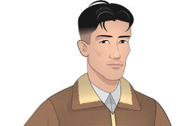
Tadashi (fictional character) is an 18-year-old Nisei Japanese American from Terminal Island whom Henry meets at Manzanar. Terminal Island is home to Japanese American fishermen and canning workers. Compared to Bainbridge Islanders, Terminal Islanders are considered tough and street-smart. Ueno lives in Block 10 and works in the mess hall.
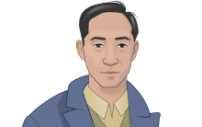
Harry Ueno (historical figure) is a 35-year old “Kibei.” Ueno was born in Hawaii and sent to Japan to be educated. As an adult, he moved to Los Angeles, started a family and sold fruit. Ueno lives in Block 22 and works in the Block 22 mess hall as a cook’s assistant.
Miss Nelson (fictional character) is a 30-year old teacher from California and a Quaker. She works as a high school teacher at Manzanar, living and working there beginning in October 1943. She is sympathetic with the young incarcerees, and encourages them to study hard. She attempts to help eligible students leave the camps for colleges on the East Coast and Midwest. This character was loosely based on Eleanor Gerard Sekerak, a teacher at the War Relocation Authority concentration camp in Topaz, Utah.

Places

Bainbridge Island is located in Puget Sound and connected to Seattle by a ferry. In the 1940s, the island was largely rural with many strawberry farms and a strawberry processing plant. In 1941, about 45 Japanese American families lived on Bainbridge Island. A Naval Radio Station was located on Bainbridge Island in 1938 and there were several military bases on nearby islands in the Puget Sound.

Manzanar Prison Camp is located about 230 miles north of Los Angeles, CA in the foothills of the Sierra Nevada mountains in a region called Owen’s Valley. The name Manzanar comes from the land’s previous use as an apple and fruit orchard (Manzanar means apple orchard in Spanish). Manzanar was the first of the ten concentration camps built to imprison Japanese Americans. It began as a temporary center and then was converted to a full prison camp with over 10,000 Japanese Americans living in 36 blocks of barracks.

Terminal Island is a largely artificial island in Los Angeles County. By the 1940s,Terminal Island had grown from a small fishing village to a vibrant Japanese American community of nearly 3,000 residents. Most worked as fishermen or in the tuna canning factories located on the island. On February 9, 1942, the FBI incarcerated all of the adult Issei males on Terminal Island and 10 days later, the remaining Terminal Islanders were given 48 hours to evacuate their homes. The TErminal Island residents were subsequently sent to prison camps and the entire Japanese American neighborhood was razed.

Department of Justice Camps: After the FBI arrested more than 5,500 Issei following the attack on Pearl Harbor, most were sent to one of ten Department of Justice (DOJ) prison camps, where they waited to appear before the Alien Enemy Hearing Board. These hearings determined whether the Issei would remain in the DOJ prison camps or be "released" to the War Relocation Authority (WRA) concentration camps. The DOJ camps also held Italian and German nationals and Japanese Latin Americans.

Tule Lake Prison Camp is located in northern California and was one of the ten concentration camps run by the U.S. government to imprison Japanese Americans. In 1943, Tule Lake was renamed the Tule Lake Isolation Center, and the facility was adapted to segregate those Japanese Americans who were deemed “disloyal” based on their responses to a questionnaire. With the shift to a segregation camp, the number of guards at Tule Lake increased from a few hundred to 930 and an eight-foot high double fence was erected. Tule Lake incarcerees responded to the harsh conditions at the prison camp with a series of protests and strikes.

As students play MISSION US: “Prisoner in My Homeland,” they will encounter many of the terms below. Some of the terms, listed in this document in purple, are included as “smartwords” in the game. See the MISSION US “At A Glance” document in the Overview section of the Teacher Materials for information on when the smartwords are included in gameplay. Additional terms are included for teacher and student reference.
American concentration camp - A place where a large number of people are imprisoned, usually because of prejudice against their identities, wartime fears, or state security.
barbed wire - A variety of metal fencing wire made with sharp points or edges along the top of the fence. It is often used to secure property.
barracks - Simple or primitive buildings (or a group of buildings) often built to house military personnel.
bento - Single-portion home–packed meal, commonly a boxed lunch.
block building - Manzanar was arranged like a military camp. Building 15 in each block was an open barrack used for meetings and events.
block manager - Man appointed by camp administrators to carry out tasks relating to each block, such as distributing supplies and relaying messages.
citizen - A person who legally belongs to a country and has the rights and protection of that country.
Civilian Exclusion Orders - A series of orders issued by General John L. DeWitt as head of the Western Defense Command (WDC) in response to Executive Order 9066. It was used to remove all Japanese Americans from the West Coast and confine them to prison camps.
Congress - The two chambers of the United States federal government consisting of the Senate and the House of Representatives.
draft - The selection of men who are required to serve in their country's military.
enlist - Volunteer to serve in the military.
euphemism - A mild word or phrase that is used in place of an unpleasant or offensive word.
Executive Order 9066 - An order signed by President Franklin D. Roosevelt in February 1942 authorizing the military to prescribe areas "from which any or all persons may be excluded," that was used to remove all Japanese Americans from the West Coast and confine them to prison camps.
FBI - The Federal Bureau of Investigation is the domestic intelligence agency and secret police service of the United States and its principal federal law enforcement agency.
firebreak - A strip of land that has been cleared to prevent a fire from moving across it.
First-generation - A resident who was born in another country and relocated to a new country with the plan to become a citizen.
forced removal - To be required to leave a place without any choice or say in the matter.
ganbari nasai - You must do your best.
General DeWitt - U.S. wartime general overseeing the defense of the Pacific Coast. DeWitt opposed allowing Japanese Americans to resettle on the West Coast on the grounds that it was "impossible to determine their loyalty."
guayule - A shrub that could be processed into rubber, which was in short supply during World War II.
harvest - The process of collecting crops that are ready to eat or sell.
heirloom - Valued personal possessions passed down in a family from one generation to another.
hick - A derogatory term used to describe someone who is from a rural location (“the country”).
incarceration - To confine or imprison as a form of punishment.
internment - Imprisoning people from another country, typically for political or military reasons.
inu - Derogatory Japanese word used for Japanese Americans accused of collaborating with the U.S. government.
Issei - First-generation Japanese immigrants to the United States.
JACL - Japanese American Citizens League; a political organization that advocated for the interests of Nisei (second-generation Japanese Americans).
judogi, gi - Woven cotton uniform worn during judo (in Japanese).
kanji - Written characters that represent words or phrases in Japanese.
Kanō sensei - Teacher Kanō Jigorō, founder of judo.
kāsan - Mother (in Japanese).
kibei - Japanese term for Japanese Americans born in the United States but sent to go to school in Japan while their parents remained in the U.S. to work.
latrine - A communal toilet used at a camp or military barracks.
Major Bendetsen - U.S. army lawyer who, along with his boss, Major General Gullion, proposed that the army forcibly remove all Japanese Americans from the West Coast. After Executive Order 9066, Bendetsen was put in charge of this "evacuation" program.
majorette - A female who performs baton twirls and stunts while marching, typically in a parade.
mess hall - A building or room built for military personnel to eat and socialize.
mochi - Traditional small cakes made of sweet steamed rice paste.
New Deal - A series of government programs and financial reforms enacted in the United States during the first administration of President Franklin D. Roosevelt, from 1933 to 1936, in response to the Great Depression.
nihongo gakkō - Japanese term for a school at which students learn to read, write, and speak Japanese and study Japanese culture, after school and on weekends.
nikyū - The second highest of the six student skill ranks in judo.
Nisei - American citizens by birth whose Japanese immigrant parents were prevented from becoming U.S. citizens.
obāchan – Grandmother (in Japanese, respectfully).
okāsan - Mother (in Japanese, respectfully).
onigiri - Steamed rice wrapped with nori (dried seaweed), sometimes with a pickled plum or salmon inside (in Japanese).
osuwari - Sit (in Japanese).
otōsan - Father (in Japanese, respectfully).
Pearl Harbor - Refers to a surprise military attack by the Imperial Japanese Navy Air Service against the United States. The attack occurred on December 7, 1941 at the naval base at Pearl Harbor in Honolulu, Hawaii. The United States entered World War II the following day.
picture bride - An arrangement in which a matchmaker paired a bride (in Japan) with a groom (in America) using only photographs and family recommendations.
Pullman train - Refers to the dining or sleeper train cars built and run on many railroads by the Pullman Company from 1867 to 1968.
questionnaire - A form designed by the U.S. military to determine whether Nisei being considered for military service would be loyal to the United States or to Japan.
randori - Freestyle practice with an opponent in judo.
rat out - To betray someone by informing authorities about their bad behavior.
rations - The specific limited quantities of goods, such as sugar, that the federal government allowed civilians to use each week during the war.
redox reactions - Chemical reactions in which one chemical strips electrons away from another chemical, as in burning wood or rusting metal.
resident - A person who lives somewhere long-term.
sasae - Drawing ankle throw (in Japanese).
Second-generation - The children of immigrants who are citizens.
Selective Service System - U.S. government agency responsible for maintaining information on persons who may be required to serve in the military.
sensei - Teacher.
shikata ga nai - It is best to accept things that cannot be helped.
shodan - First (lowest) of the ten black belt skill ranks in judo.
shogunate - The government of a hereditary military commander who ruled Japan from the end of the 12th century until 1868.
shoguns - Japanese term for a series of hereditary military commanders who governed Japan from the end of the 12th century until 1868.
sugoi - Amazing or "wow."
supervisor - A person who oversees or manages other workers.
takuan – pickled daikon radish (in Japanese).
tar paper – A strong, durable paper most often used in housing construction.
temporary detention center - A place where prisoners are held for a short time, sometimes in buildings like fairgrounds or racetracks.
Terminal Island - An engineered island in the Port of Los Angeles where many first-generation Japanese American fishermen settled in the early 1900s.
tōsan - Father (in Japanese).
tradition – Customs or beliefs passed down from one generation to the next.
Tule Lake - Location of a prison camp that became a "segregation center" for Japanese Americans who gave "incorrect" responses to the government's loyalty questions.
unqualified allegiance – loyalty or dedication to a person, country, or belief without exceptions or reservations
WAAC – The Women's Army Auxiliary Corps, an all-female volunteer unit of the U.S. Army formed in 1942.
waza – Techniques used in judo, such as holds or throws.
WRA – The War Relocation Authority -- a federal agency created by President Roosevelt in 1942 to run the detention facilities for Japanese Americans.
1. “Japanese” were “evacuated” to “internment” camps.
Using euphemistic words and phrases to describe the forced removal and incarceration of Japanese Americans during World War II minimizes the injustices that occurred. Therefore, it is important to not use terms that misrepresent certain people and events. One such mischaracterization was that “Japanese” people were affected by these events and not Japanese Americans. Describing them only as “Japanese” ignores their American identities. About 80,000 out of the 120,000 people who were imprisoned were born in the U.S. and were American citizens. Most Japanese immigrants subjected to incarceration had been residents of the U.S. for years, if not decades, prior to WWII. There is no evidence they were trying to undermine the U.S. during the war or actively supported Japan’s wartime actions. It is also misleading to say that Japanese Americans were “evacuated” from their homes. Being evacuated denotes some type of danger you are escaping (like being evacuated during a natural disaster); but Japanese Americans were not “relocated” to protect them from danger. Instead, they were forcibly removed from their homes and many of their possessions were confiscated. And finally, describing the places where Japanese Americans were sent to as “internment” camps hides another reality: Japanese Americans were imprisoned by the U.S. government, and therefore, describing what happened to them as being incarcerated is far more accurate.

2. Japanese Americans did not resist removal and incarceration.
Before, during, and after the war, Japanese Americans protested incarceration in many ways. In early 1942, leaders of the Seattle chapter of the Japanese American Citizens League spoke out, stating to Congress, “we are opposed to the idea of indiscriminate, en masse evacuation of all citizens and loyal aliens of Japanese extraction.” Japanese Americans continued to protest in the prison camps. For example, workers went on strike when barbed wire fences were installed at the Heart Mountain camp and violent demonstrations took place in the Manzanar camp. After the U.S. government distributed a loyalty questionnaire in the spring of 1943, many Japanese Americans refused to sign because they did not want to officially declare their loyalty to a country that was actively imprisoning its own citizens. And others went to court to fight the government’s actions, including Gordon Hirabayashi, Fred Korematsu, and Minoru Yasui, who took their fights against the restrictions, forced removal, and imprisonment all the way to the United States Supreme Court.

3. People of Japanese descent were incarcerated because they posed a threat to American national security.
President Roosevelt’s Executive Order 9066 authorized the military to imprison Japanese Americans in part to supposedly protect the United States’ national defense. However, there was no clear threat to national defense from the Japanese American community before the war, and no credible threat emerged during the war. In fact, a 1940 report commissioned by the State Department argued that Japanese Americans on the West Coast presented “a remarkable, even extraordinary degree of loyalty” to the United States. A report by the Chief of Naval Operations later concluded that any supposed “Japanese Problem” in the country was “magnified out of its true proportion, largely because of the physical characteristics of the people.” Indeed, there is little evidence that persons of Japanese descent living in the United States were spying on or sabotaging U.S. national interests in any significant way. Only one case -- in which three Nisei women were found guilty of helping German prisoners escape a POW camp -- was ever reported during the war.

4. People in the Japanese American community were all alike.
One of the most damaging myths about any group of people is that they all think, act, and feel the same. This misconception certainly affected perceptions of the Japanese American community during World War II. But Japanese Americans were (and are) a diverse group represented in all sections of American society. They lived in major urban centers like Los Angeles and in smaller rural communities like Bainbridge. They had careers as lawyers, professors, businessmen, dock workers, farmers, and the like. Some were very wealthy, while others were not. When this diverse group was incarcerated and forced to share tight living spaces with one another, their social, economic, and cultural differences revealed themselves on almost a daily basis.

5. The impact of incarceration ended after the camps were closed.
After the last incarceration camp closed in 1948, Japanese Americans tried to restore their pre-war lives. However, after years of imprisonment, many families had lost their homes or were forced to forfeit their businesses and personal savings. Discrimination after the war made it hard for many to find new jobs and restore their livelihoods back at home. As a result, one-third of those formerly incarcerated attempted to start over in a new state. In the 1980s, the United States government finally admitted that incarceration was the result of “racial prejudice, wartime hysteria, and...failure of political leadership.” The U.S. officially apologized and paid reparations of $20,000 each to over 80,000 surviving Japanese Americans. But for some, no apology or compensation could undo the psychological impact of incarceration. As Ted Nagata––a Japanese American held at the Topaz camp––said of his mother, “It just affected her to the point where she couldn’t carry on. She never did recover from [incarceration]. So my mother was a real casualty of Topaz, and I’m sure there were many others, too.”

Before you begin playing MISSION US: “Prisoner in My Homeland,” here are five important pieces of information to consider.

1. There was a long history of anti-Asian discrimination in the United States before World War II.
For decades before World War II, Japanese Americans and other Asian Americans were subjected to harassment and racist laws and regulations in the U.S. For example, in 1882 Congress passed the Chinese Exclusion Act, which kept most Chinese people––who had been immigrating to the West Coast to work as miners, railroad laborers, and small business owners––from entering the United States. After 1882, U.S. companies sought Japanese workers to do back-breaking, poorly-paid work in fields and factories. Some Japanese immigrants also started their own businesses, operating laundries, cafes, or other shops. But even though Americans relied on their labor, many politicians, scholars, and members of the general public -- even labor unions whose members feared losing jobs to Japanese workers -- described Japanese immigrants as people from an “undesirable race” and attempted to limit Japanese American influence and restrict their rights. The Naturalization Act of 1790 already barred nonwhite immigrants from becoming citizens. The California Alien Land Law of 1913, and similar laws in other states, for instance, prohibited “aliens ineligible for citizenship” from buying or owning land.
2. Japanese immigrants and other Japanese Americans established strong communities all along the West Coast.
Even though they faced discrimination, Japanese Americans developed strong communities throughout the western United States. Issei (Japanese immigrants) formed cultural and financial hubs known as “Little Tokyos” or Nihonmachi (Japantowns) in Seattle, San Francisco, and Los Angeles. Outside of cities, they also created churches, business clubs, and social centers dedicated to fostering cultural pride and traditions they could pass on to the next generation. Political organizations further advanced Japanese American interests throughout the country. For example, the Japanese American Citizen League, founded in 1929, focused on protecting the rights of Japanese American people. And with the help of Japanese American newspapers like Rafu Shimpo, both Issei and their American-born children (Nisei) could retain and advance their interests beyond the limits of their immediate community.
3. Antagonism between Japan and the United States grew prior to World War II.
The Empire of Japan had become an extremely powerful nation-state that held significant political and military influence in Asia and the Pacific. Beginning in 1868 with the Meiji Restoration, Japan’s emperors promoted rapid expansion of manufacturing and the military. These campaigns quickly threatened the political independence of nearby countries, and sparked conflicts throughout the region. In the 1930s, the Empire of Japan expanded even further when it invaded mainland China and its military occupied strategic islands in the Pacific. Soon it threatened areas where the U.S., British, and French had a significant imperial presence. In 1940, Japan signed The Tripartite Pact with Germany and Italy, siding with two countries at war with allies of the United States. These actions further increased Americans’ antagonism toward Japan. The U.S. declared war on Japan after the attack on the U.S. naval base at Pearl Harbor, Hawai’i in 1941.

4. U.S. wartime actions treated Japanese Americans differently from German and Italian Americans.
World War II was fought between two large groups of nations: the Allied powers (United States, Great Britain, and the Soviet Union) and the Axis powers (Germany, Italy, and Japan). Because many immigrants and foreign nationals from all three of the Axis nations lived in the U.S., some Americans questioned the loyalty of German Americans, Italian Americans, and Japanese Americans. In response, the U.S. government established incarceration camps, and the military detained and imprisoned a small fraction of German and Italian Americans: less than .1% of the total population of these communities. But Japanese Americans living on the West Coast were singled out for more extreme treatment. Thousands were forced to leave their homes and sent to prison camps for the duration of the war after President Roosevelt signed Executive Order 9066. The Order did not specify a particular race or ethnicity. But wartime propaganda portrayed Japanese people as subhuman and monstrous (such as the navy poster below that depicts the Empire of Japan as a rat), leading the general public to support the American government’s policy to treat Japanese Americans differently from their German and Italian American counterparts.
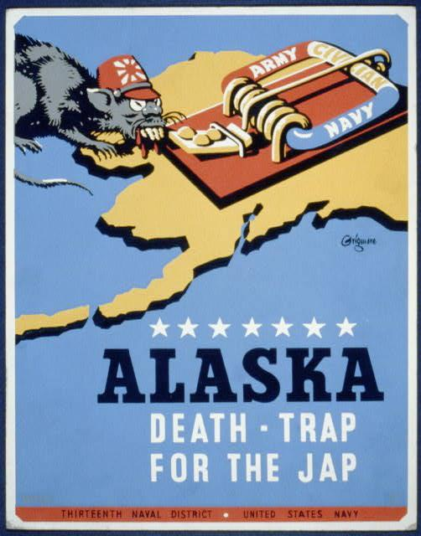
Source: Edward Thomas Grigware, “Alaska - Death-Trap for the Jap,” poster, 1941. Library of Congress Prints and Photographs Division, https://www.loc.gov/pictures/item/98510121/.

5. There were several types of incarceration camps created to detain Japanese Americans.
Because of Executive Order 9066, approximately 120,000 Japanese Americans were incarcerated in camps during World War II. Most of these facilities were hastily built and often conditions were harsh. Race tracks and fairgrounds were at times used as temporary assembly centers, where thousands of Japanese Americans lived in hastily-constructed barracks -- some even in horse stalls -- for months while the Army built more permanent prison camps euphemistically called “relocation centers” away from the coast. In order to accommodate so many people, the War Relocation Authority created ten prison camps in California, Arizona, Idaho, Utah, Wyoming, Colorado, and as far east as Arkansas. In addition to these larger encampments, the Department of Justice and the U.S. Army created detention centers for thousands of Japanese Americans they considered especially dangerous. Although the government did not call these prisons, they really were: people were held against their will in facilities that were surrounded by barbed wire and their movements were monitored by guards. They could not leave the camps for jobs or other reasons without permission. And although people were not forced into cells, the conditions in living barracks were rough, with many people in crowded quarters that were poorly heated and impossible to keep clean or comfortable.
Instructions: Use this chart to record when you receive a star toward each badge and how you earned it.
BADGE | PROLOGUE | PART 1 | PART 2 | PART 3
Stoic
(You do your best to endure the hardships of incarceration without complaint.)
Duty Calls
(You are willing to lend whatever support you can to the government's war effort.)
Question Authority
(You question the government's intentions and seek to resist its unjustified programs)

BADGE | PROLOGUE | PART 1 | PART 2 | PART 3
Community Builder
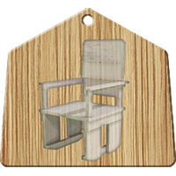
(You cope with imprisonment by seeking to improve living conditions at Manzanar.)
Family Matters
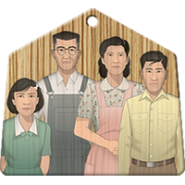
(You try to honor your family's wishes and put their needs first.)
Scholar
(Your father says it is important to develop both physically and mentally. This is the mental part.)

BADGE | PROLOGUE | PART 1 | PART 2 | PART 3
Athlete
(Your father says it is important to develop both physically and mentally. This is the physical part.)

A NOTE TO THE EDUCATOR: Students will create a memory box of cultural artifacts from the mission by completing a chart, which will be used toward a final project after students complete the game. Throughout the mission, students will document important cultural artifacts they discover to create a storyboard for an exhibit at the Bainbridge Island Japanese American Exclusion Memorial. It is recommended to have students list artifacts mainly from Part 1, since there are more objects there to choose from.

DIRECTIONS: As you play each part of the mission, look for artifacts that represent what happened to Henry during and after World War II. Artifacts can be a photo, document, or object that he used or saw when he was imprisoned and after the war was over. You can either sketch the image or take a screenshot while playing the game. You will use some of these artifacts to design an exhibit for your final project.

Consider the following when choosing artifacts:
- can be something one carries, uses, sees, or wears
- works well being displayed at an exhibit
- captures Henry’s story
- something that is unique to the time period (For example, a hammer and nails would not be the most descriptive way to illustrate this particular time period).
- will keep intact and not die or spoil, such as food or plants

MY MEMORY BOX
Select at least one artifact from each part of the mission and fill your memory box.

Part | Image of Artifact | Describe the artifact and why it was important

Part | Image of Artifact | Describe the artifact and why it was important

Part | Image of Artifact | Describe the artifact and why it was important

A NOTE TO THE EDUCATOR:
The following role-play is designed as an introductory activity, and should be completed before your students begin playing MISSION US: “Prisoner in my Homeland.” Its purpose is to sensitize your students to the advantages and disadvantages of limiting civil liberties due to a perceived threat. It also helps introduce some of the arguments for and against Japanese incarceration during World War II, though it is not intended as an exact parallel.

Your students will be asked to consider whether or not to limit the freedom of 8th graders due to a perceived threat of attack on the school. As a way to protect the school community, the administration has decided to temporarily ban certain 8th grade activities, including the freedom of movement of 8th grade students between classes, the use of cell phones, all gatherings, printing materials or public speaking in opposition to the ban, and the carrying of all bags and backpacks. Students will decide whether to 1) continue a temporary ban on 8th grade freedom or 2) end the ban immediately.

The graphic organizer will help students describe the advantages and disadvantages of the 8th grade ban.

Feel free to adapt or amend the activity to best meet your curricular goals and the needs of your students.

Steps to Complete:

- Distribute to your students (and/or read aloud) the background information about the 8th grade ban.

- Ask your students for their immediate reactions to the question: “Does the school have a right to impose restrictions on 8th graders due to the perceived threat? Why or why not?” Accept all student answers.

- Divide students into small groups of 4-5 students each. Assign each group to represent one of the following – 8th graders, 6th and 7th graders, school administrators/staff, or the general public. Ask each group to weigh the advantages and disadvantages of the ban.

- After students have had an opportunity to discuss their opinions, ask each group what they would recommend as the school’s next step.

- To extend the activity, students can share their perspectives in a debate or a mock presentation to the principal. As a homework assignment, students can also present their opinions by writing a letter to the school board or an editorial for their local newspaper.

- Explain to your students that they will soon play MISSION US: “Prisoner in my Homeland,” and the characters in the game will grapple with the same sorts of issues and problems presented in their discussions around civil liberties. However, the characters and setting of the game depict real people in a very real place and time: Japanese Americans during World War II.

ATTENTION ALL 8TH GRADERS!

Background Information:

Last week 8th graders in a neighboring district carried out a widespread graffiti attack on public buildings in our area. We do not know how many 8th graders were involved or their motives for the attack. Due to the nature of the attack and the belief it was not an isolated incident, all adjacent school districts have decided to take action. We believe protecting our school community is of the utmost importance and want to ensure all students are safe. As a cautionary measure, we are imposing an immediate ban on 8th grade activities that could endanger our school. The following rules are now in effect:

- All 8th grade students are to stay in one classroom throughout the day. Teachers will move from class to class, but all 8th grade students must stay in their homeroom for the entire school day. No exceptions.
- All cell phones belonging to 8th graders will be collected upon arrival at school and returned at the end of the day.
- All school assemblies, performances, practices, and games are cancelled until further notice.
- All 8th graders must come to school without a bag or backpack of any kind. Only a wallet with ID and money will be allowed into the building. Cell phones will be left at the door, as already noted.
- All field trips are cancelled.
- No public speaking or gathering outside of school in protest of 8th grade restrictions will be allowed.
- Printing or distributing posters or flyers that oppose the restrictions is prohibited.

In addition to the ban, all 8th graders will be subject to questioning by school authorities to help identify students who could serve as leaders of any organizing of future attacks and to help ascertain the level of risk to our community.

We ask that the entire school community, including our younger students in 6th and 7th grade, remain vigilant and aware of your surroundings. Please report any suspicious behavior to the main office immediately.

This ban will remain in effect until we feel the threat has passed. Please cooperate with school staff and safety agents as we do what we think is best to keep our community safe.
DEBATE: Should the school administration maintain current limits on 8th grade freedom until the threat of attack has passed?
I represent (circle one):

8th Graders 6th/7th Graders School Administrators/Staff General Public

ADVANTAGES  of a temporary ban on 8th grade freedom | DISADVANTAGES  of a temporary ban on 8th grade freedom

Should the school administration maintain current limits on 8th grade freedom until the threat of an attack has passed?
Our recommendation:

_____ Continue ban indefinitely
_____ Continue ban with changes
_____ End ban immediately

Explanation of reason(s) for your decision.
A NOTE TO THE EDUCATOR:
This activity is best used after students have played the Prologue section of the game. The Prologue and the primary sources in this activity illustrate the different points of view on the forced removal of Japanese Americans: the perspective of the U.S. government, a Japanese American community organization, and a Japanese American teenager. You will be assigned one or several of these sources to review. As you review each source, use the provided discussion questions to analyze it. Remember to look closely at the source and think deeply about what it tells you about the divergent views of historical actors.

PRIMARY SOURCE #1: Executive Order 9066

- Prior to having students analyze the primary source documents, instruct students to answer the following question in pairs or small groups based on the Prologue of “Prisoner in My Homeland.” Then conduct a short discussion.
Questions:
- What does it mean to be targeted as the enemy or someone to be feared?
- Remind students that during World War II the U.S. fought against Germany, Italy, and Japan. Why do you think Americans of Japanese descent were targeted in this way?

- Executive Order 9066 Analysis

Project Executive Order 9066 to students and tell them that this is a shortened version of the 3-page document written and ordered by President Franklin D. Roosevelt during World War II. They will analyze key quotes from this document through a “Dialectical Journal” activity.

Pair students up and instruct them to complete the following “Dialectical Journal” handout. A Dialectical Journal is a dual-entry journal that allows students to record their reactions to specific passages and quotes. Review vocabulary words such as those listed below to facilitate student comprehension. Guide students to break up longer quotes into sections to help them understand the passage.

Vocabulary to Review:
- prosecution - the continuation of a course of action with a view to its completion
- espionage - the practice of spying or of using spies, typically by governments to obtain political and military information
- sabotage - the act of damaging something especially for political or military advantage
- designate - to assign or appoint
- prescribe - state as a rule that should be carried out

Dialectical Journal

Directions: Read each quote in the “Direct Quote” column. Then write a response to the quote by completing the sentence prompt in the “Student Response” column.

Direct Quote | Student Response
- ...the successful prosecution of the war requires every possible protection against espionage and against sabotage to national-defense material, national-defense premises, and national-defense utilities | Reading this made me realize...
- Now, therefore, by virtue of the authority vested in me as President of the United States, and Commander in Chief of the Army and Navy, I hereby authorize and direct the Secretary of War, and the Military Commanders whom he may from time to time designate, whenever he or any designated Commander deems such action necessary or desirable, to prescribe military areas in such places and of such extent as he or the appropriate Military Commander may determine, from which any or all persons may be excluded, and with respect to which, the right of any person to enter, remain in, or leave shall be subject to whatever restrictions the Secretary of War or the appropriate Military Commander may impose in his discretion. | This section explains...
- I hereby further authorize and direct the Secretary of War and the said Military Commanders to take such other steps as he or the appropriate Military Commander may deem advisable to enforce compliance with the restrictions applicable to each Military area hereinabove authorized to be designated, including the use of Federal troops and other Federal Agencies | This detail helps me to understand…

- Executive Order 9066 Class Discussion

After students complete the Dialectical Journal, have each group of students share their responses. Then discuss the following questions:

- Why did the President of the U.S. want to create military areas where certain people would be excluded?
- Did the President state what persons of a particular ethnic background to exclude in these military areas? Who did he give the authority to make this type of decision? Why do you think that only Americans of Japanese descent were imprisoned in mass numbers when the U.S. was also fighting against Germany and Italy during World War II?

PRIMARY SOURCE #2: Civilian Exclusion Orders

https://encyclopedia.densho.org/media/encyc-psms/en-denshopd-p25-00049-1.pdf (linked in the instructions below)

Tell students that after Executive Order 9066 was implemented, the U.S. Military Western Defense Command, under the leadership of General John L. DeWitt, carried out President Roosevelt’s order by issuing Civilian Exclusion Orders. These exclusion orders targeted Americans of Japanese descent.

Project or distribute the Civilian Exclusion Order instructions that were posted all throughout neighborhoods of states on the West Coast. Then discuss the following question with students:

Question:
According to the Civilian Exclusion Orders, what were Japanese Americans required to do in order for the government to forcibly remove them from their homes and neighborhoods?

PRIMARY SOURCE #3: JACL Statement

This document is excerpted from a report released by the Japanese American Citizens League (JACL) of Seattle, Washington. Founded in 1929, the JACL served as an advocate for citizenship for Japanese and Asian immigrants. The report, dated February 28, 1942, offers a position on the forced removal of Japanese Americans from Washington State.

STATEMENT BY EMERGENCY DEFENSE COUNCIL, SEATTLE CHAPTER, JAPANESE-AMEERICAN CITIZENS LEAGUE, SEATTLE, WASH.

REPORT PRESENTED TO TOLAN CONGRESSIONAL COMMITTEE, FEBRUARY 28, 1942.

For some time now there has been agitation for the evacuation of Japanese nationals as well as American citizens of Japanese descent from Pacific Coast States. Such evacuation has been proposed in a variety of forms.
We wish to go on record now that the safety and welfare of the United States is, has been, and will continue to be foremost in our minds. We, as American citizens, have a duty to this, our country, and the first tenet of that duty is complete and unshakeable loyalty.
For this very reason, we are opposed to the idea of indiscriminate, en masse evacuation of all citizens and loyal aliens of Japanese extraction. We are wholeheartedly in favor of complete cooperation with the military and other authorities on withdrawal of civilians from the immediate vicinity of defense projects and establishments. But we do not believe that mass evacuation is either desirable or feasible. We believe that the best interests of the United States will be served by other solutions to the problem.
We also desire the privilege of remaining here to fight shoulder to shoulder, and shed our blood, if necessary, in the defense of our country and our home together with patriotic Americans of other national extractions if that time should ever come.

If it is for the greater good that evacuation be decreed, we shall obey to the best of our ability. But we are convinced that here in our homes and in our community is where we belong, where we can lend every ounce of our strength, and every cent of our resources, in creating the sinews of war so necessary to total victory. We are Americans. We want to do our duty where we can serve best.

We believe the so-called Japanese problem is not so serious as certain vocal exponents of mass evacuation profess to believe. We are sure that the benefits to be derived from large-scale evacuation of Japanese from the State of Washington are overwhelmingly overbalanced by the benefits to be derived by keeping them here under the proper supervision.
The Japanese problem is not going to be solved by evacuation. If they are a problem here, they will be a problem wherever they are sent. Since this is so, it is logical that they can be kept under better surveillance where they are now, concentrated as they are well-defined areas and where they can continue to do their bit for the national defense.
Questions:

- President Roosevelt issued Executive Order 9066 on February 19, 1942, which ordered the forced removal of Japanese Americans from the Western U.S. Why do you think the Seattle JACL issued this report on February 28, 1942?
- As you read through this selection from the report, what words stand out to you? Make a list of the most important words in this primary source. Explain your choices.
- What position does the JACL take on the forced removal of Japanese Americans? What do they propose should be done?
- What relationship does the JACL want Japanese Americans to have with the U.S. government? Do you agree or disagree with their opinion?

Making Connections

When you are finished reading Primary Source #2: JACL Statement, consider the meaning of the word “patriotism.” Working alone or with a partner, complete this graphic organizer.

Target Word

PATRIOTISM

From the perspective of the JACL in 1942, the word PATRIOTISM means...

What PATRIOTISM is…. | What PATRIOTISM is not….

The JACL’s perspective on PATRIOTISM reminds me of….(places, events, people, situations)

Why does PATRIOTISM have different meanings for different people?

PRIMARY SOURCE #4: Stanley’s Diary

(For the full diary, visit Online Archive of California).

Diaries are an excellent primary source document to examine firsthand accounts of historical events. Stanley Hyami’s diary provides insight into what he was thinking, feeling, and experiencing while at Heart Mountain prison camp. It’s interesting, engaging to read, and at times heartbreaking. There are weaknesses to this type of primary source, too. Diaries are often not objective because they generally only show one person’s perspective. Thus, it is important to corroborate diaries with other sources to verify facts. In the end, while problematic, diaries are still useful historical sources--especially for learning about the lives of young people. Here’s Stanley’s story.

Stanley Kunio Hayami (1925–45), was born on December 23, 1925, in Los Angeles, California. His family owned the Hayami Nursery in San Gabriel, California, before being forcibly excluded and sent to the Pomona Assembly Center followed by the concentration camp at Heart Mountain in 1942. While there, he served as art editor for the 1944 Tempo yearbook before graduating in June of that year. Throughout his imprisonment at Heart Mountain, Hayami kept a diary filled with pen-and-ink drawings and he reported regularly on his daily activities such as studying for tests, listening to games on the radio, or going to the movies. He also voiced his views on the incarceration and his account of the military draft, and spoke of the importance of serving his country. As a high school student, he longed to pursue a career as an artist and writer, though he felt he didn't have "enough brains" for it.

He received his army induction notice and reported for basic training on August 22, 1944, which comprised his last day in camp and the final entry in his diary. After undergoing basic training, Stanley left for overseas duty in France. In March 1945 his unit left for Italy, as part of a major assault across northern Italy. He was killed at a battle in San Terenzo, Italy, while trying to aid a fellow soldier, for which he was posthumously awarded the Bronze Star and Purple Heart.

“My Viewpoint on the Evacuation” June 26, 1943

After reading Stanley’s essay “My Viewpoint on the Evacuation,” complete Stanley’s side of the chart in your own words based on how he answers the questions in his diary. Then use the other documents (U.S. government response from Executive Order 9066, U.S. military response from the Civilian Exclusion Orders, and JACL response from the JACL Statement) to support or oppose Stanley’s reasoning. Draw examples from these documents to show what their reasoning would be as compared to Stanley’s. Use bullet points or short phrases to fill in the boxes.

QUESTION | STANLEY’S ANSWER AND REASONING | JACL and/or U.S. Government ANSWER AND REASONING
Was it constitutional?
Was racial prejudice involved?
Was it worthwhile from the standpoint of the government?
Did it do any good?
How should one cope with and respond to the forced imprisonment of Japanese Americans?
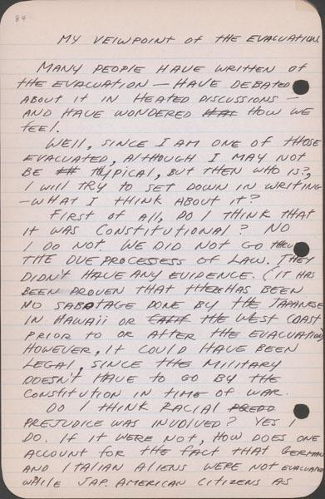
First page: http://www.oac.cdlib.org/ark:/13030/tf6k40056s/?brand=oac4
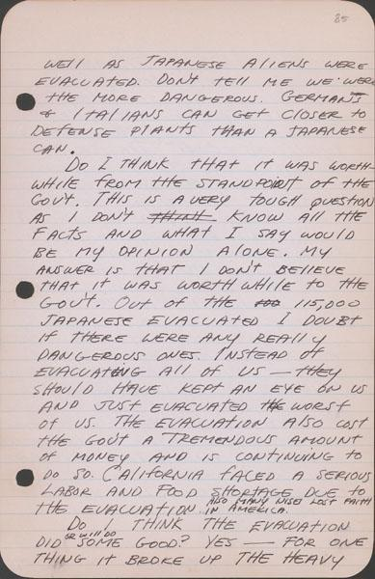
Second page: http://www.oac.cdlib.org/ark:/13030/tf3489n632/?brand=oac4
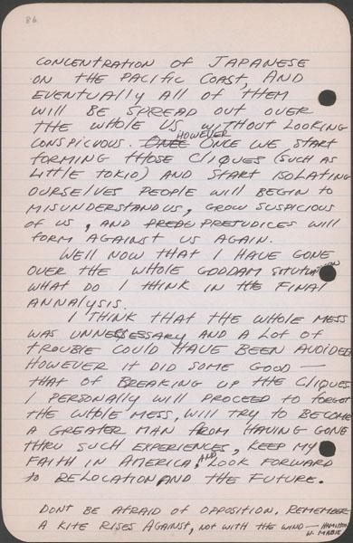
Third page: http://www.oac.cdlib.org/ark:/13030/tf2r29n604/?brand=oac4

A NOTE TO THE EDUCATOR:
On the following pages, you will find “flashcards” with terms and definitions (both combined and separate) that your students may encounter while playing “Prisoner in My Homeland.” These terms and definitions can be introduced and practiced before or during the time students see or hear them in the context of Mission US or in their American history study. The discussion questions and writing prompts will provide further opportunities for students to have more practice with the words and terms.

Divide your students into small groups of four or five, and ask each group to review the terms and definitions.

After your students have had a chance to review and discuss the terms and definitions, distribute the excerpt from an imagined talk between Maya Tanaka and a class of middle school American history students. Review the directions with your students, and ask them to complete the text using the terms they studied. Here is the order in which the vocabulary terms should be inserted into the blanks within Maya’s talk with students:

Pearl Harbor
Executive Order 9066
forced removal
heirlooms
temporary detention centers
citizens
Issei
incarceration
internment
residents
concentration camp
euphemism

American concentration camp  A place where a large number of people are imprisoned, usually because of prejudice against their identities, wartime fears, or state security. | bento  Single-portion home-packed meal, commonly a boxed lunch.  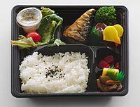
citizen  A person who legally belongs to a country and has the rights and protection of that country. | Civilian Exclusion Orders  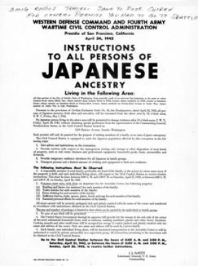  A series of orders issued by General John L. DeWitt as head of the Western Defense Command (WDC) in response to Executive Order 9066. It was used to remove all Japanese Americans from the West Coast and confine them to prison camps.
Congress  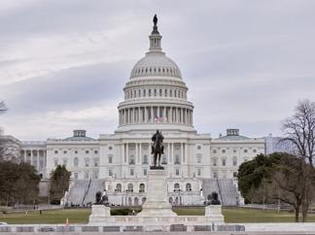  The two chambers of the United States federal government consisting of the Senate and the House of Representatives. | euphemism  A mild word or phrase that is used in place of an unpleasant or offensive word.
Executive Order 9066  An order signed by President Franklin D. Roosevelt in February 1942 authorizing the military to prescribe areas "from which any or all persons may be excluded," that was used to remove all Japanese Americans from the West Coast and confine them to prison camps.  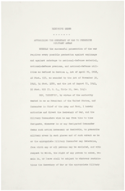 | FBI  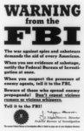  The Federal Bureau of Investigation is the domestic intelligence agency and secret police service of the United States and its principal federal law enforcement agency.
First-generation  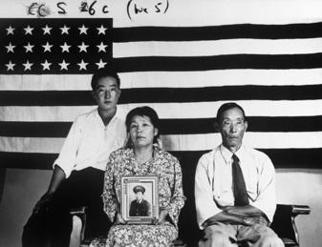  A resident who was born in another country and relocated to a new country with the plan to become a citizen. | forced removal  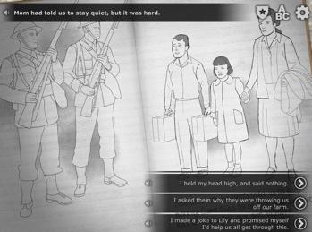  To be required to leave a place without any choice or say in the matter.
harvest  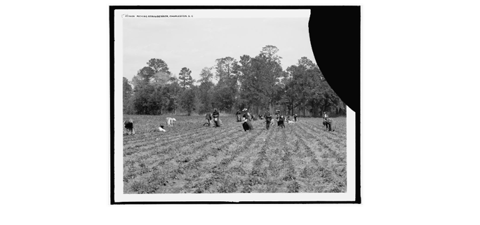  The process of collecting crops that are ready to eat or sell. | heirloom  Valued personal possessions passed down in a family from one generation to another.  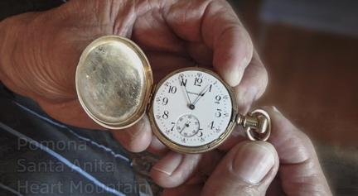
incarceration  To confine or imprison as  a form of punishment.  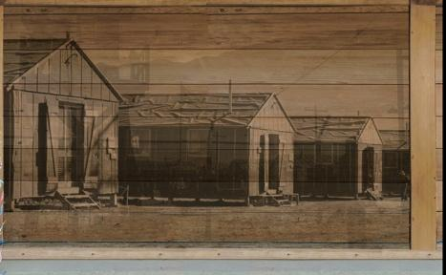 | Internment  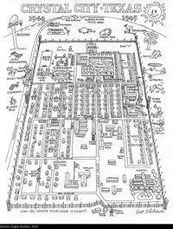  Imprisoning people from another country, typically for political or military reasons.
Issei  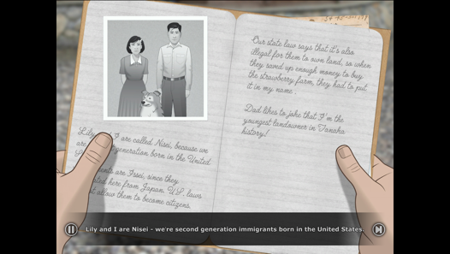  First-generation Japanese immigrants to the United States. | majorette  A female who performs baton twirls and stunts while marching, typically in a parade.  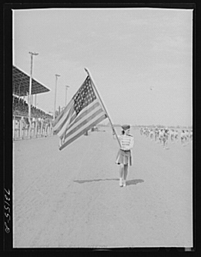

New Deal  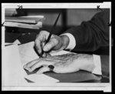  A series of government programs and financial reforms enacted in the United States during the first administration of President Franklin D. Roosevelt, from 1933 to 1936, in response to the Great Depression. | Nisei  American citizens by birth whose Japanese immigrant parents were prevented from becoming U.S.  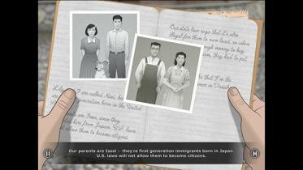  citizens.
Pearl Harbor  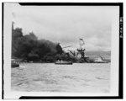  Refers to a surprise military attack by the Imperial Japanese Navy Air Service against the United States. The attack occurred on December 7, 1941 at the naval base at Pearl Harbor in Honolulu, Hawaii. The United States entered World War II the following day. | Picture bride  An arrangement in which a matchmaker paired a bride (in Japan) with a groom (in America) using only photographs and family recommendations.  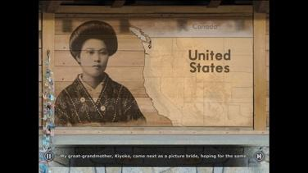

resident  A person who lives  somewhere long-term.  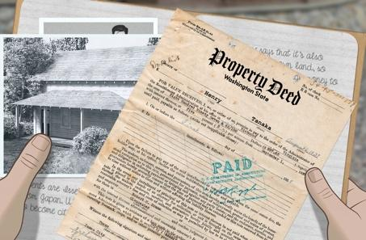 | Second-generation  The children of immigrants  who are citizens.  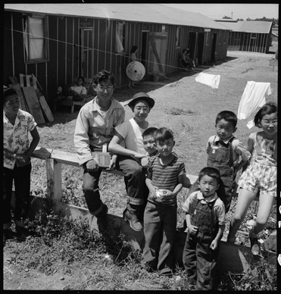
temporary detention center  The Federal Bureau of Investigation is the domestic intelligence agency and secret police service of the United States and its principal federal law enforcement agency.  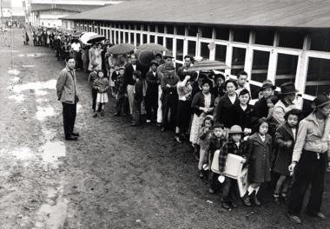 | tradition  Customs or beliefs passed  down from one generation  to the next.  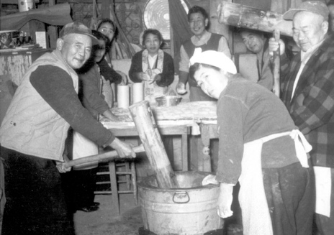

American concentration camp | bento
citizen | Civilian Exclusion Orders  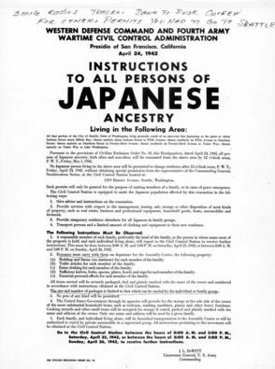
Congress  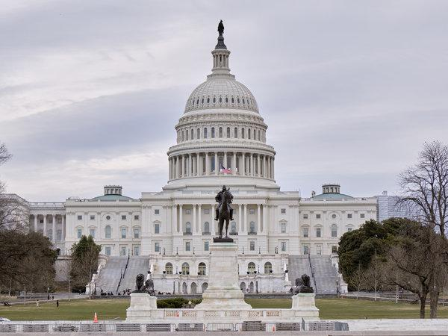 | euphemism
Executive Order 9066 | FBI
First-generation  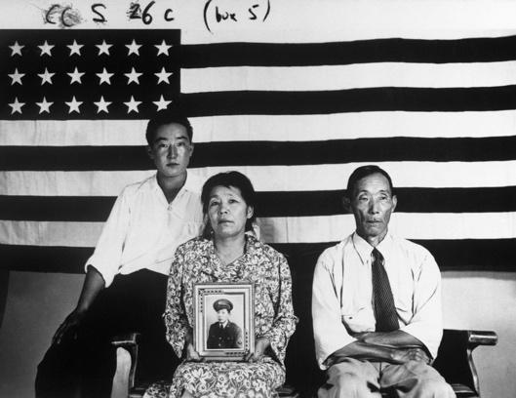 | forced removal  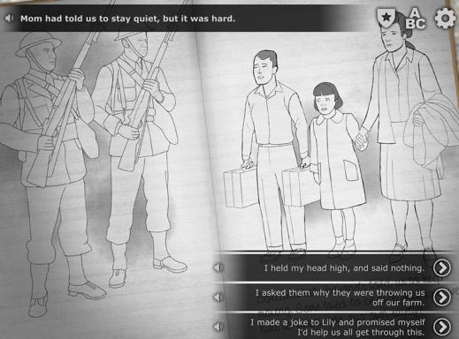
harvest | heirloom  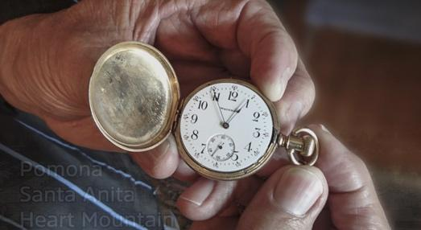

incarceration  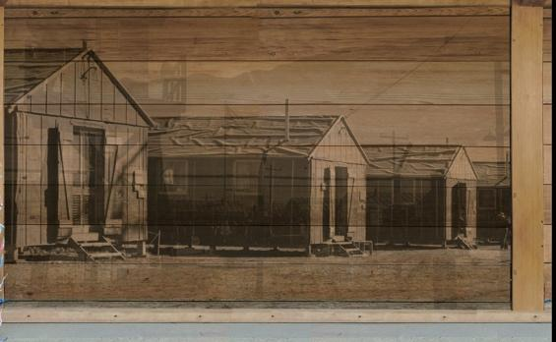 | Internment
Issei  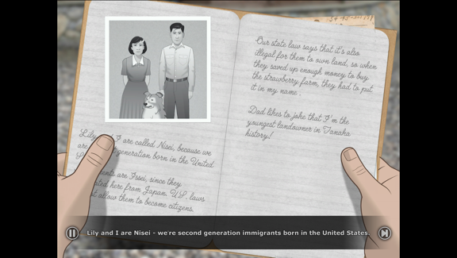 | majorette  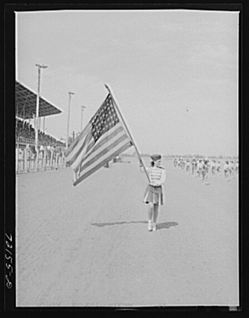
New Deal | Nisei  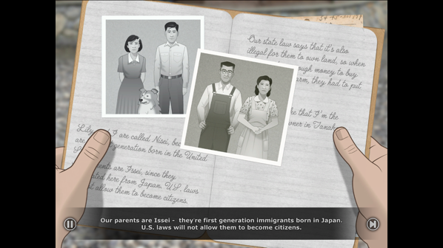

Pearl Harbor | 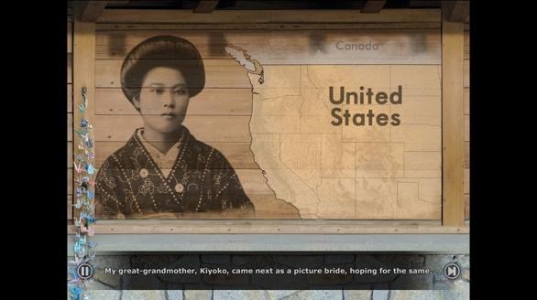  Picture bride
resident  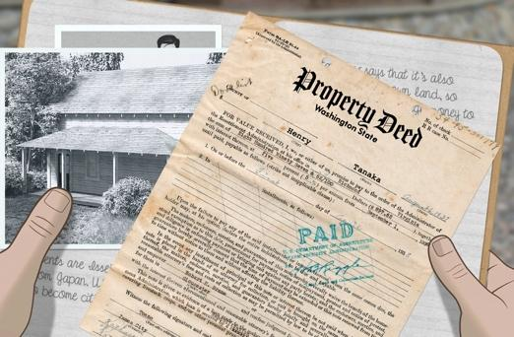 | Second-generation
temporary detention center  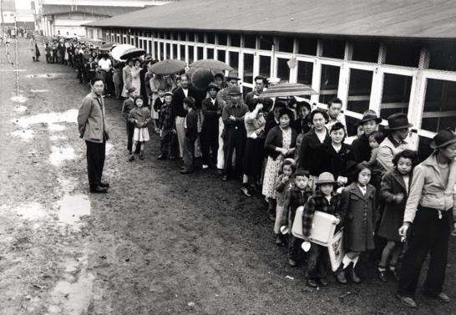 | Tradition

A place where a large number of people are imprisoned, usually because of prejudice against their identities, wartime fears, or state security. | Single-portion home-packed meal, commonly a boxed lunch.
A person who legally belongs to a country and has the rights and protection of that country. | A series of orders issued by General John L. DeWitt as head of the Western Defense Command (WDC) in response to Executive Order 9066. It was used to remove all Japanese Americans from the West Coast and confine them to prison camps.
The two chambers of the United States federal government consisting of the Senate and the House of Representatives. | A mild word or phrase that is used in place of an unpleasant or offensive word.
An order signed by President Franklin D. Roosevelt in February 1942 authorizing the military to prescribe areas "from which any or all persons may be excluded," that was used to remove all Japanese Americans from the West Coast and confine them to prison camps. | The Federal Bureau of Investigation is the domestic intelligence agency and secret police service of the United States and its principal federal law enforcement agency.
A resident who was born in another country and relocated to a new country with the plan to become a citizen. | To be required to leave a place without any choice or say in the matter.
The process of collecting crops that are ready to eat or sell | Valued personal possessions passed down in a family from one generation to another.
To confine or imprison as  a form of punishment. | Imprisoning people from another country, typically for political or military reasons.
First-generation Japanese immigrants to the United States. | A female who performs baton twirls and stunts while marching, typically in a parade.
A series of government programs and financial reforms enacted in the United States during the first administration of President Franklin D. Roosevelt, from 1933 to 1936, in response to the Great Depression. | American citizens by birth whose Japanese immigrant parents were prevented from becoming U.S. citizens.
Refers to a surprise military attack by the Imperial Japanese Navy Air Service against the United States. The attack occurred on December 7, 1941 at the naval base at Pearl Harbor in Honolulu, Hawaii. The United States entered World War II the following day. | An arrangement in which a matchmaker paired a bride (in Japan) with a groom (in America) using only photographs and family recommendations.
A person who lives  somewhere long-term. | The children of immigrants  who are citizens.
The Federal Bureau of Investigation is the domestic intelligence agency and secret police service of the United States and its principal federal law enforcement agency. | Customs or beliefs passed  down from one generation  to the next.

Name: _______________________ Date:_________________________

Activity: More than seventy-five years after the events of “Prisoner In My Homeland,” Maya Tanaka, Henry Tanaka’s present-day 20-something granddaughter, is invited to give a talk to a local middle school history class. Maya is introducing them to the World War II-era Japanese American incarceration. The following is a portion of her interactions with the students.

After reading and discussing the words and terms on the flashcards, read this excerpt from her talk with the students, and use your memory to fill in the missing words and terms.

concentration camps  forced removal  temporary detention centers | citizens  residents  Issei | Executive Order 9066  euphemism  Pearl Harbor | incarceration  heirlooms  internment

Maya Tanaka: “Today, I’m going to talk to you about events that occurred during World War II that affected my family, the Tanakas. On Sunday, December 7, 1941, the Japanese Navy attacked ______________. Immediately afterwards, President Roosevelt issued ________________, which ordered for the ____________ of nearly 120,000 Japanese Americans from their homes in California, Oregon, and Washington.

Many had to quickly sell their property or find someone to care for their homes and farms. They could bring very little with them. They gave away or burned cherished family _______________, like photos or treasured objects. At first, most families reported to __________________, often fairgrounds or racetracks ill-suited to hold so many people. These places held Japanese Americans for a little while until they were moved into more permanent prisons in harsh places across the U.S.

In the case of my grandfather and his family, they did not go to one of these centers. They were taken directly to a prison at Manzanar. They lived on Bainbridge Island near Seattle, Washington and were the first Japanese Americans to be forcibly removed.

Nearly two-thirds of Japanese American prisoners were U.S. ___________, meaning that they were born in the U.S. and were supposed to have protections and rights. Some of these people, the ___________, were first-generation immigrants and were prevented from even becoming citizens under U.S. law.

Currently, we refer to these events as the_______________ of Japanese Americans.
Student: “In our history textbook, the events are called the ‘Japanese American internment camps.’ Why do you use a different term?”

Maya Tanaka: Yes, some history textbooks still refer to these events using this incorrect term. But an_______________ camp refers to a place where prisoners of war are sent as captives, like German or Italian soldiers. Japanese Americans weren’t prisoners of war; most were hardworking, long-time ____________ of U.S. cities and towns.

Student: “What’s the right word to use for the camps?”

Maya Tanaka: “The largest prisons that held Japanese Americans during World War II are called ‘American _____________________.’ That’s when people are held in masses, usually because of some wartime fears or policies.”

Student: Why is it so important to use the right words?

Maya Tanaka: “That’s a great question. I think it’s because words have so much power. Today, we want to use the most accurate terms to describe what happened. The U.S. government wanted to make the camps seem less harmful than they actually were. So they used words like ‘internment’ or ‘evacuation’ to make their actions seem necessary during a time of war. When people use words to make something that is harmful seem less so, we call it a ______________.

Student: I see, so in changing the words, we change the way we see these events. We describe them clearly.

Maya Tanaka: Yes, words shape the way we understand history
A NOTE TO THE EDUCATOR: You will need to decide how best to share these writing prompts with your students. You might share them all and ask students to choose one for response. You might assign one or more to the entire group. You might make one or more of the topics the basis for in-class discussions. Make your decisions according to the needs of your group.

You may notice that many of the topics contain some version of the phrase, “Write about a time in your life...” The intention of these prompts is twofold: first, since students remember the content of their own lives, they can more easily respond to the questions and they are more likely to want to express themselves if they feel competent to do so; second, these questions can form a meaningful bridge between what happens in the lives of ordinary people today and the lives of people in history or in historical events themselves. For these reasons, you might decide to use some of those prompts before students encounter the history because thinking about them sets the students up to understand it and to relate to it.

Since students vary in their degree of comfort and skill in writing, you should decide when students write and how much students should write. We do suggest, though, that since students need to share their writing with each other to make personal and historical connections, you encourage them to focus on content rather than on mechanical skills. Pieces can be revised and edited later if you decide they should be shared more formally (such as on a bulletin board or newsletter).

Read through all the topics. Then choose one of them to write about. Write the title of the piece at the top of your page. Write in complete sentences. After you are finished, proofread your work for correctness.

HOME SWEET HOME. The Tanaka family lives on a strawberry farm on Bainbridge Island, Washington. Describe the farm and compare and contrast its appearance to the place where you live. Consider the environment, activities, technology, and people in your answer. How are they similar? How are they different?

DAILY CHORES. In the Prologue, we learn about the daily chores Henry and Lily Tanaka do on the farm. Do you do chores at your home? If so, how do the Tanaka’s chores compare to the work you do at your home? After learning about the items on Henry and Lily’s list, do you think about chores differently? If so, how?

ALL IN THE FAMILY. We learn a lot about the cultural and social traditions that are important to the Tanaka family (Japanese school, judo, food). We also learn about the American cultural and social customs that are important to Henry (baseball, comics). Does your family have any traditions or customs that have been passed down from previous generations? If so, what are they? Do any of these traditions ever conflict with more mainstream or “American” traditions? Have you ever felt pressure to choose between activities with your family and what your friends are doing? If not, research a cultural group in the United States and their customs. Select one custom and describe it. Why do you find it an interesting tradition?

IN THE HEADLINES. Imagine you’re Henry Tanaka and on Sunday, December 7, 1941 at home with your family you hear about the bombing of Pearl Harbor on the radio. What do you think the Tanaka’s dinner conversation might be that evening? How do you think Henry’s parents would respond to the bombing vs. Henry and his sister Lily?

HENRY’S POV. Through Henry’s eyes, think about how he would feel when he hears he has 6 days to relocate to some unknown place. Remember that his world is much smaller than your own (no cell phones, no internet, etc.). He can't easily look up information about where the family is going. He also has to leave behind his beloved dog and give up immediate plans like playing on the baseball team. Write a journal entry, from Henry’s point of view, on the day he leaves Bainbridge Island and embarks on a journey into an uncertain future.

A NOTE TO THE EDUCATOR:

The purpose of these questions is to check the students’ understanding of the action of the game and the history embedded in that action. Since the outcome of gameplay can vary depending on the choices the student makes, the answers to the questions may also vary.

Some students might learn information from the game later than others, or not at all. If you choose to discuss responses as a whole group, information can be shared among all your students.

There may be more questions here than you want your students to answer in one sitting or in one evening. In that case, choose the questions you feel are most essential for their understanding of the prologue.

Feel free to copy the following pages of this activity for your students.

If you are not planning to have your students write the answers to the questions, you’ll need to modify the directions.

Life in Manzanar Prison Camp | In the Eye of the Beholder: Dorothea Lange and Ansel Adams

Instructions

A NOTE TO THE EDUCATOR: This activity is best used after students have played the Prologue and Part 1 of the game.
During World War II, artists Dorothea Lange and Ansel Adams photographed life in Manzanar Prison Camp. Lange’s images represented more of the harsh conditions in the camp, while Adams’ presented a more optimistic view. While both photographers were commissioned to document the camp conditions in the prison by the US government, Lange’s photographs were not released to the public until after the war.
Working in small groups, students learn about Dorothea Lange and Ansel Adams and view their work documenting life in Manzanar. After examining a selection of curated images, students will record their observations about how each artist documented life in Manzanar and use a Venn diagram to compare and contrast the collection of each artist. A culminating activity asks students to write a creative response about the camp from the perspective of Lange or Adams.
Steps to Complete:
- Students complete Prologue and Part 1 of “Prisoner in My Homeland.” Briefly discuss what they experienced to ensure that they understand the major points introduced.
- Distribute the Dorothea Lange and Ansel Adams packets to students divided into groups of 2-3.
- Instruct students to complete each packet.
- Complete the Venn Diagram.
- Then, students should complete the Culminating Activity individually.
- Debrief the activity as a class by discussing the groups’ responses to the questions, Venn Diagram, and Culminating Activity.

Dorothea Lange Photographs of Manzanar
Directions: Read the text below and examine the Dorothea Lange photographs documenting life in Manzanar Prison Camp, along with the descriptive captions Lange wrote to accompany each image.
Dorothea Lange (1895-1965) is widely considered one of the greatest documentary photographers of the 20th century. Her images of the Great Depression, taken while she was employed by the Farm Security Administration (FSA), are iconic.
While working on assignment for the War Relocation Authority (WRA) during World War II, Lange photographed the forced removal and incarceration of Japanese Americans in camps. Her photos captured life in the prison camps and the often raw emotions displayed by the people who were uprooted from their homes and forced to live in the camps.
Analyzing Photographs of Dorothea Lange

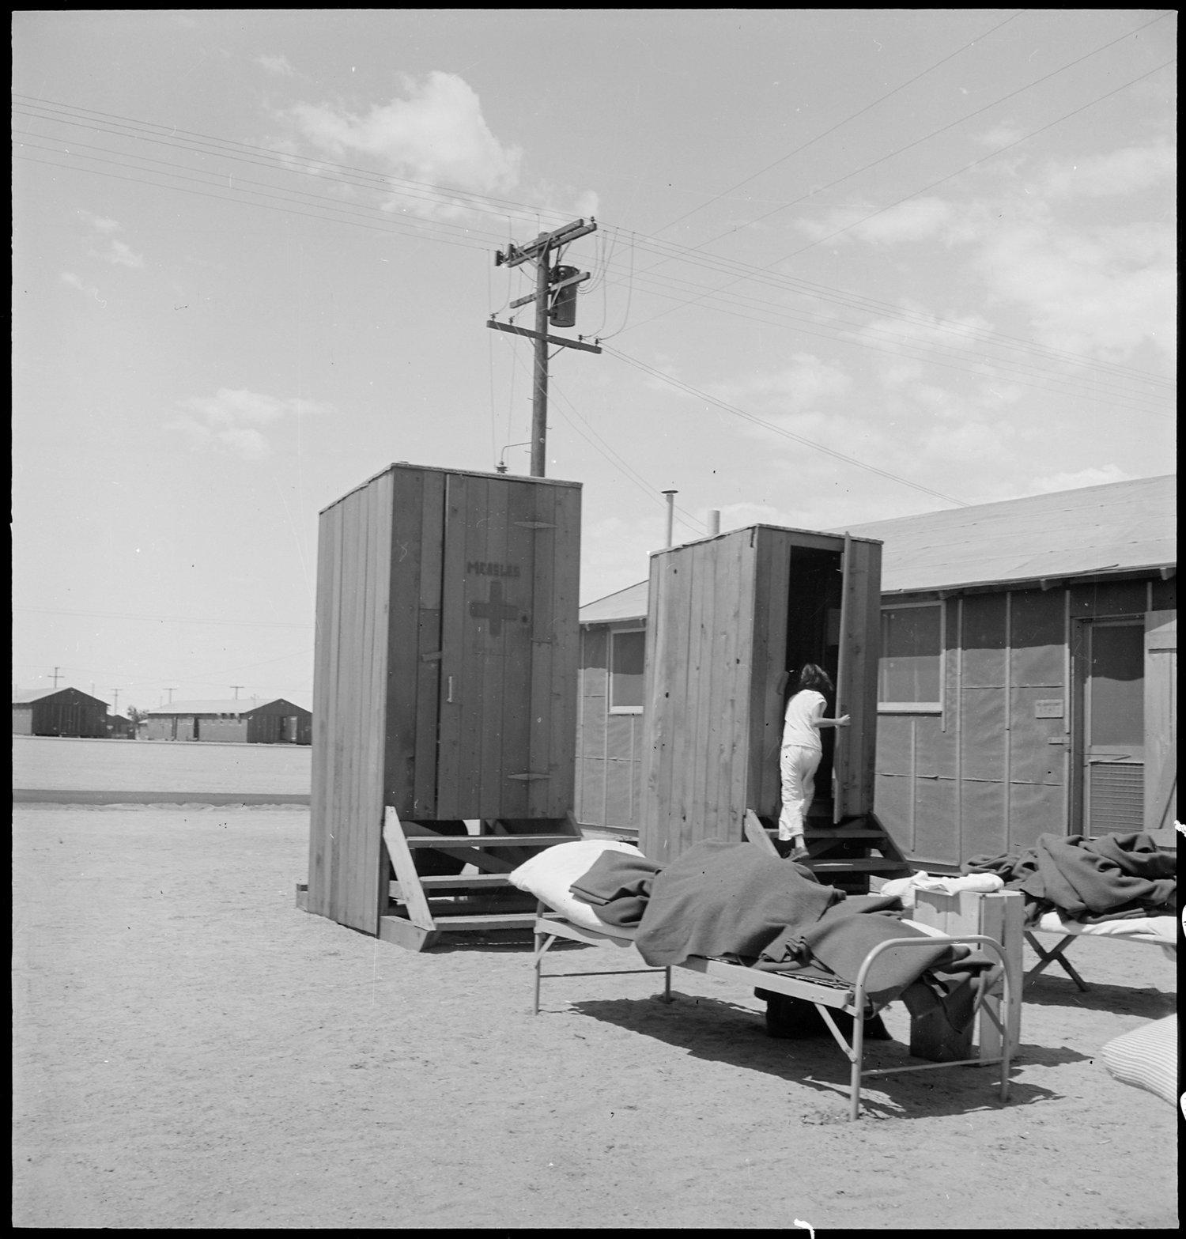
Lange’s Caption: Manzanar Relocation Center, Manzanar, California. Hospital latrines, for patients, between the barracks, which serve temporarily as wards. For the first three months of occupancy medical facilities have been meager but the new hospital fully equipped, is almost ready for occupancy.
7/1942 https://catalog.archives.gov/id/538149

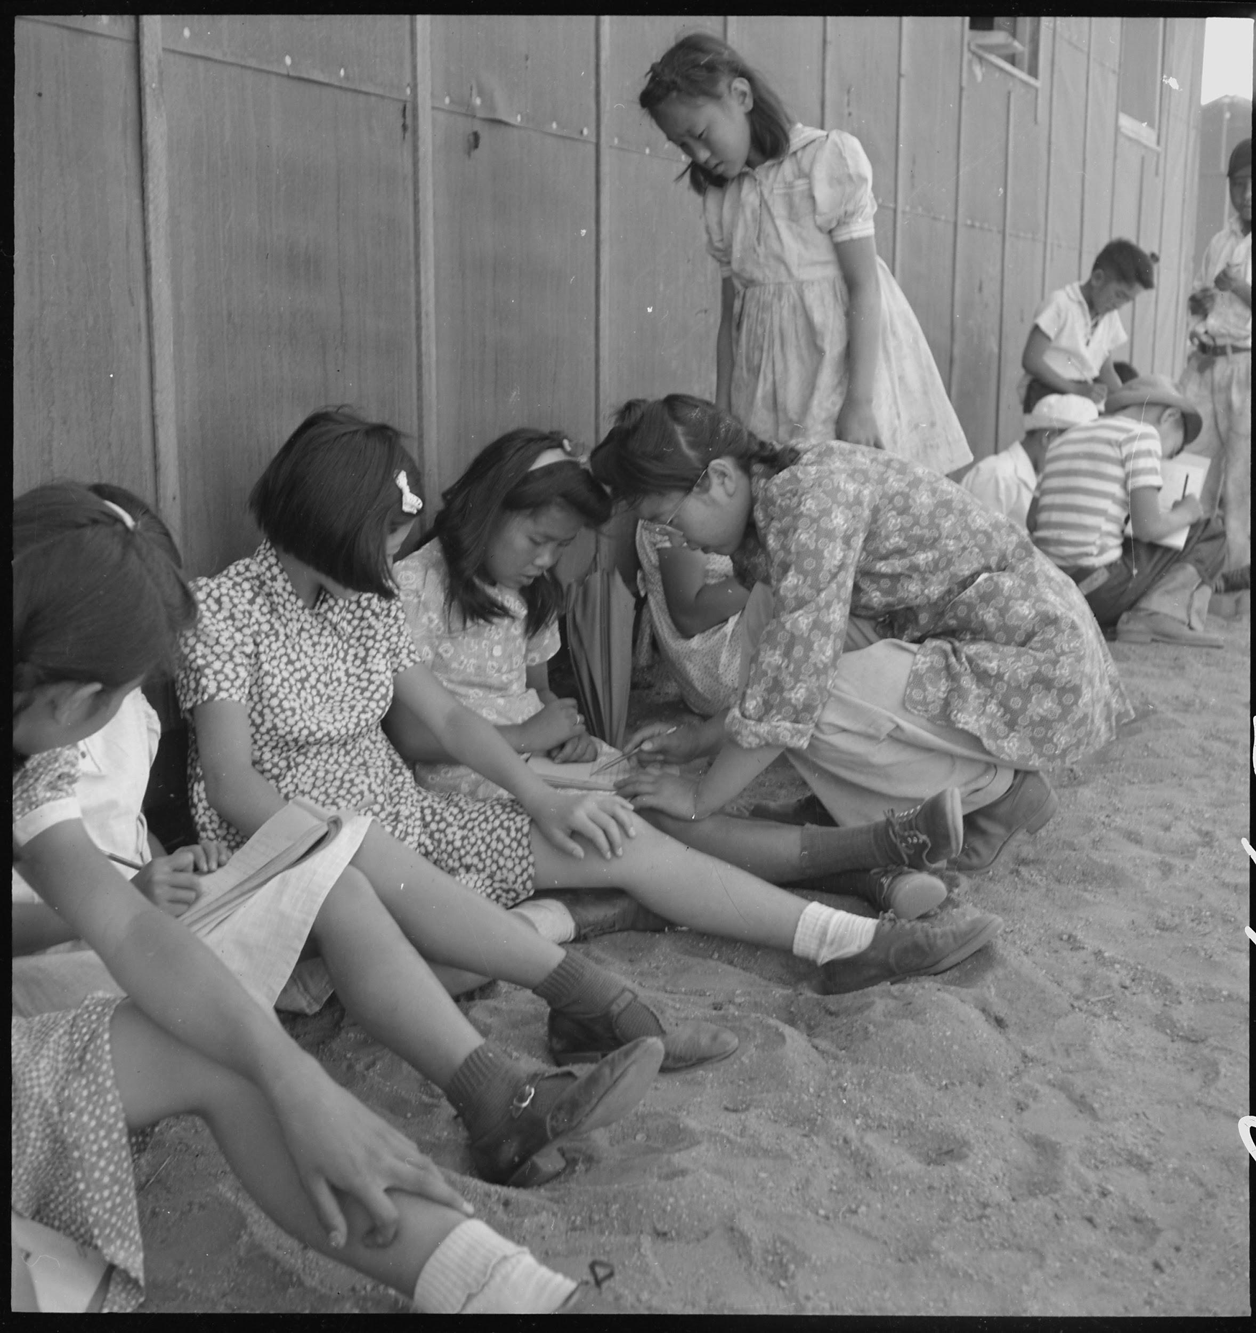
Lange’s Caption: Manzanar Relocation Center, Manzanar, California. An elementary school with voluntary attendance has been established with volunteer evacuee teachers, most of whom are college graduates. No school equipment is as yet obtainable and available tables and benches are used. However, classes are often held in the shade of the barrack building at this War Relocation Authority center. 1942.
https://catalog.archives.gov/id/537962

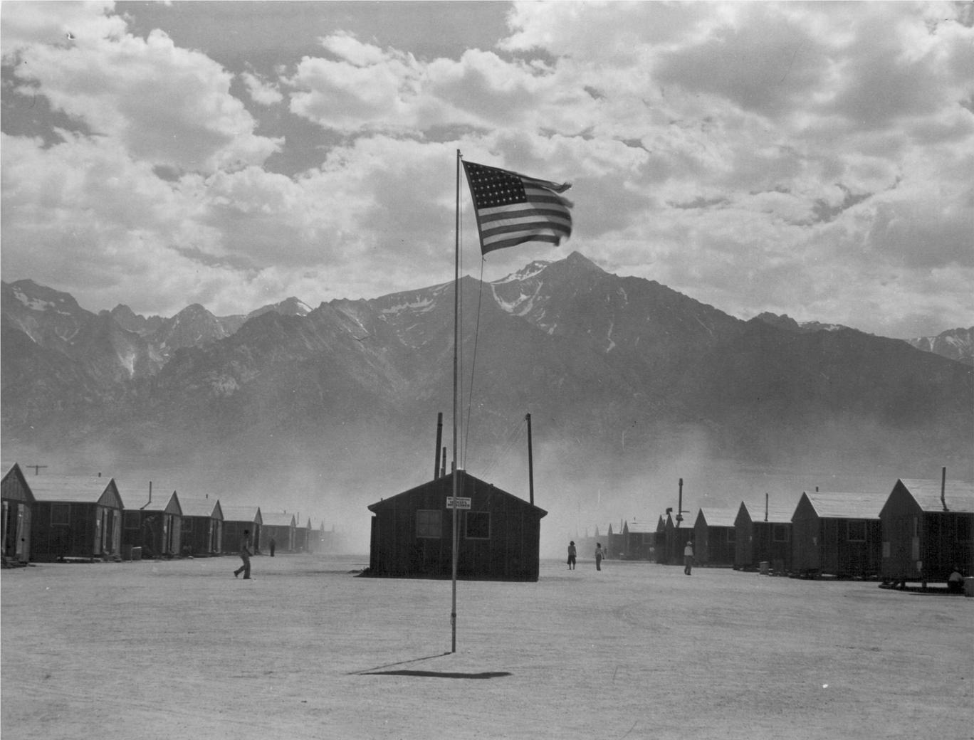
Lange’s Caption: Manzanar, California. Dust storm at this War Relocation Authority center where evacuees of Japanese ancestry are spending the duration.
https://catalog.archives.gov/id/539961

Directions: While thinking about the Dorothea Lange photographs, also think about the parts of “Prisoner in My Homeland” you have already played. Record your observations about life in Manzanar Prison Camp in the chart. You may record more than one observation in each box.

Dorothea Lange | What does the source reveal about life in Manzanar? [Hint: In the photos, consider the artist’s perspective, the framing of the image, the featured subject or activity, the tone of the image, the movement of people, people’s expressions, caption text, etc.]
Medical Care
School in Prison
View of the Buildings and Surrounding Environment

Review the photographs and your recorded observations. What do you think Dorothea Lange was trying to record with her photographs? What was her goal?

Ansel Adams Photographs of Manzanar

Directions: Read the text below and examine the Ansel Adams photographs documenting life in Manzanar Prison Camp.
Ansel Adams (1902-1984), America's most well-known photographer, documented the Manzanar War Relocation Center in California and the Japanese-Americans imprisoned there during World War II.
Adams' Manzanar work is a departure from his signature style landscape photography. Although a majority of the more than 200 photographs are portraits, the images also include views of daily life, agricultural scenes, and sports and leisure activities. When offering the collection to the Library of Congress in 1965, Adams said in a letter, "The purpose of my work was to show how these people, suffering under a great injustice, and loss of property, businesses and professions, had overcome the sense of defeat and dispair [sic] by building for themselves a vital community in an arid (but magnificent) environment....All in all, I think this Manzanar Collection is an important historical document, and I trust it can be put to good use."
Analyzing Photographs of Ansel Adams
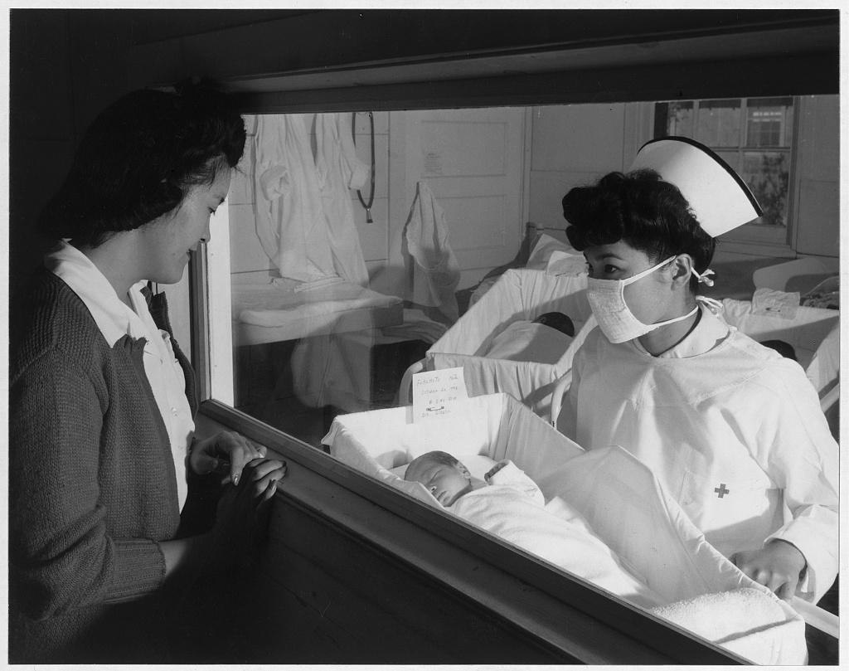
Nurse Aiko Hamaguchi, mother Frances Yokoyama, baby Fukomoto, Manzanar Relocation Center, California / photograph by Ansel Adams. 1943. https://www.loc.gov/resource/ppprs.00343/
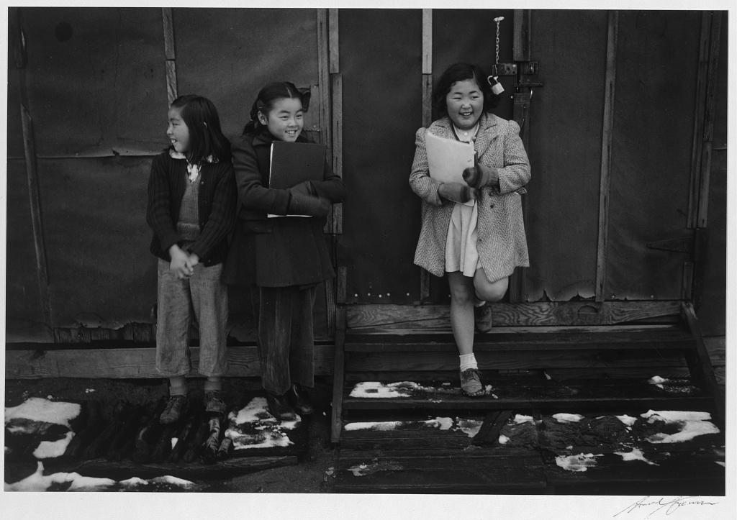
School children, Manzanar Relocation Center, California / photograph by Ansel Adams, 1943
https://www.loc.gov/resource/ppprs.00357/

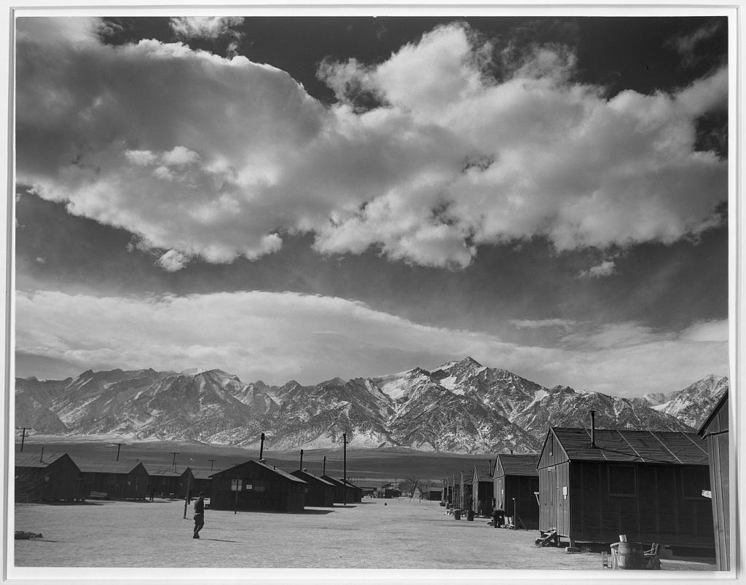
Manzanar street scene, clouds, Manzanar Relocation Center, California / photograph by Ansel Adams, 1943.
https://lccn.loc.gov/2002695966
Directions: While thinking about the Ansel Adams photographs, also think about the parts of “Prisoner in My Homeland” you have already played. Record your observations about life in Manzanar Prison Camp in the chart. You may record more than one observation in each box.
Ansel Adams | What does the source reveal about life in Manzanar from the perspective of an outsider (Adams) documenting life in a prison camp? [Hint: In the images, consider the artist’s perspective, featured subjects or activities, the tone of the images, the movement of people, people’s expressions, caption text, etc.]
Medical Care
School in Prison
View of the Buildings and Surrounding Environment

Review the photographs and your recorded observations. What do you think Ansel Adams was trying to record with his photographs? What was his goal?

Compare and Contrast
Directions: Review the information you recorded in your Dorothea Lange and Ansel Adams charts. Use the Venn diagram to list the similarities and differences between the way the two artists documented Manzanar.
Culminating Questions:
- What are the differences you see in the set of photos?
- Dorothea Lange and Ansel Adams were both commissioned by the United States government to photograph the living conditions of Manzanar Prison Camp. Lange’s photographs were not released until World War II ended. Why do you think the government did this?
Extension Activity:
Write a short story from the perspective of Henry Tanaka that he might tell his grandchildren (born after WWII) about life at Manzanar. How would he describe arriving there? How would he describe the living conditions, daily life, and how it felt to be imprisoned.
A NOTE TO THE EDUCATOR:
On the following pages, you will find “flashcards” with terms and definitions (both combined and separate) that your students may encounter while playing Part 1 of “Prisoner in My Homeland.” These terms and definitions can be introduced and practiced before or during the time students see or hear them in the context of Mission US or in their American history study. The discussion questions and writing prompts will provide further opportunities for students to have more practice with the words and terms.

Divide your students into small groups of four or five, and ask each group to review the terms and definitions.

barbed wire  A variety of metal fencing wire made with sharp points or edges along the top of the fence. It is often used to secure property.  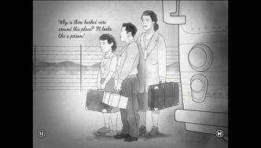 | barracks  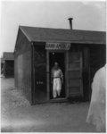  Simple or primitive buildings (or a group of buildings) often built to house military personnel.
block building  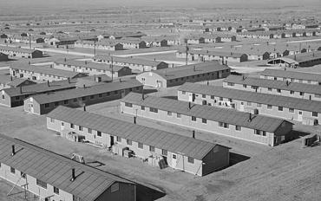  Manzanar was arranged like a military camp. Building 15 in each block was an open barrack used for meetings and events. | FBI  The Federal Bureau of Investigation is a national intelligence organization focused on security, intelligence gathering, and law enforcement.
harvest  The process of collecting crops that are ready to eat or sell.  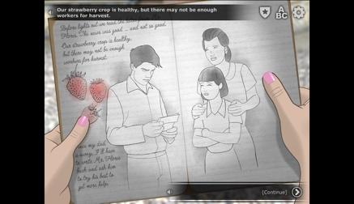 | hick  A derogatory term used to describe someone who is from a rural location (“the country”).
JACL  Japanese American Citizens League; a political organization that advocated for the interests of Nisei (second-generation Japanese Americans). | latrine  A communal toilet used at a camp or military barracks.  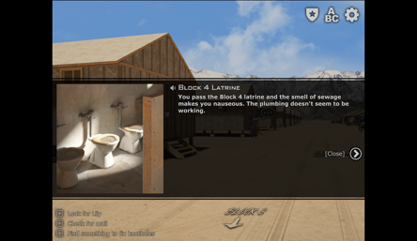
mess hall  A building or room built for military personnel to eat and socialize.  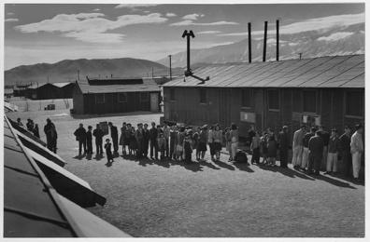 | Pullman train  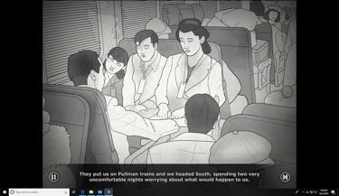  Refers to the dining or sleeper train cars built and run on many railroads by the Pullman Company  from 1867 to 1968.
supervisor  A person who oversees or manages other workers.  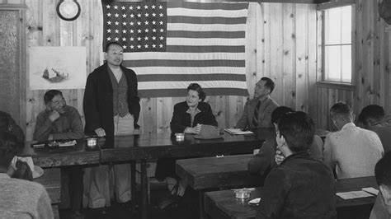 | tar paper  A strong, durable paper most often used in housing construction.  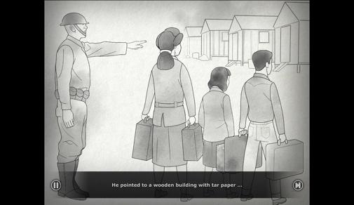

barbed wire  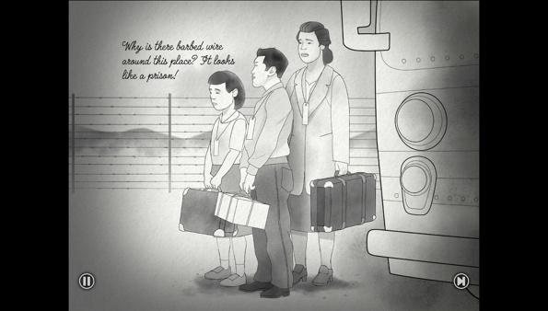 | barracks
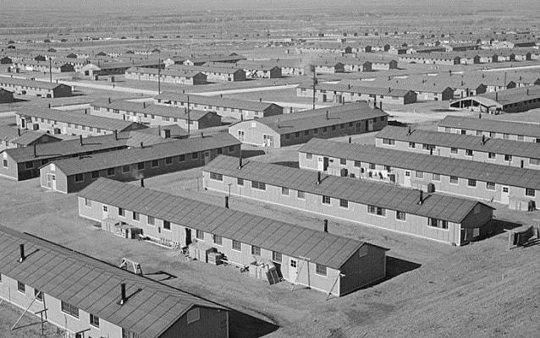  block building | FBI
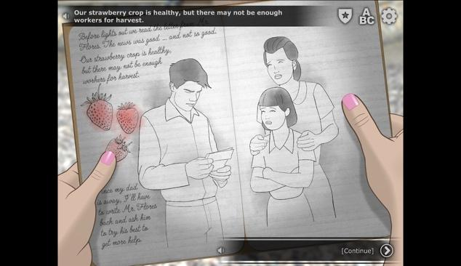  harvest | hick
JACL | 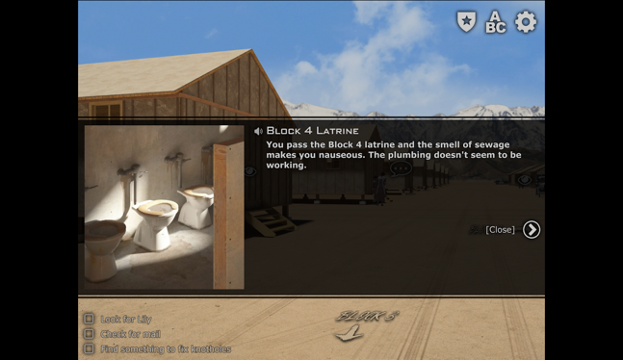  latrine
mess hall  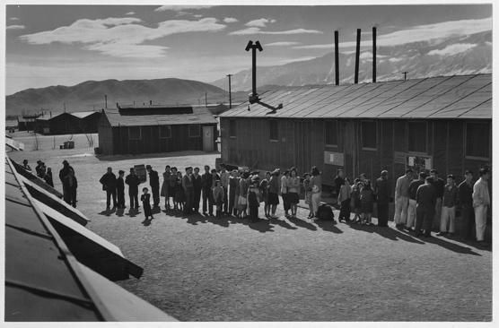 | 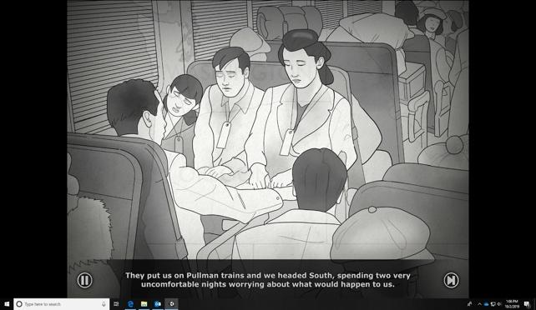  Pullman train
supervisor | 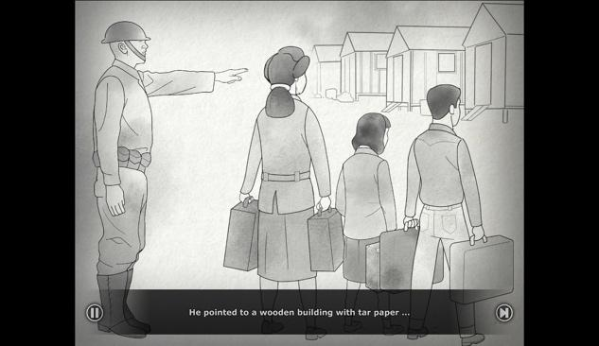  tar paper

A variety of metal fencing wire made with sharp points or edges along the top of the fence. It is often used to secure property. | Simple or primitive buildings (or a group of buildings) often built to house military personnel.
Manzanar was arranged like a military camp. Building 15 in each block was an open barrack used for meetings and events. | The Federal Bureau of Investigation is a national intelligence organization focused on security, intelligence gathering, and law enforcement.
The process of collecting crops that are ready to eat or sell. | A derogatory term used to describe someone who is from a rural location (“the country”).
Japanese American Citizens League; a political organization that advocated for the interests of Nisei (second-generation Japanese Americans). | A communal toilet used at a camp or military barracks.
A building or room built for military personnel to eat and socialize. | Refers to the dining or sleeper train cars built and run on many railroads by the Pullman Company  from 1867to 1968.
A person who oversees or manages other workers. | A strong, durable paper most often used in housing construction.

Name: _______________________ Date:_________________________

DIARY ENTRY ACTIVITY

Write a diary entry that Henry Tanaka would have written based on Part 1 of “Prisoner in My Homeland,” by completing the sentence prompts below. Describe how he would feel or wonder about the following situations:

- how Henry Tanaka’s family was split up and then forced to move to Manzanar
- what the living conditions were like
- the role of the Japanese American Citizens League (JACL) within the prison camp and how some people viewed them

The following vocabulary words from the flash cards should be used::
- FBI
- Pullman train
- barbed wire
- tar paper
- latrine
- barracks
- mess hall
- supervisor
- block building
- JACL

Sentence Prompts:

I can’t believe Dad isn’t with us and that so many other fathers were taken away too…

After packing up only what we could carry we were forced to move…

When Mom, Lily, and I arrived at Manzanar we couldn’t believe the conditions we had to live in…

It was interesting learning about Mr. Yamamoto being a block supervisor and talking to Harry Ueno and others about that organization…

A NOTE TO THE EDUCATOR: You will need to decide how best to share these writing prompts with your students. You might share them all and ask students to choose one for response. You might assign one or more to the entire group. You might make one or more of the topics the basis for in-class discussions. Make your decisions according to the needs of your group.

You may notice that many of the topics contain some version of the phrase, “Write about a time in your life...” The intention of these prompts is twofold: first, since students remember the content of their own lives, they can more easily respond to the questions and they are more likely to want to express themselves if they feel competent to do so; second, these questions can form a meaningful bridge between what happens in the lives of ordinary people today and the lives of people in history or in historical events themselves. For these reasons, you might decide to use some of those prompts before students encounter the history because thinking about them sets the students up to understand it and to relate to it.

Since students vary in their degree of comfort and skill in writing, you should decide when students write and how much students should write. We do suggest, though, that since students need to share their writing with each other to make personal and historical connections, you encourage them to focus on content rather than on mechanical skills. Pieces can be revised and edited later if you decide they should be shared more formally (such as on a bulletin board or newsletter).

Read through all the topics. Then choose one of them to write about. Write the title of the piece at the top of your page. Write in complete sentences. After you are finished, proofread your work for correctness.

NEW HOME. [This prompt should be given prior to playing Part 1]
If you had to move to a new home and neighborhood what would you be most concerned about? What would you definitely need to live comfortably? Why?

WRONGFULLY BLAMED.
The Tanaka family was among 120,000 Americans of Japanese descent who were seen as potential enemies of the U.S. during WWII even though no one was ever found guilty. How would you feel if anyone of your cultural background were blamed for something that happened to the U.S. and was forcibly moved and imprisoned in the same way that Henry was? What would you have done in this situation? Why?

TAKING ON MORE RESPONSIBILITIES.
Henry suddenly took on more responsibilities with his family when his father was imprisoned elsewhere and he and the rest of his family were imprisoned in Manzanar. He often had to make choices between doing things for himself or his family. What responsibilities do you have within your family? How do they compare to what Henry had to do for his family?

“FREELY” ROAMING.
Lily and other children were able to roam around on their own more within prison camps like Manzanar. What were the positive and negative effects of Lily being able to go off on her own? What do you think are the effects of being able to live this way as a young child? What are you allowed to do on your own? Are you obligated to tell your parents/guardians about your whereabouts? If so, in what type of situations?

DIFFERENT COMMUNITIES COMING TOGETHER.
Soon after Henry arrives at Manzanar, he meets people from California with different backgrounds and life experiences, customs, cultures, etc. At times, it’s difficult for him to navigate the differences. For many students who start at a new school (middle or high school), the process of acclimating to a new school can be hard. When you started middle school, did you feel as though you needed to change or conform to the attitudes of a larger group with students from other schools? What differences did you see with students from other schools? Were there conflicts? If so, how were they resolved?
EARNING YOUR WAY.
Henry was able to have a job and earn a little bit of money while he was imprisoned, and had some choices in what to buy. If you were able to earn money from anyone, whether it’s a job or not, what would you buy and why? How does this compare to the types of decisions Henry had to make for the money he earned?
A NOTE TO THE EDUCATOR:

The purpose of these questions is to check the students’ understanding of the action of the game and the history embedded in that action. Since the outcome of gameplay can vary depending on the choices the student makes, the answers to the questions may also vary.

Some students might learn information from the game later than others, or not at all. If you choose to discuss responses as a whole group, information can be shared among all your students.

There may be more questions here than you want your students to answer in one sitting or in one evening. In that case, choose the questions you feel are most essential for their understanding of Part 1.

Feel free to copy the following pages of this activity for your students.

If you are not planning to have your students write the answers to the questions, you’ll need to modify the directions.

Name: _______________________ Date:_________________________

Directions: After you play Part 1: Behind Barbed Wire, read and answer the following questions from the point of view of your character, Henry. You may not know all the answers, so do the best you can. Write in complete sentences and proofread your work.

- How did the Tanakas travel from Bainbridge Island to Manzanar?

- As you approached Manzanar, what did you see outside the window of the bus?

- What were the first things your family did when they arrived at Manzanar?

- What did you do as you waited in line at the Post Office? What did you learn while at the Post Office?

- What letters did you pick up from the Post Office?

- Who is Henry Ueno? What did you learn about his background?

- What materials do you use for plugging up the holes in your barrack flooring? How did you find them?

- What are the weather conditions like at Manzanar?

- What happened to your sister, Lily? What did you discover she was doing?

- What news did you get from Mr. Flores in the letter?

- On this day, you try to find a new job. Write down the job that you selected and what you did with your earnings.

Name: _______________________ Date:_________________________

Directions: After you play Part 1: Behind Barbed Wire, read and answer the following questions from the point of view of your character, Henry. You may not know all the answers, so do the best you can. Write in complete sentences and proofread your work.

- How did the Tanakas travel from Bainbridge Island to Manzanar?
The Tanakas traveled on Pullman trains for two nights. Then, they transferred to a bus.

- As you approached Manzanar, what did you see outside the window of the bus?
They saw only the desert and mountains.

- What were the first things your family did when they arrived at Manzanar?
We talked to a guard to get their block number. We filled our mattresses with straw.
We found out that the latrines are still under construction. We met a family, the
Yamamotos, who we will share a barrack with.

- What did you do as you waited in line at the Post Office? What did you learn while at the Post Office?
You read The Manzanar Free Press, a newspaper that you got from someone in the line.
You read about a dance, an “I am An American” Day, church services, and a comic.
You get learn the U.S. attacked Japan for the first time.

- What letters did you pick up from the Post Office?
You get a letter from Mr. Flores but nothing from your father.

- Who is Henry Ueno? What did you learn about his background?
He is from Terminal Island, a neighborhood in Los Angeles. Terminal Island was targeted
by the FBI. He was born in Hawai’i and educated in Japan.

- What materials do you use for plugging up the holes in your barrack flooring? How did you find them?
You get advice from Henry Ueno collect tin can lids from the Mess Hall.
Tadashi from the Mess Hall gives you the lids, after some convincing.

- What are the weather conditions like at Manzanar?
It is very windy and dusty.

- What happened to your sister, Lily? What did you discover she was doing?
She was watching bus arrivals, looking for your father.

- What news did you get from Mr. Flores in the letter?
The strawberry crop is healthy but there aren’t enough workers to harvest them.
Clark, your dog, is doing good!

- On this day, you try to find a new job. Write down the job that you selected and what you did with your earnings.
You can work at the mess hall to make meals; working making camouflage nets for the
army; or plant vegetables for the camp.
With your earnings, you can send money home to keep the farm going, buy war savings
stamps, buy something from the Sears, Roebuck and Co. catalog, or purchase a new
judogi for practicing judo.

FOR REFERENCE:
https://digitalassets.lib.berkeley.edu/jarda/ucb/text/cubanc_35_1_00259305ta.pdf
p.62 - letter mentioning literary awards of high school students Kaizo Kubo and Ruth Tanaka
p.63 - poem “Saga of a People”
P.66 - essay “The Years Between”

Finding a Way | Student Reflections on Being a Prisoner

Instructions

A NOTE TO THE EDUCATOR: This activity is best used after students have played Part 2 of the game.

Teenagers were able to express themselves through school assignments and personal diary entries. Schools were created in prison camps, but they were vastly different from schools outside of camps. They were in shoddy conditions with no heat and not enough furniture. Educational resources were limited and school was not consistently in session. Nevertheless, students had the opportunity to learn in these schools and even get their writing submitted to national contests. Two of the documents in Part 2 are pieces of literature written by high school students that were submitted into the Scholastic Magazine national contest and won awards.

This activity represents students’ perspectives on the incarceration experience during World War II, which are exhibited through a variety of literary forms: an essay, poem, and diary entry. Through the eyes of these teenagers, students will understand how Japanese Americans were treated. They will also gain an understanding of how teenagers reacted and coped with being in prison camps.

Steps to Complete
The following procedure is recommended for this activity and can be adapted based on your curricular goals and timing constraints:
- Distribute primary source document(s) to students.
- Have students work independently or in small groups to investigate the document(s) with the goal of learning how teenagers reflected on their experiences.’

- Assign students or student groups any or all of the guided questions that accompany each document.
- Review the answers to the guided questions through a whole class discussion.
- Instruct students to use the essay by Kaizo Kubo and the poem “Saga of a People” by Ruth Tanaka to complete the handout, “Youth Reflections on Mistreatment in Prison Camps.”
- Project or distribute the handout, “Create a Flyer for the Prison Camp Newspaper.” Tell students to use all the documents they have analyzed through these steps to create the flyer.
- Have students do a gallery walk to view their classmates’ flyers. Conduct a class discussion to reflect on how helpful this may have been for incarcerees in the prison camps.

Document 1 - Essay: “The Years Between” by Kaizo Kubo
Kaizo was a high school junior at Poston Incarceration Camp in Arizona and won honorable mention for this essay in a national contest sponsored by Scholastic Magazine in 1945. This was printed in the Poston Chronicle.

My name is Kaizo Kubo. I have a story to tell. It concerns three years of my past, years which will no doubt leave their marks on me to the end of my days. My name probably sounds strange, foreign; so will my story.
I am American, although for the last three long years I have been so in name only. I am writing these very words behind the shadows of barbed wire. I’ve done no wrong. My only crime is that my hair is black, my skin yellow, my eyes slant; because I am of Japanese ancestry. This is my personal account of prejudice and of human blindness. This is a plan for future justice and tolerance.
I was born in a small town in California not far from the Pacific Ocean. If not for an unfortunate quirk of fate, I would in all probability have never stirred from the scene of so many happy memories. That black day I read the news in the daily papers left me momentarily paralyzed. I stared in mute incredulity at the words emblazened in bold print: GOVERNMENT ORDERS MASS REMOVAL OF ALL JAPANESE FROM COAST HOMES TO INLAND WAR CENTERS.
I took it hard. It meant leaving the only life I knew, parting with my boyhood friends. It spelled goodbye to life. Was this what I had believed in? Was this democracy?
In the ensuing weeks I was spared little time to brood or to think. In the upheaval that followed, we lost our home. Our belongings were either discarded or at best sold at pitiful losses. Before my very eyes my world crumbled.
From the instant I stepped into the barbed wire enclosures of our destinantion, I felt that queer alienable presence within me. All the rash bravado I had saved for this precise moment vanished like a disembodied soul. I suddenly felt incredibly small and alone. So this was imprisonment.
The oppressive silhouette of the guard towers looming cold and dark in the distance affected me in only one way. They seemed to threaten, to challenge me. I hated their ugly hugeness, the power they symbolized. I hold only contempt for that for which they stand. They kept poignantly clear in my mind the unescapable truth that I was a prisoner.
Then my life as an evacuee began, with a government granted broom, a bucket, and a twelve by twenty foot room. We were quartered in converted horse stables which fairly reeked with evidence of recent occupation. Men, women, and children shared these discomforts alike. I learned to eat with strangers, to wash and bathe side by side with unfamiliar faces, and I learned that to hear and not be heard was the best or at least the most healthful policy to follow.
At first I was inclined to think my imagination was provoking the well of silence that seemed to shroud my being, but it was real, as real as evacuation itself. An incomprehensible air of tension hung over the confines of the entire center. Twenty thousand souls brooding. It was not pleasant. The next abruptly discernable phase was a lifting of the silence and in a surprisingly short time, the atmosphere had changed to a noisy, equally unpredictable show of human emotions. Camp life is like that - uncertain.
Three years of a hard existence behind steel and armed guards, no matter what the conditions, cannot go without its ill effects. Our family, like most Japanese families prior to evacuation, was very alone. Today, after three years of communal living, I find myself stumbling over words as I make vain attempts to talk to my father. I don’t understand him; he doesn’t understand me. It is a strange feeling to find such a barrier between my father and myself.
The fixed routine existence offers little incentive for progress; homes, a gradual loss of individual enterprise and initiative is in evidence. I have undergone a similar period of lethargy myself. It is like living in a realm of forgotten people. It was a strange and disturbing malady developed under unusual circumstances, but I overcame it, and with the restoration I won back my faculty of logical and clear thinking.
Here is what I say: there is no need to be bitter. We are situated thus through no fault of our own, but there is nothing to gain by eternally brooding for things that might have been. I have exacted lessons from my past which I hope to put to advantage in my future.
I shall be on my own. It will be no new experience for me. Evacuation was a pioneering project; re-establishing myself into the American stream of life can be looked upon as another such enterprise. Now I stand on the threshold of freedom. I face the future unafraid, proud of my ancestry, but even prouder of my heritage as an American.

--Kaizo Kubo
Honorable Mention
Scholastic Literary Contest

Guided Questions:
- What marks do you think Kaizo is referring to when he says that “...years which will no doubt leave their marks on me to the end of my days?”

- What does Kaizo mean by being “an American in name only”

- What is the “crime” that Kaizo is saying he committed? Why does he think he “did no wrong?”

- Why did Kaizo take the forced removal of Japanese Americans so hard?

- What were his initial thoughts and experiences when he first arrived at the prison camp?

- How did Kaizo adjust to life in the prison camp?

- How did the incarceration affect Kaizo’s relationship with his family?

- What do you think Kaizo means by “living in a realm of forgotten people?”

- How does Kaizo believe Japanese Americans should cope with this situation? Why?

- How was Kaizo ultimately affected by his situation in a Japanese American prison camp?

Document 2 - Poem: “Saga of a People” by Ruth Tanaka
Ruth was a high school junior at Poston Incarceration Camp in Arizona and won fourth prize for a national contest sponsored by Scholastic Magazine in 1945. This was printed in the Poston Chronicle.

Stanza 1
They have sprung from a race as old as Time,
Their backs are bent, their hands are wrinkled and brown,
For they have toiled long years under a harsh master—Life;
Each passing year has left its mark
Upon their seemed and weathered faces
That show as other faces do,
A heart-deep yearning for a far-off land;
A land of frail houses, stunted trees, a sacred volcano
Sleeping under a blanket of snow.
Traces of half-forgotten customs
A love for the life-giving sun, the freshening rain, the deep brown soil,
Still lingers in their hearts.
Deep scars of pain and grief are etched on their worn faces
And yet their wise twinkling eyes
Have looked on life and found it good.

Stanza 2
They have come to a fabulous land,
While still dreaming the long thoughts of youth;
They have sowed their seeds, weeded furrows,
Hoed a sun-parched land, watered it and nursed it,
Harvested their plentiful crops, built a home
And borne their children.
Lest they forget the islands of their fathers,
They have brought their little treasures with them -
A miniature chest of drawers, lacquered dragon-red;
Two dainty fans gay with dancing girls;
A bamboo screen with a tiny arched bridge
A fragile lilies reflected in still water;
Little dolls in bright kimonos of hand-painted silk;
Delicate tea cups get on a polished tray.
Stanza 3
The seeds they sowed took root and sprouted;
Grew tall and straight with bursting pods;
Giving rich promise of fulfillment.
So grew their black-haired children
Straight and tall, drawing nourishment from the free soil
Of this, their native land.
Their lives were like a deep, peaceful river
The old familiar customs of their ancestors
Mixing with the new bewildering ones of their foster country
And slowly giving way before them
Eating a breakfast of crisp bacon and scrambled eggs
Instead of the hot soup and rice they had eaten
In the home of their fathers;
Raising a huge paper carp on Boys’ Day;
Awkwardly tying a silver star to the tip of the family Christmas tree;
Reluctantly going to a movie with the children,
Leaving behind a friendly game of Go
And a cup of steaming, green tea;
Driving to the beach and learning to roast hot dogs
Over a driftwood fire,
And eating them with seed-covered rice cakes;
Passing on to their children the ceremonious courtesies
That they had learned so long ago.
And so they lived out their lives
Guided by their sons and daughters
Through this strange new world,
Slowly changing their deep-rooted ways.

Stanza 4
They have come to a new home
Living in a single room
Behind barbed wire -
They know that peace has been shattered throughout the world
By heavily laden bombs of terror and destruction;
But they who love the deeply tranquil soil
Are stunned, bewildered by it all,
By the cold wall which their American friends
Have built about them.
Stanza 5
Now they are standing on the beloved soil of their Western mother,
Their wizened bodies huddled together
Against the bitter cold.
Rising they look toward the sea
Vainly striving through the mists of the past
To live again the dreams of their youth,
Thinking of a pleasant land where cherry blossoms
Warmed their hearts in spring,
Where placid goldfish lazily swam in sunny ponds,
Where all the contented and peaceful;
They turn towards the red glow of a sinking sun
Seeing through the distant hills, seeing over all the land
The rolling hills and valleys of their western mother.
Then they turn towards each other with eyes full,
Unshamedly,
Understandingly;
For deep in their almond, brown eyes,
Deep in the innermost depths of their souls (?)
There shall always glow a hope,
A hope that peace shall come one day
A peace forging with understanding and friendship,
The islands of their long-lost youth
And the far stretching land of their children’s birth.

Guided Questions:
- Who are the people that Ruth Tanaka are referring to?

- What are they reminiscing about and longing for?

- How were their lives like a “deep, peaceful river” mixing the old and the new?

- How do the experiences and emotions conveyed in the poem relate specifically to Japanese immigrants? How may this relate to immigrants from other regions?

- How does the “new home” described in Stanzas 4 and 5 compare to their lives before they were imprisoned as well as before they came to the U.S.?

- Despite their imprisonment, the people of the poem hold on to a hope for the future. What may have helped the imprisoned Japanese Americans described in this poem to find hope?

Document 3 -Stanley Hiyami Diary Entry Analysis: “January 1, 1943”

Transcription of “January 1, 1943” Diary Entry:
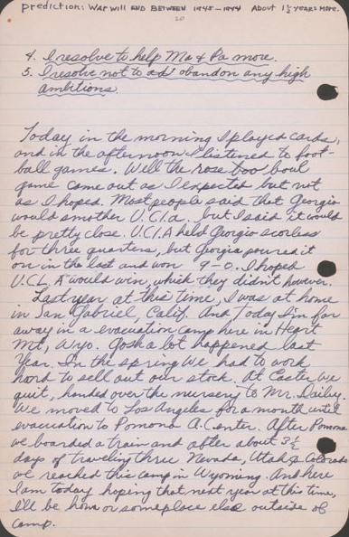
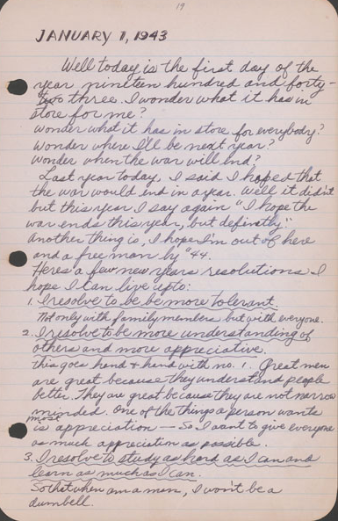

http://www.oac.cdlib.org/ark:/13030/tf338n99cz/?brand=oac4
http://www.oac.cdlib.org/ark:/13030/tf8h4nb342/?brand=oac4

JANUARY 1, 1943

Well today is the first day of the year nineteen hundred and forty three. I wonder what it has in store for everybody? Wonder where I’ll be next year? Wonder when the war will end?
Last year today, I said I hoped that the war would end in a year. Well it didn’t but this year I say again “I hope the war ends this year, but definitely.”
Another thing is, I hope I’m out of here and a free man by ‘44.

Here’s a few more New Years resolutions I hope I can live up to:

- I resolve to be more tolerant.
Not only with family members but with everyone.
- I resolve to be more understanding of others and more appreciative.
This goes hand & hand with No.1. Great men are great because they understand people better. They are great because they are not narrow minded. One of the things a person wants most is appreciation - so I want to give everyone as much appreciation as possible.
- I resolve to study as hard as I can and learn as much as I can.
So that when [I] am a man, I won’t be a dumbell.
- I resolve to help Ma & Pa more.
- I resolve not to abandon any high ambitions.

Today in the morning I played cards and in the afternoon I listened to football games. Well the [R]ose [B]owl game came out as I expected but not as I hoped. Most people said that Georgia would smother UCLA but I said it would be pretty close. UCLA held Georgia scoreless for three quarters, but Georgia poured it on in the last and won 9-0. I hoped UCLA would win which they didn’t however.

Last year at this time, I was at home in San Gabriel, Calif. And today I’m far away in an evacuation camp here in Heart Mt. Wyo. Gosh a lot happened last year. In the spring we had to work hard to sell out our stock. At Easter we quit, handed over the nursery to Mr. Dailey. We moved to Los Angeles for a month until evacuation to Pomona A. Center

Guided Questions:
- Why do you think Stanley wonders about what is in store for everybody in the future? Why is he so concerned about wanting the war to end?

- Considering that Stanley is imprisoned with thousands of other Americans of Japanese descent in a confined space, why do you think he makes the resolutions listed above?

- How do you think Stanley's resolutions could make life in the prison camp more bearable?

Youth Reflections on Mistreatment in Prison Camps

Use the essay by Kaizo Kubo, the poem “Saga of a People” by Ruth Tanaka, and/or the diary entry of Stanley Hiyami to draw a scene that indicates how they felt about being imprisoned or their mistreatment in prison. Illustrate how they were coping with life in the prison camp.

CREATE A FLYER for the Prison Camp Newsletter

Japanese Americans were allowed to have their own news media in incarceration camps like Manzanar. The camp newspapers and newsletters helped keep prisoners informed and occupied by providing reports about what was happening in other camps, listings of events and opportunities for their daily lives, as well as administrative announcements and orders.. Literature and art were also printed in newspapers.

Example: cover of a booklet created by incarcerees for a newspaper

Based on the essay by Kaizo Kubo, the poem “Saga of a People” by Ruth Tanaka, and/or the diary entry of Stanley Hiyamai, create a message showing how these teenagers may have motivated or encouraged others in the prison camps. Complete the following on a blank sheet of paper:

- Create a slogan that summarizes their message and write this in large lettering. Think about how people might be having a hard time with the changes they’ve had to endure ever since becoming prisoners.
- Write a short paragraph or make a list of what people can specifically do to cope with their situation.
- Draw a picture or symbol that summarizes this message.

A NOTE TO THE EDUCATOR:
On the following pages, you will find “flashcards” with terms and definitions (both combined and separate) that your students may encounter while playing “Prisoner in My Homeland.” These terms and definitions can be introduced and practiced before or during the time students see or hear them in the context of Mission US or in their American history study. The discussion questions and writing prompts will provide further opportunities for students to have more practice with the words and terms.

Divide your students into small groups of four or five, and ask each group to review the terms and definitions. After your students have had a chance to review and discuss the terms and definitions, distribute the excerpt from an imagined talk between Maya Tanaka and a class of middle school American history students.

Review the directions with your students, and ask them to complete the text using the terms they studied. Here is the order in which the vocabulary terms should be inserted into the blanks within Maya’s talk with students:

sensei
ganbari nasai
draft
WRA
enlist
rations
shikata ga nai
Tule Lake

draft  The selection of men who are required to serve in their country's military. | enlist  Volunteer to serve in the military.
ganbari nasai  You must do your best. | Kanō sensei  Teacher Kanō Jigorō, founder of judo.  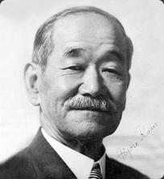
nikyū  The second highest of the six student skill ranks in judo.  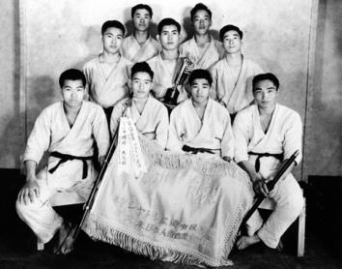 | randori  Freestyle practice with an  opponent in judo.  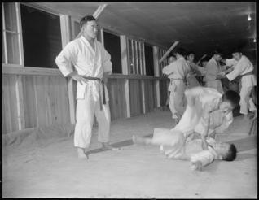
rations  The specific limited quantities of goods, such as sugar, that the federal government allowed civilians to use each week during the war. | sensi  Teacher.
shikata ga nai  It is best to accept things that cannot be helped. | shodan  First (lowest) of the ten black belt skill ranks in judo.  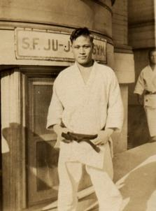
Tule Lake  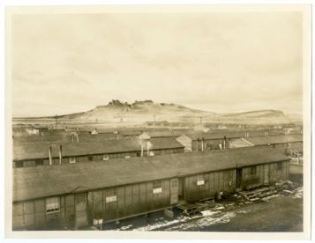  Location of a prison camp that became a "segregation center" for Japanese Americans who gave "incorrect" responses to the government's loyalty questions. | waza  Techniques used in judo, such as holds or throws.
WRA
The War Relocation Authority –
a federal agency created by President Roosevelt in 1942 to run the detention facilities for Japanese Americans.

draft | enlist
ganbari nasai | Kanō sensei  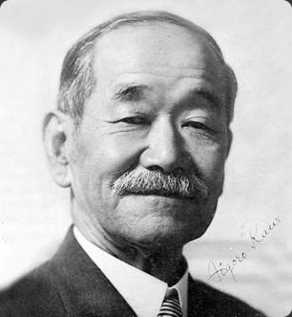
nikyū  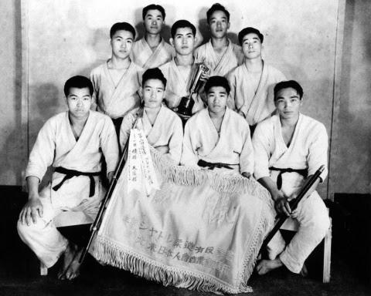 | randori  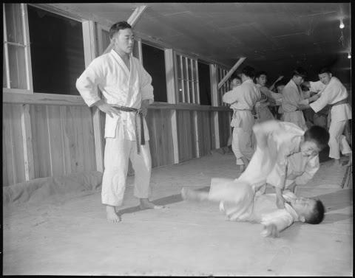
rations | sensi
shikata ga nai | shodan
Tule Lake  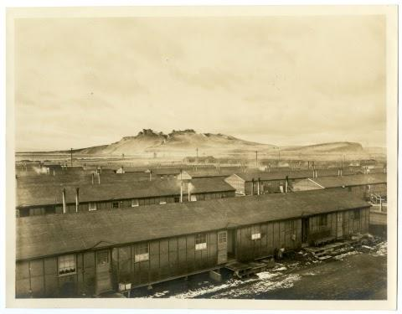 | waza
WRA

The selection of men who are required to serve in their country's military. | Volunteer to serve in the military.
You must do your best. | Teacher Kanō Jigorō, founder of judo.
The second highest of the six student skill ranks in judo. | Freestyle practice with an  opponent in judo.
The specific limited quantities of goods, such as sugar, that the federal government allowed civilians to use each week during the war. | Teacher.
It is best to accept things that cannot be helped. | First (lowest) of the ten black belt skill ranks in judo.
Location of a prison camp that became a "segregation center" for Japanese Americans who gave "incorrect" responses to the government's loyalty questions. | Techniques used in judo, such as holds or throws.
The War Relocation Authority –
a federal agency created by President Roosevelt in 1942 to run the detention facilities for Japanese Americans.

Name: _______________________ Date:_________________________

Activity: More than seventy-five years after the events of “Prisoner In My Homeland,” Maya Tanaka, Henry Tanaka’s present-day 20-something granddaughter, is invited to give a talk to a local middle school history class. Maya is telling the class some lesser-known details about life at the prison at Manzanar. The following is a portion of her interactions with the students.

After reading and discussing the words and terms on the flashcards, read this excerpt from her talk with the students, and use your memory to fill in the missing words and terms.
shikata ga nai | Tule Lake | sensei
WRA | enlist | ganbari nasai
draft | rations

Maya Tanaka: Hello class! I’m here today to talk to you about my grandfather, Henry Tanaka. Let me start when Henry was a teenager, around your age. He lived on Bainbridge Island, which is near Seattle, Washington. His family had a farm. He used to regularly practice judo at a dojo. Does anyone know what judo is? Or a dojo?

Student: Isn’t judo a kind of martial art? Like karate?

Maya Tanaka: Yes, that’s correct. Judo is a martial art that originated in Japan. The dojo is a school where martial art students meet and practice. A man named Kanō sensei developed judo. He founded the Judo Institute in 1882. He learned to use his supposed flaws, like being small, to his advantage.

Student: What happens in a judo class?

Maya Tanaka: At the dojo, the person who teaches the class is called a __________. A lot of judo is self-defense through unbalancing your opponent and using creative movement. These techniques in judo are named waza. During a class, you might see two people in their white uniforms practicing their moves, with lots of falling! That’s during the randori, when two judo students face off.

Student: Is there such a thing as a “black belt” in judo?
Maya Tanaka: Yes, there are all kinds of rankings in judo. When a judo student is first starting out, they might be ranked nikyū. And, then, after much dedication to the art and lots of hours in the dojo, they might be ranked a shodan.

Student: Was your grandfather any good at judo?

Maya Tanaka: Henry, my grandfather, was the son of a sensei. So he was very familiar with the kind of time and effort it takes to do judo. Was he any good? I’m not sure! I think he was a pretty enthusiastic learner, though, and always wanted to be top of his game. _______________, is the Japanese way of saying it.

Student: Was he able to keep on doing judo during World War II?

Maya Tanaka: He was! Amazingly, the prisoners at Manzanar, the camp where my family was held, started a dojo. They were able to maintain this art that was important to their culture and community. But things got very tense for them at Manzanar. They needed activities like judo. There was a word of an upcoming __________ of young men to send as soldiers to fight the war.

Student: They wanted to recruit soldiers inside the camp?

Maya Tanaka: Yes, the ______________, the government office that organized these prison camps, made that determination. In fact, they released a questionnaire asking young men if they would swear “unqualified allegiance,” and if they would be willing to _________ as soldiers.

Student: Why would anyone want to volunteer to go to war?

Maya Tanaka: Some Japanese wanted to defend their country. I suppose they still felt America was a place worth fighting for. Even in the face of their families put in prison, eating the limited, often poor food from the government ____________, and dealing with the cold, windy nights. Many shrugged their shoulders and thought, ____________, a Japanese way of accepting difficult situations.

Student: And other people?

Maya Tanaka: Others did not feel the same way. They answered “No,” or had mixed-responses on the questions about their loyalty and being drafted. These people were sent to another camp called _____________. I’ll have to talk to you about this camp another time!
A NOTE TO THE EDUCATOR: You will need to decide how best to share these writing prompts with your students. You might share them all and ask students to choose one for a response. You might assign one or more to the entire group. You might make one or more of the topics the basis for in-class discussions. Make your decisions according to the needs of your group.

You may notice that many of the topics contain some version of the phrase, “Write about a time in your life...” The intention of these prompts is twofold: first, since students remember the content of their own lives, they can more easily respond to the questions and they are more likely to want to express themselves if they feel competent to do so; second, these questions can form a meaningful bridge between what happens in the lives of ordinary people today and the lives of people in history or in historical events themselves. For these reasons, you might decide to use some of those prompts before students encounter the history because thinking about them sets the students up to understand it and to relate to it.

Since students vary in their degree of comfort and skill in writing, you should decide when students write and how much students should write. We do suggest, though, that since students need to share their writing with each other to make personal and historical connections, you encourage them to focus on content rather than on mechanical skills. Pieces can be revised and edited later if you decide they should be shared more formally (such as on a bulletin board or newsletter).

Read through all the topics. Then choose one of them to write about. Write the title of the piece at the top of your page. Write in complete sentences. After you are finished, proofread your work for correctness.

TEACHERS.
During Part 2 of the game, Henry Tanaka is nervous about a history test. He arrives early at school and has a conversation with his teacher, Ms. Nelson, who has newly arrived at Manzanar from Berkeley, California. Henry and Ms. Nelson talk about him going to college and the rising tensions in camp over a potential military draft. Why do you think Henry has such an easy time talking to Ms. Nelson? Have you ever had a teacher that you’ve been able to confide in? Write about an influential teacher in your life. Describe why this teacher was important to you. You might want to write about a teacher who, like Ms. Nelson, supported you during a difficult time.

RESEARCHING A HERO.
As a class assignment, Ms. Nelson assigns an essay about a hero of American democracy as an extra credit assignment. Meiko Yamamoto and Henry go to the library and research Mitsuye Endo. Endo is a Japanese American woman who, like Henry and Meiko, is incarcerated in a camp with her family. Endo is the lead plaintiff in a legal case that will challenge the U.S. government’s decision to imprison its own citizens. Why do you imagine Henry and Meiko are drawn to Endo’s story? If you were assigned the same essay, who would you choose as an American hero? Describe this person’s life, characteristics, and why you consider them to be a heroic person.

TAKING ACTION.
During Part 2, you had the option of helping Harry Ueno research the possible theft of the sugar rations by administrative staff at Manzanar. Harry Ueno asks Henry to go to each of the mess halls and record the sugar deliveries. While Henry finds the task a bit boring, he believes it is one small task he can do to challenge potential wrongdoing in the camp. Consider a time in your own life when you learned about an unfair situation in your school or community. Write about the situation in detail: What made it unfair? Who were the people involved? Finally, describe what you did (or hoped to do) to approach this problem.

REUNION.
In Part 2, Henry reunites with his father, Kinzo Tanaka, who has been under arrest at a Department of Justice prison. What do you think went through Henry’s head when he realized it was his father standing inside of the barrack? What do you imagine it was like for Henry to see his father after a period of separation? Write a first-person essay from Henry’s perspective about reuniting with his father. What are some of his joys? His worries? His hopes for the near future?

JUDO.
In Part 2, Tadashi, a friend of Henry’s at Manzanar, comes by his barrack. Henry and Tadashi then try to recruit Henry’s father, a former sensei in Bainbridge Island’s Japanese Hall, to come to practice judo at the dojo. Kinzo Tanaka is reluctant to go with the two young men. Why do you think that Kinzo protests going? And why do Tadashi and Henry try so hard to get him to accompany them? In your own experience, has a recreational activity such as judo helped you in a challenging time in your life? Write about the benefits of judo in camp for Tadashi, Henry, and Kinzo. Then, write about a sport, hobby, or activity that you pursue outside out of school and work. Discuss the role of this activity in your life and why it is important to you.

ESTABLISHING NORMAL LIFE.
Throughout Part 2, you learn about some of the ways that the prisoners attempt to establish normal routines and activities inside of the prison camp. Henry goes to school, studies for a test, and talks about baseball games. His sister, Lily, has joined the Glee Club and pesters Henry to take her to the camp dance. Why do you think prisoners have gone to such great lengths to re-establish these institutions and activities? Do you think it is possible to experience a “normal” life inside the camp? Why or why not?

A NOTE TO THE EDUCATOR:

The purpose of these questions is to check the students’ understanding of the action of the game and the history embedded in that action. Since the outcome of gameplay can vary depending on the choices the student makes, the answers to the questions may also vary.

Some students might learn information from the game later than others, or not at all. If you choose to discuss responses as a whole group, information can be shared among all your students.

There may be more questions here than you want your students to answer in one sitting or in one evening. In that case, choose the questions you feel are most essential for their understanding of Part 2.

Feel free to copy the following pages of this activity for your students.

If you are not planning to have your students write the answers to the questions, you’ll need to modify the directions.

Name: _______________________ Date:_________________________

Directions: After you play Part 2: Finding a Way, read and answer the following questions from the point of view of your character, Henry. You may not know all the answers, so do the best you can. Write in complete sentences and proofread your work.

- In your letter to your dad, what did you tell him about the prison camp?

- When you talk to Mr. Yamamoto on your way to school, what does he tell you about the JACL’s formal request to the U.S. government?

- What does your teacher Miss Nelson say about textbooks and other school supplies?

- Why does Miss Nelson encourage you to go to college in the midwest and east as opposed to the west?

- What does Miss Nelson say about discrimination against Japanese and Chinese Americans and what some people are doing about it?

- Why did Ueno-san send Tadashi to get you? What seems to be the problem?

- What did you write in your diary about your dad and his arrival to Manzanar? What do Ueno-san and Mr. Yamamoto suggest you do to help your dad?

- What do you think will happen if the JACL persuades the government to start drafting Nisei into the military?

- What often wakes you up at night?

- How does your dad respond when your mom tries to persuade him to go out more like he did on Bainbridge Island and to find a job or activity?

- What excuses does your dad give for not going to judo practice with you?

- Tadashi barges into the dance to tell you something. What does he say?

Name: _______________________ Date:_________________________

Directions: After you play Part 2: Finding a Way, read and answer the following questions from the point of view of your character, Henry. You may not know all the answers, so do the best you can. Write in complete sentences and proofread your work.

- In your letter to your dad, what did you tell him about your family’s life in the prison camp?
I tell him about how cold it is because of the poor insulation in the barracks, and that there
Is no heat in school, which has limited supplies and resources. Mom has a new job in the
hospital and I hardly see my sister Lily because she’s usually hanging out with friends.

- When you talk to Mr. Yamamoto on your way to school, what does he tell you about the JACL’s formal request to the U.S. government?
The JACL wants this request to restore full rights to Nisei. That way Nisei would be
eligible for military service.

- What does your teacher Miss Nelson say about textbooks and other school supplies?
She tells you that since textbooks still haven’t arrived, the American Friends Service
Committee donated some used books. She also says that there’s a shortage of space,
supplies, and staff.

- Why does Miss Nelson encourage you to go to college in the midwest and east as opposed to the west?
She said that there are less people of Japanese heritage, which would be better for me
Since non-Japanese Americans aren’t comfortable with too many Japanese Americans
living together.

- What does Miss Nelson say about discrimination against Japanese and Chinese Americans and what some people are doing about it?
She tells you that discrimination against Japanese and Chinese Americans has been
around a long time. She also informs you about Mitsuye Endo, a prisoner at Tule Lake
camp who is suing the U.S.government.

- Why did Ueno-san send Tadashi to get you? What seems to be the problem?
Ueno-san sent Tadashi to get you to help out with a sugar investigation. The camp is
blaming cooks for the sugar shortage but Ueno thinks an administrator is selling sugar on
the side.

- What did you write in your diary about your dad and his arrival to Manzanar? What do Ueno-san and Mr. Yamamoto suggest you do to help your dad?
I can’t believe he’s finally with us in Manzanar. He spends most of the day in the barracks.
Mr. Yamamoto says that it will take him time to adjust to life in Manzanar.
Ueno-san thinks I should help my dad find something to do.

- What do you think will happen if the JACL persuades the government to start drafting Nisei into the military?
I think that a lot of people won’t be happy about this.

- What often wakes you up at night?
The light from the guard tower.

- What does your dad say about home when your mom tries to persuade him to go out more like he did back home and find a job or activity? What reason does your dad give for not wanting to leave the barracks and go out more?
He says that this is not home and that the last time he went out to the rec hall someone
called him an inu (Japanese American accused of collaborating with the U.S.
government).

- What excuses does your dad give for not going to judo practice with you?
Dad says that mom is expecting him to be in the barracks when she comes back from the
hospital. He also says he can’t because his judogi was burned.

- Tadashi barges into the dance to tell you something. What does he say?
Tadashi tells you that one of the JACL leaders who went to Utah was attacked. Ueno-san
was accused of this and arrested.

Allegiance | “Loyalty Questionnaire”

Instructions

A NOTE TO THE EDUCATOR: This activity is best used after students have played Part 3 of the game.

The U.S. War Department and the War Relocation Authority (WRA) created a process to determine which Japanese Americans were more likely to be loyal to the U.S. This included a set of questions that informally came to be known as the “Loyalty Questionnaire.” Questions 27 and 28 were especially controversial and caused disagreements and resentment within families and among fellow Japanese American incarcerees. Those who answered “No-No” were considered disloyal and segregated to the Tule Lake Segregation Center, while those who answered “Yes-Yes” were not. Many also responded “No-Yes” and “Yes-No,” while others refused to answer these questions. Because these questions caused a great deal of confusion, Japanese Americans interpreted them in many ways and responded in a variety of different reasons depending on the individuals and their families.

Students will investigate questions 27 and 28 of the “Loyalty Questionnaire” and oral history transcripts that show examples of why Japanese Americans answered ‘yes’ or ‘no’ to these questions. Make sure to explain to students that there are a variety of ways that Japanese American individuals and families interpreted and responded to these questions. The documents listed here are two examples.

Students should also be aware that although oral history documents offer valuable insights into personal experiences, thinking, and emotions, they may also contain statements and impressions that are not entirely factual due to the subjective nature of these types of documents. In Document 2 - “A Nisei Who Said No,” the Community Analyst recorded the conversation between the Hearing Board Member and the Nisei based on what was heard by hand, not through a tape or video recording. In Documents 3 - 8, since interviewee are spontaneously recalling information that occurred many years after, it may not be exactly as it occurred.
Steps to Complete
The following procedure is recommended for this activity and can be adapted based on your curricular goals and timing constraints:

- Distribute primary source document(s) to students.
- Have students work independently or in small groups to investigate the document(s) with the goal of learning why the “Loyalty Questionnaire” was controversial and what are some of the reasons behind why Japanese Americans answered the questions the way they did.
- Tell students or student groups to answer the guided questions for Document 1: Loyalty Questionnaire.
- Review the answers to the guided questions through a class discussion.
- Instruct students or student groups to answer the Documents 2 - 8 Guided Questions for each document.
- Instruct students to use their analysis from the documents to complete the first three sections of each chart on the handout, “Loyalty Questionnaire: How Some Japanese Americans Responded” This may be done either individually or within small groups of students.
- Review student responses on the handout through a class discussion.
- Have each individual student complete the “My Response” section for each chart on the handout.
- Three Corners Activity
  - Class Preparation ahead of time:
Label three corners of the classroom with a small sign in the following way: One corner is “YES;” Another corner is “NO;” The third corner is “REFUSE TO ANSWER”
  - Instruct students that after the teacher reads the question (chart on handout) of the “Loyalty Questionnaire,” they will move to the corner that matches their response for that question and be prepared to explain their responses out loud to the class.
  - Conduct the Three Corners Activity for Question 27 and 28 as described in 9b.

Document 1 - Loyalty Questionnaire
Incarcerees received different questionnaires depending on their gender and citizen status. Nisei men who were old enough to be drafted into the army received Army Questionnaire Questions 27 and 28. Nisei women who were old enough to serve in the Army Nurse Corps received the WRA Questionnaire Questions 27 and 28.

Army Questionnaire Question 27: Are you willing to serve in the armed forces of the United States on combat duty, wherever ordered?
OR
WRA Questionnaire Question 27: If the opportunity presents itself and you are found qualified, would you be willing to volunteer for the Army Nurse Corps or the WAAC?
Army Questionnaire Question 28: Will you swear unqualified allegiance to the United States of America and faithfully defend the United States from any or all attack by foreign or domestic forces, and foreswear any form of allegiance or obedience to the Japanese emperor, or any other foreign government, power, or organization?
OR
WRA Questionnaire Question 28: Will you swear unqualified allegiance to the United States of America and forswear any form of allegiance or obedience to the Japanese emperor, or any other foreign government, power or organization?

Guided Questions
- According to these questions, what are the ways to show one's loyalty to the U.S.?
- Review the vocabulary word, “unqualified allegiance” in the Vocabulary Activity. What do you think is meant by “unqualified allegiance” and why would this type of allegiance be particularly important to the U.S.?
- Why do you think Americans of Japanese descent were specifically asked to give up any loyalty or obedience to the Japanese emperor or any other foreign power?

Documents 2 - 8 Guided Questions: Accounts of Japanese American prisoners at Incarceration Camps
- What feelings and other general reactions did this person or people he/she knew have to the “Loyalty Questionnaire?”
- Why did people think that the government didn’t have the right to ask them to complete the “Loyalty Questionnaire?”
- How did people feel about Japan and being asked about Japan?
- How did this person or people he/she knew answer Question 27 and/or Question 28 on the “Loyalty Questionnaire?” How did this person or people he/she knew respond to the topics within these questions? Why?
Document 2 - “A Nisei Who Said No”
This is an excerpt of the reasoning behind why a Nisei answered “no” to Question 28, as recorded by the Community Analyst of Manzanar. The first section is part of an exchange between the Hearing Board to determine who would be segregated and the Nisei who responded to “no.” The second section is the fuller statement that the Community Analyst later collected from the Nisei independently.

WAR RELOCATION AUTHORITY
Community Analysis Section
January 15, 1944
Community Analysis Notes No.1

FROM A NISEI WHO SAID “NO”.

Section 1:

Hearing Board Member: Don’t you want to tell us? Perhaps there is something that we can do. If you say “No” you are giving away your citizenship. Is that what you want to do? Feel free to talk. We’re not here to argue with you but we want to help you.

Nisei: What I was thinking. I thought that since there is a war on between Japan and America, since the people of this country have to be geared up to fight against Japan, they are taught to hate us. So they don’t accept us. First I wanted to help this country, but they evacuated us instead of giving us a chance. Then I wanted to be neutral, but now that you force a decision, I have to say this. We have a Japanese face. Even if I try to be American I won’t be entirely accepted…

Nisei: If I would say “Yes”, I’d be expected to say that I’d given up my life for this country. I don’t think I could say that because this country has not treated me as a citizen. I could go three-quarters of the way but not all the way after what has happened.

HBM: Would you be willing to be drafted?

Nisei: No I wouldn’t do that.

Later I contacted this young man and asked him for a fuller statement of his views. The following is what he told me:

--------------------------------

Section 2:
...I don’t know Japan. I’m not interested in Japan. That’s another thing that worries me. I don’t know what will become of me and people like me if we have to go to Japan...[My father] doesn’t tell me what to do but I know what he wants me to do about this answer. I can sense it from the way he talks.
In order to go out prepared and willing to die, expecting to die, you have to believe in what you are fighting for. If I am going to end the family line, if my father is going to lose his only son, it should be for some cause we respect. I believe in democracy as I was taught it in school. I would have been willing to go out forever before evacuation. It’s [not] that I’m a coward or afraid to die. My father would have been willing to see me go out at one time. But my father can’t feel the same after this evacuation and I can’t either.

…I’m sick right now. Right now while I’ve been talking to you I’ve had a cramp in the pit of my stomach.
I appreciate this talk with you. But my mind is made up. I know my father is planning to return to Japan. I know he expects me to say “No” so there will be no possibility that the family will be separated. There isn’t much I can do for my father [anymore]; I can’t work for him the way I used to. But I can at least quiet his mind on this.
Document 3 - Transcript of Interview with Paul Nagano by Densho on May 25,1999
https://ddr.densho.org/interviews/ddr-densho-1000-65-8/
https://ddr.densho.org/media/ddr-densho-1000/ddr-densho-1000-65-8-transcript-7142576b37.htm

Background:
Paul Nagano was incarcerated with his family in Poston, Arizona, where he served as the one of the first English-speaking Japanese American pastors in any of the prison camps. He responded ‘yes-yes’ to Questions 27 and 28 of the “Loyalty Questionnaire” and partly attributes his Christian faith and prayers to how he came to this decision. He states: "It was a grave and traumatic decision as I felt I must prove my loyalty to the United States,"^{[2]}
[Summary resourced from: https://encyclopedia.densho.org/Paul%20M.%20Nagano/#cite_note-ftnt_ref2-2]

Note: “442” within the transcript refers to the 442nd Regimental Combat Team, a U.S. Army unit during WWII that consisted of Japanese American enlisted men.

...Christian fellows, particularly at the beginning, they were volunteering for the special regimental team, 442. And we had to think that thing through, because here they're incarcerated in camp because they're Japanese Americans, and then to volunteer for the U.S. Army. Parents are still in there, and then to go overseas to fight the battles. It was a hard decision...And I could say the Christian fellows were more readily responding to that, saying, "Yes, I'll volunteer."

...Here we are in these camps -- American citizens -- concentration camps, really. And they want us to volunteer and serve the United States Army. It was sort of a paradoxical experience.
BF: Do you recall some of the things that you said?
PN: Well, it's very difficult to answer those questions. But I wrestled with it myself, and so I volunteered. But I volunteered as a chaplain. My friends were going and I was at that age, still able to volunteer. And I volunteered as a chaplain. And a couple of weeks later they called me in from the other camp saying, "You cannot serve as a chaplain because you don't have your seminary training." And so I was rejected. But in, in thinking about this, we felt that, well we could get mad and say, "Here, we are in camp, and we're considered prisoners. And we should -- why should we go out and fight for the United States?" But we didn't know where our future was to be or where do we belong? And we realized we're -- actually, our future will be here in America. We are American citizens, this is our proper responsibility. And we thought about the future. So that was the counseling that I gave out. I tried to be an example, myself, by volunteering.

Document 4 - Transcript of Interview with Frank Emi by Densho on March 20, 1994

Background: Frank Emi was one of the leaders of a resistance movement that questioned the legal rights of forcing Japanese American men to be drafted into the U.S. Army during World War II, since they were imprisoned by the government without constitutional rights.

Frank Emi: ...And when 27 asked about, "Will you go into combat duty wherever ordered?" I thought it was very stupid, and a very... arrogant question to ask of us, after we were thrown out of our homes and put into these concentration camps, without even a word about our citizenship rights or civil rights, or constitutional rights being restored. And then question 28 was very, another very ambiguous and a very senseless question, because it said, "Will you" -- one of the phrases was, "Will you forswear allegiance to the Emperor of Japan?" And something that we had never sworn allegiance to the Emperor of Japan, and how can we forswear something we had never sworn to before? So that didn't make sense. And then for the, our parents to forswear allegiance to Japan, that would have left them without a country, they'd have become stateless persons. So it really made me very angry just reading that thing, and that's when I got sort of involved into it.
That night, after studying it carefully, I formed my answers to both questions. I put down, "Under the present conditions and circumstances, I am unable to answer these questions." And I put that on both 27 and 28. And then I had thought that maybe many of the camp people might have a hard time answering these questions, so I got my younger brother and we put out, wrote out our answers, "Suggested answers to questions 27 and 28," and we made a bunch of copies and pasted up in the different mess hall doors and latrine doors, wherever people gathered.
Emiko Omori: What was the suggested answers? What were they?
FE: Questions 27 and 28, put both: "Under the present conditions and circumstances, I cannot answer these questions." Because you are there under duress, without due process, and how can you answer questions like that under those conditions? It just got to a point where the government was compounding one injustice onto another one.
EO: So what happened?
FE: ...I don't remember for sure whether it was the Christian pastor there, or the associate editor of the Heart Mountain Sentinel, the camp newspaper, who was Nobu Kawai, who was the past president of the Pasadena chapter of JACL before the war. He was, it was either one of those two, gave a talk on why we should register and not cause any problems, you know. It was our duty to register, and not only that, but the WRA had, I think, said that penalties would be assessed or something if we didn't register. Which was a lie, because we found out later -- this was after the war -- that you didn't have to answer these, you didn't have to sign 'em. Anyway, at that meeting, after this fellow gave that talk on why we should cooperate, another older fellow -- found out later his name was Kiyoshi Okamoto -- got up and said that, "You know, the government evacuated us, put us in these concentration camps without any due process of law," and he says, "They trampled on all your constitutional rights." And this was the first time we -- at least I -- heard about due process or constitutional law or anything like that. But he gave some very good reasons for people to think about this registration before they signed it, you know

.

Document 5 - Transcript of Interview with Amy Uno Ishii by Betty E. Mitson and Kristin Mitchell on July 9 and July 20, 1973 for the California State University, Fullerton Oral History Program Japanese American Project
http://content.cdlib.org/view?docId=ft18700334&brand=calisphere&doc.view=entire_text

Yes, it was a loyalty questionnaire. Everyone called it "question 27 and 28." It was worded something to the effect, "Will you be willing to bear arms for this country, or will you not fight on behalf of Japan?" And, "Would you be loyal to this country?" Of course, what is the justification of the government bringing questionnaires such as that into these barbed wire encampments where we were being "protected," when we didn't ask to be protected, when we didn't feel we needed to be protected. (laughter) They looked upon us as enemies of this country, and yet they dared to bring in this type of questionnaire asking us all to sign those questions saying, "Will you be faithful and loyal to this country?" How could we be anything but? They had us where they wanted us, behind barbed wire, guard towers, searchlights, and armed guards. So this was really a ridiculous thing. It was really an insult to the integrity of the American people, to put forth these types of questions to the Japanese internees, and we were considered internees. And yet, the boys still were forced to sign these questionnaires. Many, many Japanese people said, "Don't sign it. By golly, they've got us here. If they want us to be loyal Americans, turn us loose, put us back where we were, send us home, and then draft our boys into the service. Then our boys would be justified to go and fight for this country and prove their loyalty to this country." So there were a lot of hard feelings.
...My mother, who had done nothing against the country except raise ten children, was behind barbed wire. In spite of all that, my mother felt, "If you boys go and serve this country and prove your loyalty, maybe they will turn Daddy loose, and at least give a chance for Dad to join Mother and the children and bring back the family unit." So with this in mind, my brothers said, "Yes, there's a good chance that they might allow Dad to be either completely released or at least released where he can come and join Mother and the children." So the boys decided that they would go.

Document 6 - Interview with George Fujii by Ronald C. Larson on August 31, 1976 for the California State University, Fullerton Oral History Program Japanese American Project
http://texts.cdlib.org/view?docId=ft1f59n61r&doc.view=entire_text

… we were asked [on a questionnaire to determine loyalty for military service and resettlement out of camp] questions 27 and 28, whether we would defend the United States.^{[23]} I told the truth and answered yes, yes. I signed the whole thing away. In the first place, anything the government asked me to do, I did it. In the second place, in order for me to protest the government, or demand a right to the government, I would have to be a citizen. If you declare yourself a non-citizen, then you have no right to protest. That was my interpretation of the whole matter. So, I kept my position as a citizen intact so that I could protest to the government.
...There were those [interned Japanese Americans] who said, "If they're going to treat us like Japanese, then the hell with serving in the U.S. Army." I told them to take it easy; I calmed them down.

Document 7 - Interview with James M. Omura by Arthur A. Hansen on August 22-25, 1984 for the California State University, Fullerton Oral History Program Japanese American Project
http://texts.cdlib.org/view?docId=ft1f59n61r&doc.view=entire_text
I objected to the phraseology, and I wrote them a long letter and sent it back, and told them I had thrown the forms out. They sent me a letter and told me that they appreciated my stand, but by law I was required to fill it out, and if I don't fill it out, they were going to put me in jail. So I said, "I don't want to violate any law, and if you will send me the questionnaire again, I'll fill it out." They sent it to me, so I filled it out, except I refused to answer that question. I left it blank. Then I sent it in. That was the end of that. But then, since I actually had kept the other copy, I copied it. I have the copy of my answer. (laughter)

Document 8 - Interview with Chizuko Iyama by Densho on December 11, 1983
...And it created a lot of problems in camp. I was working with social services at that time and so I sat in on a lot of the family discussions that people were having. It was very difficult. Because mixed into was a lot of the bitterness that people felt about what had happened to them in evacuation, the uncertainty of what was going to happen to them in the future, the feeling that we should not sign any declaration that says that we are willing to forswear allegiance to Japan because there were some people for whom it would mean that they would have no land if anything should happen to, you know, in the future in the war. And so there were a lot of mixed feelings at that time and I could see a lot of tragedies that were developing. There were instances, for example, of people who had children in Japan and therefore wanted to check to make sure that their children were okay, but at the same time, they wanted to stay in the United States. And I know of one family where, you know, the families just separated along those lines. People who were gonna stay and people who had to go back to Japan, not because they were disloyal, but because they had family that they had to check on. We had instances where the parents were very discouraged about what had happened to them and therefore did not want their children to volunteer for the army. At the same time, we had people who were very strong about demonstrating loyalty and therefore joining the army. And so the whole camp was put into a terrible situation because people could not under the circumstances make what they think is a wise and reasoned decision. That was very difficult, and I saw families split as a result of it. And I've talked to some people who've told me that even today, they just don't talk about that period because it was so painful to them.

Loyalty Questionnaire: How Some Japanese Americans Responded

Directions: Use responses to the Guided Questions of all documents to help you complete the following charts.
Army Questionnaire Question 27: Are you willing to serve in the armed forces of the United States on combat duty, wherever ordered?

OR

WRA Questionnaire Question 27: If the opportunity presents itself and you are found qualified, would you be willing to volunteer for the Army Nurse Corps or the WAAC?
- Some Japanese Americans responded “YES” because... | From all the documents within this activity, who responded in this way?
- Some Japanese Americans  responded “NO” because... | From all the documents within this activity, who responded in this way?
- Some Japanese Americans  refused to answer because... | From all the documents within this activity, who responded in this way?
MY RESPONSE
If I were forced to answer this question as a Japanese American incarceree I would respond __________________ because…

Army Questionnaire Question 28: Will you swear unqualified allegiance to the United States of America and faithfully defend the United States from any or all attack by foreign or domestic forces, and foreswear any form of allegiance or obedience to the Japanese emperor, or any other foreign government, power, or organization?

OR

WRA Questionnaire Question 28: Will you swear unqualified allegiance to the United States of America and forswear any form of allegiance or obedience to the Japanese emperor, or any other foreign government, power or organization?
Some Japanese Americans responded “YES” because... | From all the documents within this activity, who responded in this way?
Some Japanese Americans responded “NO” because... | From all the documents within this activity, who responded in this way?
Some Japanese Americans refused to answer because... | From all the documents within this activity, who responded in this way?
MY RESPONSE
If I were forced to answer this question as a Japanese American incarceree I would respond __________________ because…

A NOTE TO THE EDUCATOR:
On the following pages, you will find “flashcards” with terms and definitions (both combined and separate) that your students may encounter while playing “Prisoner in My Homeland.” These terms and definitions can be introduced and practiced before or during the time students see or hear them in the context of Mission US or in their American history study. The discussion questions and writing prompts will provide further opportunities for students to have more practice with the words and terms.

Divide your students into small groups of four or five, and ask each group to review the terms and definitions. After your students have had a chance to review and discuss the terms and definitions, distribute the excerpt from an imagined talk between Maya Tanaka and a class of middle school American history students.

Review the directions with your students, and ask them to complete the text using the terms they studied. Here is the order in which the vocabulary terms should be inserted into the blanks within Maya’s talk with students:

mochi
sugoi
General DeWitt
questionnaire
Selective Service System
WAAC
unqualified allegiance

General DeWitt  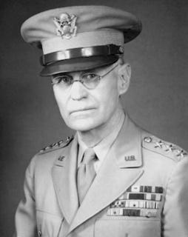  U.S. wartime general overseeing the defense of the Pacific Coast. DeWitt opposed allowing Japanese Americans to resettle on the West Coast on the grounds that it was "impossible to determine their loyalty." | mochi  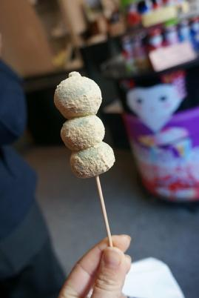  Traditional small cakes made of sweet steamed rice paste.
Questionnaire  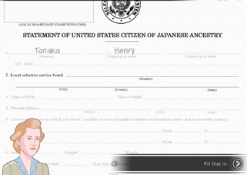  A form designed by the U.S. military to determine whether Nisei being considered for military service would be loyal to the United States or to Japan. | Selective Service System  U.S. government agency responsible for maintaining information on persons who may be required to serve in the military.
sugoi  Amazing or “wow.” | unqualified allegiance  loyalty or dedication to a person, country, or belief without exceptions or reservations
WAAC
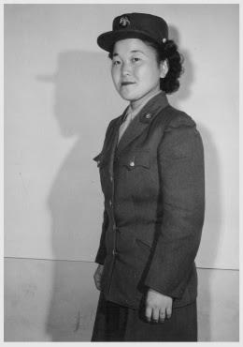
The Women's Army Auxiliary Corps, an all-female volunteer unit of the U.S. Army formed in 1942.

General DeWitt  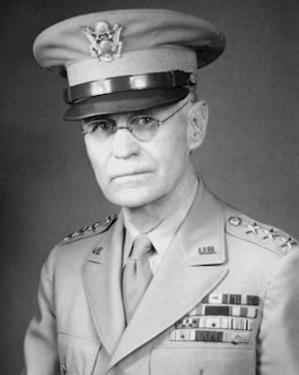 | mochi
Questionnaire  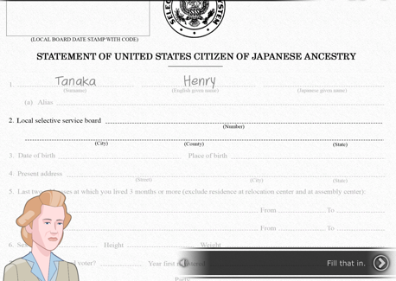 | Selective Service System
sugoi | unqualified allegiance
WAAC

U.S. wartime general overseeing the defense of the Pacific Coast. DeWitt opposed allowing Japanese Americans to resettle on the West Coast on the grounds that it was "impossible to determine their loyalty." | Traditional small cakes made of sweet steamed rice paste.
A form designed by the U.S. military to determine whether Nisei being considered for military service would be loyal to the United States or to Japan. | U.S. government agency responsible for maintaining information on persons who may be required to serve in the military.
Amazing or “wow.” | loyalty or dedication to a person, country, or belief without exceptions or reservations
The Women's Army Auxiliary Corps, an all-female volunteer unit of the U.S. Army formed in 1942.

Name: _______________________ Date:_________________________

Activity: More than seventy-five years after the events of “Prisoner In My Homeland,” Maya Tanaka, Henry Tanaka’s present-day 20-something granddaughter, is invited to give a talk to a local middle school history class. Maya is telling the class about a controversial decision made by the U.S. government in the World War II-era Japanese incarceration camps. The following is a portion of her interactions with the students.

After reading and discussing the words and terms on the flashcards, read this excerpt from her talk with the students, and use your memory to fill in the missing words and terms.

WAAC | sugoi | unqualified allegiance
General DeWitt | Selective Service System | mochi
questionnaire

Maya Tanaka: Hello class! I’m back to speak with you about my family’s history in the World War II-era Japanese American incarceration camps. Today, I’m going to share with you about a time that my grandfather, Henry Tanaka, faced a tough decision in the camps. It was near the New Year of 1943. That must seem like a long time ago to you!

Student: What did people do to celebrate the new year in the camps?

Maya Tanaka: From reading my grandfather’s diary, I learned that people would make _________ in the camps. Do you know that is?

Student: Yes! I’ve had the ice cream. It’s like a rice dessert.

Maya Tanaka: That’s right. I’m pretty surprised you know! We might say, _________ in Japanese. Though, I guess a lot of people today may have eaten that kind of ice cream. It’s sticky cakes, pounded from cooked rice. It can be both sweet or savory. This food is an important part of Japanese and Japanese American tradition, especially for celebrating the new year.

Student: Why do you bring mochi up?
Maya Tanaka: People like my grandfather would make mochi in the camps as a way of carrying their cultural traditions forward while in prison. It was a difficult time, the year of 1943. ___________________ was the person in charge of many of the decisions about what happened in these prisons. Along with many other government officials, he decided to hand out a ________________.

Student: Like a test?

Maya Tanaka: Yes, sort of like a test. It was a way that the government decided to determine who might be willing to serve in the military. The official term the government agency that establishes eligibility for the draft is __________________.

Student: What about women in the camps? How would they respond to a question about military service in 1943?

Maya Tanaka: That’s a great question. In this document, the government asked women if they were willing to sign up for the __________________. Women could serve as translators, medical professionals, or administrative roles. These roles were pretty complicated. Sometimes, their families did not like them serving in these roles. Some became translators for military documents.

Student: It seems like a lot was figured out in a very short time period!

Maya Tanaka: That’s right. The Japanese Americans in the prisons during World War II had to make big decisions. The government wanted to assess their “______________________” to the United States on a paper questionnaire. You’ll find out more about what happened soon. I’ll be back to talk about the consequences of these answers on the questionnaire.

A NOTE TO THE EDUCATOR:
You will need to decide how best to share these writing prompts with your students. You might share them all and ask students to choose one to respond to. You may assign one or more to the entire class. You might make one or more of the topics the basis for in-class discussions. Where there are multiple questions in a single prompt, choose the question or questions that best suits your students. Make your decisions according to the needs of your group.

You may notice that many of the topics contain some version of the phrase, “Write about a time in your life…” The intent of these prompts is twofold: first, since students remember the content of their own lives, they can more easily respond to the questions, and they are more likely to want to express themselves if they feel competent to do so; second, these questions can form a meaningful bridge between what happens in the lives of ordinary people today and the lives of people in history. For these reasons, you might decide to use some of the prompts before students encounter the history, because thinking about them sets the students up to understand and relate to it better.

Since students vary in their degree of comfort and skill in writing, you should decide when and how much students should write. We suggest that since students need to share their writing with each other to make personal and historical connections, you should encourage them to focus on content rather than mechanical skills. Pieces can be revised and edited later if you decide they should be shared formally (such as on a bulletin board or in a newsletter).

PRISON AND RESISTANCE.
After President Roosevelt issued Executive Order 9066, Japanese American families were forcibly removed from their homes--from everything they know--and relocated to inhumane prison camps in the middle of nowhere. In Part 3 of the game, you learn about the unjust arrest of Harry Ueno. Write about a time in your life when you actively resisted something you thought was unjust. What did you do? How did it make you feel to take a stand? Or, write about a time when you wish you had resisted something and explain why you decided to not take a stand.

ADDRESSING USE OF FORCE
In Part 3 of the game, you learn about a delegate to a JACL meeting in Salt City who is beat-up by a group of prisoners at Manzanar. Some prisoners speak out against the detention of Harry Ueno, who is accused of beating up the JACL delegate. Military police are called into the camp and fire into a crowd, resulting in the death of two young people. Why do you think administrators of the camp felt it was necessary to bring military police into the camp? What do you think of the use of force against prisoners who express dissent? Write your opinion about the use of policing against the prisoners: Was it fair or unfair? What other measures might have been taken? Does the incident at Manzanar remind you of any current events? Can you draw connections between the use of policing at Manzanar and the relationships between communities and police today?

WHAT IS A RIOT?
During this part of the game, prisoners are vocal about the arrest of Henry Ueno, who is blamed for attacking a prisoner who attended a JACL meeting in Utah. Military police are brought into Manzanar to suppress prisoners’ protests and expressions of anger. Tensions rise and, ultimately, police shoot into a crowd and kill two young men. This incident was sometimes called a “riot” by media describing the events from outside the camp. What do you picture in your head when you hear the word, “riot”? Why do you think people who are outside the camp might depict the Japanese American prisoners as “rioting”? Later, historians studying these events have re-named these same events at Manzanar as an “uprising.” In your thinking, what is the difference between calling the events a “riot” versus an “uprising”?

NEW YEAR TRADITIONS.
In Part 2, you hear a little about the tradition of making mochi on New Year’s in the camp. Mochi is a savory or sweet rice cake that is made from pounded rice. Prisoners at Manzanar still continued cultural traditions from life outside of the camp. Write about some of the important rituals and traditions within your own family, either for New Year’s or for another holiday or important marker. What is one tradition that your family repeats each year? Describe this tradition and its history in your family: Does it emerge from your family’s culture or ethnic roots? Has your family added their own “spin” to this tradition? Why is it important for people to have yearly, repeated rituals?

SUDDEN CHANGES.
During Part 3, Henry Tanaka describes how three big changes re-directed their lives in the camp. Henry and his family learn that they may be relocated to Minidoka, a prison camp in Idaho. Both Bainbridge Islanders and camp administrators at Manzanar believe that re-locating to Minidoka will help reduce tensions within the camp. They also learn about a possible military draft and a questionnaire that will be issued about prisoners’ willingness to move to other parts of the U.S. These are many big changes that face the Tanaka family all at once. Can you talk about an example, either from personal experience or from current events, when a family is facing a sudden change, especially one over which they have little control? Describe this sudden change and the social, economic, or personal factors that caused it.

WHEN TINY DECISIONS MATTER.
At the end of Part 3, Henry Tanaka makes decisions about filling out the questionnaire distributed to prisoners in the Japanese American incarceration camps in 1943. At each stage of the process, he weighs all of the options: Should he refuse to answer? Should he say “yes” to be drafted for military service? These were the small but important decisions that many people, young and old, made as they filled out this questionnaire. Now, think about an example when someone had to make a seemingly small decision that, in the end, mattered a lot. You can draw from your own life or from current events, history, books, or movies. Write about the small decisions this person had to make, the factors that influenced their decision, and what decision this person ended up making. Consider the deeper political or social circumstances that led to their situation.

A NOTE TO THE EDUCATOR:

The purpose of these questions is to check the students’ understanding of the action of the game and the history embedded in that action. Since the outcome of gameplay can vary depending on the choices the student makes, the answers to the questions may also vary.

Some students might learn information from the game later than others, or not at all. If you choose to discuss responses as a whole group, information can be shared among all your students.

There may be more questions here than you want your students to answer in one sitting or in one evening. In that case, choose the questions you feel are most essential for their understanding of Part 3.

Feel free to copy the following pages of this activity for your students.

If you are not planning to have your students write the answers to the questions, you’ll need to modify the directions.
Name: _______________________ Date:_________________________

Directions: After you play Part 3: Allegiance, read and answer the following questions from the point of view of your character, Henry. You may not know all the answers, so do the best you can. Write in complete sentences and proofread your work.

- Henry describes what he calls a riot. What happened? Why?

- What happened to Harry Ueno as a result of this incident? How did Japanese Americans react to this?

- When Harry Ueno was not released from jail, how did prisoners respond? What were the consequences?

- Why did many Bainbridge Islanders want to transfer to Minidoka? Describe where and what Minidoka was.

- How does your father respond when you ask about the Japanese American battalion and what it may mean to you?

- Why does the JACL believe that Henry and other Nisei men should join the U.S. Army?
.

- When Mr. Yamamoto describes what the questionnaire is, what do you ask him and how does he respond?

- According to Meiko, what will happen if you pass the “Application for Resettlement” form?

- What do you think your form titled “Statement of United States Citizen of Japanese Ancestry” means?

- What do you say when Meiko says that some of the questions seem like trick questions?

- Where would Meiko be allowed to volunteer to join the war effort?

- How does your father respond if you refuse to answer the question about who your relatives are?

- If you fill out your father’s occupation is a judo instructor what does your mother say?

- How does your mother respond when you answer questions about your Japanese language skills?

Name: _______________________ Date:_________________________

Directions: After you play Part 3: Allegiance, read and answer the following questions from the point of view of your character, Henry. You may not know all the answers, so do the best you can. Write in complete sentences and proofread your work.

1. What happened at the riot? Why?
One of the JACL who went to Salt Lake City got beaten up. Some Japanese Americans
at Manzanar didn’t like those who were collaborating with the government.

2. What happened to Harry Ueno as a result of this incident? How did Japanese Americans react to this?
The JACL leader who was attacked blamed Harry even though he couldn’t identify any
of his attackers. Harry was arrested and taken into town. A meeting was called to demand
Harry’s release.

- When Harry Ueno was not released from jail, how did prisoners respond? What were the consequences?
A crowd protested outside of the administration building. The military police was called in
to break up the protest. The police used tear gas, which caused more chaos and led them
to fire into the crowd. As a result, two young prisoners were killed. More police were sent
there to patrol day and night.

- Why did many Bainbridge Islanders want to transfer to Minidoka? Describe where and what Minidoka was.
Minidoka was a prison camp in Idaho where most Japanese Americans from Washington
and Oregon were sent. Bainbridge Islanders want to move here since the riot made things
worse, and so there would be less tension with Terminal Islanders or the authorities.

- How does your father respond when you ask about the Japanese American battalion and what it means for you?
He says that he will not let his only son sacrifice himself for a government that locks up
Innocent people.

- Why does the JACL believe that Henry and other Nisei men should join the U.S. Army?
It’s an opportunity to convince the U.S. that Japanese Americans are not the enemy.
.

- When Mr. Yamamoto describes what the questionnaire is, what do you ask him and how does he respond?
You ask him if you’ll be able to move back home to Bainbridge Island. Mr. Yamamoto
does not know.

- According to Meiko, what will happen if you pass the “Application for Resettlement” form?
She calls it a test and says that you both will be allowed to join the war effort.

- What do you think your form titled “Statement of United States Citizen of Japanese Ancestry” means?
You think it’s a way for the U.S. to see if they can trust us.

- What do you say when Meiko says that some of the questions seem like trick questions?
You refer to questions 27 and 28.

- Where would Meiko be allowed to volunteer to join the war effort?
The Army Nurse Corps or the Women’s Army Auxiliary Corps (WAAC).

- How does your father respond when you refuse to answer the question about who your relatives are?
Your father says that he also doesn’t see why you have to fill that information out. He tells
you to list your parents and Lily because it isn’t worth it to get the family separated again.

- When you fill out your father’s occupation is a judo instructor what does your mother say?
She questions as to whether you should state that and doesn’t want your father to be sent
away again.

- How does your mother respond when you answer questions about your Japanese language skills?
She is relieved that your skills are not very good since you didn’t work hard in Japanese
school.

Creating a Storyboard for the Bainbridge Island Japanese American Exclusion Memorial Exhibit

A NOTE TO THE EDUCATOR:
This activity is intended to give students a deeper understanding of the events that unfold during the Epilogue.
This activity is best used after students have completed their gameplay and viewed the Epilogue cinematic..

The Bainbridge Island Japanese American Exclusion Memorial was established to memorialize what Americans of Japanese descent went through during World War II. Imagine that the Bainbridge Island Japanese American Exclusion Memorial is in the planning stages of creating an exhibit to document prisoners’ lives there and that Henry Tanaka’s story will be a featured section. Students will create a storyboard of what happened to Henry Tanaka during and after World War II by focusing on events in the Epilogue and referring to the other parts of the mission. Students will illustrate what the exhibit would look like by completing the “Exhibit Storyboard for Henry Tanaka’s Story” handout and using the Cultural Artifacts Memory Box they filled out throughout the game.

Other Options or Extension Activities:
- After creating their storyboards, students can work in groups to create the actual exhibit on posters or exhibit boards and display it for the rest of the class. Each student can be in charge of putting together one of the four parts of Henry’s story that they highlight in the “Exhibit Storyboard for Henry Tanaka’s Story” handout.
- Use the “Exhibit Storyboard for Henry Tanaka’s Story” handout to create a zine or booklet of his life.
- Use the “Exhibit Storyboard for Henry Tanaka’s Story” handout to create a PowerPoint or Google Slide presentation of his life.

Exhibit Storyboard for Henry Tanaka’s Story

Part I: Write an opening paragraph to introduce the exhibit visitor to Henry Tanaka and his family’s experience during and after World War II. Use the Prologue and Part 1 sections to help summarize what life was like for his family before they were imprisoned, how they were imprisoned, and how they adjusted to life at Manzanar.

Opening Paragraph:

_______________________________________________________________________________________

_______________________________________________________________________________________

_______________________________________________________________________________________

_______________________________________________________________________________________

Part II: Choose four different situations that happened to Henry during the Epilogue. For each event, do the following:

- Choose an object from the “Cultural Artifacts Memory Box” handout to draw an artifact that could be displayed to demonstrate that part of Henry’s life.
- Write a caption to describe Henry’s experience as it relates to the artifact and what happened to Henry. Be clear about when and where this occurred.

- Give a title for each event.

Event 1 Title: __________________________________________________________________________

________________________________________________________

________________________________________________________

________________________________________________________

_________________________________________________________

________________________________________________________

Event 2 Title: __________________________________________________________________________

________________________________________________________

________________________________________________________

________________________________________________________

_________________________________________________________

________________________________________________________

Event 3 Title: __________________________________________________________________________

________________________________________________________

________________________________________________________

________________________________________________________

_________________________________________________________

________________________________________________________

Event 4 Title: __________________________________________________________________________

________________________________________________________

________________________________________________________

________________________________________________________

_________________________________________________________

________________________________________________________

Part III. Write a closing paragraph describing how Henry was impacted by his experiences during and after World War II.

Closing Paragraph:

_______________________________________________________________________________________

_______________________________________________________________________________________

_______________________________________________________________________________________

_______________________________________________________________________________________

A NOTE TO THE EDUCATOR: You will need to decide how best to share these writing prompts with your students. You might share them all and ask students to choose one for a response. You might assign one or more to the entire group. You might make one or more of the topics the basis for in-class discussions. Make your decisions according to the needs of your group.

You may notice that many of the topics contain some version of the phrase, “Write about a time in your life...” The intention of these prompts is twofold: first, since students remember the content of their own lives, they can more easily respond to the questions and they are more likely to want to express themselves if they feel competent to do so; second, these questions can form a meaningful bridge between what happens in the lives of ordinary people today and the lives of people in history or in historical events themselves. For these reasons, you might decide to use some of those prompts before students encounter the history because thinking about them sets the students up to understand it and to relate to it.

Since students vary in their degree of comfort and skill in writing, you should decide when students write and how much students should write. We do suggest, though, that since students need to share their writing with each other to make personal and historical connections, you encourage them to focus on content rather than on mechanical skills. Pieces can be revised and edited later if you decide they should be shared more formally (such as on a bulletin board or newsletter).

Read through all the topics. Then choose one of them to write about. Write the title of the piece at the top of your page. Write in complete sentences. After you are finished, proofread your work for correctness.

FAMILY BONDS. In this last part of Prisoner in My Homeland, you are exposed to the many life changes that the Tanaka family undergoes. They move to a new prison camp in Idaho. Henry makes a series of decisions that will alter the course of his life, whether it be choosing to attend college or enlisting to serve in the military. No matter the choice, Henry and his family drift apart as each family member moves to a new, faraway place. Can you think of a time in your own life--or it could be in a book you’ve read or a movie that you’ve seen--in which a family was changed due to hardship or members leaving home? Describe what happened to the family and how the change reshaped the family.

MAKING HARD CHOICES. In the final part of the game, Henry faces a series of tough decisions. His family was moved to another prison camp at Minidoka in Idaho. Henry has to decide whether he will enlist or resist the military. He has to consider whether he will pursue a college education or remain with his family for the duration of the war. Consider a time when you or a family member had to make a hard decision. Write any important background information and explain what decision was faced. What happened as a result? In what ways did your life change or not change? In thinking about it, do you think you made the right choice? Explain!

RETURNING TO “NORMAL LIFE.” The last part of the game covers what happens to the Tanaka family after World War II ends. Very few Japanese American families were able to return to the same communities that they lived in before the camps. Many people moved to new cities all across the United States to attend college, start new jobs, and have families. Others returned to the West Coast, finding their former homes completely changed and encountering people hostile to their return. Write about this process of starting over. What struggles do you think Japanese Americans faced after the war? Has there been a time in your own life where you or your family had to start over and try to establish a normal life?

A FIGHT FOR JUSTICE. In the aftermath of World War II, Japanese American activists and allies led a decades-long effort to demand justice for their illegal imprisonment. These collective actions are called the “Redress Movement,” meaning that Japanese Americans called for the U.S. government to acknowledge and correct their wrongdoing. As a part of this movement, a special government commission was set up in 1980. Survivors of the prison camps shared their stories, engaging in a process of truth-telling and documentation of their experience. In 1988, President Ronald Reagan signed the Civil Liberties Act, which offered a formal apology and issued $20,000 to surviving Japanese Americans incarcerated during World War II.

Why do you think it was so important for Japanese Americans to receive an apology and repayment for losses? Do you think that such wrongs in history can be “repaired”? What are the benefits of laws like the Civil Liberties Act? What are its limits?

MEMORIALIZATION. You learn in the final part of the game about “pilgrimages” that some Japanese Americans made to the former prisons that once incarcerated their families. A “pilgrimage” is a journey to a place that has a meaningful history or religious importance. Attending these pilgrimages in one way in which survivors and their families come together to heal from their painful experiences and losses.

Many communities have found ways to remember difficult events and histories. Can you think of a place that you have been to that “memorializes” a part of history? Write about this place and describe it in detail. Next, discuss some of your impressions of the place. What did you learn about this history? Why should people remember it? What effect did it have on you to visit this place?

HISTORY AND MEMORY. At the very end of the game, Henry Tanaka’s sister Lily, now in her 90’s, says, “History has many layers. Without uncovering those layers, how can we learn?” What do you think she means by this statement? Why is it so important to remember history, especially events like the World War II-era Japanese American incarceration period? Then, write about the impact of learning this history on you. In interacting with the Tanaka family’s story, what did you take away? Write a reflection on Lily’s final words in the game and any of your own takeaways from learning this story.

The creators of MISSION US have assembled the following list of websites, fiction, and non-fiction to enhance and extend teacher and student learning about the people, places, and historical events depicted in the game.

WEBSITES

Densho. http://densho.org/
This extensive collection includes online archival sources, oral history interviews, and encyclopedia articles that document the Japanese American WWII experience.

Fred T. Korematsu Institute. http://www.korematsuinstitute.org/curriculum-kit-order-form/
This nonprofit organization educates to advance racial equity, social justice, and human rights for all by distributing copies of a free multimedia curriculum kit to K-12 educators on the WWII Japanese American incarceration and civil rights hero Fred Korematsu’s legacy. Curricular materials connect this history with current issues such as anti-Muslim bigotry and post-9/11 discrimination. The “Martial Law” clip from Resistance at Tule Lake is featured on the kit DVD.

Japanese American Citizens League. https://jacl.org/education/resources/
As the oldest Asian American civil rights organization established in 1929, the JACL maintains the civil rights of Japanese Americans and others victimized by injustice and bigotry. Part of their mission is to promote awareness of this history through resources on Asian American history, the Japanese American WWII experience, and the Redress Movement, including the Power of Words Handbook.

National Japanese American Historical Society. https://www.njahs.org/for-educators/
This nonprofit organization offers a variety of curricular resources that complement Resistance at Tule Lake, including Tule Lake Segregation Center lesson plans, an interactive Detention Camp kit with photos, an activity guide on Children of the Camps, and a teacher’s guide on the Bill of Rights and the Japanese American WWII experience.

Japanese American National Museum. http://www.janm.org/education/resources/
The museum website provides links to a variety of resources on World War II Japanese American incarceration history as well as online museum collections.

Current Special Exhibition - Exclusion: The Presidio’s Role in World War II Japanese American Incarceration. The Presidio Trust. https://www.presidio.gov/officers-club/exhibitions/exclusion
This landmark exhibit is available virtually on the Presidio Trust website and physically for free in-person visits until spring 2019. It focuses on the role of the Presidio of San Francisco as home base for planning the forced removal of Japanese Americans, offering a new angle to understand this complicated history. The Army’s Western Defense Command was located at the Presidio, where Lieutenant General John L. Dewitt issued Civilian Exclusion Orders and organized the development of detention centers and incarceration camps.

Primary Sources
Ansel Adams's Photographs of Japanese-American Internment at Manzanar, Library of Congress
http://www.loc.gov/pictures/collection/manz/
In 1943, Ansel Adams (1902-1984) documented the Manzanar prison camp in California and the Japanese Americans incarcerated there during World War II. On this site, digital scans of both Adams's original negatives and his photographic prints appear side by side allowing viewers to see Adams's darkroom technique.

Japanese American Relocation Digital Archive (JARDA), Calisphere. https://calisphere.org/exhibitions/t11/jarda/
Calisphere provides free access to unique and historically important artifacts for research, teaching, and curious exploration. The Japanese American Relocation Digital Archives (JARDA) contains thousands of primary sources documenting Japanese American incarceration.

WWII Japanese American Internment and Relocation Records in the National Archives: Introduction, National Archives and Records Administration.
https://www.archives.gov/research/japanese-americans/internment-intro
The introductory page for the National Archives and Records Administration's records on the World War II Japanese American Incarceration. Notable databases include War Relocation Authority (WRA) Records, which contains personal descriptive information on all individuals removed to 10 camps during World War II, and the Commission on Wartime Relocation and Internment of Civilians (CWRIC) Records, or the hearings and testimonies from more than 750 people who had lived through the events of World War II.

BOOKS
Non-Fiction for Students

Atkins, Laura, Yogi, Stan, and Yutaka Houlette. Fred Korematsu Speaks Up. Berkeley: Heydey Books, 2017.
This book is aimed at younger readers, but packs a punch for any age: Through colorful illustrations and design, the book tells the story of Fred Korematsu, who resisted the incarceration orders and would later bring a landmark case against the U.S. government.
Grady, Cynthia. Write to Me: Letters from Japanese American Children to the Librarian They Left Behind. New York: Penguin Random House, 2018.
When Executive Order 9066 is enacted after the attack at Pearl Harbor, children's librarian Clara Breed's young Japanese American patrons are to be sent to prison camp. Before they are moved, Breed asks the children to write her letters and gives them books to take with them. To tell the story, Grady uses illustrations and excerpts from children's letters held at the Japanese American National Museum.

Okubo, Miné. Citizen 13660. Seattle: University of Washington Press, 1983.
Okubo's classic graphic memoir of life in relocation centers in California and Utah, illuminates this experience with moving illustrations and incisively-composed text.

Takei, George. They Called Us Enemy. San Diego: Top Shelf Productions, 2019.
They Called Us Enemy is Takei's firsthand account of those years behind barbed wire, the joys and terrors of growing up under legalized racism, his mother's hard choices, his father's faith in democracy, and the way those experiences planted the seeds for his astonishing future.

Fiction for Students

Conkling, Winifred. Sylvia & Aki. New York: Yearling Books, 2013.
This historical novel is based on the real-life stories of Sylvia Mendez and Aki Munemitsu, both third-graders during World War II. Sylvia is the center of a landmark legal battle over school segregation. Japanese American Aki is forced from her home and her life as she knew it. The novel’s chapters alternate between their experiences.

Kadohata, Cynthia. A Place to Belong. New York: Atheneum/Caitlyn Dlouhy Books, 2019.
In this novel for YA readers, a Japanese-American family, reeling from their ill-treatment in prison camps, gives up their American citizenship to move back to Hiroshima, unaware of the devastation caused by the atomic bomb.

Kadohata, Cynthia. Weedflower. New York: Simon and Schuster, 2008.
After the attacks on Pearl Harbor, twelve-year-old Sumiko Sumiko and her family find themselves being shipped to a prison camp in one of the hottest deserts in the United States. In the course of this YA novel, Sumiko soon discovers that the camp is on an Indian reservation and meets a young Mohave boy.

Nagai, Mariko. Dust of Eden. Parkridge, IL: Albert Whitman & Co., 2018.
In early 1942, thirteen-year-old Mina Masako Tagawa and her Japanese American family are sent from their home in Seattle to an internment camp in Idaho. This novel for middle-grade readers asks: What do you do when your home country treats you like an enemy?

Sepahban, Lois. Paper Wishes. New York: Farrar, Straus and Giroux, 2016.
Ten-year-old Manami did not realize how peaceful her family's life on Bainbridge Island was until the day it all changed. This YA novel follows Manami and her family after the attack on Pearl Harbor in 1942 as they leave their home by the sea and join other Japanese Americans at a prison camp in the desert.

Sugiura, Misa. This Time Will Be Different. New York: HarperTeen, 2019.
This YA novel is about seventeen-year-old CJ, who never lived up to her mom’s type A ambition. CJ is perfectly happy just helping her aunt, Hannah, at their family’s flower shop. Then her mom decides to sell the shop—to the family who swindled CJ’s grandparents when thousands of Japanese Americans were sent to internment camps during World War II.
Uchida, Yoshiko. Journey to Topaz. Berkeley: Heydey Books, 1971.
First published in 1971, this book is a widely read classic. Based on Yoshiko Uchida's personal experiences, this is the story of one girl's struggle to remain brave during the Japanese incarceration during World War II.

Wakatsuki Houston, Jeanne and James D. Houston. Farewell to Manzanar. Boston: Houghton Mifflin Company, 1973.
Aimed at middle grade readers, this book has long been used by teachers to introduce students to the Japanese American incarceration. Curriculum for this book is available from Facing History and Ourselves.
Non-Fiction for Teachers

Bannai, Lorraine K. Enduring Conviction: Fred Korematsu and His Quest for Justice. University of Washington Press, 2015.
This book tells the story of Fred Korematsu's decision to resist F.D.R.'s Executive Order 9066, which provided authority for the internment of Japanese Americans during World War II.

Commission on Wartime Relocation and Internment of Civilians. Personal Justice Denied: Report of the Commission on Wartime Relocation and Internment of Civilians. Seattle: University of Washington Press and Washington D.C.: Civil Liberties Public Education Fund, 1997.
This report by the U.S. Commission on Wartime Relocation and Internment of Civilians (CWRIC), a commission created by the U.S. Congress in 1980, studies the causes and consequences of the incarceration of Japanese Americans during World War II. It includes a December 1982 report on the Commission's findings, as well as the Commission's June 1983 recommendations. The Commission's report and findings were responses to the growing campaign for redress for Japanese Americans who suffered imprisonment during World War II and laid the foundation for Congress to provide redress through the Civil Liberties Act of 1988.

Daniels, Roger, Sandra Taylor, and Harry Kitano, eds. Japanese Americans: From Relocation to Redress. Seattle: University of Washington Press, 1988.
One of the earlier comprehensive accounts of the Japanese American experience, covering the forced removal during World War II to the public policy debate over redress and reparations. This chronology is underscored by first-person accounts and essays by scholars.

Gordon, Linda, and Gary Y. Okihiro, Eds. Impounded: Dorothea Lange and the Censored Images of Japanese American Internment. New York: W.W. Norton & Company, Inc., 2006.
Dorothea Lange’s indelible images are an extraordinary photographic record of the Japanese American incarceration. She was one of a handful of white people impelled to speak out.

Hayami, Stanley, and Joanne Oppenheim, Ed. Stanley Hayami: Nisei Son—His Diary, Letters, & Story. Shelter Island Hts., NY: J.T. Colby & Company, Inc., 2008.
Stanley Hayami was sixteen when he was sent to Heart Mountain. He kept a diary of his life in the camps, augmented with sketches and drawings. This book is based on his diary, now in the permanent collection of the Japanese American National Museum.

Inada, Lawson Fusao, Ed. Only What We Could Carry: The Japanese American Internment Experience. Berkeley: Heyday, 2000.
Inada’s edited volume is a cogent and well-organized blend of historical artifacts, literary texts, art, and memoir, and a key resource for any teacher of this chapter of American history.

Ishizuka, Karen L. Lost & Found: Reclaiming the Japanese American Incarceration. Los Angeles: Japanese American National Museum, 2006.
For decades, victims of the U.S. mass incarceration were kept from understanding their experience by governmental cover-ups, euphemisms, and societal silence. Combining heartfelt stories with first-rate scholarship, this companion book to the Japanese American National Museum’s critically acclaimed exhibition, America’s Concentration Camps: Remembering the Japanese American Experience, reveals the complexities of a people reclaiming their own history.

Kashima, Tetsuden. Judgment without Trial: Japanese American Imprisonment during World War II. Seattle: University of Washington Press, 2003.
An important overview of the many programs and shifting policies during the incarceration period. Kashima reveals that long before the attack on Pearl Harbor, the U.S. government began making plans for the eventual incarceration of the Japanese American incarceration. The book also covers the “Loyalty Questionnaire” and the redesignation of Tule Lake as a segregation center.

Muller, Eric L. American Inquisition: The Hunt for Japanese American Disloyalty in World War II. Chapel Hill: University of North Carolina Press, 2007.
A study of the Japanese American incarceration that examines the complex inner workings of the only loyalty screening that the American government has ever deployed against its own citizens.

National JACL Power of Words II Committee. Power of Words Handbook: A Guide to Language About Japanese Americans in World War II. National JACL Power of Words II Committee, 2013.
This is an essential guide for teachers wishing to know more about the importance of terminology in teaching this history.

Weglyn, Michi. (1976). Years of Infamy: The Untold Story of America’s Concentration Camps. New York: William Morrow and Company.
Weglyn’s classic 1976 text is one of the most comprehensive and subtle histories of the Japanese American incarceration period. Her text also gives thorough readings of the loyalty questionnaire, the resistance of the military draft, and the renunciation of citizenship movement at Tule Lake.

Yamashita, Karen Tei. Letters to Memory. Minneapolis, Coffee House Press, 2017.
Letters to Memory examines the Japanese American incarceration using archival materials from the Yamashita family as well as a series of letters to composite characters. Yamashita’s letters explore expand the history’s implications beyond her family and our nation-state, examining ideas of debt, forgiveness, civil rights, orientalism, and community.

FILMS & VIDEO

And Then They Came for Us. Directed by Abby Ginzberg. Berkeley, CA: Social Action Media, 2020.
A 40-minute film that serves as an effective introduction for learners new to this history. Featuring George Takei and many others who were incarcerated, as well as newly rediscovered photographs of Dorothea Lange, the film brings history into the present, retelling this difficult story and following Japanese American activists as they speak out against the Muslim registry and travel ban.

The Art of Gaman: The Story Behind the Objects. Directed by Rick Quan. Oakland, CA: Rick Quan Productions.
https://www.youtube.com/watch?v=8Fk8cHkCQV0
A short documentary film that accompanies the exhibition, The Art of Gaman: Arts and Crafts from the Japanese American Internment Camps, 1942-1946. The documentary and exhibit features arts and crafts created by Japanese Americans while incarcerated in World War II concentration camps.

The Asian Americans. Produced by Renee Tajima-Peña. Arlington, VA: WETA.
In the second episode of this landmark PBS series, an American-born generation straddles their country of birth and their parents’ homelands in Japan and Korea. Those loyalties are tested during World War II, when families are imprisoned in detention camps, and brothers find themselves on opposite sides of the battle lines.

The Cats of Mirikitani. Directed by Linda Hattendorf. San Francisco, CA: Center for Asian American Media, 2007.
Documentary about Jimmy Mirikitani, a painter working and living on the street near the World Trade Center. After 9/11, film editor Linda Hattendorf convinces the elderly Jimmy to move in with her. Hattendorf investigates the California-born, Japan-raised artist's life, resulting in a compelling inquiry into his main subjects of cats and the World War II-era Japanese incarceration.

Children of the Camps. Directed by Stephen Holsapple. San Francisco, CA: Center for Asian American Media, 1999.
This powerful documentary shares the experiences, cultural and familial issues, and long internalized grief and shame felt by six Japanese Americans who were only children when they were incarcerated in concentration camps during World War II.

Conscience and the Constitution. Directed by Frank Abe. Seattle, WA: Independent Television Service (ITVS).
Conscience and the Constitution reveals the lesser-known story of the organized draft resistance at the American concentration camp at Heart Mountain, Wyoming, and the suppression of that resistance by Japanese American leaders.

A Flicker in Eternity. Directed by Ann Kaneko and Sharon Yamato, 2012.
A short tale of a gifted teenager is told through his endearing cartoons and witty observations. Based on the diary and letters of Stanley Hayami, the story is told from the perspective of a promising young man thrown into the turmoil of World War II.

From a Silk Cocoon: A Japanese American Renunciation Story. Directed by Emery Clay III, Stephen Holsapple, and Satsuki Ina. San Francisco, CA: Center for Asian American Media, 2007.
Woven through letters, diary entries, and haiku poetry is the story of a young couple whose shattered dreams and forsaken loyalties lead them to renounce their American citizenship while held in separate prison camps during World War II. They struggle to prove their innocence and fight deportation during a time of wartime hysteria and racial profiling.

The Orange Story. Chicago, IL: Full Spectrum Features NFP, 2016. https://theorangestory.org/
The Orange Story is a 17-minute movie based on these historical events. It follows Koji Oshima, the proud owner of a small grocery store, as he prepares to abandon everything and report to an assembly center. Made for educators, the movie is shown in four chapters. Between chapters, viewers are invited to examine archival documents and images, as well as oral histories.

Rabbit in the Moon. Directed by Emiko Omori. San Francisco, CA: Wabi-Sabi Productions, 1999.
A groundbreaking film that provides a comprehensive overview of the Japanese American incarceration experience. This many-layered history is told through the co-producers’ family story and through the testimonials of other former inmates.

Relocation: Arkansas: The Aftermath of Incarceration. Directed by Vivienne Schiffer. Houston, TX: Rescue Film Production, 2016.
This documentary chronicles the Japanese American incarceration experience in Arkansas during World War II, focusing on the unlikely tale of those Japanese Americans who remained behind and the small town Arkansas mayor who sought to preserve the history of the Arkansas-located camps.

Resistance at Tule Lake. Directed by Konrad Aderer. San Francisco, CA: Center for Asian American Media, 2017.
Resistance at Tule Lake tells the long-suppressed story of incarcerated Japanese Americans who defied the government by refusing to swear unconditional loyalty to the U.S. Though this was an act of protest and family survival, they were branded as “disloyals” by the government and packed into the newly designated Tule Lake Segregation Center.

Ugly History: Japanese American Incarceration Camps. Directed by Lizete Upīte. New York, NY: TED-Ed.
https://www.youtube.com/watch?time_continue=43&v=hI4NoVWq87M&feature=emb_logo
A short, animated YouTube video that follows 16 year-old Aki Kurose as she shares in the horror of millions of Americans when Japanese planes attacked Pearl Harbor. TED-Ed partners with Densho to explore the racism and paranoia that led to the unjust imprisonment of Japanese Americans.

TEACHING STRATEGIES

UC Berkeley History-Social Science Project. http://ucbhssp.berkeley.edu/content/teachers
This organization bridges the University of California, Berkeley academy and K-12 communities to help teachers strengthen their instructional practice and provide equitable educational opportunities to all students, through a model of learning, practicing, and doing. UC Berkeley offers professional development training and resources on teaching historical thinking skills within the context of a diverse array of topics.

Facing History and Ourselves.
https://www.facinghistory.org/
This international educational and professional development nonprofit organization engages students of diverse backgrounds in an examination of racism, prejudice, and antisemitism in order to promote the development of a more humane and informed citizenry by providing lesson plans that reflect these topics as well as teaching strategies and professional development. Included on their website are resources on “Bearing Witness to Japanese American Incarceration.”

Library of Congress, Teaching with Primary Sources.
http://www.loc.gov/teachers/
The Library of Congress offers classroom materials and professional development to help teachers effectively use primary sources from the Library's vast digital collections in their teaching. Find Library of Congress lesson plans and more that meet Common Core standards, state content standards, and the standards of national organizations.

Stanford History Education Group.
https://sheg.stanford.edu/
Strategies such as “Reading Like a Historian” and “Civic Online Reasoning” are featured here. Lesson plans engage students in historical inquiry and teach them to critically evaluate news articles.

PBS RESOURCES

PBS LearningMedia, “The Fred T. Korematsu Institute.”
https://ny.pbslearningmedia.org/collection/korematsu-institute-collection/
This collection from the education non-profit, The Fred T. Korematsu Institute, includes teacher-authored lessons related to documentary films on the Japanese American incarceration experience. Lessons are paired with short clips from the films.

PBS LearningMedia, “Injustice at Home.” https://ny.pbslearningmedia.org/resource/injustice-at-home/injustice-at-home-the-japanese-american-experience-of-the-world-war-ii-era/
This educational resource includes five educational videos and an inquiry-based unit of study. Topics include help Executive Order 9066 and the resulting incarceration of Japanese Americans during World War II; the failure of political leadership; the military experience of Japanese Americans; and historic discrimination and racial prejudice against Japanese Americans. Produced by KSPS Public Television and Eastern Washington educators.

PBS LearningMedia, “Japanese Internment Camps: Teaching with Primary Sources.”
https://ny.pbslearningmedia.org/resource/b10f6426-c8eb-4a6e-ac74-67ed6fb1dafb/japanese-internment-camps/
This inquiry kit features a series of Library of Congress sources related to the American internment of Japanese-Americans during World War II.

PBS Website for Children of the Camps. Directed by Stephen Holsapple, 1999.
https://www.pbs.org/childofcamp/history/
The accompanying website for Children of the Camps, a one-hour documentary that portrays the poignant stories of six Japanese Americans who were interned as children in US concentration camps during World War II.

PBS Website for “Dorothea Lange: Grab a Hunk of Lightning,” American Masters. Directed by Dyanna Taylor, 2014.
https://www.pbs.org/wnet/americanmasters/dorothea-lange-world-war-ii-the-internment-of-japanese-americans/3205/
This episode of PBS’ American Masters covers photographer Dorothea Lange as she is hired to document the forced removal of Japanese Americans in the Pacific Coast area during World War II. The website features clips from the episode.

PBS Website for The War. Directed by Ken Burns and Lynn Novick, 2007.
https://www.pbs.org/thewar/at_home_civil_rights_japanese_american.htm
The companion website for The War, a documentary series about four American towns and how their citizens experienced World War II. The website offers interviews and other primary sources for educators.

Research Bibliography:

Allinder, Jasmine. Moving Images: Photography and the Japanese American Incarceration. (2009).

Austin, Allan W. From Concentration Camp to Campus: Japanese American Students and World War II. The Asian American Experience (2004).

Daniels, Roger. Prisoners Without Trial: Japanese Americans in World War II. Hill & Wang Publishing, New York (1993).

Daniels, Roger, Sandra Taylor, and Harry Kitano, eds. Japanese Americans: From Relocation to Redress. Seattle: University of Washington Press (1988).
Embrey, Sue Kunitomi, Arthur A. Hansen, and Betty Kulberg Mitson. Manzanar Martyr: Interview with Harry Y. Ueno (1986).

Fugita, Stephen S., and Marilyn Fernandez. Altered Lives, Enduring Community: Japanese Americans Remember Their World War II Incarceration (2004).

Gesensway, Deborah and Roseman, Mindy. Beyond Words. Cornell University Press, Ithaca, New York (1987).

Gordon, Linda, and Gary Y. Okihiro, eds. Impounded: Dorothea Lange and the Censored Images of Japanese American Internment (2006).

Gruenewald, Mary Matsuda. Looking Like the Enemy: My Story of Imprisonment in Japanese American Internment Camps (2005).
Hansen, Arthur and Lane Ryo Hirabayashi. Barbed Voices: Oral History, Resistance, and the World War II Japanese American Social Disaster (2018).

Hayami, Stanley and Oppenheim, Joanne. Stanley Hayami, Nisei Son: His Diary, Letters, and Story from an American Concentration Camp to Battlefield, 1942-1945 (2008).

Hayashi, Brian Masaru. Democratizing the Enemy: The Japanese American Internment. (2004).

Higa, Karin editor. View From Within: Japanese American Art From the Internment Camps, 1942-1945. University of Washington Press, Seattle (1992).

Inada, Lawson Fusao, ed. Only What We Could Carry: The Japanese American Internment Experience (2000).

Inouye, Mamoru. The Heart Mountain Story: Photographs by Hansel Mieth and Otto Hagel of the World War II Internment of Japanese Americans. M. Inouye, Los Gatos, California (1997).

Kashima, Tetsuden. Judgment Without Trial: Japanese American Imprisonment During World War II (2003).

Muller, Eric L. American Inquisition: The Hunt for Japanese American Disloyalty in World War II. Chapel Hill: University of North Carolina Press (2007).

Neiwert, David. Strawberry Days: How Internment Destroyed a Japanese American Community (2005).

Ng, Wendy. Japanese American Internment during World War II: A History and Reference Guide. (2001).

Okada, John. No, No Boy. University of Washington, Seattle (1976).

Okihiro, Gary Y. Whispered Silences: Japanese Americans and World War II (1996).

Okubo, Mine. Citizen 13660. University of Washington Press, Seattle (1983).

Robinson, Gerald H. Elusive Truth: Four Photographers at Manzanar (2002).

Sekerak, Eleanor Gerard. "A Teacher at Topaz," In Japanese Americans: From Relocation to Redress, Revised Edition. Edited by Roger Daniels, Sandra C. Taylor, and Harry H.L. Kitano, 38-43. Seattle: University of Washington Press, 1991.

Spicer, Edward Holland et al. Impounded People: Japanese-Americans in the Relocation Centers (1969).

Unrau, Harlan D. The Evacuation and Relocation of Persons of Japanese Ancestry during World War II: A Historical Study of the Manzanar War Relocation Center, Vol. One and Two (1996).

Woodward, Mary. In Defense of Our Neighbors: The Walt and Milly Woodward Story (2008).

Online Resources

Densho, Densho Encyclopedia, http://encyclopedia.densho.org/

Bainbridge Island Japanese American Community, https://www.bijac.org/

FDR Called Them Concentration Camps: Why Terminology Matters
http://blog.angryasianman.com/2017/02/fdr-called-them-concentration-camps-why.html

National Park Service, “A Brief History of Japanese American Relocation During World War II,” Manzanar National Historic Site
https://www.nps.gov/articles/historyinternment.htm

University of California - Japanese American Relocation Digital Archive (JARDA)
https://calisphere.org/exhibitions/t11/jarda/

Library of Congress Newspaper Archive: Manzanar Free Press
https://lccn.loc.gov/sn84025948
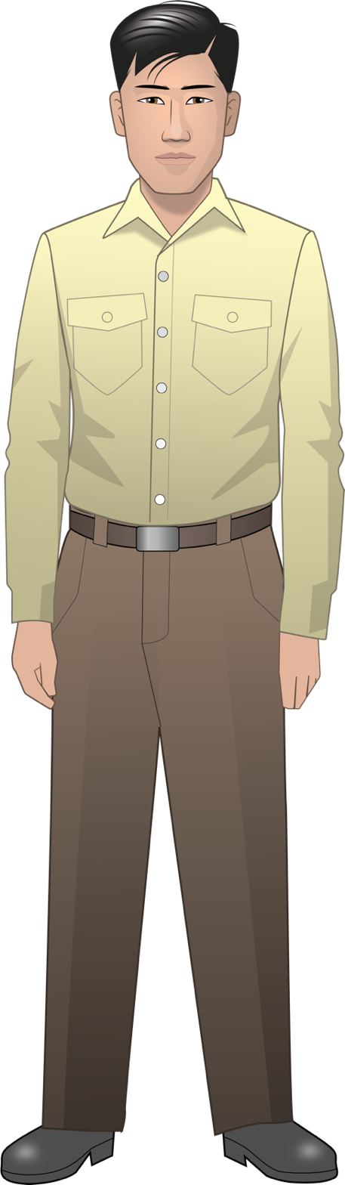
Henry Tanaka
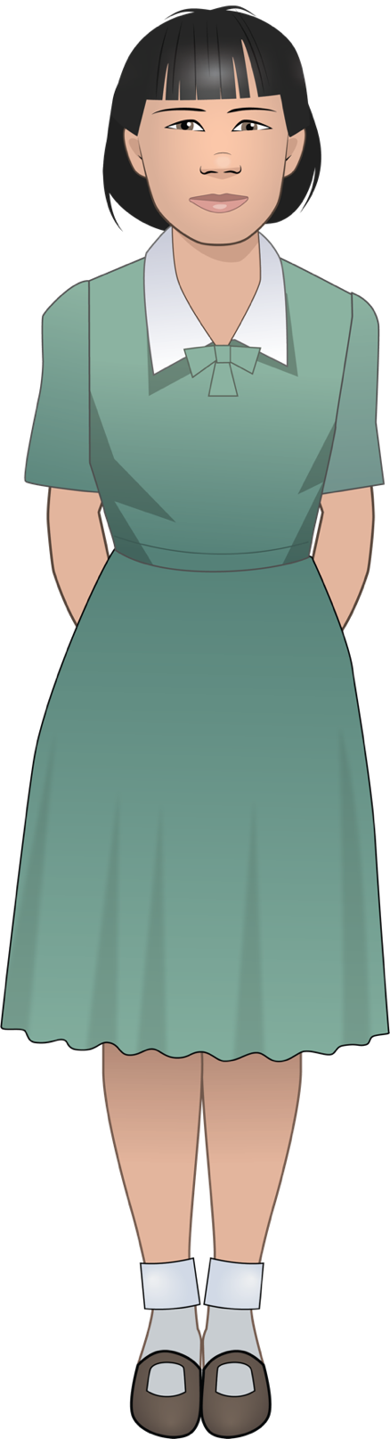
Lily Tanaka
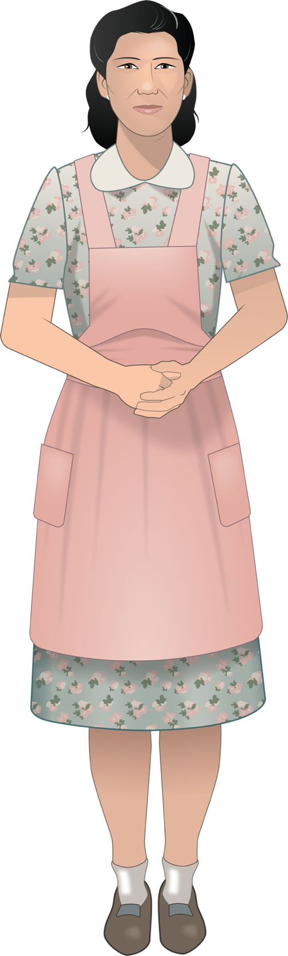
Kiyoko Tanaka

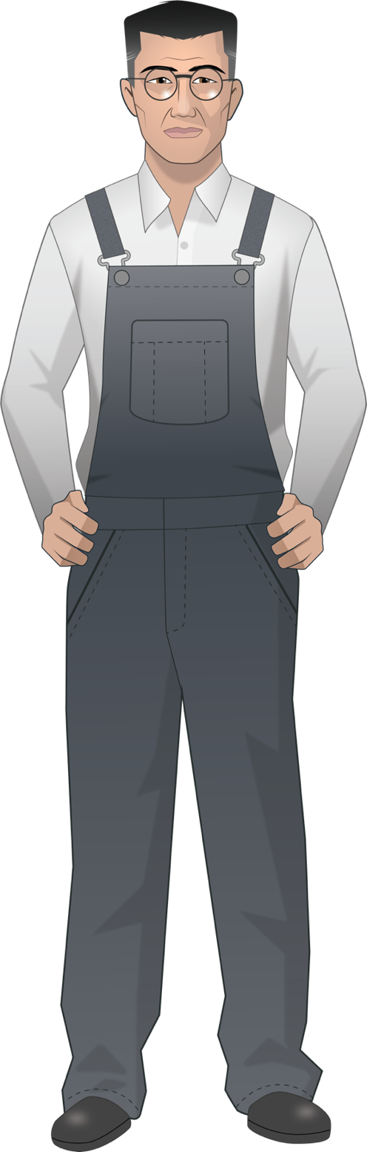
Kinzo Tanaka
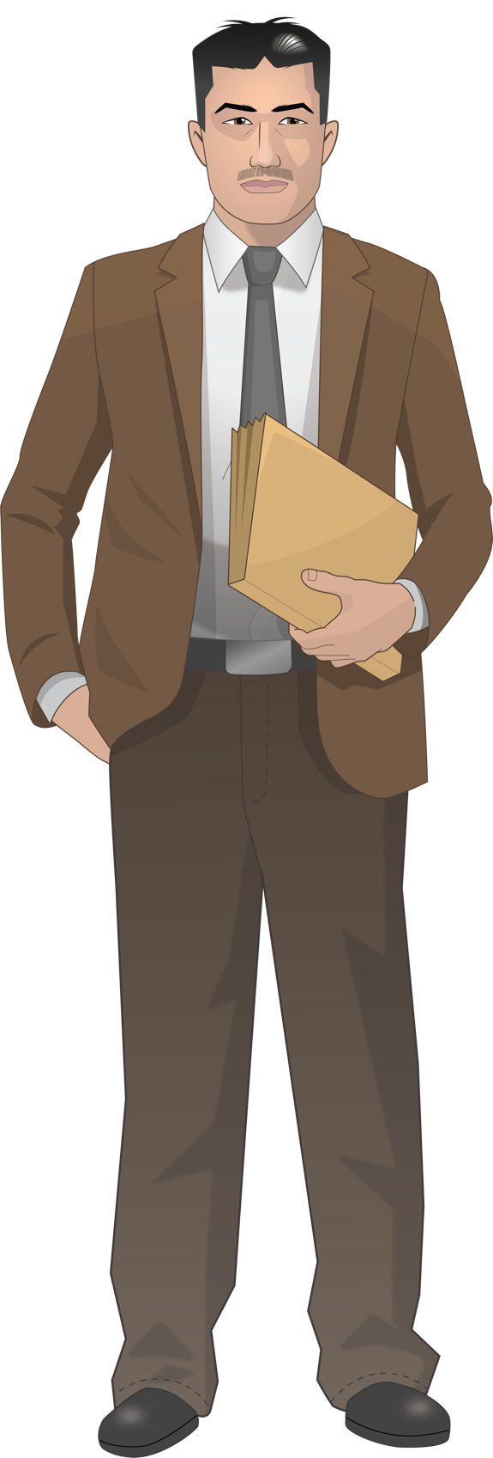
Mr. Yamamoto
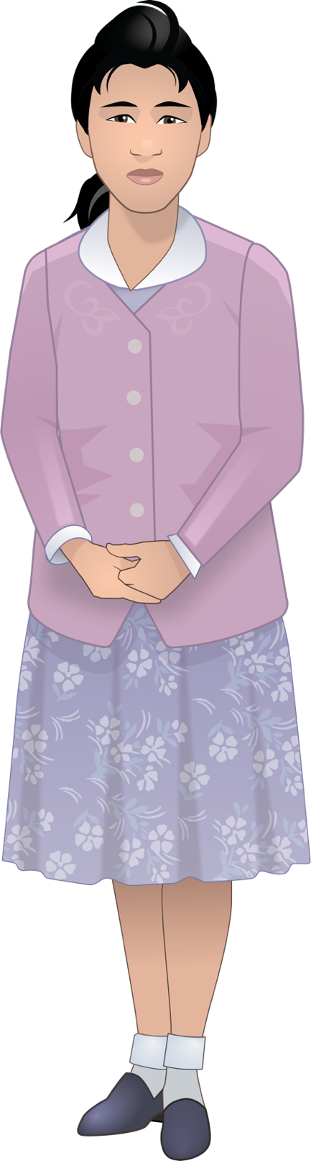
Meiko Yamamoto
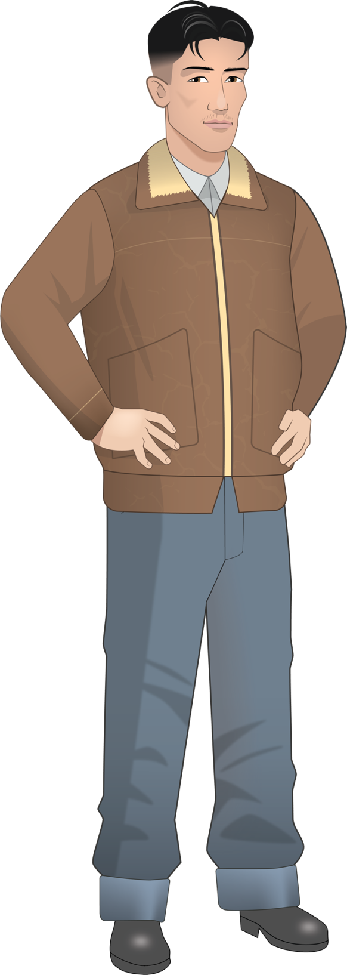
Tadashi
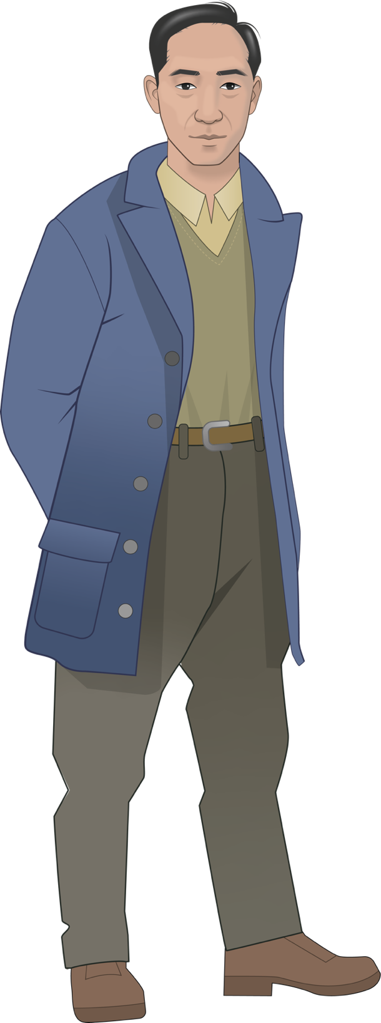
Harry Ueno

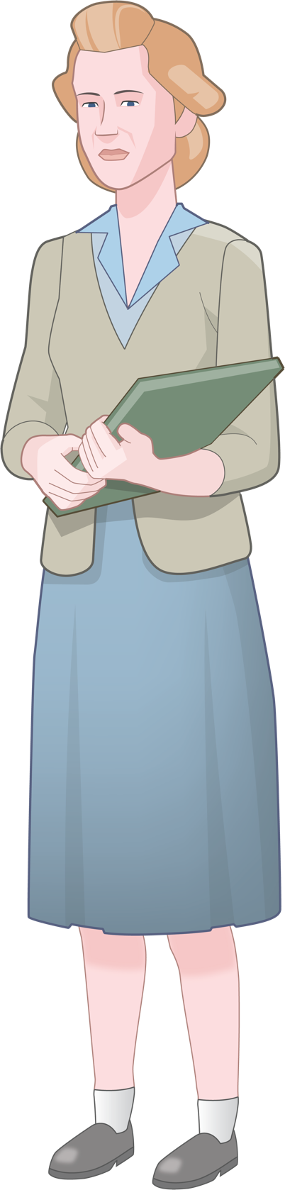
Miss Nelson
Oral History Excerpt from Bainbridge Island before World War Two

Yaeko Sakai Yoshihara was 12 years old and in the 7th grade when her family was forcibly removed from Bainbridge Island in March 1942. She was the youngest of six children. Her family had a strawberry farm before the war. This interview was recorded in December 2006.

Life on Bainbridge was pretty simple. Even where our house was located, there was no electricity. It was pretty primitive... outdoor plumbing, well water, kerosene lamps, wood stove. It was very simple. . . . Socially, the Japanese, more or less, kind of stuck to themselves. There was a Japanese community... the Japanese Hall where people assembled. There was Japanese language school. When the kids were in third grade they would start the Japanese language school as a first grader. That's how I began. In the third grade I started Japanese language school. Then with... we played with our friends. In school we mixed... we were able to, you know, on the playground everybody played together. But when it came to kinda group things, it was always with our Japanese friends. We generally were not invited to the Caucasian parties or homes.

In the Japanese community, at that time, they had... like they would have annual bazaar. And then from time to time, a person from Seattle would bring Japanese movies. We would watch that. Then, sometimes there would be a talent show or some program and the people participated. For some reason I was always nominated to sing. 'Cause I liked to sing. But, I don't know, I just picked to do that. Then the Japanese school would have a program. We had to sing Japanese songs or whatever we learned.
Source: Bainbridge Island Japanese American Community, https://www.bijac.org/index.php?p=HISTORYPre_LifeBefore

Oral History Excerpt from Bainbridge Island before World War Two
Jerry Nakata was 19 years old when his family was forcibly removed from Bainbridge Island in March 1942. He was the second youngest of six children. Jerry's parents both owned a barbershop in Winslow and farmed strawberries. In the late 1930s his older brother John started a small grocery business. Before the war Jerry was working for his brother. Jerry graduated from Bainbridge High School in 1941. Following the war, the Nakata family returned to Bainbridge Island and re–built their grocery business in partnership with Ed Loverich. This interview was recorded in February, 2006

...growing up at the barber shop, mostly Caucasian trade, and I grew up with more Caucasian kids than I did with Japanese kids. I joined the Boy Scouts when I was 12 years old. . . Our class was fifty kids, eight, like I said, eight Japanese kids. I really had fun in high school. I didn't study much, and I got to be good buddies with a couple of kids, like this Reese Moran, he was probably my closest, and then Earl Hanson, I got involved with him, and Hal Champness. We were a real close–knit class, even after 65 years, we still get together, and I think that's, it's nice. It's nice when you get in your eighties and you hash out all, all the world problems. [Laughs]
I didn't like working on the farm, so I went to Japanese school, I think it was about four to six. But then when sports, basketball, just forget Japanese school. I didn't care to learn Japanese at that time. Of course, the war came along, it changed all that.
Source: Bainbridge Island Japanese American Community, https://www.bijac.org/index.php?p=HISTORYPre_LifeBefore

Photo of the Forced Removal From Bainbridge Island
On March 25, 1942, Soldiers began nailing up posters across Bainbridge Island. The posters contained the Civilian Exclusion Order No. 1 along with special instructions to all Japanese residents of the island telling them exactly how they were to comply with the new decree.

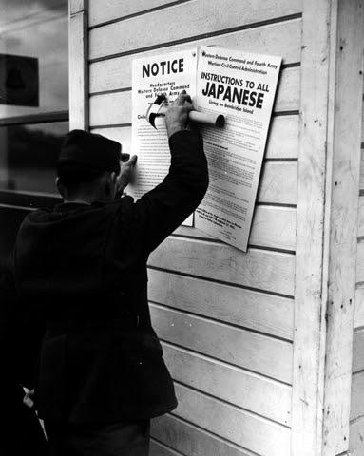
Source: Densho Digital Repository: ddr-densho-36-28 (Legacy UID: denshopd-i36-00028) Courtesy of the Seattle Post-Intelligencer Collection (number PI-28035), Museum of History & Industry

Photo of the Forced Removal From Bainbridge Island
On March 30, 1942, military troops arrived on Bainbridge Island to force the removal of all Japanese American residents. Kikuyo (back left) and Henry Takayoshi waited at the Eagledale ferry dock with their children. A special ferry transported them from Bainbridge Island to Seattle where they were placed on trains and sent to California.

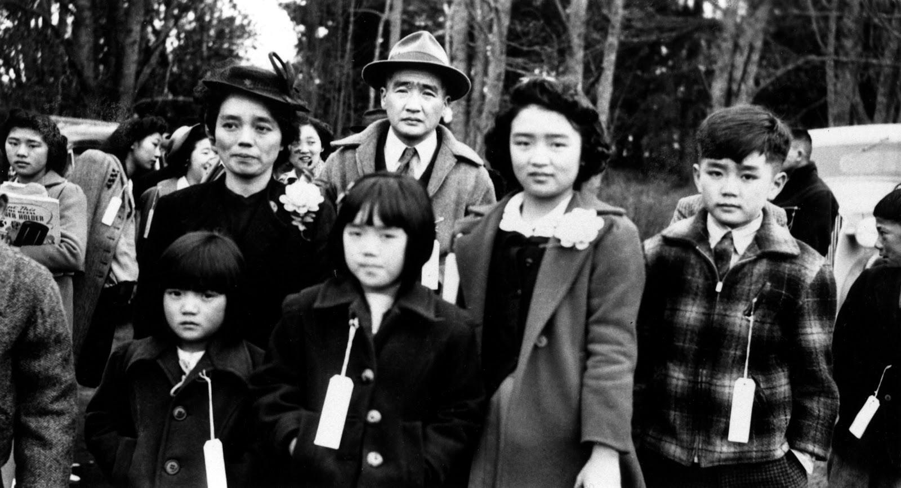

Source: Densho Digital Repository: ddr-densho-34-80 (Legacy UID: denshopd-i34-00080)

Photo of the Forced Removal From Bainbridge Island
On March 30, 1942, military troops arrived on Bainbridge Island to force the removal of all Japanese American residents. Mr. and Mrs. Moji (inside truck) and their dog, King were among those removed. Japanese Americans were not allowed to take family pets with them to prison camp, if they were lucky, they could leave the animals with friends or neighbors.
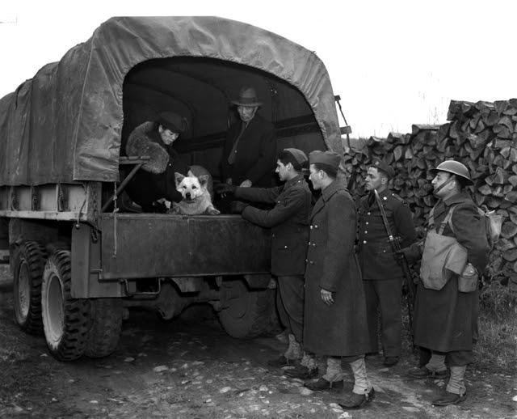

Source: Densho Digital Repository, ddr-densho-36-24 (Legacy UID: denshopd-i36-00024) Courtesy of the Seattle Post-Intelligencer Collection (number PI-28046), Museum of History &

Photo of the Forced Removal From Bainbridge Island
On March 30, 1942, military troops arrived on Bainbridge Island to force the removal of all Japanese American residents. A special ferry was docked at the Eagledale dock to transport the residents to Seattle where they were placed on trains and sent to California.

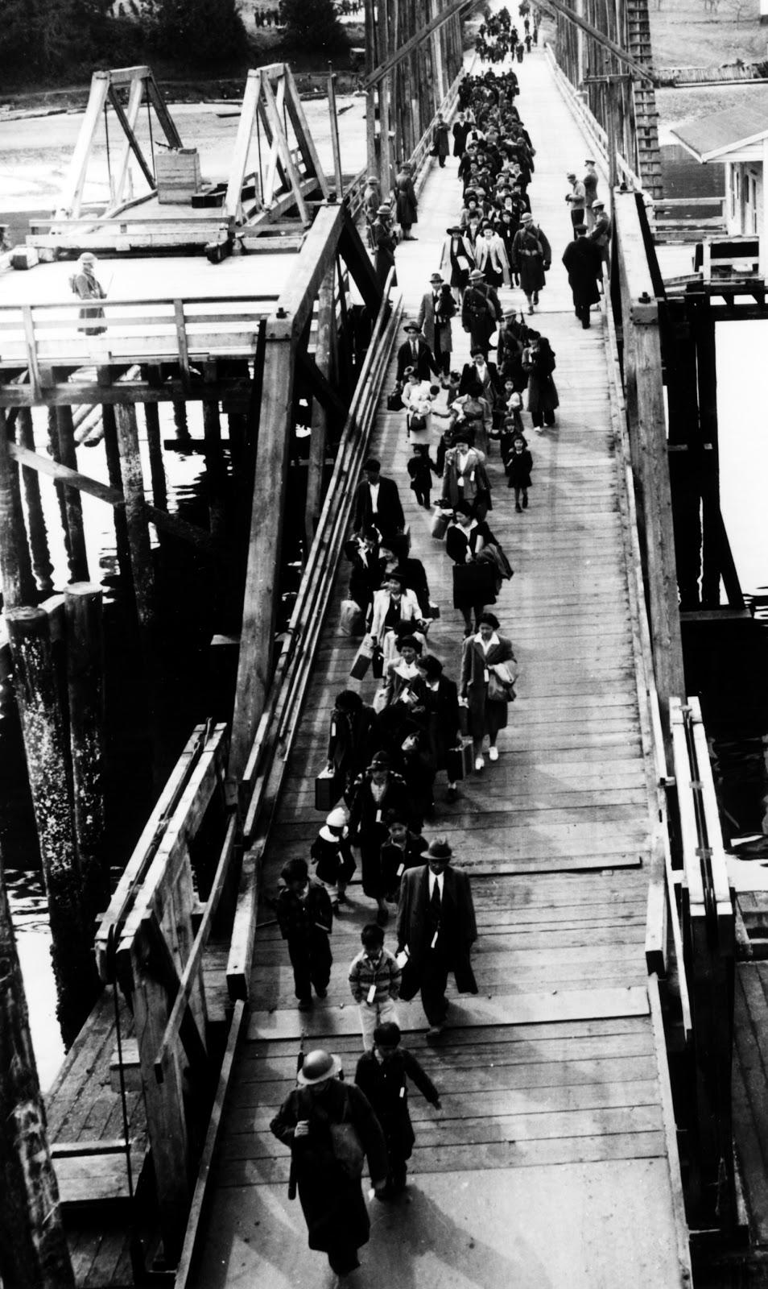
Source: Densho Digital Repository, ddr-densho-34-2 (Legacy UID: denshopd-i34-00002) Courtesy of the Bainbridge Island Japanese American Community

Japanese American Citizens League of Seattle Statement, Excerpt
Founded in 1929, the Japanese American Citizens League (JACL) served as an advocate for citizenship for Japanese and Asian immigrants. In February 1942, the Seattle branch of the organization drafted a report to express its opposition to the forced removal of Japanese Americans. This document is an excerpt from that report.

STATEMENT BY EMERGENCY DEFENSE COUNCIL, SEATTLE CHAPTER, JAPANESE-AMEERICAN CITIZENS LEAGUE, SEATTLE, WASH.

REPORT PRESENTED TO TOLAN CONGRESSIONAL COMMITTEE, FEBRUARY 28, 1942.

For some time now there has been agitation for the evacuation of Japanese nationals as well as American citizens of Japanese descent from Pacific Coast States. Such evacuation has been proposed in a variety of forms.

We wish to go on record now that the safety and welfare of the United States is, has been, and will continue to be foremost in our minds. We, as American citizens, have a duty to this, our country, and the first tenet of that duty is complete and unshakeable loyalty.

For this very reason, we are opposed to the idea of indiscriminate, en masse evacuation of all citizens and loyal aliens of Japanese extraction. We are wholeheartedly in favor of complete cooperation with the military and other authorities on withdrawal of civilians from the immediate vicinity of defense projects and establishments. But we do not believe that mass evacuation is either desirable or feasible. We believe that the best interests of the United States will be served by other solutions to the problem.

We also desire the privilege of remaining here to fight shoulder to shoulder, and shed our blood, if necessary, in the defense of our country and our home together with patriotic Americans of other national extractions if that time should ever come.

If it is for the greater good that evacuation be decreed, we shall obey to the best of our ability. But we are convinced that here in our homes and in our community is where we belong, where we can lend every ounce of our strength, and every cent of our resources, in creating the sinews of war so necessary to total victory. We are Americans. We want to do our duty where we can serve best.

We believe the so-called Japanese problem is not so serious as certain vocal exponents of mass evacuation profess to believe. We are sure that the benefits to be derived from large-scale evacuation of Japanese from the State of Washington are overwhelmingly overbalanced by the benefits to be derived by keeping them here under the proper supervision.

The Japanese problem is not going to be solved by evacuation. If they are a problem here, they will be a problem wherever they are sent. Since this is so, it is logical that they can be kept under better surveillance where they are now, concentrated as they are well-defined areas and where they can continue to do their bit for the national defense.

Source: Online Archive of California, Special Collections and Archives, The UC Irvine Libraries
https://oac.cdlib.org/view?docId=hb8s2008kv&brand=oac4&doc.view=entire_text

Executive Order No. 9066

On February 19, 1942, President Franklin D. Roosevelt signed Executive Order 9066. This order gave the military broad powers to ban any citizen from a fifty- to sixty-mile-wide coastal area stretching from Washington state to California and extending inland into southern Arizona. The order also authorized transporting these citizens to assembly centers hastily set up and governed by the military in California, Arizona, Washington state, and Oregon.

Executive Order No. 9066
The President
Executive Order
Authorizing the Secretary of War to Prescribe Military Areas
Whereas the successful prosecution of the war requires every possible protection against espionage and against sabotage to national-defense material, national-defense premises, and national-defense utilities as defined in Section 4, Act of April 20, 1918, 40 Stat. 533, as amended by the Act of November 30, 1940, 54 Stat. 1220, and the Act of August 21, 1941, 55 Stat. 655 (U.S.C., Title 50, Sec. 104);
Now, therefore, by virtue of the authority vested in me as President of the United States, and Commander in Chief of the Army and Navy, I hereby authorize and direct the Secretary of War, and the Military Commanders whom he may from time to time designate, whenever he or any designated Commander deems such action necessary or desirable, to prescribe military areas in such places and of such extent as he or the appropriate Military Commander may determine, from which any or all persons may be excluded, and with respect to which, the right of any person to enter, remain in, or leave shall be subject to whatever restrictions the Secretary of War or the appropriate Military Commander may impose in his discretion. The Secretary of War is hereby authorized to provide for residents of any such area who are excluded therefrom, such transportation, food, shelter, and other accommodations as may be necessary, in the judgment of the Secretary of War or the said Military Commander, and until other arrangements are made, to accomplish the purpose of this order. The designation of military areas in any region or locality shall supersede designations of prohibited and restricted areas by the Attorney General under the Proclamations of December 7 and 8, 1941, and shall supersede the responsibility and authority of the Attorney General under the said Proclamations in respect of such prohibited and restricted areas.
I hereby further authorize and direct the Secretary of War and the said Military Commanders to take such other steps as he or the appropriate Military Commander may deem advisable to enforce compliance with the restrictions applicable to each Military area hereinabove authorized to be designated, including the use of Federal troops and other Federal Agencies, with authority to accept assistance of state and local agencies.
I hereby further authorize and direct all Executive Departments, independent establishments and other Federal Agencies, to assist the Secretary of War or the said Military Commanders in carrying out this Executive Order, including the furnishing of medical aid, hospitalization, food, clothing, transportation, use of land, shelter, and other supplies, equipment, utilities, facilities, and services.
This order shall not be construed as modifying or limiting in any way the authority heretofore granted under Executive Order No. 8972, dated December 12, 1941, nor shall it be construed as limiting or modifying the duty and responsibility of the Federal Bureau of Investigation, with respect to the investigation of alleged acts of sabotage or the duty and responsibility of the Attorney General and the Department of Justice under the Proclamations of December 7 and 8, 1941, prescribing regulations for the conduct and control of alien enemies, except as such duty and responsibility is superseded by the designation of military areas hereunder.
Franklin D. Roosevelt
The White House,
February 19, 1942.
[F.R. Doc. 42–1563; Filed, February 21, 1942; 12:51 p.m.]

Source: Executive Order No. 9066, February 19, 1942, General Records of the United States Government; Record Group 11; National Archives.

Bainbridge Review Editorial February 5, 1942

The Bainbridge Review was a small weekly newspaper published by Bainbridge Island residents Walter and Milly Woodward. It was one of the few newspapers along the West Coast to caution against anti-Japanese hysteria and oppose the removal of Japanese Americans from the coastal region. Even after the forced removal of all Japanese Americans from Bainbridge island, the newspaper continued to consider them as part of the Bainbridge community and hired a young Nisei to write weekly reports from the Manzanar prison camp.

More Plain Talk
The time has come to bear out the truth of our words, written two months ago in an extra edition of The review published the day after Hawaii was bombed. We spoke of an American recoil to Japanese treachery and wrote:
“And in such recoil of sentiment there is danger of a blind, wild, hysterical hatred of all persons who can trace ancestry to Japan.”
Up and down the Pacific Coast, in the newspapers and in the halls of Congress are words of hatred now for all Japanese, whether they be citizens of America. These words reached a shrieking crescendo when Henry McLemore, with all the intelligence of a blind pig, wrote in the Seattle Times: “Personally, I hate the Japanese. And that goes for all of them.”
That may be patriotism of a hysterical degree; but it certainly isn’t the kind of patriotism that will win the war. Let us think, for a moment, what would happen if the government should adopt Mr. McLemore’s fervid plea for the “immediate removal of every Japanese on the West Coast to a point deep in the interior. I don’t mean a nice part of the interior, either.”
Just who would grow our fruits and vegetables if Mr. McLemore’s advice is followed? We have no figures before us, but it certainly is an apparent fact that the bulk of our produce snd, we dare say, the bulk of the produce grown for our Army and Navy encampments on the West Coast, come from Japanese gardens. The economy of one-third of the nation would be thrown into utter confusion if all Japanese were herded into the interior.
But what of another factor--the wreckage that it would bring to lives of thousands and thousands of loyal American citizens who can’t avoid ancestry in Japan!
For Who--besides those so blind as Mr. McLemore--can say that the big majority of our American-Japanese citizens are not loyal to the land of their birth--The United States! Their record bespeaks nothing but loyalty: Their sons are in our Army; they are heavy contributors to the Red Cross and to the defense bond drives. Even in Hawaii, was there any, record of any Japanese-American citizen being other than intensely loyal?

The Review argues only with Mr. McLemore and his ilk. It will not dispute the federal government if it, in its infinite wisdom, calls for the removal from the Coast of all Japanese. Such order--which we hope will not come--will be based on military necessities and not on hatred.
Japanese people, whether citizens or aliens, must prepare themselves for what may seem to them unfair and unreasoning treatment. But if they value their American citizenship and the right to live in this free nation, they must stand fast in their loyalty. American boys--including some of their sons--are giving their lives for Liberty. Any other sacrifice is not too great.
Source: Kipsap History Online, A Special Collection of Kipsap Regional Library. https://cdm16169.contentdm.oclc.org/digital/collection/p16169coll1/id/2185/rec/50

I Am An American
Dorothea Lange had photographed the plight of migrant families for the Farm Security Administration during the Great Depression in the 1930s. She was hired again in the early 1940s by the War Relocation Authority to document the forced removal of Japanese Americans from the West Coast. This photo was taken in March 1942 and shows the Wanto Co. store in Oakland, California. The business was owned by the Matsuda family. Tatsuro Matsuda, a University of California graduate, commissioned and installed the "I am an American" sign.
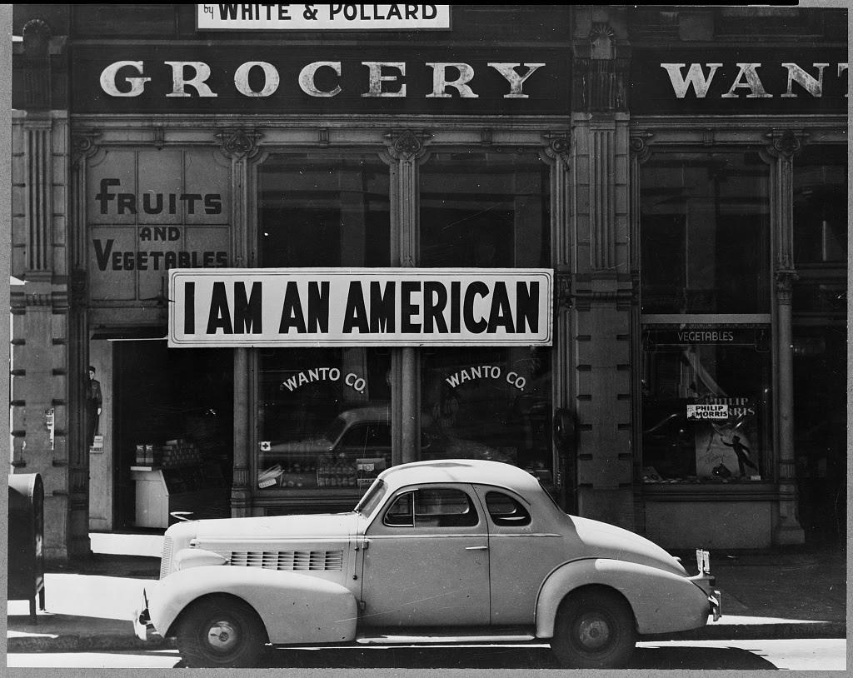

Photographer’s caption: Oakland, Calif., Mar. 1942. A large sign reading "I am an American" placed in the window of a store, at [401 - 403 Eighth] and Franklin streets, on December 8, the day after Pearl Harbor. The store was closed following orders to persons of Japanese descent to evacuate from certain West Coast areas. The owner, a University of California graduate, will be housed with hundreds of evacuees in War Relocation Authority centers for the duration of the war.
Source: Library of Congress Prints and Photographs Division, https://www.loc.gov/item/2004665381/

Dr. Seuss Cartoon, December 10, 1942

In the 1940s, children’s book author Theodor Seuss Geisel, known as Dr. Seuss, created political cartoons for PM, a daily newspaper published in New York. Although the newspaper’s mission statement claimed: “PM is against people who push other people around,” Dr. Seuss’s cartoons portrayed stereotyped and racist images of Japanese Americans.

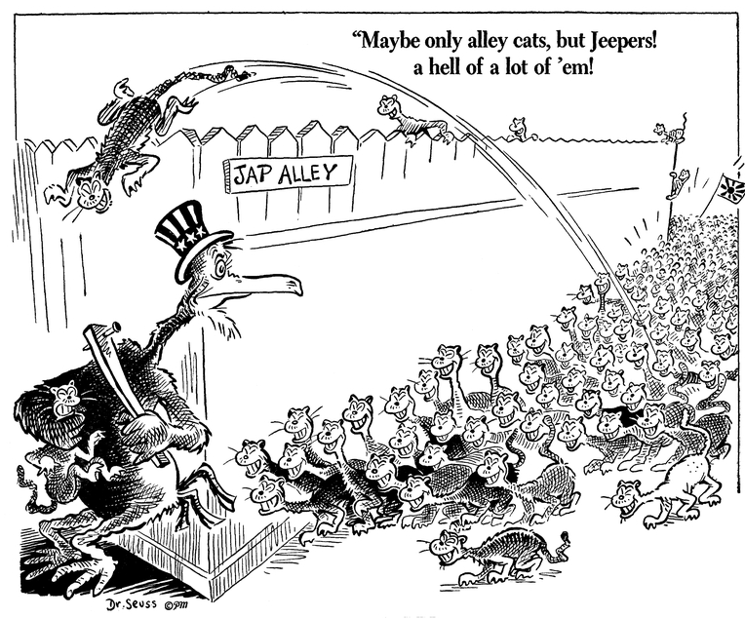

Source: Maybe only alley cats, but Jeepers! A hell of a lot of 'em!, December 10, 1941, Dr. Seuss Political Cartoons. Special Collection & Archives, UC San Diego Library. Digital object made available by Special Collections & Archives, UC San Diego, La Jolla, 92093-0175 (https://lib.ucsd.edu/sca)

Dr. Seuss Cartoon, February 13, 1942

In the 1940s, children’s book author Theodor Seuss Geisel, known as Dr. Seuss, created political cartoons for PM, a daily newspaper published in New York. Although the newspaper’s mission statement claimed: “PM is against people who push other people around,” Dr. Seuss’s cartoons portrayed stereotyped and racist images of Japanese Americans.

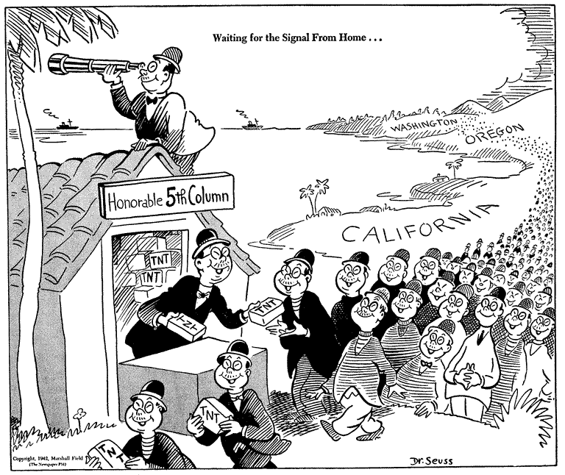

Source: Waiting for the signal from home..., February 13, 1942, Dr. Seuss Political Cartoons. Special Collection & Archives, UC San Diego Library. Digital object made available by Special Collections & Archives, UC San Diego, La Jolla, 92093-0175 (https://lib.ucsd.edu/sca)

Instructions to all Persons of Japanese Ancestry

These instructions for the removal of Japanese Americans living in Seattle, Washington were posted throughout Japanese American neighborhoods. In addition to these instructions, military troops posted flyers informing Japanese Americans of their imminent removal. These orders followed Executive Order 9066, which gave the Western Defense Command of the Department of War the authority to exclude anybody from what it deemed strategic areas.

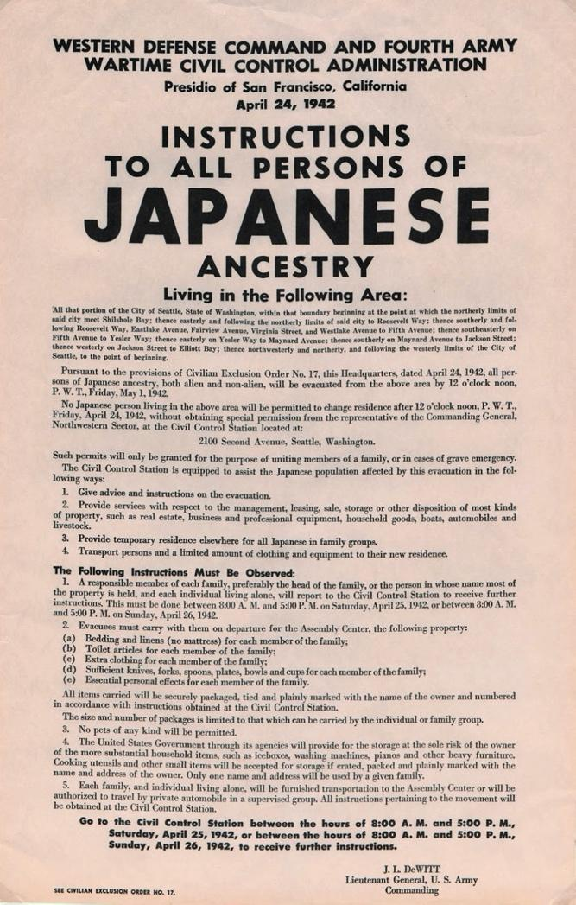
Source: Western Defense Command and Fourth Army Wartime Civil Control Administration, “Instructions to all persons of Japanese ancestry,” Washington State University, Digital Exhibits, accessed April 17, 2020, http://digitalexhibits.wsulibs.wsu.edu/items/show/4407.

WESTERN DEFENSE COMMAND AND FOURTH ARMY
WARTIME CIVIL CONTROL ADMINISTRATION

Presidio of San Francisco, California
April 24, 1942

INSTRUCTIONS
TO ALL PERSONS OF
JAPANESE
ANCESTRY

Living in the Following Area:

All that portion of the City of Seattle, State of Washington, within that boundary beginning at the point at which the northerly limits of said city meet Shilshole Bay; easterly and following the northerly limits of said city to Roosevelt Way; thence southerly and following Roosevelt Way, Eastlake Avenue, Fairview Avenue, Virginia Street, and Westlake Avenue to Fifth Avenue; thence southeasterly on Fifth Avenue to Yesler Way; thence easterly on Yesler Way to Maynard Avenue; thence southerly on Maynard Avenue to Jackson Street; thence westerly on Jackson Street to Elliot Bay; thence northwesterly and northerly, and following the westerly limits of the City of Seattle, to the point of beginning.

Pursuant to the provisions of Civilian Exclusion Order No. 17, this Headquarters, dated April 24, 1942, all persons of Japanese ancestry, both alien and non-alien, will be evacuated from the above area by 12 o'clock noon, P.W.T., Friday, May 1, 1942.

No Japanese person living in the above area will be permitted to change residence after 12 o'clock noon, P.W.T., Friday, April 24, 1942, without obtaining special permission from the representative of the Commanding General, Northwestern Sector, at the Civil Control Station located at:

2100 Second Avenue, Seattle, Washington.

Such permits will only be granted for the purpose of uniting members of a family, or in cases of grave emergency.

The Civil Control Station is equipped to assist the Japanese population affected by this evacuation in the following ways:
1. Give advice and instructions on the evacuation.
2. Provide services with respect to the management, leasing, sale, storage or other disposition of most kinds of property, such as real estate, business and professional equipment, household goods, boats, automobiles and livestock.
3. Provide temporary residence elsewhere for all Japanese in family groups.
4. Transport persons and a limited amount of clothing and equipment to their new residence.

The Following Instructions Must be Observed:

1. A responsible member of each family, preferably the head of the family, or the person in whose name most of the property is held, and each individual living alone, will report to the Civil Control Station to receive further instructions. This must be done between 8:00 A. M. and 5:00 P. M. on Saturday, April 25, 1942, or between 8:00 A. M. and 5:00 P. M. on Sunday, April 26, 1942.

2. Evacuees must carry with them on departure for the Assembly Center, the following property:
(a) Bedding and linens (no mattress) for each member of the family;
(b) Toilet articles for each member of the family;
(c) Extra clothing for each member of the family;
(d) Sufficient knives, forks, spoons, plates, bowls and cups for each member of
the family;
(e) Essential personal effects for each member of the family.

All items carried will be securely packaged, tied and plainly marked with the name of the owner and numbered in accordance with instructions obtained at the Civil Control Station. The size and number of packages is limited to that which can be carried by the individual or family group.

3. No pets of any kind will be permitted.

4. The United States Government through its agencies will provide for the storage at the sole risk of the owner of the more substantial household items, such as iceboxes, washing machines, pianos and other heavy furniture. Cooking utensils and other small items will be accepted for storage if crated, packed and plainly marked with the name and address of the owner. Only one name and address will be used by a given family.

5. Each family, and individual living alone, will be furnished transportation to the Assembly Center or will be authorized to travel by private automobile in a supervised group. All instructions pertaining to the movement will be obtained at the Civil Control Station.

Go to the Civil Control Station between the hours of 8:00 A. M. and 5:00 P. M.,
Saturday, April 25, 1942, or between the hours of 8:00 A. M. and 5:00 P. M.,
Sunday, April 26, 1942, to receive further instructions.

J. L. DEWITT
Lieutenant General, U. S. Army
Commanding

SEE CIVILIAN EXCLUSION ORDER NO. 17.

Stanley Hayami Diary Entries December. 1942
Stanley Kunio Hayami was sixteen in 1942 when his family was forcibly removed from Los Angeles, California and incarcerated at Heart Mountain Wyoming. Throughout his imprisonment at Heart Mountain, Hayami kept a diary filled with pen-and-ink drawings and he reported regularly on his daily activities such as studying for tests, listening to football games on the radio, or going to the movies. He also voiced his views on the incarceration and the military draft, and spoke of the importance of serving his country. As a high school student, he longed to pursue a career as an artist and writer. Stanley Hayami’s experiences and thoughts served as an inspiration for the Henry Tanaka character in A Prisoner in My Homeland
.
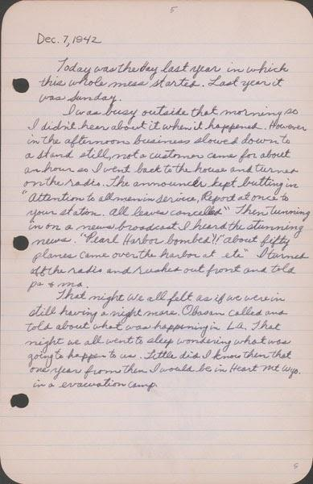

Dec. 7, 1942
Today was the day last year in which this whole mess started. Last year it was Sunday.
I was busy outside that morning so I didn’t hear about it when it happened. However in the afternoon business slowed down to a stand still, not a customer came for about an hour so I went back to the house and turned on the radio. The announcer kept butting in. “Attention to all men in service. Report at once to your station. All leaves cancelled.” Then tuning in on a news broadcast I heard the stunning news. “Pearl Harbor bombed!!” “About fifty planes came over the harbor at etc.” I turned off the radio and rushed out front and told pa & ma.
That night we all felt as if we were in [sic] still having a nightmare. Obasan called and told about what was happening in L.A. That night we all went to sleep wondering what was going to happen to us. Little did I know then that one year from then I would be in Heart Mountain Wyo. in a [sic] evacuation camp.

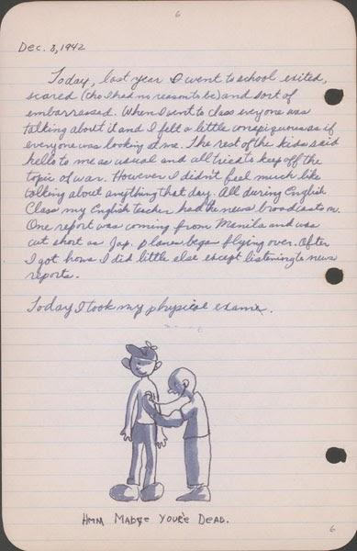

Dec. 8, 1942
Today, last year I went to school excited, scared (tho I had no reason to be) and sort of embarrassed. When I went to class everyone was talking about it and I felt a little conspicuous as if everyone was looking at me. The rest of the kids said hello to me as usual and all tried to keep off the topic of war. However I didn’t feel much like talking about anything that day. All during English class my English teacher had the news broadcasts on. One report was coming from Manila and was cut short as Jap. planes began flying over. After I got home I did little else except listening to the news reports.
Today I took my physical exam.

Source: Hayami (Stanley) Diary Collection, Japanese American National Museum. Accessed through Calisphere, April 20, 2020. Recto of page 10: https://calisphere.org/item/ark:/13030/tf267n98tj/ Verso of page 10: https://calisphere.org/item/ark:/13030/tf996nb3qv/

Gordon Hirabayashi Letter: “Why I Refused to Register for Evacuation,” May 13, 1942

In 1940, Gordon Hirabayshi was a college student in Seattle, Washington. He was a pacifist and had registered with the Selective Service as a conscientious objector. After President Roosevelt issued Executive Order 9066 and it became clear that Japanese Americans would be removed from the West Coast, Hirabayashi left school to work with the American Friends Service Committee, organized by Quakers, to assist Japanese American families. As a U.S. citizen, Hirabayashi assumed his rights would be respected, but when orders came first for the curfew and then the removal he chose to resist and turned himself into the FBI to create a test case for the constitutionality of those orders.
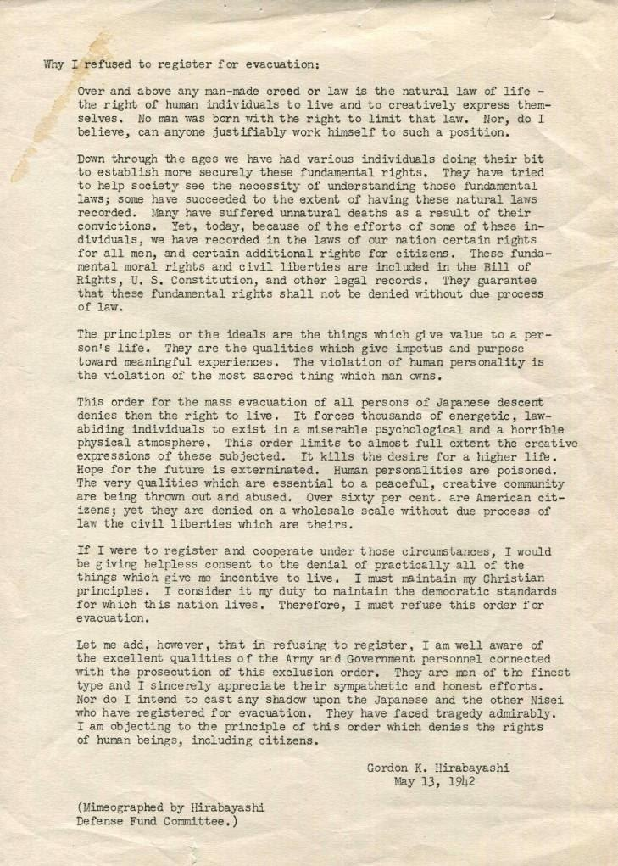
Source: University of Washington Libraries, Special Collections, https://digitalcollections.lib.washington.edu/digital/collection/pioneerlife/id/21356/

Why I refused to register for evacuation:

Over and above any man-made creed or law is the natural law of life – the right of human individuals to live and to creatively express themselves. No man was born with the right to limit that law. Nor, do I believe, can anyone justifiably work himself to such a position.

Down through the ages we have had various individuals doing their bit to establish more securely these fundamental rights. They have tried to help society see the necessity of understanding those fundamental laws; some have succeeded to the extent of having these natural law recorded. Many have suffered unnatural deaths as a result of their convictions. Yet, today, because of the efforts of some of these individuals, we have recorded in the laws of our ration certain rights for all men, and certain additional rights for citizens. These fundamental moral rights and civil liberties are included in the Bill of Rights, U.S. Constitution, and other legal records. They guarantee that these fundamental rights shall not be denied without due process of law.

The principles or the ideals are the things which give value to a person’s life. They are the qualities which give impetus and purpose toward meaningful experiences. The violation of human personality is the violation of the most sacred thing which man owns.

This order for the mass evacuation of all persons of Japanese descent denies them the right to live. It forces thousands of energetic, law-abiding individuals to exist in a miserable psychological and horrible physical atmosphere. This order limits to almost full extent the creative expressions of those subjected. It kills the desire for a higher life. Hope for the future is exterminated. Human personalities are poisoned. The very qualities which are essential to a peaceful, creative community are being thrown out and abused. Over sixty per cent are American citizens; yet they are denied on a wholesale scale without due process of law the civil liberties which are theirs.

If I were to register and cooperate under these circumstances, I would be giving helpless consent to the denial of practically all of the things which give me incentive to live. I must maintain my Christian principles. I consider it my duty to maintain the democratic standards for which this nation lives. Therefore, I must refuse this order for evacuation.

Let me add, however, that in refusing to register, I am well aware of the excellent qualities of the Army and Government personnel connected with the persecution of this exclusion order. They are men of the finest type and I sincerely appreciate their sympathetic and honest efforts. Nor do I intend to cast any shadow upon the Japanese and the other Nisei who have registered for evacuation. They have faced tragedy admirably. I am objecting to the principle of this order which denies the rights of human beings, including citizens.

Gordon K. Hirabayashi
May 13, 1942

"First impression of Manzanar" A Kango Takamura Painting

Kango Takamura was an Issei artist who had been a photo retoucher for RKO Studios in Hollywood before being incarcerated at the Manzanar prison camp. He documented his experiences at Manzanar in a series of watercolor paintings and drawings.

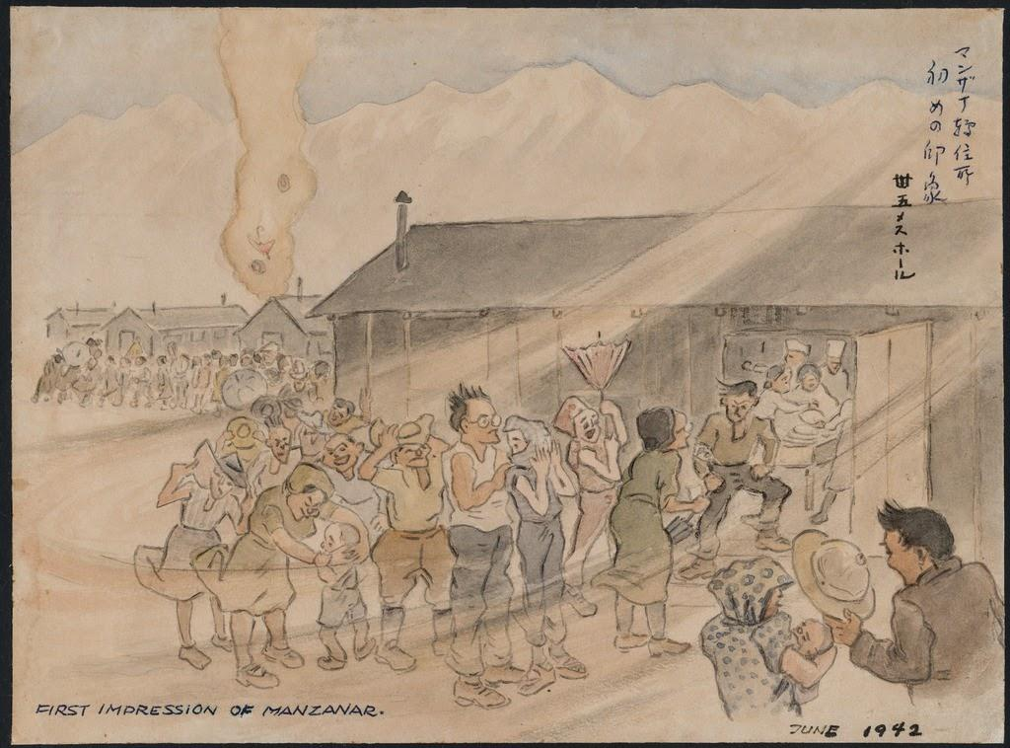

Courtesy of Manzanar National Historic Site and the Kango Takamura Collection http://ddr.densho.org/ddr-manz-2-42/
Copyright restricted

Dorothea Lange Photo - Hospital Latrines

Dorothea Lange had photographed the plight of migrant families for the Farm Security Administration during the Great Depression in the 1930s. She was hired again in the early 1940s by the War Relocation Authority to document the forced removal of Japanese Americans from the West Coast. Many of Lange’s photographs exposed the difficulties and harsh conditions in the camps, and were censored by the government during the war. The following image––taken in the first months at Manzanar––depicts temporary hospital beds and outdoor latrines (toilets) for patients.

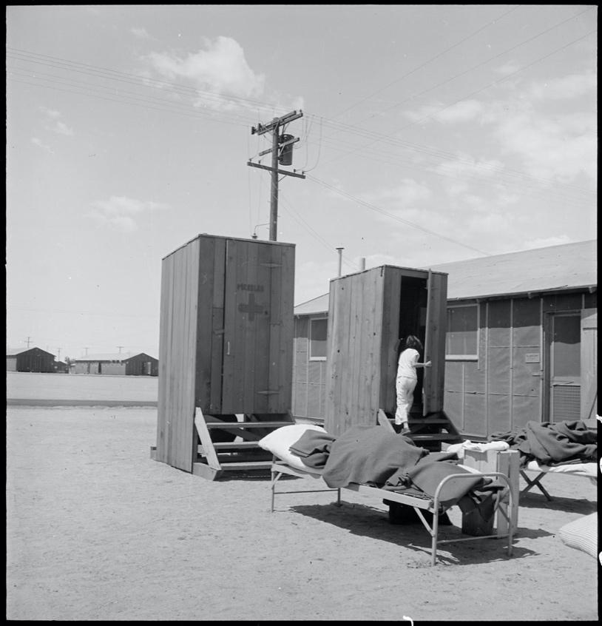

Caption: Manzanar Relocation Center, Manzanar, California. Hospital latrines, for patients, between the barracks, which serve temporarily as wards. For the first three months of occupancy medical facilities have been meager but the new hospital fully equipped, is almost ready for occupancy. 7/1942

Source: National Archives: Record Group 210: Records of the War Relocation Authority, 1941 - 1989 Series: Central Photographic File of the War Relocation Authority, 1942 - 1945 https://catalog.archives.gov/id/538149
Dorothea Lange Photo: Dust Storm at Manzanar

Dorothea Lange had photographed the plight of migrant families for the Farm Security Administration during the Great Depression in the 1930s. She was hired again in the early 1940s by the War Relocation Authority to document the forced removal of Japanese Americans from the West Coast. Many of Lange’s photographs exposed the difficulties and harsh conditions in the camps, and were censored by the government during the war. The following image shows a dust storm blowing through the Manzanar camp.

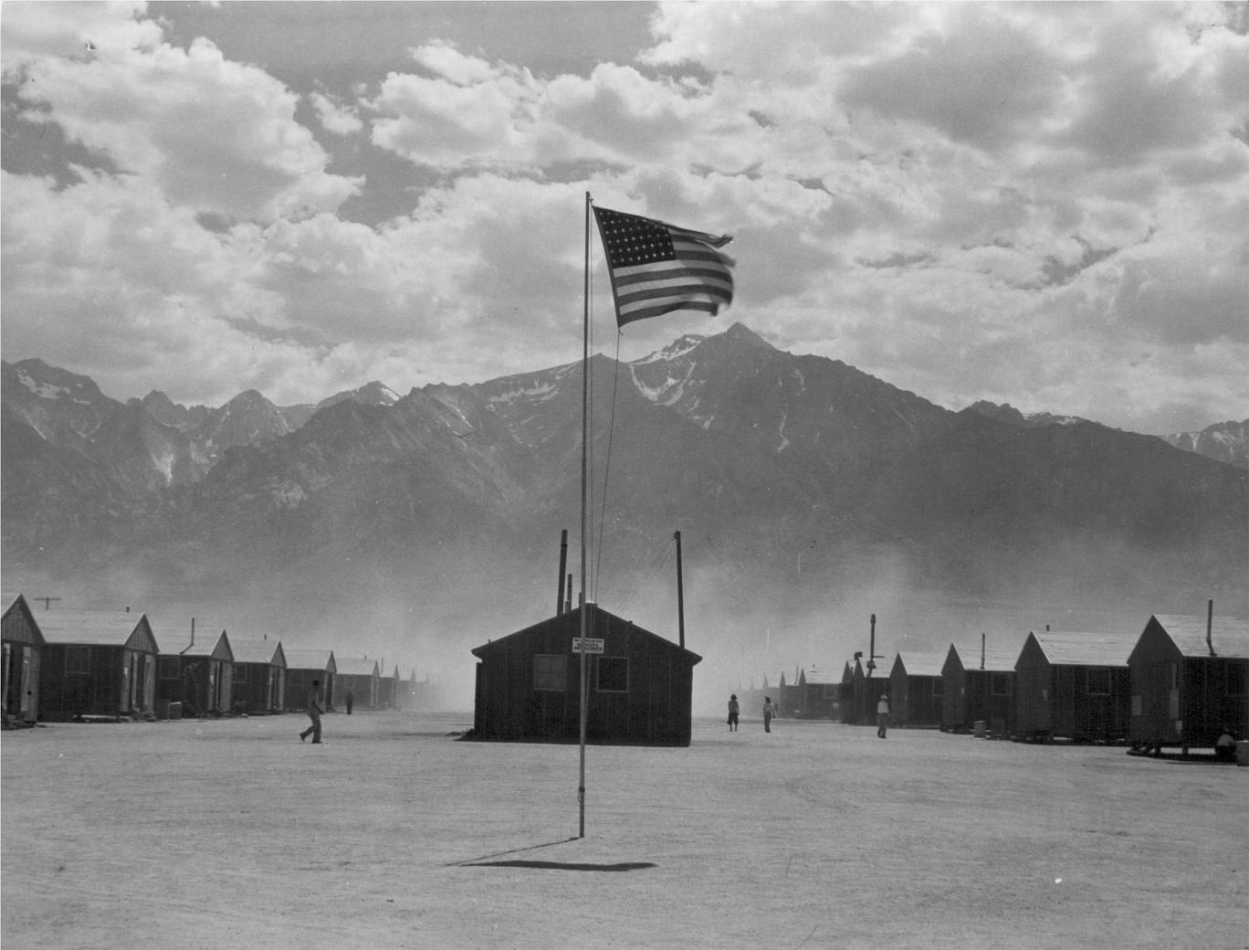

Caption: Manzanar, California. Dust storm at this War Relocation Authority center where evacuees of Japanese ancestry are spending the duration.

Source: National Archives: Record Group 210: Records of the War Relocation Authority, 1941 - 1989 Series: Central Photographic File of the War Relocation Authority, 1942 - 1945 https://catalog.archives.gov/id/539961
Dorothea Lange Photo: Elementary School

Dorothea Lange had photographed the plight of migrant families for the Farm Security Administration during the Great Depression in the 1930s. She was hired again in the early 1940s by the War Relocation Authority to document the forced removal of Japanese Americans from the West Coast. Many of Lange’s photographs exposed the difficulties and harsh conditions in the camps, and were censored by the government during the war. The following image shows an incarceree teaching children in a makeshift outdoor classroom.

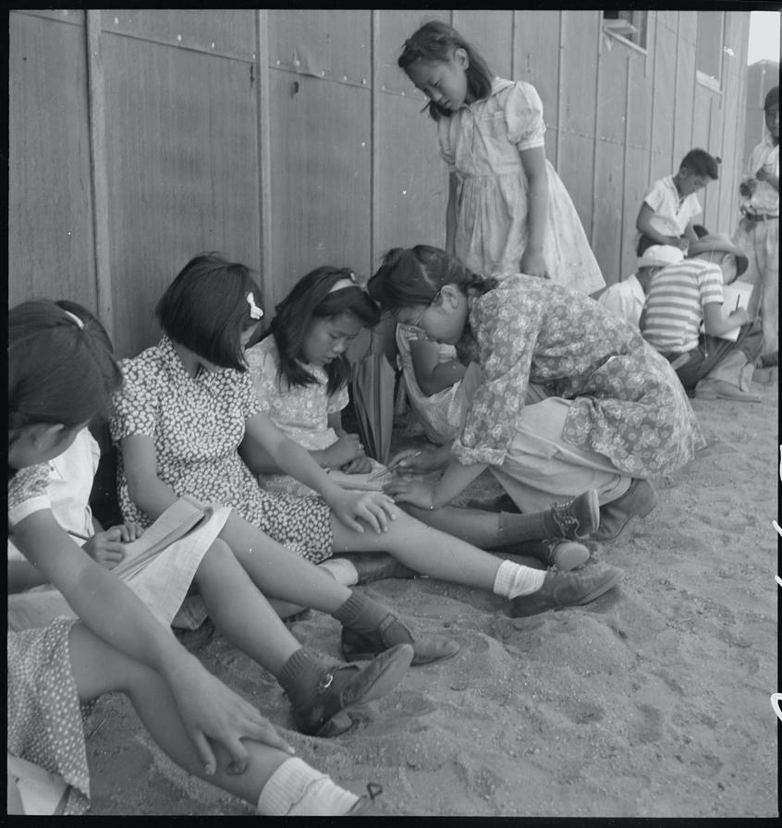

Caption: Manzanar Relocation Center, Manzanar, California. An elementary school with voluntary attendance has been established with volunteer evacuee teachers, most of whom are college graduates. No school equipment is as yet obtainable and available tables and benches are used. However, classes are often held in the shade of the barrack building at this War Relocation Authority center. 1942.

Source: National Archives: Record Group 210: Records of the War Relocation Authority, 1941 - 1989 Series: Central Photographic File of the War Relocation Authority, 1942 - 1945 https://catalog.archives.gov/id/5379
Ansel Adams Photo: Nurse Aiko Hamaguchi
In the 1940s, Ansel Adams, one of the most famous photographers in the United States, went to the Manzanar to document the imprisoned Japanese Americans. He later described the purpose of this photo project as an effort “to show how these people, suffering under a great injustice, and loss of property, businesses and professions, had overcome the sense of defeat and despair by building for themselves a vital community in an arid (but magnificent) environment.” The following image from 1943 shows the newly-built maternity ward at Manzanar.
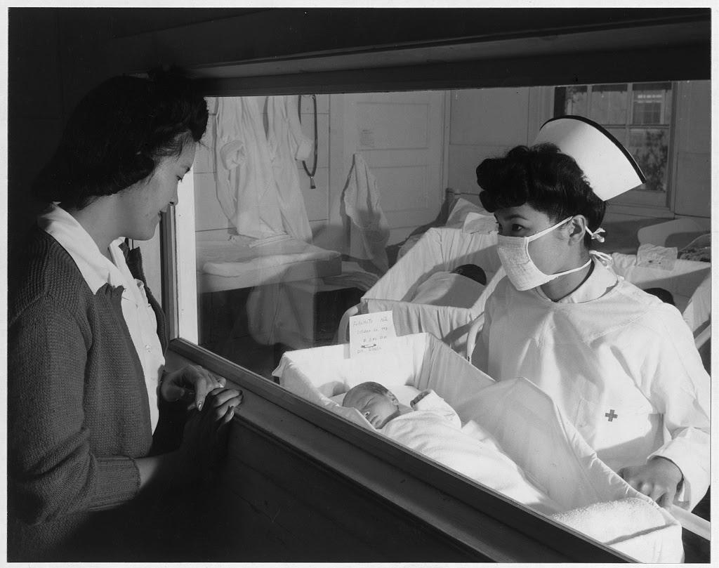

Caption: Nurse Aiko Hamaguchi, mother Frances Yokoyama, baby Fukomoto, Manzanar Relocation Center, California / photograph by Ansel Adams. 1943.

Source: Library of Congress, Prints and Photographs Division, Adams, Ansel, photographer. Nurse Aiko Hamaguchi, mother Frances Yokoyama, baby Fukomoto, Manzanar Relocation Center, California / photograph by Ansel Adams. California Manzanar, 1943. Photograph. https://www.loc.gov/item/2002697854/.
https://www.loc.gov/resource/ppprs.00343/

Ansel Adams Photo: School Children
In the 1940s, Ansel Adams, one of the most famous photographers in the United States, went to the Manzanar to document the imprisoned Japanese Americans. He later described the purpose of this photo project as an effort “to show how these people, suffering under a great injustice, and loss of property, businesses and professions, had overcome the sense of defeat and despair by building for themselves a vital community in an arid (but magnificent) environment.” The following image shows Manzanar school children holding notebooks and leaning on the outside of a barrack.
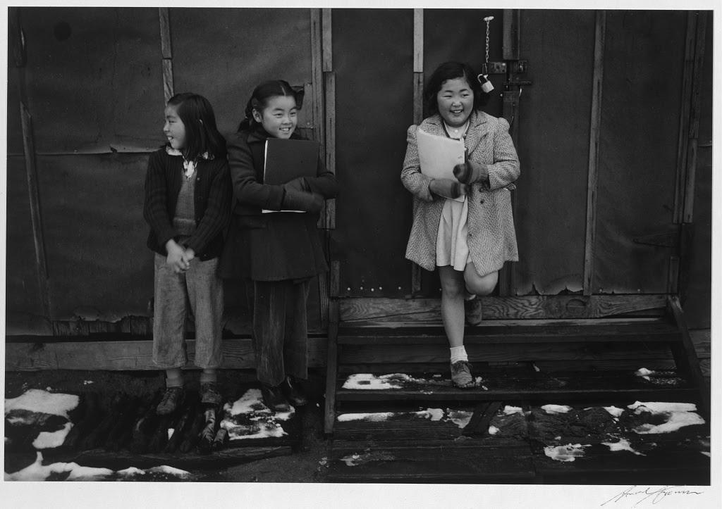

Caption: School children, Manzanar Relocation Center, California / photograph by Ansel Adams, 1942

Source: Library of Congress, Prints and Photographs Division, Adams, Ansel, photographer. School children, Manzanar Relocation Center, California / photograph by Ansel Adams. California Manzanar, 1943. Photograph. https://www.loc.gov/item/2002697874/.
https://www.loc.gov/resource/ppprs.00357/

Ansel Adams Photo: Manzanar Street Scene, Clouds
In the 1940s, Ansel Adams, one of the most famous photographers in the United States, went to the Manzanar to document the imprisoned Japanese Americans. He later described the purpose of this photo project as an effort “to show how these people, suffering under a great injustice, and loss of property, businesses and professions, had overcome the sense of defeat and despair by building for themselves a vital community in an arid (but magnificent) environment.” The following image depicts the barracks at Manzanar with the Sierra Nevada mountains in the background.
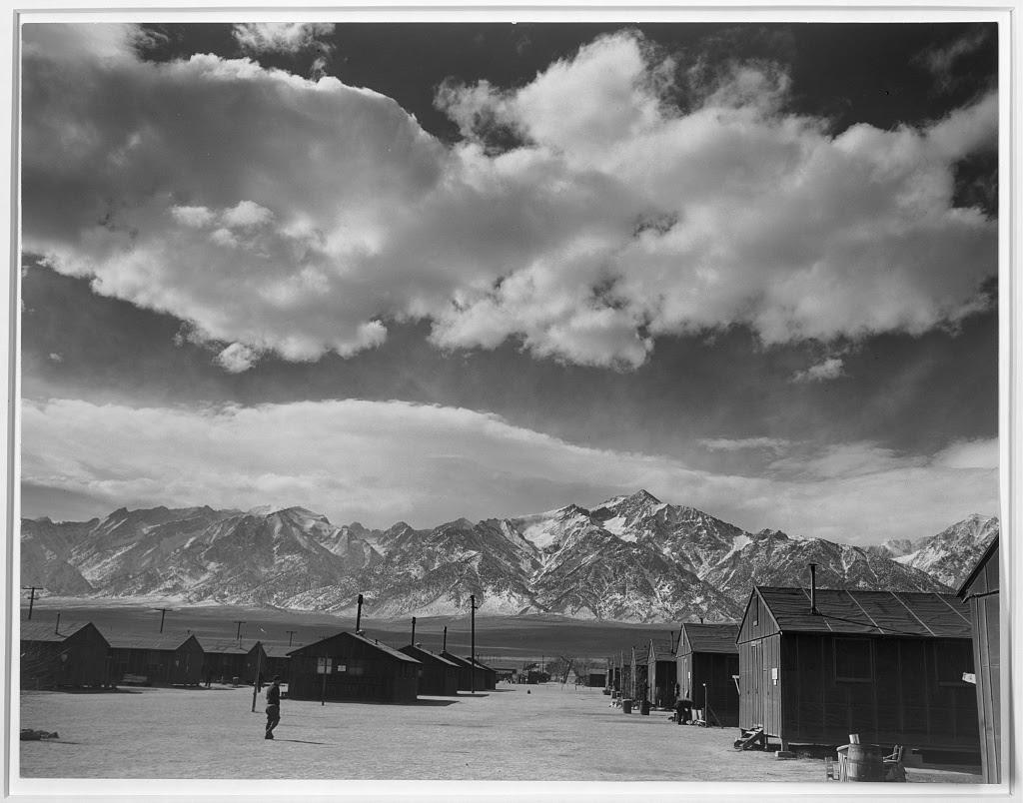

Caption: Manzanar street scene, clouds, Manzanar Relocation Center, California / photograph by Ansel Adams, 1943.

Source: Library of Congress, Prints and Photographs Division, Adams, Ansel, photographer. Manzanar street scene, clouds, Manzanar Relocation Center, California / photograph by Ansel Adams. California Manzanar, 1943. http://loc.gov/pictures/resource/ppprs.00284/

Manzanar Center Citizens Join Net Project en Masse

Various jobs paying minimal wages were available for the Japanese Americans imprisoned at Manzanar. The work included running the mess halls, delivering mail, farming, and caring for young children. One of the more controversial jobs was working on the military contract for camouflage nets, which was limited to U.S. citizens or nissei. This article from the prison camp newspaper, Manzanar Free Press reports on the camouflage work.

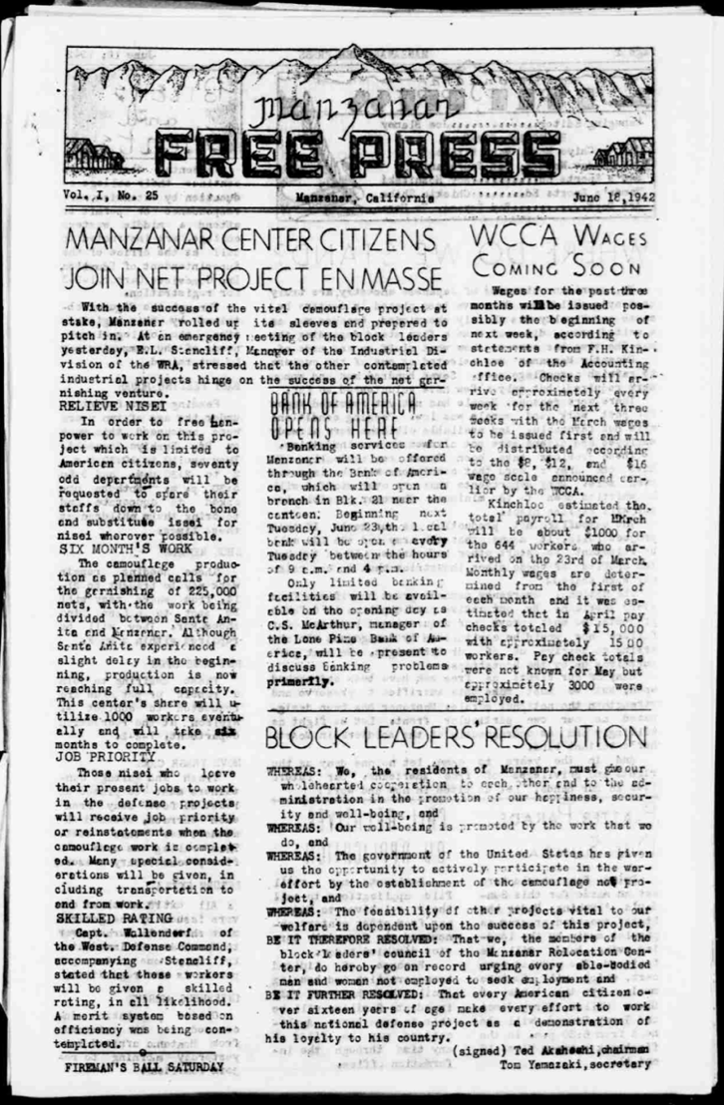

Manzanar Free Press, Vol. I, No. 25
June 18, 1942
https://lccn.loc.gov/sn84025948
MANAZAR CENTER CITIZENS JOIN NET PROJECT EN MASSE

With the success of the vital camouflage project at stake, Manzanar rolled up its sleeves and prepared to pitch in. At an emergency meeting of the block leaders yesterday, E.L. Stancliff, Manager of the Industrial Division of the WRA, stressed that the other contemplated industrial projects hinge on the success of the net garnishing venture.

RELIEVE NISEI
In order to free manpower to work on this project which is limited to American citizens, seventy odd departments will be requested to spare their staffs down to the bone and substitute issei for nisei wherever possible.

SIX MONTH’S WORK
The camouflage production as planned calls for the garnishing of 225,000 nets, with the work being divided between Santa Anita and Manzanar. Although Santa Anita experienced a slight delay in the beginning, production is now reaching full capacity. This center’s share will utilize 1000 workers eventually and will take six months to complete.

JOB PRIORITY
Those nisei who leave their present jobs to work in the defense projects will receive job priority or reinstatements when the camouflage work is completed. Many special considerations will be given, including transportation to and from work.

SKILLED RATING
Capt. Wallendorf of the West. Defense Command, accompanying Stancliff, stated that these workers will be given a skilled rating, in all likelihood. A merit system based on efficiency was being contemplated.

“The Years Between” by Kaizo Kubo
Kaizo was a high school junior at Poston Incarceration Camp in Arizona and won honorable mention for this essay in a national contest sponsored by Scholastic Magazine in 1945. This essay was printed in the Poston Chronicle, prison camp newspaper.

My name is Kaizo Kubo. I have a story to tell. It concerns three years of my past, years which will no doubt leave their marks on me to the end of my days. My name probably sounds strange, foreign; so will my story.
I am American, although for the last three long years I have been so in name only. I am writing these very words behind the shadows of barbed wire. I’ve done no wrong. My only crime is that my hair is black, my skin yellow, my eyes slant; because I am of Japanese ancestry. This is my personal account of prejudice and of human blindness. This is a plan for future justice and tolerance.
I was born in a small town in California not far from the Pacific Ocean. If not for an unfortunate quirk of fate, I would in all probability have never stirred from the scene of so many happy memories. That black day I read the news in the daily papers left me momentarily paralyzed. I stared in mute incredulity at the words emblazened in bold print: GOVERNMENT ORDERS MASS REMOVAL OF ALL JAPANESE FROM COAST HOMES TO INLAND WAR CENTERS.
I took it hard. It meant leaving the only life I knew, parting with my boyhood friends. It spelled goodbye to life. Was this what I had believed in? Was this democracy?
In the ensuing weeks I was spared little time to brood or to think. In the upheaval that followed, we lost our home. Our belongings were either discarded or at best sold at pitiful losses. Before my very eyes my world crumbled.
From the instant I stepped into the barbed wire enclosures of our destinantion, I felt that queer alienable presence within me. All the rash bravado I had saved for this precise moment vanished like a disembodied soul. I suddenly felt incredibly small and alone. So this was imprisonment.
The oppressive silhouette of the guard towers looming cold and dark in the distance affected me in only one way. They seemed to threaten, to challenge me. I hated their ugly hugeness, the power they symbolized. I hold only contempt for that for which they stand. They kept poignantly clear in my mind the unescapable truth that I was a prisoner.
Then my life as an evacuee began, with a government granted broom, a bucket, and a twelve by twenty foot room. We were quartered in converted horse stables which fairly reeked with evidence of recent occupation. Men, women, and children shared these discomforts alike. I learned to eat with strangers, to wash and bathe side by side with unfamiliar faces, and I learned that to hear and not be heard was the best or at least the most healthful policy to follow.
At first I was inclined to think my imagination was provoking the well of silence that seemed to shroud my being, but it was real, as real as evacuation itself. An incomprehensible air of tension hung over the confines of the entire center. Twenty thousand souls brooding. It was not pleasant. The next abruptly discernable phase was a lifting of the silence and in a surprisingly short time, the atmosphere had changed to a noisy, equally unpredictable show of human emotions. Camp life is like that - uncertain.
Three years of a hard existence behind steel and armed guards, no matter what the conditions, cannot go without its ill effects. Our family, like most Japanese families prior to evacuation, was very alone. Today, after three years of communal living, I find myself stumbling over words as I make vain attempts to talk to my father. I don’t understand him; he doesn’t understand me. It is a strange feeling to find such a barrier between my father and myself.
The fixed routine existence offers little incentive for progress; homes, a gradual loss of individual enterprise and initiative is in evidence. I have undergone a similar period of lethargy myself. It is like living in a realm of forgotten people. It was a strange and disturbing malady developed under unusual circumstances, but I overcame it, and with the restoration I won back my faculty of logical and clear thinking.
Here is what I say: there is no need to be bitter. We are situated thus through no fault of our own, but there is nothing to gain by eternally brooding for things that might have been. I have exacted lessons from my past which I hope to put to advantage in my future.
I shall be on my own. It will be no new experience for me. Evacuation was a pioneering project; re-establishing myself into the American stream of life can be looked upon as another such enterprise. Now I stand on the threshold of freedom. I face the future unafraid, proud of my ancestry, but even prouder of my heritage as an American.

--Kaizo Kubo
Honorable Mention
Scholastic Literary Contest

Poem: “Saga of a People” by Ruth Tanaka
Ruth Tanaka was a high school junior at Poston Incarceration Camp in Arizona and won fourth prize for a national contest sponsored by Scholastic Magazine in 1945. This poem was printed in the Poston Chronicle, the prison camp newspaper.

They have sprung from a race as old as Time,
Their backs are bent, their hands are wrinkled and brown,
For they have toiled long years under a harsh master—Life;
Each passing year has left its mark
Upon their seemed and weathered faces
That show as other faces do,
A heart-deep yearning for a far-off land;
A land of frail houses, stunted trees, a sacred volcano
Sleeping under a blanket of snow.
Traces of half-forgotten customs
A love for the life-giving sun, the freshening rain, the deep brown soil,
Still lingers in their hearts.
Deep scars of pain and grief are etched on their worn faces
And yet their wise twinkling eyes
Have looked on life and found it good.

They have come to a fabulous land,
While still dreaming the long thoughts of youth;
They have sowed their seeds, weeded furrows,
Hoed a sun-parched land, watered it and nursed it,
Harvested their plentiful crops, built a home
And borne their children.
Lest they forget the islands of their fathers,
They have brought their little treasures with them -
A miniature chest of drawers, lacquered dragon-red;
Two dainty fans gay with dancing girls;
A bamboo screen with a tiny arched bridge
A fragile lilies reflected in still water;
Little dolls in bright kimonos of hand-painted silk;
Delicate tea cups get on a polished tray.

The seeds they sowed took root and sprouted;
Grew tall and straight with bursting pods;
Giving rich promise of fulfillment.
So grew their black-haired children
Straight and tall, drawing nourishment from the free soil
Of this, their native land.
Their lives were like a deep, peaceful river
The old familiar customs of their ancestors
Mixing with the new bewildering ones of their foster country
And slowly giving way before them
Eating a breakfast of crisp bacon and scrambled eggs
Instead of the hot soup and rice they had eaten
In the home of their fathers;
Raising a huge paper carp on Boys’ Day;
Awkwardly tying a silver star to the tip of the family Christmas tree;
Reluctantly going to a movie with the children,
Leaving behind a friendly game of Go
And a cup of steaming, green tea;
Driving to the beach and learning to roast hot dogs
Over a driftwood fire,
And eating them with seed-covered rice cakes;
Passing on to their children the ceremonious courtesies
That they had learned so long ago.
And so they lived out their lives
Guided by their sons and daughters
Through this strange new world,
Slowly changing their deep-rooted ways.

They have come to a new home
Living in a single room
Behind barbed wire -
They know that peace has been shattered throughout the world
By heavily laden bombs of terror and destruction;
But they who love the deeply tranquil soil
Are stunned, bewildered by it all,
By the cold wall which their American friends
Have built about them.

Now they are standing on the beloved soil of their Western mother,
Their wizened bodies huddled together
Against the bitter cold.
Rising they look toward the sea
Vainly striving through the mists of the past
To live again the dreams of their youth,
Thinking of a pleasant land where cherry blossoms
Warmed their hearts in spring,
Where placid goldfish lazily swam in sunny ponds,
Where all the contented and peaceful;
They turn towards the red glow of a sinking sun
Seeing through the distant hills, seeing over all the land
The rolling hills and valleys of their western mother.
Then they turn towards each other with eyes full,
Unshamedly,
Understandingly;
For deep in their almond, brown eyes,
Deep in the innermost depths of their souls (?)
There shall always glow a hope,
A hope that peace shall come one day
A peace forging with understanding and friendship,
The islands of their long-lost youth
And the far stretching land of their children’s birth.

Stanley Hayami Essay: My Viewpoint of the Evacuation

Stanley Kunio Hayami was sixteen in 1942 when his family was forcibly removed from Los Angeles, California and incarcerated at Heart Mountain Wyoming. Throughout his imprisonment at Heart Mountain, Hayami kept a diary filled with pen-and-ink drawings and he reported regularly on his daily activities such as studying for tests, listening to football games on the radio, or going to the movies. He also voiced his views on the incarceration and the military draft, and spoke of the importance of serving his country. As a high school student, he longed to pursue a career as an artist and writer. Stanley Hayami’s experiences and thoughts served as an inspiration for the Henry Tanaka character in A Prisoner in My Homeland.
First page:
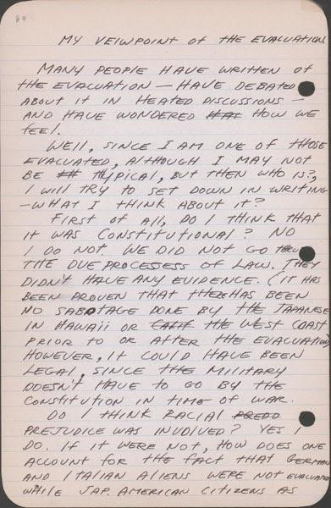
http://www.oac.cdlib.org/ark:/13030/tf6k40056s/?brand=oac4

Second page: http://www.oac.cdlib.org/ark:/13030/tf3489n632/?brand=oac4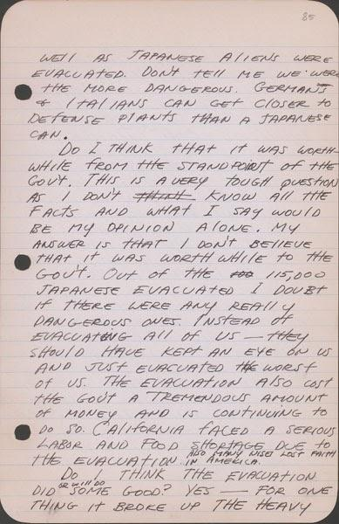

Third page:
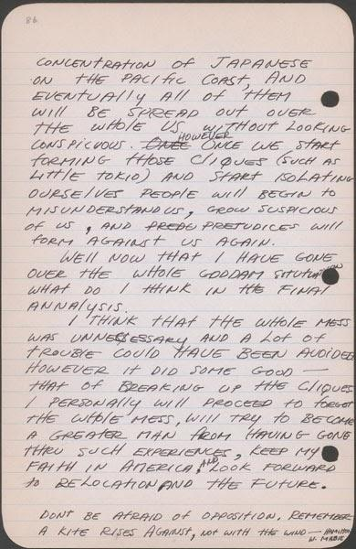
http://www.oac.cdlib.org/ark:/13030/tf2r29n604/?brand=oac4

"Making Rice Cakes" A Kango Takamura Painting

Kango Takamura was an Issei artist who had been a photo retoucher for RKO Studios in Hollywood before being incarcerated at the Manzanar prison camp. He documented his experiences at Manzanar in a series of watercolor paintings and drawings.

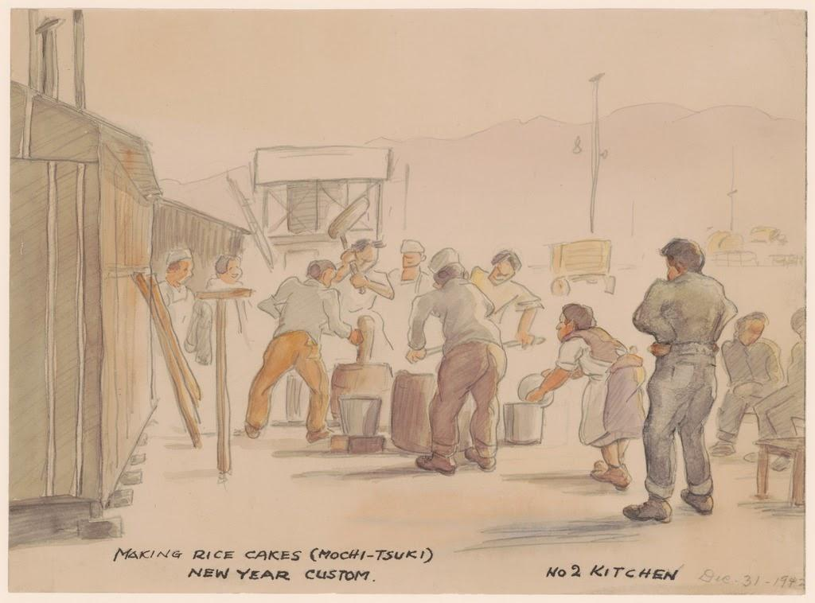

Caption: "Making rice cakes (mochi-tsuki). New Year custom. No 2 kitchen. Dec. 31 - 1942."

Courtesy of Manzanar National Historic Site and the Kango Takamura Collection
http://ddr.densho.org/ddr-manz-2-5/
Copyright restricted

“Saturday Afternoon Spring Scene” A Kango Takamura Painting

Kango Takamura was an Issei artist who had been a photo retoucher for RKO Studios in Hollywood before being incarcerated at the Manzanar prison camp. He documented his experiences at Manzanar in a series of watercolor paintings and drawings.
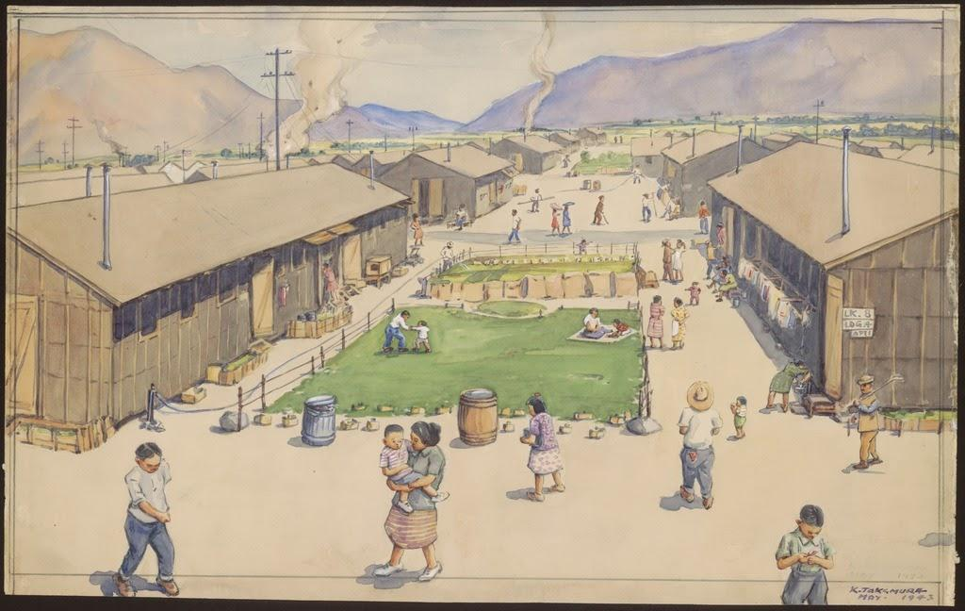
Caption: "Saturday afternoon spring scene looking south from Block 8; quiet inside, sand pillars outside Manzanar."

Courtesy of Manzanar National Historic Site and the Kango Takamura Collection http://ddr.densho.org/ddr-manz-2-16/
Copyright restricted

Mess Hall Workers Meeting on Sugar Shortages

Sugar was an important commodity at Manzanar: it was used to sweeten beverages, as an ingredient in baking, and as a way to preserve other foods. The war made sugar very difficult to obtain, however, leading to widespread shortages and rationing. In the following meeting minutes of the Mess Hall Workers Union at Manzanar, incarcerees discuss the sugar rations as yet another example of their unfair treatment within the camp.

The meeting of the Manzanar Mess Hall Workers Association was called by Mr. Amano on Friday evening, November 5, 1942 at Mess Hall #22 from 7:30 p. m. . . .

The question of rationing and distribution of the food was discussed. The question in reference to the distribution of meat was: How much meat is allotted to each person per week? This question will be brought up with Mr. Winchester by the negotiation committee. Sugar rationing was next brought up. At a Block Leaders meeting recently, Mr. Winchester has stated that the people within the Center should be given more sugar than those outside for the reason that we are not supplied with pastry of any kind, or any other form of sweets. At present only seven ounces of sugar is being given to each person in the Center, while the rate of ration outside is eight ounces per person per week. Sugar used in the baking of the pastries must be taken out of the seven ounces allotted to each individual. Therefore, the members felt that we should receive a better rate of ration than the seven ounces a person per week in order that the people may have baked foods more frequently than at present. . .

With no further business, the meeting was adjourned by Mr. Amano at 9:35 p. m.
Source: Minutes for Meetings of the Mess Hall Workers’ Union, Ueno Papers, JARP, UCLA Reprinted in Manzanar Martyr : An Interview with Harry Y. Ueno, by Harry Y Ueno; Sue Kunitomi Embrey; Arthur A Hansen; Betty Kulberg Mitson. Fullerton, Calif.: Oral History Program, California State University, ©1986.

Notes on the Manzanar Shooting

Morton Grodzins was a political scientist. In the aftermath of the violent uprising at Manzanar in December, 1942, Grodzins visited the camp and wrote down his own impressions and observations. In this section of his report draft, Grodzins disputes the argument that the violence stemmed from pro-Japanese and anti-American forces within the camp during a celebration of Pearl Harbor––an argument picked up by numerous newspapers at the time––and instead insisted that frustration with camp administration was more to blame. In 1949, Grodzins wrote a book on the mistreatment of Japanese Americans during the war called Americans Betrayed.

The Manzanar shooting incident was attributed by Camp Director Ralph Merritt, in his statement to the newspapers, to “a celebration of Pearl Harbor by the pro-axis group among the Japanese.” This entire report points to the doubtful validity of this statement. From the evidence at hand, there is no indication that a celebration of Pearl Harbor had anything to do with the affair. It would be crediting the Japanese with over-abundant prophetic powers to believe that they could foresee that Uyeno [Harry Ueno] would be removed from the camp following the beating of Tayama. Uyeno did not come forward and confess, thus setting up cause for reaction. Rather, the evidence indicates that he was identified by Tayama’s wife on tenuous evidence, and removed from the camp over his own protest.  Furthermore, there is little evidence to corroborate the view that pro-axis sentiment was the main factor in creating the riot situation. Pro-axis elements appear to have been the catalysts at work. But the main dynamics are anti-administration rather than anti-American. The basis of this anti-administration feeling has been traced chronologically to at least the early part of August, and quantitatively to all segments of the Manzanar population, old and young, American and non-American. That the anti-administration feeling came to a head on December 6 is pure chance. If it had come to a breaking point on December 25, Mr. Merritt, with equal validity, could have called it a Christmas celebration. | validity: accuracy  prophetic powers: predicting the future  tenuous: weak  catalysts: causing something the happen quickly  quantitatively: measuring the numbers of

Source: Grodzins, Morton. " The Manzanar Shooting, Jan. 10, 1943. " The Japanese American Evacuation and Resettlement: A Digital Archive, Bancroft Library, University of California. BANC MSS 67/14 c, folder O10.04. https://digitalassets.lib.berkeley.edu/jarda/ucb/text/cubanc6714_b210o10_0004.pdf

“Snow in January 1944” A Kango Takamura Painting

Kango Takamura was an Issei artist who had been a photo retoucher for RKO Studios in Hollywood before being incarcerated at the Manzanar prison camp. He documented his experiences at Manzanar in a series of watercolor paintings and drawings.

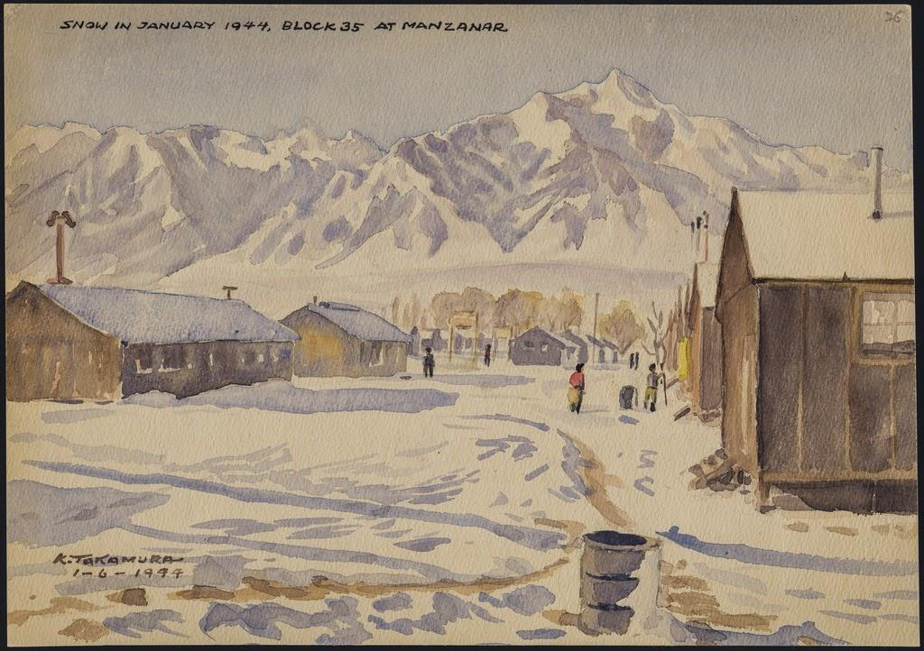

Caption: "Snow in January 1944, block 35 at Manzanar."
Courtesy of Manzanar National Historic Site and the Kango Takamura Collection http://ddr.densho.org/ddr-manz-2-65/
Copyright restricted

Statement of United States Citizen of Japanese Ancestry: Joe Yamikido

In 1943, the U.S. military required all draft-age Nisei to fill out a “Statement of United States Citizen of Japanese Ancestry.” This form would be informally known as the loyalty questionnaire, as two of the more controversial questions on the document (questions 27 and 28) asked participants if they would serve in the armed forces, and if they would pledge allegiance to the United States. The questionnaire created a good deal of confusion, fear, and anger throughout the camps, as Nisei were being asked to swear allegiance to their own country while they were being simultaneously incarcerated by the government. The following completed form shows how one incarceree responded to these controversial questions. When asked in Question 27 if he would serve in the armed forces if ordered, Joe Yamakido responded, “Yes, if drafted [and] provided I am given equal rights and opportunity as caucasians.” Yamakido was arrested for resisting the draft, but served in the army after World War II.

Full Completed Form

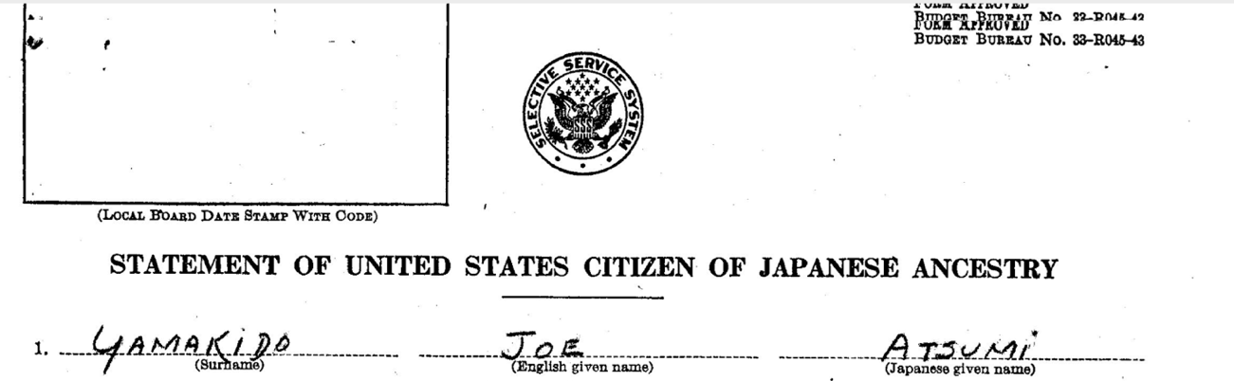

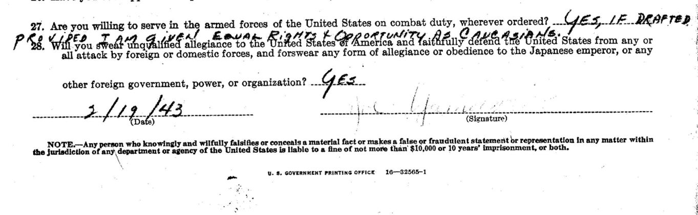
Source: Joe Yamakido, “Statement of United States Citizen of Japanese Ancestry.” National Archives, Records of the War Relocation Authority 210.3.4.

The WRA Application for Leave Clearance

The following form was developed by the War Relocation Authority (WRA) and given to incarcerated Japanese Americans. The WRA created the questionnaire to serve a similar purpose as the U.S. army’s questionnaire for draft-age Nisei and many of the questions are identical, including the controversial question 28. However, the WRA’s intention was to determine whether incarcerees could be trusted to leave the camps. As with the army’s questionnaire, there was widespread fear and confusion as to the form’s purpose and how it would be used.

Full Form

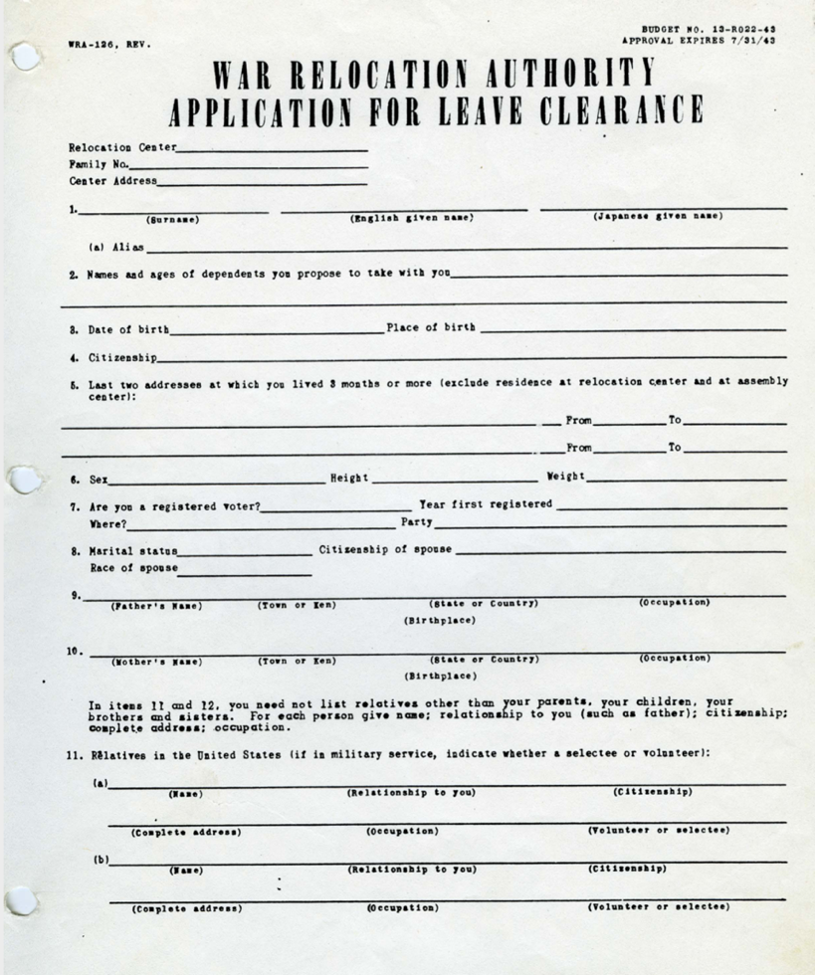

Source: WRA, “Application for Leave Clearance,” 1943, Courtesy of K. Morgan Yamanaka, Densho Digital Repository, ddr-densho-188-5. https://ddr.densho.org/ddr-densho-188-5/

The Fair Play Committee Bulletin
In response to the questions asked on the “loyalty questionnaire,” incarcerees at the Heart Mountain camp in Wyoming formed The Fair Play Committee, an organization dedicated to restoring Japanese American civil rights. The Committee believed that Nisei should not be drafted into the army until their rights as American citizens were restored. When the military reinstated the draft, the group resisted, and 85 members were arrested. Those convicted were later pardoned by President Truman in 1947. The following is an excerpt from a Fair Play Committee bulletin describing the organization and its positions and goals.

Q. What’s this Fair Play Committee about?
A. The Fair Play Committee (FPC) is organized to inject justice in all the problems pertaining to our evacuation, concentration, detention and pauperization without hearing or due process of law, and oppose all unfair practices within our center, State, or Union...
Q. What does the FPC think is the right thing for any loyal American citizen to do in our present status?
A. The FPC believes that the first duty as loyal American citizens is to protect and uphold the Constitution of the United States THE CORNERSTONE OF THIS INSTRUMENT OF OUR GOVERNMENT IS INJUSTICE, LIBERTY, FREEDOM AND THE PROTECTION OF HUMAN RIGHTS, AND THE DESECRATION OF ANY ONE OF THESE IS A DIRECT ATTACK ON THE FUNDAMENTALS THAT MOLDED OUR DEMOCRATIC INSTITUTION.
Q. Is this an objectors group?
A. No. It definitely is not an objectors group, but we would like to present both sides of this draft issue.
Q. What does the FPC think about this present draft program?
A. The FPC believes we have a right to ask that the discriminatory features in regards to this selective service be abolished, out status be clarified, and full restoration of our rights of our before being drafted. THIS ABSENCE OF CLARIFICATION OF OUR STATUS, RESTORATION OF OUR RIGHTS, AND THE LIFTING OF DISCRIMINATORY RESTRICTIONS IS THE KEYSTONE OF OUR ATTITUDE TOWARDS THE PRESENT PROGRAM OF DRAFTING US FROM THIS CONCENTRATION CAMP.
Q. Why can’t we contest the whole issue after the war?
A. Because if we knew of a cause and a country worthy of our blood, then we need never feel ashamed to look the enemy in the eye. And by the granting of these it will not only liquidate the injustices of the past, but it will guarantee against any future inroads upon the Constitution and its principles. It will guarantee assurance to the minorities who otherwise may face a similar fate in the future.

Source: “Fair Play Committee Bulletin #2,” ca. 1944, Courtesy of Frank Abe, Densho Digital Repository, ddr-densho-122-400. http://ddr.densho.org/ddr-densho-122-400/

Honor Roll Sign at Minidoka Prison Camp

The following image of Japanese Americans looking at the camp's honor roll, was taken in 1944. The honor roll listed all of the Japanese Americans from the Minidoka concentration camp who volunteered for military service during World War II. Minidoka had the highest number of volunteers from the mainland United States.

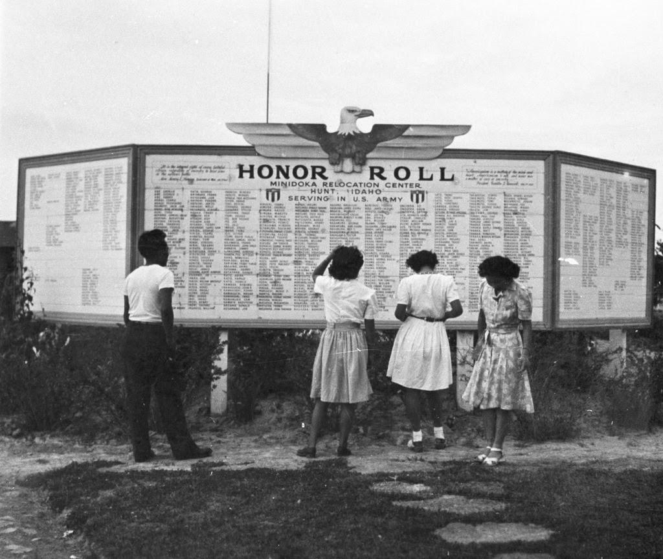

Source: Densho Digital Repository, Courtesy of the Mitsuoka Family Collection https://ddr.densho.org/ddr-densho-15-82/

Excerpt from “A Nisei Who Said No”
The following excerpts are from interviews with a Nisei in camp who answered “no” to Question 28 on the “Statement of United States Citizen of Japanese Ancestry” questionnaire. Question 28 asked incarcerees if they would swear allegiance to the United States and disavow allegiance to the Emperor of Japan. The first section is part of an exchange between the Manzanar Hearing Board and the Nisei who responded “no.” The second section is a longer statement later collected from the incarceree.

Hearing Board Member: Don’t you want to tell us? Perhaps there is something that we can do. If you say “No” you are giving away your citizenship. Is that what you want to do? Feel free to talk. We’re not here to argue with you but we want to help you.

Nisei: What I was thinking. I thought that since there is a war on between Japan and America, since the people of this country have to be geared up to fight against Japan, they are taught to hate us. So they don’t accept us. First I wanted to help this country, but they evacuated us instead of giving us a chance. Then I wanted to be neutral, but now that you force a decision, I have to say this. We have a Japanese face. Even if I try to be American I won’t be entirely accepted…

Nisei: If I would say “Yes”, I’d be expected to say that I’d given up my life for this country. I don’t think I could say that because this country has not treated me as a citizen. I could go three-quarters of the way but not all the way after what has happened.

HBM: Would you be willing to be drafted?

Nisei: No I wouldn’t do that.

Later I contacted this young man and asked him for a fuller statement of his views. The following is what he told me:

--------------------------------

...I don’t know Japan. I’m not interested in Japan. That’s another thing that worries me. I don’t know what will become of me and people like me if we have to go to Japan...[My father] doesn’t tell me what to do but I know what he wants me to do about this answer. I can sense it from the way he talks.

In order to go out prepared and willing to die, expecting to die, you have to believe in what you are fighting for. If I am going to end the family line, if my father is going to lose his only son, it should be for some cause we respect. I believe in democracy as I was taught it in school. I would have been willing to go out forever before evacuation. It’s [not] that I’m a coward or afraid to die. My father would have been willing to see me go out at one time. But my father can’t feel the same after this evacuation and I can’t either . . .
I’m sick right now. Right now while I’ve been talking to you I’ve had a cramp in the pit of my stomach.
I appreciate this talk with you. But my mind is made up. I know my father is planning to return to Japan. I know he expects me to say “No” so there will be no possibility that the family will be separated. There isn’t much I can do for my father [anymore]; I can’t work for him the way I used to. But I can at least quiet his mind on this.

Source: War Relocation Authority, Community Analysis Notes: From a Nisei who said “no.”, January 15, 1944. Densho Digital Repository, https://ddr.densho.org/ddr-csujad-2-84/.

Justice Murphy’s Dissent in Korematsu v. United States

In 1942, Fred Korematsu defied the mandate to be forcibly removed from his home in California. He was arrested and later sued the federal government for violating his constitutional rights. The case went all the way to the Supreme Court, where in 1944 the court decided 6-3 against Korematsu. Justice Frank Murphy––one of the three judges who ruled in favor of Korematsu––wrote the following dissenting opinion. In 1983, Korematsu challenged his conviction and the ruling was overturned.

This exclusion of "all persons of Japanese ancestry, both alien and non-alien," from the Pacific Coast area on a plea of military necessity in the absence of martial law ought not to be approved. Such exclusion goes over "the very brink of constitutional power," and falls into the ugly abyss of racism...

I dissent, therefore, from this legalization of racism. Racial discrimination in any form and in any degree has no justifiable part whatever in our democratic way of life. It is unattractive in any setting, but it is utterly revolting among a free people who have embraced the principles set forth in the Constitution of the United States. All residents of this nation are kin in some way by blood or culture to a foreign land. Yet they are primarily and necessarily a part of the new and distinct civilization of the United States. They must, accordingly, be treated at all times as the heirs of the American experiment, and as entitled to all the rights and freedoms guaranteed by the Constitution.

Source: Korematsu v. United States, 323 U.S. 214. December 18, 1944 (Murphy, Frank, dissenting).

Looking for Work after the Camps

After incarceration ended, some Japanese Americans were unable to return to their pre-war lives: they had lost their homes, their jobs, their savings, and their property while imprisoned. Facing difficult employment opportunities and prejudice, one-third of former incarcerees were forced to move to a different state. In response, the War Relocation Authority (WRA) created a resettlement program for those Japanese Americans. In the following photograph from 1945, three former incarcerees of the Heart Mountain camp in Wyoming look over a bulletin board of possible job opportunities at the WRA headquarters in Philadelphia, Pennsylvania.

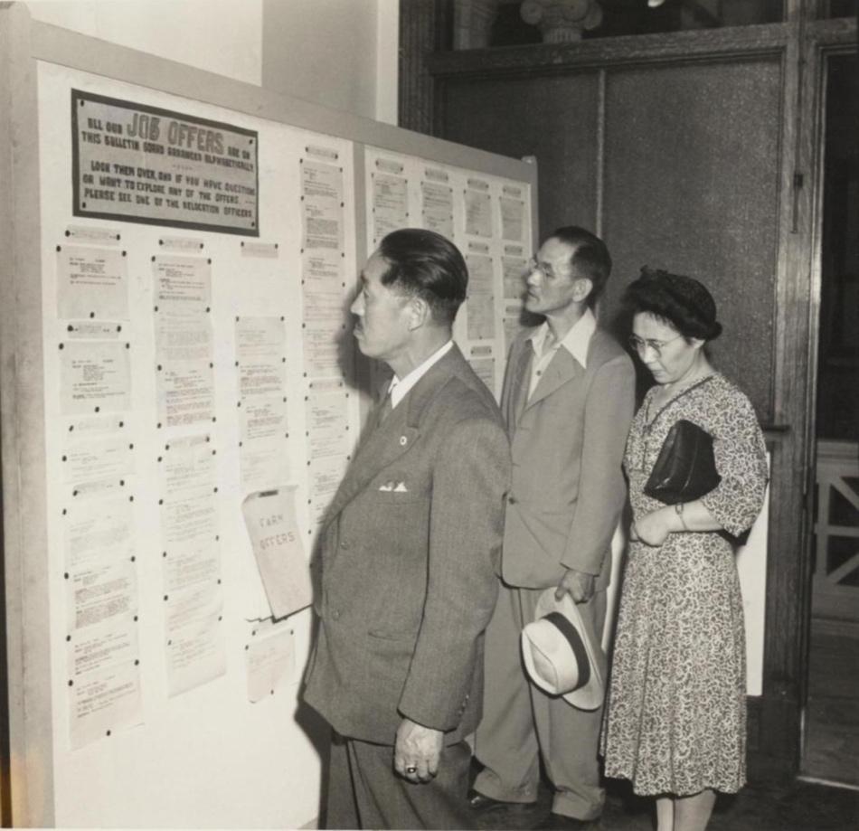

Source: Gretchen Van Tassel, “Mr. and Mrs. Tomatsu Gorai and Mr. Ushimatsu Kubota looking over the job bulletin board in the Philadelphia WRA office,” photograph, July, 1945. WRA no. G-932, War Relocation Authority Photographs of Japanese-American Evacuation and Resettlement, Bancroft Library, UC Berkeley. https://oac.cdlib.org/ark:/13030/ft4779n99z/?order=3&brand=oac4
Presidential Apology Letter
The passage of the Civil Liberties Act in 1988 granted financial compensation and a formal apology by the President of the United States to all Japanese Americans who were incarcerated during World War II. However, two years passed before the funds were distributed as the following apology letter by President George HW Bush (dated October 1990) shows. When completed, 82,219 people received an apology and compensation for the “serious injustices” done to them or their heirs during the war.

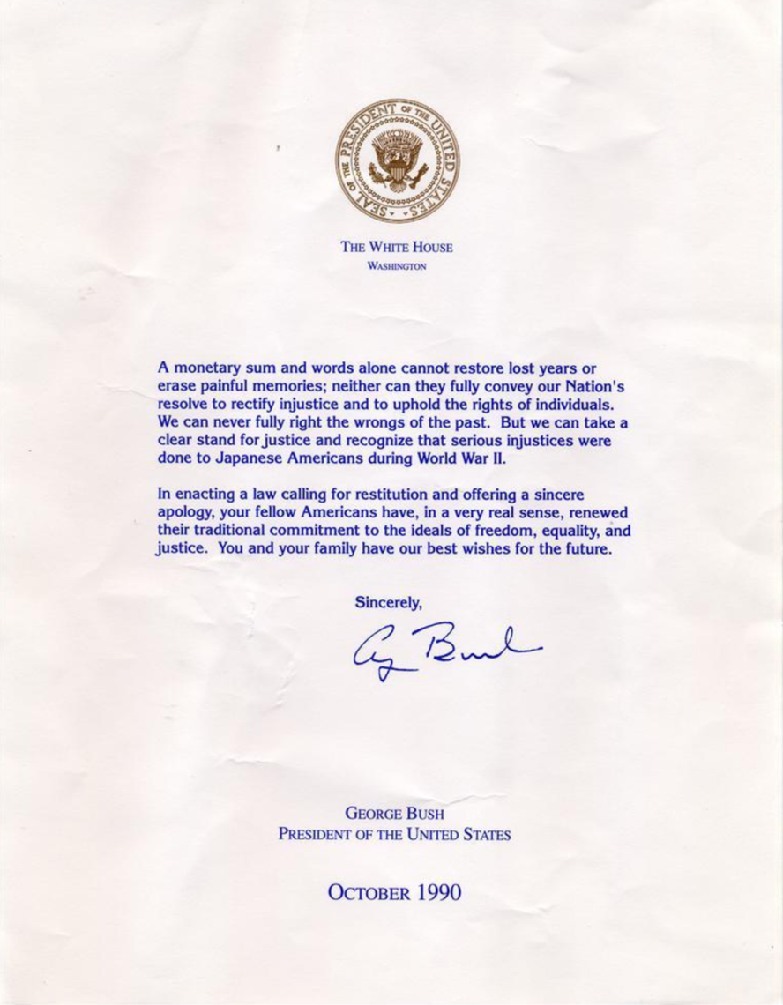

Source: George Bush, Presidential Apology Letter, 1990. Densho Digital Repository, ddr-densho-153-20. Courtesy of Majorie Matsushita. http://ddr.densho.org/ddr-densho-153-20/

Fumiko Hayashida Advocates for the Bainbridge Island Japanese American Memorial

In 2006, Fumiko Hayashida was the oldest living Bainbridge Islander who had been forcibly relocated to the Manzanar internment camp. In the following excerpt, Hayashida testifies to the U.S. House of Representatives Subcommittee on National Parks in favor of erecting a memorial to those forcibly removed from the island. The bill passed the following year, and the Bainbridge Island Japanese American Exclusion Memorial officially opened in 2011. Hashida passed away in 2014 at the age of 103.
...When the war finally ended and we were freed from Minidoka, no one wanted to talk about our painful years in internment camps. We buried our pain, suffering and shame, choosing to try to forget the past, persevere and for the sake of the children move forward with our lives.
We returned to Bainbridge Island to find that we lost everything. Our farm and strawberries were not well maintained and we had to start from scratch. We tried to make a go of it, but having three young and growing children, we had to find a more stable income. After a year my husband got a job at Boeing in Seattle, but the long ferry and bus commute from Bainbridge Island became too taxing. We decided to leave Bainbridge Island and buy a home in Seattle, where I have lived to this very day.
The years we experienced in Minidoka and Manzanar changed not only our lives, but the years of internment during World War II changed the lives of all 120,000 Japanese Americans who were forcibly exiled by the United States government.
I am grateful that Presidents Ronald Reagan, Gerald Ford, George H.W. Bush and Bill Clinton have apologized for this shameful period in American history, and that the US Congress passed the Civil Liberties Act of 1988 and the modest reparations that followed. These are powerful statements from our nation of healing and honor.
As the very first place where the World War II internment story literally began, the passage of H.R. 5817, the Bainbridge Island Japanese American Monument Act of 2006 would be another powerful statement by the United States of America that we must learn and never forget the lessons from this unfortunate chapter in American history.
Only a small fraction of the Japanese Americans who experienced the internment are still alive. My husband died in 1983. We never celebrated our golden anniversary. Only my youngest sister and two of my children are alive today from my immediate family.
I am an old woman in the 95th year of my life. I hope to live long enough to see the Bainbridge Island Japanese American Memorial earn the honor and recognition from our federal government and become a unit of the National Parks Service. I urge you to please urgently pass this measure so that all Americans can learn from and take to heart the spirit of the memorial’s name: “Nidoto Nai Yoni – Let it not happen again.”
Source: Fumiko Hayashia, Testimony Before the Committee on Resources, Subcommittee on National Parks, United States House of Representatives. Congressional Records, Hearing on H.R. 5817: The Bainbridge Island Japanese American Monument Act of 2006. September 28, 2006.

George Takei: Internment, America’s Great Mistake

George Takei is an Japanese American actor and activist most known for his portrayal of Sulu on the original Star Trek television series. As a young boy, however, Takei and his family were incarcerated in the Rohwer, Arkansas and Tule Lake, California incarceration camps. In the following excerpt from an opinion piece written in 2017, Takei reflects on his experiences, details the importance of pilgrimages back to the camps, and compares the events of his childhood with modern-day American politics.

...I was 7 years old when we were transferred to another camp for “disloyals.” My mother and father’s only crime was refusing, out of principle, to sign a loyalty pledge promulgated by the government. The authorities had already taken my parents’ home on Garnet Street in Los Angeles, their once thriving dry cleaning business, and finally their liberty. Now they wanted them to grovel; this was an indignity too far.

A pilgrimage to Tule Lake also occurs every year, symbolically on July 4. I have gone three times. I remember a terrifying moment while I was held there when armed military police burst into the barracks and hauled away several young men.

On the pilgrimages, I finally saw where they had been taken: a concrete cell block called the stockade. On the concrete walls, there was graffiti, now made illegible by the passage of time. Also fading were brown splotches I was told were blood stains. This was what could happen in an America that had become un-American.

It has been the lifelong mission of many to ensure we remember the internment. Our oft-repeated plea is simple: We must understand and honor the past in order to learn from and not repeat it. But in the 75 years since President Franklin D. Roosevelt signed Executive Order 9066 authorizing the internment of Japanese-Americans, never have we been more anxious that this mission might fail.

It is imperative, in today’s toxic political environment, to acknowledge a hard truth: The horror of the internment lay in the racial animus the government itself propagated. It whipped up hatred and fear toward an entire group of people based solely on our ancestry...

My way of remembering the cruelties of the past was to help found the Japanese American National Museum, as well as to turn my family’s experience into a Broadway show, “Allegiance,” in the hope that more will heed the warning. The pilgrimages to camps like

Manzanar, Rohwer and Tule Lake are another way of honoring those who suffered, and lost, and had to rebuild shattered lives. They remind us all today of the threat to American values from cynically manufactured fear and the deliberate targeting of a vulnerable minority.

Source: George Takei, “Interment, America’s Great Mistake,” The New York Times, April 28, 2017. https://www.nytimes.com/2017/04/28/opinion/george-takei-japanese-internment-americas-great-mistake.html

California Legislature Apologizes for Japanese Incarceration

While the Federal Government began issuing apologies for the incarceration of Japanese Americans during World War II in the 1980s, the state of California (in which both the Manzanar and Tule Lake prison camps were located) did not officially acknowledge these wrongs until 2020, seventy-eight years after Executive Order 9066. In the following excerpt from the California legislature, the state outlines the damage caused by forced relocation and incarceration, and formally apologizes for the failure of the state to “defend the civil rights and civil liberties of Japanese Americans.”

WHEREAS, On February 19, 1942, President Franklin Delano Roosevelt signed Executive Order No. 9066 (EO9066), under which more than 120,000 people of Japanese ancestry were incarcerated in 10 concentration camps scattered throughout western states and the State of Arkansas during World War II; and
WHEREAS, EO9066 inflicted upon more than 120,000 Americans and residents of Japanese ancestry a great human cost of abandoned homes, businesses, farms, careers, professional advancements, disruption to family life, and public humiliation...
WHEREAS, The year 2020 marks the 76th anniversary of the Supreme Court of the United States’ decisions in the Japanese American incarceration cases. While the Supreme Court ordered Mitsuye Endo released from incarceration, it denied, in Korematsu v. United States, that EO9066 reflected racial prejudice and upheld EO9066 in light of the “strategic imperative” to keep the west coast secure from invasion; now, therefore, be it
Resolved by the Assembly of the State of California, That the Assembly apologizes to all Americans of Japanese ancestry for its past actions in support of the unjust exclusion, removal, and incarceration of Japanese Americans during World War II, and for its failure to support and defend the civil rights and civil liberties of Japanese Americans during this period...

Source: California State Legislature, HR-77 “Relative to World War II Japanese American concentration camps” Revised February 20, 2020. http://leginfo.legislature.ca.gov/faces/billTextClient.xhtml?bill_id=201920200HR77

