Much of “No Turning Back” is based on actual events, places, and people. While some characters are fictional, others are based on actual historical figures. Brief background information is included here on the Mission’s fictional characters, as well as biographical information on the historical figures included in the game.

Fictional Game Characters

Verna Baker (fictional character) is a sixteen-year-old who lives with her family in Sunflower County, Mississippi. Her family are tenant farmers and have decided that Verna can live with her uncle, Reverend Curtis Starling, in Greenwood to attend high school.

Lucretia Baker (fictional character) is Verna’s grandmother. The game opens on the grandfather’s funeral and Verna learns more about her grandparents’ involvement in pursuing change and empowerment in the preceding decades. Lucretia moves to Greenwood later in the game and Verna accompanies her as she attempts to register to vote.
Reverend Curtis Starling (fictional character) is Verna’s uncle. The Starling family lives in Greenwood and Curtis is the minister of a small Baptist church and drives a taxi to help make ends meet. Like many Baptist ministers of the time, he is resistant to rocking the boat and seeks to maintain the safety of his church, his parishioners, and his livelihood.

Mabel Starling (fictional character) is Verna’s aunt. She attended NAACP meetings in the past but no longer does out of fear of losing her job as a domestic worker for Judge Chalmers’s household.

Addie Starling (fictional character) is Verna’s fifteen-year-oldcousin who knows everyone around town and is an active member of the church’s youth choir. She is open to the movement, but cautious because of her father’s outlook.

Miss Annetta (fictional character) The new youth choir director at the church, Fannie has sung professionally, including as a backup singer to Sam Cooke. She also works at one of the local hair salons.

Robert Atkins (fictional character) The seventeen-year-old son of Verna’s father’s best friend, Robert and his family moved to Chicago a few years ago. He hasn’t visited since the Emmitt Till murder, but returns for the funeral and corresponds with Verna throughout the game.

Historical Figures

Sam Block: Sam Block came to Greenwood in the summer of 1962 as a member of SNCC to promote voting rights and Black registration. He persevered through beatings and sabotage to build the movement in Greenwood.

Medgar Evers: The Mississippi field secretary for the NAACP, Evers fought for desegregation and voting rights. He was assassinated in 1963.

Locations

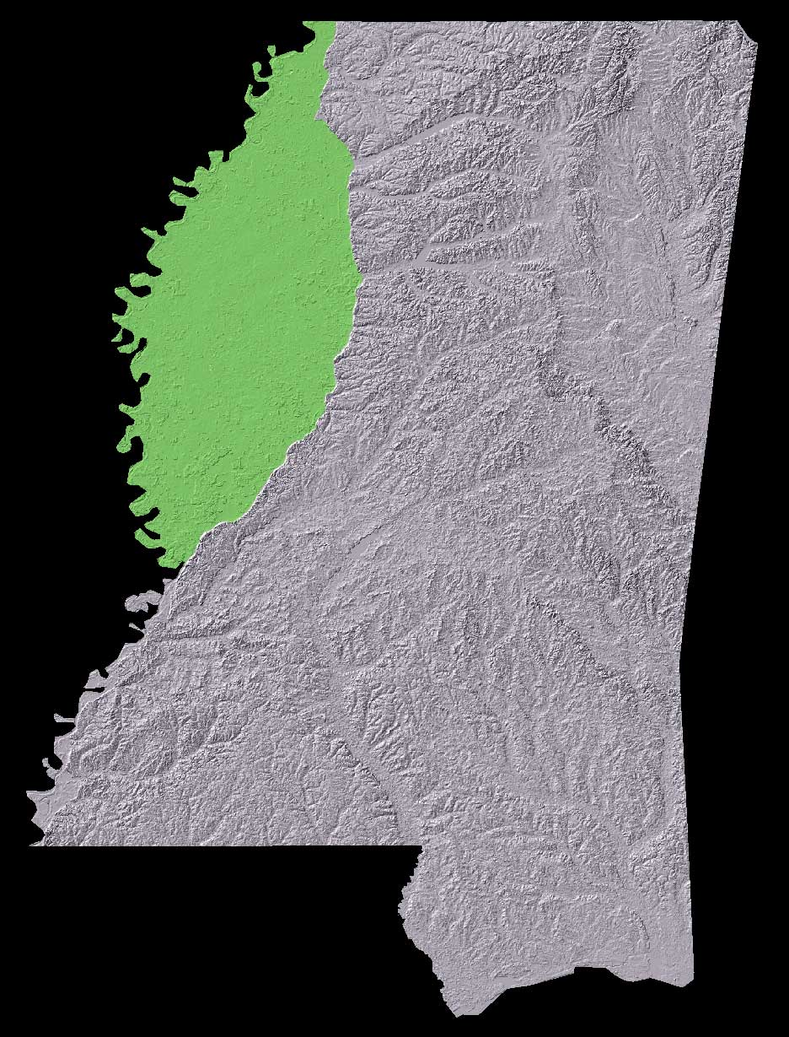
The Mississippi Delta: The Northwest section of the state of Mississippi is referred to as the Delta. Because of the rich fertile soil created by the floodplain of the Mississippi River, the Delta was an agricultural area predominated by large white-owned cotton farms that were worked by families of African American sharecroppers and renters. It is also known for the Blues musicians who came from the region and whose music became known throughout the country and the world.

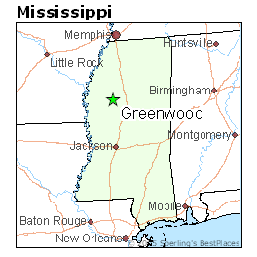

Greenwood, Mississippi: Greenwood is located at the eastern edge of the Mississippi Delta and on the Yazoo River and became a cotton trading center in the nineteenth century. In the 1960s, it was still a major center for wholesale cotton trading and had a population of just over 20,000, about half of whom were African American. The African American community supported a number of Black-run small businesses, churches, and social organizations. Despite the 1954 Brown v. Board of Education Supreme Court ruling, the schools in Greenwood were still segregated in the 1960s, and the public swimming pool, parks, and library were for whites only.

