Student Nonviolent Coordinating Committee Constitution

Building on the momentum of the sit-ins, student leaders from Shaw University founded the Student Nonviolent Coordinating Committee (SNCC) in Greensboro, North Carolina in 1960. SNCC was the central organization of student activism efforts during the civil rights movement. SNCC leaders drafted and re-drafted a constitution which outlined the purpose, structure, and responsibilities of the organization.
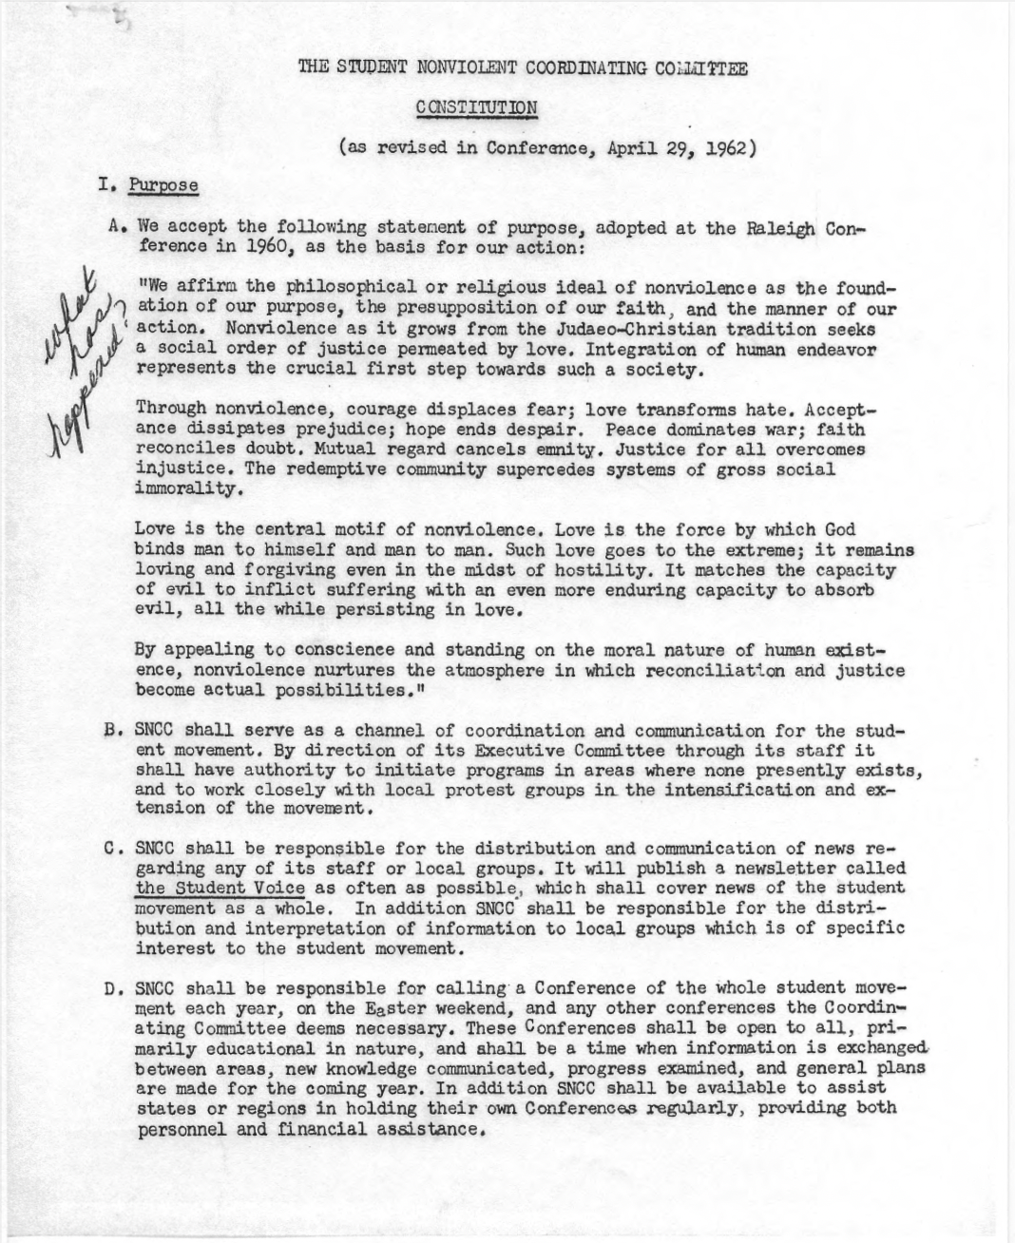

Source: https://www.crmvet.org/docs/sncc_constitution_62.pdf

Discussion Questions:

- How did SNCC leaders see nonviolence as the central organizing value in their organization?
- What impact did SNCC hope to have by using nonviolent strategies in their efforts?

