Five-Point Action Program of the Citizen’s Council

White opponents of racial integration in public schools formed Citizens’ Councils throughout the South during the 1950s and 1960s. In Mississippi, the Citizens’ Council received funding from the state budget. These white segregationists, often prominent business and social leaders, organized against Black voter registration and used violence and intimidation to stop civil rights actions.

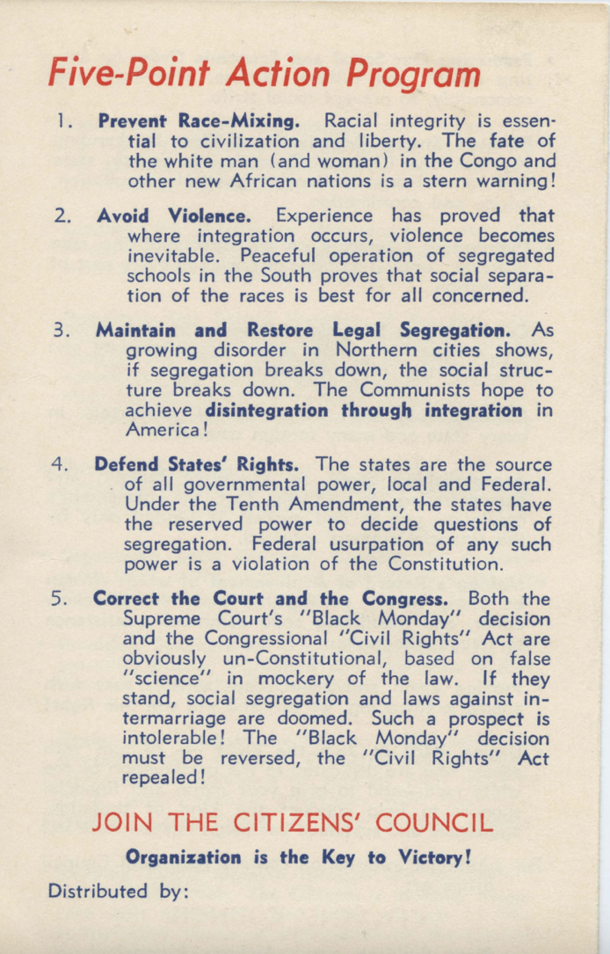

Source: https://egrove.olemiss.edu/cgi/viewcontent.cgi?article=1086&context=citizens_pamph

Discussion Questions:

- How did white segregationists organize to oppose integration?
- What were the main aims of the Citizens’ Council in the action program?
- What did the Citizens’ Council say would happen if integration was successful?

