Woolworth’s Sit-In

On May 28, 1963, students and faculty from Tougaloo College staged a sit-in at the Woolworth’s lunch counter in Jackson, Mississippi. For three hours, the group endured insults and attacks. The increasingly violent white mob slapped the protesters, hit them with items from the lunch counter, and even burned cigarettes on their skin.

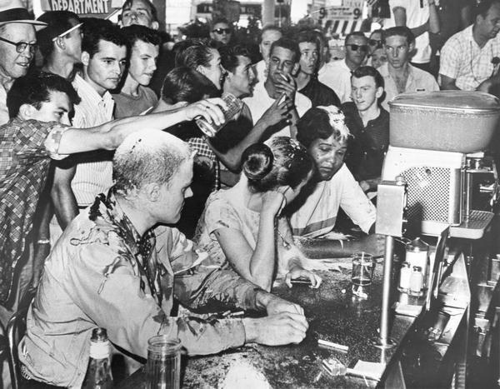

Source: AP, Jackson Daily News, photographer Fred Blackwell https://www.wisconsinhistory.org/Records/Image/IM2381

Discussion Questions:

- What do you notice about the crowd behind the sit-in participants?
- What do you notice about the behavior of the sit-in participants in this photo?
- Why might have the photographer felt it was important to capture this moment?

