Jean’s Beauty Shop

In 1953, Peggy Jean Connor became the owner of her family’s beauty shop in Hattiesburg, Mississippi at the age of 21. Her father owned a shoe shine parlor in the front of her shop. Connor did not personally have experience in activism work, but in 1962, two SNCC organizers, Curtis Hayes and Hollis Watkins, arrived in Hattiesburg and opened a Council of Federated Organizations (COFO) office across the street from her beauty shop. Connor decided to get involved. She learned how to teach local residents to register to vote and eventually played a pivotal role in the actions of Freedom Summer. Connor’s story demonstrated the important roles Black small business owners played in supporting and sustaining the movement.
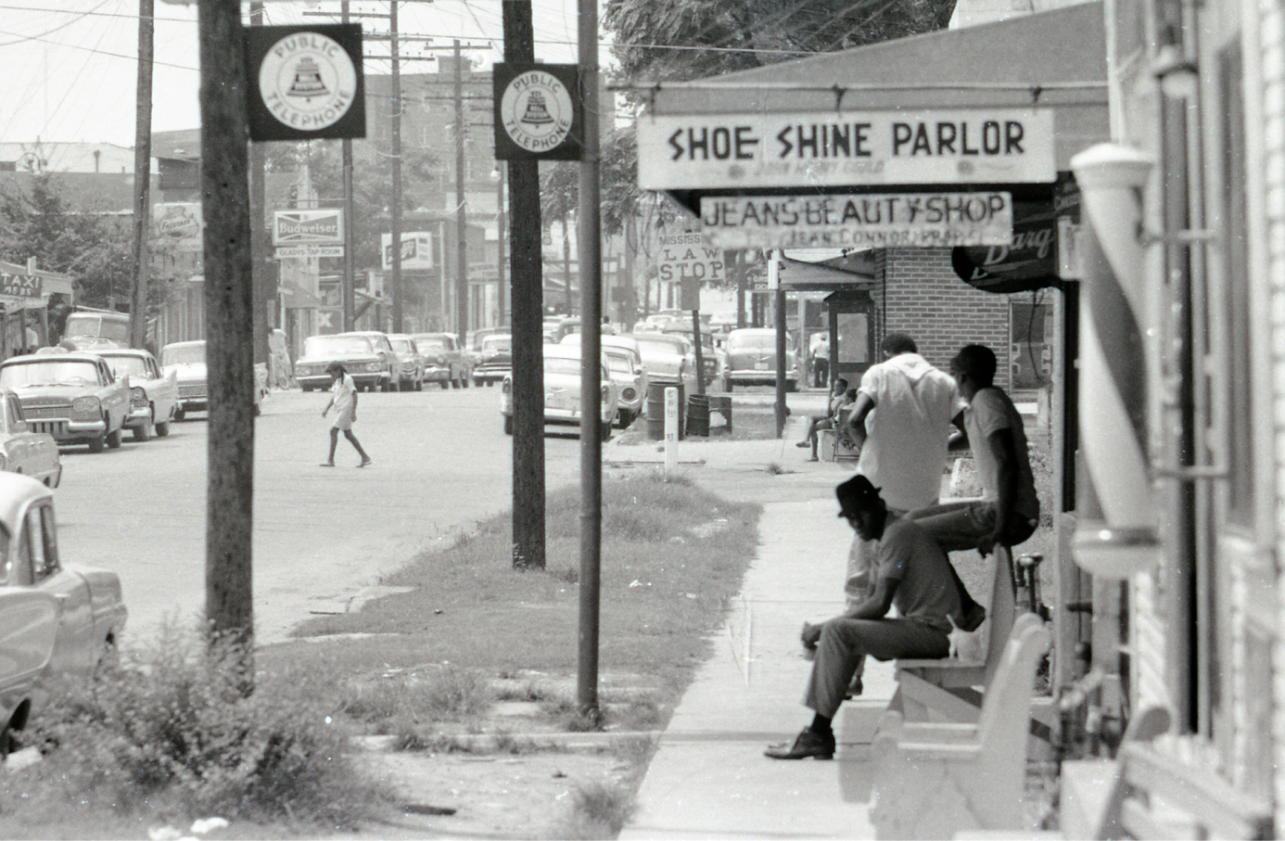

Source: https://snccdigital.org/people/peggy-jean-connor/

Discussion Questions:

- How did Peggy Jean Connor become involved in the civil rights movement?
- Why was it important that a Black small business owner supported the movement?

