Gordon Parks Photographs

Gordon Parks, a Black photojournalist, captured the realities of Jim Crow segregation on film. The following three photographs were part of a series taken in Alabama, focusing on one multigenerational family and their experiences of segregation in 1956.

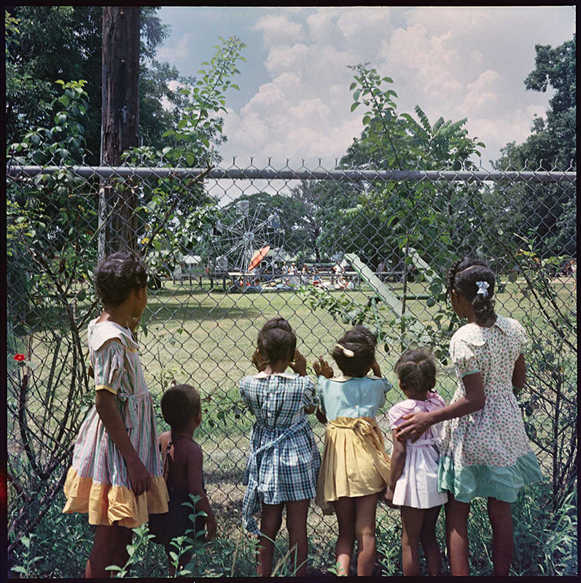
Outside Looking In, Mobile, Alabama, 1956.

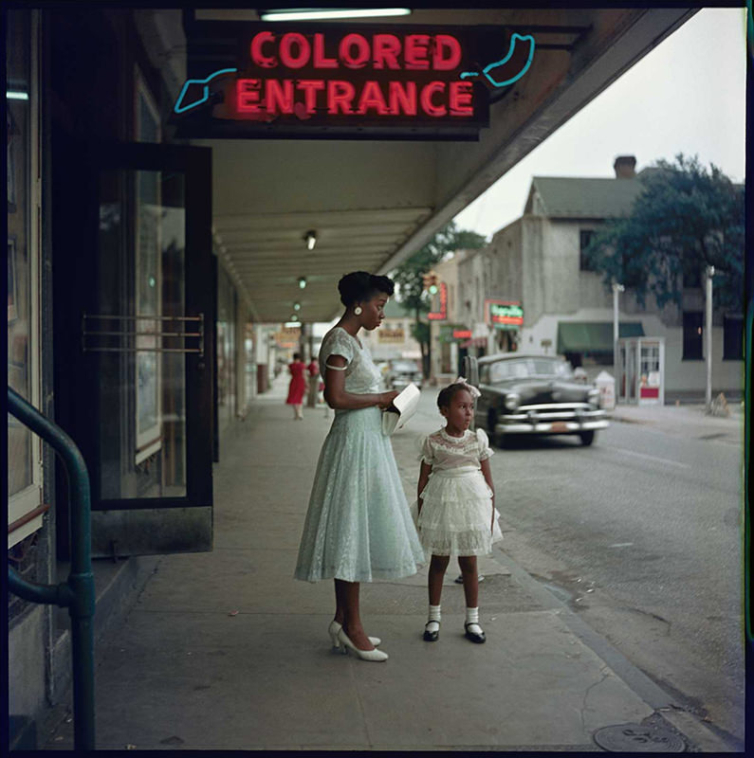
Department Store, Mobile, Alabama,1956.

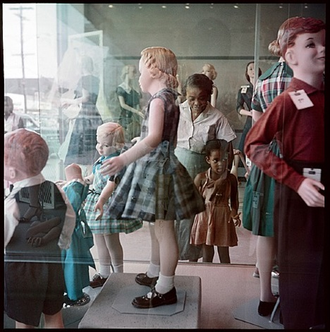
Ondria Tanner and Her Grandmother Window-shopping, Mobile, Alabama, 1956.

Credit: Photographs by Gordon Parks.
Copyright: Courtesy of and copyright The Gordon Parks Foundation.

Discussion Questions:

- How did Gordon Parks capture segregation through photography?
- What do you notice about children’s perspectives in these photos? About adults’ perspectives?

