The Chicago Defender, Sept. 10, 1955

After Emmett Till was murdered on August 28, 1955, his mother, Mamie, decided to hold an open casket funeral so the country would see the brutality he suffered and the type of racial violence that went unpunished in the South. Photos of Till’s mutilated corpse were published in Black newspapers and magazines across the country, and front page headlines helped raise public awareness of anti-Black violence.
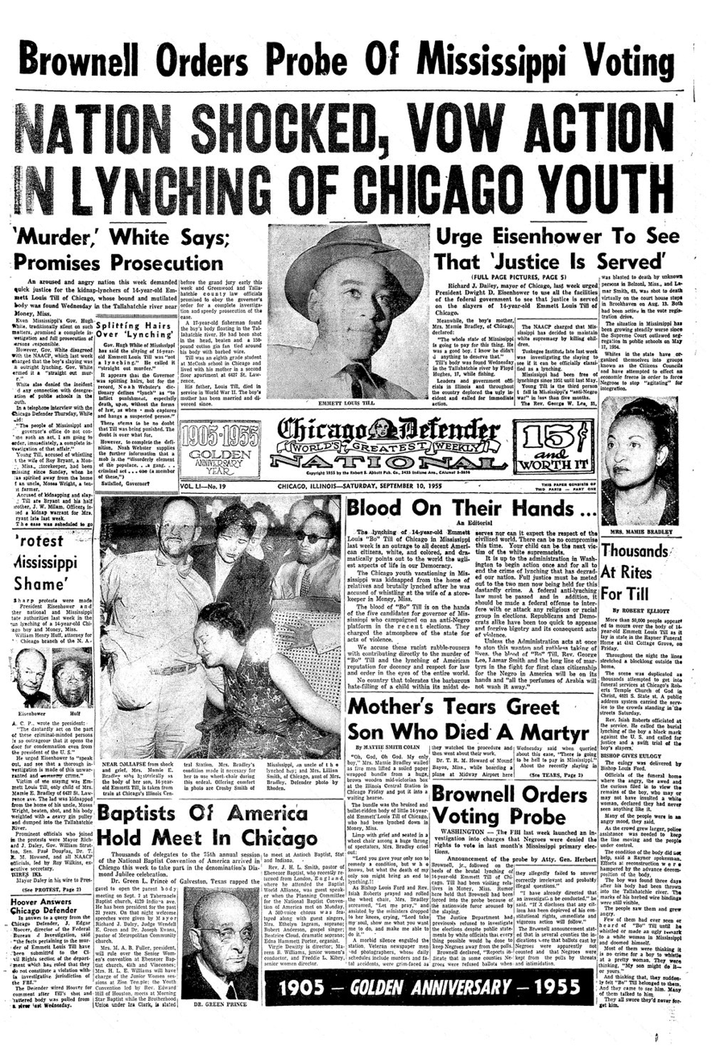

Source: https://images.squarespace-cdn.com/content/v1/55bbe8c4e4b07309dc53b00f/1503883950142-QLWHRAFE7H4L0815PSJF/Chicago+Defender+_+Sept+10+_+front+page.jpg?format=1000w

Discussion questions:

- What was the significance of Mamie Till’s decision to hold an open casket funeral?
- How did the Black press spread awareness about Emmett Till’s murder?
- Read at the various headlines: which types of “action” was the Chicago Defender calling for?

