A NOTE TO THE EDUCATOR:
In the Prologue, Verna meets her cousin Robert, who has traveled to Mississippi for their grandfather’s funeral from Chicago. Robert moved with his family from Mississippi to Chicago as part of the Great Migration, a vital part of the historical context for the campaign for voting rights in Mississippi in the 1960s. The Great Migration refers to the relocation of about six million African Americans from the South to the North and West, that occurred between 1916 and 1970. African Americans fled the racial terror of the Jim Crow South and pursued greater economic opportunity in the big cities in other regions of the country.

In this activity, students will be introduced to the Great Migration by analyzing a map depicting population movements during its first phase between 1916 and 1930. They will make observations about the map and note questions that it leaves unanswered about the Great Migration. Then they will discuss both the strengths and limitations of maps in helping us understand the past.

Steps to Complete:

- Make Observations in Groups
In groups of 3-4, ask students to take 10 minutes observing the map and writing down what they notice. You might ask them to record their thoughts using the See, Think, Wonder routine:
- See: What do I see on the map? What text, shapes, symbols, and colors do I see that will help me interpret the map? What information does the map provide?
- Think: What is the purpose of the map? What is the story that it is telling? What does the maker of this map want to help me understand?
- Wonder: What information does it leave out that I would like to know? What additional information do I need in order to fully understand the story the map is telling? What else do I wonder about after looking closely at this map?

- Interpret the Maps a Whole Group
Come back together and share students’ responses from the See, Think, Wonder routine. If necessary, you might begin the conversation simply by asking questions that will help students use the map:
- Where are we on this map?
- What do the different colors on this map mean?
- Where are the arrows pointing and what does that mean?

Then use the reflection questions at the end of the See-Think-Wonder handout to move into a deeper discussion of how this activity provides context for the people and setting that are introduced in the Prologue, as well as the strengths and limitations of maps as historical documents in general.

Throughout the discussion, share additional details about the Great Migration, the relocation of about six million African Americans from the South to the North, that occurred between 1916 and 1970. During this time the Black population of the United States shifted enormously; many people left home for places they had never been or seen before. They moved from primarily rural areas in the South to urban centers in the East, Midwest, and West. But community ties persisted and people who had migrated returned South to visit family.

Mapping the Great Migration

Directions: Take a few minutes to look at and think carefully about the map below and complete the See-Think-Wonder chart that follows. Then, respond to the reflection questions after the chart.

https://shec.ashp.cuny.edu/files/original/migration-map_5687edec2a.jpg

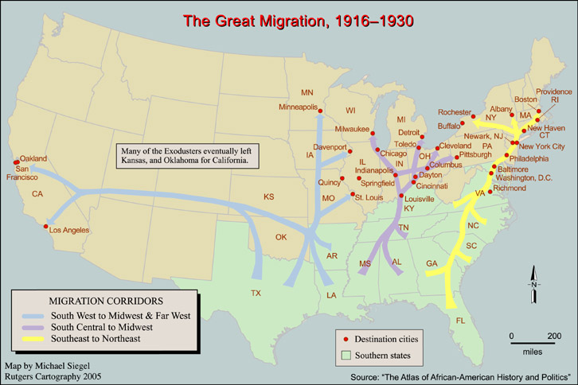

See  What do I see on the map? What text, shapes, symbols, and colors do I see that will help me interpret the map? What information does the map provide? | Think  What is the purpose of the map? What is the story that it is telling? What does the maker of this map want to help me understand? | Wonder  What information does it leave out that I would like to know? What additional information do I need in order to fully understand the story the map is telling? What else do I wonder about after looking closely at this map?

Reflection Questions:
- How has this map helped you understand the Great Migration? What questions do you have that it does not answer?
- How does this map help you understand the people and the setting that you experienced in the Prologue of “No Turning Back”?
- Describe at least one way that maps can be important tools for understanding the past. Describe at least one limitation maps have in explaining the past.

