A NOTE TO THE EDUCATOR:
In the Prologue, Verna’s cousin Robert talks about the murder of Emmett Till and it’s effect on his family’s willingness to visit their relatives in Mississippi. Mamie Till, Emmett’s mother, moved to Chicago from Mississippi in the 1920s as part of the Great Migration. While visiting his Mississippi family in 1955, 14-year-old Emmett was murdered by white men who claimed that he had whistled at a white woman.

In this activity, students will analyze the front page of the Chicago Defender from September 10, 1955, less than two weeks after Emmett Till was murdered. They will also reflect on the meaning of the word justice and observe how that concept appears in the Defender’s reporting.

Steps to Complete:

- Create a Concept Map for Justice
Begin with a concept map exercise with the word justice. Tell students to take 2 minutes and write a list of words or phrases that come to mind when they hear the word, using the space on the handout.

Then, in pairs or groups of three, have students compare their answers and respond to the following questions:
- Were there things you all had on your list?
- What differences did you notice between your lists?
- What was the first thing you thought of, and what was the last?
- What words from your list or your partners’ lists surprised you?

Come back together as a class and have each group report out on common items from their lists. Record the words on the board to create a class word cloud.

- Review the Story of Emmett Till

If students have already completed the prologue, begin by asking them what they learned from it about Emmett Till. Who was he? What happened to him?

Make sure that at least the following information comes up in the discussion:
One child of the Great Migration was Emmett Till. His mother, Mamie, had been born in
Mississippi in the 1920s and moved to Chicago as a toddler; Emmett was born there in
1941. When he was 14, his mother sent him to Mississippi to visit family, and while there he
was murdered by white men who claimed he had whistled at and verbally harassed a white
woman, Carolyn Bryant. The Emmett Till case sent shock waves throughout the country and
was talked about all over the nation. The specifics of the case tied Chicago and Mississippi
together, as Emmett had been visiting Mississippi from Chicago when he was killed.

- Analyze Front Page of Chicago Defender
Share the image of the front page of the Chicago Defender from September 10, 1955. Give students several minutes to examine the front page of the Chicago Defender from September 10, 1955. Then have them respond to the following analysis questions (also printed on their handouts) individually or in pairs.
- What words in the newspaper headline stick out to you?
- Where is justice mentioned, directly or indirectly?
- What did the writers in the Chicago Defender highlight about Emmett Till and what had happened to him?
- Based on the headlines, which types of “action” was the Chicago Defender calling for?

The Murder of Emmett Till

Defining Justice
What does the word justice mean to you? Take a few minutes to create a simple concept map by connecting words and phrases that come to mind when you think of justice to the word below.

Justice

Share your concept map with one or more classmates, and answer the following questions:
- Were there things you all had on your list?
- What differences did you notice between your lists?
- What was the first thing you thought of, and what was the last?
- What words from your list or your partners’ lists surprised you?

Feel free to add ideas from your classmates’ charts to yours.
Analyze the Chicago Defender Front Page
Carefully examine the image of the front page of the Chicago Defender from September 10, 1955. Then respond to the questions that follow the image.

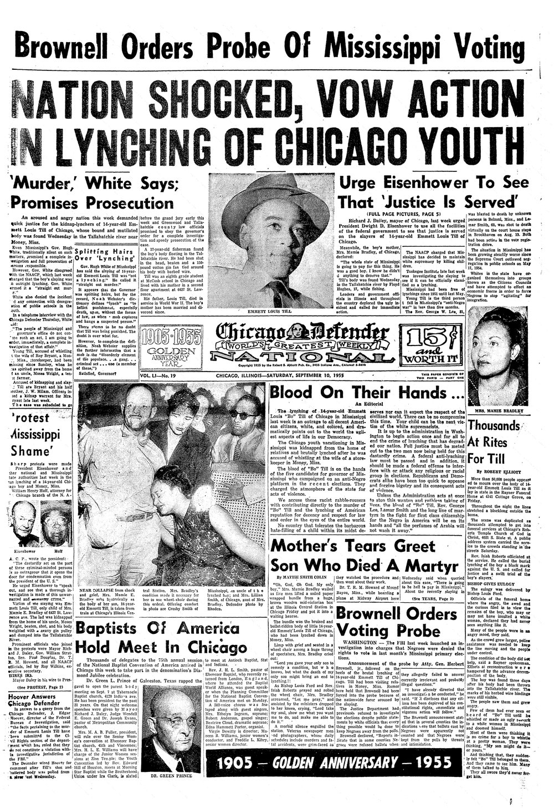
Analysis Questions
- What words in the newspaper headlines stick out to you?
- Where is justice mentioned, directly or indirectly?
- What did the writers in the Chicago Defender highlight about Emmett Till and what had happened to him?
- Based on the headlines, which types of “action” was the Chicago Defender calling for?

