Introduction to MISSION US: No Turning Back for Parents, Teachers, and Administrators
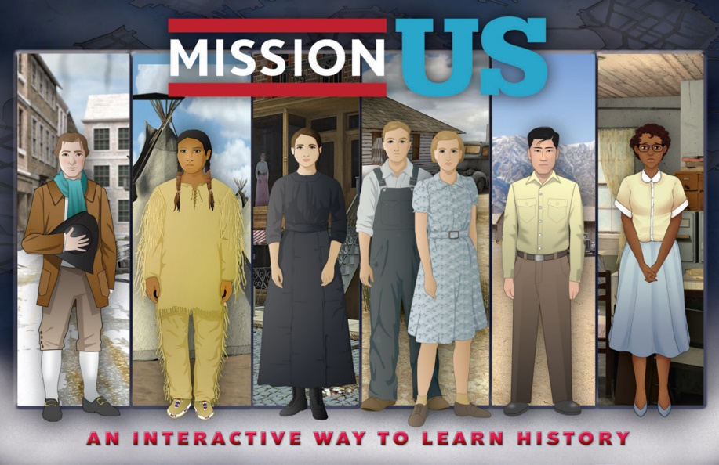
This introduction includes information about the Mission US educational media project and its interactive mission about the civil rights movement, “No Turning Back.” To learn more, visit mission-us.org, or reach out to the Mission US team at missionus@thirteen.org.

ABOUT MISSION US
(View a video intro to Mission US here or on the website in the ABOUT section.)
Developed for use by middle school students in the classroom and beyond, Mission US (mission-us.org) is a deeply-researched, award-winning educational media project with proven positive impact on history learning. Interactive missions immerse players in historical settings and empower them to make choices that illuminate key themes. Teacher’s guides provide resources and activities that show the broader historical context of events and perspectives in the games. Hallmarks of Mission US include its:
- Proven effectiveness
- Being deeply and collaboratively researched
- Ethical and age-appropriate design
- Inclusive social studies curriculum content
- Accessibility and ease of use (in classroom and out)

Mission US is part of an expanding body of “serious games” that encourage perspective-taking, discussion, and analysis of evidence. The missions are not simulations, nor truly games in the sense that there is no “winning” or “losing,” nor do users get a score. They are sophisticated interactive narratives developed in collaboration with community stakeholders and scholars. We test each mission with a diverse range of students and involve educators to help ensure the material is developmentally and academically appropriate for children in grades 5-8.

Serving a growing base of more than 3.8 million users, including 120,000 teachers, in all fifty states, Mission US has earned praise from educators, parents, students, and critics, as well as endorsements from Common Sense Media, the Parents’ Choice Award, the Japan Prize for Educational Media, the International Serious Play Awards, and the Games for Change Award for “Most Significant Impact.” Research shows that the series increases students’ history knowledge and skills, and is effective for reaching struggling learners who have difficulty learning from a textbook.

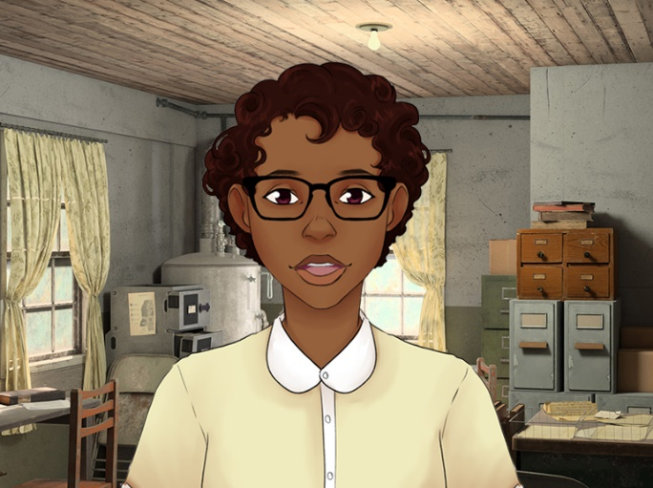
ABOUT NO TURNING BACK
In No Turning Back, players step into the role of Verna Baker, a fictional African American teen from the Mississippi Delta. Through Verna’s experiences, the player learns about the challenges of life under segregation in the Jim Crow south and ways Black community members supported each other. Eventually, the player becomes a part of efforts by young people to organize around voter registration efforts. The game focuses on the important role that youth played in bringing about change during the 1960s civil rights movement, and remains very relevant today. The Mission US team worked with various advisors, including historical scholars, former SNCC (Student Nonviolent Coordinating Committee) staff, Mississippi community members, youth development experts, and dozens of teachers and students, to develop the game.

BEFORE STUDENTS PLAY
We strongly encourage parents and educators to preview the entire mission themselves, and make certain it is appropriate for their children/students and community. On the website, we have provided background information, activities, discussion starters, primary source documents, suggestions for further reading and research, and other resources to help contextualize and deepen students’ understanding of the historical content in the mission.

We also recommend that students view the video and/or handout entitled “Top 5 Things to Know Before You Play Mission US,” linked here and available on the website.

CONTENT AND LANGUAGE ADVISORY FOR NO TURNING BACK
The following content and language advisory is presented at the beginning of No Turning Back to prepare students for material that may be challenging or offensive out of context. We suggest you review the advisory in case your students have questions or concerns.

The History of No Turning Back
No Turning Back is about the 1960s Civil Rights Movement, a period of significant change that continues to shape our nation today.
The game tells the story of how one Black community in Mississippi challenged an unjust racial system based on the idea of white supremacy. While most of the characters are fictionalized, the game is closely based on real people and events.
We hope No Turning Back provides a way to learn about and reflect on how ordinary citizens – including many young people – worked to expand rights for all.
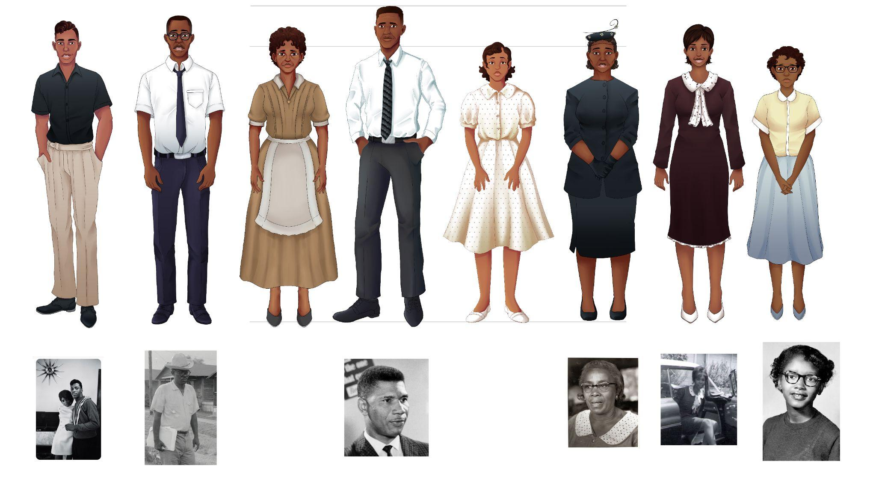
The Difficult Content of No Turning Back
Before you begin, you should know that characters in the game experience different forms of racial discrimination. They also hear about racial violence, including lynching. Your character, however, does not experience violence directly.
We recognize that the game content may be upsetting, especially to those who have been personally affected by racial discrimination or violence. (And we advise parents and teachers to fully play the game before sharing it.)
We encourage you to reach out to a family member, teacher, or other trusted adult if you have any concerns or questions about No Turning Back or the events that it portrays. You can also reach out directly to us at missionus@thirteen.org.
The Language of No Turning Back
The Mission US series uses historical terms and phrases that have changed over time. Characters in this Mission use terms like “colored” and “Negro,” which were considered respectful in the early 1960s, to refer to members of the Black community.
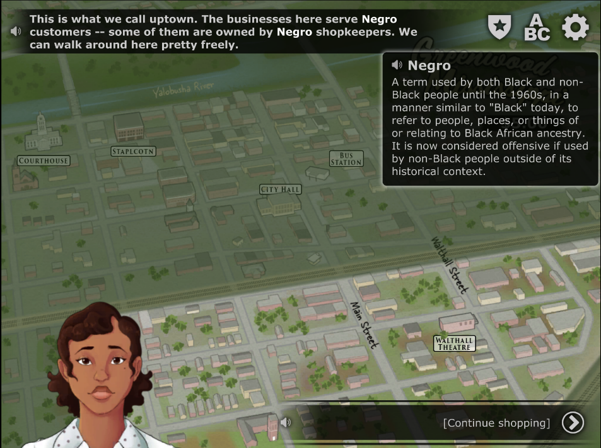
Today, some members of the Black community have reclaimed, reimagined, and repurposed “colored” and “Negro.” However, it is now inappropriate and offensive for non-Black people to use these words (aside from discussing historical material).
To learn more about the history and context of these words, and our language choices, we encourage you to click on “smartwords” in No Turning Back and explore some of the resources provided on this website.

FOR ADDITIONAL INFORMATION
The following blogs provide further historical context for the mission (linked here or accessible from the website on the mission page):
- Historical Terms and Why They Matter
- Marching Home: Honoring Family Stories and Civil Rights in the Mississippi Delta

Support materials, including historical background, activities, and additional resources for No Turning Back, are available in the TEACH section of the Mission US website at mission-us.org.

Please feel free to reach out to the Mission US team any time at missionus@thirteen.org.

