Instructions: Use this chart to record when you receive a star toward each badge and how you earned the point. At the end of this chart, you can list “community connections” made throughout the game.

GRANDFATHER’S LEGACY Which item did you select, the Book of Poetry, School Bus Photograph, or UNIA Pin? _____________________
Why did you select that item? _____________________________________________________________________________________________________
________________________________________________________________________________________________________________________________

BADGE | PROLOGUE | PART 1 | PART 2 | PART 3
TAKING A STAND
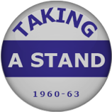
(You get this badge by refusing to do business in places where you receive second-class treatment.
BOLD MOVES
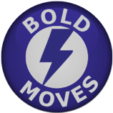
(You get this badge by making bold (but extremely risky) choices that challenge Jim Crow customs.)

BADGE | PROLOGUE | PART 1 | PART 2 | PART 3
COOL CUSTOMER
(You exercise icy patience and composure when confronted with second-class treatment.
RESOURCEFUL READER
(You take advantage of reading opportunities and sharing your knowledge.)
FAVORITE NIECE
(You do things that your uncle and aunt appreciate, and don’t cause trouble.)

BADGE | PROLOGUE | PART 1 | PART 2 | PART 3
PEOPLE POWER
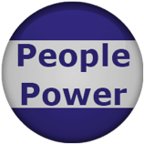
(You bring new people to the Movement.)

COMMUNITY CONNECTIONS  List the people in Verna’s community with whom you meet and form a connection. They will appear in the “community connections” part of the game dashboard. | PROLOGUE | PART 1 | PART 2 | PART 3

