A NOTE TO THE EDUCATOR:
On the following pages, you will find “flashcards” with terms and definitions (both combined and separate) that your students may encounter while playing “No Turning Back.” These terms and definitions can be introduced and practiced before or during the time students see or hear them in the context of Mission US or in their American history study. The discussion questions and writing prompts will provide further opportunities for students to have more practice with the words and terms.

Divide your students into small groups of four or five and ask each group to review the terms and definitions.

After your students have had a chance to review and discuss the terms and definitions, distribute the excerpt from an imagined letter from Verna to her grandmother. Review the directions with your students and ask them to complete the text using the terms they studied as well as the glossary. Here is the order in which the vocabulary terms should be inserted into the blanks within Verna’s letter:

homegoing
reminiscing
lynching
KKK
the Brown decision
sharecroppers
segregation
CORE
the NAACP
sit-ins

Bill Russell  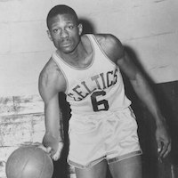  African American basketball superstar; he played center for the Boston Celtics in the 1950s and 60s, where he won eight consecutive championships beginning in 1959. | Brown Decision  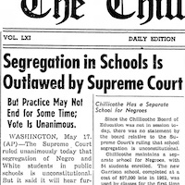  Brown v. Board of Education, a landmark 1954 decision by the U.S. Supreme Court stating that U.S. state laws establishing racial segregation in public schools were unconstitutional, even if the segregated schools were otherwise equal in quality.
Castro  Cuban revolutionary Fidel Castro, who assumed power over the country in 1959. He then allied Cuba with communist countries and criticized the poverty and racism faced by African Americans in the United States.  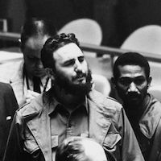 | Chicago Defender  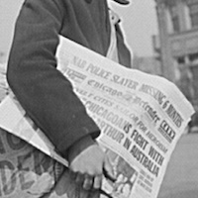  An influential African American newspaper founded in 1905. It reported extensively on violations of African Americans' rights and the civil rights movement and urged African Americans to move North.
Citizens’ Councils  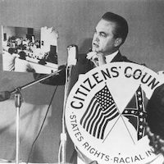  A national network of pro-segregation organizations formed by white professional workers and businessmen. They used their social and economic power to oppose civil rights groups. | CORE  The Congress of Racial Equality, an interracial civil rights organization founded in Chicago in 1942, which sought to use nonviolent protests as a tactic for challenging racial segregation in the United States.  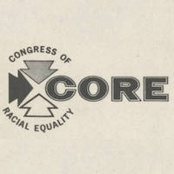

Diahann Carroll  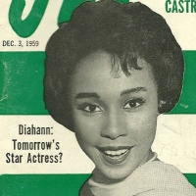  African American actress and singer; she began performing in nightclubs and Broadway as a teenager and made her film debut in the mid-1950s. | Freedom Songs  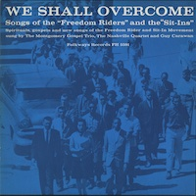  Songs used for spiritual support in the 1960s civil rights movement. They were often based on familiar, easy-to-learn hymns or pop songs, with lyrics improvised to fit the circumstances.
James Meredith  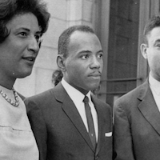  A Black Mississippian with an accomplished academic and military record, he was twice denied admission to the University of Mississippi. In 1962, the Supreme Court ruled that he had the right to be admitted. | Jim Crow  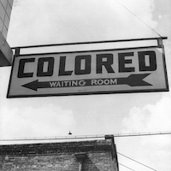  The extensive system of legal, social, and economic control of African Americans by white Americans after they regained political power in the late 1870s and continuing until the 1970s. The system included, but went far beyond, segregation laws and customs.
Kennedy  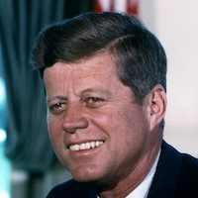  John F. Kennedy, a Democrat, was narrowly elected in 1960 as 35th president of the United States. On the campaign trail, he promised voters he would uphold and protect the civil rights of African Americans. His brother, Robert F. Kennedy, was Attorney General and his advisor. | KKK  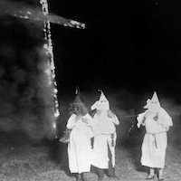  The Ku Klux Klan, a white supremacist organization founded after the Civil War. Beginning in the 1950s, local groups calling themselves the KKK used violence, including murder, to terrorize African Americans.

Lena Horne  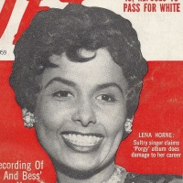  African American actor, dancer, singer, and civil rights activist; she became famous for starring roles in two early Hollywood movie musicals to feature Black casts, Stormy Weather and Cabin in the Sky. | Mahalia Jackson  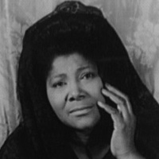  African American singer; one of the first singers to take gospel music out of the church and popularize it for Black and white audiences. In her long career she sold millions of records and became one of the key voices of the civil rights movement.
Parchman  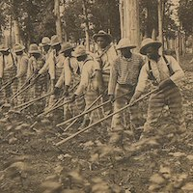  Mississippi State Penitentiary, a notoriously brutal state prison where inmates were forced to work on chain gangs, overseen by other inmates with rifles, picking cotton from dawn to dusk. | Sam Cooke  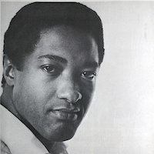  An influential African American singer and songwriter born in Mississippi who grew up in Chicago. The son of a pastor, he initially sang in a gospel quartet. As a solo artist, his hit songs were popular with both Black and white audiences.
sit-in / sit-down  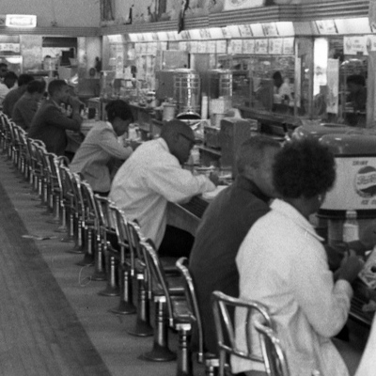  A form of protest against segregation, in which protesters peacefully occupy a space, such as a library or lunch counter, that is open to the white public but denied to other racial and ethnic groups. | SNCC  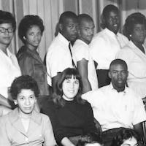  The Student Nonviolent Coordinating Committee, a youth-led national civil rights organization mentored by Ella Baker. Singing, independence from authority, and the use of nonviolent tactics such as sit-ins and boycotts were key parts of its culture.

Bill Russell | Brown Decision
Castro | Chicago Defender
Citizens’ Councils | CORE

Diahann Carroll | Freedom Songs
James Meredith | Jim Crow
Kennedy | KKK

Lena Horne | Mahalia Jackson
Parchman | Sam Cooke
sit in / sit down | SNCC

African American basketball superstar; he played center for the Boston Celtics in the 1950s and 60s, where he won eight consecutive championships beginning in 1959. | Brown v. Board of Education, a landmark 1954 decision by the U.S. Supreme Court stating that U.S. state laws establishing racial segregation in public schools were unconstitutional, even if the segregated schools were otherwise equal in quality.
Cuban revolutionary Fidel Castro, who assumed power over the country in 1959. He then allied Cuba with communist countries and criticized the poverty and racism faced by African Americans in the United States. | An influential African American newspaper founded in 1905. It reported extensively on violations of African Americans' rights and the civil rights movement and urged African Americans to move North.
A national network of pro-segregation organizations formed by white professional workers and businessmen. They used their social and economic power to oppose civil rights groups. | The Congress of Racial Equality, an interracial civil rights organization founded in Chicago in 1942, which sought to use nonviolent protests as a tactic for challenging racial segregation in the United States.

African American actress and singer; she began performing in nightclubs and Broadway as a teenager and made her film debut in the mid-1950s. | Songs used for spiritual support in the 1960s civil rights movement. They were often based on familiar, easy-to-learn hymns or pop songs, with lyrics improvised to fit the circumstances.
A Black Mississippian with an accomplished academic and military record, he was twice denied admission to the University of Mississippi. In 1962, the Supreme Court ruled that he had the right to be admitted. | The extensive system of legal, social, and economic control of African Americans by white Americans after they regained political power in the late 1870s and continuing until the 1970s. The system included, but went far beyond, segregation laws and customs.
John F. Kennedy, a Democrat, was narrowly elected in 1960 as 35th president of the United States. On the campaign trail, he promised voters he would uphold and protect the civil rights of African Americans. His brother, Robert F. Kennedy, was Attorney General and his advisor. | The Ku Klux Klan, a white supremacist organization founded after the Civil War. Beginning in the 1950s, local groups calling themselves the KKK used violence, including murder, to terrorize African Americans.

African American actor, dancer, singer, and civil rights activist; she became famous for starring roles in two early Hollywood movie musicals to feature Black casts, Stormy Weather and Cabin in the Sky. | African American singer; one of the first singers to take gospel music out of the church and popularize it for Black and white audiences. In her long career she sold millions of records and became one of the key voices of the civil rights movement.
Mississippi State Penitentiary, a notoriously brutal state prison where inmates were forced to work on chain gangs, overseen by other inmates with rifles, picking cotton from dawn to dusk. | An influential African American singer and songwriter born in Mississippi who grew up in Chicago. The son of a pastor, he initally sang in a gospel quartet. As a solo artist, his hit songs were popular with both Black and white audiences.
A form of protest against segregation, in which protesters peacefully occupy a space, such as a library or lunch counter, that is open to the white public but denied to other racial and ethnic groups. | The Student Nonviolent Coordinating Committee, a youth-led national civil rights organization mentored by Ella Baker. Singing, independence from authority, and the use of nonviolent tactics such as sitins and boycotts were key parts of its culture.

Name: _______________________ Date:_________________________

Activity: By the end of the Prologue, Verna has moved to Greenwood to live with her aunt, uncle, and cousin so that she can attend a new school. Imagine that upon arriving, she writes a letter to her grandmother in Sunflower County.

Use the words and definitions on the flashcards, as well as the glossary to fill in the missing words and terms in the letter below.

lynching  CORE  homegoing | the Brown Decision  sharecroppers  sit-ins | KKK  homegoing  reminiscing | the NAACP

Dear Grandma,

I wish I had had more time to spend with you before I left with Uncle Curtis for Greenwood. Granddaddy’s __________________ was such a special time to be together with family and friends to celebrate his life. I learned so much about Granddaddy, __________________ with you about his life. I can’t believe how much I didn’t know about him, how he drove the community school bus and followed the UNIA!

As sad as I was when Granddaddy passed, I was so happy to see Robert in Mississippi. I wish he visited more often from Chicago, but he told me that Emmett Till’s __________________, and stories in the newspaper about the __________________ terrorizing people here in Mississippi have made his family and other Black people in the North think twice before coming back South.

I wish I didn’t have to move away to go to a better school. I don’t understand why we still can’t go to the same schools as the white kids, six years after the Supreme Court issued __________________ and said that separate would never be equal, like we didn’t already know that! I think Daddy is right; Black folks will never get ahead tilling the soil down here as __________________. Getting an education is the best chance I have.

Sometimes I think __________________ will never end, and we’ll always be second class citizens in this country. But when I hear about organizations like __________________ and __________________, and the __________________ happening at Woolworth’s I start to feel hopeful, and a little afraid.

I have so much to do to get settled in here in Greenwood before school starts. I promise I will write again as soon as I can. I miss you already!

Love,
Verna

Prologue Vocabulary Activity - ANSWER KEY

Dear Grandma,

I wish I had had more time to spend with you before I left with Uncle Curtis for Greenwood. Granddaddy’s [homegoing] was such a special time to be together with family and friends to celebrate his life. I learned so much about Granddaddy, [reminiscing] with you about his life. I can’t believe how much I didn’t know about him, how he drove the community school bus and followed the UNIA!

As sad as the day was, I was so happy to see Robert there. I wish he visited more often from Chicago, but he told me that Emmett Till’s [lynching], and stories in the newspaper about the [KKK] terrorizing people here in Mississippi have made his family and other Black people in the North think twice before coming back South.

I wish I didn’t have to move away to go to a better school. I don’t understand why we still can’t go to the same schools as the white kids, six years after the Supreme Court issued [the Brown decision] and said that separate would never be equal, like we didn’t already know that! I think Daddy is right; Black folks will never get ahead tilling the soil down here as [sharecroppers]. Getting an education is the best chance I have.

Sometimes I think [segregation] will never end, and we’ll always be second class citizens in this country. But when I hear about organizations like [CORE] and [the NAACP], and the [sit-ins] happening at Woolworth’s I start to feel hopeful, and a little afraid.

I have so much to do to get settled in here in Greenwood before school starts. I promise I will write again as soon as I can!

Love,
Verna

