A NOTE TO THE EDUCATOR:
In Part 1 of “No Turning Back,” Addie takes Verna shopping in Greenwood, and we get a glimpse of their experiences of Jim Crow segregation in 1960s Mississippi. This activity gives students the opportunity to deepen their understanding of the experiences of African Americans during Jim Crow through responding to the photographs of Gordon Parks, a Black photojournalist.

Steps to Complete

- Share Photographs
Distribute handouts for this activity, which include the three Parks photographs to students. Since the photographs are best experienced in color, you might also make a few color photocopies of each and set up a gallery walk so that students can move around the room to view them. Give students several minutes to examine the photographs in whatever format you provide them.

- Respond to Photos with Identify-Imagine-Connect
After viewing the photographs, students can respond to them using the Identify-Imagine-Connect chart included in the handout. Students will be choosing one person from the photographs to write about in their responses. After completing the chart, students might gather in groups according to the photograph in which the person they chose appears. In those groups, they can share and discuss their Identify-Imagine-Connect responses.

- Discuss the Power of Photography and Perspective-taking
Complete the activity by leading a whole group discussion based on the following questions (also included on the handout):
- How did Gordon Parks capture segregation through photography?
- What do you notice about children’s perspectives in these photos? About adults’ perspectives?
- To what extent do you think that we can understand what another person experienced, thought, or felt at a particular moment in history? Why do you think it is important to try to understand the perspectives of people who lived in the past?

Directions: Read the text below and examine the Gordon Parks photographs documenting the realities of Jim Crow segregation, along with the captions for each image.

Gordon Parks, a Black photojournalist, captured the realities of Jim Crow segregation on film. The following three photographs were part of a series taken in Alabama, focusing on one multigenerational family and their experiences of segregation in 1956.

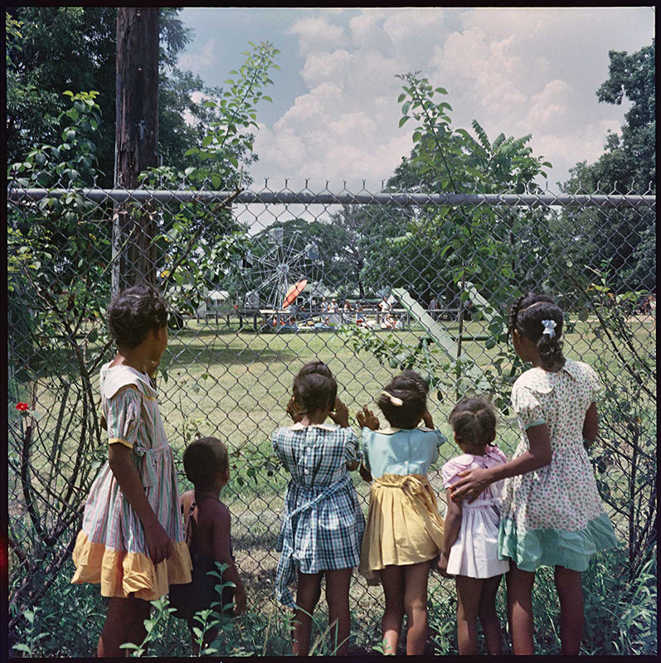
Outside Looking In, Mobile, Alabama, 1956.
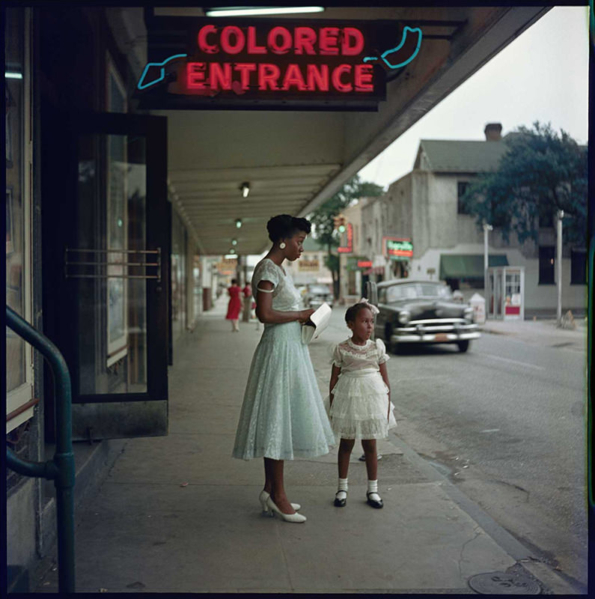
Department Store, Mobile, Alabama,1956.
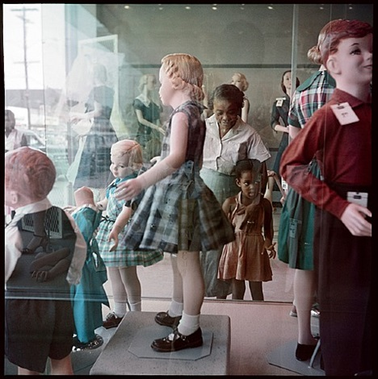
Ondria Tanner and Her Grandmother Window-shopping, Mobile, Alabama, 1956.

Credit: Photographs by Gordon Parks.
Copyright: Courtesy of and copyright The Gordon Parks Foundation.

Directions: Respond to Gordon Parks’ photographs by completing the questions in the chart below:

Identify  Choose one person from one of the three photographs, and describe them using your observation of details in the image. Where is the person? What other people, buildings, and objects are near them? What is the person doing? What is happening around them? | Imagine  What do you think the person you identified might be thinking or feeling at the moment the photograph was taken? What makes you say that? | Connect  Make a connection between the person you identified and Verna, or another character, in “No Turning Back.” What might be similar about their experiences, thoughts, or feelings? What might be different? Use specific evidence from the game to support your response.

Discussion Questions:
- How did Gordon Parks capture segregation through photography?
- What do you notice about children’s perspectives in these photos? About adults’ perspectives?
- To what extent do you think that we can understand what another person experienced, thought, or felt at a particular moment in history? Why do you think it is important to try to understand the perspectives of people who lived in the past?

This activity is adapted from Project Zero’s "Feelings and Options" thinking routine.

